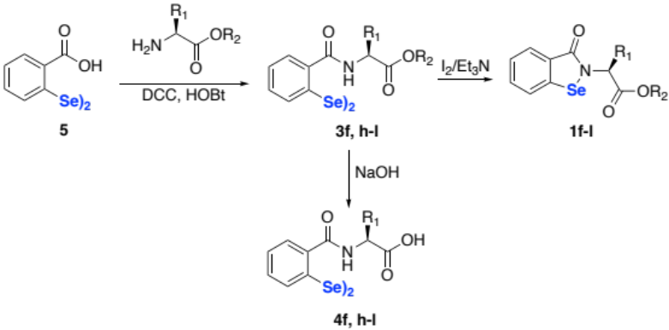
Scheme 1. Synthesis of diselenides 3,4 and benzisoselenenazolones 1f-l. For R1 and R2 see Table 1. For synthetic details see references.^{31,32}

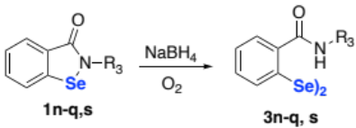
Scheme 2. Synthesis of diselenides 3n-q, s.

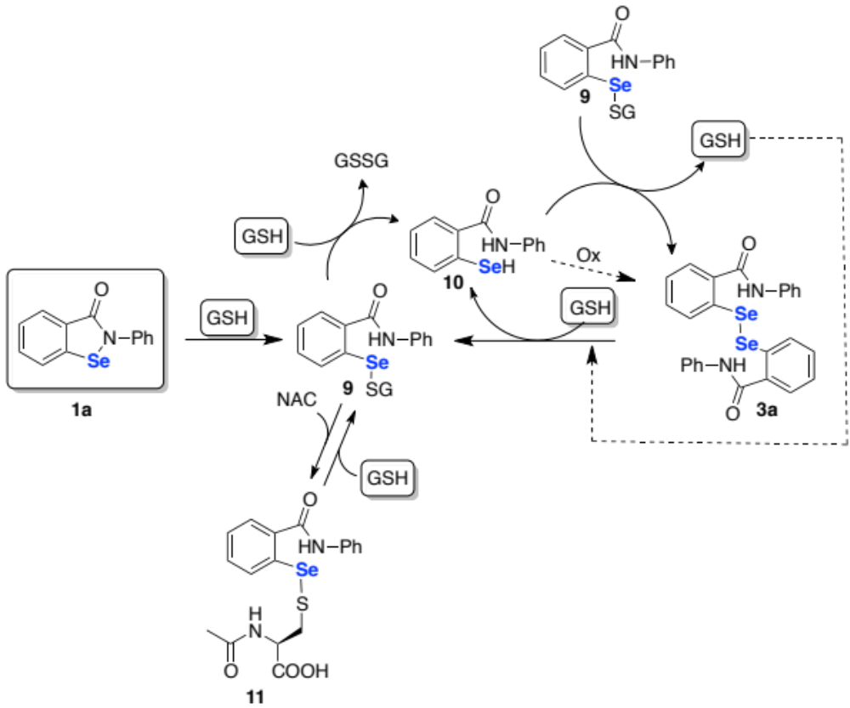
Scheme 3. Fate of Ebselen 1a and the corresponding diselenide 3a in the presence of GSH.

