Table 1. Structures and IC₅₀ values of all the Ebselen derivatives 1f-s.
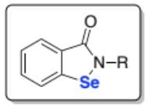
compound | R | IC₅₀ nM | compound | R | IC₅₀ nM | compound | R | IC₅₀ nM
1f | 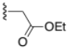 | 201.4 ± 24.3 | 1k | 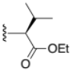 | 56.30 ± 31.1 | 1p | 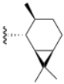 | 311.5 ª
1g | 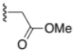 | 166.8 ± 41.0 | 1l | 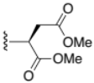 | 101.16 ± 97.4 | 1q | 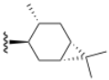 | 487.2 ª
1h | 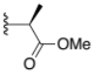 | 149. 5 ± 18.1 | 1m | 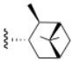 | 358.8 ª | 1r | 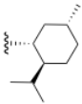 | 346.2 ª
1i | 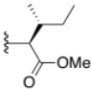 | 87.64 ± 19.8 | 1n | 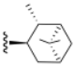 | 334.9 ª | 1s | 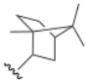 | 203.2 ª
1j | 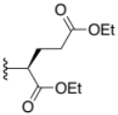 | 101.5 ± 39.5 | 1o | 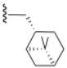 | 518.9 ª
a) acquired as a single experiment.
Table 2. Structures and IC₅₀ values of diselenides 3f, 3h-s; 4f, 4h-i.
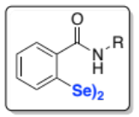
compound | R | IC₅₀ μM | compound | R | IC₅₀ μM | compound | R | IC₅₀ μM
3f |  | 0.56 ± 0.21 | 3j |  | 6.28 ± 4.04 | 3n | 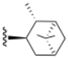 | ND
4f | 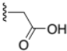 | 6.49 ± 1.36 | 4j | 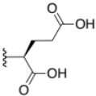 | > 100 | 3o |  | 6.133 ª
3h |  | 1.06 ± 0.23 | 3k |  | 1.39 ± 0.09 | 3p |  | 3.449 ª
4h | 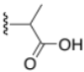 | 5.44 ± 1.86 | 4k | 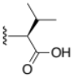 | 4.87 ± 2.97 | 3q |  | 8.332 ª
3i |  | 1.26 ± 0.36 | 3l |  | 1.92 ± 0.68 | 3s |  | 43.16 ª
4i | 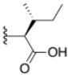 | 5.14 ± 2.39 | 4l | 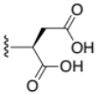 | 11.84 ± 2.48
a) acquired as a single experiment

Table 3. Structures and IC₅₀ values of other diselenides (5-8).
compound |  | IC₅₀ μM | compound |  | IC₅₀ μM
5 | 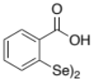 | ND | 7 | 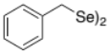 | ND
6 | 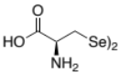 | 64.86 ª | 8 | 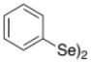 | 1.87 ± 0.26
a) acquired as a single experiment; ND not determined.

Table 7. anti Mpro activity of 1a and 3a
compound | IC₅₀
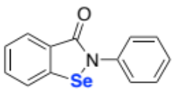 | 36 nMª
 | 432 μM^{b}
1a
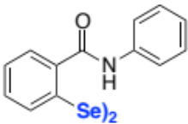 | 65 nMª
 | 209.46 μM^{b}
3a
ªTested in the absence of DTT; ^{b}tested in the presence of DTT.

