Supporting info

New insights in the mechanism of the SARS-CoV-2 M^{pro} inhibition by benzisoselenazolones and diselenides

Luca Sancineto,¹ Francesca Mangiavacchi,¹ Agnieszka Dabrowska,^{2,3} Agata J. Pacuła-Miszewska,⁴ Magdalena Obieziurska-Fabisiak,⁴ Cecilia Scimmi,¹ Veronica Ceccucci,¹ Juan Kong,⁵ Yao Zhao,⁵ Gianluca Ciancaleoni,⁶ Vanessa Nascimento,⁷ Bruno Rizzuti,^{8,9} Anna Kula-Pacurar,² Haitao Yang,⁵ Jacek Ścianowski,⁴ Ying Lei,^{5*} Krzysztof Pyrc^{2*}, and Claudio Santi.^{1*}
- Department of Pharmaceutical Sciences, University of Perugia, Via del Liceo 1, 06100 Perugia (PG), Italy
- Virogenetics Laboratory of Virology, Malopolska Centre of Biotechnology, Jagiellonian University, Gronostajowa 7a, 30–387 Krakow, Poland.
- Microbiology Department, Faculty of Biochemistry, Biophysics and Biotechnology, Jagiellonian University, Gronostajowa 7, 30-387 Krakow, Poland.
- Department of Organic Chemistry, Faculty of Chemistry, Nicolaus Copernicus University, 7 Gagarin Street, Torun, Poland
- Shanghai Institute for Advanced Immunochemical Studies and School of Life Science and Technology, ShanghaiTech University, Shanghai, China
- Dipartimento di Chimica e Chimica Industriale (DCCI) Università di Pisa Via Giuseppe Moruzzi, 13 - 56124 Pisa, Italy
- Departamento de Quımica Organica, Universidade Federal Fluminense, Laboratorio de Sintese e Aplicaçao de Substancias Supramoleculares e Organocalcogenios (SupraSelen), Outeiro Sao Joao Batista s/n, 24020-141, Niteroi, RJ, Brazil
- CNR-NANOTEC, SS Rende, Department of Physics, University of Calabria, Rende (CS) 87036, Italy
- Institute of Biocomputation and Physics of Complex Systems, Joint Unit GBsC-CSIC-BIFI, University of Zaragoza, Zaragoza 50018, Spain

Table S1 S2
Figure S1 DFT-optimized geometry of 3p S3
Figure S2 cellular toxicity of the studied compounds S11
Figure S3 Antiviral activities of all the tested compounds S12
Figure S4 Spectral data for compound 9 and its reaction with GSH S14
Figure S5 Spectral data for compound 3a and its reaction with GSH. S16
Figure S6 Spectral data for compound 3k and its reaction with GSH. S18
Figure S7 Thiol exchange reaction S20
Table S2 S21
Figure S8 HRMS analyses S22

Table S1. Single point tests
Compound Code | Compound Name | Compound concentration (uM) | Inhibition%  (repeat1) | Inhibition% (repeat2) | Inhibition% average
1 | 8 (DSBA) | 40 | 23.4549 | 23.49053 | 23.47271
2 | 3f (SeGlyE) | 40 | 104.1679 | 106.5624 | 105.3651
3 | 4f (SeGly) | 40 | 98.75486 | 102.9584 | 100.8566
4 | 1f (EbsGlyE) | 40 | 102.8522 | 105.1895 | 104.0209
5 | 1g (EbsGlyEM) | 40 | 102.5259 | 102.1353 | 102.3306
6 | 3h (SeAlaE) | 40 | 104.3668 | 106.8705 | 105.6186
7 | 4h (SeAla) | 40 | 103.2194 | 103.6856 | 103.4525
8 | 1h (EbsAlaE) | 40 | 103.9924 | 105.1298 | 104.5611
9 | 3i (SeIleE) | 40 | 102.6115 | 101.0565 | 101.834
10 | 4i (SeIle) | 40 | 73.52064 | 70.85315 | 72.1869
11 | 1i (EbsIleE) | 40 | 103.3598 | 101.3292 | 102.3445
12 | 3j (SeGlutE) | 40 | 69.2309 | 64.56561 | 66.89826
13 | 4j (SeGlut) | 40 | 20.76941 | 25.72844 | 23.24893
14 | 1j (EbsGlutE) | 40 | 100.6027 | 102.7449 | 101.6738
15 | 3k (SeValE) | 40 | 86.45158 | 88.67362 | 87.5626
16 | 4k (SeVal) | 40 | 102.2683 | 105.1923 | 103.7303
17 | 1k (EbsValE) | 40 | 104.5922 | 104.9643 | 104.7783
18 | 3l (SeAspE) | 40 | 105.8074 | 105.2287 | 105.518
19 | 4l (SeAsp) | 40 | 97.8449 | 98.29484 | 98.06987
20 | 1l (EbsAspE) | 40 | 104.8261 | 104.5128 | 104.6695
21 | 6 (SeCys) | 40 | 54.6485 | 54.43289 | 54.5407
22 | 7 (BzSe)₂) | 40 | 76.18954 | 73.99094 | 75.09024
23 | 8 (PhSe)₂) | 40 | 103.5625 | 103.8694 | 103.716
24 | 1a (Ebselen) | 40 | 103.7943 | 102.295 | 103.0447
25 | 1m (CHB1) | 40 | 101.5471 | 101.7948 | 101.671
26 | 1n (CHB2) | 40 | 101.1082 | 101.9617 | 101.5349
27 | 1o (CHB3) | 40 | 102.6438 | 102.8427 | 102.7433
28 | 1p (CHB4) | 40 | 101.6966 | 101.7246 | 101.7106
29 | 1q (CHB5) | 40 | 102.4123 | 102.1041 | 102.2582
30 | 1r (CHB6) | 40 | 102.0525 | 100.9658 | 101.5091
31 | 1s (CHB7) | 40 | 99.09721 | 99.29166 | 99.19443
32 | 3n (CHD2) | 40 | 93.95084 | 92.23135 | 93.0911
33 | 3o (CHD3) | 40 | 66.43249 | 71.64838 | 69.04044
34 | 3p (CHD4) | 40 | 99.82873 | 100.8763 | 100.3525
35 | 3q (CHD6) | 40 | 96.56074 | 95.60711 | 96.08393
36 | 3s (CHD7) | 40 | 76.08326 | 71.4908 | 73.78703

Figure S1
DFT optimized conformation of 3p.
DFT optimized geometries (XYZ)

1a (Ebselen)
H -0.00134 -4.02750 2.76865
C -0.00135 -3.69787 1.72675
C -0.00135 -2.78670 -0.95143
C -0.00057 -2.32414 1.44817
C -0.00221 -4.60899 0.67155
C -0.00213 -4.15219 -0.65849
C -0.00064 -1.88613 0.11762
H -0.00309 -5.68178 0.87490
H -0.00249 -4.87233 -1.48072
H -0.00122 -2.43837 -1.98678
C 0.00035 -1.26789 2.48434
O -0.00029 -1.48162 3.69374
N 0.00000 -0.00000 1.90389
C -0.00102 1.24382 2.58051
C -0.00350 3.76807 3.85329
C -0.00169 1.33634 3.98826
C -0.00155 2.43550 1.82940
C -0.00283 3.67994 2.45889
C -0.00288 2.58965 4.60414
H -0.00134 0.42805 4.58120
H -0.00111 2.40933 0.73777
H -0.00359 4.58405 1.84585
H -0.00318 2.63832 5.69625
H -0.00441 4.74182 4.34880
Se 0.00000 0.00000 0.00000

1f(EbsGlvE)
H -0.02801 4.87754 -1.41534
C -0.02330 4.15115 -0.61225
C -0.01110 2.30582 1.46328
C -0.02464 2.79794 -0.92040
C -0.01953 4.58828 0.71832
C -0.01588 3.67017 1.75644
C -0.01605 1.88782 0.13176
H -0.03177 2.46550 -1.94982
H -0.02079 5.64888 0.93269
H -0.01038 3.99071 2.79033
Se 0.00000 0.00000 0.00000
N 0.00000 -0.00000 1.87116
C 0.13242 -1.25913 2.58792
H 0.07123 -2.05469 1.84137
C 0.02174 1.23042 2.47172
O 0.06479 1.38707 3.69282
C -0.99507 -1.49183 3.59713
H -0.95540 -0.76316 4.40262
H -0.91516 -2.49440 4.01127
H -1.95051 -1.40240 3.07974
C 1.53865 -1.39432 3.17890
O 2.45878 -0.64046 2.97142
O 1.63420 -2.50081 3.91631
C 2.93455 -2.78387 4.48024
H 3.66445 -2.91338 3.68346
H 2.81241 -3.70521 5.04066
H 3.24243 -1.97027 5.13437

1i(EbsIleE)
H 0.02800920832755 0.06283588473096 -0.22349982220774
C -0.00928009628314 -0.03405620366642 0.86480907131588
C -0.09198953734191 -0.25571366847023 3.63950823948775
C -0.10595338353852 -1.30580941278928 1.43337132985703
C 0.04315285643303 1.12188824245776 1.66519297190459
C 0.00674814698691 1.01365520438924 3.05359271911005
C -0.14887103191160 -1.40073496164233 2.82840838847754
H -0.14517063750623 -2.19707769993477 0.80387233717007
H 0.11824383246440 2.10348402577303 1.19187007884480
H 0.05548100622497 1.89372144525484 3.69905970050245
Se -0.29102728625275 -2.97989660224634 3.86780080130148
N -0.30101606030718 -1.84016729244753 5.36349183399459
C -0.10003207185963 -2.38552248739369 6.69810868820089
H -0.26240056015748 -3.47413314103386 6.61928440044045
C -0.11160017675362 -0.50420631304198 5.09549496139689
O 0.02482413833110 0.34312863307024 5.97841411905533
C -1.07920474906981 -1.85645620167262 7.78013621818614
H -0.64852894378802 -0.92579956300131 8.17608781537285
C 1.39205849492981 -2.21655853962072 7.04923774559185
O 2.26917925484558 -2.17596462596257 6.21473861498198
O 1.60971605479045 -2.14293648175604 8.35676764741240
C 2.97428558138219 -1.99675902256610 8.80964970592921
H 3.53890333610757 -2.89647849342664 8.51807927111697
H 3.42466266250027 -1.13672416197708 8.29080458806568
C -1.19007105855779 -2.87975948314664 8.93282099065297
H -0.25073409905724 -3.44258712094411 9.02673286331370
H -1.96869224034718 -3.61841627065251 8.67031028723960
C -2.46099497069291 -1.53327024623722 7.20233171166392
H -2.89933537468996 -2.41246314569164 6.70059258905441
H -2.42128025272573 -0.70727166091988 6.47844637639333
H -3.14381074446468 -1.23192063899364 8.01258130021598
C 2.93512205875417 -1.80389494266608 10.30764768536388
H 3.95720298041308 -1.65772548023102 10.68980078537678
H 2.49866051089447 -2.68123620859798 10.80993383860830
H 2.33607385226863 -0.91832677224515 10.57053984490036
C -1.50226393228459 -2.23269194468827 10.28152435678969
H -1.62179576417580 -2.99250974381697 11.07044844982278
H -2.42893344034061 -1.63601112013505 10.24994425771173
H -0.68333756354782 -1.55863378406043 10.58106323738339

1k(EbsValE)
H -0.12675637728835 -0.04033352023017 -0.20927502294776
C -0.13180814700372 -0.10670119287280 0.88192872395882
C -0.14075483525288 -0.25075697883402 3.66346971385530
C -0.14683962340915 -1.36422394196284 1.48825243998279
C -0.12219700336602 1.07310355464199 1.64835524538457
C -0.12474958685919 1.00381591521063 3.03978859392988
C -0.14991814702092 -1.41974934092535 2.88582338321186
H -0.15304251075269 -2.27475573448255 0.88555523425105
H -0.11217668337977 2.04322807644598 1.14660840993620
H -0.11437716455674 1.90349145198935 3.65942387997604
Se -0.17142943864773 -2.97435025840146 3.96928575368461
N -0.21893257970831 -1.79498648297030 5.43168672700578
C 0.02337826191628 -2.29222454987688 6.77574185336714
H -0.06006208179988 -3.39164723644632 6.72602766286904
C -0.12678112710632 -0.45670086092308 5.12646462772774
O -0.05290182249968 0.42288987922562 5.98428767465857
C -1.01213038070655 -1.80799754661202 7.83740355988577
H -0.64128741999229 -0.85655429808708 8.24737679274114
C 1.49734505758821 -2.00777637428952 7.12086044511438
O 2.32784457306673 -1.69291462182077 6.29783171692124
O 1.76698185335174 -2.18200581997428 8.41072681079606
C 3.13981579208822 -2.00493229039273 8.83271012229614
H 3.76753832833901 -2.71925651579181 8.27825406474251
H 3.46287271145050 -0.99047136763096 8.55394105996256
C -1.13646879990176 -2.83312038575226 8.97230502902294
H -0.16376545541519 -3.07415985915311 9.41932835182568
H -1.58496833594240 -3.76816496777051 8.59404158175001
H -1.79392825244727 -2.44281887730264 9.76516615630605
C -2.38918847716457 -1.55463624679451 7.21205238116412
H -2.77786288106063 -2.46359380426352 6.72201390386966
H -2.36592835271484 -0.74791746881796 6.46747485117139
H -3.10183142666748 -1.26440643473289 7.99978942665998
C 3.20114762320467 -2.23143297191531 10.32468656204730
H 4.23376839584416 -2.08080314236262 10.67613599131751
H 2.89042060199937 -3.25565259235872 10.58476090312069
H 2.55097371181545 -1.52248319376457 10.85871538843325

1p(CHB4)
H 1.69563845465190 0.50247790497036 0.76455666441028
C 1.18393012824374 0.20140389427247 1.68205776727296
C -0.11213556001021 -0.53515380335460 4.03672796380980
C 1.40463944166368 -1.07814142060960 2.19805830138931
C 0.31672654551529 1.10532798570576 2.32233084337155
C -0.33000510640444 0.74101880402758 3.50165063544390
C 0.74465232946388 -1.43318407789781 3.37959371694777
H 2.07819295965408 -1.77464586796404 1.69381699505047
H 0.15221003400153 2.09573199054712 1.89202481264818
H -0.99846243790711 1.42774935862339 4.02622064786635
Se 0.85331753387259 -3.07959443571676 4.31501869751212
N -0.30852516930861 -2.30218014709072 5.57248010231672
C -0.69679961239236 -1.01195432970312 5.31090649100542
O -1.41410851428838 -0.34348916832340 6.05899010153163
C -0.53500925963217 -2.98580673709183 6.85358444715639
C -0.27961348471836 -2.38142445991001 9.40063384156628
C -2.15170644175093 -3.93322493310063 8.49674156903604
C -1.56588103041424 -3.15033087890903 9.68639062171711
C -2.03264373523336 -3.19225022092076 7.15946120651145
C 0.21469804284511 -2.26320791247225 7.97333546474721
H -1.66704934566306 -4.91950321008276 8.39421684434438
H -2.31594774351246 -2.40403691880510 9.99847960151228
H -2.48896872212897 -2.19575596446873 7.26512024805141
H 0.60035640062779 -1.28596020512511 7.67335642407407
H -0.10895454084224 -3.99410612767793 6.72145924573398
H -0.18132167240824 -1.47044626593652 10.00062670755664
H -3.21382254855586 -4.14541283184227 8.70133747624412
H -1.43647305386695 -3.82804167552093 10.54877162163669
C -2.72980551694477 -3.94544379036782 6.02675110691276
H -2.24141560346750 -4.91844255673765 5.84356693063840
H -2.70025531730636 -3.37459124668002 5.08606798651269
H -3.78489016448550 -4.14267927646678 6.27489251128105
C 1.04547784633410 -3.00395297512207 9.00514157348376
C 2.30601339629515 -2.29018292057728 9.46459497988669
H 3.14945845461716 -2.52116930366890 8.79150765006247
H 2.59441910308426 -2.60681574074919 10.48192795221392
H 2.17173748234167 -1.19687182306639 9.47213833134538
C 1.21745222639702 -4.50939986571495 8.94406477849514
H 1.97718031917491 -4.78426680358906 8.19192991634651
H 0.29586462939280 -5.05013526612182 8.69730269518350
H 1.56782925306538 -4.88990677676087 9.91816452717315

3k(SeValE)
Se -1.48514709840722 0.03310794937978 -0.77119483741710
C -1.90867831496121 -0.22492626965387 1.09757183555635
C -2.37685987663960 -0.79911219466314 3.80326345945883
C -1.21539596349523 -1.26331111383482 1.74193039344652
C -2.83318228863096 0.56598699092271 1.82313083789711
C -3.04227151093245 0.25275148416568 3.17842354871402
C -1.44901289655072 -1.55867505024920 3.08460471589848
H -0.48822674972527 -1.84688050421042 1.17445013507785
H -3.75158868152112 0.86619455459295 3.73452299862326
H -0.90953748867281 -2.37836572397472 3.56447753227847
H -2.58813171964989 -1.02903375244225 4.85026024925628
C -3.65333374101066 1.74306899764737 1.34086798223813
O -4.09214577965084 2.56245240260236 2.15436376589732
N -3.96339906854660 1.84934900203163 0.03281735436458
H -3.57913808725535 1.19691808879665 -0.64366690997898
Se 0.38193033224711 1.52242407327378 -0.50324060513098
C -0.46687772543267 2.87511200534543 0.58841931979090
C -1.61569305654508 4.64318845472247 2.44345242862433
C -0.28222146545195 2.69403680203338 1.96842470131885
C -1.25178589339726 3.95783107929618 0.12244588127024
C -1.82050111726099 4.81951113477497 1.07506741611048
C -0.84104748456990 3.57525131924801 2.89485344101441
H 0.30049283006919 1.84012763787401 2.31653845079242
H -2.43373377273940 5.64475771844514 0.71133757981473
H -0.67792342291517 3.40882447230668 3.96229814929619
H -2.07478203016040 5.33579511095267 3.15165839083317
C -1.57255676132601 4.33850056294895 -1.30289191993318
O -2.60996330664692 4.95592385683614 -1.56064004577626
N -0.67862483298308 4.06291429847445 -2.28038538301582
H 0.17439084009075 3.55790586014965 -2.06007683614317
C -0.82485555647576 4.67768482527833 -3.58826892433915
H -0.98884972168763 5.75649791268842 -3.44243356504994
C -4.79538133484639 2.94595175151732 -0.42451708991411
H -4.25354404825165 3.88556070990058 -0.27247706355907
C 0.44211931190847 4.49198307057129 -4.42610294948479
H 0.66662523964945 3.43527791396570 -4.62919366827463
H 1.29556180538610 4.93307490256802 -3.88932038814775
H 0.33069107601083 5.01558885886851 -5.38537970685690
C -2.09587734207195 4.26751282832394 -4.35091295078520
O -2.75050944457243 5.09855028113916 -4.93753401683660
C -5.09884665725213 2.79474264140825 -1.91468163294035
H -4.16687118476329 2.78554046853120 -2.49474657216718
H -5.70192874294143 3.64375050026455 -2.26774683981516
H -5.65733714408602 1.86478571178118 -2.10094518791351
C -6.11587003623900 2.93151624648167 0.35904789670053
O -6.77493063691909 1.92280412401852 0.47818816760582
O -2.49123653513631 2.98869252926288 -4.41979357091105
C -1.73853032288478 1.86914184991937 -3.94042298916365
H -0.68917585304802 1.91545316878878 -4.25914084729940
H -2.20940864159625 0.98440285712858 -4.38570032044919
H -1.79146395300380 1.80306532546980 -2.84814081120771
O -6.59867322887053 4.08131275629420 0.84345447879337
C -5.80442024579536 5.27407562109863 0.91551040990680
H -4.90720736201503 5.09155747952938 1.52213413945875
H -6.43843870444880 6.02612969388290 1.40109632529036
H -5.51669460337743 5.63571672352617 -0.08305635281775

3p(CHD4)
Se -3.72355031614088 1.44729435822094 0.09184863148538
C -3.49111594095754 0.39838135391199 1.70079849224744
C -3.37179659607137 -0.90080535705643 4.18514430501946
C -3.14310428099238 1.10785766844910 2.86112995774051
C -3.76174870688502 -0.98552857886503 1.77866936219627
C -3.71852373944676 -1.61042987586767 3.03384349022250
C -3.07252856801330 0.46147568780418 4.09736613055064
H -2.93217128687743 2.17636450493565 2.78866517584484
H -3.96468995913083 -2.67285446576494 3.09606453806144
H -2.79012963349640 1.02625644558082 4.98868587266864
H -3.33429651949600 -1.41474161988902 5.14883107721704
C -4.10792093680658 -1.88184898908329 0.61059582190263
O -5.08891257992819 -2.62402538629151 0.66555081308335
N -3.23532995351305 -1.83630311035247 -0.41737378633522
H -2.40790513437788 -1.25920356926168 -0.29290865857325
Se -1.64131634278755 1.04256737594843 -0.97312245038329
C -0.52078717048171 2.19427064979919 0.11055816927288
C 1.08566789214342 3.69045383040380 1.85203535499268
C 0.04550672338232 1.59822020507068 1.24954296664937
C -0.29637580363918 3.56331763215416 -0.16265510521286
C 0.50387473111169 4.29115472665187 0.73459518049241
C 0.85245559381633 2.33846171123931 2.11581883110422
H -0.16062461818043 0.54763375127810 1.46257547969451
H 0.66844436328937 5.35108589115694 0.53334106850398
H 1.28979512899406 1.85724702195316 2.99375100590637
H 1.71300693558926 4.28291291871803 2.52228452995863
C -0.87894338890621 4.37514033923400 -1.30499284253207
O -1.19972889748264 5.55056648414827 -1.11407902933593
N -0.96720915047121 3.77579586017059 -2.50969325212690
H -0.69632491713787 2.80267248548125 -2.58914147277937
C -1.53233675994860 4.40076599806220 -3.69822239883289
C -1.09041364771679 4.14096559710122 -6.28520085744613
C -3.45808516853313 4.49861213907104 -5.30937958167943
C -2.59163945759426 4.18029826908957 -6.53846507154375
C -2.93964011556825 3.84599437159572 -4.02171746554638
C -0.56066955128888 4.21632572333354 -4.86506967042378
H -3.53052108598665 5.58775313726493 -5.14280229893857
H -2.88307598898175 3.17968058232694 -6.90067886923993
H -2.82606547983377 2.75989067771125 -4.20625060273194
H 0.27243926320662 3.54748038160173 -4.62529823552001
H -1.63955406184538 5.46515929945712 -3.44183621989423
H -0.56691145915245 3.43300887362478 -6.93696875009467
H -4.48764604541929 4.15375578717573 -5.50067039272176
H -2.82999689667842 4.88076112070065 -7.35769140769511
C -3.91894034942365 4.04179689946507 -2.86613125495723
H -4.07159855652083 5.11177476894602 -2.64962677162861
H -3.55302731064882 3.56472291220803 -1.94555150167082
H -4.89814866118255 3.59935161291732 -3.10833030232270
C -0.24065272657362 5.31989986163095 -5.85694788050923
C 1.18617429587676 5.35157360059896 -6.37864476239053
H 1.84014811679054 5.91605471781759 -5.69212440626018
H 1.23514595570108 5.84462170679859 -7.36495970304417
H 1.60119261520429 4.33669897698933 -6.48280188670687
C -0.83087235552287 6.70895103502028 -5.69823124774679
H -0.82991982317012 7.23527775224261 -6.66746978778419
H -0.22311117566201 7.30701749317416 -4.99739189145421
H -1.86183116710003 6.71038211492174 -5.32456972934852
C -3.26889642589828 -2.66320234091853 -1.62587413457395
C -3.30795232120171 -5.25133459698002 -2.14543958312140
C -4.58116215440183 -3.52559119612570 -3.59037586447904
C -4.33804320823508 -5.00141171482333 -3.23598098003948
C -4.62493804583914 -2.60505278884072 -2.36452129449823
C -2.81207903906040 -4.09107333246059 -1.30885697538600
H -3.81168213446619 -3.15381597418059 -4.28763334803774
H -5.29058055490085 -5.42194949747396 -2.86957665286032
H -5.38900900922937 -2.98614707619576 -1.66946443855529
H -2.70173932398038 -4.27807739748603 -0.23630827841507
H -2.53170413064240 -2.18716569349908 -2.29452423672256
H -3.49165443767756 -6.17760403290042 -1.58925741719743
H -5.53649751509113 -3.44172075608616 -4.13412032577124
H -4.08122968161740 -5.57051668977601 -4.14708400292915
C -4.97493877161833 -1.17050529966249 -2.75869842731290
H -4.21189099449133 -0.75853545028059 -3.44229685119978
H -5.02387974310221 -0.51017221063046 -1.88081226461641
H -5.94475530299612 -1.12985791028064 -3.28082783633670
C -1.84884726215745 -4.85191782130060 -2.20651767253939
C -1.24445910839997 -4.20715133732037 -3.44180834810482
H -0.84335352460159 -4.98473431717275 -4.11400739637193
H -0.40530278771426 -3.54675485174442 -3.16207377737973
H -1.95502794959628 -3.60907937771399 -4.02462340268345
C -0.86648979880337 -5.76756806987373 -1.49850305991342
H -0.53588499287644 -6.58441771719766 -2.16344181760282
H -1.31359532492915 -6.22211241412465 -0.60053979105847
H 0.03143421399497 -5.20749549567634 -1.18352853169693

5(DSBA)
Se 0.14672559148643 -0.07157870422595 1.63722419620421
Se -0.41199330787373 -0.58182651664196 -0.63346295758769
C 1.03609985289534 0.44357960294527 -1.40934140277311
C 3.15835842121875 2.11264171590954 -2.18709697383643
C 2.35717502513524 0.10653456436912 -1.09160766992054
C 0.77619776642359 1.62421785376274 -2.13896258825180
C 1.84528113261485 2.45903835432811 -2.50198834743167
C 3.41420679333698 0.92853921407035 -1.48744831439080
H 2.55701067299686 -0.79098419850616 -0.50358051826891
H 1.63150279746258 3.37994486599634 -3.04599683351600
H 4.43881261315516 0.64557048346642 -1.23254854000986
H 3.97878582461427 2.76671963178892 -2.48904956314977
C 0.37743003952326 1.83124852345280 1.34795126860171
C 1.02751153438129 4.50054839906377 0.74195319225440
C 1.68598942322446 2.30413571586381 1.50728449999823
C -0.62271345032487 2.71008825154236 0.87176676018265
C -0.27520978412023 4.03365856094313 0.55990454075734
C 2.00885674023137 3.63504113830023 1.22524733695254
H 2.46635790896178 1.61394755769889 1.83078529198835
H -1.04514054383370 4.70094367261334 0.17339916828157
H 3.03492032108711 3.98413445338423 1.36348368778811
H 1.27572620974682 5.53408191684281 0.49073741845248
C -2.05132796019869 2.30280780393572 0.70913854664268
O -2.63080998834115 1.49458450075570 1.39962468880698
O -2.65902658554223 2.96973173244251 -0.28654785957468
H -3.58781626076868 2.67443244105776 -0.31874104090835
C -0.60475222915045 1.98201986127577 -2.57319500726237
O -1.45623130024438 1.16997026797724 -2.87224908629608
O -0.81067987620893 3.30313804019635 -2.61793137804383
H -1.73624738188909 3.45409029539089 -2.88275251568935

6(SeCys)
Se -0.65979810863174 0.19833021026940 0.26274497773385
Se 1.50901693731493 0.60759014905713 -0.57336654330212
C -0.72267766370430 1.55681577510842 1.69178138779966
H 0.09519014899911 1.34443179389575 2.39217876739625
H -1.67397440932688 1.34244162438367 2.20663296522244
C 1.11073896808841 1.06006985430642 -2.45850142759244
H 0.72495656752039 0.15779449984762 -2.94545808666141
H 2.10998610338178 1.28054511059699 -2.87065070634019
C -0.62950869623140 3.03473954204114 1.28711996529596
C 0.15169814453370 2.21945599470524 -2.68389237497815
C -1.87557619405555 3.46076318952495 0.49943915672901
O -1.94424086377896 3.44412753723714 -0.71166952839903
O -2.93217657064425 3.85310236491480 1.21504076702268
H -2.69148664200326 3.92621517628602 2.15617225774093
C -0.10362254812291 2.35969835578017 -4.19975273135627
O -0.48621934797740 1.45038728761571 -4.90676907465999
O 0.13794258645753 3.58370486880883 -4.64197163504417
H 0.44463264518796 4.05535838149717 -3.79944108714427
N -0.36692594416868 3.81308345501248 2.48469034523303
H -0.35294904208390 4.81644642426967 2.30683645994223
H -1.01085916634189 3.61519133902876 3.25154436455956
H 0.21909853144128 3.15469241673195 0.59520946676523
H -0.82098585354293 1.95970388727325 -2.23462023051513
N 0.59565856985715 3.51195955663267 -2.16919465785617
H -0.09212009172198 3.86071344409014 -1.50082005638263
H 1.50420193955379 3.45963776108450 -1.70828274120887

8
Se 0.03865780319416 0.06223844555158 1.34679371653009
Se -0.40810973683704 -0.24298708137270 -0.97719163670988
C 1.23759418619277 0.48157982113428 -1.67862139873692
C 3.58911702312023 1.58736601786009 -2.71445980269938
C 2.48189069793638 -0.03399176412608 -1.28841775173948
C 1.16839259424601 1.54944824277796 -2.58229140133218
C 2.34668333947229 2.09247431876751 -3.10834979373013
C 3.65376941363721 0.52704319224074 -1.79973074726668
H 2.53263813929755 -0.85880141939848 -0.57395884749831
H 0.19942986552841 1.96476267283402 -2.86887203355535
H 2.28802976913334 2.92550078164405 -3.81379669087202
H 4.62121439300758 0.12838155031966 -1.48257402427788
H 4.50659991813173 2.02353863885972 -3.11737304471335
C 0.17364929494812 1.98570684236977 1.35087999876844
C 0.40828075832933 4.76961839627805 1.33985775214136
C 1.44370570366969 2.57853109954966 1.30482301066051
C -0.97988783062854 2.78268505028479 1.38980185545337
C -0.85884365093015 4.17419583013224 1.38091252046850
C 1.55687181660800 3.97295280298162 1.30377503348086
H 2.33704834001702 1.95241950002997 1.26274986563442
H -1.96588767553623 2.31397493696883 1.42310355608217
H -1.75701328783895 4.79588221173936 1.41107438968695
H 2.54540597627648 4.43842111147848 1.26862251284253
H 0.50076314902457 5.85905880109487 1.33624296138236

Figure S2
Evaluation of cellular viability of increasing doses (in µM concentration range) of compounds in Vero cells. The data were presented as normalized value to untreated control which was arbitrary set at 100%.

Figure S3 Antiviral activities of all the tested compounds.

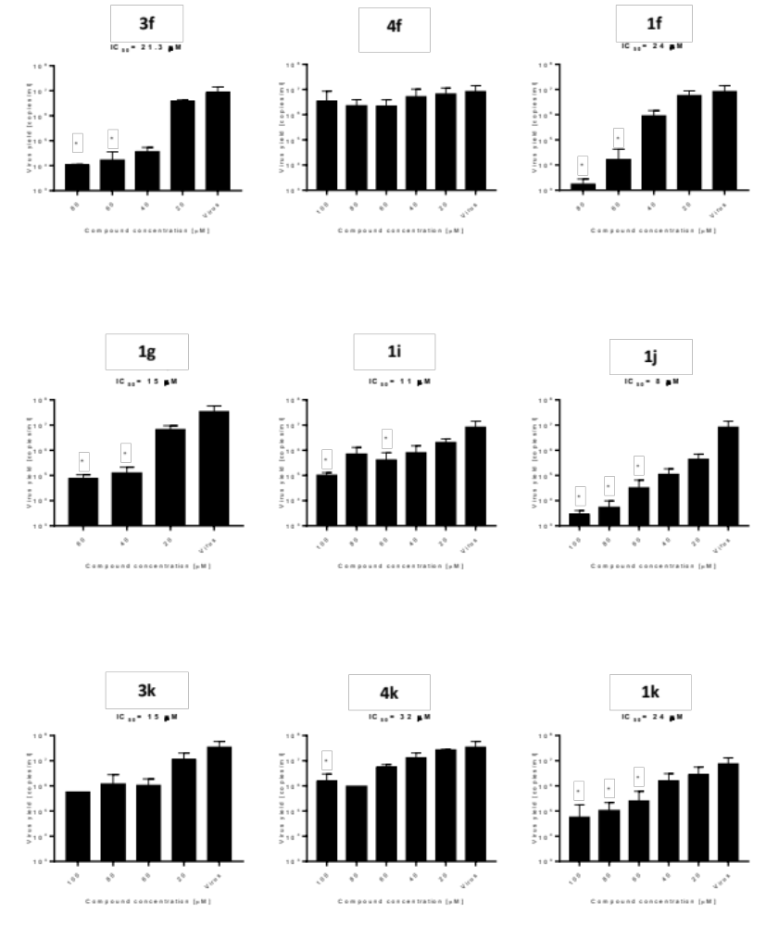
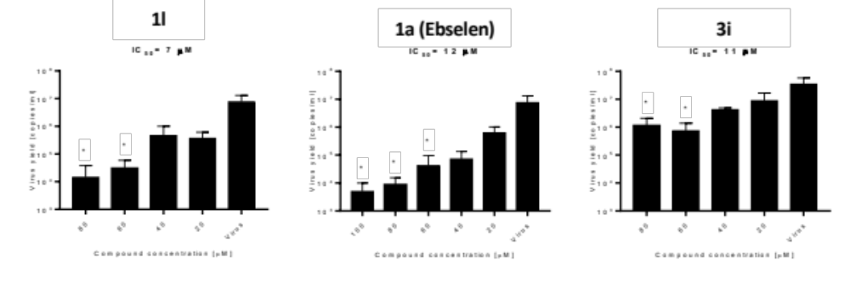

Figure S4
Spectral data for compound 9 and its reaction with GSH.
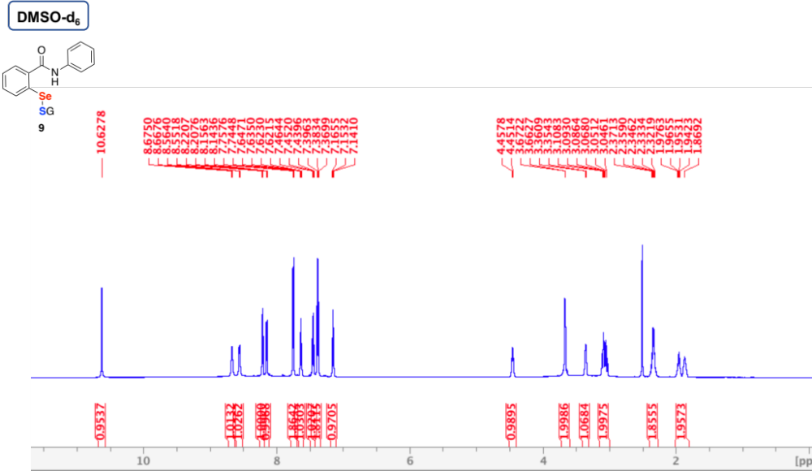

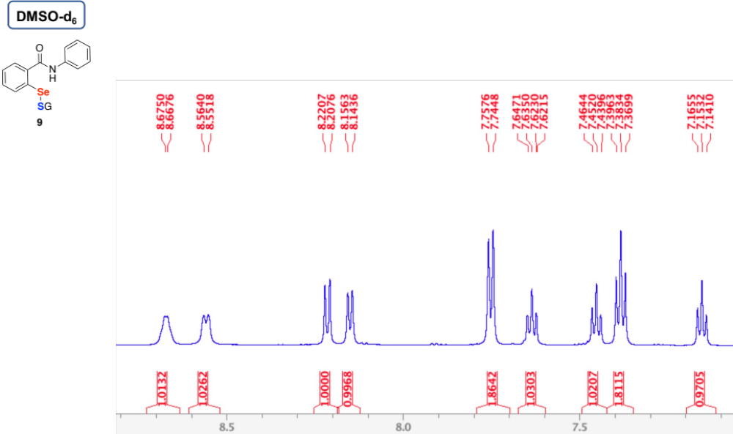

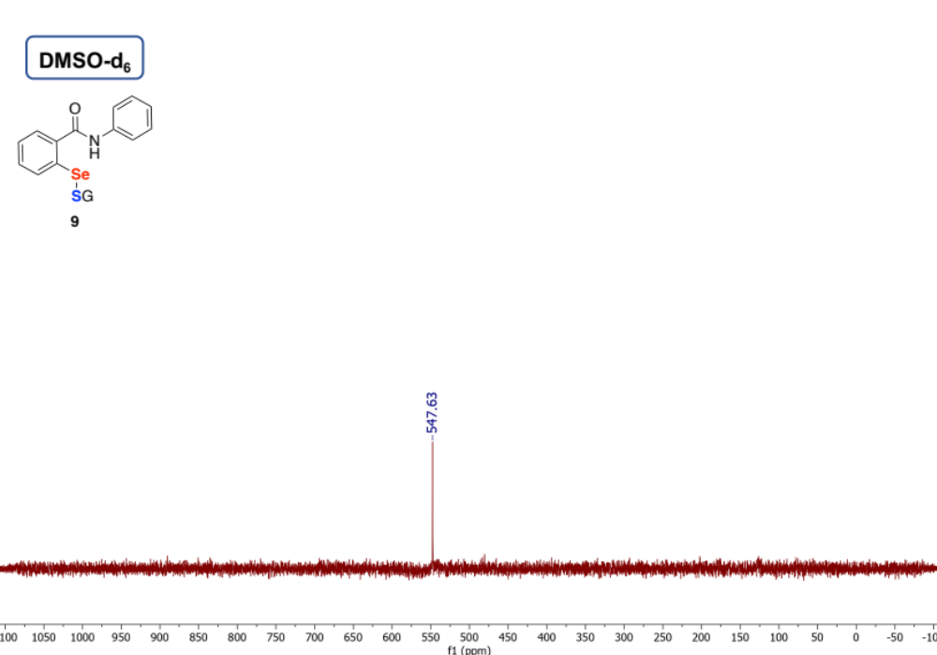

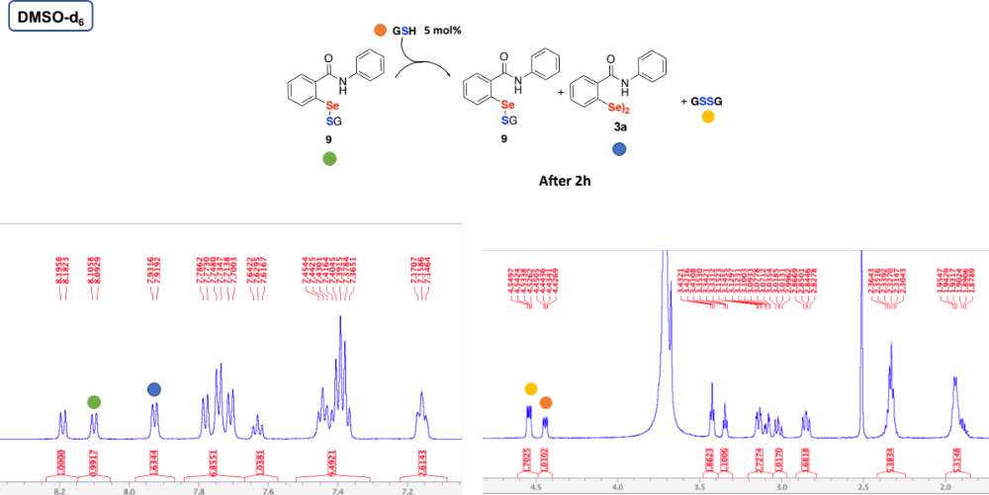

Figure S5
Spectral data for compound 3a and its reaction with GSH.

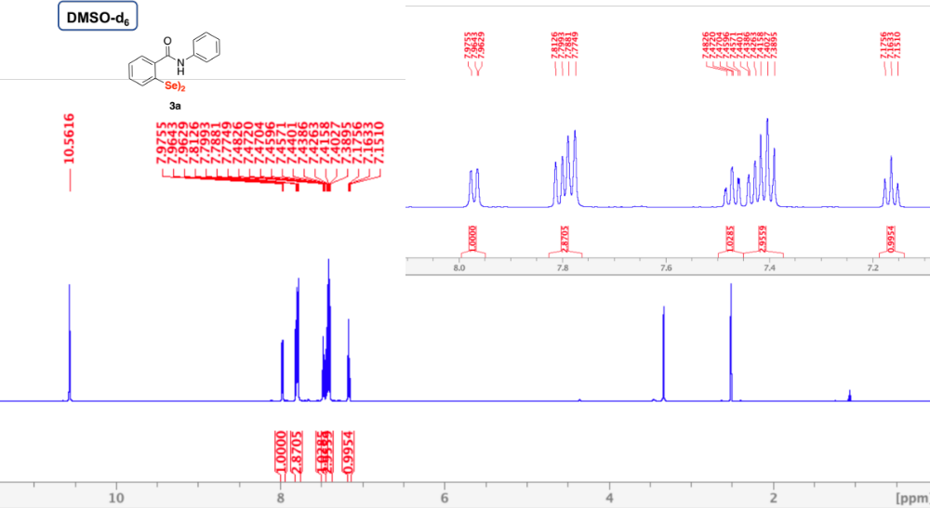

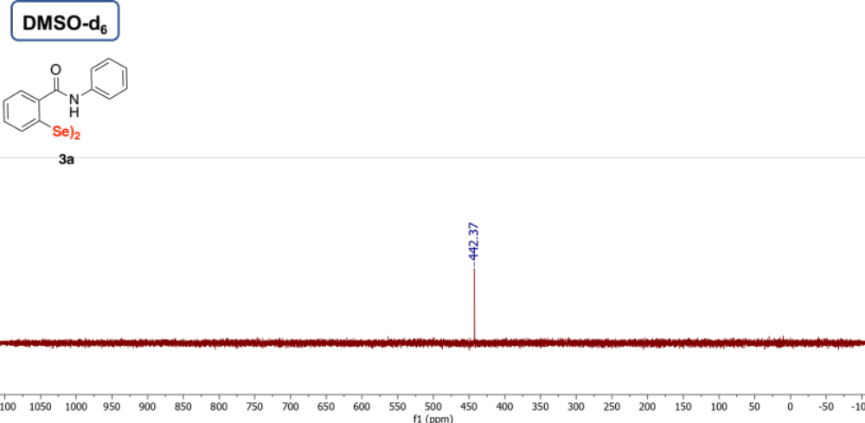

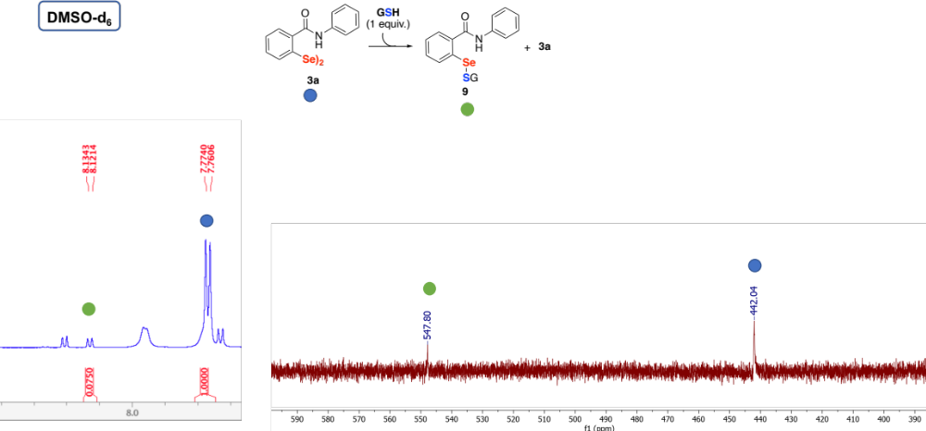

Figure S6
Spectral data for compound 3k and its reaction with GSH.

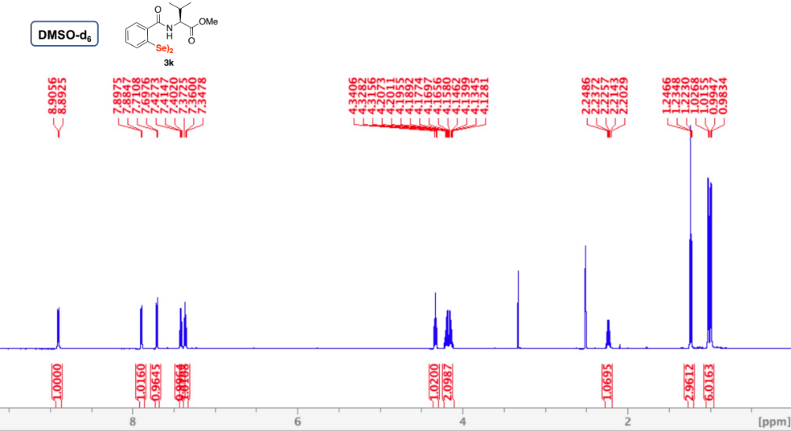

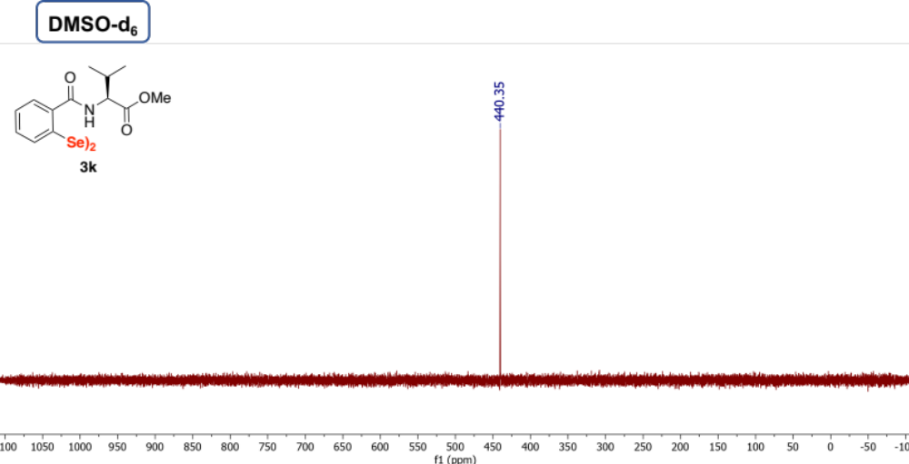

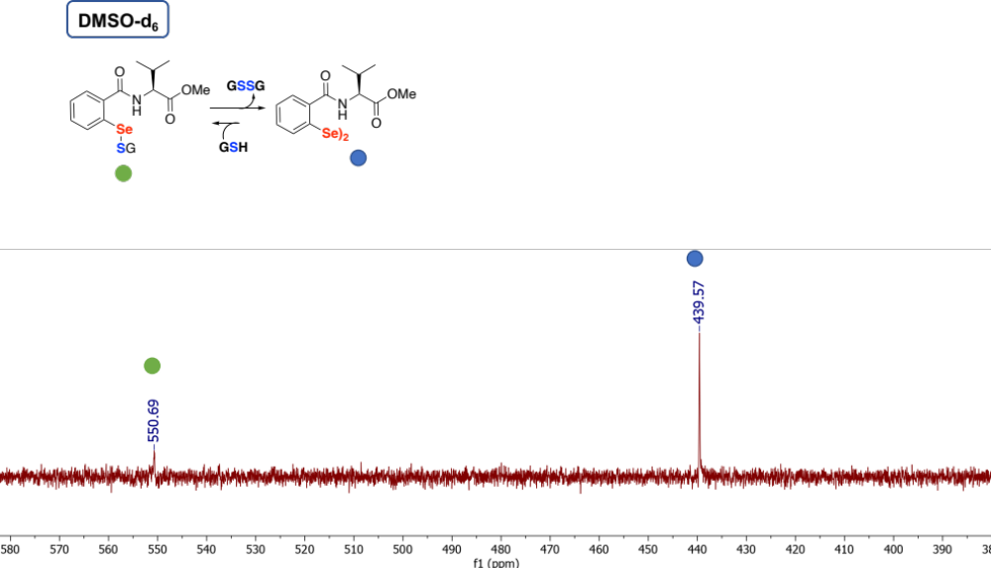

Figure S7
Thiol exchange reaction

Table S2
 | 3a （DiSEBS） |  |  | Ebselen
 | repeat |  |  | repeat
concentration(μM ) | 1 | 2 | 3 | 1 | 2 | 3
40 | 100.53 | 100.22 | 100.88 | 101.52 | 101.05 | 98.79
20 | 97.67 | 97.01 | 95.28 | 101.35 | 100.23 | 101.21
10 | 92.96 | 94.84 | 94.20 | 98.42 | 99.07 | 102.89
5 | 90.97 | 93.00 | 92.75 | 99.70 | 101.04 | 101.16
2.5 | 88.35 | 88.77 | 88.52 | 99.31 | 100.06 | 100.41
1.25 | 85.54 | 83.57 | 83.97 | 102.53 | 100.08 | 101.42
0.625 | 83.17 | 83.17 | 81.39 | 99.39 | 100.82 | 100.57
0.3125 | 67.78 | 64.71 | 66.59 | 97.09 | 97.23 | 96.66
0.15625 | 56.88 | 52.85 | 49.88 | 82.14 | 91.24 | 84.12
0.078125 | 39.99 | 37.76 | 31.19 | 71.71 | 82.33 | 73.16
0.039063 | 34.71 | 28.30 | 30.46 | 51.82 | 52.48 | 45.35
0.019531 | 14.17 | 4.84 | 13.71 | 31.12 | 25.32 | 24.42
0.009766 | -0.50 | 3.36 | -2.10 | 7.42 | 2.10 | 14.05
0.004883 | -7.75 | -8.18 | -7.14 | 3.79 | 3.88 | -1.15
IC50 | 0.065μM |  |  | 0.036μM

The reaction mixture included 0.1 μM protein M^{pro}，20 μM substrate and compounds in 60μl. The purified M^{pro} was diluted in 50 mM Tris-HCl pH 7.3, 1 mM EDTA.

Figure S8 HRMS analysis

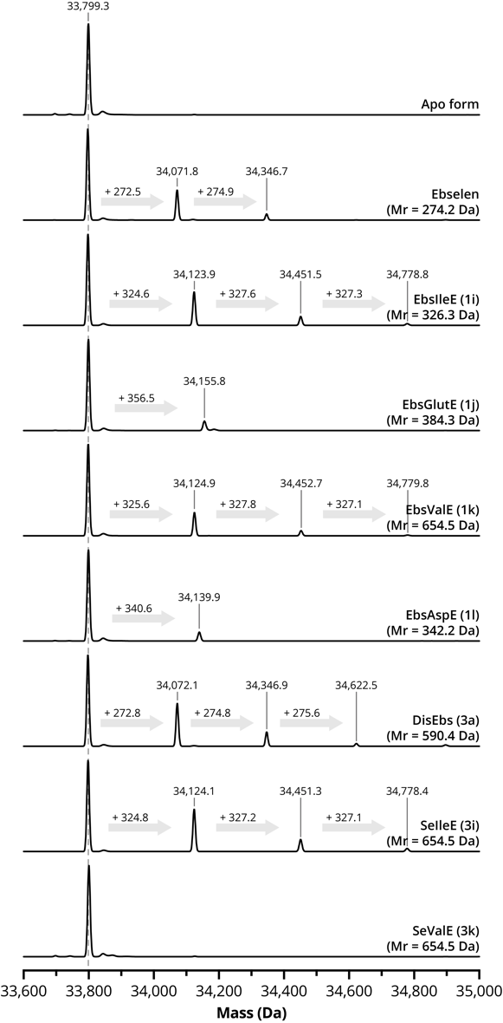

50μl SARS-CoV-2 Main protease in gel filtration buffer (20mM Tris-HCl pH 8.0，150mM NaCl，4 mM DTT) at 10 mg/ml is mixed with 2.5μl compounds (10 mM in DMSO). The mixtures were kept at room temperature for 30 min and then applied to liquid chromatography–mass spectrometry to measure the molecular weight change of the Mpro.

