Supplement Table 1. Search Strategy
Database | Search Strategy
PubMed | (((machine learn [mh]) OR (machine learn [tw])) OR ((machine learning [mh]) OR (machine learning [tw])) OR ((deep learning [mh]) OR (deep learning [tw])) OR ((artificial intelligence [mh]) OR (artificial intelligence [tw])) OR ((artificial learning [mh]) OR (artificial learning [tw])) OR ((machine intelligence [mh]) OR (machine intelligence [tw])) OR ((neural networks [mh]) OR (neural networks [tw])))  AND (((adverse drug reaction [mh]) OR (adverse drug reaction [tw])) OR ((adverse drug event [mh]) OR (adverse drug event [tw])) OR ((ADE [mh]) OR (ADE [tw])) OR ((ADR [mh]) OR (ADR [tw])))  AND (((predict[mh]) OR (predict[tw])) OR ((prediction[mh]) OR (prediction [tw])) OR ((predicting[mh]) OR (predicting [tw])) OR ((risk [mh]) OR (risk [tw])) OR ((predictive [mh]) OR (predictive [tw])))
Embase | (machine learn.mp. or exp machine learn/ or machine learning.mp. or exp machine learning/ or deep learning.mp. or exp deep learning/ or artificial intelligence.mp. or exp artificial intelligence/ or artificial learning.mp. or exp artificial learning/ or machine intelligence.mp. or exp machine intelligence/ or neural networks.mp. or exp neural networks/)  AND (exp adverse drug reaction/ or adverse drug reaction. mp. or exp adverse drug event/ or adverse drug event. mp. or exp ADE/ or ADE.mp. or exp ADR/ or ADR.mp.)  AND (exp predict/ or predict. mp. or exp predicting/ or predicting. mp. or exp prediction/ or prediction.mp. or exp risk/ or risk.mp. or exp predictive / or predictive.mp. or exp predictive/ or predictive.mp.)
Web of Science | TS= (machine learn OR machine learning OR deep learning OR artificial intelligence OR artificial learning OR machine intelligence OR neural networks)  AND TS= (adverse drug reaction OR adverse drug event OR ADE OR ADR)  AND TS= (predict OR prediction OR predicting OR risk OR predictive OR predictive)
IEEE | (machine learn OR machine learning OR deep learning OR artificial intelligence OR artificial learning OR machine intelligence OR neural networks) [Abstract]  AND (adverse drug reaction OR adverse drug event OR ADE OR ADR) [Abstract]  AND (predict OR prediction OR predicting OR risk OR predictive OR predictive) [Abstract]

Supplement Table 2. Full characteristics of included studies
Study ID | Location | No. of included patients | Population | Database | Data period | Data types | Age | Male (%) | No. of patient with ADR/ADE (%) | No of patients with ADR/ADE | No. of drugs that cause ADR/ADE | length of stay | The top five types of drugs that cause ADR/ADE (n) | Type of ADR/ADE | The top five types of ADR/ADE (n) | Important risk factors | Machine learning algorithms | Evaluation and validation | Evaluation indicator | Result
Hu, 2022 [5] | China | 1800 | Older inpatients | Self-built database | 2015-2017 | Structured  clinical data | Total: 69.84±8.14  No ADR/ADE: 70.12 ± 8.19  ADR/ADE: 67.95±7.55 | 58.56% | 234  (13.00%) | 296 | 21 | Total: 10.19±8.94  No ADE: 9.44±8.07  ADE: 15.19±12.28 | Antineoplastic (165), Antimicrobial (44), Anticoagulant (18), Antihypertensive (13), Analgesic (9) | 32 | Nausea (64), Leukopenia (36), Hepatotoxicity/ Transaminase disorder (25), Diarrhea (22), Vomiting (22) | Number of true triggers (+), Length of stay, Doses per patient, Age, Number of admissions in the previous year, Surgery, Drugs per patient, Number of medical diagnoses, Antibacterial use, and Gender | Seven algorithms: XGBoost, AdaBoost, CatBoost, GBDT, LightGBM, TPOT, and RF | Training and Testing | 1. AUC, 2. Accuracy, 3. Precision,4. Recall,5. F1 scores 6. Precision-recall curve | Adaboost with the best predicting abilities (Accuracy: 88.06%, Precision: 68.57%, Recall: 48.21%, F1 scores: 52.75%, AUC: 91.00%)
Yu, 2021 [26] | China | 1746 | Pediatric inpatients | Self-built database | 2013-2015 | Structured  clinical data | Total: 3.84 ± 3.89  No ADR/ADE: 3.86 ± 3.85  ADR/ADE: 3.72 ± 4.12 | Total: 65.00%  No ADR/ADE: 64.70%  ADR/ADE: 67.40% | 221  (12.70%) | 247 | 27 | total: 7.83 ± 5.29  No ADE: 7.48±4.66  ADE: 10.23 ± 8.03 | Antibacterials (86), Sedatives (55), Immunomodulators (14), Anti-epileptics (12), Potassium chloride, glucose (10) | 28 | Over sedation\ Hypotension (47), Rash (35), Diarrhea (34), Candidiasis (25), Constipation (21), Vomiting (21) | Number of trigger true (TT) (+), Number of doses, BMI, Number of drugs, Number of admissions, Height, Length of hospital stays, Weight, Age, and Number of diagnoses | Seven algorithms: XGBoos, AdaBoost, CatBoost, GBDT, LightGBM, TPOT, and RF | Training and Testing | 1. AUC, 2. Precision,3. Recall,4. F1 scores 5. precision-recall curve | GBDT with the best predicting abilities (Precision: 44%, Recall: 25%, F1 scores: 31.88%, AUC: 80.90%)
Langenberge, 2023 [16] | USA | 210181 | all population | MIMIC-IV (version 2.1) | 2008-2019 | Unstructured and structured  clinical data | No ADR/ADE: 59.8±19.7  ADR/ADE: 63.3±16.9 | No ADR/ADE: 49.40%  ADR/ADE: 51.50% | 10957  (5.21%) | 27667 | N | No ADE: 4.00 ±6.49  ADE: 9.12±11.8 | Antineoplastic (165), Antimicrobial (44), Anticoagulant (18), Antihypertensive (13), Analgesic (9) | 102 | Other secondary thrombocytopenia (5153), Other iatrogenic hypotension (4388), Fever, unspecified (4010), Dermatitis due to drugs and medicines taken internally (1871), Enterocolitis due to Clostridium difficile (1222) | Admission type, Temperature, Chief complaint, Systolic blood pressure, Age, Serotonin receptor antagonists, Heart rate, Glucocorticoids, Antiviral agents, Rifamycin | Six algorithms: RF, GBM, Ridge, LASSO, EN, and LR | Training and Testing | 1. AUC, 2. Accuracy, 3. Precision,4. Recall 5. F1 scores 6. G-mean, 7. Youden Index 8. Negative predictive value,9. Specificity 10. Precision-recall curve, 11. Brier score | GBM with the best predicting abilities (Accuracy 66.67%, precision 10.10 %, Recall 67.50%, F1 17.50%, NPV 97.50%, Specificity 66.50%, G-mean 66.30%, Youden Index 35.00%, AUC 74.70%, AUC-PR 13.40%)
Karlsson, 2014 [27] | Sweden | 16287 | all population | Stockholm EPR corpus | 2009-2010 | Unstructured and structured  clinical data | N | N | 4128  (25.34%) | N | N | N | N | 14 | N | N | Four algorithms:  RF with 4 tree sizes and 4 configurations (2 (log and sqrt  as baseline) and 2 re-sampling  approaches (ren and reinf)) | 10-fold cross-validation | 1. AUC, 2. F1 scores, 3. Brier score, 4. Prediction | RF-ren model performed with the best predicting abilities (F1 84.02%, AUC 94.48%, Brier score 12.98%). However, no significant relationship was observed between the models
Ponraj, 2021 [28] | India | 5000 | all population | Self-built database | N | Structured  clinical data | N | N | N | N | N | N | N | N | N | N | Three algorithms: SVM, DT, MLP | Training and  Testing | Accuracy | DT with the best predicting abilities (Fatality Rate-Accuracy: 91.40%, Severity rate-Accuracy: 81.70%)
Karlsson, 2016 [29] | Sweden | 35711 | all population | Stockholm EPR corpus | 2007-2014 | Unstructured and structured  clinical data | N | N | 16062  (44.98%) | N | N | N | N | 27 | Allergy, unspecified (5540), Unspecified adverse effect of drug or medicament (1967), angioneurotic oedema (1146), Maternal care for (suspected) damage to fetus by drugs (1096), Generalized skin eruption due to drugs and medicaments (861) | N | Five algorithms: RPF with 4 configurations (RPF-ed (1), RPF-ed (2), RPF (3,1), RPF (3,2)) and RF | 10-fold-cross validation | 1.F1 scores, 2. Brier score, 3. Prediction | There was no significant difference between RPF and RF performance (RF-F1 scores: 84.45%, RF-Brier score: 11.66%)
Zhao, 2021 [30] | China | 30703 | all population | An EHR Database in China | N | Unstructured and structured  clinical data | N | N | N | N | N | N | N | N | N | Age, Course of treatment, Transfusion stash time, Infusion speed, Solvent dosage, Solvent category, Dermatiti, Xueshuantong, Naodanbai, Hypertension, Sanqi Xiaozhong, Capsule, Fasudil, Chronic Obstructive Pulmonary Disease, Loose-Jointed Pill, Enteritis, Erysipelas, Syringomyelia, Pelvic Infection, Aescin | Six algorithms: SVM, RF, AdaBoost, XGBoost, ANN, LR | Training and  Testing | 1. Sensitivity, 2. Specificity, 3. Recall 4. F1 scores | XGBoost, AdaBoost, and RF obtained relatively similar results (XGBoost-Recall: 75.00%, XGBoost-Specificity: 92.86%, XGBoost- F1 scores: 82.98%)
Zhao, 2015a [31] | Sweden | 14303 | all population | Stockholm EPR corpus | 2009-2010 | Unstructured and structured  clinical data | N | N | 2807  (19.62%) | N | N | N | N | 27 | Allergy, unspecified (737), Unspecified adverse effect of drug or medicament (442), Other complications following infusion, transfusion and therapeutic injection (342), Generalized skin eruption due to drugs and medicaments (156), Angioneurotic oedema (108) | N | Nine algorithms: DT, SVM Poly, SVM RBF, RF, KNN，AdaBoost, Bagging, NB, and LR | 1) Training and Testing;  2) 10-fold cross-validation | 1. AUC, 2. Accuracy | RF (Accuracy: 84.47%, AUC: 76.30%)
Zhao, 2015b [32] | Sweden | 14696 | all population | Stockholm EPR corpus | 2009-2010 | Unstructured and structured  clinical data | N | N | 2928  (19.92%) | N | N | N | N | 14 | Allergy, unspecified (984), Unspecified adverse effect of drug or medicament (472), Other complications following infusion, transfusion and therapeutic injection (353), Maternal care for (suspected) damage to fetus by drugs (334), Generalized skin eruption due to drugs and medicaments (174) | N | Three algorithms: RF with three strategies (BE, BBE, and BWE) | 1) Training and Testing;  2) 10-fold cross-validation | 1. AUC, 2. Accuracy, 3. Precision,4. Recall,5. F1 scores 6. Precision-recall curve | RF-BWE with the best predicting abilities (Accuracy: 88.35%, Recall: 43.49%, Precision: 52.21%, F1 scores: 45.00%)
Zhao, 2016 [33] | Sweden | 38709 | all population | Stockholm EPR corpus | 2009-2015 | Unstructured and structured  clinical data | N | N | 5733  (14.81%) | N | N | N | N | 19 | Secondary thrombocytopenia (1246), Unspecified adverse effect of drug or medicament (1047), Drug-induced aplastic anemias (593), allergy (574), Other complications following infusion, transfusion and therapeutic injection (538) | N | Four algorithms: RF with two learned weights and two preassigned weights (LWA, LWS, PWA, and PWS) | 1) Training and Testing;  2) 10-fold cross-validation | 1. AUC, 2. Accuracy, 3. Precision-recall curve | RF-LWS with the best predicting abilities (Accuracy: 88.85; AUC: 79.7%)
N, Not mentioned, ADR/ADE, Adverse drug reaction or adverse drug event; MIMIC, Medical Information Mart for Intensive Care, EHR, Electronic Health Record, XGBoost, eXtreme Gradient Boosting; GBDT, Gradient Boosting Decision Tree; LightGBM, Light Gradient Boosting Machine, TPOT, Tree-based Pipeline Optimization Tool, RF, Random Forest; GBM, gradient boosting machine; LASSO, least absolute shrinkage and selection operator; EN, Elastic net; LR; Logistic regression; NB, Naïve Bayes; KNN, k nearest neighbors; SVM, support vector machine; SVM Poly, Support Vector Machine (polynomial kernel of degree 3); SVM RBF, Support Vector Machine (RBF kernel, gamma = 0.0); DT, Decision trees; MLP, Multi-layer perceptron; RPF, random pattern forest, ANN, artificial neural network, BE, Bag of Events; BBE, Bag of Binned Events; BWE, Bag of Weighted Events; PWA, preassigned weights in the weighted aggregation; LWA, learned weights in the weighted aggregation; PWS, preassigned weights in the weighted sampling; LWS, learned weights in the weighted sampling, AUC: Area under the curve of the receiver operating characteristic curve.

Study ID | Risk of bias |  |  |  | Applicability concerns |  |  | Overall
Study ID | Participant selection | Predictors | Outcome | Analysis | Participant  selection | Predictors | Outcome | Risk of Bias | Applicability concerns
Hu, 2022 [5] | low | low | low | low | low | low | low | low | low
Yu, 2021 [26] | low | low | low | low | low | low | low | low | low
Langenberge, 2023 [16] | low | low | low | low | low | low | low | low | low
Karlsson, 2014 [27] | high | high | unclear | low | low | high | unclear | high | high
Ponraj, 2021 [28] | high | unclear | low | high | high | high | high | high | high
Karlsson, 2016 [29] | low | high | low | high | low | low | low | high | low
Zhao, 2021 [30] | low | low | low | high | low | low | low | high | low
Zhao, 2015a [31] | low | high | low | high | low | low | low | high | low
Zhao, 2015b [32] | low | high | low | high | low | low | low | high | low
Zhao, 2016 [33] | low | high | low | high | low | low | low | high | low
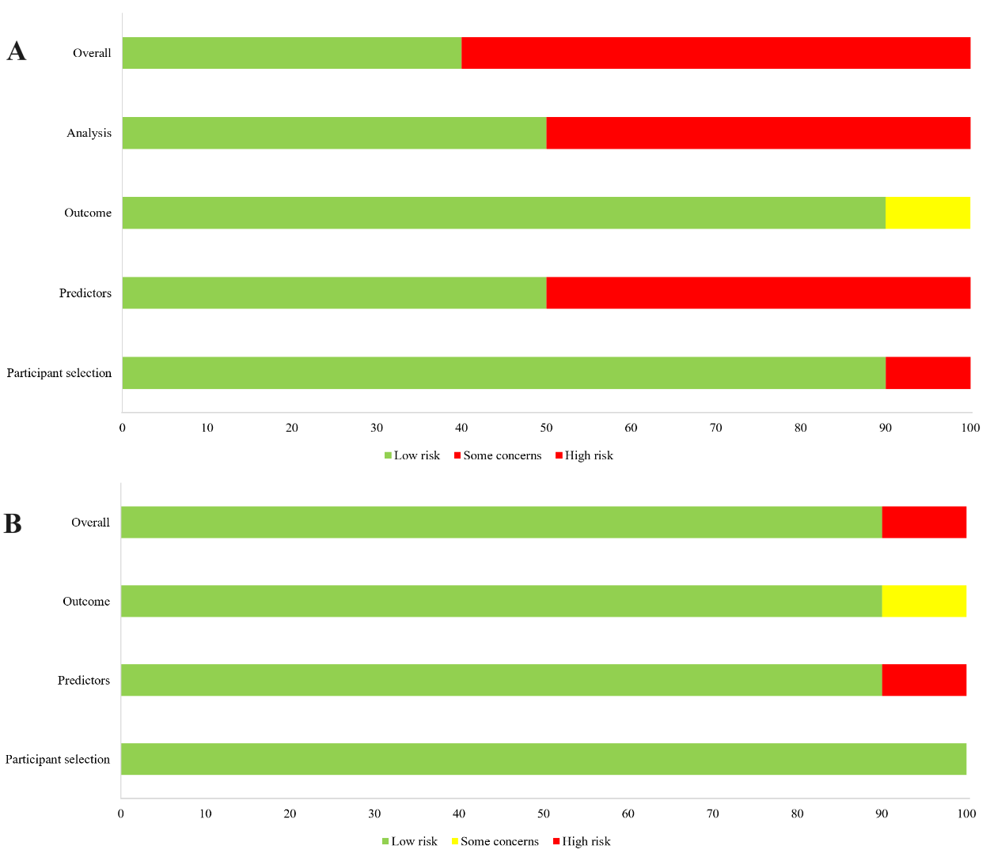
Supplement Table 3. Quality assessment based on PROBAST
Supplement Figure 1 The evaluation result diagram of PROBAST A, risk of bias; B, Applicability

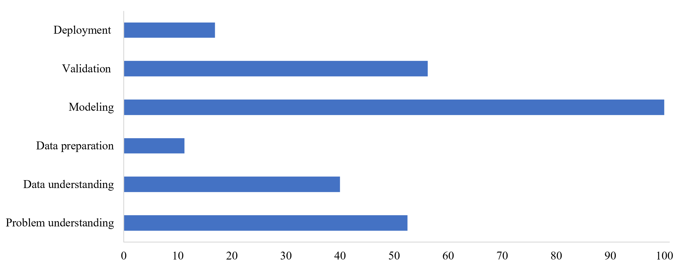
Supplement Table 4. Quality assessment based on the ChAMAI checklist
Study ID | Problem understanding (10) | Data understanding (6) | Data preparation (8) | Modeling (6) | Validation (12) | Deployment (8) | Total (50)
Hu, 2022 [5] | 9.5 | 5 | 0 | 6 | 4 | 3 | 27.5
Yu, 2021 [26] | 9 | 5 | 0 | 6 | 2.5 | 2.5 | 25
Langenberge, 2023 [16] | 4.5 | 5 | 4 | 6 | 10 | 3 | 32.5
Karlsson, 2014 [27] | 6 | 1 | 0 | 6 | 10 | 1 | 24
Ponraj, 2021 [28] | 4 | 2 | 2 | 6 | 5 | 1 | 20
Karlsson, 2016 [29] | 6 | 1 | 0 | 6 | 8 | 1 | 21
Zhao, 2021 [30] | 6 | 2 | 3 | 6 | 5 | 1 | 23
Zhao, 2015a [31] | 6 | 1 | 0 | 6 | 9 | 1 | 23
Zhao, 2015b [32] | 6 | 1 | 0 | 6 | 7 | 0 | 20
Zhao, 2016 [33] | 6 | 1 | 0 | 6 | 7 | 0 | 20
Average score | 6.3 | 2.4 | 0.9 | 6 | 6.75 | 1.35 | 23.7
Supplement Figure 2 The scoring rate of ChAMAI checklist

Supplement Table 5 ADR/ADE involved in included studies
Study ID | ADE | Number of ADE
Hu, 2022 [5] | Hypokalemia, Hyperkalemia, Hypoglycemia, Hepatotoxicity/Transaminase disorder, Nephrotoxicity/ Creatinine disorder, Urinary Retention, Candidiasis, Infection of the upper respiratory tract, Myalgia, Allergy, Fever, Weakness, Pain, Cold sweating, Dizziness, Sleepiness, Tremor, Constipation, Diarrhea, Nausea, Anorexia, Vomiting, Acute gastric mucosal injury, Abdominal distension, Hypotension, Palpitation, Bradycardia, Vascular headache, Hemorrhage, Leukopenia, Thrombocytopenia, Hemoglobin decline | 32
Yu, 2021 [26] | Diarrhea, Constipation, Vomiting, Convulsions, Convulsions grandmal, Over sedation\Hypotension, Rash, Candidiasis, Infection fungal, Hyperkalemia, Hypokalemia, Hypoglycemia, Hyperglycemia, Hyponatremia, Hepatotoxicity/Increased transaminases, Coagulopathy, Respiratory depression, Bronchospasm, Dyspnea, Leukopenia, Dystonia, Arthritis, Allergic reactions, Anaphylactoid reaction, Nephritis/Nephrosis, Euphoria, Tachycardia | 27
Langenberge, 2023 [16] | Other secondary thrombocytopenia, Other iatrogenic hypotension, Fever, unspecified, Dermatitis due to drugs and medicines taken internally, Dermatitis due to drugs and medicines taken internally, Enterocolitis due to Clostridium difficile, Hypotension due to drugs, Essential and other specified forms of tremor, Toxic gastroenteritis and colitis, Generalized skin eruption due to drugs and medicaments taken internally, Nephropathy induced by other drugs, medicaments and biological substances, Hepatitis, unspecified, Drug-induced polyneuropathy, Polyneuropathy due to drugs, Drug-induced adrenocortical insufficiency, Autoimmune hemolytic anemias, Secondary cardiomyopathy, unspecified, Localized skin eruption due to drugs and medicaments taken internally, Drug induced fever, Postprocedural (acute) (chronic) kidney failure, Other specified hypoglycemia, Drug withdrawal syndrome in newborn, Drug withdrawal syndrome in newborn, Other iatrogenic hypothyroidism, Cardiomyopathy due to drug and external agent, Cushing's syndrome, Drug-induced interstitial lung disorders, unspecified, Iatrogenic pituitary disorders, Hypothyroidism due to medicaments and other exogenous substances, Drug-induced tremor, Drug-induced myopathy, Neonatal withdrawal symptoms from maternal use of drugs of addiction, Allergic purpura, Folate-deficiency anemia, Contact dermatitis and other eczema due to drugs and medicines in contact with skin, Toxic liver disease with acute hepatitis, Newborn affected by other maternal medication, Drug-induced hypoglycemia without coma, Toxic liver disease, unspecified, Toxic liver disease with cholestasis, Iodine hypothyroidism, Stevens-Johnson syndrome, Other nonthrombocytopenic purpura, Abuse of laxatives, Other nonthrombocytopenic purpuras  Toxic liver disease with hepatitis, not elsewhere classified, Toxic liver disease with chronic persistent hepatitis, Drug-induced Cushing's syndrome, Abuse of other non-psychoactive substances, Drug-induced nonautoimmune hemolytic anemia, Other chorea’s, Analgesic nephropathy, Neuroleptic malignant syndrome, Acute drug-induced interstitial lung disorders, Chronic drug-induced interstitial lung disorders, Erythema multiforme, unspecified, Toxic liver disease with other disorders of liver, Drug induced acute pancreatitis without necrosis or infection, Nephropathy induced by unspecified drug, medicament or biological substance, Unspecified misadventure during medical care, Erythema multiforme, unspecified, Abuse of steroids or hormones, Toxic liver disease with fibrosis and cirrhosis of liver, Allergic contact dermatitis due to drugs in contact with skin, Maternal anesthesia and analgesia affecting fetus or newborn, Drug-induced thyroiditis, Unspecified contact dermatitis due to drugs in contact with skin, Newborn affected by maternal anesthesia and analgesia in pregnancy, labor and delivery, Sideroblastic anemia, Malignant neuroleptic syndrome, Other erythema multiforme, Unspecified misadventure during surgical and medical care, Acute dermatitis due to solar radiation, Acute dermatitis due to solar radiation, Acute dermatitis due to solar radiation, Drug-induced autoimmune hemolytic anemia, Erythema multiforme major, Iatrogenic thyroiditis, Drug-induced systemic lupus erythematosus, Anticonvulsants affecting fetus or newborn via placenta or breast milk, Osteonecrosis due to drugs, unspecified bone, Toxic nephropathy, not elsewhere classified, Antimetabolic agents affecting fetus or newborn via placenta or breast milk, Withdrawal symptoms from therapeutic use of drugs in newborn, Drug-induced hypopituitarism, Secondary parkinsonism due to other external agents, Drug induced acute pancreatitis with uninfected necrosis, Irritant contact dermatitis due to drugs in contact with skin, Drug-induced gout, unspecified site, Drug-induced gout, multiple sites, Cardiac complications of anesthesia or other sedation in labor and delivery, delivered, with or without mention of antepartum condition, Drug-induced folate deficiency anemia, Hypoglycemic coma, Abuse of herbal or folk remedies, Drug-induced chorea, Dermatitis due to other specified substances taken internally, Drug phototoxic response, Systemic sclerosis induced by drug and chemical, Nephropathy induced by heavy metals, Cardiac complications of anesthesia or other sedation in labor and delivery, delivered, with mention of postpartum complication, Central nervous system complications of anesthesia during labor and delivery, Central nervous system complications of anesthesia or other sedation in labor and delivery, delivered, with mention of postpartum complication | 102
Karlsson, 2014 [27] | Drug-induced aplastic anemia, secondary sideroblastic anemia due to drugs and toxins, mental and behavioral disorders due to opioid use (acute intoxication), mental and behavioral disorders due to opioid use (chronic intoxication), Drug use), cardiomyopathy due to drugs and other external factors, dermatitis due to ingestion, kidney disease due to other drugs, pharmaceutical and biological agents, maternal care (suspected) of fetal injury through drugs, anaphylactic shock not specified, angioneurotic edema, allergies not specified, Other complications associated with infusion, transfusion, and therapeutic injection, anaphylactic shock due to side effects of the correct use of the correct drug or agent, side effects of an unspecified drug or agent | 14
Ponraj, 2021 [28] | N | N
Karlsson, 2016 [29] | Secondary sideroblastic anemia due to drugs and toxins, Drug-induced adrenocortical insufficiency, Mental and behavioral disorders (MBOs) due to use of opioids: acute intoxication, MBDs due to use of opioids: dependence syndrome, MBDs due to use of sedatives or hypnotics: acute intoxication, MBOs due to use of sedatives or hypnotics: dependence syndrome, MBDs due to use of other stimulants, including caffeine: acute intoxication, MBOs due to use of other stimulants, including caffeine: harmful use, MHOs due to use of other stimulants, including caffeine: dependence syndrome, MHOs due to multiple drug use: acute intoxication, MBDs due to multiple drug use: dependence syndrome, MBDs due to multiple drug use: unspecified mental and behavioral disorder, Drug Induced Dystonia, Drug-induced headache, not elsewhere classified, Drug-Induced Polyneuropathy, Cardiomyopathy Due To Drug And External Agent, Hypotension Due To Drugs, Generalized skin eruption due to drugs and medicaments, Localized skin eruption due to drugs and medicaments, Maternal care for (suspected)damage to fetus by drugs, Toxic effect of unspecified gases, fumes and vapors, Adverse effects: anaphylactic shock, unspecified, Adverse effects: angioneurotic oedema, Adverse effects: allergy, unspecified, Other complications following infusion, transfusion and therapeutic injection, Anaphylactic shock due to correct drug or medicament properly administered, Unspecified adverse effect of drug or medicament | 27
Zhao, 2021 [30] | N | N
Zhao, 2015a [31] | Secondary sideroblastic anemia due to drugs and toxins, Drug-induced adrenocortical insufficiency, Mental and behavioral disorders (MBDs) due to use of opioids: acute intoxication, MBDs due to use of opioids: dependence syndrome, MBDs due to use of sedatives or hypnotics: acute intoxication, MBDs due to use of sedatives or hypnotics: dependence syndrome, MBDs due to use of other stimulants, including caffeine: acute intoxication, MBDs due to use of other stimulants, including caffeine: harmful use, MBDs due to use of other stimulants, including caffeine: dependence syndrome, MBDs due to multiple drug use: acute intoxication, MBDs due to multiple drug use: dependence syndrome, MBDs due to multiple drug use: unspecified mental and behavioral disorder, Drug-induced dystonia, Drug-induced tremor, Drug-induced headache, not elsewhere classified, Drug-induced polyneuropathy, Cardiomyopathy due to drugs and other external agents, Hypotension due to drugs, Generalized skin eruption due to drugs and medicaments, Localized skin eruption due to drugs and medicaments, Maternal care for (suspected) damage to fetus by drugs, Adverse effects: anaphylactic shock, unspecified, Adverse effects: angioneurotic oedema, Adverse effects: allergy, unspecified, Other complications following infusion, transfusion and therapeutic injection, Anaphylactic shock due to correct drug or medicament properly administered, Unspecified adverse effect of drug or medicament | 27
Zhao, 2015b [32] | Secondary sideroblastic anemia due to drugs and toxins, Drug-induced dystonia, Drug-induced headache, not elsewhere classified, Drug-induced polyneuropathy, Hypotension due to drugs, Generalized skin eruption due to drugs and medicaments, Localized skin eruption due to drugs and medicaments, Maternal care for (suspected) damage to fetus by drugs, Adverse effects: anaphylactic shock, unspecified, Adverse effects: angioneurotic oedema, Adverse effects: allergy, unspecified, Other complications following infusion, transfusion and therapeutic injection, Anaphylactic shock due to correct drug or medicament properly administered, Unspecifed adverse effect of drug or medicament | 14
Zhao, 2016 [33] | Drug-induced aplastic anemia, Drug-induced secondary sideroblastic anemia, Secondary thrombocytopenia, Drug-induced adrenocortical insufficiency, Drug-induced polyneuropathy, Drug-induced hypotension, Drug-induced generalized skin eruption, Drug-induced localized skin eruption, Drug-induced osteoporosis with pathological fracture, Drug-induced osteoporosis, Maternal care for damage to fetus by drugs, Drug-induced fever, Adverse effects: anaphylactic shock, Adverse effects: angioneurotic oedema, Adverse effects: allergy, Vascular complications following infusion, transfusion and therapeutic injection, Other complications following infusion, transfusion and therapeutic injection, Drug-induced anaphylactic shock, Unspecified adverse effect of drug or medicament | 19
Supplement Table 6. Contingency tables for adverse drug reaction or event prediction (20 tables from 3 studies)
Study ID | Model | TP | FP | FN | TN | Accuracy | Precision | Sensitivity(recall) | Specificity | F1 score
Hu, 2022 [5] | GBDT | 27 | 19 | 29 | 285 | 86.67% | 58.69% | 48.21% | 93.75% | 52.94%
Hu, 2022 [5] | LightGBM | 23 | 16 | 33 | 288 | 86.39% | 58.97% | 41.07% | 94.74% | 48.42%
Hu, 2022 [5] | Adaboost | 24 | 11 | 32 | 293 | 88.06% | 68.57% | 42.86% | 96.38% | 52.75%
Hu, 2022 [5] | RF | 18 | 6 | 38 | 298 | 87.78% | 75.00% | 32.14% | 98.06% | 45.00%
Hu, 2022 [5] | Catboost | 25 | 16 | 31 | 288 | 86.94% | 60.97% | 44.64% | 94.74% | 51.55%
Hu, 2022 [5] | TOPT | 27 | 15 | 29 | 289 | 87.78% | 64.29% | 48.21% | 95.07% | 55.10%
Hu, 2022 [5] | XGboost | 25 | 14 | 31 | 290 | 87.50% | 64.10% | 44.64% | 95.40% | 52.63%
Yu, 2021 [26] | GBDT | 11 | 14 | 33 | 292 | 86.57% | 44.00% | 25.00% | 95.43% | 31.88%
Yu, 2021 [26] | LightGBM | 3 | 8 | 41 | 298 | 86.00% | 27.27% | 6.82% | 97.39% | 10.91%
Yu, 2021 [26] | Adaboost | 7 | 10 | 37 | 296 | 86.57% | 41.18% | 15.91% | 96.73% | 22.95%
Yu, 2021 [26] | RF | 6 | 20 | 38 | 286 | 83.43% | 23.08% | 13.64% | 93.46% | 17.14%
Yu, 2021 [26] | Catboost | 6 | 7 | 38 | 299 | 87.14% | 46.15% | 13.64% | 97.71% | 21.05%
Yu, 2021 [26] | TOPT | 6 | 2 | 38 | 304 | 88.57% | 75.00% | 13.64% | 99.35% | 23.08%
Yu, 2021 [26] | XGboost | 9 | 17 | 35 | 289 | 85.14% | 34.61% | 20.45% | 94.44% | 25.71%
Langenberge, 2023 [16] | RF | 1591 | 13419 | 628 | 26399 | 63.80% | 9.60% | 71.70% | 66.30% | 17.00%
Langenberge, 2023 [16] | GBM | 1498 | 13332 | 721 | 26486 | 66.70% | 10.10% | 67.50% | 66.520% | 17.60%
Langenberge, 2023 [16] | LASSO | 1518 | 13816 | 701 | 26002 | 65.50% | 9.70% | 68.40% | 65.30% | 17.00%
Langenberge, 2023 [16] | Ridge | 1502 | 13824 | 717 | 25994 | 66.10% | 9.80% | 67.70% | 65.280% | 17.10%
Langenberge, 2023 [16] | EN | 1513 | 13925 | 706 | 25893 | 66.10% | 9.80% | 68.20% | 65.030% | 17.20%
Langenberge, 2023 [16] | LR | 1498 | 13788 | 721 | 26030 | 66.10% | 9.80% | 67.50% | 65.370% | 17.10%

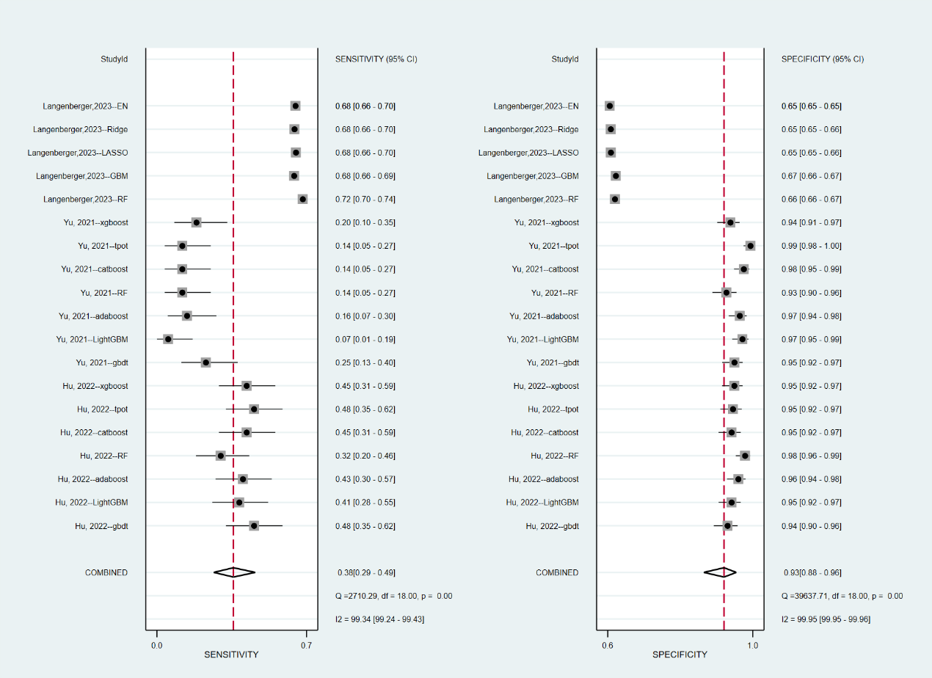
Supplement Figure 3. Forest plots of sensitivity and specificity (LR excepted)

Supplement Table 7. Subgroup analysis according to different population
Population | Included studies | Pooled specificity (95% CI) | I² | Pooled sensitivity (95% CI) | I² | Pooled AUCPRC  (95% CI)
Older inpatients | Hu, 2022⁵ | 96% (94-96) | 25.74 | 43% (38-39) | 0.00 | 80% (76-83)
Pediatric inpatients | Yu, 2021²⁶ | 97% (95-98) | 72.83 | 15% (11-20) | 11.55 | 41% (36-45)
All population | Langenberge, 2023¹⁶ | 65% (65-66) | 87.58 | 69% (67-70) | 67.12 | 71% (67-75)
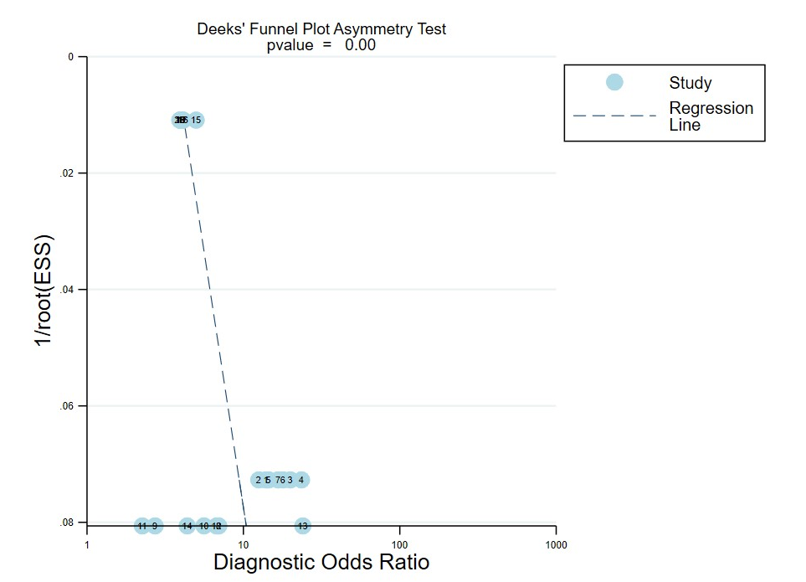
Supplement Figure 4. Publication bias for adverse drug reaction or event prediction (20 tables from 3 studies)

