Appendixes
Appendix 1: Stages of oyster mushroom cultivation
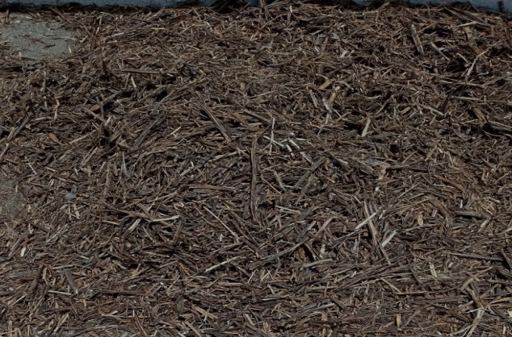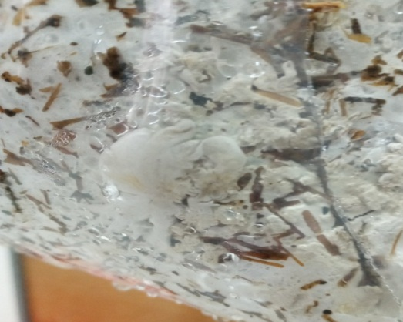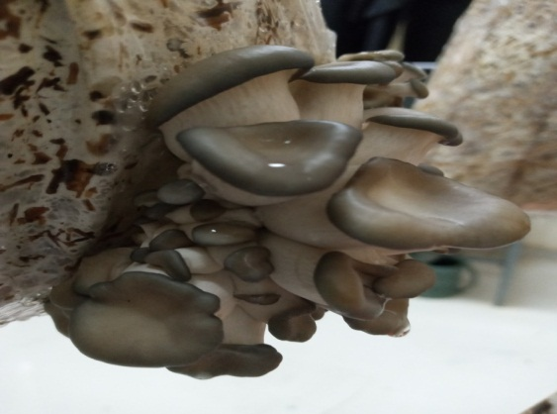
Figure 1: Graphic expression of the experiment carried out in the current study. Chopped sesame substrate (I); Primordial initiation after mycelial colonization (II); Pinhead (baby mushrooms) formation (III) and matured mushroom fruiting body.

III

II

I

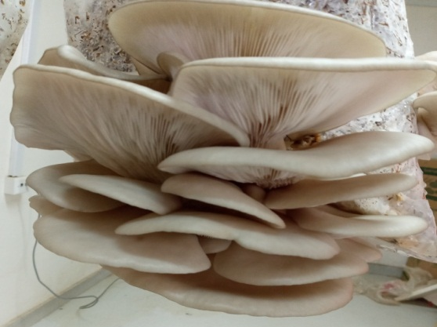
IV

