Supplementary Information
for

Optimal development of apoptotic cells-mimicking Liposomes Targeting Macrophages

Li Zhang^{1#}, Yujiao Li^{2#}, Xing Liu^{3#}, Xiaolu He², Jieyu Zhang², Jun Zhou²,

Youbei Qiao⁴, Hong Wu⁴, Fangfang Sun^{1*} and Qing Zhou^{2*}

1. Department of Prosthodontics, Nanjing Stomatological Hospital, Affiliated Hospital of Medical School, Institute of Stomatology, Nanjing University, Nanjing 210002, China;
2. Department of Clinical Pharmacy, Jinling Hospital, Medical School of Nanjing University, Nanjing 210002, China;
3. Department of Infectious Disease and Liver Disease, the Second Hospital of Nanjing, Nanjing University of Chinese Medicine, Nanjing, 210003, China;
4. Department of Medicinal Chemistry and Pharmaceutical Analysis, School of Pharmacy, Air Force Medical University, Xi’an, 710032, China.

# These authors contributed equally to this work.
*Corresponding author: Qing Zhou, E-mail: qingchou0504@163.com; Fangfang Sun, E-mail: sff0517@163.com.

Figure S1. Synthesis and characterization of DSPE-PEG2000-Man. (A) Schematic of synthetic DSPE-PEG2000-Man. (B) The 1H-NMR spectrum of DSPE-PEG2000 in chloroform. (C) The 1H-NMR spectrum of DSPE-PEG2000-Man.
Figure S2. DoE strategy for optimizing liposome composition ratio in Library B. (A) Particle sizes, PDI and (B) Zeta potentials of the prepared liposomes in Library B (n = 3). (C) Flow cytometry analysis of cellular uptake and (D) Cell viability of different liposomal formulations in Library A on RAW 264.7 cells (n = 3). Data were expressed as the mean ± SD, ****p < 0.0001.
Figure S3. Response contour plot for DPPS, DSPC, and Chol (respectively). The colored contour bands show ranges of different mean fluorescence intensity (MFI) values obtained from flow cytometry experiments (n = 3).
Figure S4. Chemical structure of PS- and PG- lipids used in the preparation of liposomes.
Figure S5. Chemical structure of PC- lipids used in the preparation of liposomes.
Figure S6. Schematic illustration of the establishment of three murine inflammatory models. (A) DSS-induced colitis model in BALB/c mice. (B) LPS-induced lung inflammation model in C57BL/6 mice. (C) Collagen II-induced RA model in DBA/1 mice.
Figure S7. (A) Ex vivo fluorescent images of major organs (heart, liver, spleen, lung, and kidney) in healthy BALB/c mice (n = 3) at 24 h post intravenous administration of free DiR and DiR-loaded liposomes (PC-Lipo/DiR and PS-Lipo/DiR). (B) Quantitative analysis of the fluorescent signal intensity from the DiR dye. Data were expressed as the mean ± SD.
Figure S8. (A) Ex vivo fluorescent images of colons in healthy BALB/c mice (n = 3) at 24 h post intravenous administration of free DiR and DiR-loaded liposomes (PC-Lipo/DiR and PS-Lipo/DiR). (B) Quantitative analysis of the fluorescent signal intensity from the DiR dye. Data were expressed as the mean ± SD, ****p < 0.0001.
Figure S9. In vivo lung inflammation model assessing targeting of PS-presenting liposomes to macrophages. (A) outlining the procedure from acclimation to lung inflammation induction with LPS, and followed by IVIS monitoring after intravenous injection. (B) Histological comparison of lung sections from control mice and those with LPS-induced lung inflammation, stained with H&E. The scale bar is 200 μm. (C) IVIS images of major organs (heart, liver, spleen, lung, and kidney) showing the distribution of free DiR and DiR-loaded liposomes (PC-Lipo/DiR and PS-Lipo/DiR) (n = 3). (D) Quantitative analysis of the fluorescent signal intensity from the DiR dye. Data were expressed as the mean ± SD.
Table S1. Library B of DoE array (molar ratio).
Table S2. Library C of TaE array (molar ratio).
Table S3. Library D of TaE array (molar ratio).
Table S4. Library E of experiment array (molar ratio).

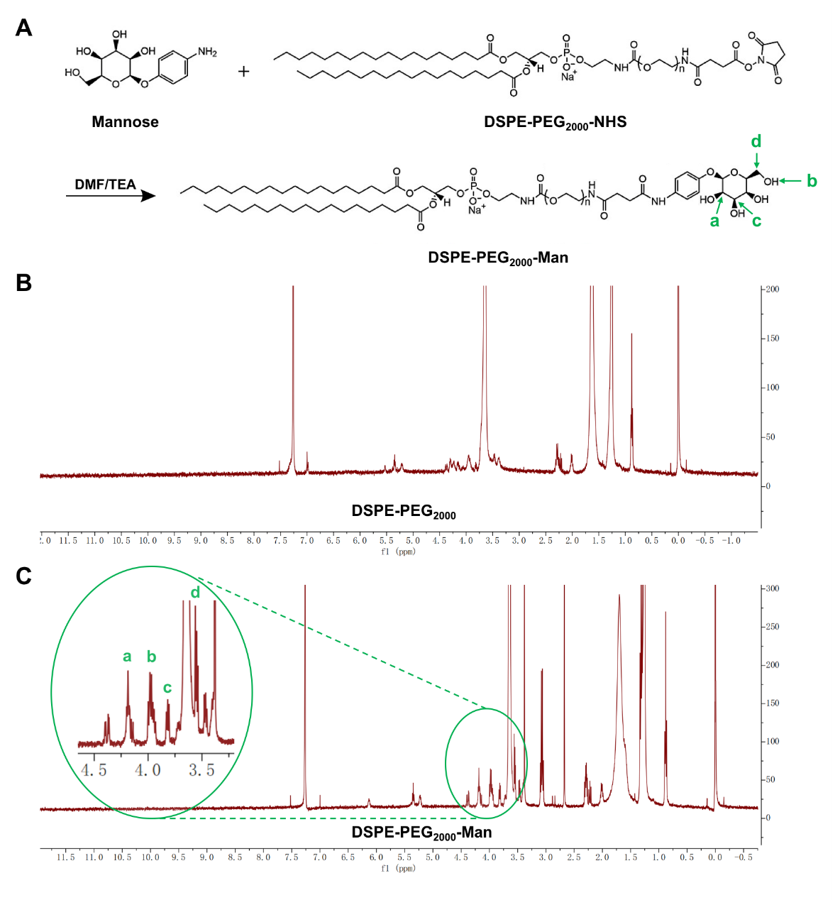
Figure S1. Synthesis and characterization of DSPE-PEG2000-Man. (A) Schematic of synthetic DSPE-PEG2000-Man. (B) The 1H-NMR spectrum of DSPE-PEG2000 in chloroform. (C) The 1H-NMR spectrum of DSPE-PEG2000-Man.

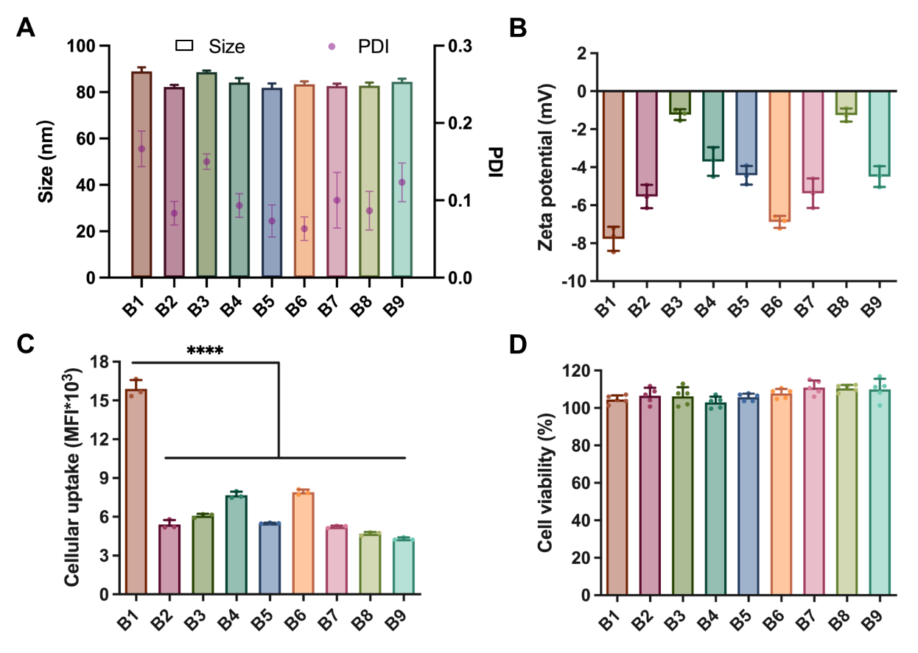
Figure S2. DoE strategy for optimizing liposome composition ratio in Library B. (A) Particle sizes, PDI and (B) Zeta potentials of the prepared liposomes in Library B (n = 3). (C) Flow cytometry analysis of cellular uptake and (D) Cell viability of different liposomal formulations in Library A on RAW 264.7 cells (n = 3). Data were expressed as the mean ± SD, ****p < 0.0001.

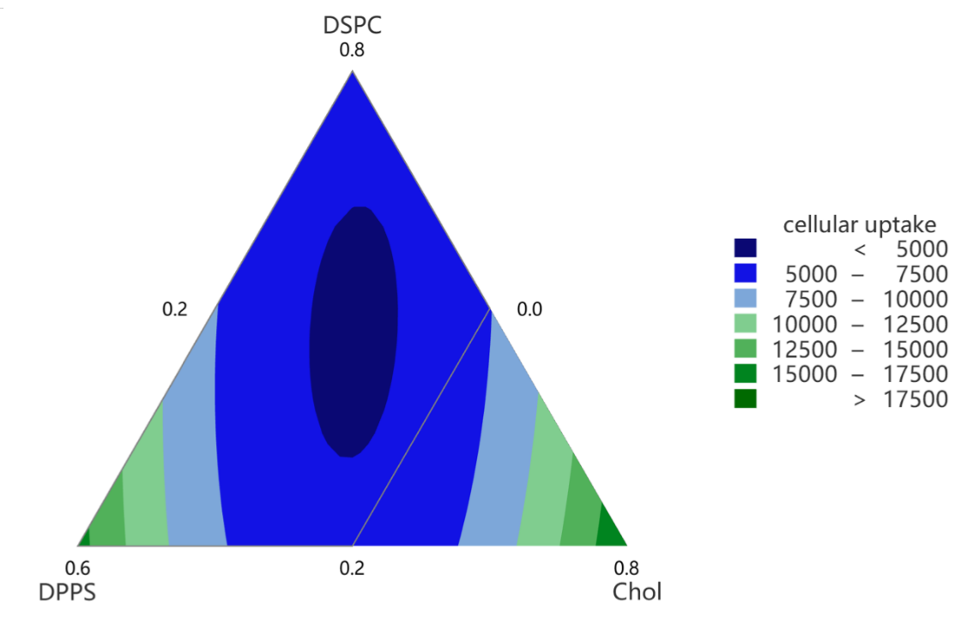
Figure S3. Response contour plot for DPPS, DSPC, and Chol (respectively). The colored contour bands show ranges of different mean fluorescence intensity (MFI) values obtained from flow cytometry experiments (n = 3).

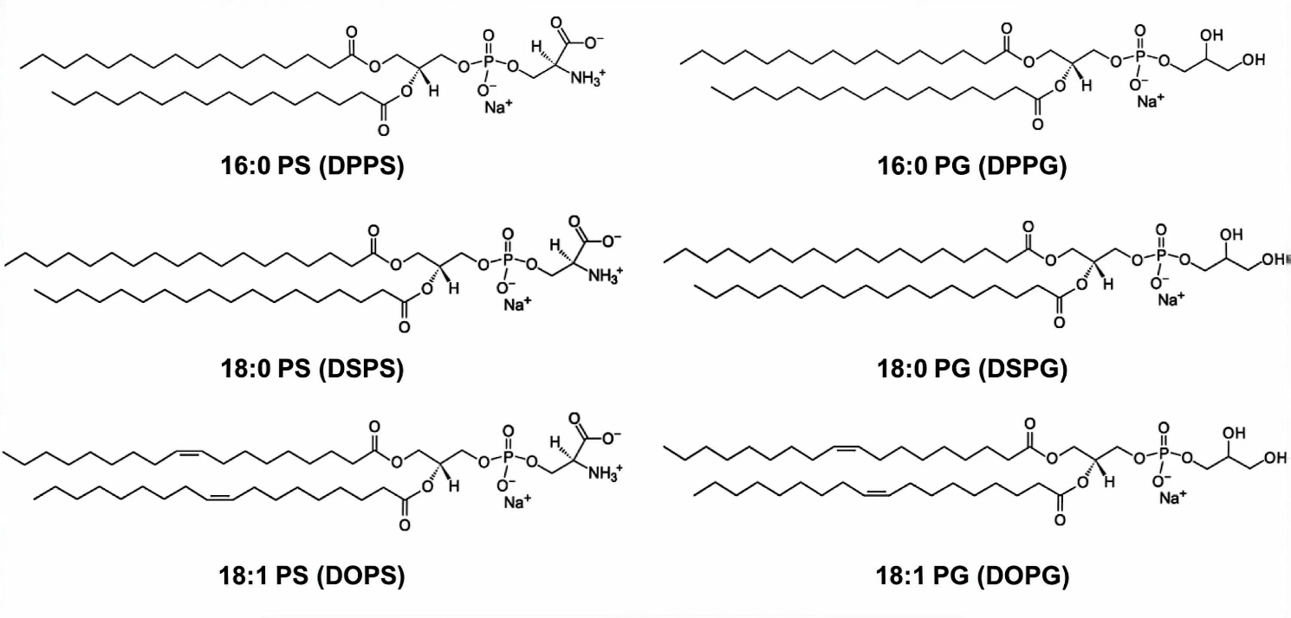
Figure S4. Chemical structure of PS- and PG- lipids used in the preparation of liposomes.

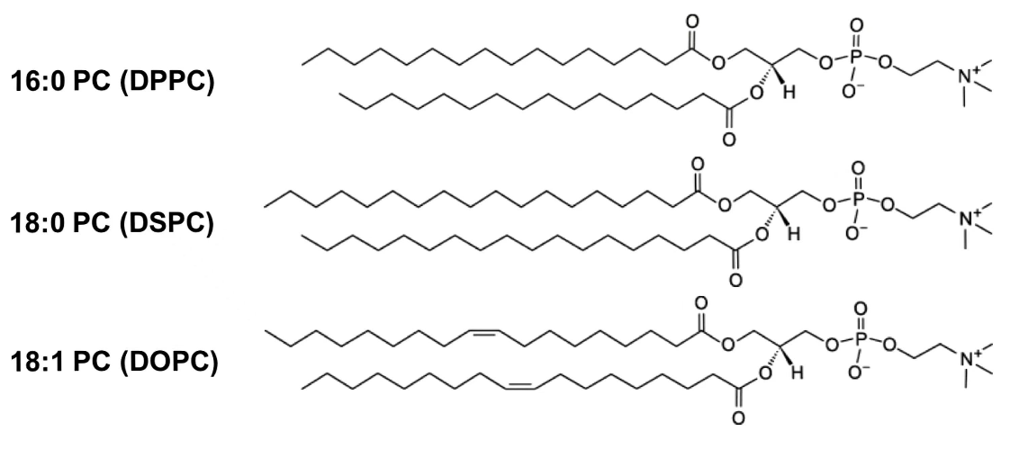
Figure S5. Chemical structure of PC- lipids used in the preparation of liposomes.

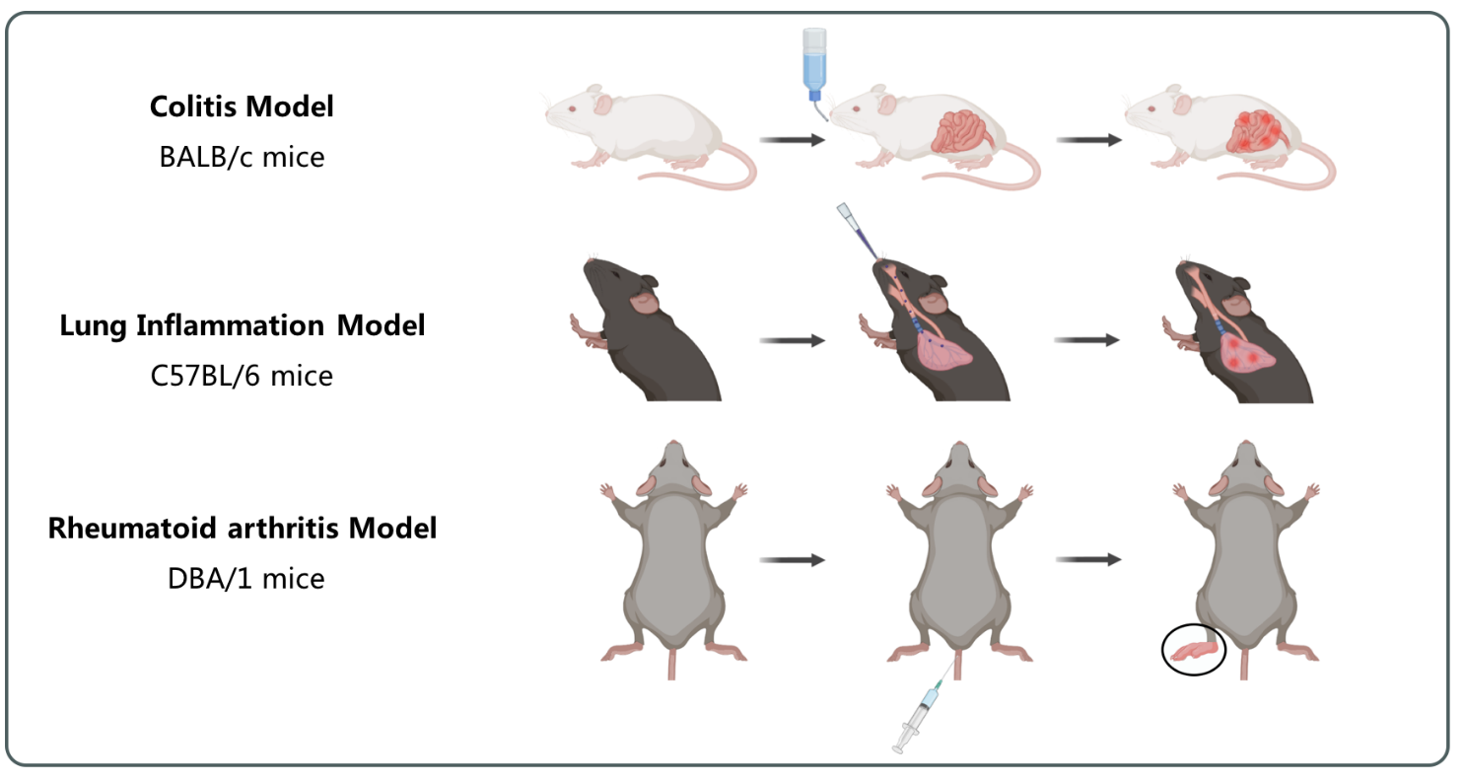Figure S6. Schematic illustration of the establishment of three murine inflammatory models. (A) DSS-induced colitis model in BALB/c mice. (B) LPS-induced lung inflammation model in C57BL/6 mice. (C) Collagen II-induced RA model in DBA/1 mice.

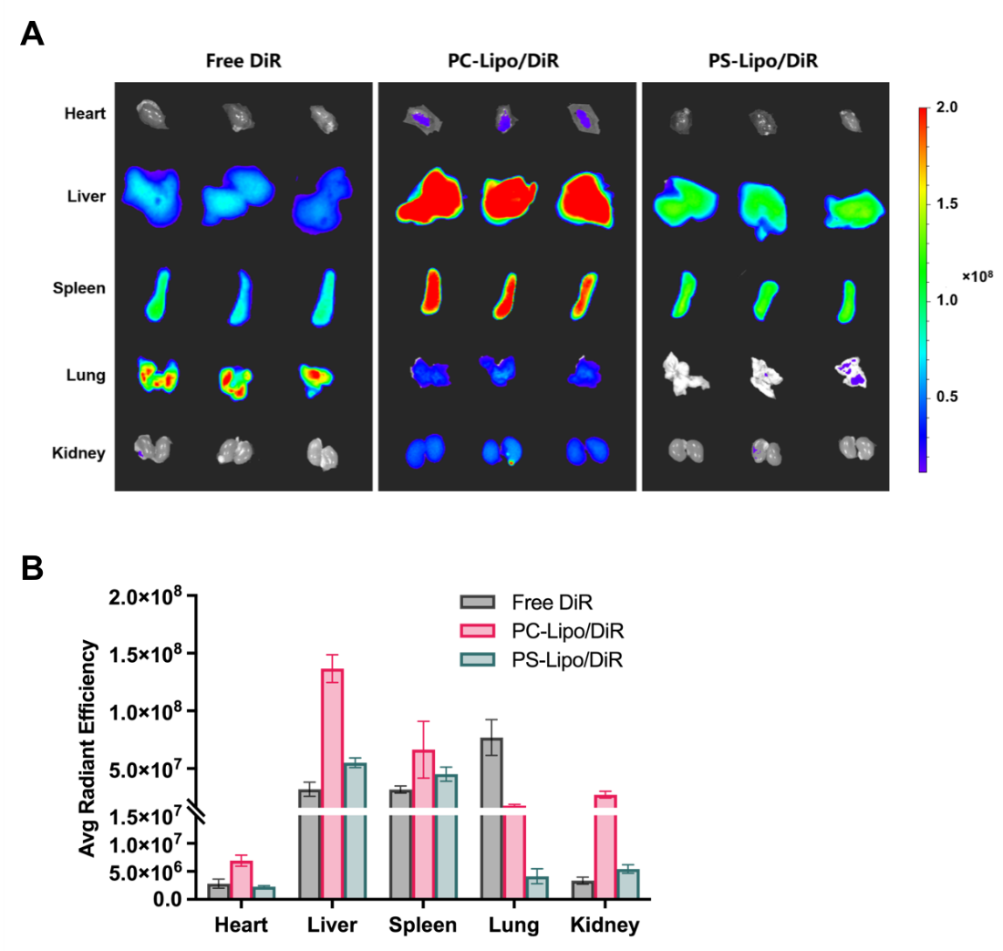
Figure S7. (A) Ex vivo fluorescent images of major organs (heart, liver, spleen, lung, and kidney) in healthy BALB/c mice (n = 3) at 24 h post intravenous administration of free DiR and DiR-loaded liposomes (PC-Lipo/DiR and PS-Lipo/DiR). (B) Quantitative analysis of the fluorescent signal intensity from the DiR dye. Data were expressed as the mean ± SD.

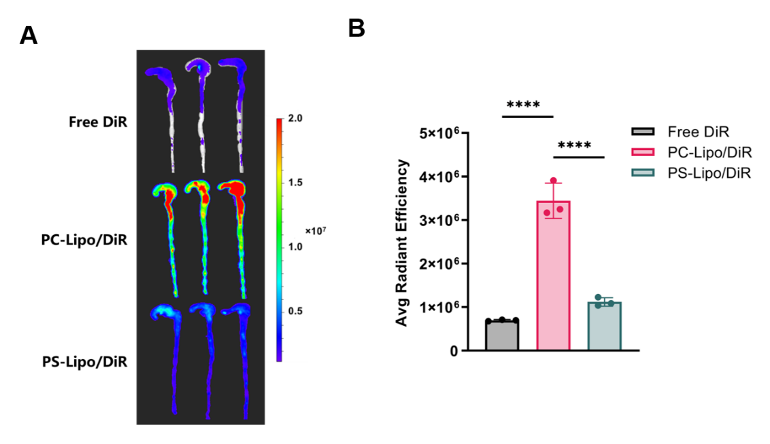
Figure S8. (A) Ex vivo fluorescent images of colons in healthy BALB/c mice (n = 3) at 24 h post intravenous administration of free DiR and DiR-loaded liposomes (PC-Lipo/DiR and PS-Lipo/DiR). (B) Quantitative analysis of the fluorescent signal intensity from the DiR dye. Data were expressed as the mean ± SD, ****p < 0.0001.

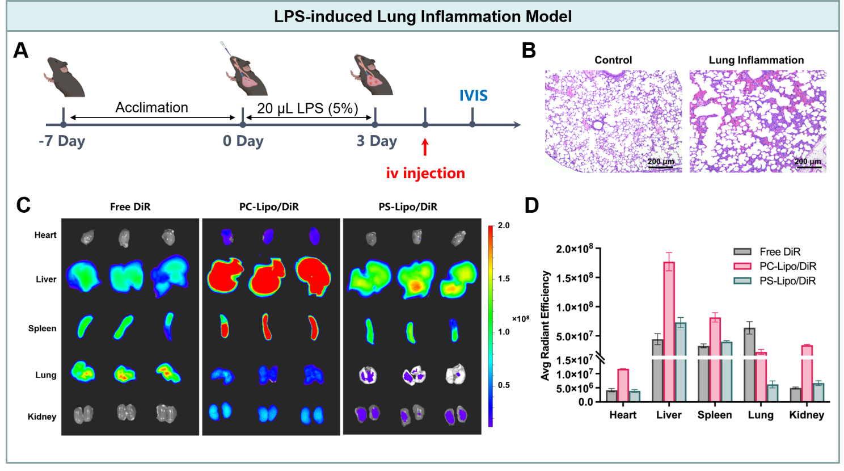Figure S9. In vivo lung inflammation model assessing targeting of PS-presenting liposomes to macrophages. (A) outlining the procedure from acclimation to lung inflammation induction with LPS, and followed by IVIS monitoring after intravenous injection. (B) Histological comparison of lung sections from control mice and those with LPS-induced lung inflammation, stained with H&E. The scale bar is 200 μm. (C) IVIS images of major organs (heart, liver, spleen, lung, and kidney) showing the distribution of free DiR and DiR-loaded liposomes (PC-Lipo/DiR and PS-Lipo/DiR) (n = 3). (D) Quantitative analysis of the fluorescent signal intensity from the DiR dye. Data were expressed as the mean ± SD.

Table S1. Library B of DoE array (molar ratio).
 | DSPC | DPPS | Chol | Man-PEG-DSPE
B1 | 20 | 60 | 20 | 2
B2 | 20 | 30 | 50 | 2
B3 | 80 | 0 | 20 | 2
B4 | 50 | 0 | 50 | 2
B5 | 42 | 22 | 36 | 2
B6 | 32 | 40 | 28 | 2
B7 | 32 | 26 | 42 | 2
B8 | 60 | 12 | 28 | 2
B9 | 46 | 12 | 42 | 2

Table S2. Library C of TaE array (molar ratio).
 | 20 | 60 | 20 | 2
C1 | DSPC | DPPS | Chol | Man-PEG-DSPE
C2 | DSPC | DSPS | Chol | Man-PEG-DSPE
C3 | DSPC | DOPS | Chol | Man-PEG-DSPE
C4 | DSPC | DPPG | Chol | Man-PEG-DSPE
C5 | DSPC | DSPG | Chol | Man-PEG-DSPE
C6 | DSPC | DOPG | Chol | Man-PEG-DSPE

Table S3. Library D of TaE array (molar ratio).
 | 20 | 60 | 20 | 2
D1 | DPPC | DSPS | Chol | Man-PEG-DSPE
D2 | DSPC | DSPS | Chol | Man-PEG-DSPE
D3 | DOPC | DSPS | Chol | Man-PEG-DSPE

Table S4. Library E of experiment array (molar ratio).
 | DSPC | DOPC | DSPS | Chol | PEG-DSPE | Man-PEG-DSPE
E1 | 80 | 0 | 0 | 20 | 0 | 0
E2 | 80 | 0 | 0 | 20 | 2 | 0
E3 | 80 | 0 | 0 | 20 | 10
E4 | 80 | 0 | 0 | 20 | 0 | 2
E5 | 80 | 0 | 0 | 20 | 0 | 10
E6 | 0 | 20 | 60 | 20 | 2
E7 | 0 | 20 | 60 | 20 | 10
E8 | 0 | 20 | 60 | 20 | 0 | 2
E9 | 0 | 20 | 60 | 20 | 0 | 10

