Supplemental figures
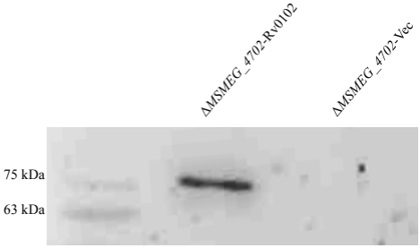
Supplementary Figure 1. Lysates were prepared from complement strain and subjected to Western Blot to detect His-tagged Rv0102 protein using mouse anti-His antibody, the lysate of ΔMSMEG_4702-Vec as a control.

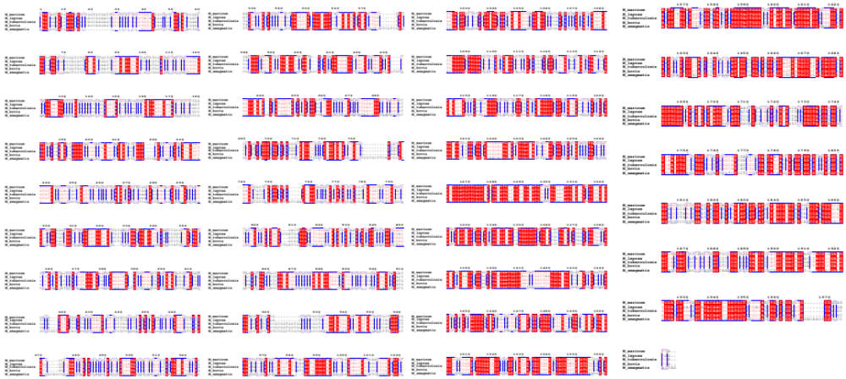
A
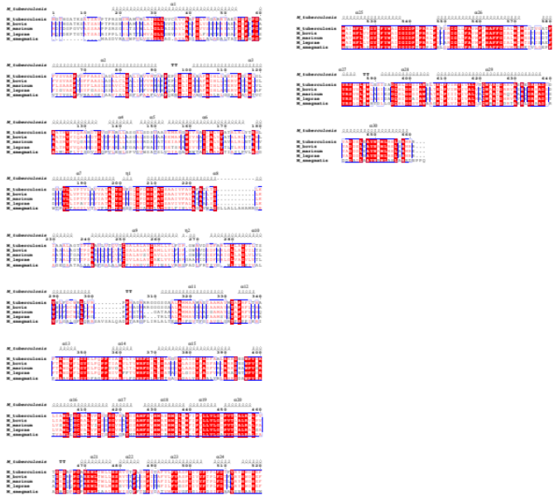
B
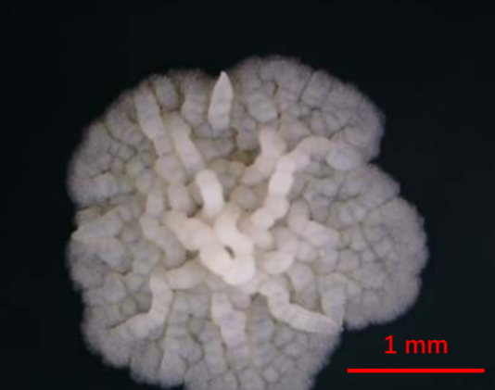
Supplementary Figure 2. Conservation analysis of the DNA (A) and amino acid (B) sequences of Rv0102 in Mycobacterium tuberculosis.
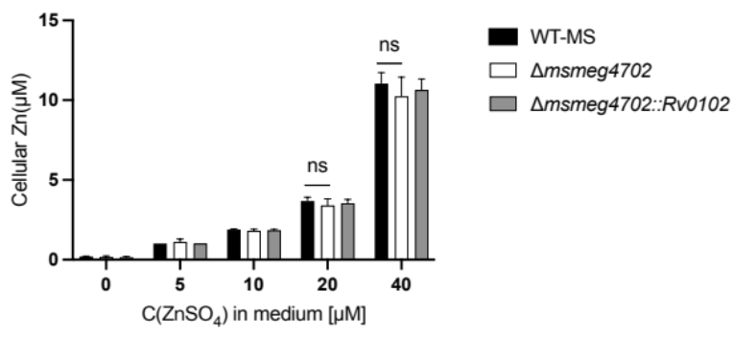
A B
Supplementary Figure 3. (A) M. smegmatis (black bar), Δmsmeg4702 (white bar), and Rv0102 complement strains (gray bar) were cultured in homemade zinc-free Middlebrook 7H9 medium with final ZnSO₄ concentrations of 0, 5, 10, 20, and 40 μM. The cultures were grown for 3 days, and samples were collected. The concentration of zinc ions was determined by measuring the absorbance of the Zn-5-Br-PADAP complex at 560 nm. Statistical significance was indicated as follows: * p≤0.05, ** p≤0.01, *** p≤0.001. The number of replicates (N) was 5. The error bars represent the standard deviation. (B) The typical morphology of wild-type Mycobacterium smegmatis striatum in 7H10 medium.

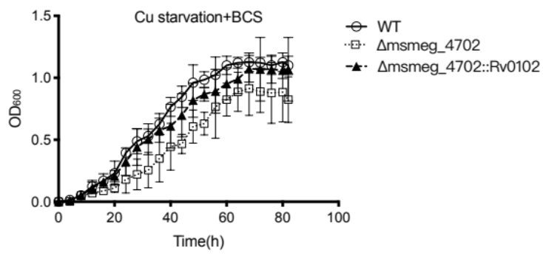
Supplementary Figure 4. WT-Ms, ΔMSMEG_4702 mutant and the complemented strains were cultured in copper-free 7H9 medium supplemented with BCS. Error bars indicate standard deviation;

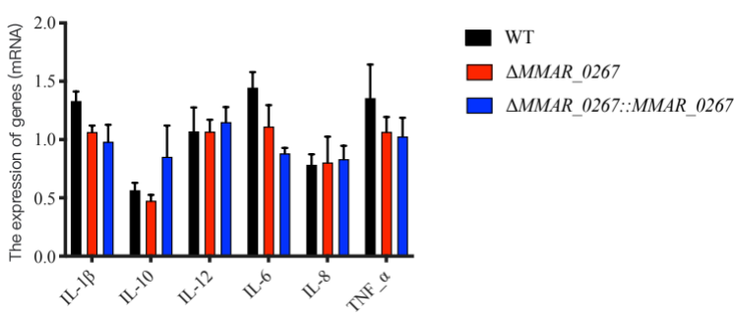
Supplementary Figure 5. MS_4702 deficiency in M. smegmatis does not change the abundance of pro-informatory cytokines. PMA-differentiated THP-1 cells (2 × 106/well/2 ml) were infected with WT-MS, ΔMS_4702 and ΔMS_4702::Rv0102 strains. After 24h infection, the infected cells and supernatant were collected. RT-PCR was used for analyze IL-1β mRNA, IL-10 mRNA, IL-12 mRNA, IL-6 mRNA, IL-8 mRNA, IL-10 mRNA and TNF-α mRNA.
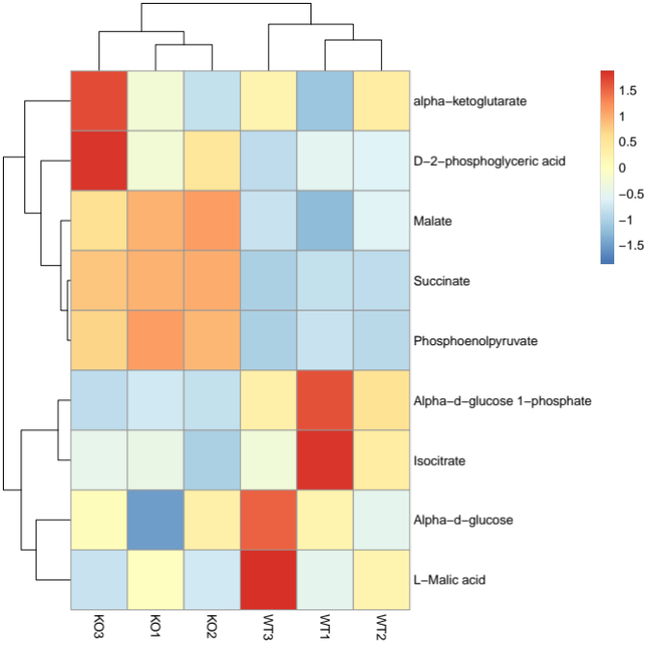
Supplementary Figure 6. The consumption of lactate and the increase of alpha-ketoglutarate reflect the activation of the glycolytic pathway. Conducting metabolomic analysis on zebrafish infected with the wild-type (WT) strain and the ΔMMAR_0267 knockout (KO) strain respectively. Each group consist of three replicates.

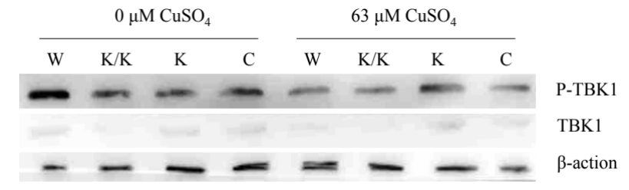
Supplementary Figure 7. The expression of TBK1 and phosphorylated TBK1 in THP-1 cells at 4hour post-infection. After infection, the samples were divided into two groups, one of which was treated with 63μM CuSO₄ in 1640 medium, while the other group was not treated. W:WT-MM; K/K:ΔMSMEG_4702/ΔCFP-10; K:ΔMSMEG_4702; C:ΔMSMEG_4702::MSMEG_4702.
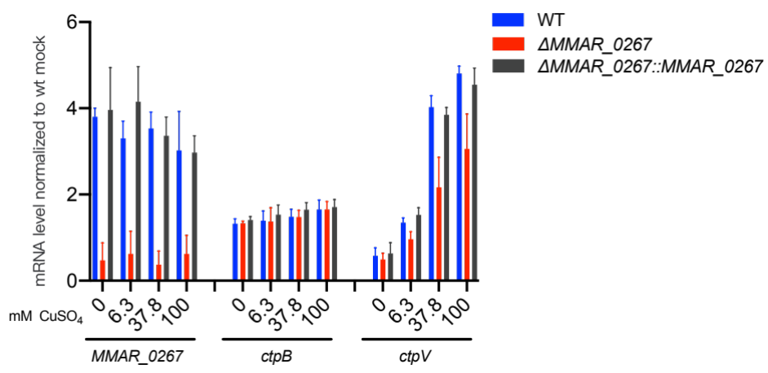
Supplementary Figure 8. M. marinum senses and reacts to toxic levels of Cu²⁺ in vitro. Normalized mRNA levels of MMAR_0267, ctpB and ctpV in M. marinum grown in copper free 7H9 with increasing concentrations.

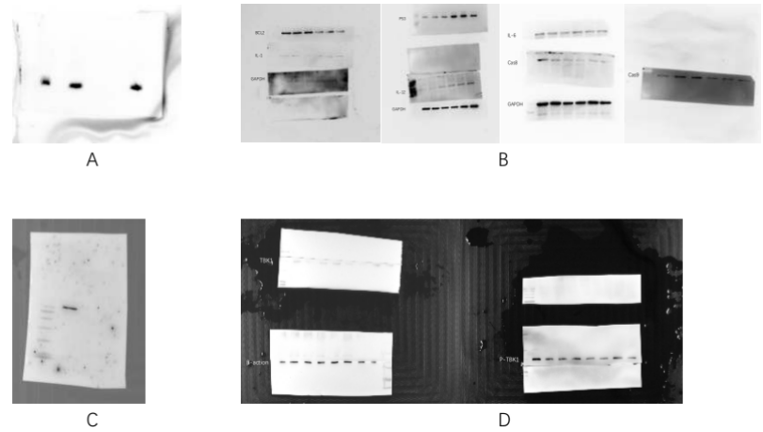
Supplementary Figure 9. Entire blot of all immunoblot results in this article. (A) For the entire blot result in Figure 1C, please refer to Figure 1C for details. (B) For the entire blot result in Figure 5B. (C) For the entire blot result in Supplementary Figure 1 and (D) For the entire blot result in Supplementary Figure 8.

