Supporting Material
Sodium Alginate Carboxymethyl Cellulose Composite Hydrogel beads for Oral Drug Delivery
Hidayatullahª, Muhmmad Akramª*, Haiqa Khan^{c}, Muhammad Irfanª, Ayaz Hassanª.
ª Interdisciplinary Research Centre in Biomedical Materials (IRCBM), COMSATS University Islamabad (CUI), Lahore Campus, Defence Road Off Raiwind Road, Lahore 54000, Pakistan.
^{b} Office of Research, Innovation and Commercialization, Peshawar Medical College, Riphah International University, 46000, Islamabad, Pakistan.

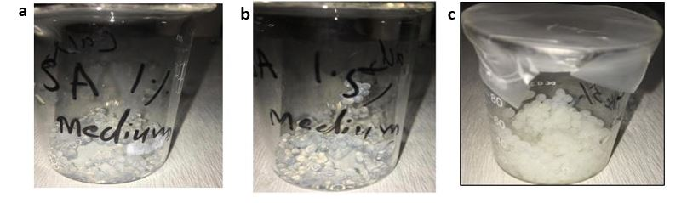
Figure S1 Physical appearance of Sodium alginate (a) 1% w (w/v %) (b) 1.5% w (w/v %) and (c) composite hydrogel beads SA2% C2% % w (w/v %)

Table S1 Comparison of drug loading contents with different concentration of polymer
Sample (n=20) | Average weight (g) | Dimension (mm)
SA3% (low viscosity) | 0.031 | 2.72
SA2% (low viscosity) | 0.021 | 1.91
SA1.5% (low viscosity) | 0.019 | 1.86
SA1% (low viscosity) | 0.015 | 1.40
SA 2% (medium viscosity) | 0.052 | 2.61
SA 1.5% (medium viscosity) | 0.024 | 1.83
SA 1% (medium viscosity) | 0.016 | 1.52
SA1% (low viscosity) C1% | 0.026 | 2.85
SA1 % (low viscosity) C2% | 0.034 | 2.96
SA1 % (low viscosity) C3% | 0.042 | 3.14
SA1 % (low viscosity) C4% | 0.046 | 3.39
SA2% (low viscosity) C1% | 0.031 | 3.13
SA2% (low viscosity) C2% | 0.041 | 3.48
SA2% (low viscosity) C3% | 0.057 | 3.82
SA2% (low viscosity) C4% | 0.062 | 4.14

* Correspondence to Dr. Muhammad Akram, Email: drmakram@cuilahore.edu.pk.

