Nutrition-oriented reformulation of extruded cereals and associated environmental footprint: a case-study
Supplementary material
Authors: N Espinoza-Orias¹, A Vlassopoulos², G Masset^{3*,}
Affiliations: ¹ Société des Produits Nestlé S.A., Vers-chez-les-Blanc, CP44, CH-1000 Lausanne 26, Switzerland; ² Vlassopoulos, Nutrition, Diet & Scientific Consulting, Ellispontou 35, 16232, Athens, Greece; ³ Cereals Partners Worldwide, Chemin du Viaduc 1, CH-1008 Prilly, Switzerland
*Corresponding author: gabriel.masset@nestle.com
Table S1. Ingredients used in Chocapic (Cereal 1) breakfast cereal (period 2003-2018).
(g ingredient needed / 100g finished product) – cut-off 0.15%

Ingredients | 2003 recipe | 2010 recipe | 2018 recipe
Refined wheat flour | 52.0 | 24.9 | 16.8
Whole wheat flour |  | 31.9 | 33.5
Corn semolina |  |  | 15.1
Sugar | 38.0 | 32.6 | 21.8
Dextrose | 4.01 | 3.62
Glucose syrup |  |  | 7.38
Cocoa powder | 7.72 | 8.57 | 7.33
Palm oil | 2.0 | 1.64
Sunflower oil |  |  | 1.65
Calcium carbonate | 0.66 | 0.70 | 1.15
Salt | 0.38 | 0.29 | 0.25
Soya lecithin | 0.40 | 0.44
Sunflower lecithin |  |  | 0.43
Malt extract | 0.18 | 2.13

Table S2. Ingredients used in Lion (Cereal 2) breakfast cereal (period 2003-2018).
(g ingredient needed / 100g finished product) – cut-off 0.15%

Ingredients | 2003 recipe | 2010 recipe | 2018 recipe
Refined wheat flour | 35.6 | 17.7 | 23.0
Whole wheat flour |  | 34.6 | 41.3
Corn semolina | 13.5
Rice flour |  | 6.29
Sugar | 28 | 26.1 | 21.3
Glucose syrup | 8.80 | 6.85 | 11.8
Cocoa powder/mass | 2.25 | 1.99 | 2.54
Palm oil | 7.23 | 5.18
Sunflower oil |  |  | 5.58
Caramel paste | 7.97 | 8.52
Skim milk powder | 2.10
Sweetened condensed milk |  |  | 3.23
Dextrose | 1.18 | 1.02
Calcium carbonate | 1.38 | 0.68 | 1.18
Salt | 0.59 | 0.51 | 0.49

Table S3. Ingredients used in Nesquik (Cereal 3) breakfast cereal (period 2003-2018).
(g ingredient needed / 100g finished product) – cut-off 0.15%

Ingredients | 2003 recipe | 2010 recipe | 2018 recipe
Rice flour | 34.3 | 6.17
Corn semolina | 18.1 | 23.7 | 17.0
Wheat starch | 5.0
Whole wheat flour |  | 31.8 | 51.4
Sugar | 35.3 | 32.8 | 23.1
Dextrose | 2.85 | 1.98
Glucose syrup |  |  | 11.3
Cocoa powder | 5.63 | 6.02 | 5.68
Palm oil | 2.85 | 1.66
Calcium carbonate | 0.67 | 0.70 | 1.12
Salt | 0.70 | 0.47 | 0.43

Table S4. Sourcing of materials.
Material | Source | Mode of transportation | Distance [km]
Refined wheat flour | France | Truck, > 32 ton | 250
Whole wheat flour | France | Truck, > 32 ton | 250
Rice flour | Europe | Truck, > 32 ton | 1 000
Corn semolina | Europe | Truck, > 32 ton | 1 000
Wheat starch | Europe | Truck, > 32 ton | 1 000
Sugar | France | Truck, > 32 ton | 250
Dextrose | Europe | Truck, > 32 ton | 1 000
Glucose syrup | Europe | Truck, > 32 ton | 1 000
Sweetened condensed milk | Europe | Truck, > 32 ton | 1 000
Caramel paste | Europe | Truck, > 32 ton | 1 000
Cocoa powder | East Africa | Truck, > 32 ton | 1 000
Cocoa powder | East Africa | Transoceanic ship | 10 000
Palm oil & palm kernel oil | South East Asia | Truck, > 32 ton | 1 000
Palm oil & palm kernel oil | South East Asia | Transoceanic ship | 10 000
Sunflower oil | France | Truck, > 32 ton | 250
Calcium carbonate | Europe | Truck, > 32 ton
Salt | France | Truck, > 32 ton | 250
Soya lecithin | United States | Truck, > 32 ton | 1 000
Soya lecithin | United States | Transoceanic ship | 6 000
Sunflower lecithin | France | Truck, > 32 ton | 250
Malt extract | Europe | Truck, > 32 ton | 1 000
Skimmed milk powder | Europe | Truck, > 32 ton | 1 000
HDPE bag | Europe | Truck, > 32 ton | 1 080
Folding board box (FBB) | Europe | Truck, > 32 ton | 1 080
Folding board box (FBB) | France | Truck, > 32 ton | 384
Corrugated board case | France | Truck, > 32 ton | 250
LLDPE Stretch film | Europe | Truck, > 32 ton | 1 080

Table S5. Packaging system composition [g material/breakfast cereal box].

Packaging material | Chocapic (430 g) |  |  |  |  | Lion (480 g) |  |  |  |  | Nesquik (450 g)
Packaging material | 2003 |  | 2010 |  | 2018 | 2003 |  | 2010 |  | 2018 | 2003 |  | 2010 |  | 2018
HDPE bag | 9.80 |  | 8.70 |  | 8.20 | 9.40 |  | 10.10 |  | 9.60 | 10.80 |  | 9.50 |  | 9.00
Folding board box (FBB) | 52.40 |  | 45.60 |  | 44.70 | 55.40 |  | 48.20 |  | 47.40 | 59.60 |  | 54.20 |  | 53.30
Corrugated board case | 23.30 |  | 21.20 |  | 19.30 | 20.90 |  | 19.00 |  | 16.80 | 25.70 |  | 23.30 |  | 21.20
LLDPE Stretch film | 0.84 |  | 0.76 |  | 0.69 | 0.69 |  | 0.63 |  | 0.57 | 0.91 |  | 0.82 |  | 0.75
Boxes per pallet | 576 |  |  |  |  | 704 |  |  |  |  | 432

Table S6. Manufacturing processes data [per kg of product]

Inputs | Consumption  2003 |  | Consumption  2010 |  | Consumption  2018
Electricity (France) [MJ] | 4.86 | 4.72 | 4.58 | 4.16 | 2.17 | 1.52
Heat (natural gas) [MJ] | 3.18 | 5.76 | 4.32 | 2.96 | 4.42 | 2.89
Water [l] | 12.30 | 9.60 | 3.57 | 3.05 | 5.20 | 3.16

Table S7. End of life options for packaging materials in France.

Material | Year | SL | I | IER | R | C
Municipal solid waste | 2003 | 38.0% | 2.2% | 31.8% | 15.0% | 13.0%
Municipal solid waste | 2010 | 29.1% | 1.2% | 33.6% | 20.0% | 16.0%
Municipal solid waste | 2018 | 20.9% | 0.3% | 34.8% | 25.1% | 18.9%
Plastic packaging | 2003 | 43.9% | 2.5% | 36.7% | 17.0% | -
Plastic packaging | 2010 | 36.0% | 1.5% | 41.5% | 21.0% | -
Plastic packaging | 2018 | 27.5% | 0.3% | 45.7% | 26.5% | -
Cardboard | 2003 | 30.6% | 1.7% | 25.6% | 42.0% | -
Cardboard | 2010 | 20.0% | 0.8% | 23.1% | 56.0% | -
Cardboard | 2018 | 12.0% | 0.1% | 19.9% | 68.0% | -
C: Composting; I: Incineration without energy recovery; IER: Incineration with energy recovery; R: Recycling; SL: Sanitary landfill

Table S8. Nutritional content of all breakfast cereal recipes
Product | Cereal 1 |  |  | Cereal 2 |  |  | Cereal 3
Year | 2003 | 2010 | 2018 | 2003 | 2010 | 2018 | 2003 | 2010 | 2018
Nutritional Labels / 100 g
Energy (kcal) | 392 | 393 | 385 | 422 | 407 | 408 | 394 | 379 | 369
Protein | 7.7 | 8.4 | 8.5 | 6.4 | 7.4 | 8.1 | 5 | 7.3 | 8.4
Carbohydrate | 79.9 | 76 | 73.4 | 77.5 | 76.7 | 72.8 | 83.6 | 79.1 | 75.8
Sugars | 42 | 37 | 24.9 | 39.1 | 35 | 25 | 38 | 35 | 24.9
Fat | 4.6 | 4.8 | 4.6 | 9.6 | 7.8 | 7.9 | 4.4 | 3.8 | 1.7
Saturated fat | 2.8 | 2 | 1.3 | 4.8 | 3.2 | 1.4 | 3 | 1.6 | 0.6
Fibre | 3.5 | 5.9 | 8 | 1.7 | 4.3 | 6.7 | 2.4 | 5.1 | 8.7
Sodium | 0.2 | 0.1 |  | 0.3 | 0.2 |  | 0.3 | 0.2
Salt |  |  | 0.33 |  |  | 0.49 |  |  | 0.44
Nutri-Score (Letter / score) | D / 14 | C / 9 | C / 6 | E / 19 | D / 13 | C / 8 | D / 15 | C / 9 | B / 0

Table S9. Relative contribution of life cycle stages to overall impacts for Cereal 1.

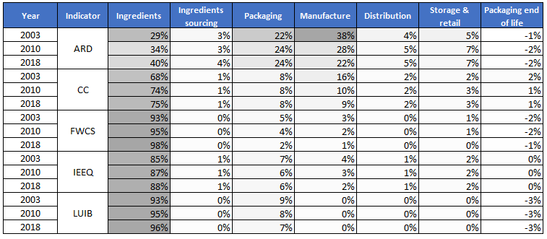
CC: Climate change; ARD: Abiotic resource depletion; LUIB: Land use impact on biodiversity; IEEQ: Impact on ecosphere/ecosystems quality; FWCS: Freshwater consumption scarcity.

Table S10. Relative contribution of life cycle stages to overall impacts for Cereal 2.
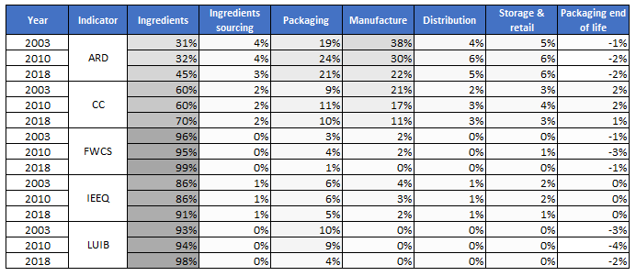
CC: Climate change; ARD: Abiotic resource depletion; LUIB: Land use impact on biodiversity; IEEQ: Impact on ecosphere/ecosystems quality; FWCS: Freshwater consumption scarcity.

Table S11. Relative contribution of life cycle stages to overall impacts for Cereal 3.

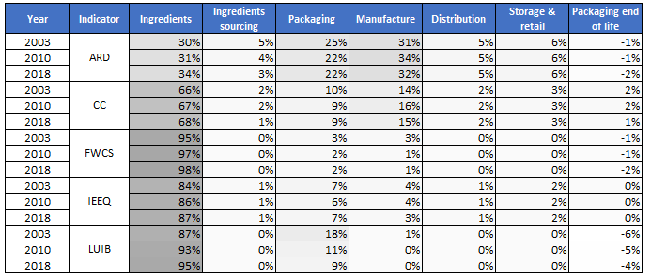
CC: Climate change; ARD: Abiotic resource depletion; LUIB: Land use impact on biodiversity; IEEQ: Impact on ecosphere/ecosystems quality; FWCS: Freshwater consumption scarcity.

Figure S1. Environmental impacts of one serving size (30 g) of three breakfast cereal products manufactured in France over a 15 year period (2003 – 2018).
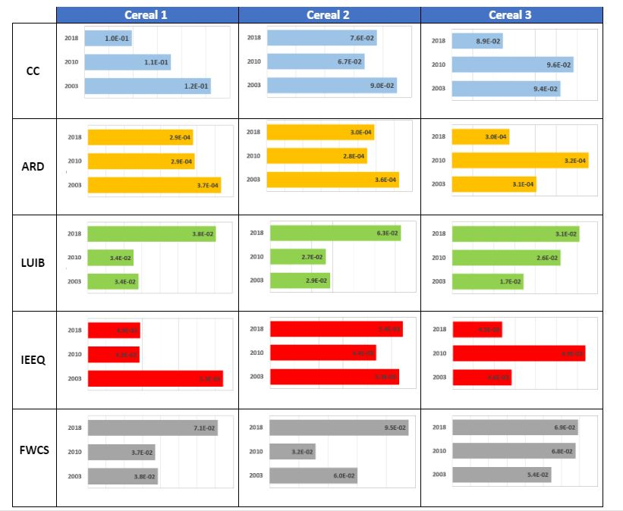

CC: Climate change; ARD: Abiotic resource depletion; LUIB: Land use impact on biodiversity; IEEQ: Impact on ecosphere/ecosystems quality; FWCS: Freshwater consumption scarcity.

