SUPPLEMENTARY INFORMATION
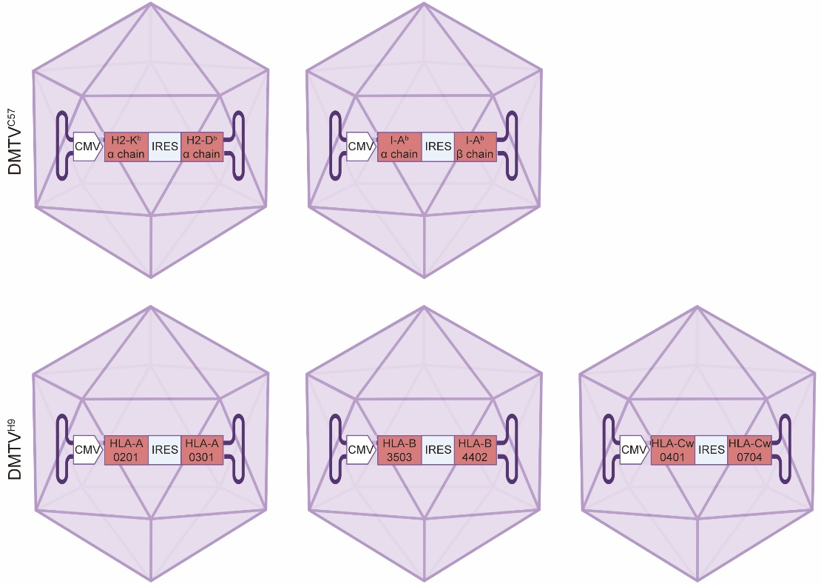
Supplementary information, Fig. S1 AAV delivery system designed for thymus vaccination.
An AAV2/8-CMV-H2-K^{b} α chain-IRES-H2-D^{b} α chain was constructed to express MHC class I molecules of C57BL/6 mice. An AAV2/8-CMV-I-A^{b} α chain-IRES-I-A^{b} β chain was constructed to express MHC class II molecules of C57BL/6 mice. AAV2/8-CMV-HLA-A0201-IRES- HLA-A0301, AAV2/8-CMV-HLA-B3503-IRES- HLA-B4402, AAV2/8-CMV-HLA-Cw0401-IRES- HLA-Cw0704 were constructed to express MHC class I molecules of H9 hESCs.

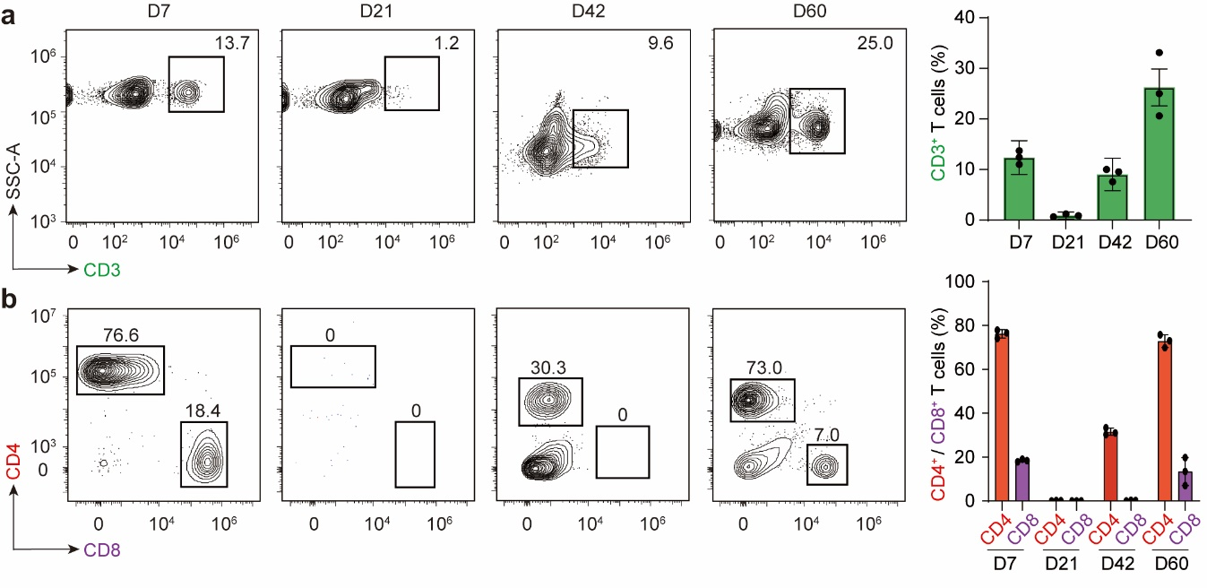
Supplementary information, Fig. S2 FACS analysis of the depletion and reconstitution of TCR repertoire.
After thymus vaccination in recipient BALB/c mice, anti-CD4 and anti-CD8 mAbs were used to deplete T cells, and the proportions of CD3⁺ T cells (a), CD4⁺ and CD8⁺ T cells (b) in PBMCs were analyzed with FACS along the T cell reconstitution process. Representative flow cytometry plots illustrating T cell populations in peripheral PBMCs after T cell depletion (left panel); Quantification analyses of percentages of CD3⁺, CD4⁺ and CD8⁺ T cells (right panel). Data are mean ± SEM (n=3 independent experiments).
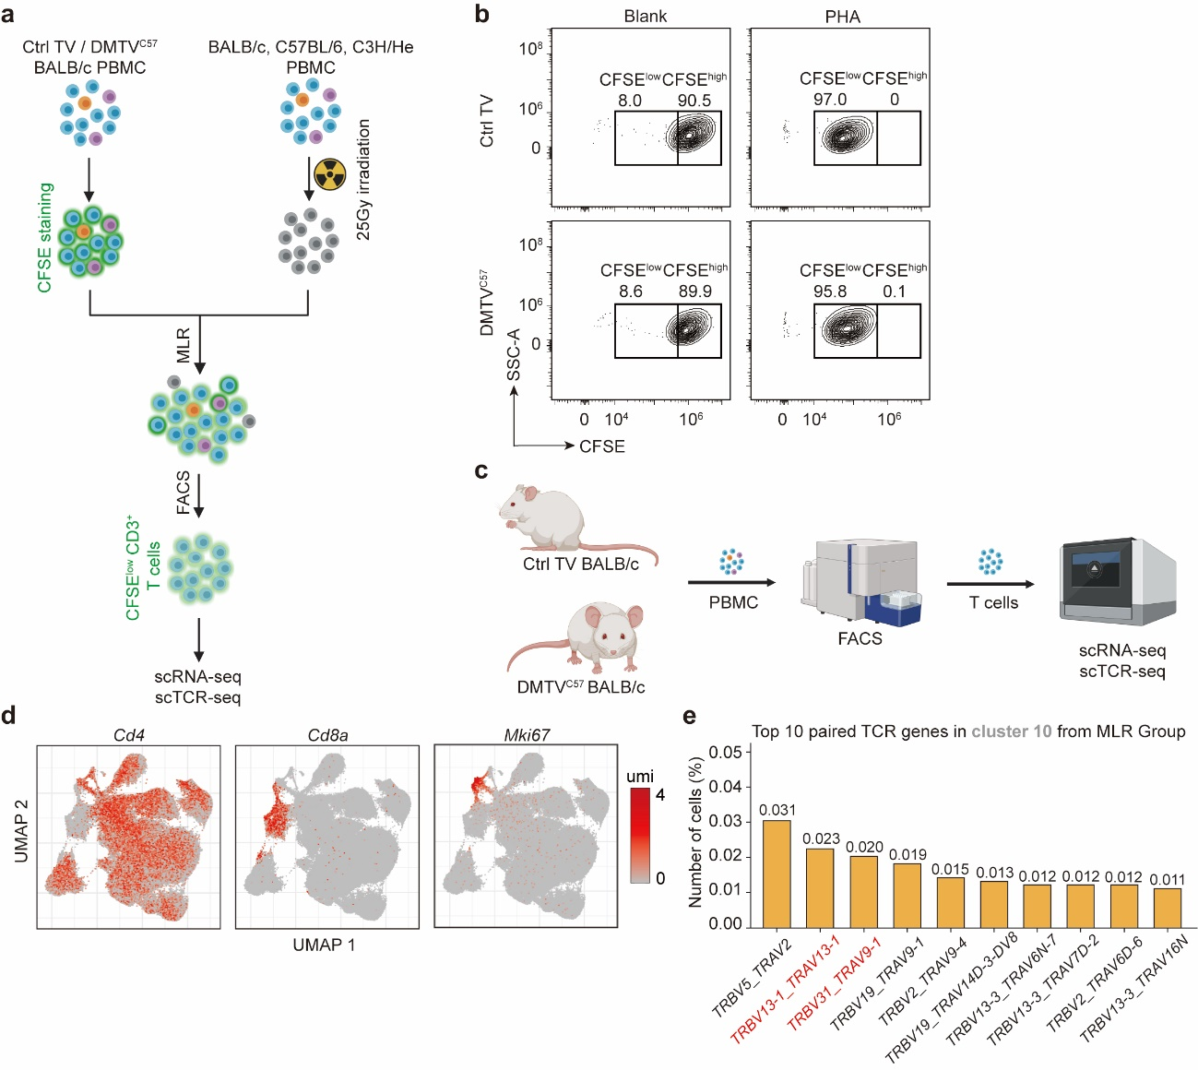
Supplementary information, Fig. S3 Immunoreactive analysis of the reconstituted T cells after thymus vaccination.
a Schematic representation of mixed lymphocyte reaction (MLR) analysis followed by integrative single-cell RNA sequencing (scRNA-seq) and single-cell TCR sequencing (scTCR-seq) to capture clonally expanded T cells or TCRs. PBMCs from thymus vaccinated BALB/c mice were stained with the intracellular fluorescent label carboxyfluorescein diacetate succinimidyl ester (CFSE) and incubated with irradiation-inactivated PBMCs from BALB/c, C57BL/6 or C3H/He mice for 10 days. CD3⁺ CFSE^{low} T cells were considered as the clonally expanded T cell populations, which were FACS enriched for integrated scRNA-seq & scTCR-seq.
b MLR analysis in CD3⁺ T cells isolated from Ctrl TV- and DMTV^{C57}-treated BALB/c mice revealed comparable immunoreactivity to common antigen phytohemagglutinin (PHA).
c Schematic representation of integrated scRNA-seq & scTCR-seq in CD3⁺ T cells isolated from PBMCs of Ctrl TV- or DMTV^{C57}-treated BALB/c mice.
d TRAV_TRBV pairing profiles in clonally expanded Cluster #10 T cells in MLR. TRBV13-1_TRAV13-1 and TRBV31_TRAV9-1, TCR pairs enriched in clonally expanded Cluster #9 CD8⁺ T cells and Cluster #1 CD4⁺ T cells after C57BL/6 PBMC priming, were also enriched in clonally expanded Cluster #10 proliferating T cells.
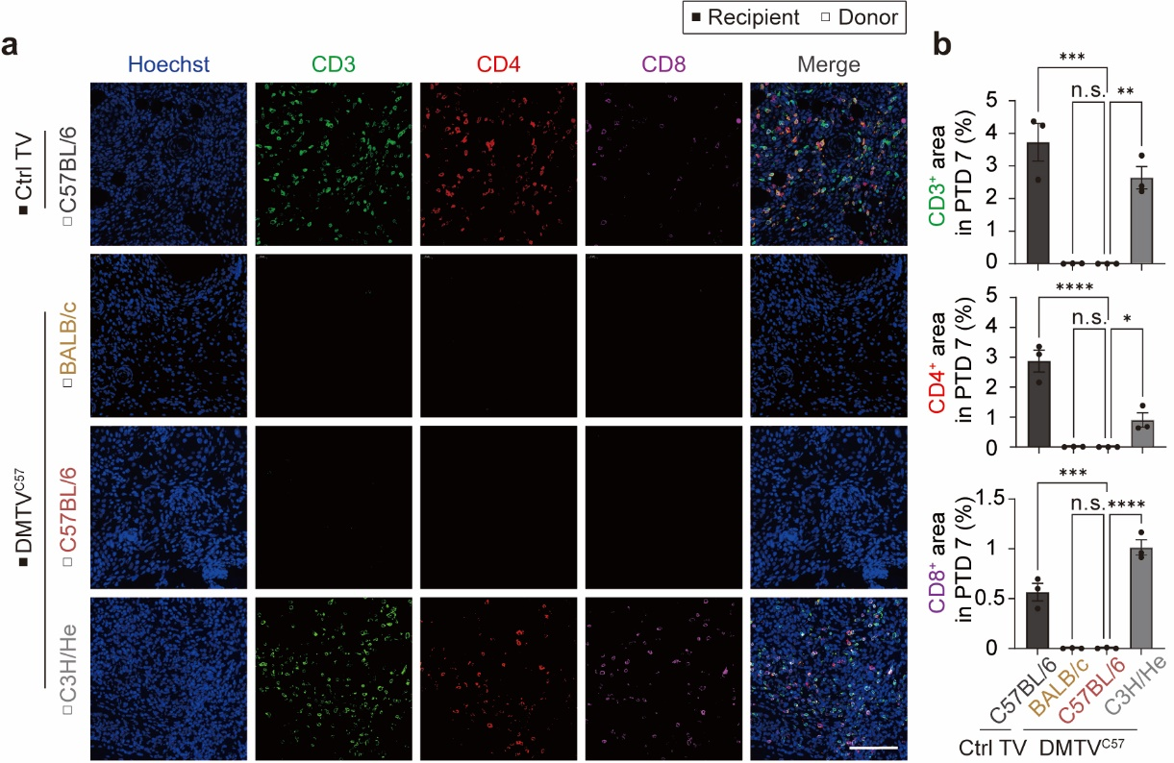
Supplementary information, Fig. S4 DMTV ameliorates T cell infiltration in allotransplanted mouse skin.
a Representative immunofluorescence (IF) staining of CD3⁺, CD4⁺ and CD8⁺ T cells in slices of skin tissues 7 days after transplantation. Scale bar, 100 μm.
b Quantification analyses of CD3, CD4 and CD8 positively stained area 7 days after transplantation in a. Data are mean ± SEM (n=3 independent experiments). ****P < 0.0001; ***P < 0.001; **P < 0.01; *P < 0.05; non-significant (n.s.); One-Way ANOVA.

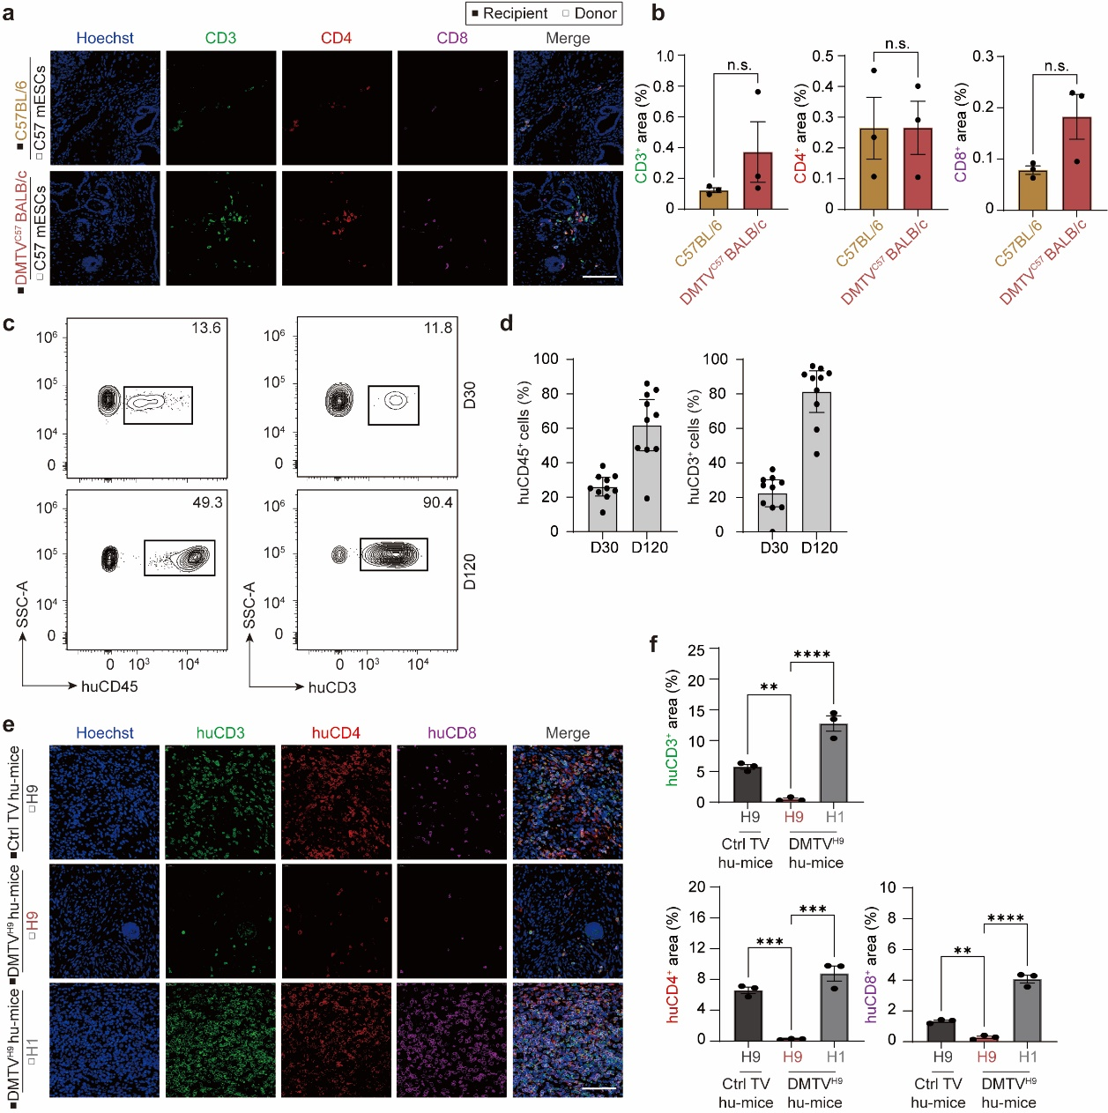
Supplementary information, Fig. S5 DMTV ameliorates T cell infiltration in allogeneic mouse and human embryonic stem cell-originated multi-lineages.
a Representative IF staining of CD3⁺, CD4⁺, CD8⁺ T cells in teratomas originated from C57BL/6 mouse embryonic stem cell (mESC) subcutaneous transplantation in C57BL/6 mice and DMTV^{C57}-treated BALB/c mice. Scale bar, 100 μm.
b Quantification analyses of proportions of infiltered CD3⁺, CD4⁺, CD8⁺ T cells in teratomas in a. Data are mean ± SEM (n=3 independent experiments). non-significant (n.s.); Student’s t-test.
c Representative FACS analysis of proportions of huCD45⁺ cells in PBMCs and huCD3⁺ cells in huCD45⁺ cells in BLT-humanized mice at Day 30 and Day 120.
d Quantification analyses of huCD45⁺ cells in PBMCs and huCD3⁺ cells in huCD45⁺ cells in c. Data are mean ± SEM (n=10 independent experiments).
e Representative IF staining of huCD3⁺, huCD4⁺, huCD8⁺ T cells in H9 hESC-derived teratomas in the Ctrl TV-treated BLT-humanized mice or H9 and H1 hESC-derived teratomas in DMTV^{H9}-treated BLT-humanized mice. Scale bar 100μm.
f Quantification analyses of proportions of infiltered huCD3⁺, huCD4⁺, huCD8⁺ T cells in teratomas in e. Data are presented as mean ± SEM; n=3 independent experiments. ****P < 0.0001; ***P < 0.001; **P < 0.01; One-way ANOVA.

