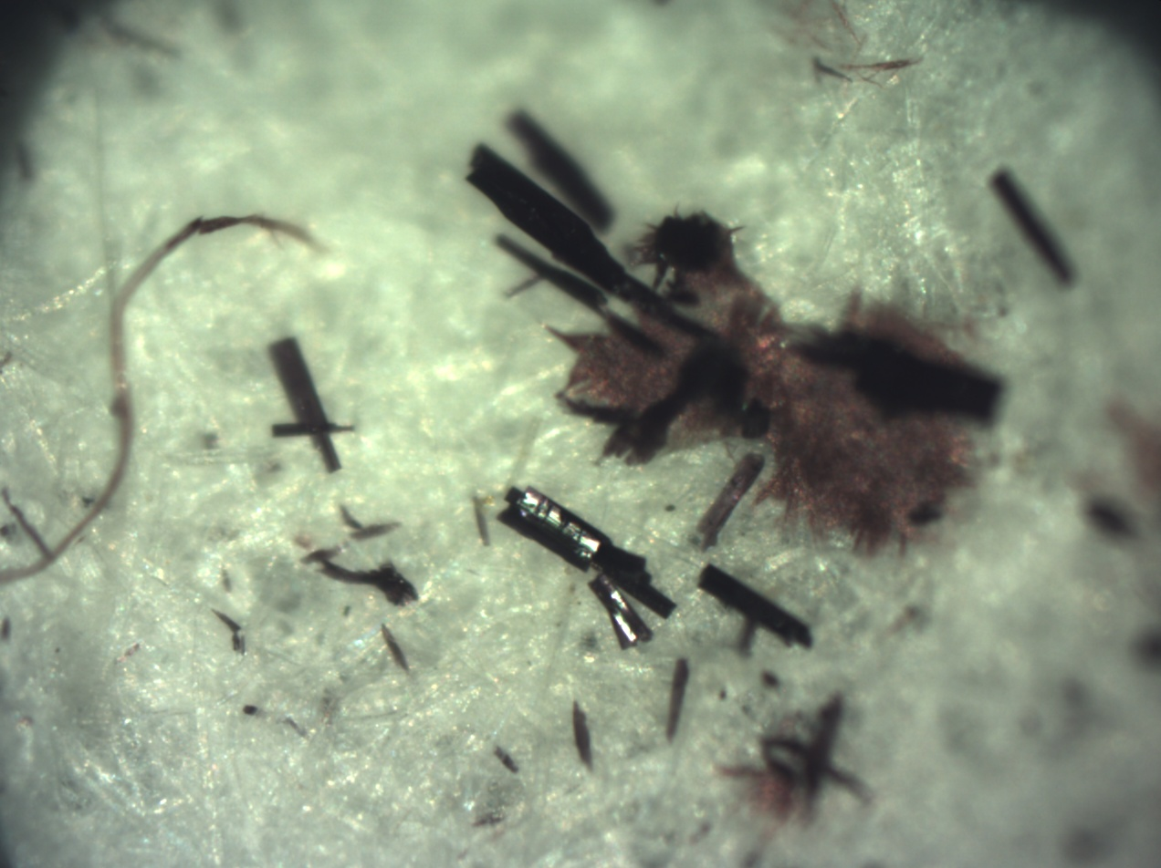
Figure.S1 : form of crystal complex CuL
Figure.S2 : Spectrum ¹H NMR of the ligand L.

Figure.S3 : Spectrum ¹³C NMR of the ligand L.
Figure.S4 : Spectrum ¹H NMR of the compound CuL.
2

