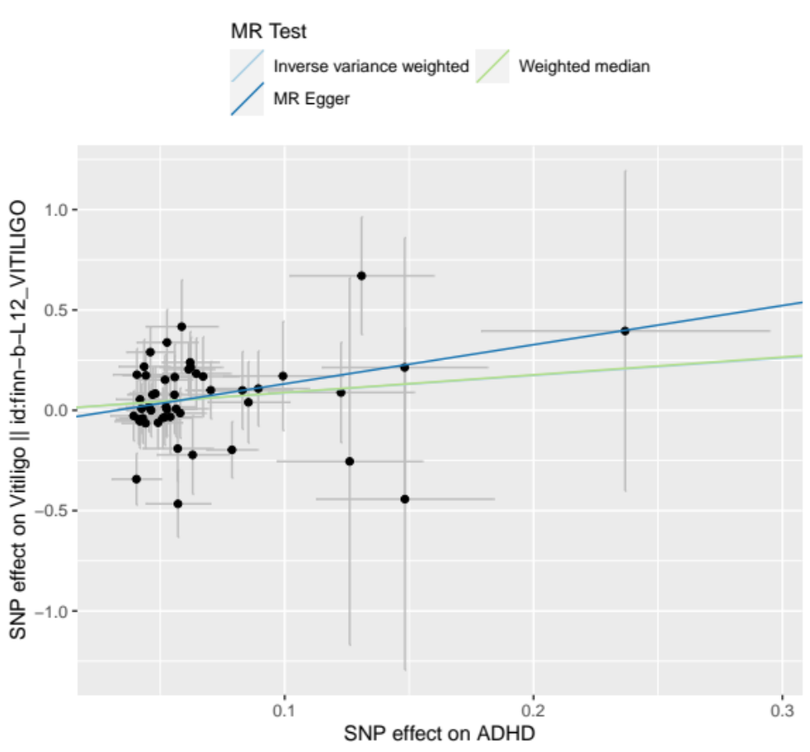
Figure S1 Scatter plots for the causal association between ADHD and vitiligo

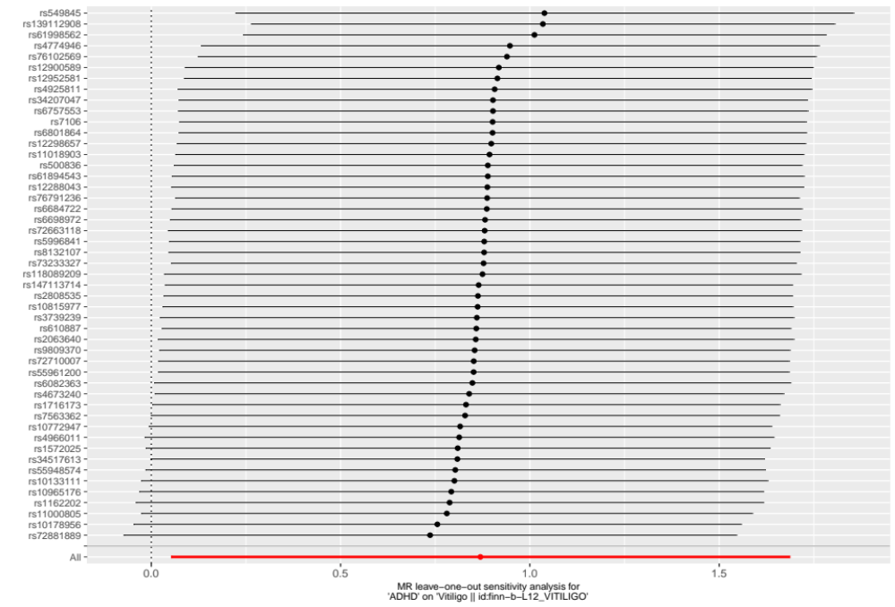
Figure S2 Forest plot of the result of leave-one-out test on the casual relationship between ADHD and vitiligo
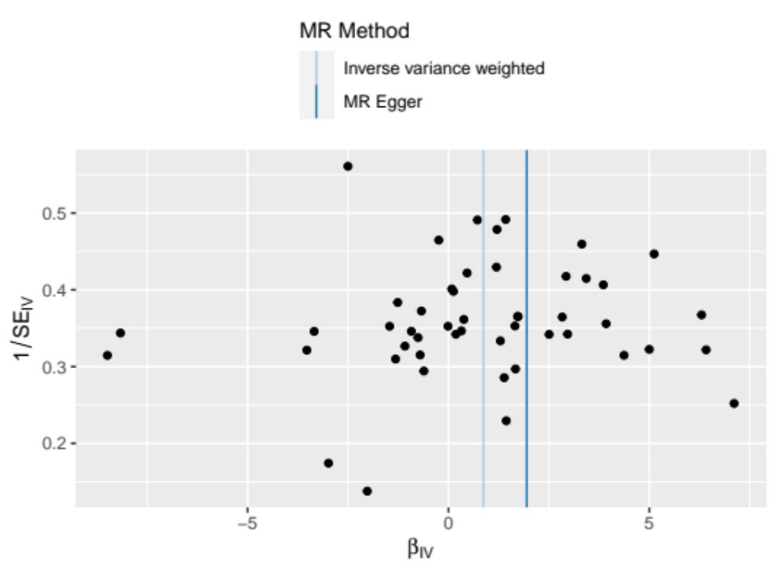
Figure S3 Funnel plot of the casual relationship between ADHD and vitiligo

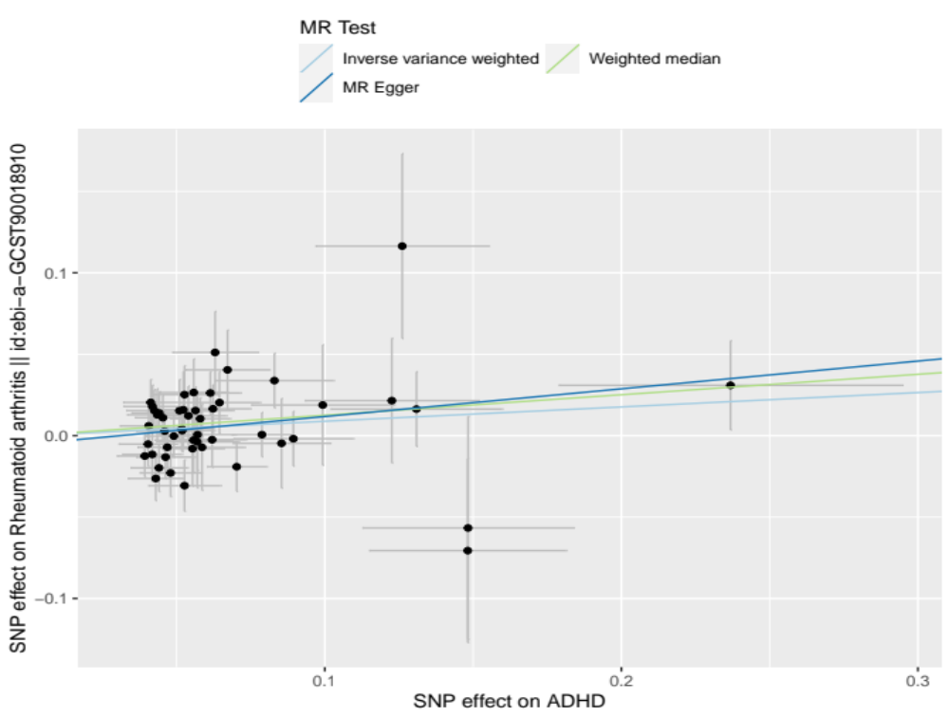
Figure S4 Scatter plots for the causal association between ADHD and rheumatoid arthritis

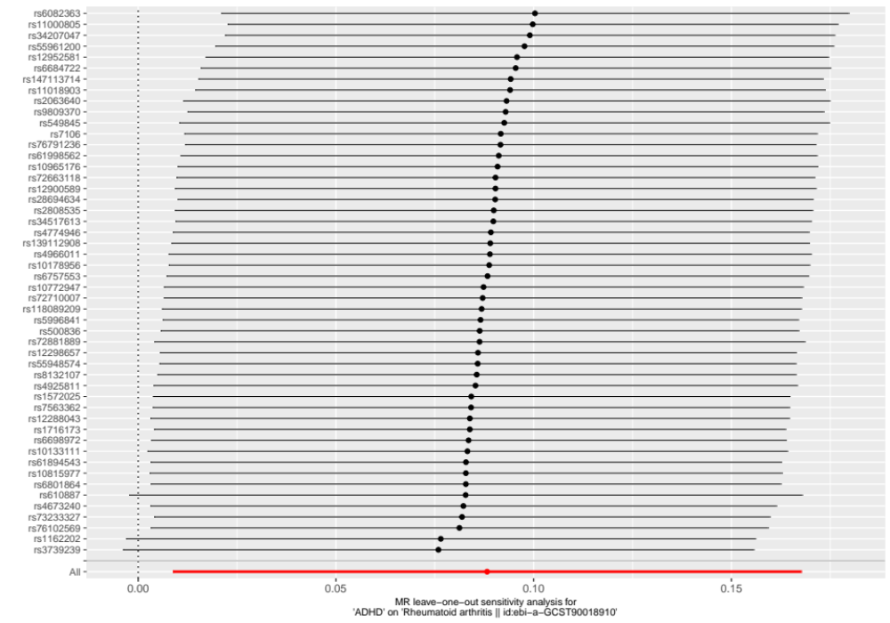
Figure S5 Forest plot of the result of leave-one-out test on the casual relationship between ADHD and rheumatoid arthritis

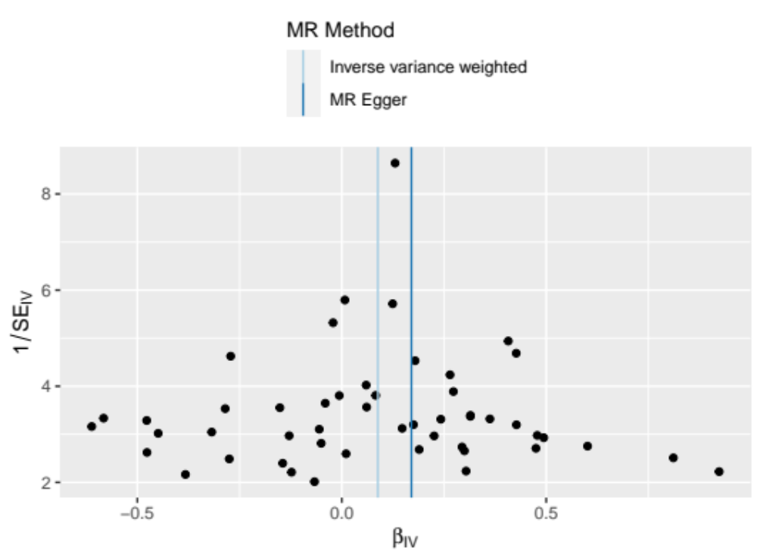
Figure S6 Funnel plot of the casual relationship between causal relationship between ADHD and rheumatoid arthritis

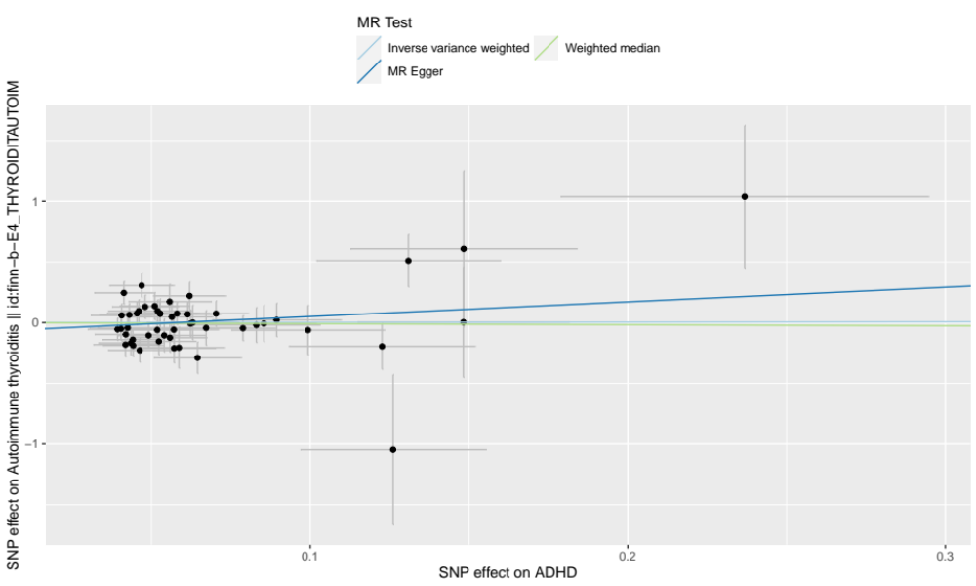
Figure S7 Scatter plots for the causal association between ADHD and autoimmune thyroiditis

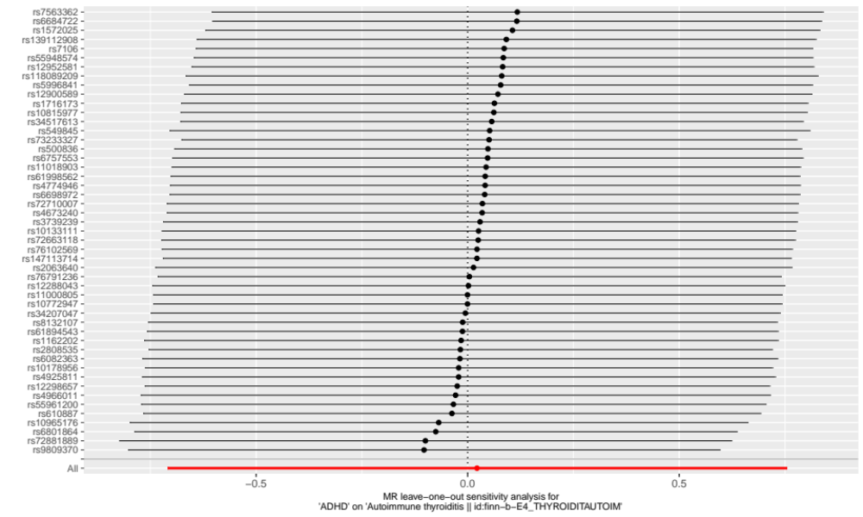
Figure S8 Forest plot of the result of leave-one-out test on the casual relationship between ADHD and autoimmune thyroiditis

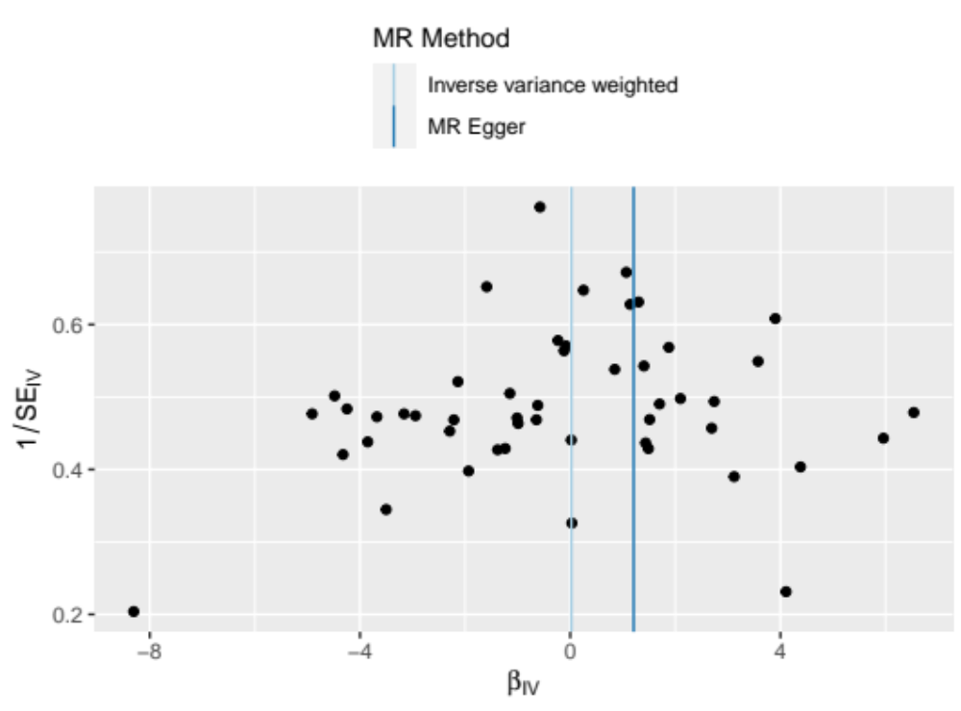
Figure S9 Funnel plot of the casual relationship between casual relationship between ADHD and autoimmune thyroiditis

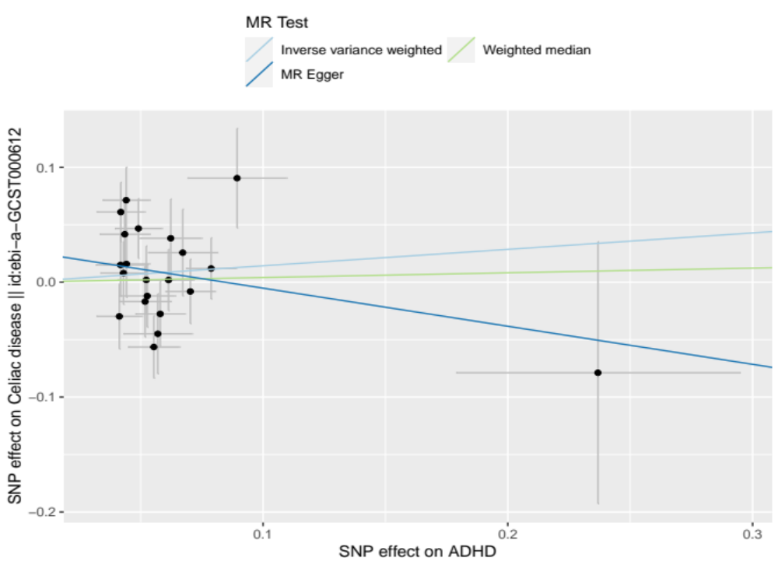
Figure S10 Scatter plots for the causal association between ADHD and celiac disease

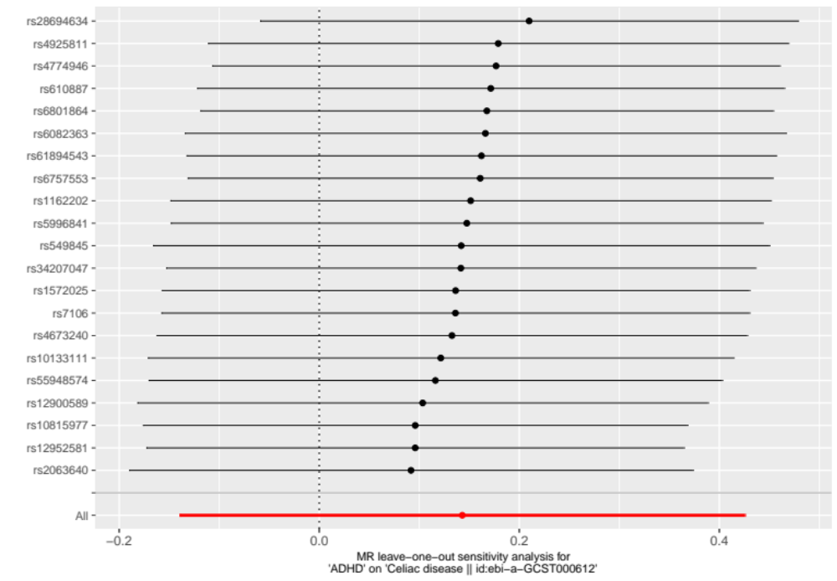
Figure S11 Funnel plot of the result of leave-one-out test on the casual relationship between ADHD and celiac disease

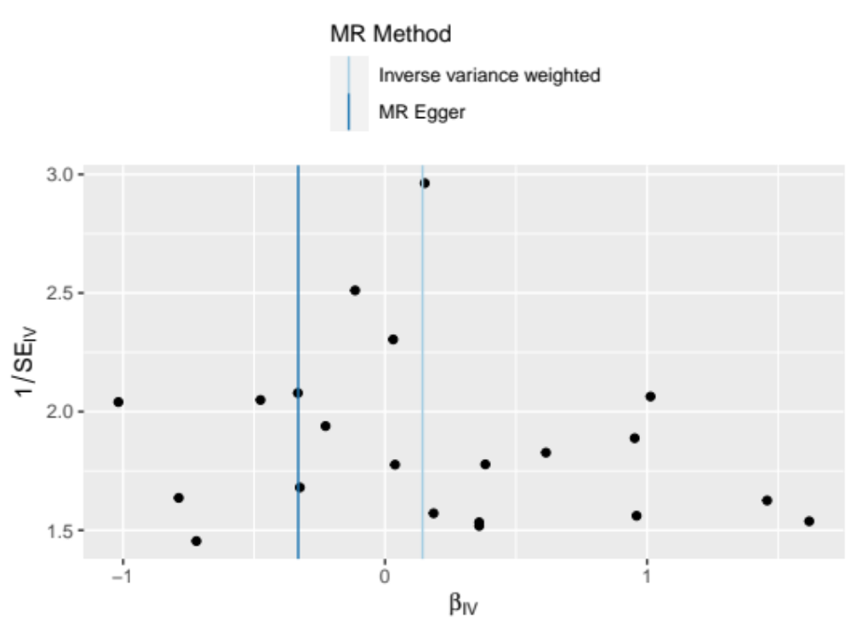
Figure S12 Funnel plot of the casual relationship between ADHD and celiac disease

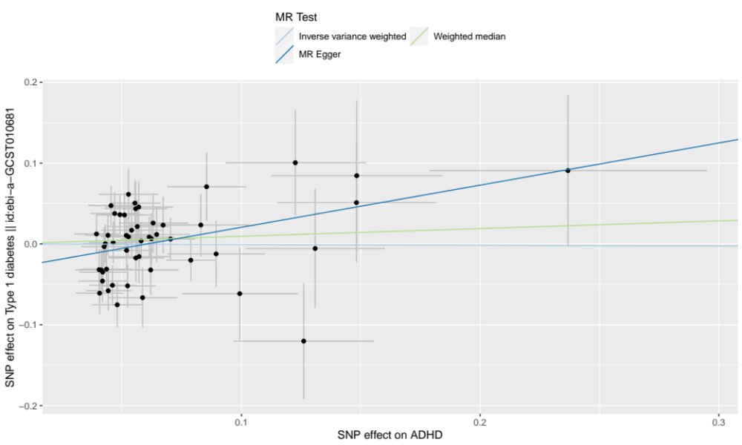
Figure S13 Scatter plots for the causal association between ADHD and type 1 diabetes

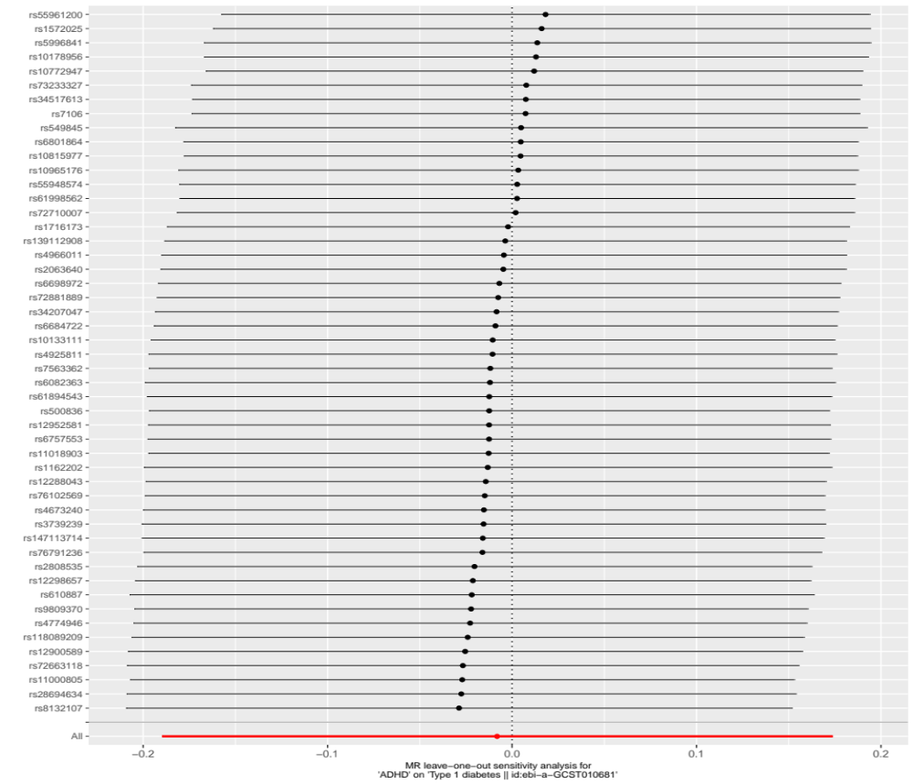
Figure S14 Funnel plot of the result of leave-one-out test on the casual relationship between ADHD and type 1 diabetes
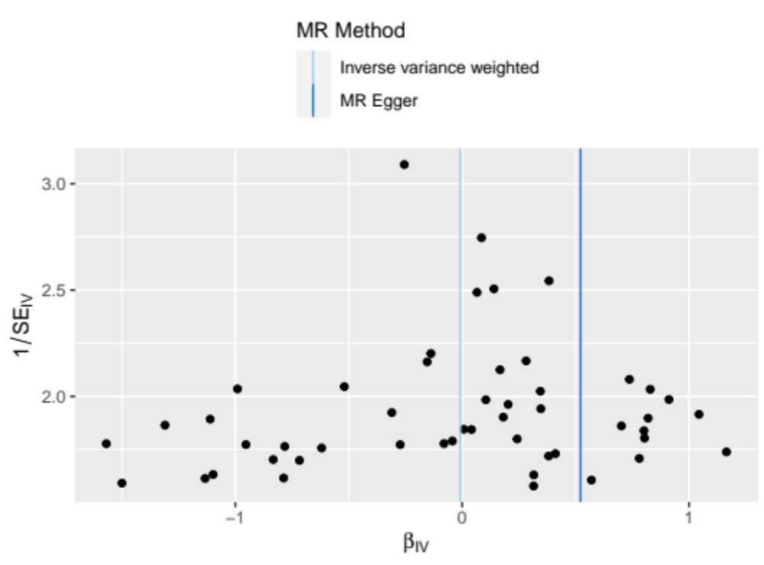
Figure S15 Funnel plot of the casual relationship between ADHD and type 1 diabetes

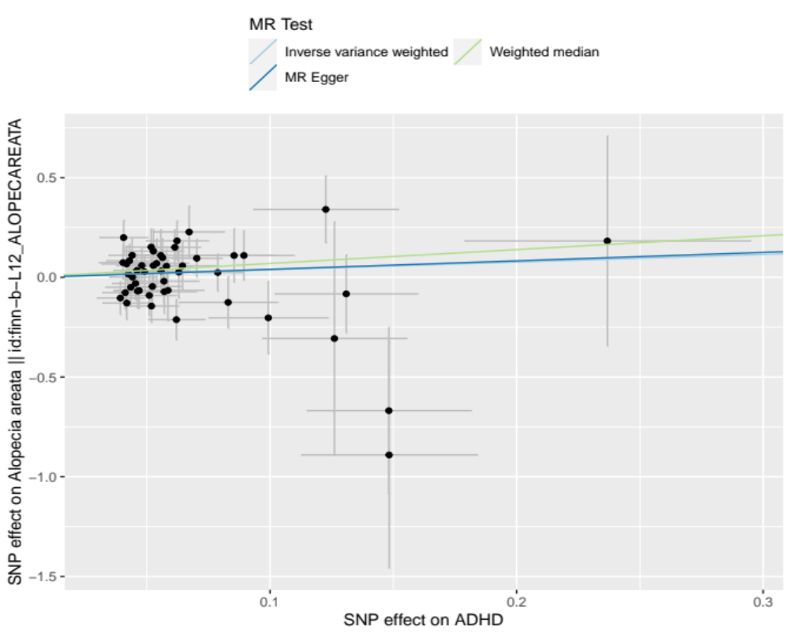
Figure S16 Scatter plots for the causal association between ADHD and alopecia areata
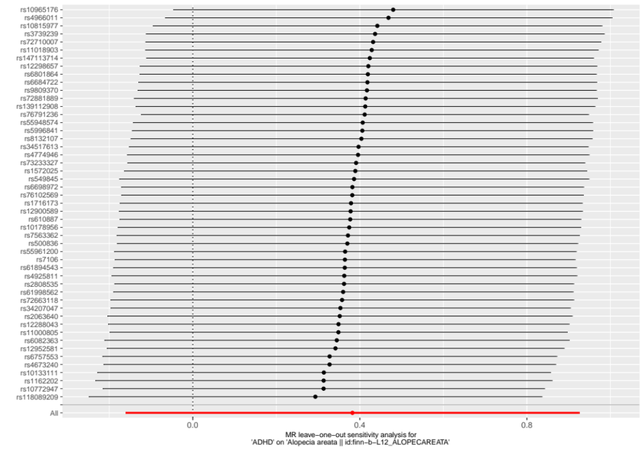
Figure S17 Funnel plot of the result of leave-one-out test on the casual relationship between ADHD and alopecia areata

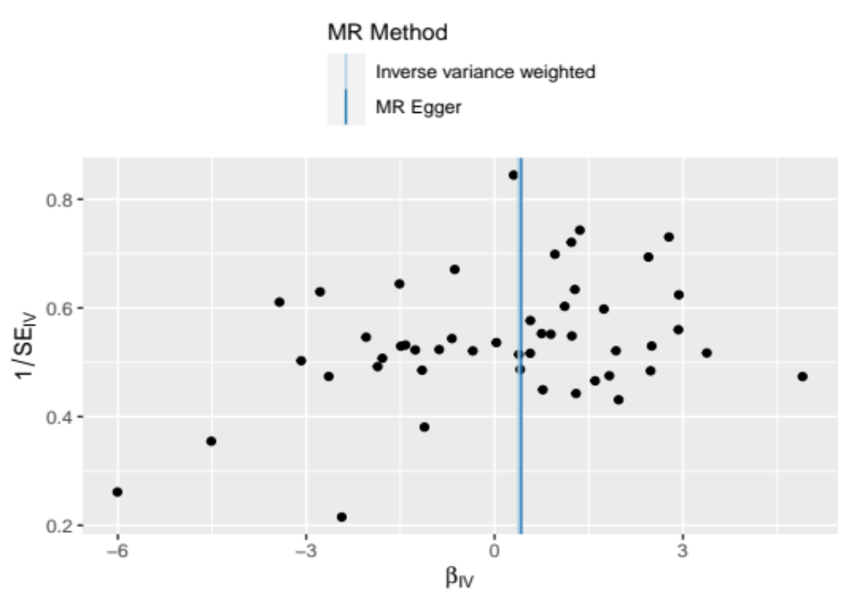
Figure S18 Funnel plot of the casual relationship between ADHD and alopecia areata

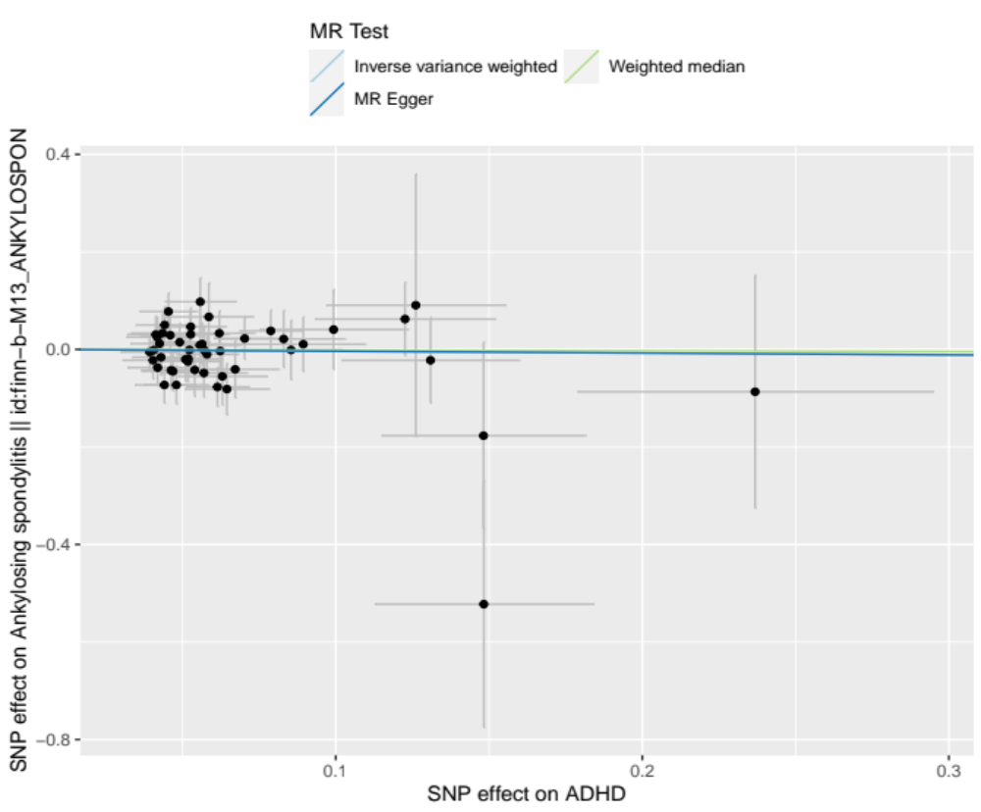
Figure S19 Scatter plots for the causal association between ADHD and ankylosing spondylitis

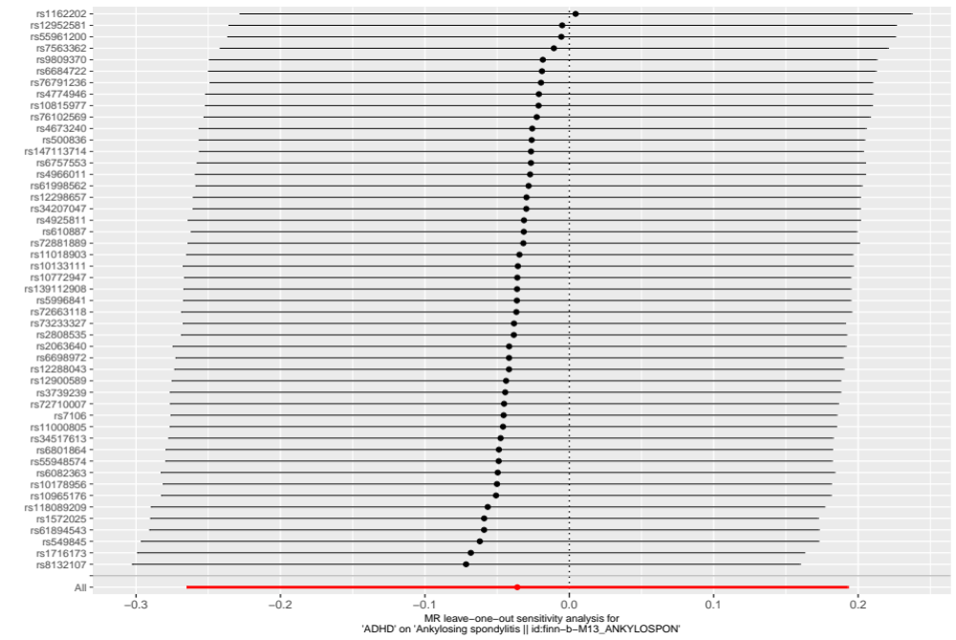
Figure S20 Funnel plot of the result of leave-one-out test on the casual relationship between ADHD and ankylosing spondylitis
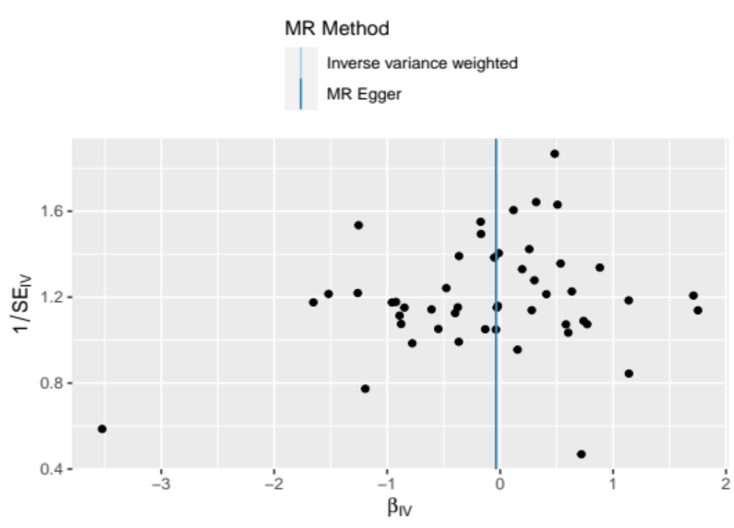
Figure S21 Funnel plot of the casual relationship between ADHD and ankylosing spondylitis

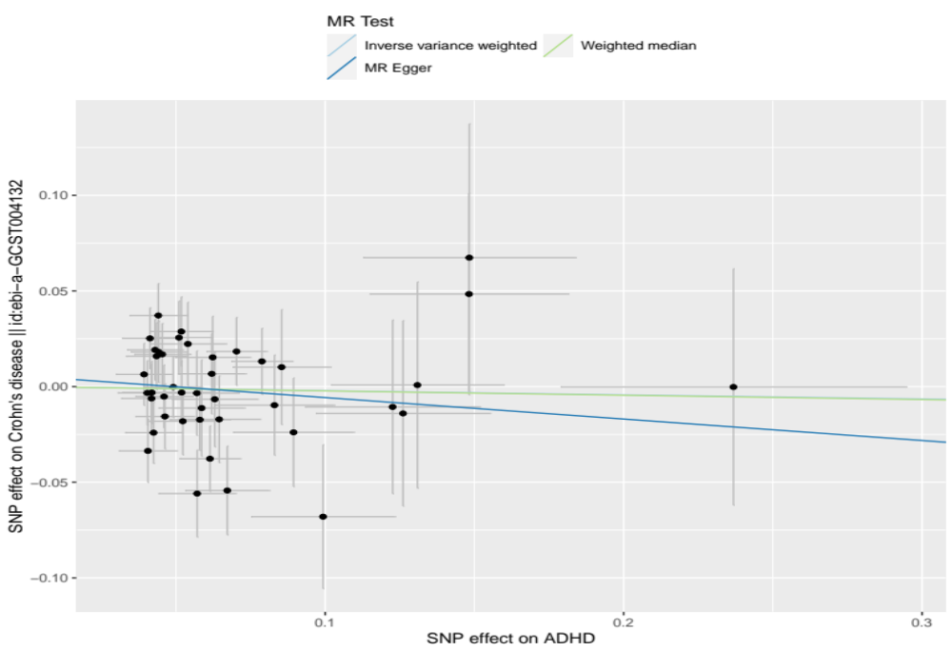
Figure S22 Scatter plots for the causal association between ADHD and Crohn’s disease

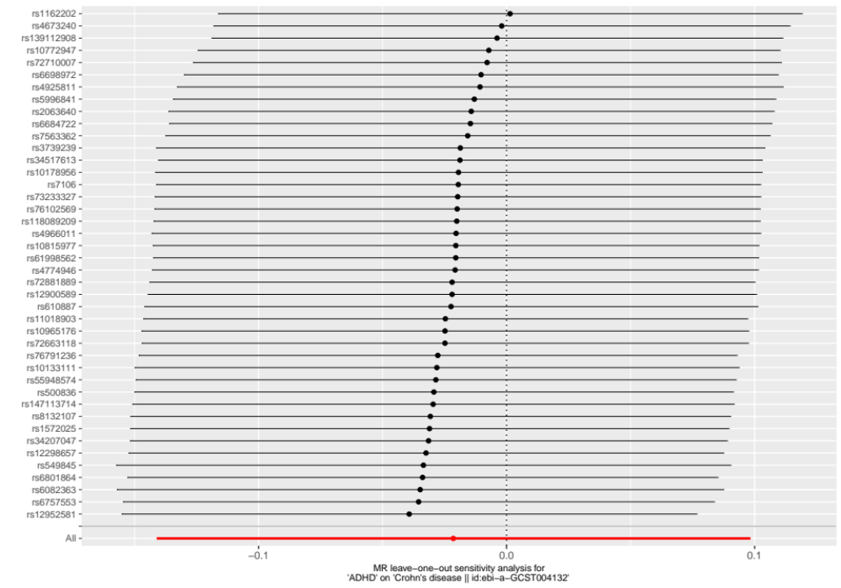
Figure S23 Funnel plot of the result of leave-one-out test on the casual relationship between ADHD and Crohn’s disease

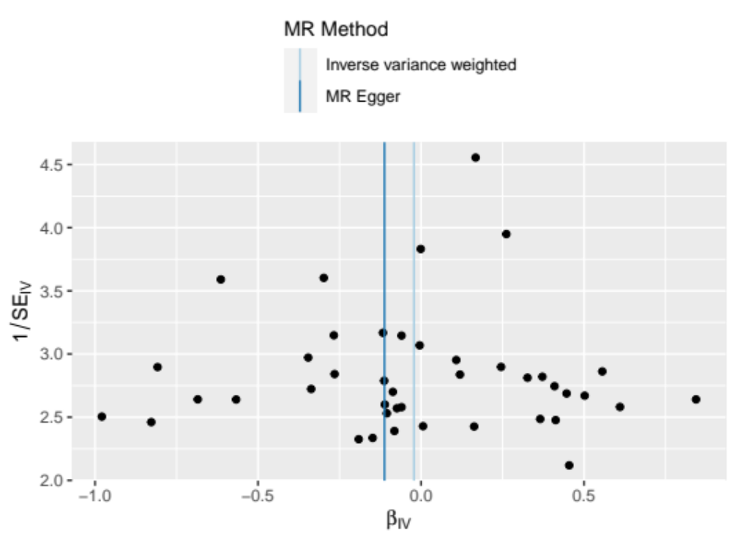
Figure S24 Funnel plot of the casual relationship between ADHD and Crohn’s disease

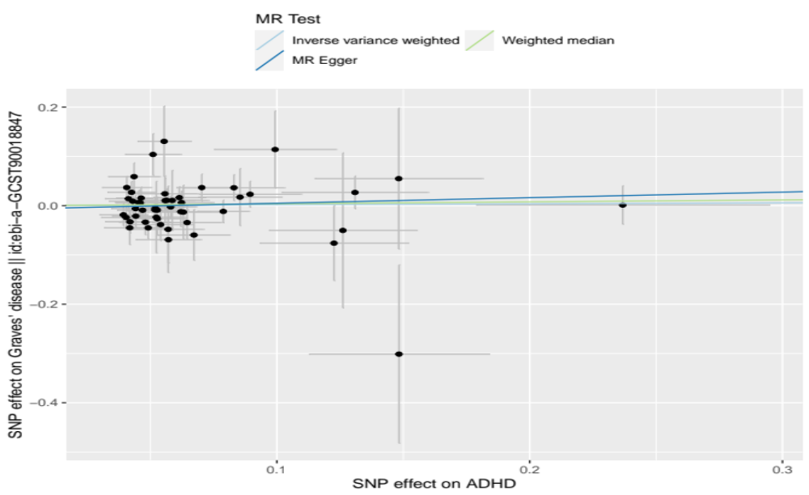
Figure S25 Scatter plots for the causal association between ADHD and Graves' disease

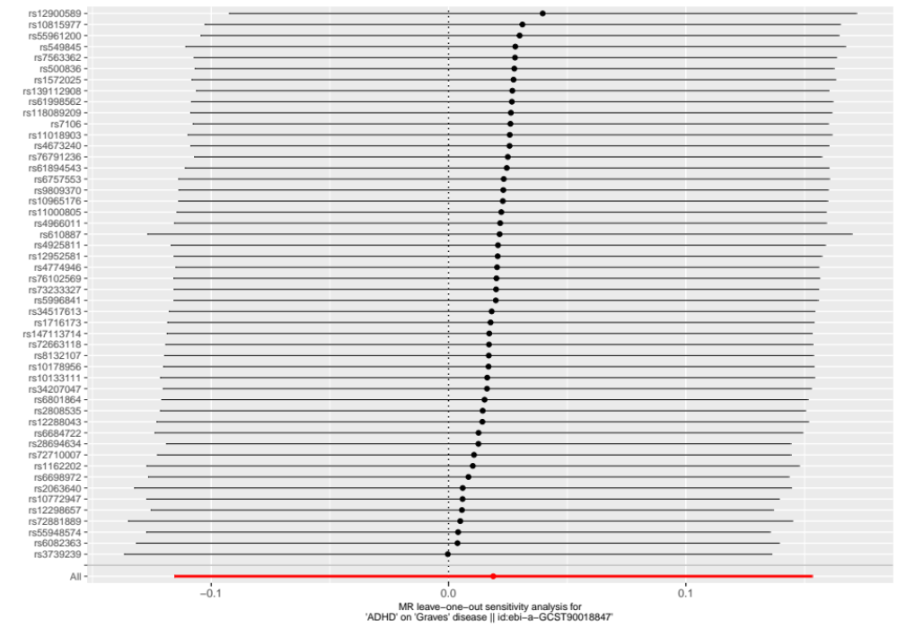
Figure S26 Funnel plot of the result of leave-one-out test on the casual relationship between ADHD and Graves' disease

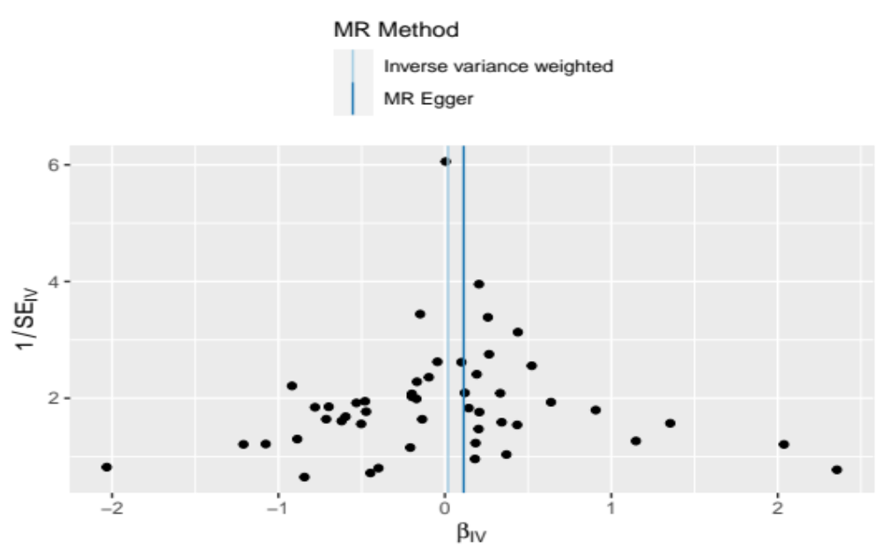
Figure S27 Funnel plot of the casual relationship between ADHD and Graves' disease

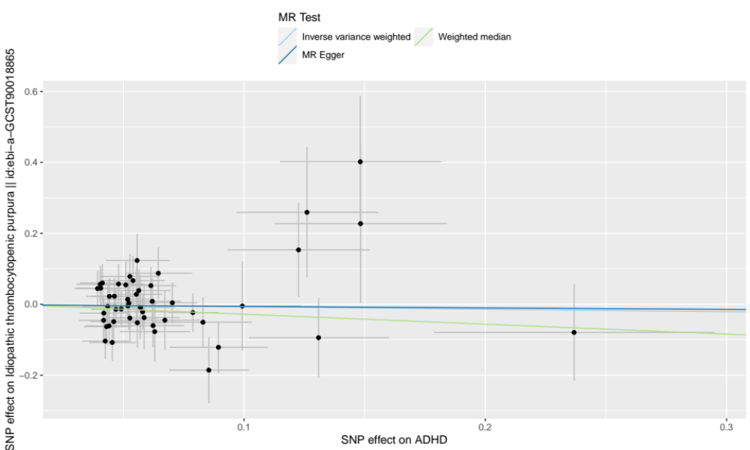
Figure S28 Scatter plots for the causal association between ADHD and idiopathic thrombocytopenic purpura

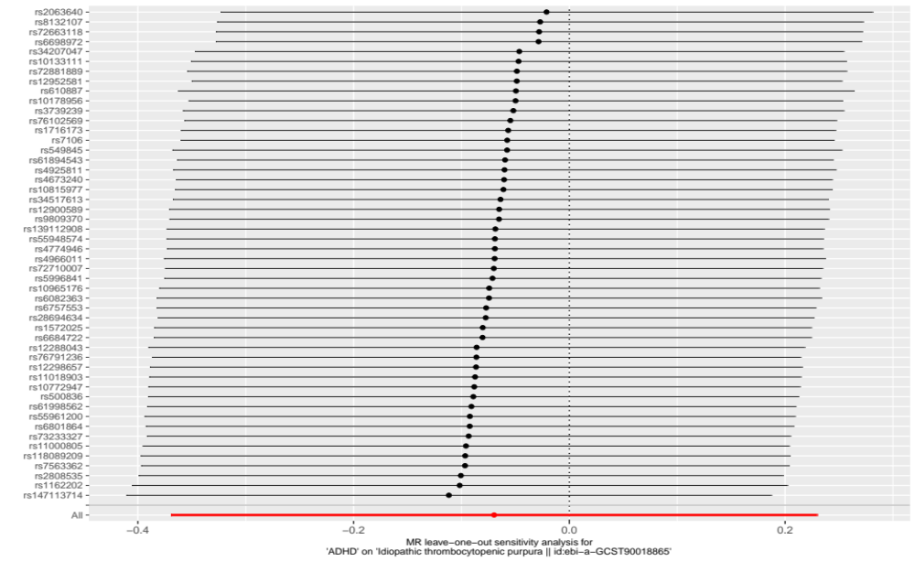
Figure S29 Funnel plot of the result of leave-one-out test on the casual relationship between ADHD and idiopathic thrombocytopenic purpura

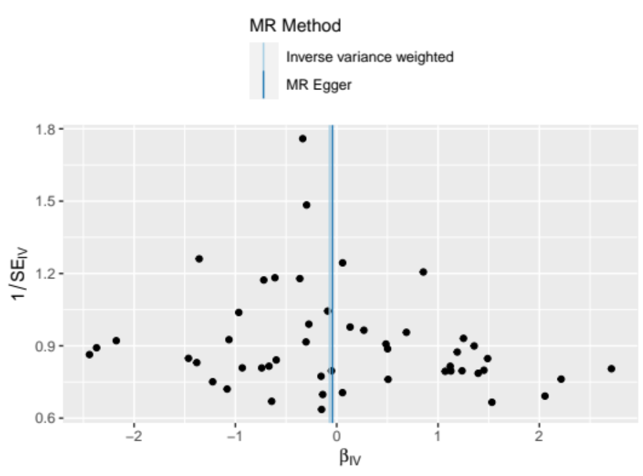
Figure S30 Funnel plot of the casual relationship between ADHD and idiopathic thrombocytopenic purpura

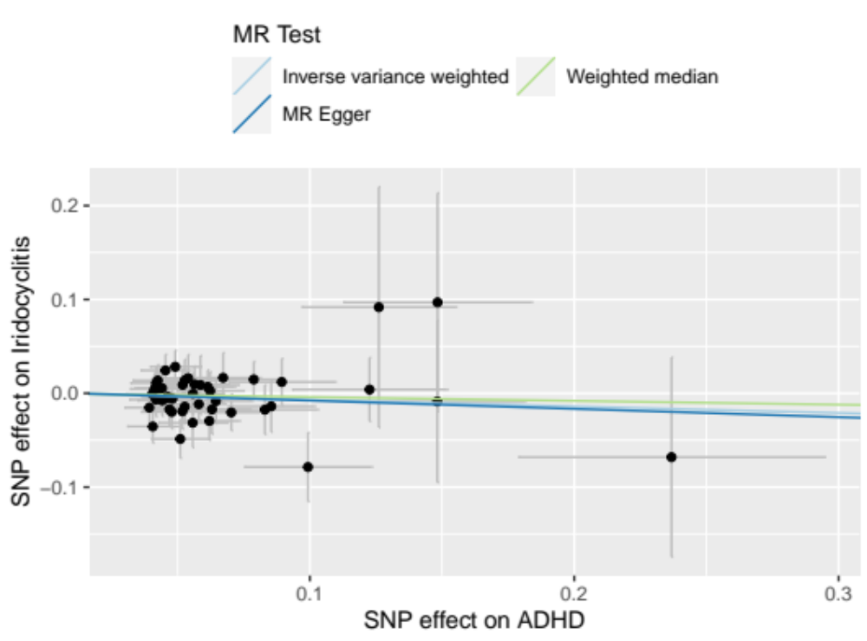
Figure S31 Scatter plots for the causal association between ADHD and iridocyclitis

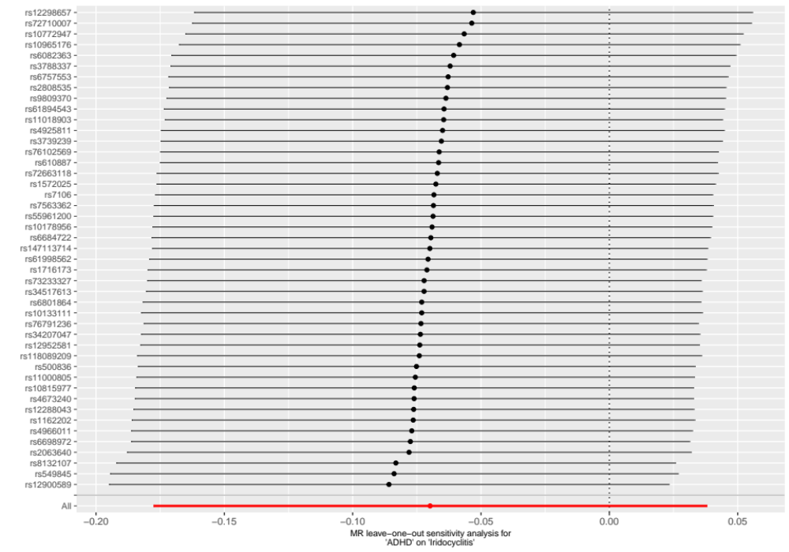
Figure S32 Funnel plot of the result of leave-one-out test on the casual relationship between ADHD and iridocyclitis

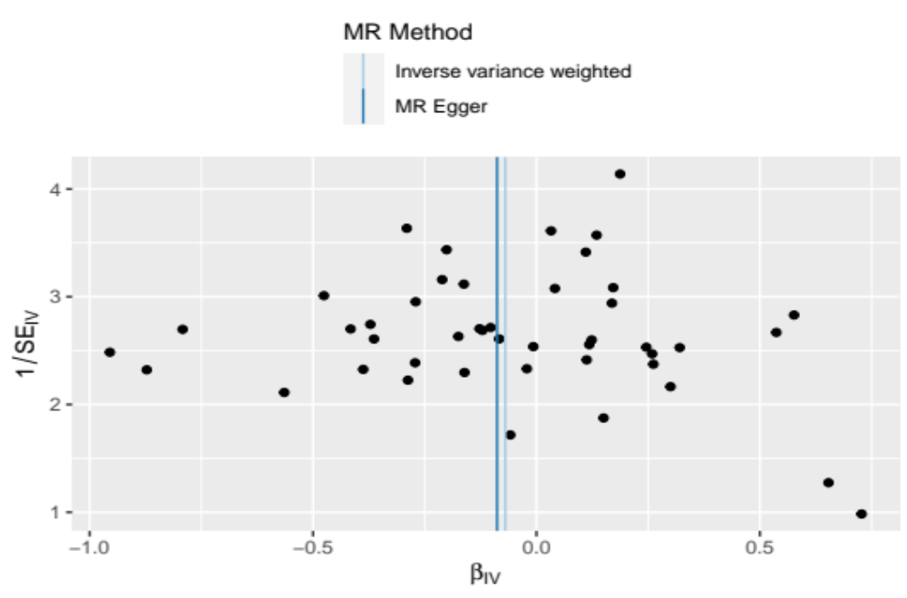
Figure S33 Funnel plot of the casual relationship between ADHD and iridocyclitis

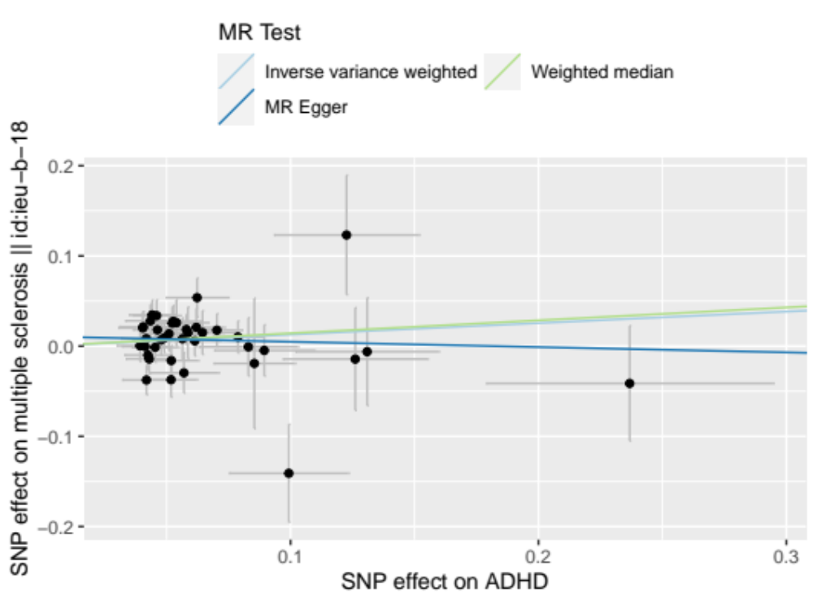
Figure S34 Scatter plots for the causal association between ADHD and multiple sclerosis

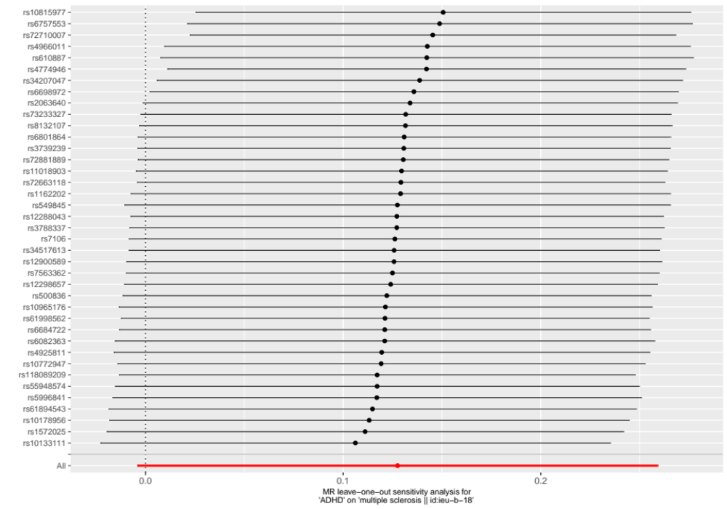
Figure S35 Funnel plot of the result of leave-one-out test on the casual relationship between ADHD and multiple sclerosis

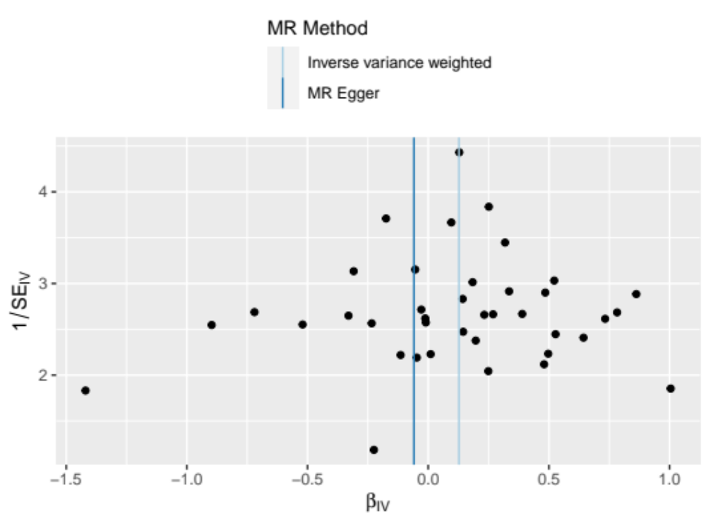
Figure S36 Funnel plot of the casual relationship between ADHD and multiple sclerosis

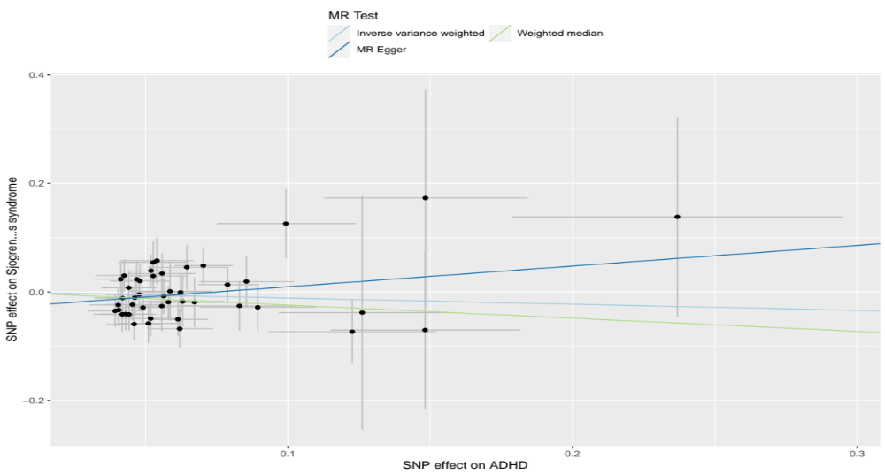
Figure S37 Scatter plots for the causal association between ADHD and Sjogren’s syndrome

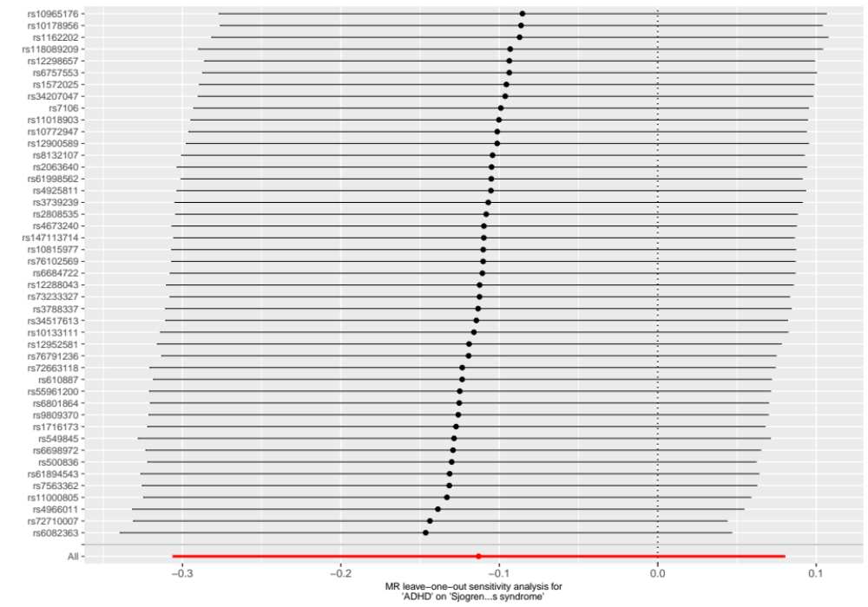
Figure S38 Funnel plot of the result of leave-one-out test on the casual relationship between ADHD and Sjogren’s syndrome

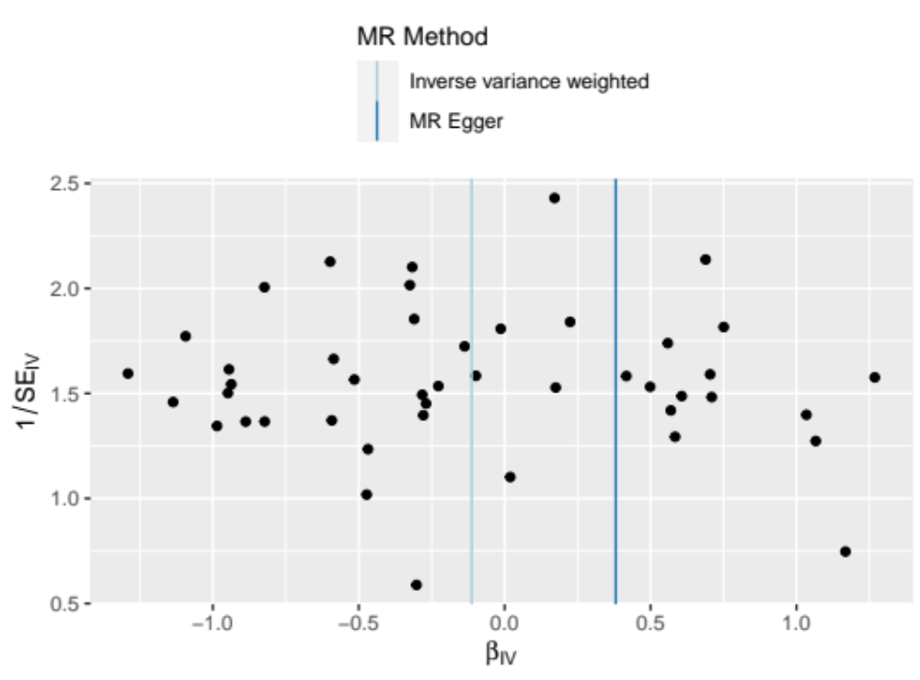
Figure S39 Funnel plot of the casual relationship between ADHD and Sjogren’s syndrome

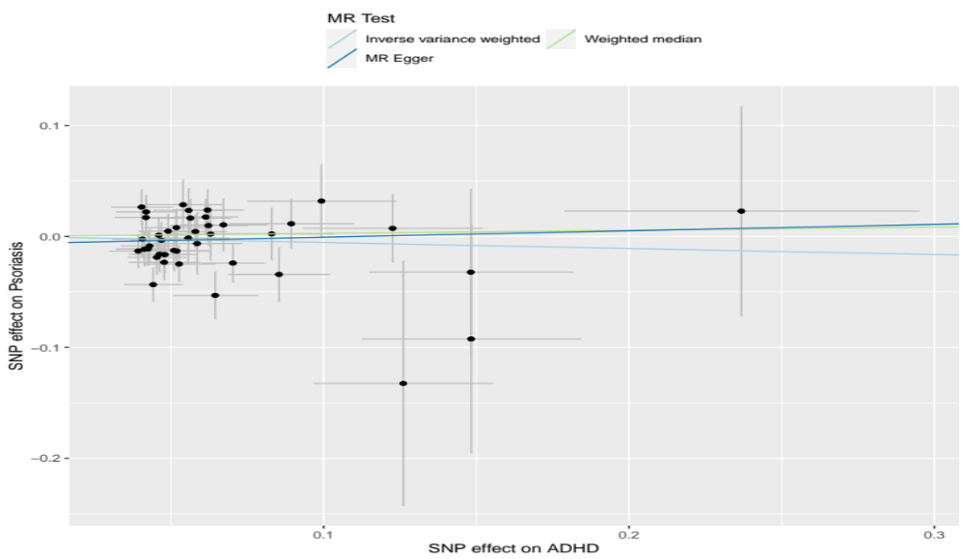
Figure S40 Scatter plots for the causal association between ADHD and Psoriasis

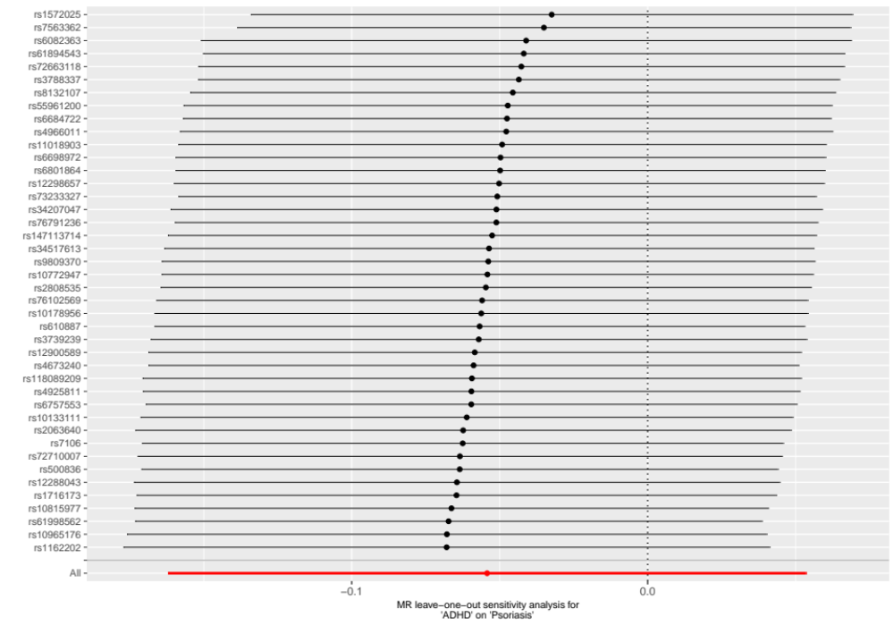
Figure S41 Funnel plot of the result of leave-one-out test on the casual relationship between ADHD and Psoriasis

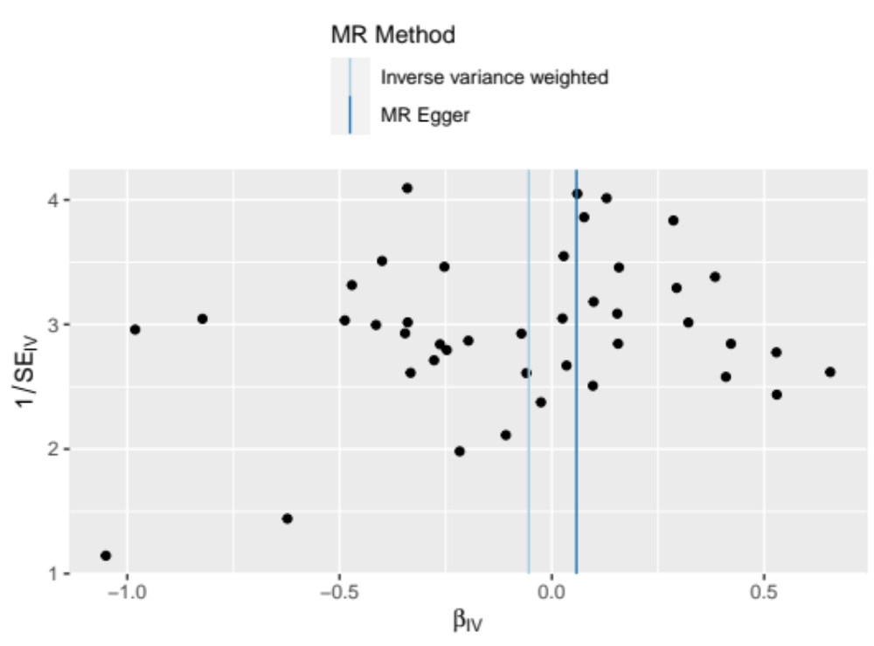
Figure S42 Funnel plot of the casual relationship between ADHD and Psoriasis

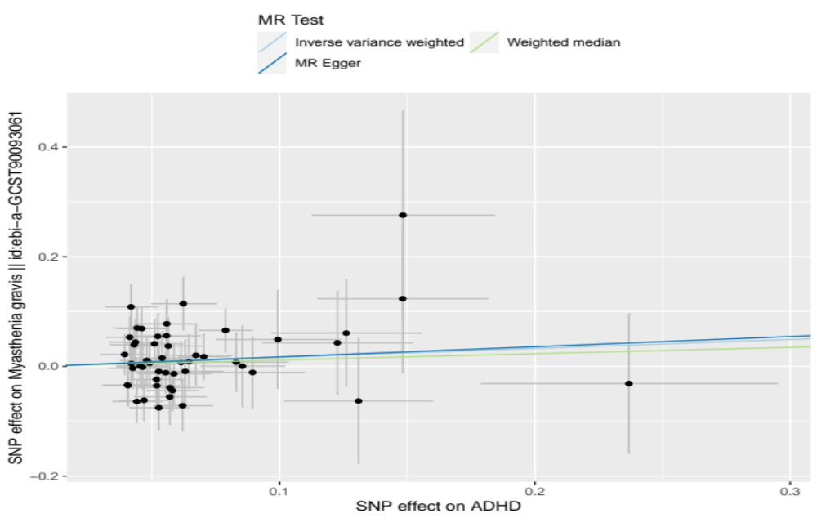
Figure S43 Scatter plots for the causal association between ADHD and myasthenia gravis

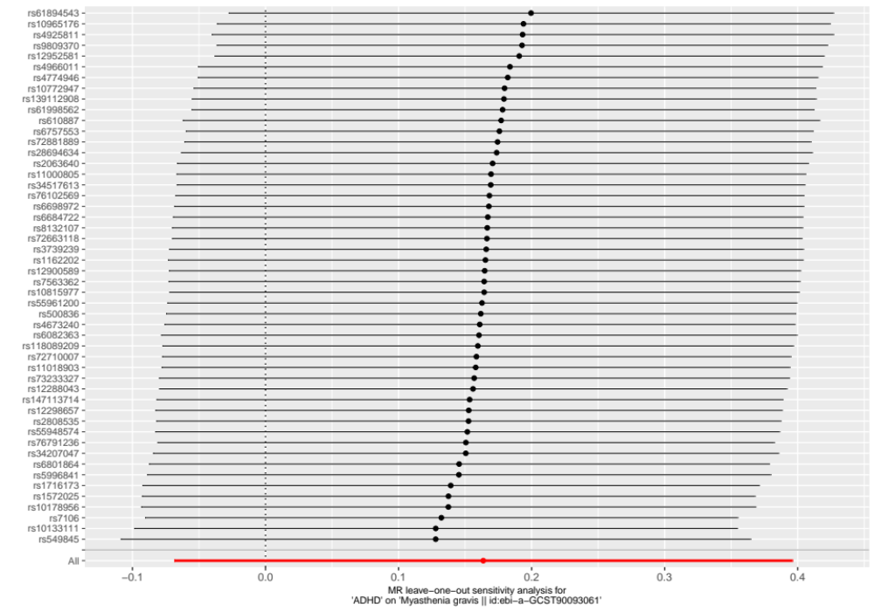
Figure S44 Funnel plot of the result of leave-one-out test on the casual relationship between ADHD and myasthenia gravis

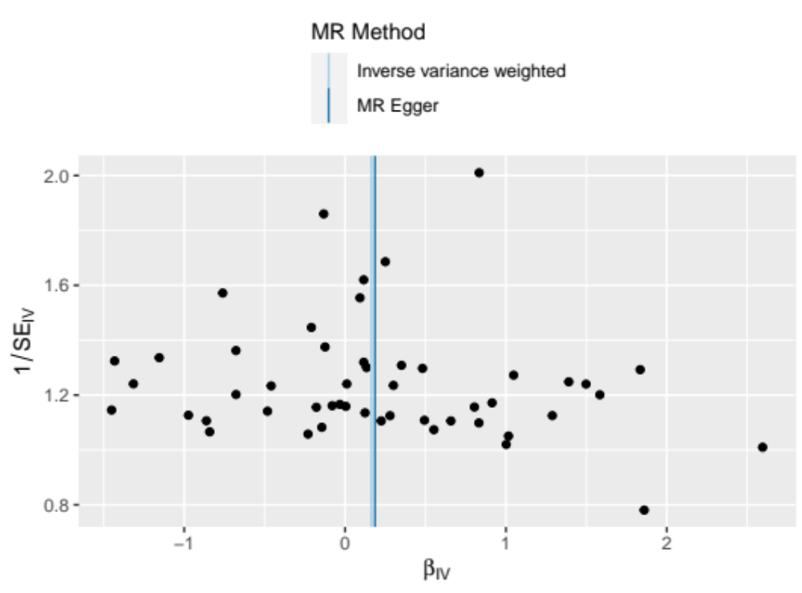
Figure S45 Funnel plot of the casual relationship between ADHD and myasthenia gravis

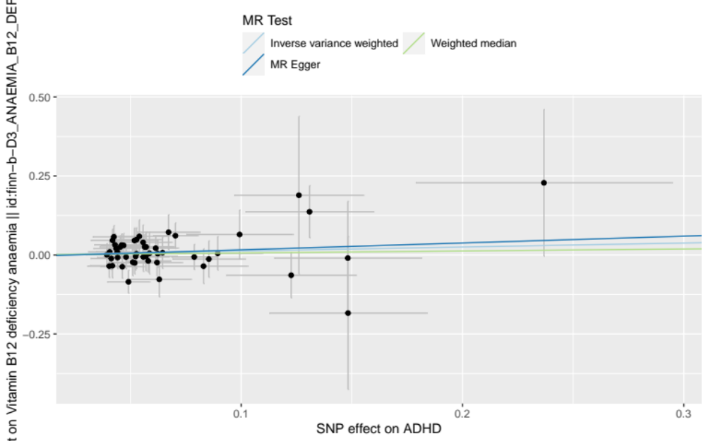
Figure S46 Scatter plots for the causal association between ADHD and Vitamin B12 deficiency anemia

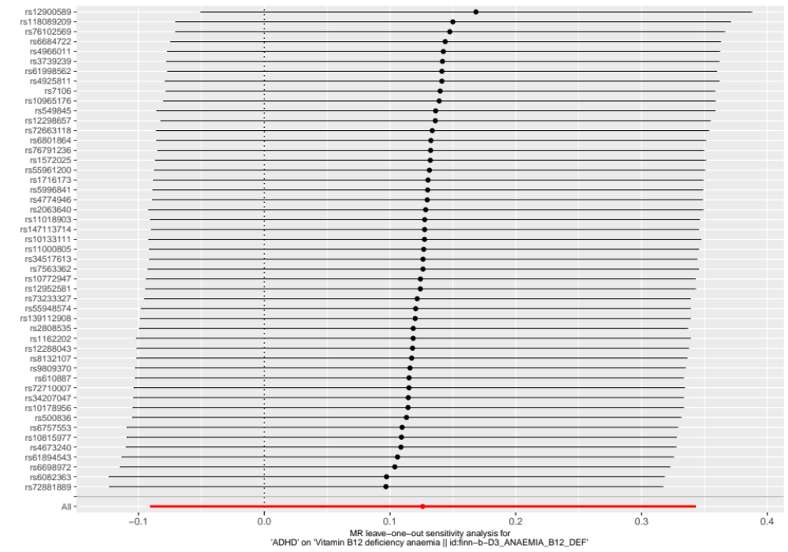
Figure S47 Funnel plot of the result of leave-one-out test on the casual relationship between ADHD and Vitamin B12 deficiency anemia

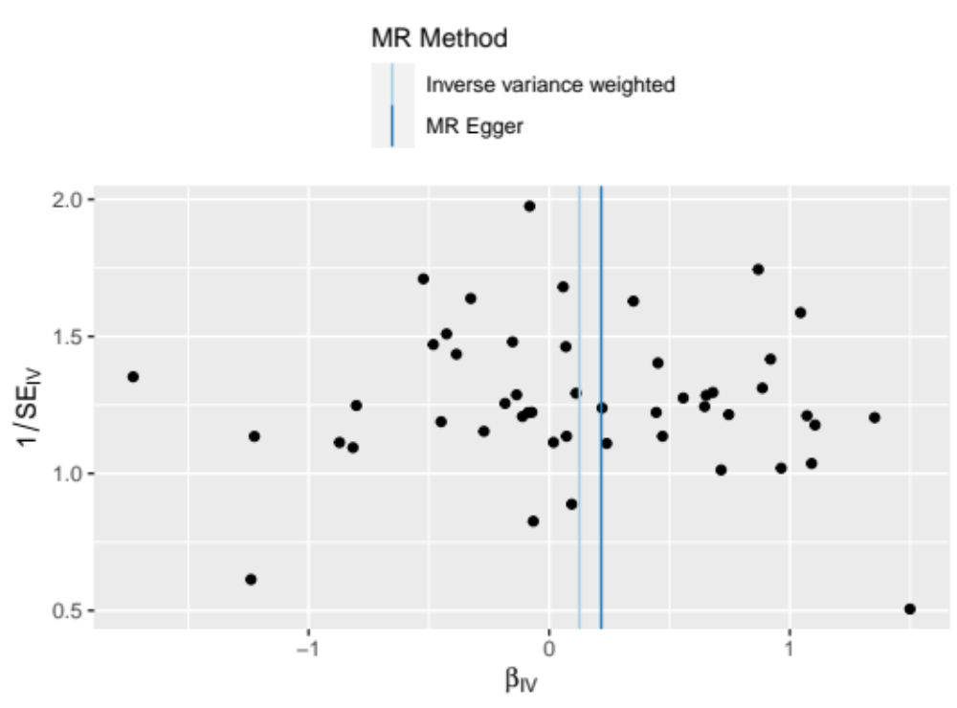
Figure S48 Funnel plot of the casual relationship between ADHD and Vitamin B12 deficiency anemia
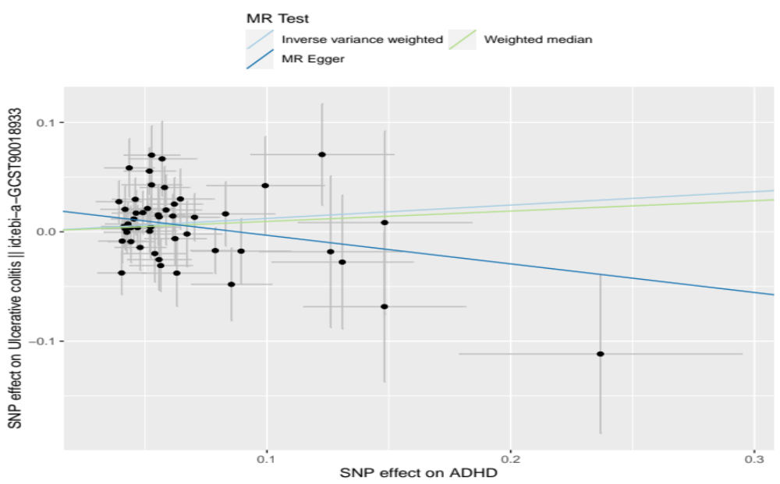
Figure S49 Scatter plots for the causal association between ADHD and ulcerative colitis

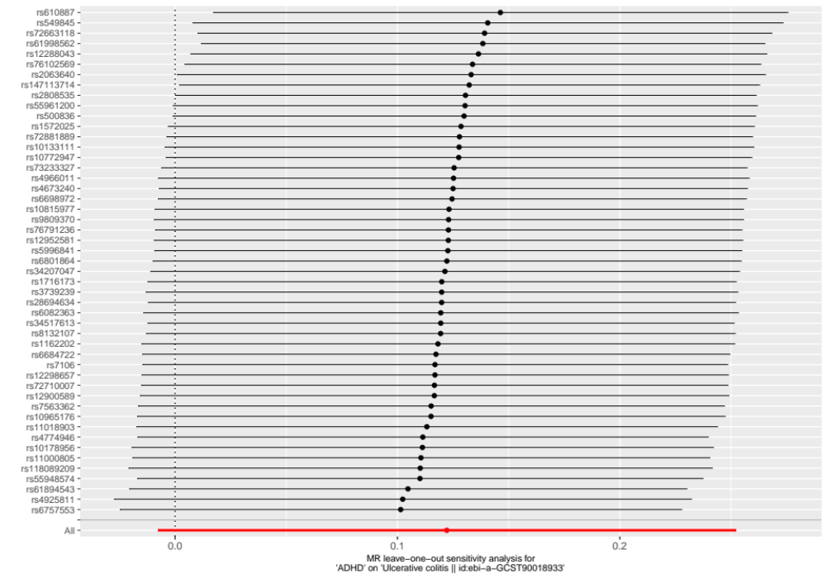
Figure S50 Funnel plot of the result of leave-one-out test on the casual relationship between ADHD and ulcerative colitis

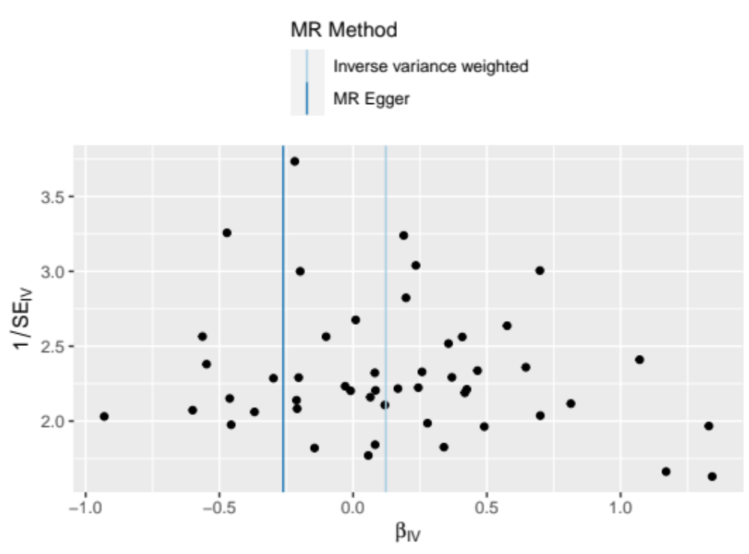
Figure S51 Funnel plot of the casual relationship between ADHD and ulcerative colitis

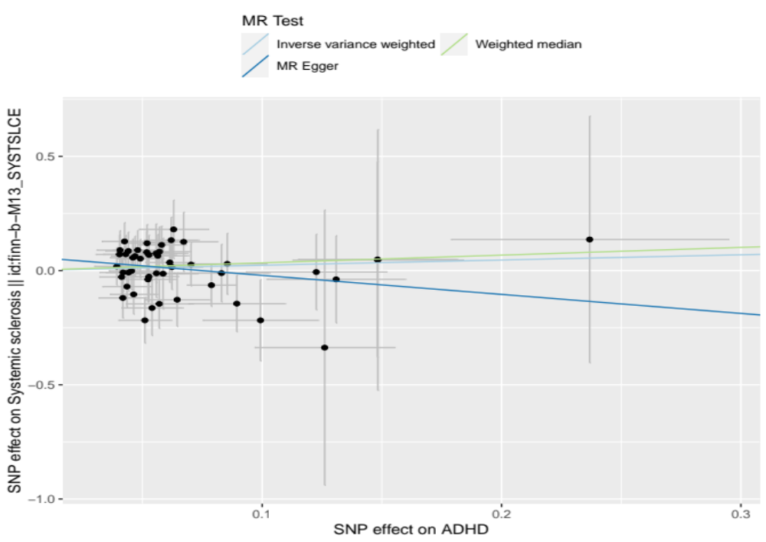
Figure S52 Scatter plots for the causal association between ADHD and Systemic sclerosis

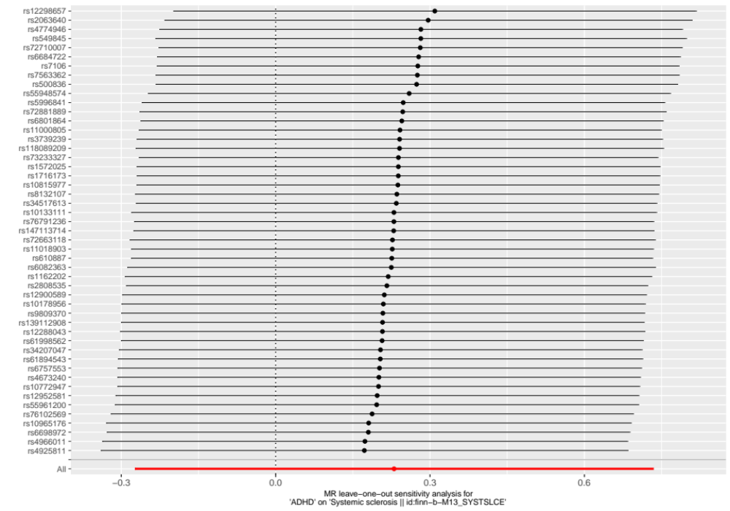
Figure S53 Funnel plot of the result of leave-one-out test on the casual relationship between ADHD and Systemic sclerosis

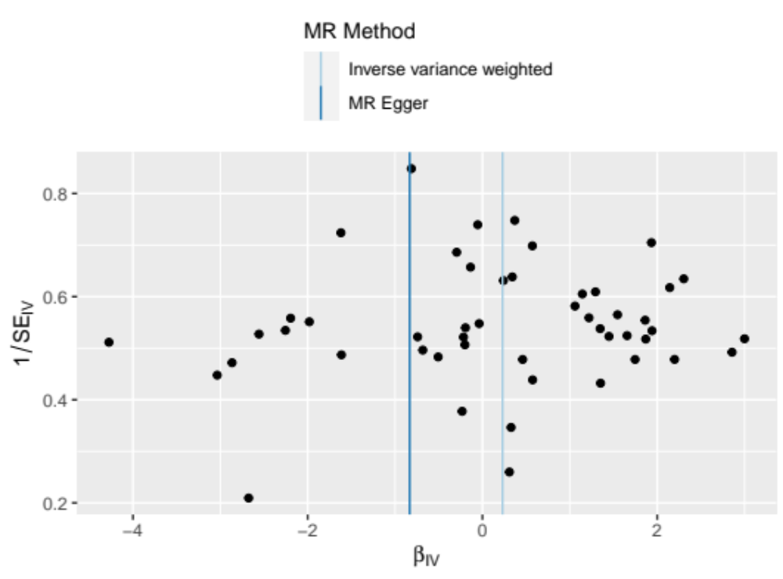
Figure S54 Funnel plot of the casual relationship between ADHD and Systemic sclerosis

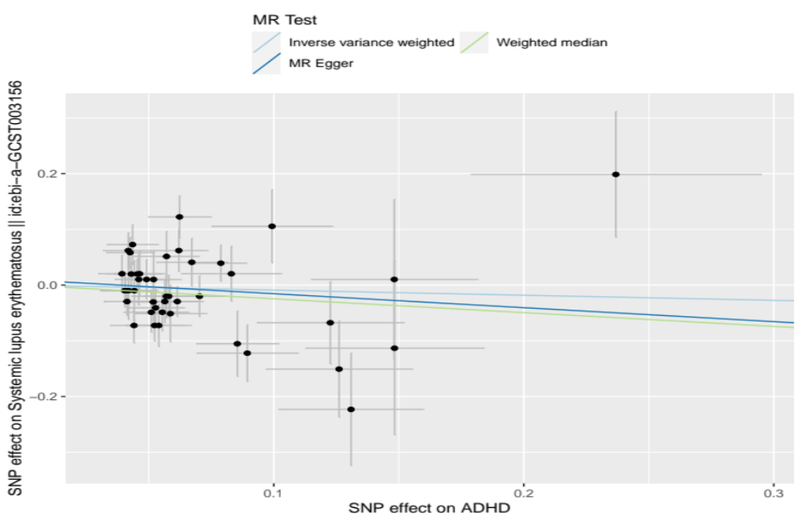
Figure S55 Scatter plots for the causal association between ADHD and Systemic lupus erythematosus

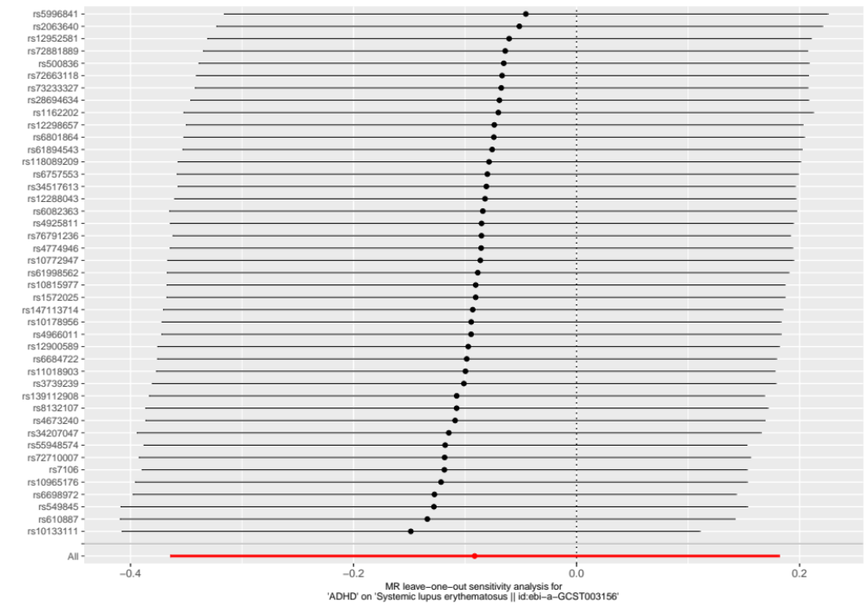
Figure S56 Funnel plot of the result of leave-one-out test on the casual relationship between ADHD and Systemic lupus erythematosus

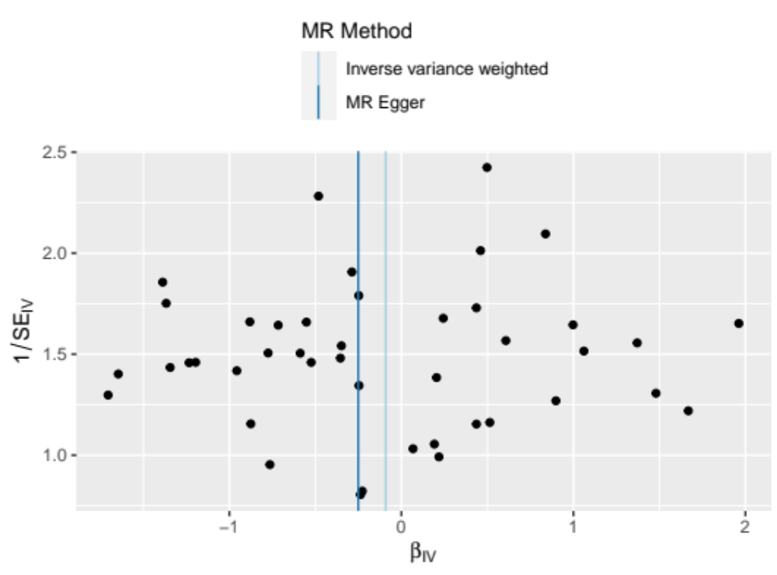
Figure S57 Funnel plot of the casual relationship between ADHD and Systemic lupus erythematosus

