Table 1 The reported literature on natural polymers as metal corrosion inhibitors.
Polymers | Metal/  Medium | The highest η% /  Dosage | References
Starch
Tapioca starch | AA6061alloy/  seawater | 93.98%  (1000 ppm) | Rosliza and Wan Nik (2010)
Cassava starch-acryl amide graft copolymer (CS-AAGC) | 1060 aluminum /  1.0 M H₃PO₄ | 90.6%  (1 g/L) | Deng et al. (2021)
Activated and carboxymethylated starch cassava starch | XC 35 carbon steel/Alkaline  200 mg/L NaCl | -- | Bello et al. (2010)
Cellulose
Carboxymethyl cellulose | Mild steel/  2 M H₂SO₄ | 64.8%  (0.5 g/L) | Solomon et al. (2010)
Methyl hydroxyethyl cellulose | Copper/  1M HCl | 90.29%  (4 g/L) | Sobhi and Eid (2018)
Borated aminated cellulose citrate | A3 steel/ simulated cooling water | 88.33%  (200 mg/L) | Gan et al. (2018)
Tetrazole cellulose | Carbon steel/  1 M HCl | 94.2%  (100 ppm) | Al Kiey et al. (2021)
Hydroxyethyl cellulose (HEC)  (potassium iodide, KI) | Mild steel/  0.5 M H₂SO₄ | 92.74%  (2 g/L HEC+0.5 g/L KI) | Arukalam et al. (2014)
Methyl cellulose (MC) | Magnesium /  0.1 M HCl | -- | Hassan and Ibrahim (2021)
Hydroxyethyl cellulose | Carbon steel (1018 grade) / 3.5% NaCl | 96.7%  (0.5 mM) | El-Haddad. (2014)
Chitosan
N-phenyl-O-benzylthiourea chitosan | Carbon steel /  acidic solutions | 97.8%  (150 mg/L) | Zhang et al. (2023)
Salicylaldehyde Schiff-base grafted chitosan | Mild steel/  1 M HCl | 75.35%  (1500 ppm) | Menaka and Subhashini (2016)
5-hydroxymethylfurfural grafted chitosan | Mild steel/  1 M HCl | 97.01%  (200 mg/L) | Zhang et al. (2023)
8-hydroxyquinoline functionalized chitosan | N80 steel/  1 M HCl | 98.52%  (800 mg/L) | Wu et al. (2023)
Vanillin Schiff base functionalized chitosan | Mild steel/  1 M HCl | 91.1%  (1500 ppm) | Ramanathan et al. (2022)
Triazole-modified chitosan | Carbon steel/  1 M HCl | 90.81%  (200 ppm) | Chauhan et al. (2019)
Sulfonated chitosan | Carbon steel/  2 M HCl | 95.6%  (5000 ppm) | Farhadian et al. (2020)
L-Arginine grafted chitosan | Mild steel/  0.5 M HCl | 91.4%  (500 ppm) | Dalhatu et al. (2023)
Pectin
Pectin extracted from fresh lemon peel | Mild steel/  1 M HCl | 94.2%  (2 g/L) | Fiori-Bimbi et al. (2015)
Pectin extracted from apple | X60 pipeline steel/  0.5 M HCl | 78.7%  (1000 ppm) | Umoren et al.  (2015)
Pectin-g-polyacrylic acid | Mild steel/  3.5% NaCl | 85.53%  (800 ppm) | Geethanjali et al. (2014)
Sugar beet pectin | Mild steel/  1 M HCl | 93.9%  （1g/L） | Abou-Elseoud et al. (2021)
Pectin extracted from citrus peel | Mild steel/  1 M H₃PO₄ | 70.26%  (800 ppm) | Sushmitha and Rao (2020)
Sunflower head pectin（Mw = 4.50 kDa） | Mild steel/  1 M HCl | 90.3%  (2 g/L） | Ma et al. (2019)
Exudate gums
Phosphorylated xanthan gum (PXG) | Mild steel/  200 ppm NaCl | 92.54%  (150 ppm) | Vimal Kumar and Appa Rao (2019)
Gum Arabic (GA) | Carbon steel/  Synthetic brine | 94%  (5 g/L) | Shen et al. (2019)
polysaccharide guar gum(GG) | Carbon steel/  CO2-saturated saline solution | 76.16%  (0.4 g/L) | Palumbo et al. (2023)
Gum arabic | 09G2S steel /  0.1% NaCl | --  (2g/L) | Danyliak and Rizun (2022)
Moringa oleifera (G2) | Mild steel/  Diesel/saline water biphasic system | 95.75%  (5000 ppm) | Palanisamy et al. (2023)
Tragacanth Gum-Ceftriaxone | Mild steel/  1 M HCl | 98.1%  (250 ppm) | Barrodi et al. (2023)
Plant polysaccharides
Lentinan | Q235 steel/  1 M HCl | 92.66%  (100 mg/L) | Liu et al. (2022)
Plantago polysaccharide | Carbon steel/  1 M HCl | 93.54%  (1000 ppm) | Mobin and Rizvi (2017)
Adlay seed hull polysaccharide (ASP) | Mild steel/  1 M HCl | 94.7%  (800 mg/L) | Chen et al. (2021)
Prickly pear nopales Pulp polysaccharide | Mild steel/  1 M HCl | 93.22%  (25 ppm) | Madaci et al. (2023)
Fucoidan | 304 stainless steel/  3.5% NaCl | 81.7%  (200 ppm) | Keshk et al. (2023)

Table 2 The corrosion protection properties of some different types of polymeric surfactant corrosion inhibitors.
Surfactant Type | Metal and electrolyte | Nature of adsorption | The highest η% | References
Cationic
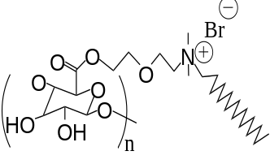 | Mild Steel/  1 M HCL | Langmuir | 80.05%  (1000M) | Shaban et al. (2019)
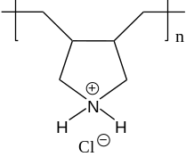 | 304L SS /  1 M HCL | Langmuir | 94.42%  (50 ppm) | Goni et al. (2023)
Anionic
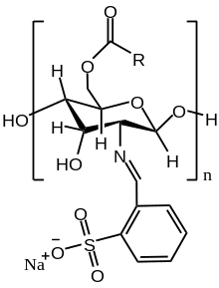 | Steel /  1.0 M HCl | Langmuir | 92.62%  (800 ppm) | Badr et al. (2020)
Non-ionic
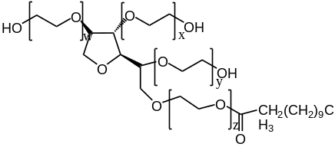 | Zinc/  0.1 M Na₂SO₄ | -- | 60.12%  (32 ppm) | Bawazeer et al. (2017)
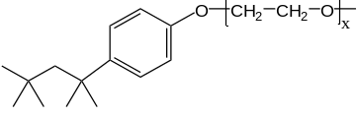 | Mild steel/  5% HCl | Langmuir | 62.89%  (20 ppm) | Attia and Abdel-Fatah (2019)
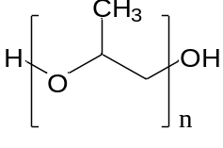 | Mild steel /  0.5 M H₂SO₄ | Temkin | 71%  (1000 ppm) | Umoren et al. (2015)
Zwitterionic
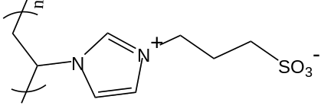 | Carbon Steel /  0.5 M HCL | Langmuir | 93.36%  (500 ppm) | Wang et al. (2020)
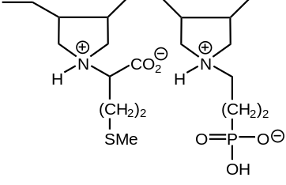 | Mild steel /  1 M HCl | Langmuir | 94.7%  (100 ppm) | Jafar Mazumder (2019)

Table 3 The literature reports on polymeric ionic liquids as metal corrosion inhibitors.
Polymers | Metal/  Medium | The highest η% / Dosage | References
The PIL inhibitors based on imidazolium
Vinylimidazolium poly(ionic liquid)s | API 5L X60 /  1 M H₂SO₄ | 75%  (175 ppm) | Gómez-Sánchez et al.  (2023)
Poly [3-butyl-1-vinylimidazolium bromide] | Mild Steel /  1M HCL | 96.4%  (400 ppm) | Kamali Ardakani et al. (2020)
Polymeric imidazolates from alkylimidazolium | API 5L X52 /  Production water | 80%  (150 ppm) | Likhanova et al. (2022)
6.Vinylalkylimidazolium-Based  Polymeric Ionic Liquids | API 5L X60 /  1 M H₂SO₄ | 85%  (175 ppm) | Atta et al. (2015b)
9.Polymeric Ionic Liquids Based on Benzimidazole Derivatives | X-65 steel /  1 M HCl | 99.3%  (250 ppm) | El Nagy et al. (2020)
Bisimidazole-based copoly(ionic liquid)s | Copper /  0.5 M H₂SO₄ | 96.5%  (0.2 g/L) | Huang et al. (2019)
Poly(1-vinyl-3-alkyl-imidazolium Hexafluorophosphate) | AA6061 /  1 M H₂SO₄ | 61%  (100 ppm) | Arellanes-Lozada et al. (2014)
The PIL inhibitors based on acrylamide
5.Poly Ionic Liquid-Based on 2-  Acrylamido-2-methyl Propane Sulfonic Acid | Steel /  Acidic chloride  solutions | 93.7%  (25 ppm) | Atta et al. (2015b)
Novel acrylamide ionic liquids | X-65 Steel /  1 M HCL | 91.4%  (250 ppm) | El Tamany et al. (2018)
1-Butyl-3 Methylimidazolium Acrylate polymer | C1020 steel /  1 M HCl | 91.8%  (200 ppm) | Gobara et al. (2019)
Poly(2-acrylamido-2-methylpropane sulfonic acid) | Steel /  1 M HCl | 85%  (250 ppm) | Atta et al. (2015a)
The PIL inhibitors based on ammonium
Coumarate ionic liquid coupled with ammonium cation | AS1020 steel /0.01 M NaCl | 99.1%  ( 8 mM) | Udabe et al. (2020)
The PIL inhibitors based on chitosan
Chitosan polymeric ionic liquids(CSPTA-lauric) | X-65 steel/  1 M HCl | 98.6%  (250 ppm) | Elsaeed et al. (2018)

Table 4 β-CD-basedpolymers as metal corrosion inhibitors
Molecular structural formula | Metal/  Medium | The highest  η%/Dosage | References
Natural polymer-modified β-CD
β-cyclodextrin with xanthan gum  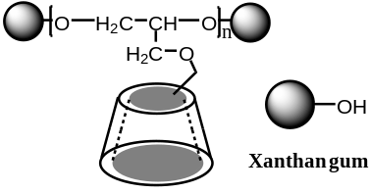 | X80 steel/ 1M H₂SO₄  L80 steel/  1 M HCl | 94.85%  (150 mg/L)  94.74%  (200 mg/L) | Cao et al. (2021)  Cao et al. (2021)
β-cyclodextrin modified chitosan  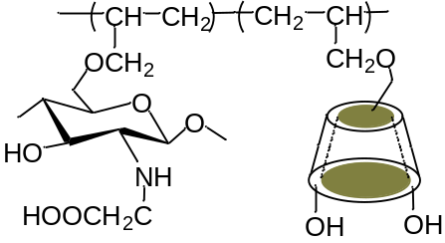 | Carbon steel/  0.5 M HCl | 96.02%  (230 mg/L) | Liu et al. (2015)
β-CD modified with synthetic polymers
β-cyclodextrin grafted polyacrylamide  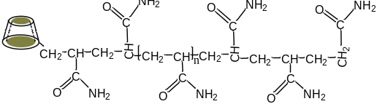 | X80 steel/  1 M H₂SO₄ | 92.48%  (200 mg/L) | Wang et al. (2021)
Polyaspartic acid graft copolymer  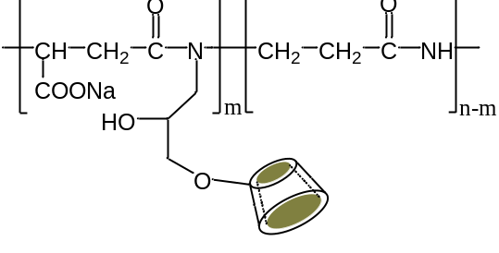 | N80 carbon steel/  Simulate oilfield  water | 94.6%  (250 mg/L) | Fu et al. (2020)
β-cyclodextrin–polyethylene glycol  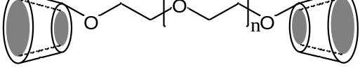 | Steel/  produced-water in shale gas well | 89.1%  (180 mg/L) | Liu et al. (2016)
β-Cyclodextrin-modified polyacrylamide  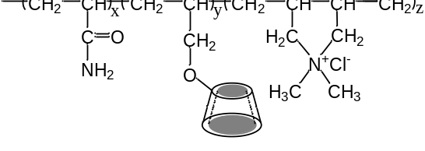 | X70 steel/  0.5 M H₂SO₄ | 84.9%  (150 mg/L) | Yan et al. (2014)
Divinyl sulfone cross-linked β-cyclodextrin polymer  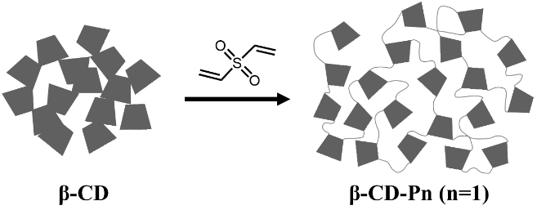 | Zn anode/  3.5 M KOH | 93.61%  (250 ppm) | Abd El-Lateef and Elremaily (2016)
Hydroxypropyl-β-cyclodextrin/octadecylamine | Q235 steel/  Simulated condensate water | 95%  (50 mg/L) | Fan et al. (2014)
β-CD-based supramolecular (host-guest) systems
Soluble cyclodextrin polymer (SCDP) | Mild steel/  3.5 % NaCl | 92.2%  (125 mg/L) | Ma et al. (2019)
Dibenzylthiourea with α and β forms of hydroxypropylated cyclodextrins | Carbon steel/  1 M HCl | 91.3%  (0.1 mM) | de Souza et al. (2016)
Carboxymethylated beta-cyclodextrin and an aniline trimer  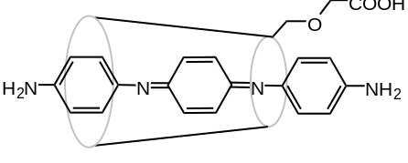 | Q235 steel/  1 M HCl | 99.2%  (250 mg/L) | Yang et al. (2019)
Beta-cyclodextrin-zinc acetylacetonate inclusion complex | Mild steel/  3.5 % NaCl | 88%  -- | Dehghani et al. (2020)
5-mercapto-1-phenyl-tetrazole and β-CD | Bronze/  Acid rain | 98%  (654 M⁻¹) | Monticelli et al. (2019)
2-mercapto-benzothiazole and β-CD | Zinc/  - M KCl | -- | Altin et al. (2018)
2-Phosphonobutane-1,2,4-tricarboxylic acid with β-CD | Q235 steel/  1 M H₂SO₄ | 90%  (100 mg/L) | Zou et al. (2013)

Table 5 Polymeric nanocomposites as metal corrosion inhibitors.
Polymers | Metal/  Medium | The highest η%/ Dosage | References
L-proline nitrate and graphene oxide nanohybrid (IL-GO) | Mild steel/  1 M HCl | 86.5%  (250 ppm) | Mobin et al. (2022)
Conducting polyaniline–sulfonated naphthalene formaldehyde nanocomposites | 316L stainless steel/  1 M HCl | 99.3%  (50 ppm) | Packiaraj and Kumar (2021)
Polyaniline/V₂O₅ composites | Mild steel/  5 M HCl | 94.256%  (7.5 mg/L) | Maruthi et al. (2021)
Carboxymethyl cellulose/silver nanoparticles composite | St37 specimen/  15% H₂SO₄ | 96.37%  (1000 ppm) | Solomon et al. (2017)
Novel cellulose derivatives containing metal (Cu, Fe, Ni) oxide nanoparticles | C-steel/  1 M HCl | 98.6%  (250 mg/L) | Gouda and El-Lateef (2021)
Carboxymethyl cellulose/metal (Fe, Cu and Ni) nanocomposites | Carbon steel/  2 N HCl | 98.4%  (400 mg/L) | El-Lateef et al. (2020)
Poly[(2,6-dicarbonylpyridine)(2,5-dihydrazinyl-1,3,4-thiadiazole)] (AMTP) with α-Al(OH)₃-gel | C1018-steel/  1 M H₂SO₄ | 97.6%  (100 mg/L) | Abd El-Lateef et al. (2022)
Poly 12-(3-amino phenoxy) dodecane-1-thiol surfactant self assembled on silver nanoparticles | Carbon steel/  1 M HCl | 87.59%  (375 ppm) | Azzam and Abd El-Aal (2013)
Poly para aminophenol (PpAP)/Al₂O₃ composite | Mild steel/  1 M HCl | 97.4%  (200 mg/L) | Thenmozhi et al. (2014)
Chitosan–CuO Nanocomposite | Carbon Steel/  5% HCl | 90.35%  (0.5% CHT_{1.0}-CuO) | Umoren et al. (2022)
A chitosan/silver nanoparticles (AgNPs/chitosan) composite | St37 Steel/  15% HCl | 97.09%  (1000 ppm) | Solomon et al. (2016)
Chitosan based new nanocomposites | Mild steel/  1 M HCl | 97%  (400 mg/L) | Srivastava et al. (2019)
Chitosan Schiff base derivative (CVZ) doped with ZnO nanoparticles | Q235 steel/  3.5 wt% NaCl | 99.6%  (200 ppm) | Liu et al. (2022)
Water-soluble poly (N-vinyl imidazole) grafted carboxymethyl chitosan composite | X70 steel/  1 M HCl | --  (500 ppm) | Eduok et al. (2018)
Polyaniline & Polyaminophenol Nanomaterials | Mild steel/  1 M HCl | 94.66%  (100 mg/L  Tween80  50 mg/L) | Gao et al. (2019)
Spherical polydopamine (PDA) nanoparticles | Mild steel/  1 M HCl | 86%  (40 mol/L) | Yang et al. (2017)
Mussel-inspired bio-polymers based on Polydopamine Nanospheres | Mild steel/  1 M HCl | 99%  (5 mg/L) | Habibiyan et al. (2020)
Grape seed proanthocyanidins loaded Zein-NaCas composite nanoparticles | Q235 steel/  Seawater | 96.06%  (200 mg/L) | Wang et al. (2022)
Addition of CeO₂ nanoparticles to pectin | X60 steel/  0.5 M HCl | 91.3%  (500 ppm pectin + 5 mM CeO₂) | Umoren and Madhankumar (2016)

