Exploring the Relationship Between Tuberculosis and Gut Microbiota: A Multi-Omics Approach
Chunying Zhang, Mengjiao Li, Mengyuan Lyu, Yanbing Zhou, Yili Wang, Liting You, Tangyuheng Liu, Wu Peng, Hao Bai, Zhenzhen Zhao, Binwu Ying*

¹Department of Laboratory Medicine, West China Hospital, Sichuan University, Sichuan Province, P. R China
* Corresponding author: Binwu Ying,
Address: No.37 Guoxue Lane, West China Hospital, Sichuan University, Chengdu 610041, Sichuan Province, P. R China
Email address: yingbinwu@scu.edu.cn
Telephone：+86-18980601655

Supplementary Tables
Supplementary Table. 1
The differentially abundant taxa identified by a LEfSe analysis
Biomarker | Level | Logarithm value | Group | LDA value | p value
Verrucomicrobia | Phylum | 4.618 | T | 4.217 | 0.0005
Verrucomicrobiae | Class | 4.618 | T | 4.217 | 0.0005
Verrucomicrobiales | Order | 4.617 | T | 4.218 | 0.0003
Akkermansiaceae | Family | 4.617 | T | 4.218 | 0.0003
Akkermansia | Genus | 4.617 | T | 4.218 | 0.0003
Erysipelatoclostridium | Genus | 3.704 | T | 3.259 | 0.0005
Clostridium_innocuum_group | Genus | 3.360 | T | 3.005 | 0.001
Eubacterium_hallii_group | Genus | 3.639 | C | 3.063 | 0.005
Eubacterium_ventriosum_group | Genus | 3.603 | C | 3.038 | 0.003
Lachnospira | Genus | 3.662 | C | 3.177 | 0.018
Ruminococcus_2 | Genus | 4.038 | C | 3.450 | 0.039
Roseburia | Genus | 4.404 | C | 3.593 | 0.0009
Blautia | Genus | 4.759 | C | 4.088 | 0.047
Lachnospiraceae | Family | 5.498 | C | 4.660 | 0.0267

Supplementary Table. 2
The sensitivity, specificity of the 9 genera
Biomarker | Sensitivities | Specificities | AUC | Enriched in TB
Akkermansia | 0.966 | 0.586 | 0.778 | Enriched
Erysipelotrichaceae | 0.586 | 0.897 | 0.766 | Enriched
Clostridium_innocuum_group | 0.828 | 0.690 | 0.750 | Enriched
Blautia | 0.517 | 0.828 | 0.652 | depleted
Roseburia | 0.759 | 0.69 | 0.754 | depleted
Ruminococcus_2 | 0.752 | 0.621 | 0.658 | depleted
Lachnospira | 0.931 | 0.379 | 0.680 | depleted
Eubacterium_hallii_group | 0.448 | 0.897 | 0.716 | depleted
Eubacterium_ventriosum_group | 0.517 | 0.897 | 0.724 | depleted
Combine 9 genus | 0.793 | 0.897 | 0.922 | /
Combine 3 genus | 0.897/0.828 | 0.655/0.724 | 0.831 | /

Supplementary Table. 3
Thirty-three differential metabolites in this study
Icon | metabolites | VIP | log2_FC  (T/C) | p value | Enriched group
NEG_  M128T583 | Cyanuric acid | 1.796 | 4.44 | 0.000033 | T
NEG_  M241T767 | Pentadecanoic acid | 5.487 | -2.36 | 0.000406 | C
NEG_  M271T31 | Epiandrosterone | 3.523 | -1.96 | 0.000007 | C
NEG_  M305T814 | 11,14,17-Eicosatrienoic acid | 11.322 | -3.92 | 0.010928 | C
NEG_  M329T810 | Docosapentaenoic acid (22n-3) | 5.043 | -2.95 | 0.003832 | C
NEG_  M392T783 | Deoxycholic acid | 8.617 | -1.85 | 0.002973 | C
NEG_  M821T706_2 | Rifampicin | 3.208 | 5.78 | 0.024504 | T
POS_  M103T75 | Cadaverine | 5.265 | 1.70 | 0.044767 | T
POS_  M113T105 | Uracil | 3.379 | 2.11 | 0.000088 | T
POS_  M116T96 | Indole | 15.071 | 2.56 | 0.000965 | T
POS_  M120T88 | L-Threonine | 7.585 | 2.21 | 0.003651 | T
POS_  M127T252 | Thymine | 2.452 | 0.83 | 0.033951 | T
POS_  M132T223_2 | L-Leucine | 17.414 | 0.76 | 0.003531 | T
POS_  M132T88 | 3-Methylindole | 2.789 | 3.51 | 0.023801 | T
POS_  M132T89 | Creatine | 3.263 | 2.82 | 0.002517 | T
POS_  M133T141 | 5,6-Dihydro-5-fluorouracil | 2.580 | 0.82 | 0.007070 | T
POS_  M136T192 | 2-Phenylacetamide | 2.004 | 0.80 | 0.037175 | T
POS_  M139T101 | Indole-3-propionic acid | 2.630 | 1.48 | 0.000393 | T
POS_  M147T77 | L-Lysine | 5.682 | 1.48 | 0.003271 | T
POS_  M147T88 | L-Glutamine | 2.023 | 0.88 | 0.018464 | T
POS_  M153T108 | Xanthine | 2.078 | 1.601 | 0.000956 | T
POS_  M159T89 | 1-Hydroxymethylnaphthalene | 5.119 | 1.69 | 0.001186 | T
POS_  M161T78 | Bethanechol | 2.049 | 5.03 | 0.001580 | T
POS_  M165T192 | 3,4-Dihydroxyphenylpropanoate | 2.210 | 0.86 | 0.032952 | T
POS_  M166T147 | D-Phenyllactic acid | 2.915 | 1.66 | 0.001522 | T
POS_  M175T84 | L-Arginine | 2.037 | 3.03 | 0.029331 | T
POS_  M182T151 | 3-Hydroxy-L-phenylalanine | 5.398 | 1.28 | 0.006293 | T
POS_  M204T97 | N-Acetyl-D-glucosamine | 5.027 | 2.01 | 0.021452 | T
POS_  M205T87 | Ethambutol | 15.080 | 4.61 | 0.003659 | T
POS_  M214T89 | Amifostine | 2.056 | 1.96 | 0.015803 | T
POS_  M244T97 | Ribavirin | 5.580 | 2.15 | 0.031245 | T
POS_  M84T89 | Amitrole | 2.632 | 1.09 | 0.001228 | T
POS_  M95T817 | Dimethyl sulfone | 4.601 | 5.15 | 0.026660 | T

Supplementary Figures
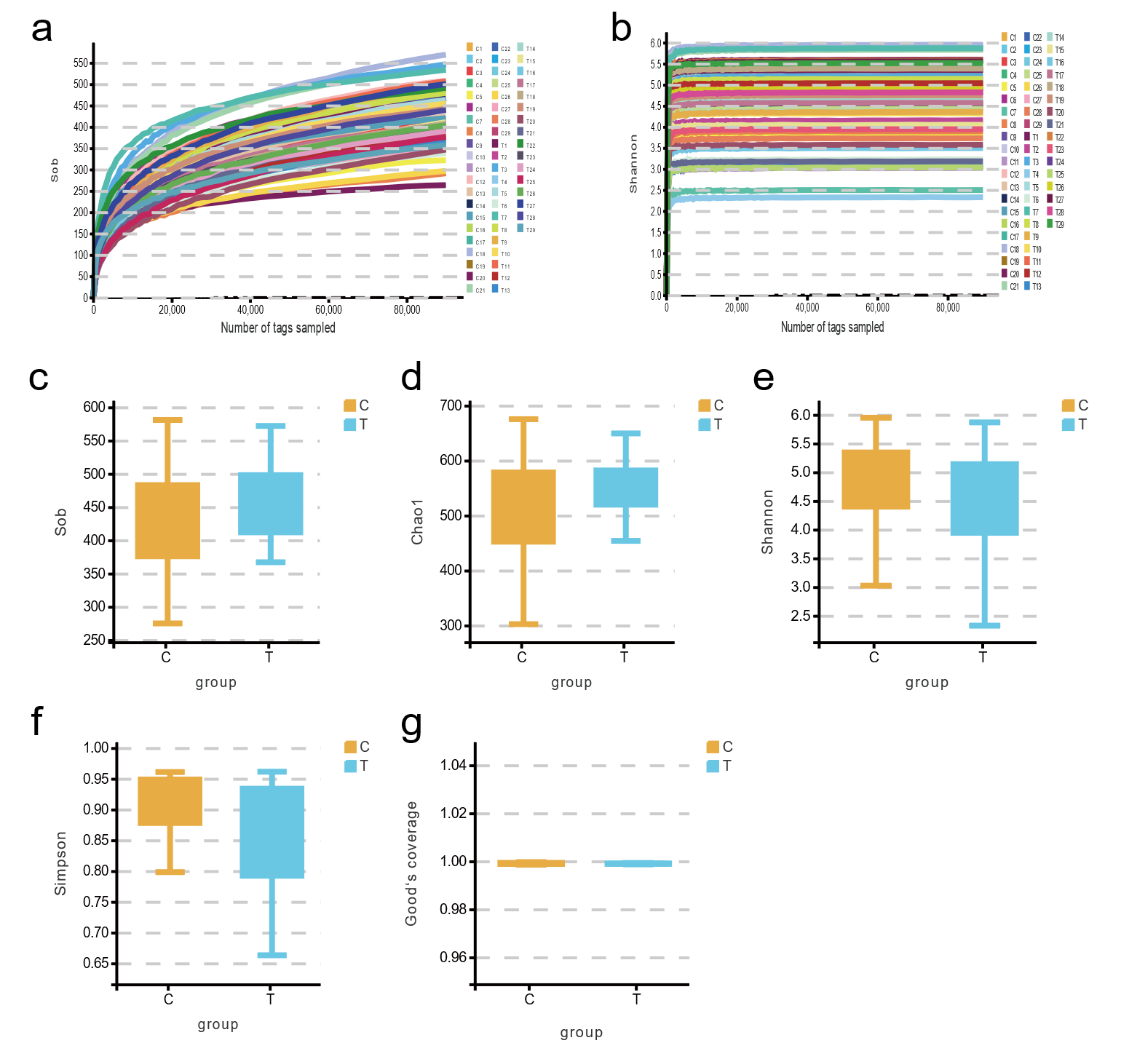

Supplementary Fig.1. The rarefaction curve and of alpha diversity index in patients with TB versus HCs. a, The rarefaction curve of the alpha diversity index, Sob and Good’s coverage index, approached a plateau which indicating sufficient sequencing depth. b, The alpha diversity assessed by Sobs, Chao1, Shannon, Simpson and Good’s coverage, these indexes were no differences in the TB and HCs groups. T: tuberculosis (TB); C: healthy controls (HCs).

