Supplementary Information
Fluorine-induced d-band center shift of the Nb site boosts anodic formamide electrosynthesis
Mou et al.

Contents
Supplementary Figure 1. XRD pattern and SEM image of Nb₃O₇F and Nb₂O₅ 3
Supplementary Figure 2. XPS data of Nb₂O₅/CP catalyst 4
Supplementary Figure 3. Optimization molar ratios of CH₃OH/NH₃ 5
Supplementary Figure 4. LSV curves and FEs of Nb₂O₅/CP 6
Supplementary Figure 5. Chronoamperometry curves of different applied potentials 7
Supplementary Figure 6. Calibration curves of formamide and H₂O₂ 8
Supplementary Figure 7. ¹H NMR spectrum for the formamide 9
Supplementary Figure 8. Methanol and NH₃ consumption 10
Supplementary Figure 9. XPS spectrum of F-Nb₂O₅/CP catalysts after stability test 11
Supplementary Figure 10. XRD patterns and SEM image of F-Nb₂O₅/CP after stability test 12
Supplementary Figure 11. CVs of F-Nb₂O₅/CP and Nb₂O₅/CP 13
Supplementary Figure 12. Gibbs free energy diagram of formamide synthesis path 2 14
Supplementary Figure 13. Atomic configurations of intermediates on F-Nb₂O₅ (100) for path 1 15
Supplementary Figure 14. Atomic configurations of intermediates on Nb₂O₅ (100) for path 1 16
Supplementary Figure 15. Slow growth simulation data for C-N bond formation 17
Supplementary Figure 16. Atomic configurations of intermediates on F-Nb₂O₅ (100) for path 2 18
Supplementary Figure 17. Atomic configurations of intermediates on Nb₂O₅ (100) for path 2 19
Supplementary Figure 18. Charge density difference analysis for F-Nb₂O₅ and Nb₂O₅ (100) 20
Supplementary Figure 19. COHP analysis of *CH₂O on F-Nb₂O₅ (100) and Nb₂O₅ (100) surface 21

Table S1. Comparison of anodic amide synthesis performance for F-Nb₂O₅/CP 22

References 22

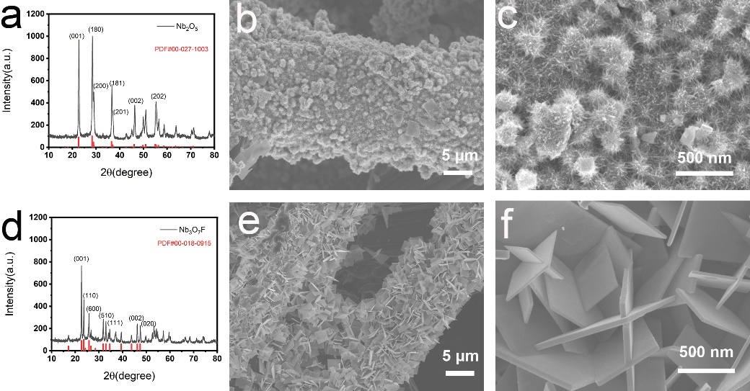
Supplementary Figure 1 │ (a) XRD patterns of Nb₂O₅, (b) and (c) SEM image of Nb₂O₅ nanoparticles on carbon nanofiber paper (Nb₂O₅/CP). (d) XRD patterns of Nb₃O₇F. (e) and (f) SEM image of Nb₃O₇F nanosheets on carbon nanofiber paper (Nb₃O₇F/CP).

Supplementary Figure 2│(a) Survey XPS spectrum of Nb₂O₅/CP catalysts. High-resolution XPS spectra of (b) F 1s and (c) O 1s and (d) Nb 3d of Nb₂O₅/CP catalysts.

Supplementary Figure 3 │Faradaic efficiency and yield rate of HCONH₂ with different CH₃OH/NH₃ molar ratios on F-Nb₂O₅/CP at 1.5 V versus Hg/HgO.

Supplementary Figure 4 │ (a) LSV curves of Nb₂O₅/CP in 0.5 M KHCO₃ solution, with methanol and NH₃. (b) FEs of oxidation products on Nb₂O₅/CP at different potentials.

Supplementary Figure 5│ The chronoamperometry curves of different applied potentials for (a) F-Nb₂O₅/CP and (b) Nb₂O₅/CP.

Supplementary Figure 6│ (a) Chromatograph curve of formamide and (b) External standard calibration curve used for calculation of formamide detected by HPLC. (c) Absorption spectra of H₂O₂ and (d) External standard calibration curve used for calculation of formamide detected by UV-Vis.

Supplementary Figure 7│ ¹H nuclear magnetic resonance spectrum for the formamide product.

Supplementary Figure 8│ (a) The detection of methanol consumption using HS-GCMS, (b) The detection of NH₃ consumption using ion chromatography.

Supplementary Figure 9│ (a) Survey XPS spectrum of F-Nb₂O₅/CP catalysts after stability test. High-resolution XPS spectra of (b) F 1s and (c) O 1s and (d)Nb 3d of F-Nb₂O₅/CP catalysts after stability test.

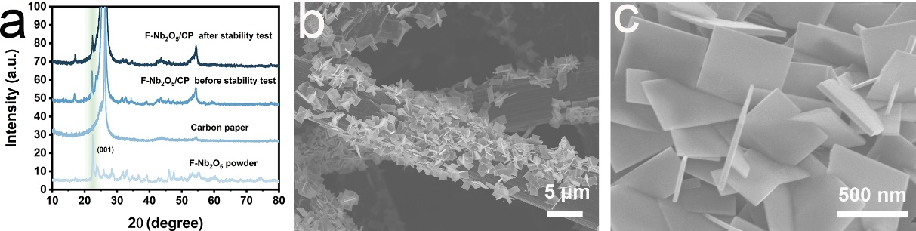
Supplementary Figure 10│ (a) XRD patterns of F-Nb₂O₅/CP before and after the stability test. (b) and (c) SEM image of the F-Nb₂O₅/CP after stability test.

Supplementary Figure 11│(a) CVs of a) F-Nb₂O₅/CP and (b) Nb₂O₅/CP with various scan rates (10–100 mV s^{–1}) in the regions of 0.12 to 0.22 V vs. RHE.

Supplementary Figure 12│Gibbs free energy diagram of formamide synthesis path 2 on （a) F-Nb₂O₅ (100) surface and （b) Nb₂O₅ (100) surface.

Supplementary Figure 13│Atomic configurations of formamide synthesis intermediates on F-Nb₂O₅ (100) for path 1.

Supplementary Figure 14│Atomic configurations of formamide synthesis intermediates on Nb₂O₅ (100) for path 1.

Supplementary Figure 15│(a) Potential of mean force derived from slow growth simulation (blue line) and thermodynamic integrations (orange line) of *NH₂+*CH₂O→ *CH₂ONH₂ with a step size of 0.0005 Å, and (b) corresponding C-N bond length change. (c) Potential of mean force derived from slow growth simulation (dark blue line) and thermodynamic integrations (orange line) of *NH₂+*CHO→ *CO + *NH₃ with a step size of 0.0005 Å, and (d) corresponding C-N and N-H bond length change.

Supplementary Figure 16│Atomic configurations of formamide synthesis intermediates on F-Nb₂O₅ (100) for path 2.

Supplementary Figure 17│ Atomic configurations of formamide synthesis intermediates on Nb₂O₅ (100) for path 2.

Supplementary Figure 18│Charge density difference analysis for a) F-doped Nb₂O₅ (100) and b) Nb₂O₅ (100).

Supplementary Figure 19│ Crystal Orbital Hamilton Population (COHP) analysis of *CH₂O on F-Nb₂O₅ (100) and Nb₂O₅ (100) surface.

Table S1│ Comparison of anodic amide synthesis performance for F-Nb₂O₅/CP with other anodic amide-producing electrocatalysts.
Catalyst | Electrolyte |  | Reactants | Products | FE% | Potential | Current density | Stability | Yield | Ref.
F-Nb₂O₅/CP |  | 0.5 M KHCO₃ | CH₃OH NH₃ | Formamide | 52.0 | 1.5 V  v.s Hg/HgO | 20 mA cm⁻² | 120 h | 252 μmol cm⁻² h⁻¹ | This work
Pt-Ti |  | 0.5 M NaHCO₃ | CH₃OH NH₃ | Formamide | 40.39 | ∼1.6 V  Cell potential | 100 mA cm⁻² | 46 h | 305.4 μmol cm⁻² h⁻¹ | [1]
BDD |  | 0.5 M NaHCO₃ | CH₃OH NH₃ | Formamide | 41.20 | 3.2 V  v.s SCE^{[a]} | 120 mA cm⁻² | N/A | 461.39 μmol cm⁻² h⁻¹ | [2]
Pr-Doped MnO₂ |  | 0.5 M NaHCO₃ | CH₃OH NH₃ | Formamide | 22.63 | N/A | 100 mA cm⁻² | 50 h | 211.32 μmol cm⁻² h⁻¹ | [3]
β-Ni(OH)₂ |  | 1.0 M KOH | CH₃OH NH₃ | Acetamide | ∼32^{[b]} | 0.65 V  v.s Hg/HgO | ≈600 mA cm⁻² | 16 h | ∼1 mmol cm⁻²h⁻¹ | [4]
graphite flake |  | 0.7 M K₂CO₃ | TMA | DMF | 40.0 | 1.1 V  v.s Hg/HgO | 40 mA cm⁻² | 24 h | 7.63 μmol cm⁻² h⁻¹ | [5]

[a] Retrieve data from LSV curves of BDD in electrolytes in supporting information. [b] Retrieve data from the FE and production rate of acetamide on β-Ni(OH)₂ anode.

References
1 Meng, Nannan, et al. Electrosynthesis of formamide from methanol and ammonia under ambient conditions. Nat. Commun., 13, 5452, (2022).
2 Shao, Jiang, et al. Scalable Electrosynthesis of formamide through C− N coupling at the industrially relevant current density of 120 mA cm⁻². Angew. Chem. Int. Ed. 61, e202213009, (2022).
3 Zhu, Jiewei, et al. Formamide Electrosynthesis from Methanol and Ammonia in Water over Pr-Doped MnO₂. JACS Au 3, 2987-2992, (2023):
4 Lu, Yuxuan, et al. Anodic Electrosynthesis of Amide from Alcohol and Ammonia. CCS Chem. 6, 125-136, (2024).
5 Jin, Meng, et al. Electrosynthesis of N, N-dimethylformamide from market-surplus trimethylamine coupled with hydrogen production. Green Chem. 25, 5936-5944 (2023).

