Supplementary information

One-stone-two-birds Nano-cocktail Enables Cancer Cells/Stem Cells Dual Depletion and Efficacy/Toxicity Benefit Maximization in Breast Cancer Therapy

Tongyao Zhao^{1#}, Yao Chen^{1#}, Haimeng Yuan¹, Shuqian Yang¹, Hongyuan Zhang¹, Yuequan Wang¹, Shenwu Zhang¹, Qin Chen³, Jin Sun^{1,2}, Zhonggui He^{1,2}, Cong Luo^{1,2*}

Affiliations:
¹Department of Pharmaceutics, Wuya College of Innovation, Shenyang Pharmaceutical University, Shenyang 110016, P.R. China
²Joint International Research Laboratory of Intelligent Drug Delivery Systems, Ministry of Education, Shenyang Pharmaceutical University, Shenyang 110016, PR China
³Department of Pharmacy, Cancer Hospital of China Medical University, Liaoning Cancer Hospital & Institute, Shenyang 110042, P.R. China
#These authors contributed equally to this work.

*Corresponding authors:
Cong Luo, Ph.D.
Professor, Department of Pharmaceutics, Wuya College of Innovation, Shenyang Pharmaceutical University, 103 Wenhua Road, Shenyang 110016, China
E-mail address: luocong@syphu.edu.cn

Contents
Figure S1. The synthetic route of dimeric prodrug of docetaxe 3
Figure S2. Characterization of dimeric prodrug of docetaxel 4
Figure S3. Zeta potential of NAs 5
Figure S4. Colloidal stability of PDS NAs 6
Figure S5. Long-term storage stability of PDS NAs 7
Figure S6. Lyophilization stability of PDS NAs 8
Figure S7. Size distribution and TEM images of PDS NAs in the presence of DTT 9
Figure S8. Quantitative analysis of cellular uptake in 4T1 cancer cells 10
Figure S9. IC₅₀ values 11
Figure S10. The proportion of CSCs in 4T1 cancer cells after treatment with SAL. 12
Figure S11. Identification of CSCs 13
Figure S12. Relative GSH levels 14
Figure S13. Tumor growth curves 15
Figure S14. Image of tumors 16
Figure S15. The H&E staining images of heart, liver, spleen, lung and kidney 17
Figure S16. Quantification of TUNEL fluorescence intensity 18
Figure S17. Hemolysis test 19
Figure S18. The proportion of CD133⁺ CSCs in tumor tissues 20
Figure S19. The percentage of CD44⁺CD24⁻ CSCs in tumor tissues 21
Figure S20. The ratio of side population cells in tumor tissues 22
Figure S21. Western blotting analysis 23
Table S1. Characterization of NAs at different molar ratios of DSSD and SAL 24
Table S2. Optimizing the synergistic dose ratio between DSSD and SAL 25
Table S3. Drug loading capacity of NAs 26
Table S4. Pharmacokinetic parameters 27

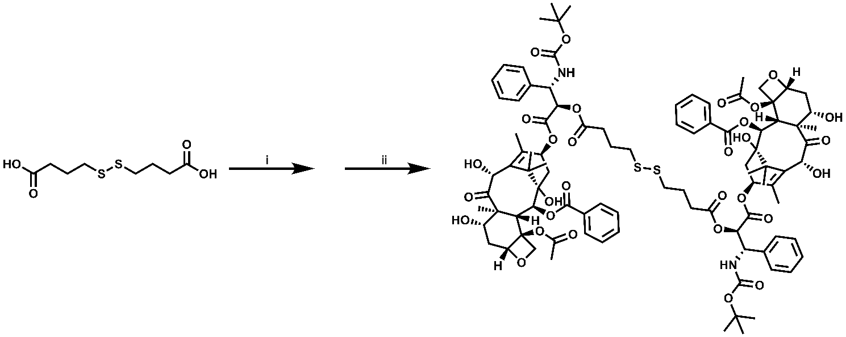
Figure S1. The synthetic route of dimeric prodrug of docetaxel (DTX-SS-DTX). Reagents and conditions: (i) EDCI, DMAP, DTX, CH₂Cl₂, 25 °C, 1 h; (ii) EDCI, DMAP, 25 °C, 24 h.

Figure S2. Characterization of dimeric prodrug of docetaxel (DTX-SS-DTX). (A) Mass spectrum of DTX-SS-DTX. (B) ¹H NMR spectrum of DTX-SS-DTX.

Figure S3. Zeta potentials of DS NAs and PDS NAs. Data are presented as mean ± SD (n = 3).

Figure S4. Stability of PDS NAs incubated in PBS (pH 7.4) containing 10% FBS. Data are presented as mean ± SD (n = 3).

Figure S5. Long-term storage stability of PDS NAs after being stored at 4 ℃ for 30 days. Data are presented as mean ± SD (n = 3).

Figure S6. Particle size and representative figures of PDS NAs before and after lyophilization. Data are presented as mean ± SD (n = 3).

Figure S7. (A) Intensity size distribution profiles and (B) TEM image of PDS NAs in the presence of 5 mM DTT. Scale bar represents 100 nm. (C) Changes in particle size and (D) particle distribution index (PDI) of PDS NAs at different time points after incubation with 5 mM DTT.

Figure S8. Cellular uptake in 4T1 cancer cells quantified by flow cytometry for 0.5 and 2 h. Data are presented as mean ± SD (n = 3). **p < 0.01, ***p < 0.001.

Figure S9. IC₅₀ values of various formulations against 4T1 cancer cells, MCF-7 cancer cells, and L02 normal cells. Data are presented as mean ± SD (n = 3). ***p < 0.001.

Figure S10. The proportion of CSCs in 4T1 cancer cells after co-incubation with SAL for 48 h. (A) Representative images and (B) quantification of CD133⁺ CSCs in 4T1 cancer cells following treatment with SAL. Data are presented as mean ± SD (n = 4). ****p < 0.0001. (C) Representative images and (D) quantification of CD44⁺CD24⁻ CSCs in 4T1 cancer cells following treatment with SAL. Data are presented as mean ± SD (n = 4). ****p < 0.0001.

Figure S11. (A) Representative images of CD44⁺CD24⁻ CSCs in 4T1 cancer cells and 3D mammospheres. (B) The percentage of CD44⁺CD24⁻ CSCs in 4T1 cancer cells and 3D mammospheres. (C) Representative images of CD133⁺ CSCs in 4T1 cancer cells and 3D mammospheres. (D) The percentage of CD133⁺ CSCs in 4T1 cancer cells and 3D mammospheres. Data are presented as mean ± SD (n = 3). ****p < 0.0001.

Figure S12. Relative GSH levels in 4T1 cancer cells and CSCs. Data are presented as mean ± SD (n = 3). **p < 0.01.

Figure S13. Tumor growth curves of each 4T1 breast tumor-bearing mice after different treatments (n = 5).

Figure S14. Image of tumors following the final treatment (n = 5).

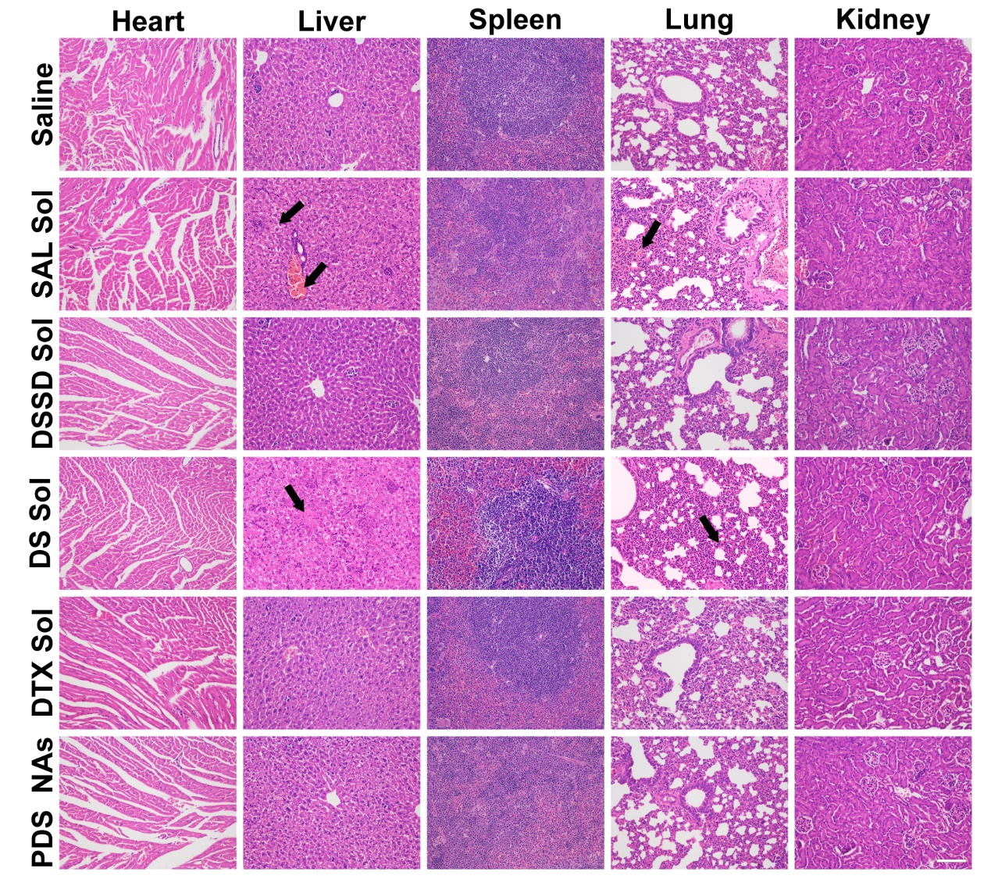
Figure S15. The H&E staining images of heart, liver, spleen, lung and kidney after different treatments. Scale bar represents 100 μm.

Figure S16. Quantitative results of TUNEL fluorescence intensity in tumor sections after different treatments (n = 3). *p < 0.05, **p < 0.01.

Figure S17. The hemolysis ratio of red blood cells after treatment with SAL Sol or PDS NAs for 1 h and 3 h. Saline and water were used as the negative and positive controls, respectively. Data are presented as mean ± SD (n = 3).

Figure S18. The proportion of CD133⁺ CSCs in tumor tissues after treatment with various formulations.

Figure S19. The percentage of CD44⁺CD24⁻ CSCs in tumor tissues following treatment with different formulations.
Figure S20. The ratio of side population cells in tumor tissues treated with various formulations.

Figure S21. Western blotting analysis of Oct4 protein expression in tumor tissues.

Table S1. Characterization of the non-PEGylated nanoassemblies and PEGylated nanoassemblies at different molar ratios of DSSD and SAL (n = 3).
Formulations  DSSD/SAL (mol/mol) | Non-PEGylated nanoassemblies |  | PEGylated nanoassemblies
Formulations  DSSD/SAL (mol/mol) | Size (nm) | PDI | Size (nm) | PDI
5:1 | 289.9 ± 7.508 | 0.243 ± 0.018 | 91.61 ± 1.219 | 0.145 ± 0.035
4:1 | 333.4 ± 10.55 | 0.293 ± 0.024 | 88.51 ± 2.953 | 0.138 ± 0.017
3:1 | 348.8 ± 16.64 | 0.208 ± 0.077 | 88.94 ± 2.601 | 0.110 ± 0.009
2:1 | 207.2 ± 4.431 | 0.073 ± 0.083 | 85.63 ± 1.190 | 0.151 ± 0.062
1:1 | 120.9 ± 2.052 | 0.099 ± 0.052 | 81.66 ± 1.153 | 0.095 ± 0.051
1:2 | 164.3 ± 1.365 | 0.077 ± 0.054 | 95.73 ± 1.819 | 0.121 ± 0.057
1:3 | 133.6 ± 2.836 | 0.102 ± 0.072 | 100.1 ± 2.426 | 0.108 ± 0.053
1:4 | 134.6 ± 1.168 | 0.106 ± 0.018 | 106.3 ± 2.179 | 0.158 ± 0.015
1:5 | 121.5 ± 1.815 | 0.152 ± 0.049 | 108.2 ± 4.331 | 0.159 ± 0.011

Table S2. Screening the synergistic dose ratio of DSSD and SAL through cytotoxicity assessment.
Formulations  DSSD/SAL (mol/mol) | Cooperativity index (CI)
5:1  4:1  3:1  2:1  1:1  1:2  1:3  1:4  1:5 | 0.570
5:1  4:1  3:1  2:1  1:1  1:2  1:3  1:4  1:5 | 0.440
5:1  4:1  3:1  2:1  1:1  1:2  1:3  1:4  1:5 | 0.422
5:1  4:1  3:1  2:1  1:1  1:2  1:3  1:4  1:5 | 0.341
5:1  4:1  3:1  2:1  1:1  1:2  1:3  1:4  1:5 | 0.294
5:1  4:1  3:1  2:1  1:1  1:2  1:3  1:4  1:5 | 0.378
5:1  4:1  3:1  2:1  1:1  1:2  1:3  1:4  1:5 | 0.384
5:1  4:1  3:1  2:1  1:1  1:2  1:3  1:4  1:5 | 0.396
5:1  4:1  3:1  2:1  1:1  1:2  1:3  1:4  1:5 | 0.496

Table S3. Drug loading capacity of non-PEGylated nanoassemblies (DS NAs) and PEGylated nanoassemblies (PDS NAs).
Nanoassemblies | Drug loading of DTX | Drug loading of SAL
DS NAs | 63% | 29%
PDS NAs | 50% | 23%

Table S4. Pharmacokinetic parameters of DiR Sol and DiR/PDS NAs (n = 6).
Formulations | AUC_{0-24 h} (μg/mL*h)) | C_{max} (μg/mL)
DiR Sol | 1.172 ± 0.389 | 0.275 ± 0.157
DiR/PDS NAs | 54.897 ± 8.747 | 12.541 ± 1.837

