Extended Data Figure 1
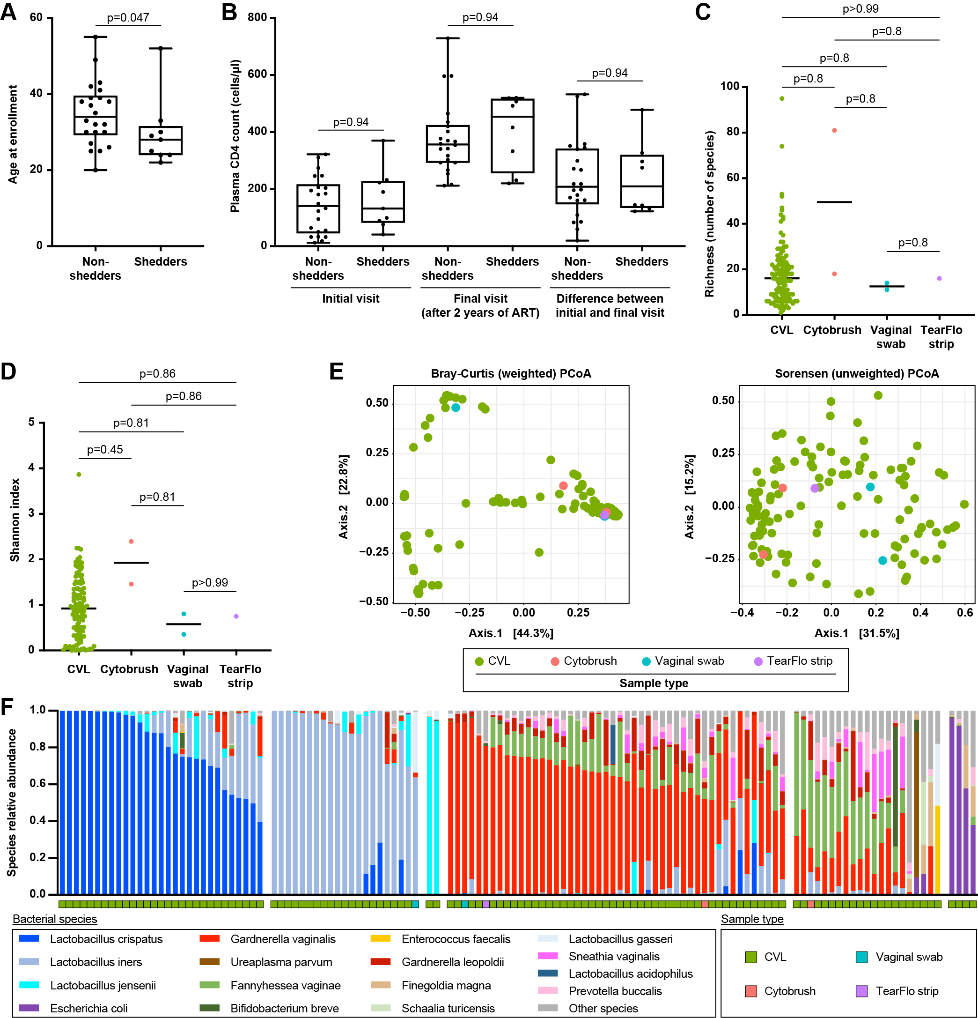
Extended Data Figure 1: Cohort characteristics and specimen types. A. Non-shedder and shedder ages at study enrollment. Statistical significance was assessed using the Mann-Whitney test. B. Plasma CD4 counts in non-shedders and shedders at the first study visit (left) and final study visit (middle), and the difference in CD4 counts from the initial to final visit for each individual (right). Statistical significance was assessed using the Mann-Whitney test and p-values were adjusted for multiple comparisons using the Benjamini-Hochberg method. C. Bacterial richness in different specimen types. Statistical significance was assessed using the Kruskal-Wallis test with follow-up Wilcoxon rank sum test for pairwise comparisons. D. Bacterial Shannon index in different specimen types. Statistical significance was assessed using the Kruskal-Wallis test with follow-up Wilcoxon rank sum test for pairwise comparisons. E. Principal coordinates analysis (PCoA) using Bray-Curtis dissimilarity (weighted, as in Figure 2C; left) and Sorensen dissimilarity (unweighted, right) comparing different specimen types. Statistical significance assessed by PERMANOVA, p=0.82 for Bray-Curtis and p=0.11 for Sorensen. F. Samples grouped by microbiome community cluster as in Figure 1B, with specimen type indicated by the row of colored squares below the samples. Statistical significance assessed by multinomial logistic regression, see Supplementary Table 2 for p values.

Extended Data Figure 2
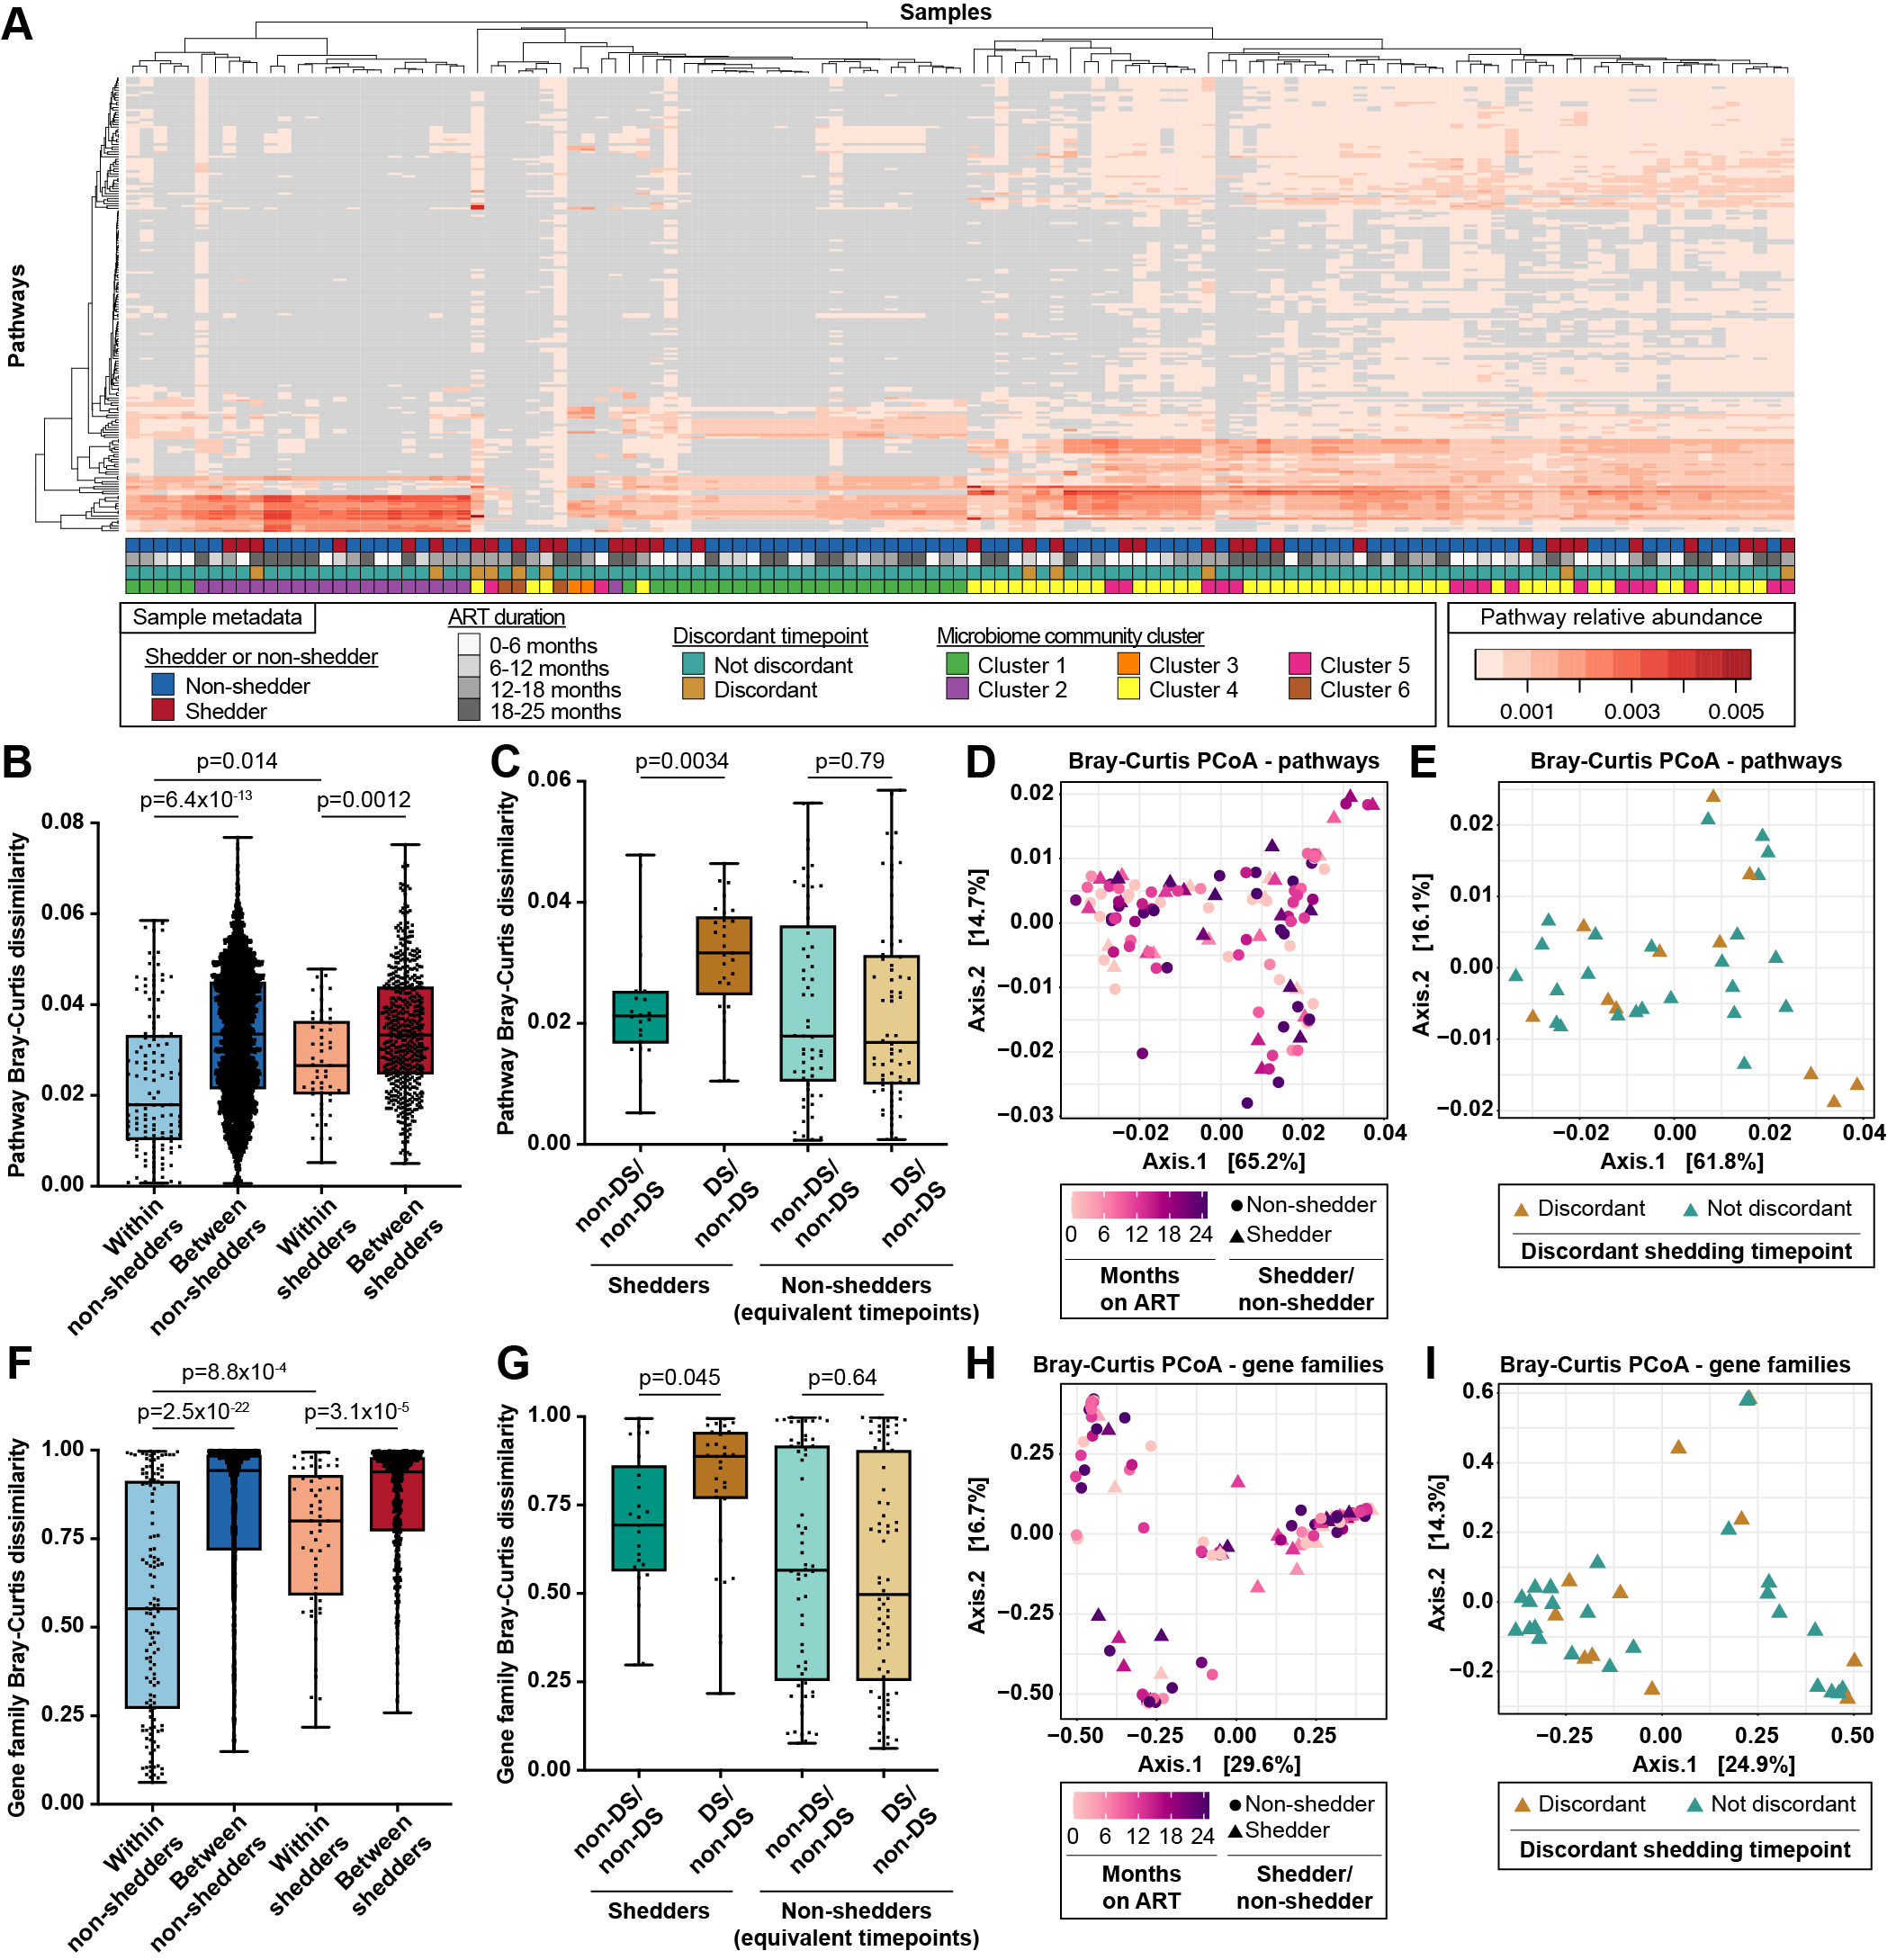
Extended Data Figure 2: Functional profiling at the gene family level. A. Heatmap of metabolic pathway relative abundance in shedder and non-shedder samples. Columns represent samples and rows represent pathways, both arranged using hierarchical clustering on pathway relative abundance values. Pathways are shown if they were identified in at least 10% of samples (>=13). Metadata is shown as rows of colored squares beneath the samples. B. Metabolic pathway Bray-Curtis dissimilarity between pairs of samples from the same individual (within-individual comparisons) or from different individuals (between-individual comparisons). Statistical significance was assessed using the Mann-Whitney test and p-values were adjusted for multiple comparisons using the Benjamini-Hochberg method. C. Metabolic pathway Bray-Curtis dissimilarity between pairs of non-discordant samples within the same shedder individual (non-DS/non-DS), or sample pairs with one discordant shedding timepoint and one non-discordant timepoint within the same individual (DS/non-DS). Equivalent timepoints from non-shedders serve as a control. Statistical significance was assessed using the Mann-Whitney test and p-values were adjusted for multiple comparisons using the Benjamini-Hochberg method. D. Principal coordinates analysis (PCoA) of shedder and non-shedder samples, using metabolic pathway Bray Curtis dissimilarity. Samples are colored by ART duration. Non-shedder samples are shown as circles and shedder samples are shown as triangles. Statistical significance assessed by PERMANOVA, p=0.44 for ART duration and p=0.73 for shedder/non-shedder status. E. PCoA of shedder samples, using metabolic pathway Bray-Curtis dissimilarity. Discordant shedding timepoints are colored brown, and non-discordant samples are colored green. Statistical significance assessed by PERMANOVA, p=0.26. F. Like B), above, using gene family Bray-Curtis dissimilarity. G. Like C), above, using gene family Bray-Curtis dissimilarity. H. Like D), above, using gene family Bray-Curtis dissimilarity. P=0.31 for ART duration and p=0.32 for shedder/non-shedder status. I. Like E), above, using gene family Bray-Curtis dissimilarity. P=0.86.

Extended Data Figure 3
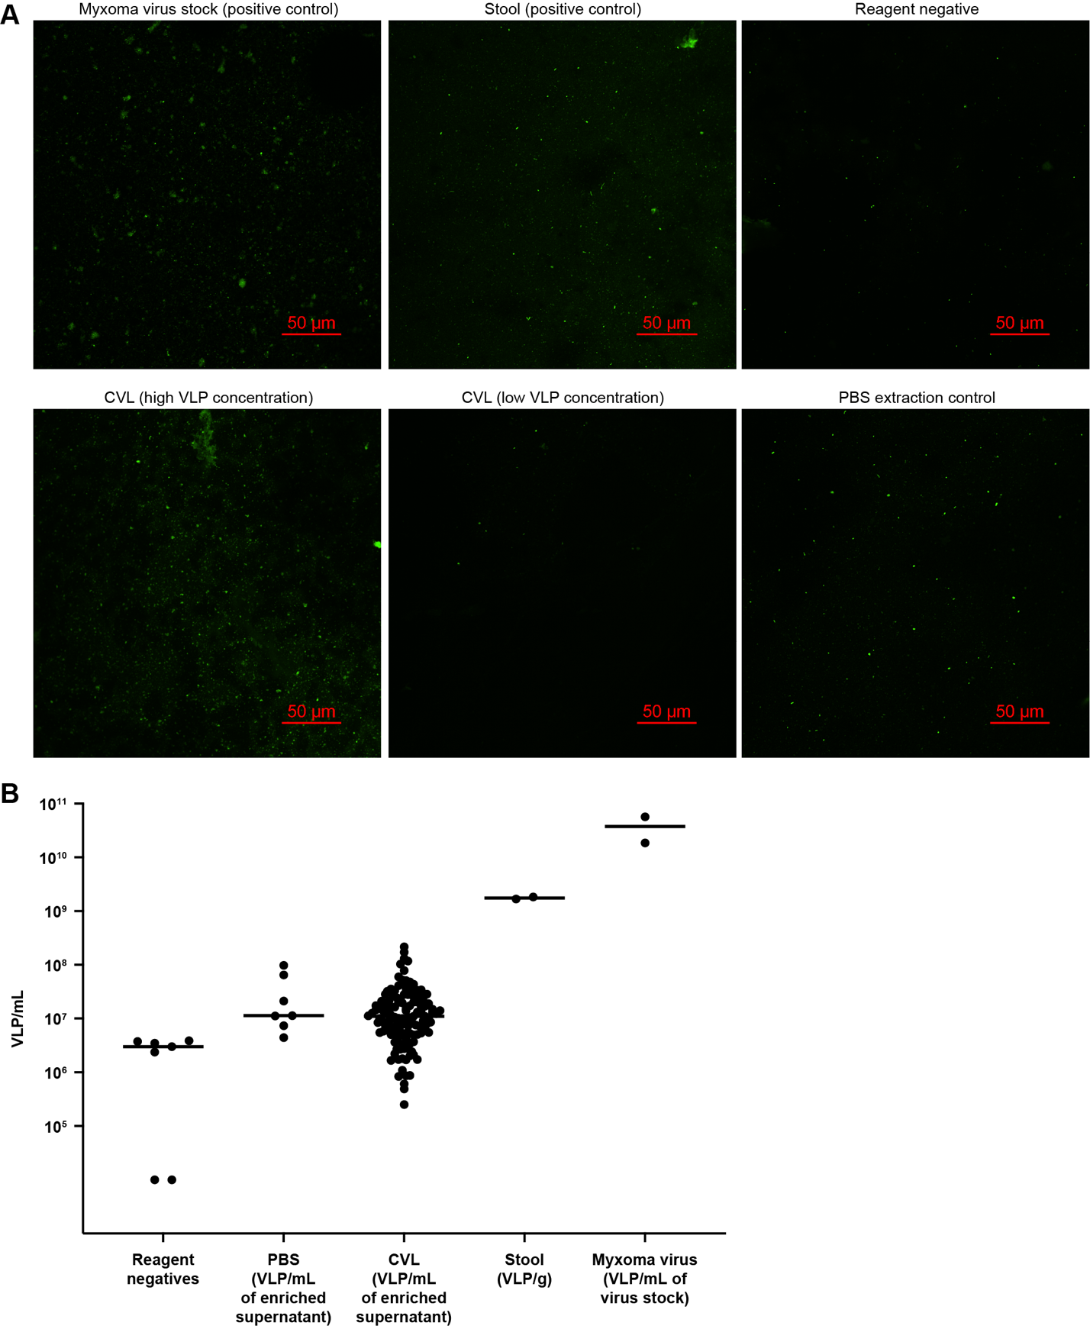
Extended Data Figure 3: Visualization of virus-like particles by epifluorescence microscopy. A. Representative images of virus-like particles (VLPs) in different specimen types. Particles sized between 50 and 500 nm were counted as VLPs. Top row from left to right: Myxoma virus stock, stool enriched for VLPs, reagent negative control (nuclease-free water). Bottom row from left to right: VLP-enriched CVL with a high VLP concentration (5.1x10⁷ VLP/mL of enriched filtrate), VLP-enriched CVL with a low VLP concentration (8.6x10⁵ VLP/mL of enriched filtrate), PBS processed in parallel with the CVL samples. B. VLP counts in different specimen types. VLP counts are expressed as VLP/mL of nuclease-free water or SM buffer for reagent negatives; VLP/mL of enriched supernatant for CVL samples and PBS controls; VLP/g of stool; and VLP/mL of myxoma virus stock.

Extended Data Figure 4
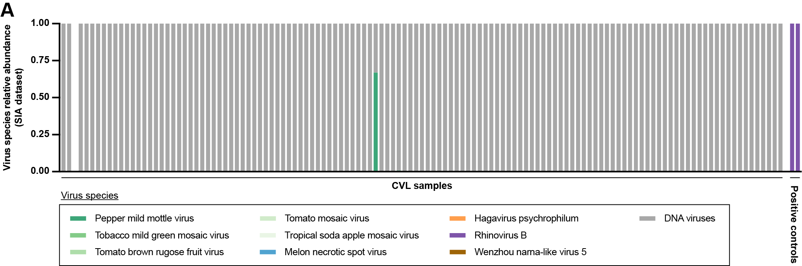
Extended Data Figure 4: RNA virome analysis. A: Relative abundance of RNA and DNA viruses identified by sequence independent amplification (SIA) and next-generation sequencing. Positive controls (RNA extracted from rhinovirus B14 stock) are on the right and CVL samples are on the left.

Extended Data Figure 5
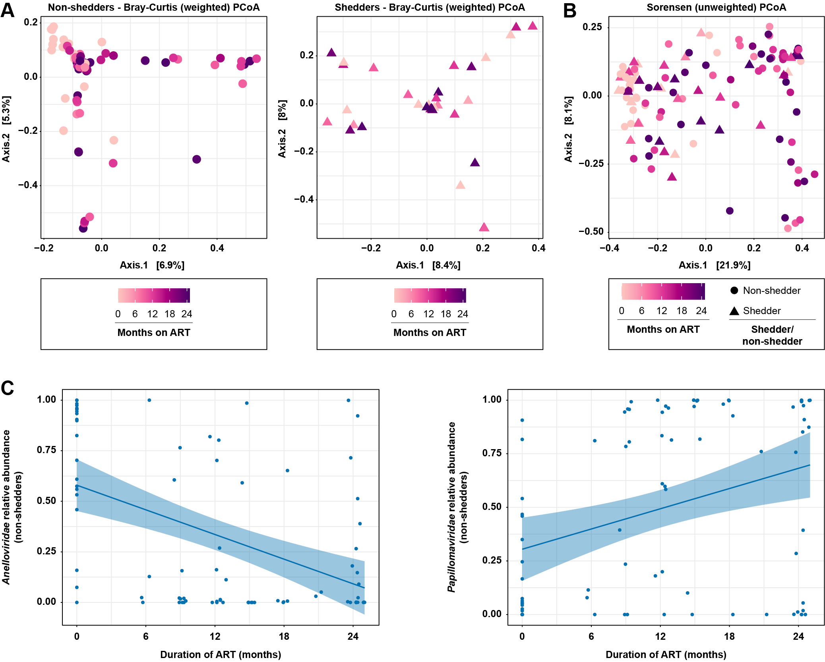
Extended Data Figure 5: Extended virome analyses. A: Principal coordinates analysis (PCoA) of non-shedders only (left) and shedders only (right), using Bray Curtis dissimilarity calculated from virus contig relative abundance. Samples are colored by duration of ART. Non-shedder samples are shown as circles and shedder samples are shown as triangles. Statistical significance was determined by PERMANOVA, p=0.001 for non-shedders and p=0.072 for shedders. B: PCoA of shedder and non-shedder samples, using Sorensen dissimilarity calculated from virus contig presence/absence. Samples are colored by duration of ART. Non-shedder samples are shown as circles and shedder samples are shown as triangles. Statistical significance was determined by PERMANOVA, p=0.001 for ART duration and p=0.63 for shedder/non-shedder status. C. Anelloviridae relative abundance (left) and Papillomaviridae relative abundance (right) in non-shedders over time on ART. Linear regression lines and 95% confidence bands are shown in blue. Statistical significance was determined by MaAsLin2, q=4.6x10⁻⁶ for Anelloviridae and q=0.0032 for Papillomaviridae.

Extended Data Figure 6
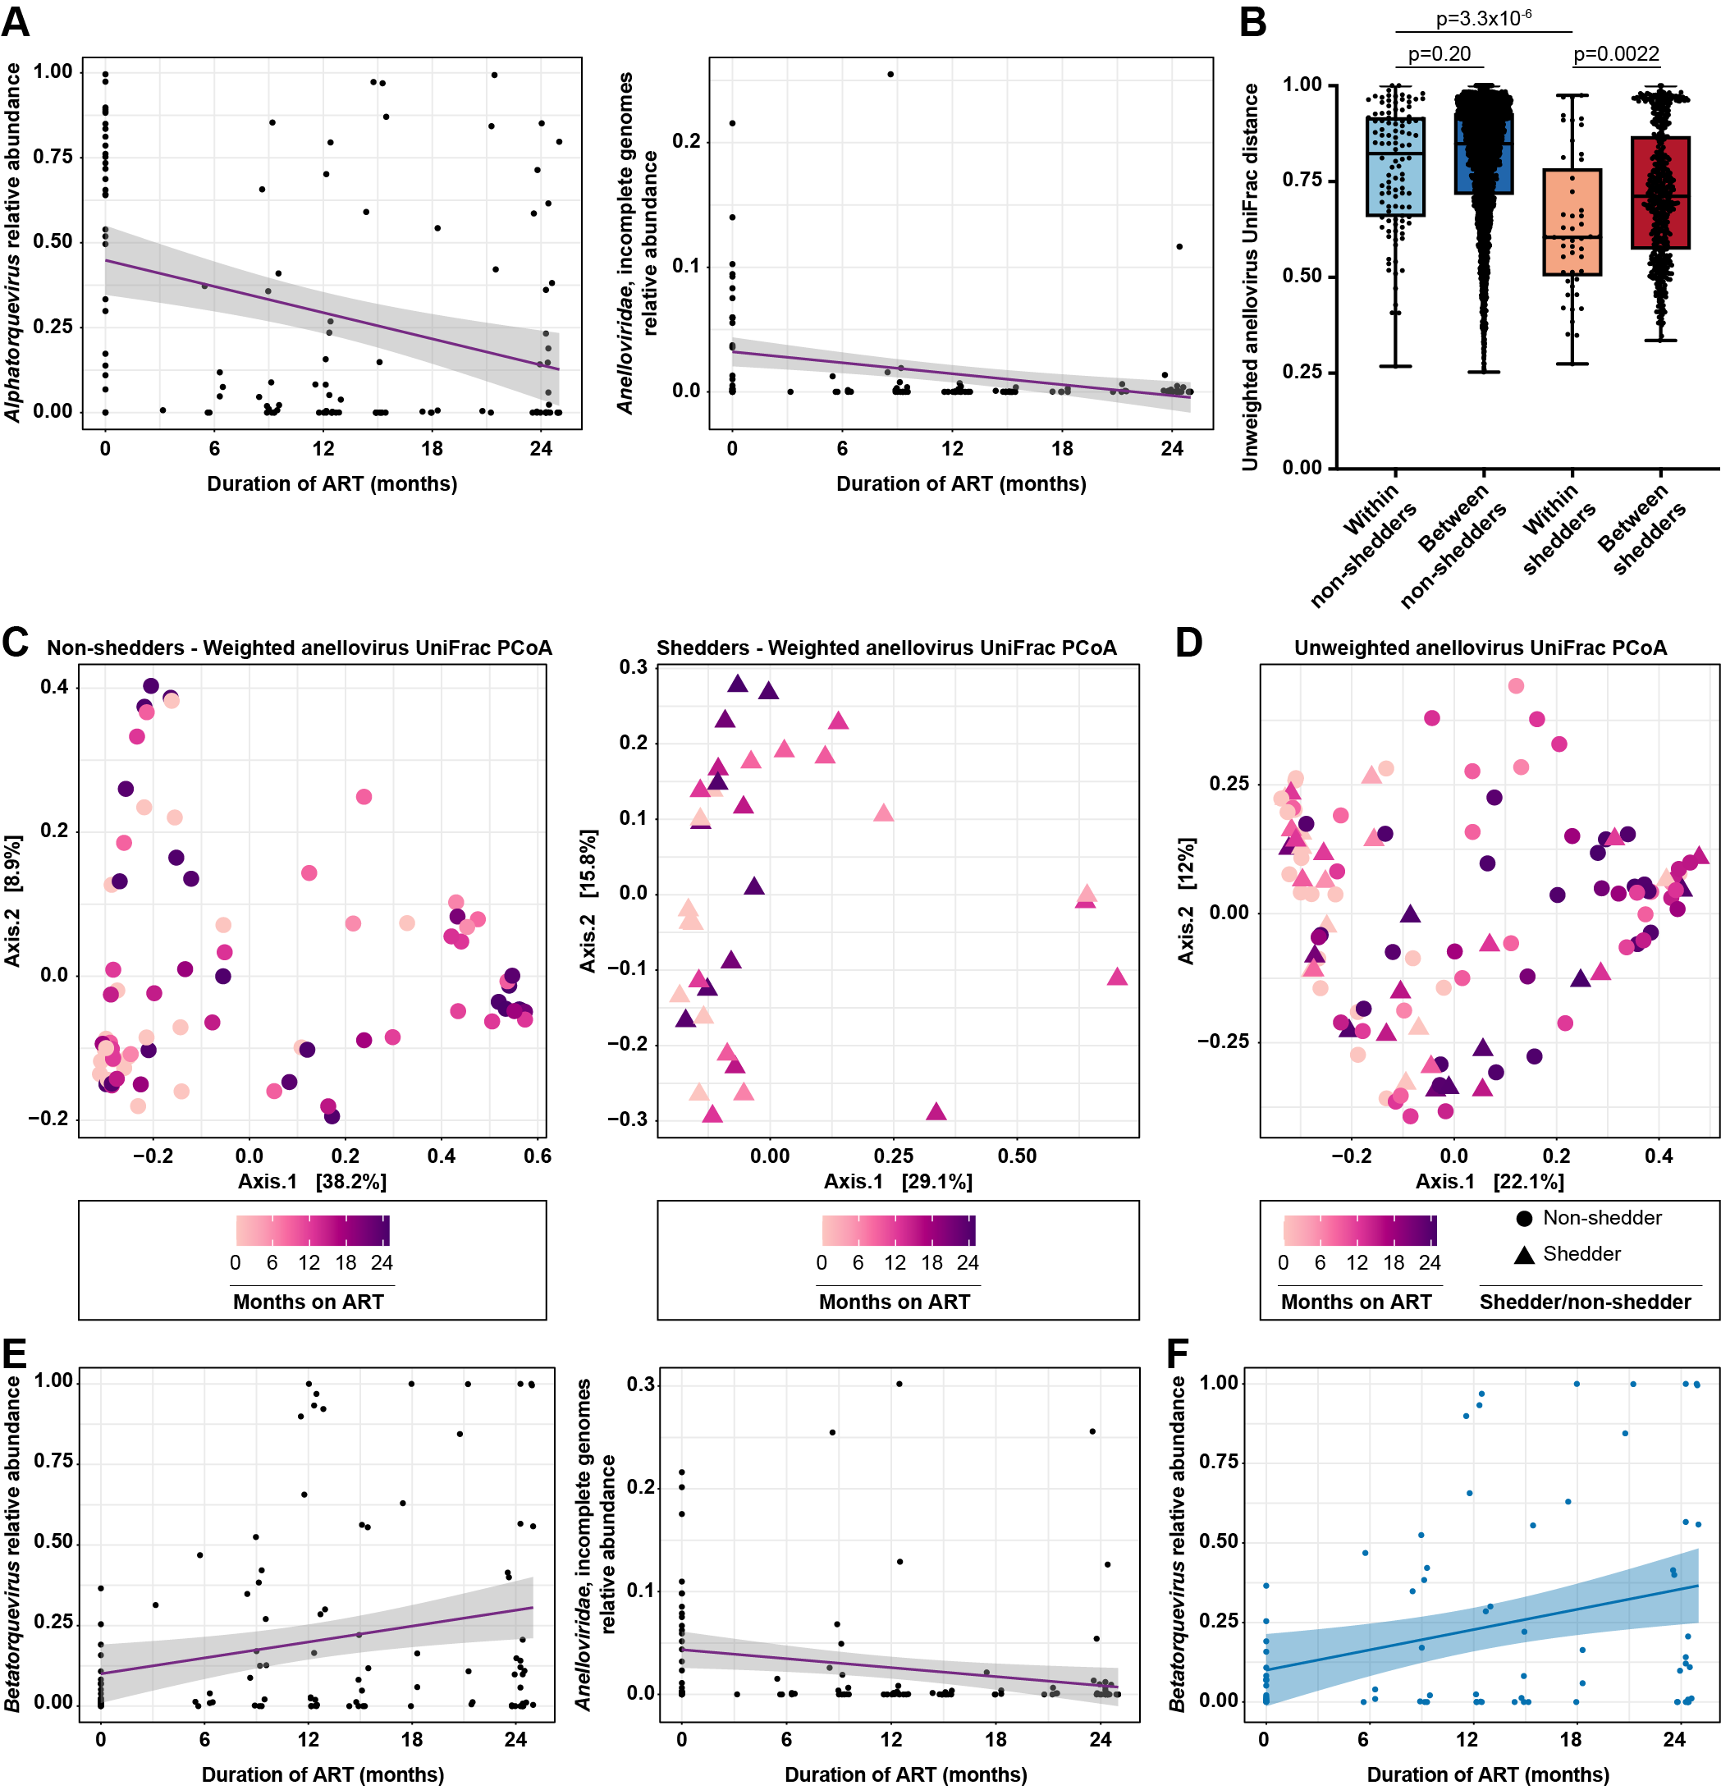
Extended Data Figure 6: Extended anellovirus analyses. A. Abundance of Alphatorquevirus (left) and incomplete Anelloviridae sequences (right), relative to all viral genera. Shedder and non-shedder samples are plotted together. Linear regression lines are shown in purple and 95% confidence bands are shown in gray. Statistical significance was determined with MaAsLin2, q=0.0019 for Alphatorquevirus and q=0.0019 for incomplete Anelloviridae sequences. B. Unweighted anellovirus UniFrac distance between pairs of samples from the same individual (within-individual comparisons) or from different individuals (between-individual comparisons). Statistical significance was assessed using the Mann-Whitney test and p-values were adjusted for multiple comparisons using the Benjamini-Hochberg method. C. Principal coordinates analysis (PCoA) of non-shedders only (left) and shedders only (right), using weighted anellovirus UniFrac distance calculated from anellovirus phylogeny and relative abundance. Samples are colored by duration of ART. Non-shedder samples are shown as circles and shedder samples are shown as triangles. Statistical significance was determined by PERMANOVA, p=0.006 for non-shedders and p=0.12 for shedders. D. Principal coordinates analysis (PCoA) of shedder and non-shedder samples, using unweighted UniFrac distance calculated from anellovirus phylogeny and presence/absence. Samples are colored by duration of ART. Non-shedder samples are shown as circles and shedder samples are shown as triangles. Statistical significance was determined by PERMANOVA, p=0.001 for ART duration and p=0.59 for shedder/non-shedder status. E. Abundance of Betatorquevirus (left) and Anelloviridae with no genus determination (right), relative to other anellovirus genera. Shedder and non-shedder samples are plotted together. Linear regression lines are shown in purple and 95% confidence bands are shown in gray. Statistical significance was determined by MaAsLin2, q=0.036 for Betatorquevirus and q=0.036 for incomplete Anelloviridae sequences. F. Abundance of Betatorquevirus relative to other anellovirus genera in non-shedders. Linear regression line and 95% confidence bands are shown in blue. Statistical significance was determined by MaAsLin2, q=0.028.

Extended Data Figure 7
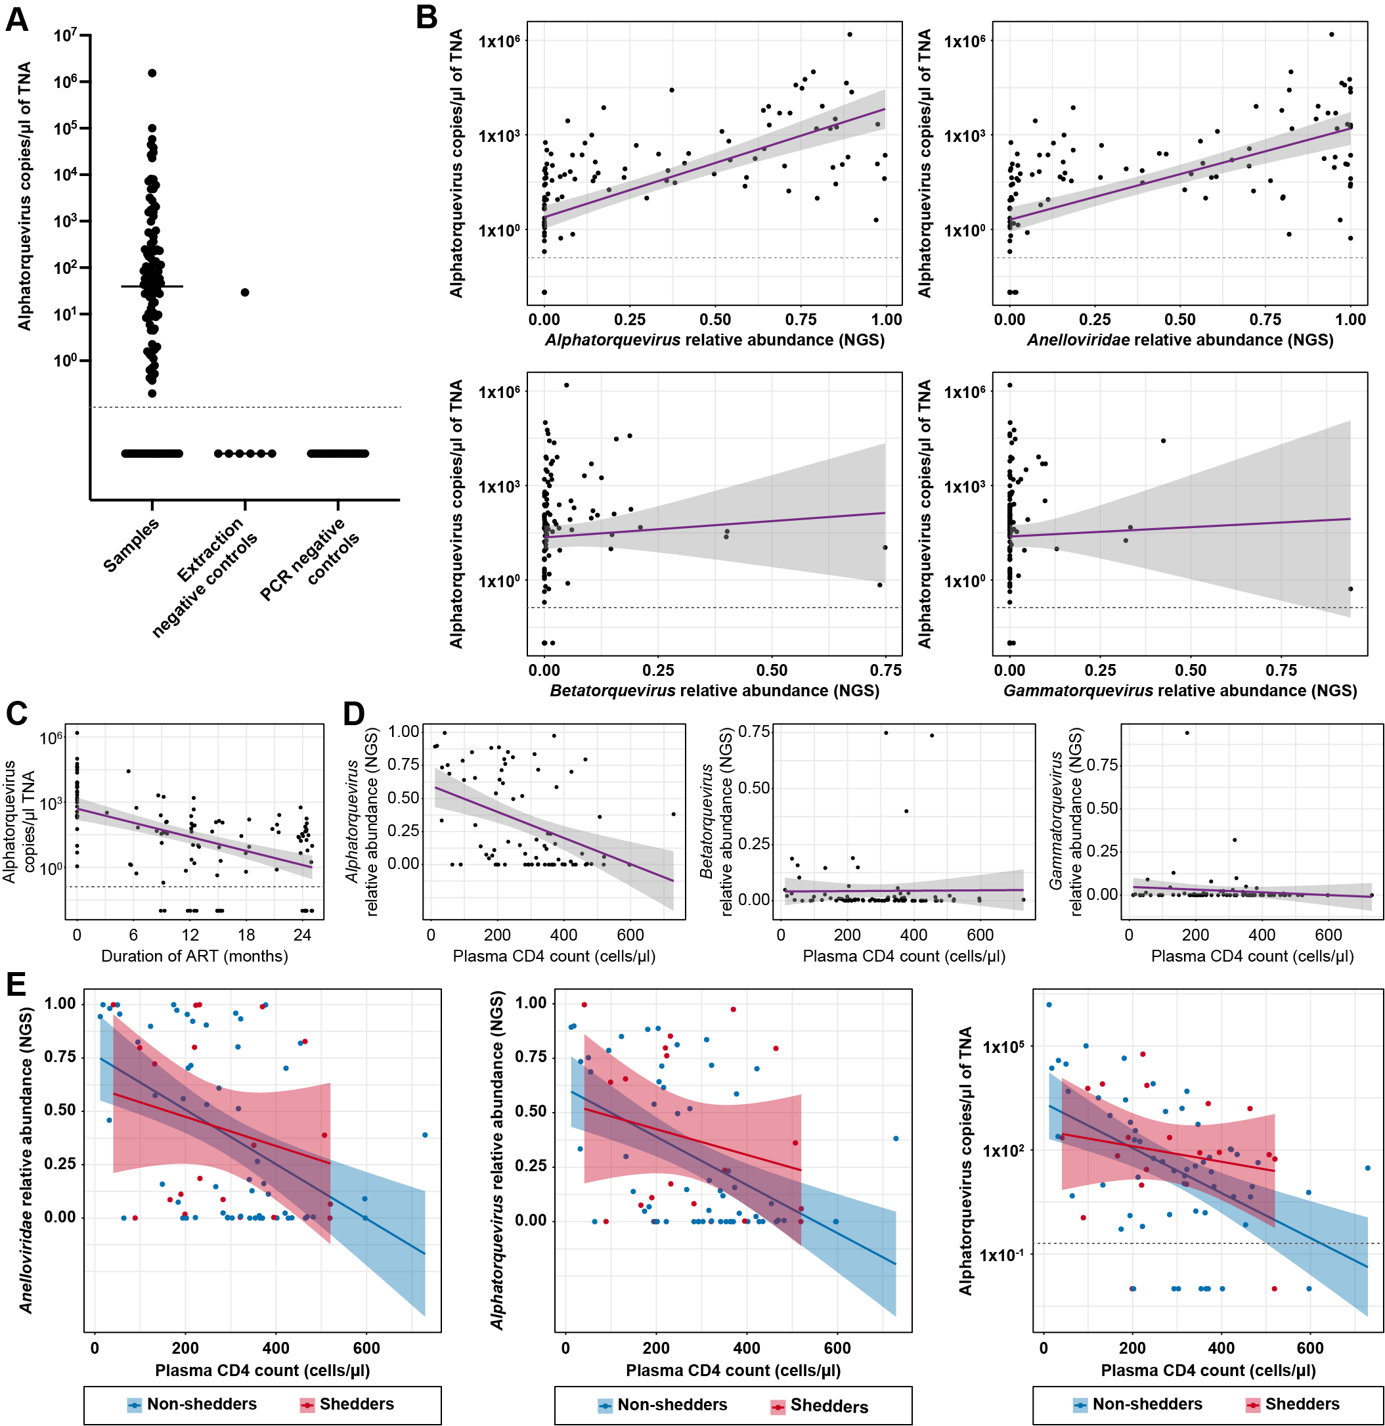
Extended Data Figure 7: Extended qPCR and CD4 analyses. A. Alphatorquevirus qPCR copy numbers in different sample types. Copy numbers are expressed in copies/μl of extracted total nucleic acid (TNA). To facilitate visualization on a log scale, a pseudocount of 0.01 copies/μl was added to all qPCR copy numbers in this and subsequent panels, but statistical analyses were based on raw copy numbers. In this and subsequent panels, dotted horizontal lines separate samples with detectable and undetectable alphatorquevirus by qPCR. B. Alphatorquevirus qPCR copy numbers versus Alphatorquevirus NGS relative abundance (top left), Anelloviridae NGS relative abundance (top right), Betatorquevirus NGS relative abundance (bottom left), and Gammatorquevirus NGS relative abundance (bottom right). Shedder and non-shedder samples are plotted together. Linear regression lines are shown in purple and 95% confidence bands in gray. Statistical significance was assessed by linear mixed modeling (LME), p=0.041 for Alphatorquevirus, p=0.085 for Anelloviridae, p=0.96 for Betatorquevirus and p=0.84 for Gammatorquevirus. C. Alphatorquevirus qPCR copy numbers by ART duration. Shedder and non-shedder samples are plotted together. Linear regression lines are shown in purple and 95% confidence bands in gray. Statistical significance was assessed by LME, p=0.090. D. Relative abundance of Alphatorquevirus (left), Betatorquevirus (middle), and Gammatorquevirus (right) versus CD4 counts. Shedder and non-shedder samples are plotted together. Linear regression lines are shown in purple and 95% confidence bands in gray. Statistical significance was assessed by linear mixed modeling LME, p=1.7x10⁻⁴, p=0.77, and p=0.36, respectively. E. Anelloviridae relative abundance, Alphatorquevirus relative abundance, and alphatorquevirus qPCR copy numbers versus CD4 counts, stratified by shedder/non-shedder status. Shedder samples are shown in red and non-shedder samples in blue. Regression lines and 95% confidence bands are plotted separately for each group. Statistical significance was assessed by LME; p=2.1x10⁻⁴, p=1.3x10⁻⁴, and p=0.04, respectively, for non-shedders; p=0.17, p=0.24, and p=0.54 for shedders, respectively.

Extended Data Figure 8
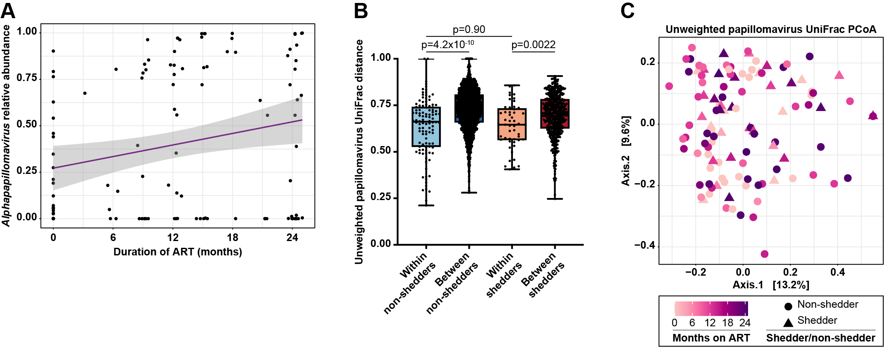
Extended Data Figure 8: Extended papillomavirus analyses. A. Abundance of Alphapapillomavirus relative to all viral genera. Shedder and non-shedder samples are plotted together. The linear regression lines are shown in purple and the 95% confidence bands are shown in gray. Statistical significance was determined by MaAsLin2, q=0.044. B. Unweighted papillomavirus UniFrac distance between pairs of samples from the same individual (within-individual comparisons) or from different individuals (between-individual comparisons). Statistical significance was assessed using the Mann-Whitney test and p-values were adjusted for multiple comparisons using the Benjamini-Hochberg method. C. Principal coordinates analysis (PCoA) of shedder and non-shedder samples, using unweighted UniFrac distance calculated from papillomavirus phylogeny and presence/absence. Samples are colored by duration of ART. Non-shedder samples are shown as circles and shedder samples are shown as triangles. Statistical significance was determined by PERMANOVA, p=0.18 for ART duration and p=0.10 for shedder/non-shedder status.

