Supporting information

An Isolable Phosphinidene Oxide
Chenyang Hu,^{a,b} Nicolas H. Rees,ª Maren Pink,^{b} and Jose M. Goicoechea^{b,}*
ª Department of Chemistry, University of Oxford, Chemistry Research Laboratory, 12 Mansfield Rd., Oxford, OX1 3TA, U.K.
^{b} Department of Chemistry, Indiana University, 800 East Kirkwood Ave., Bloomington, Indiana, 47405, U.S.A.
E-mail: jgoicoec@iu.edu

Contents
1. Experimental details 1
2. Mechanistic study of the generation of 3 8
3. Saturation Transfer Differential NMR spectroscopy of 4 (³¹P 1D-EXSY) 11
4. IR and NMR spectra 14
5. X-ray Crystallographic Studies 34
6. Computational Details 39
7. References 110

1. Experimental details
Characterization techniques: NMR spectra were acquired on Bruker AVIII 400 MHz, Bruker AVIII HD 500 MHz (w/ detect ¹³C cryoprobe), and Bruker NEO 600 MHz (w/ broadband helium cryoprobe) spectrometers. ¹H and ¹³C NMR spectra were referenced to the most downfield protio-solvent resonance (¹H NMR C₆D₆: δ = 7.16 ppm, CDCl₃: δ = 7.26 ppm, d₈-THF = 1.73 ppm; ¹³C NMR C₆D₆: δ = 128.06 ppm, CDCl₃: δ = 77.16 ppm, d₈-THF = 67.57 ppm). ¹H NMR spectra in d₈-THF were referenced to the resonance at 1.73 ppm due to overlap of the most downfield resonance with that arising from 18-crown-6. ³¹P NMR spectra were externally referenced to an 85% solution of H₃PO₄ in H₂O. ⁷⁷Se NMR spectra were externally referenced to a solution of SeMe₂ in C₆D₆. IR data were obtained by using Fourier Transform Infrared Spectroscopy (FTIR) method, spectra were recorded on a Shimadzu Plastic Analyzer spectrometer. Elemental analyses were carried out by London Metropolitan University. Samples (approx. 5 mg) were submitted in vacuum sealed Pyrex ampoules. High Resolution Mass Spectrometry (HRMS) was performed with a Thermo Orbitrap Exactive MS System.

1.1. Synthesis of S1
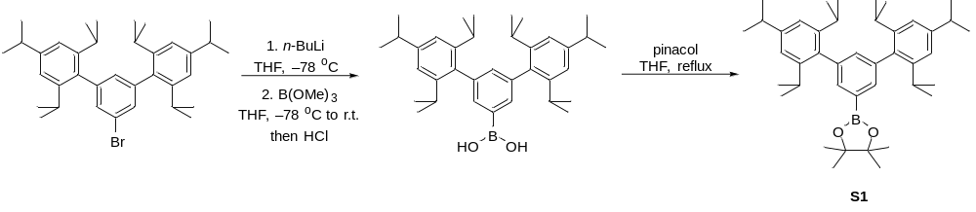
Scheme S1. Synthesis of S1.

n-BuLi (1.6M in hexane, 8.26 ml, 13.3 mmol, 1.07 eq.) was added dropwise to a stirring THF solution (150 ml) of HIPTBr (7 g, 12.46 mmol, 1.00 eq.) at –78 °C. The reaction was allowed to stir at this temperature for 2 h before B(OMe)₃ (4.2 ml, 37.4 mmol, 3.00 eq.) was added to the solution dropwise. The reaction was allowed to slowly warm to room temperature overnight, then treated a 1M HCl (60 ml) and stirred for 2h. The mixture was extracted with Et₂O and the combined organic layer was dried over MgSO₄. All volatiles were removed in vacuo, and to the resulting oily solid was added a THF solution (100 ml) of pinacol (1.484 g, 12.6 mmol, 1.01 eq.). The mixture was heated to reflux overnight, and solvent evaporated afterwards. The crude mixture was purified by silica gel column chromatography (PE:CHCl₃ = 4:1) to give S1 (6.05g, 9.96mmol; 80% yield) as a white powder.
Anal. Calcd. for C₄₂H₆₁B₁O₂ (M.W. 608.76 g mol⁻¹): C, 82.87; H, 10.10; Found: C 83.05; H, 10.21.
¹H NMR (500 MHz, CDCl₃): δ (ppm) 1.03 (d, ³J_{H–H} = 6.9 Hz, 12H; CH(CH₃)₂), 1.14 (d, ³J_{H–H} = 6.8 Hz, 12H; CH(CH₃)₂), 1.29 (d, ³J_{H–H} = 6.9 Hz, 12H; CH(CH₃)₂), 1.33 (s, 12H; CH₃), 2.71 (sept, ³J_{H–H} = 6.8 Hz, 4H; CH(CH₃)₂), 2.92 (sept, ³J_{H–H} = 6.8 Hz, 2H; CH(CH₃)₂), 7.02 (s, 4H; ArH), 7.13 (t, ⁴J_{H–H} = 1.7 Hz, 1H; ArH), 7.59 (d, ⁴J_{H–H} = 1.7 Hz, 2H; ArH).
¹³C{¹H} NMR (125 MHz, CDCl₃): δ (ppm) 24.18, 24.63, 25.17 (s, CH(CH₃)₂), 24.27 (s, OC(CH₃)₂), 30.50, 34.46 (s, CH(CH₃)₂), 83.77 (s; OC(CH₃)₂), 120.48, 134.13, 134.34, 137.13, 139.86, 146.65, 147.81 (s, ArC).

1.2. Synthesis of 1
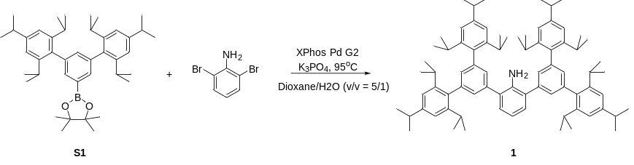
Scheme S2. Synthesis of 1.

To a solid mixture of S1 (6.0 g, 9.858 mmol, 2.02 eq.), 2,6-dibromoaniline (1.224 g, 4.878 mmol, 1.0 eq.), XPhos Pd G2 (100 mg) and K₃PO₄ (4.06 g, 19.13 mmol, 3.92 eq.), a degassed mixture of dioxane (100 ml) and H₂O (20ml) was added. The mixture was stirred at 95 °C overnight. After cooling to room temperature, the mixture was extracted with EtOAc (200 ml) and the combined organic layer was dried over MgSO₄. All volatiles were removed in vacuo, and the residue was purified by silica gel column chromatography (PE:CHCl₃ = 10:1) to give S1 (4.7 g, 4.46 mmol; 91% yield) as a white powder. Single crystals of 1 suitable for X-ray diffraction were obtained by slow evaporation of a concentrated petroleum ether solution of the product at room temperature.
Anal. Calcd. for C₇₈H₁₀₃N (M.W. 1054.69 g mol⁻¹): C, 88.83; H, 9.84; N, 1.33; Found: C 88.46; H, 9.80; N, 1.32.
¹H NMR (600 MHz, C₆D₆): δ (ppm) 1.17 (d, ³J_{H–H} = 6.8 Hz, 24H; CH(CH₃)₂), 1.26 (d, ³J_{H–H} = 6.8 Hz, 24H; CH(CH₃)₂), 1.31 (d, ³J_{H–H} = 6.8 Hz, 24H; CH(CH₃)₂), 2.90 (sept, ³J_{H–H} = 6.8 Hz, 4H; CH(CH₃)₂), 3.06 (sept, ³J_{H–H} = 6.8 Hz, 8H; CH(CH₃)₂), 3.95 (s, 2H; NH), 6.80 (t, ³J_{H–H} = 7.6 Hz, 1H; ArH), 7.09 (t, ⁴J_{H–H} = 1.6 Hz, 2H; ArH), 7.21 (s, 8H; ArH), 7.37 (d, ³J_{H–H} = 7.6 Hz, 2H; ArH), 7.61 (d, ⁴J_{H–H} = 1.6 Hz, 4H; ArH).
¹³C{¹H} NMR (151 MHz, C₆D₆): δ (ppm) 24.41, 24.47, 25.71 (s, CH(CH₃)₂), 31.10, 34.93 (s, CH(CH₃)₂), 119.33, 120.84, 129.13, 130.66, 130.78, 137.38, 140.00, 141.37, 141.91, 146.88, 148.58 (s, ArC).
HRMS(m/z): [M+H]⁺ calcd. For C₇₈H₁₀₄N, 1054.8163; found 1054.8119.

1.3. Synthesis of S2 and 2
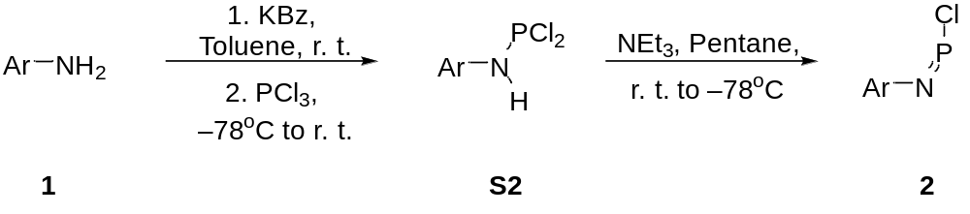
Figure S3. Synthesis of S2 and 2.

To a solid mixture of 1 (2.0 g, 1.896 mmol, 1.0 eq.) and KBz (248 mg, 1.896 mmol, 1.0 eq.), toluene (80 ml) was added. The mixture was stirred at room temperature for 2 h before cooling to –78 °C. PCl₃ (0.2 ml, 2.29 mmol, 1.2 eq.) was added dropwise at this temperature and then the mixture was allowed to slowly warm up to room temperature overnight. All volatiles were removed in vacuo, and the residue was re-dissolved in hexane (100 ml). The solution was filtered using a filter cannula to remove KCl. All volatiles were removed in vacuo again affording S2 (1.95 g, 1.73 mmol; 91% yield) as a white powder. Note: due to the identical solubility of 1 and S2, S2 can not be isolated as a compositionally pure compound, and always contains ~5% of 1. Single crystals of S2 suitable for X-ray diffraction were obtained by slow evaporation of a concentrated hexane solution of the product at room temperature.
¹H NMR (500 MHz, C₆D₆): δ (ppm) 1.24 (d, ³J_{H–H} = 6.8 Hz, 24H; CH(CH₃)₂), 1.28–1.31 (m, 48H; CH(CH₃)₂), 2.89 (sept, ³J_{H–H} = 6.8 Hz, 4H; CH(CH₃)₂), 3.10 (sept, ³J_{H–H} = 6.8 Hz, 8H; CH(CH₃)₂), 6.24 (s, 1H; NH), 6.84 (td, ³J_{H–H} = 7.5 Hz, ⁶J_{P–H} = 2.5 Hz, 1H; ArH), 7.21–7.25 (m, 12H; ArH), 7.34 (d, ⁴J_{H–H} = 1.5 Hz, 4H; ArH).
¹³C{¹H} NMR (125 MHz, C₆D₆): δ (ppm) 24.45, 24.54, 24.83 (s, CH(CH₃)₂), 31.02, 34.92 (s, CH(CH₃)₂), 120.88 (s), 125.16 (d, ³J_{P–C} = 3.2 Hz), 129.68 (d, ⁴J_{P–C} = 2.5 Hz), 130.94 (d, ⁴J_{P–C} = 2.9 Hz), 131.90 (s), 135.07 (s), 136.72 (d, ²J_{P–C} = 4.8 Hz), 139.36 (d, ⁵J_{P–C} = 1.7 Hz), 136.99 (s), 142.33 (s), 146.94 (s), 148.74 (s) (ArC).
³¹P{¹H} NMR (202 MHz, C₆D₆): δ (ppm) 168.3(s)

To a pentane solution (80 ml) of S2 (500 mg, 0.44 mmol, 1.0 eq.), NEt₃ (0.5 ml, 3.58 mmol, 8.14 eq.) was added at room temperature. The mixture was slowly cooled to –78 °C, and kept at this temperature with constant stirring for 4 h. The solution was filtered using a filter cannula at –78 °C (Note: the reaction is under dynamic equilibrium, and product is favored at low temperature). The filtrate was allowed to warm up to room temperature, after which all volatiles were removed in vacuo to give 2 (342 mg, 0.306 mmol; 69% yield) as a yellow powder. Note: due to the identical solubility of 1, S2 and 2, 2 can not be isolated as a compositionally pure compound, the product always contains ~5% of 1 and trace amount of S2. Single crystals of 2 suitable for X-ray diffraction were obtained by slow evaporation of a concentrated hexane solution of the product at room temperature.
¹H NMR (500 MHz, C₆D₆): δ (ppm) 1.22–1.24 (m, 48H; CH(CH₃)₂), 1.30 (d, ³J_{H–H} = 6.8 Hz, 24H; CH(CH₃)₂), 2.89 (sept, ³J_{H–H} = 6.8 Hz, 4H; CH(CH₃)₂), 3.07 (sept, ³J_{H–H} = 6.8 Hz, 8H; CH(CH₃)₂), 6.90 (t, ³J_{H–H} = 6.5 Hz, 1H; ArH), 7.09 (t, ⁴J_{H–H} = 1.5 Hz, 2H; ArH), 7.21 (s, 8H; ArH), 7.37 (d, ³J_{H–H} = 6.5 Hz, 2H; ArH), 7.46 (d, ⁴J_{H–H} = 1.5 Hz, 4H; ArH).
¹³C{¹H} NMR (125 MHz, C₆D₆): δ (ppm) 24.46, 24.57, 24.76 (s, CH(CH₃)₂), 31.03, 34.93 (s, CH(CH₃)₂), 120.84 (s), 126.19 (s), 129.44 (s), 130.04 (s), 131.14 (s), 133.00 (d, ²J_{P–C} = 10.6 Hz), 137.35 (s), 139.86 (s), 141.43 (s), 146.92 (s), 148.59 (s), 148.74 (s) (ArC).
³¹P NMR (202 MHz, C₆D₆): δ (ppm) 161.5 (s).
HRMS(m/z): [M+H]⁺ calcd. For C₇₈H₁₀₂NPCl, 1118.7444; found 1118.7840.

1.4. Synthesis of S3
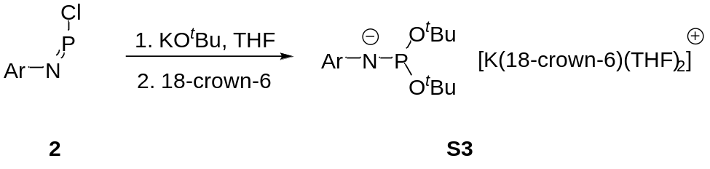
Scheme S4. Synthesis of S3.

To a solid mixture of 2 (24 mg, 0.02 mmol, 1.0 eq.) and KO^{t}Bu (4.4 mg, 0.04 mmol, 2 eq.), THF (0.5 ml) was added. The mixture was stirred vigorously for 5 min before all volatiles were removed in vacuo. Hexane (10 ml) was added to the residue, and the solution was filtered. Filtrate was dried under vacuum, and THF (0.3 ml) was added to redissolve the residue. A solution of 18-crown-6 (5.3 mg, 0.02 mmol, 1.0 eq.) in THF (0.3ml) was then added to the mixture, and stirred for 2h. Hexane was then layered on top of the THF solution, and left for 24 h before supernatant was removed and the remaining crystals dried in vacuo to afford S3 (23 mg, 0.015 mmol; yield: 75%) as a yellow powder. Single crystals of S3 suitable for X-ray diffraction were obtained by slow diffusion of hexane into a concentrated THF solution of the product at room temperature.
Anal. Calcd. for C₉₈H₁₄₃NO₈PK (M.W. 1533.29 g mol⁻¹): C, 76.77; H, 9.40; N, 0.91; Found: C 73.55; H, 8.48; N, 0.83.
¹H NMR (500 MHz, d₈-THF): δ (ppm) 1.02–1.04 (m, 42H; CH(CH₃)₂ and OC(CH₃)₃), 1.16 (d, ³J_{H–H} = 6.8 Hz, 24H; CH(CH₃)₂), 1.24 (d, ³J_{H–H} = 6.8 Hz, 24H; CH(CH₃)₂), 2.86 (sept, ³J_{H–H} = 6.8 Hz, 4H; CH(CH₃)₂), 3.11 (sept, ³J_{H–H} = 6.8 Hz, 8H; CH(CH₃)₂), 3.52 (s, 24H; 18-crown-6), 5.97 (t, ³J_{H–H} = 7.4 Hz, 1H; ArH), 6.55 (s, 2H; ArH), 6.76 (d, ³J_{H–H} = 7.4 Hz, 2H; ArH), 6.98 (s, 8H; ArH), 7.58 (d, ³J_{H–H} = 7.6 Hz, 2H; ArH), 7.63 (s, 4H; ArH).
¹³C{¹H} NMR (125 MHz, d₈-THF): 24.45, 24.68, 30.61, 32.26, 32.33, 35.17 (s, CH(CH₃)₂ and OC(CH₃)₃), 71.02 (s, 18-crown-6), 71.60 (d, ²J_{P–C} = 2.4 Hz; OC(CH₃)₃), 120.42 (s), 120.82 (s), 127.55 (s), 130.83 (d, ³J_{P–C} = 3.7 Hz), 131.12 (s), 134.21 (d, ²J_{P–C} = 5.0 Hz), 138.49 (s), 139.98 (s), 147.07 (s), 147.11 (s), 147.50 (s), 148.35 (s) (ArC).
³¹P{¹H} NMR (162 MHz, C₆D₆): δ (ppm) 139.4 (br).
HRMS(m/z): not detected

2. Mechanistic study of the generation of 3
2.1 1:1 reaction between 2 and KOTMS
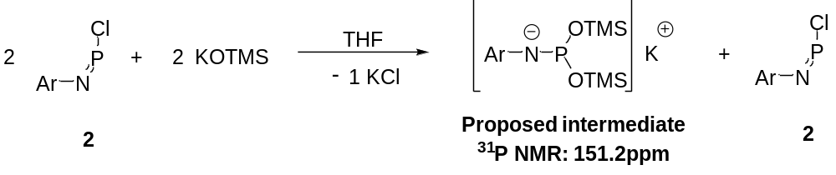
Scheme S5. 1:1 reaction between 2 and KOTMS.

To a solid mixture of 2 (10 mg, 0.009 mmol, 1.0 eq.) and KOTMS (1.1 mg, 0.009 mmol, 1 eq.), THF (0.5ml) was added. The mixture was stirred vigorously for 5 min before a ³¹P NMR spectrum was measured. At this time, a 1:1 mixture was observed in the ³¹P NMR spectrum with one of the components being unconsumed starting material 2. Based on this finding, we propose that a 1:2 reaction between 2 and KOTMS is taking place, generating the K[ArNP(OTMS)₂] as an intermediate.
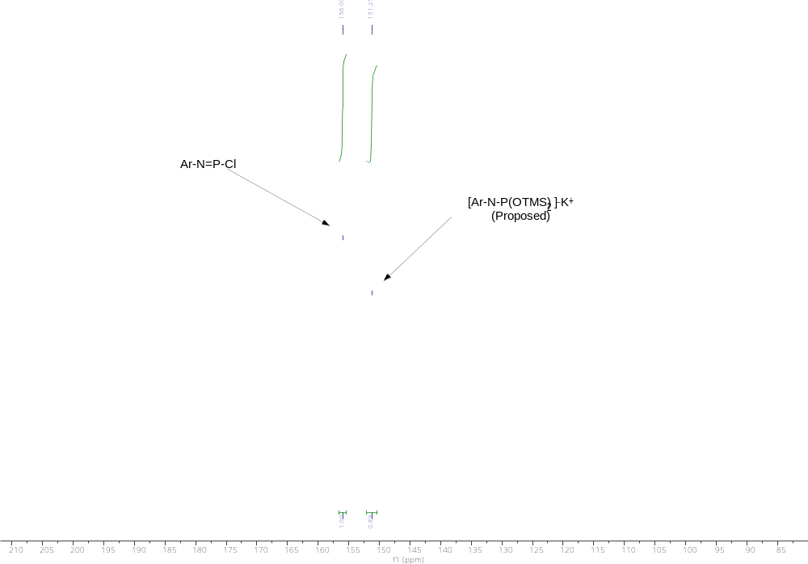
Figure S1. In situ ³¹P NMR spectrum of a 1:1 reaction of 2 and KOTMS. (162 MHz, THF).
2.2 1:2 reaction between 2 and KOTMS
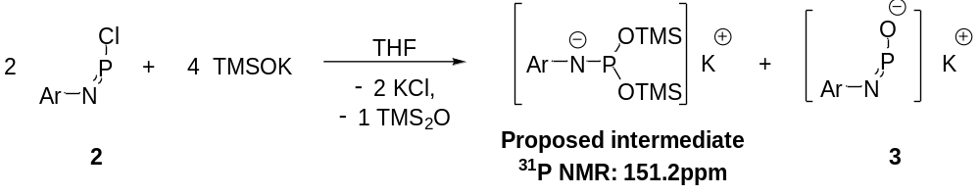
Scheme S6. 1:2 reaction between 2 and KOTMS.

To a solid mixture of 2 (10 mg, 0.009 mmol, 1.0 eq.) and KOTMS (2.2 mg, 0.018 mmol, 2 eq.), THF (0.5 ml) was added. The mixture was stirred vigorously for 5 min before submitted for in situ ³¹P NMR spectrum measurement. A 1:1 mixture was observed in the ³¹P NMR spectrum again, with one of the component being the final 3, and the other component is the intermediate at 151.2 ppm, which we proposed to be the [ArNP(OTMS)₂]–K⁺. Excess KOTMS was then added to the reaction mixture, and only the final product 3 was observed in the ³¹P NMR spectrum. Therefore, we propose that the reaction mixture between 2 and KOTMS first went through the [ArNP(OTMS)₂]–K⁺ intermediate. The following elimination of the Hexamethyldisiloxane (TMS₂O) was assisted by excess KOTMS.
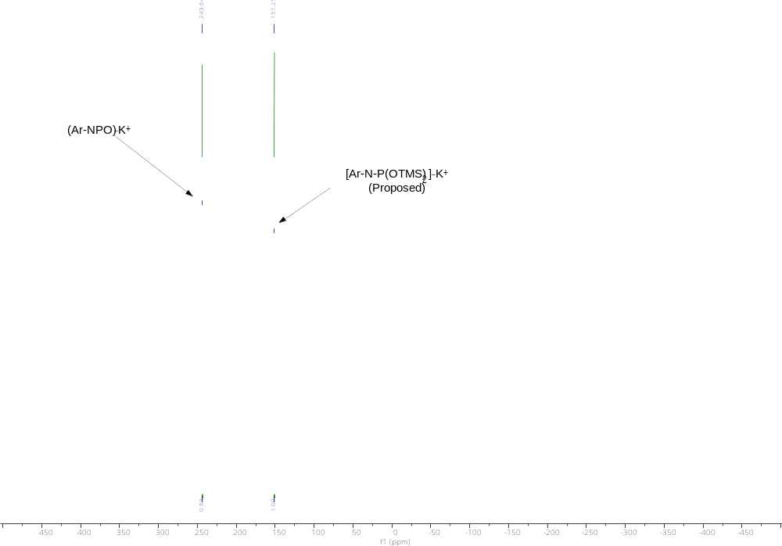
Figure S2. In situ ³¹P NMR spectrum of a 1:2 reaction of 2 and KOTMS. (162 MHz, THF).

2.3 1:2 reaction between 2 and KO^{t}Bu
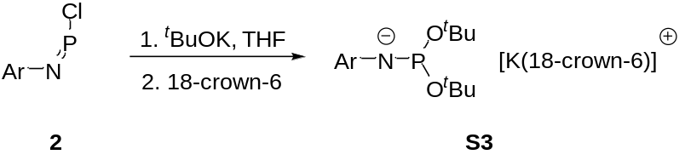
Scheme S7. 1:2 reaction between 2 and KO^{t}Bu.

Due to the inertness of C–O bond, when the was reagent changed from KOTMS to KO^{t}Bu, the generated product K[ArNP(O^{t}Bu)₂] did not eliminate di-tert-butyl ether (tBu₂O). Upon adding 18-crown-6, S3 can be isolated in a 75% yield. The structure of S3 was confirmed through single crystal X-ray diffraction, further supporting our hypothesis that K[ArNP(OTMS)₂] is an intermediate in the synthesis of 3.

3. Saturation Transfer Differential NMR spectroscopy of 4 (³¹P 1D-EXSY)
The ³¹P exchange experiments were acquired on a Bruker AVIII 500 MHz spectrometer. The 1D-EXSY experiments used the pulse sequence 90°-t1-90°-t_{m}-90°-acquire^{[1]} with proton decoupling during the acquisition period to determine the exchange rate between the two isomers of 4 between 343 and 363K. The main ³¹P peak is set on resonance and t1 is set to 1 / 2*Δν, where Δν is the frequency separation of the two exchanging singlets. This selectively inverts the on resonance peak at the beginning of the mixing time (t_{m}). The ³¹P relaxation times were determined using an inverse recovery experiment and the result used to set the relaxation delay and t_{m} was arrayed between 0 and 5 × T1 to monitor the magnetization transfer between the two resonances as they relaxed back to equilibrium. The non-exchanging T1 values for each peak and the exchange rate was then fitted to resulting peak volumes using the CIFIT program, plots of which are shown in Figure S3. Finally, the exchange rates determined for the different temperatures were used to generate an Eyring plot from which the thermodynamic parameters were extracted.

The data points show the experimental peak intensities and the lines the fit by the program.

Figure S3. CIFIT fits of the non-exchanging T1 values for each of the two peaks observed for 4 at five different temperatures (343, 348, 353, 358 and 363 K).

Table S1. Data determined from ³¹P 1D-EXSY NMR studies and used for an Eyring analysis.
Temp/K | 1/T | k | ln(K/T)
343 | 0.002915 | 18.1288 | –2.94023
348 | 0.002874 | 31.4111 | –2.40504
353 | 0.002833 | 43.4883 | –2.09398
358 | 0.002793 | 53.9112 | –1.89319
363 | 0.002755 | 106.6231 | –1.2251

4. IR and NMR spectra
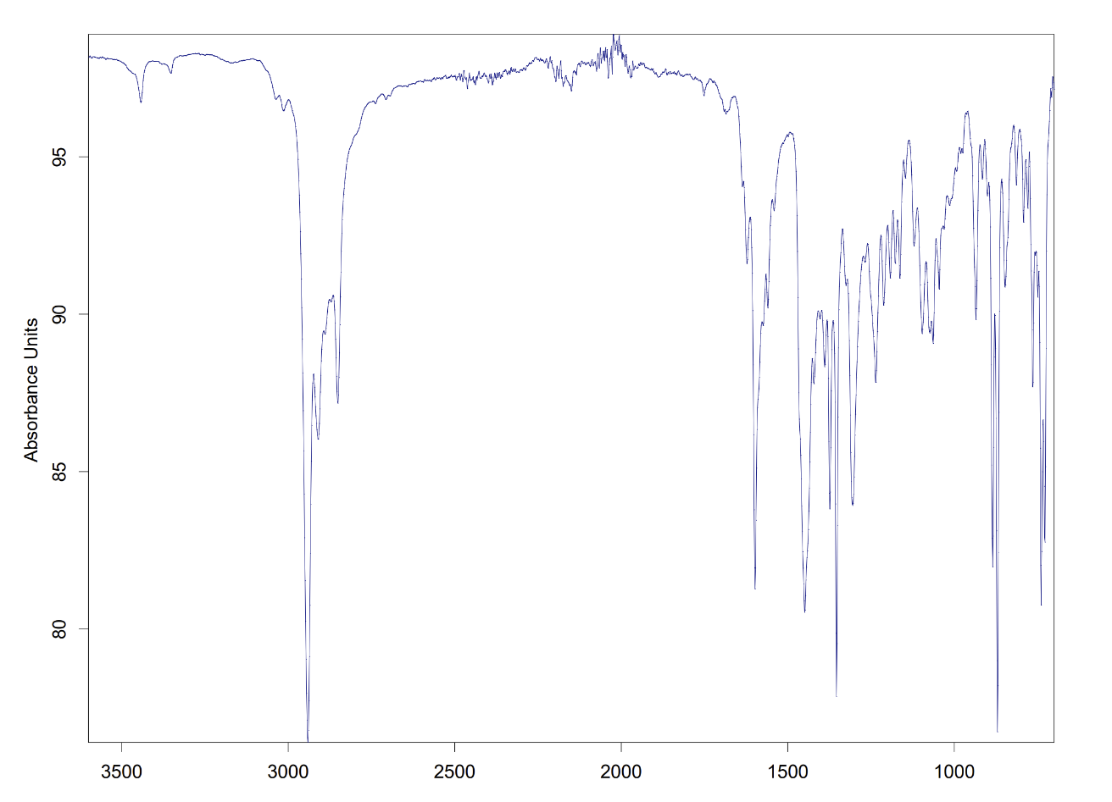
Figure S4. FTIR spectrum of 1.
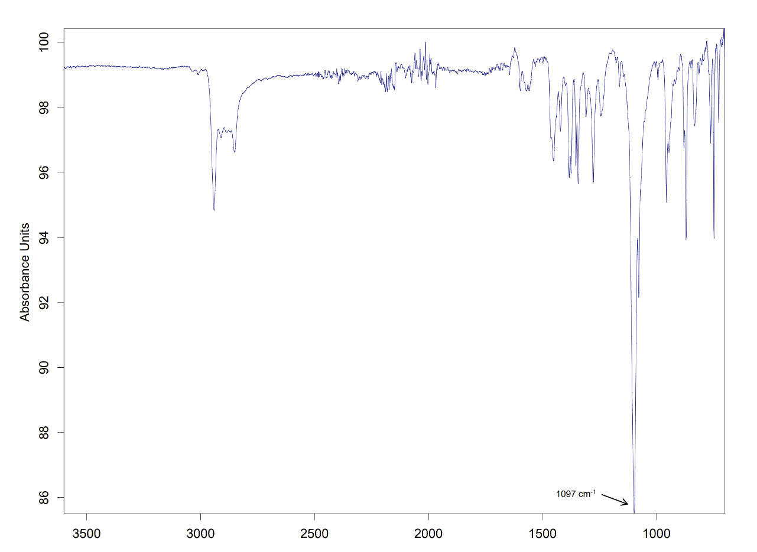
Figure S5. FTIR spectrum of 3.
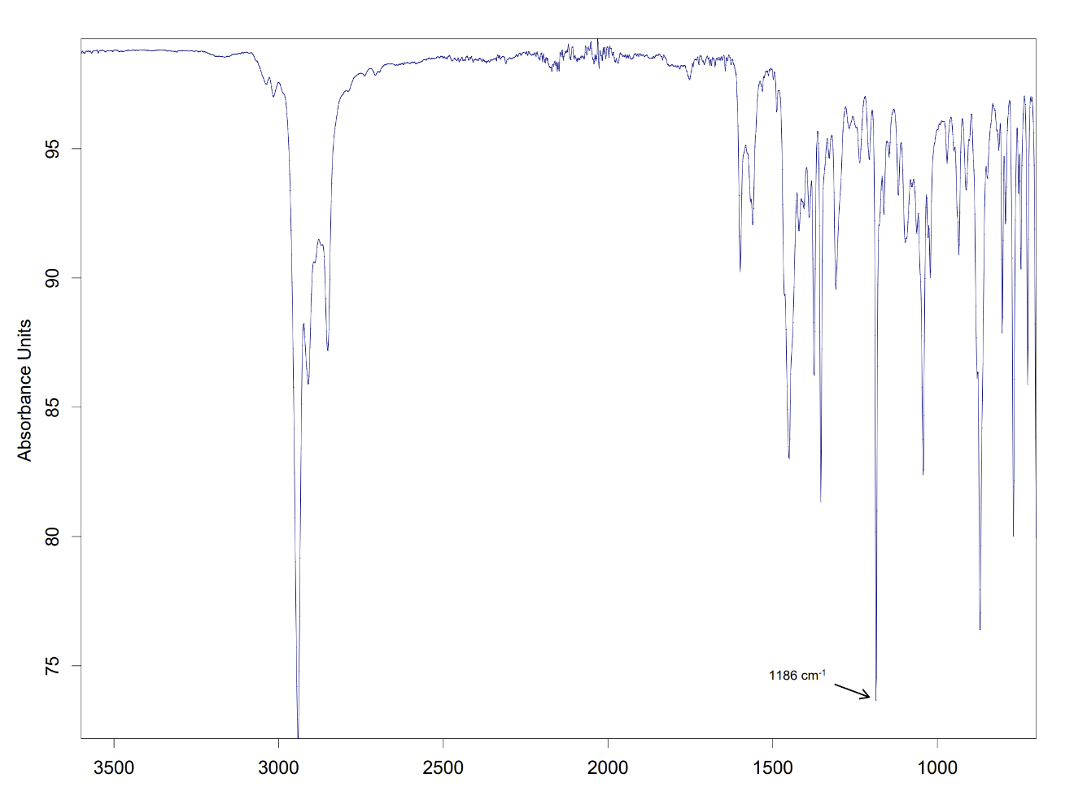
Figure S6. FTIR spectrum of 4.
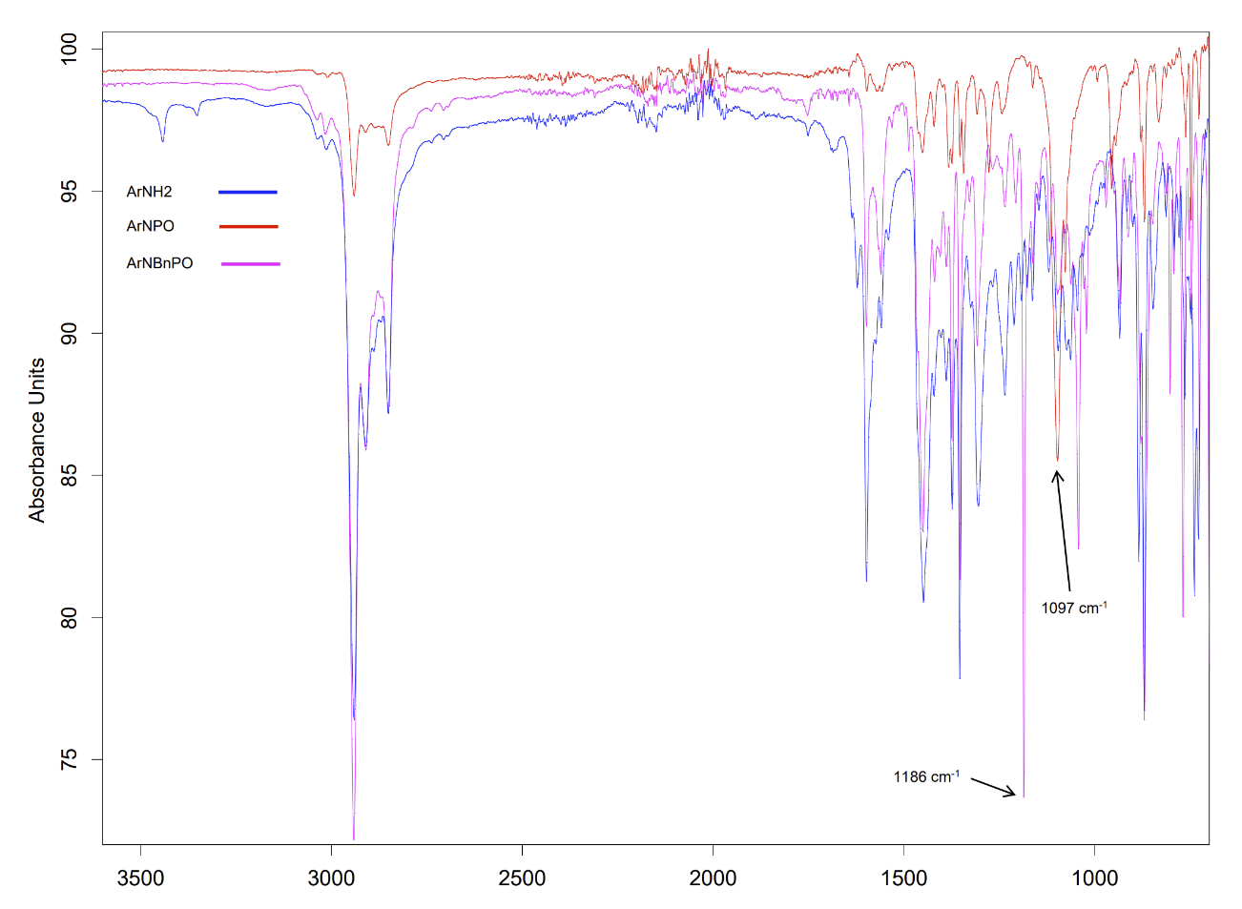
Figure S7. Overlaid FTIR spectra of 2, 3 and 4.
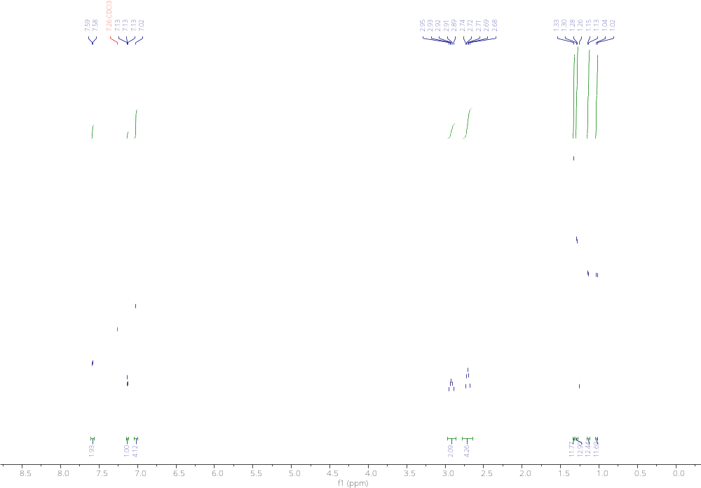
Figure S8. ¹H NMR spectrum of S1 (500 MHz, CDCl₃).
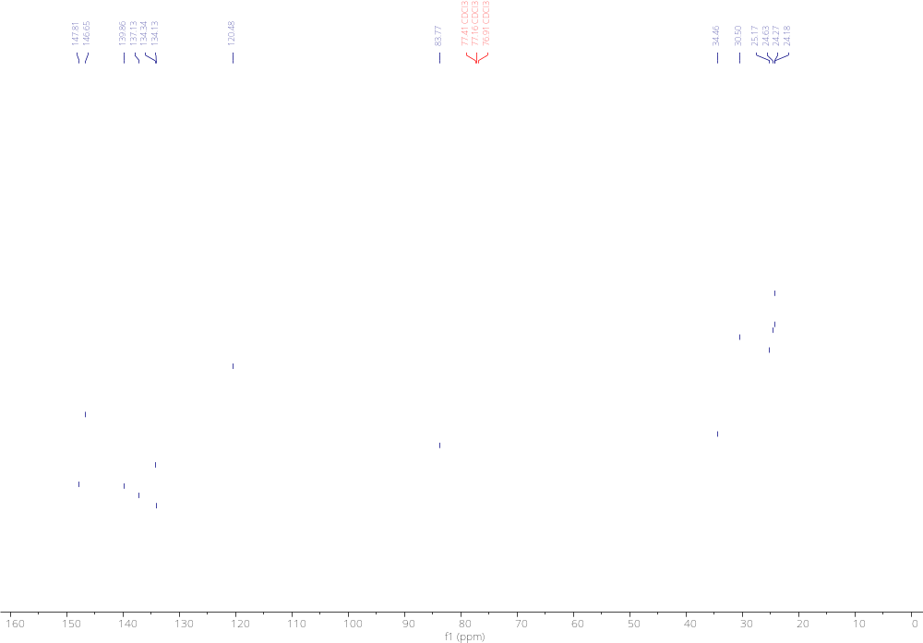
Figure S9. ¹³C NMR spectrum of S1 (125 MHz, CDCl₃).
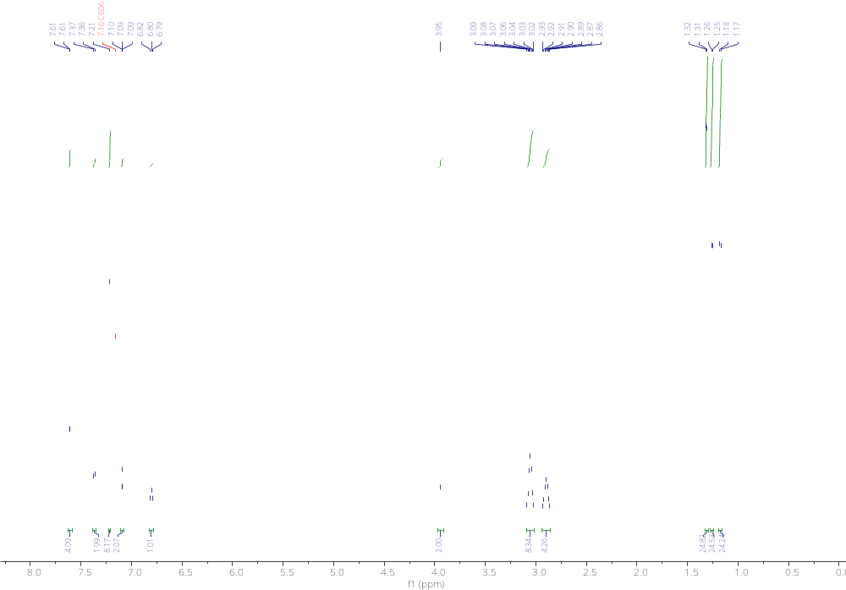
Figure S10. ¹H NMR spectrum of 1 (600 MHz, C₆D₆).
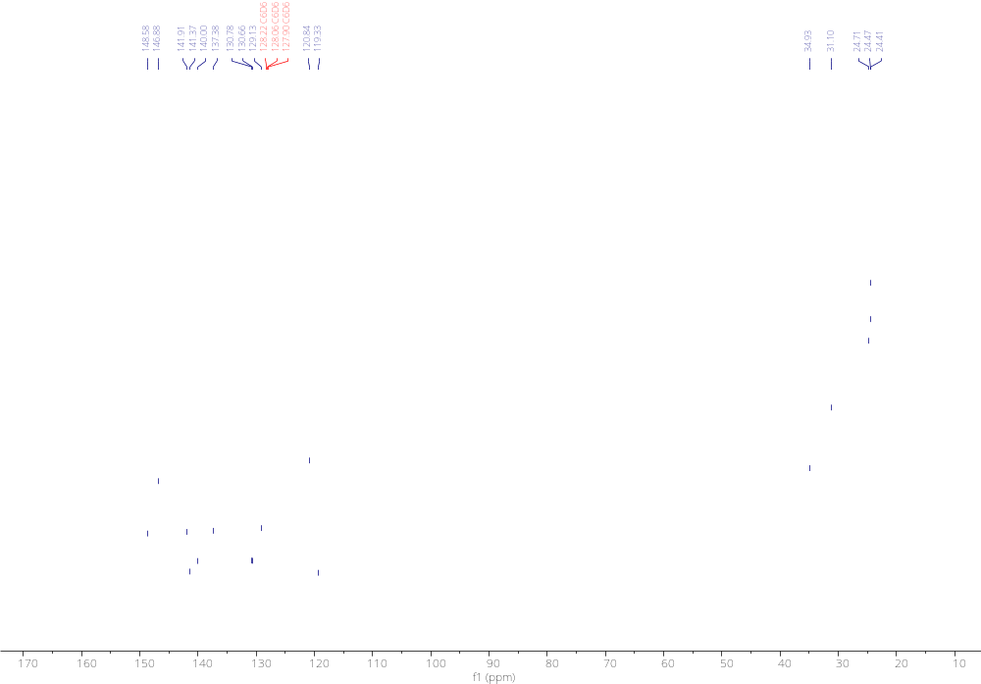
Figure S11. ¹³C NMR spectrum of 1 (151 MHz, C₆D₆).
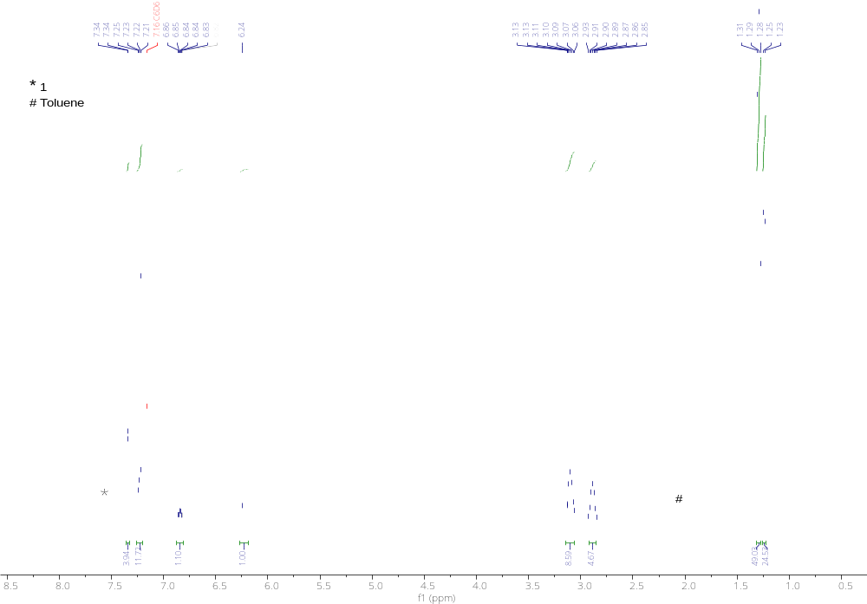
Figure S12. ¹H NMR spectrum of S2 (500 MHz, C₆D₆).
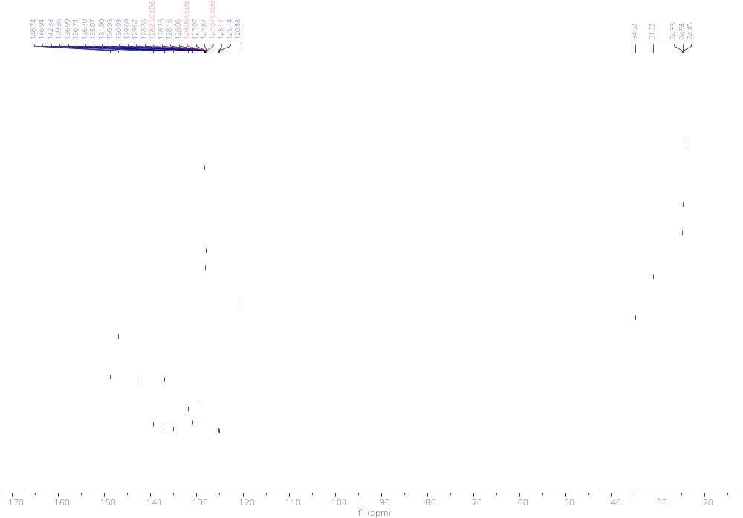
Figure S13. ¹³C NMR spectrum of S2 (125 MHz, C₆D₆).
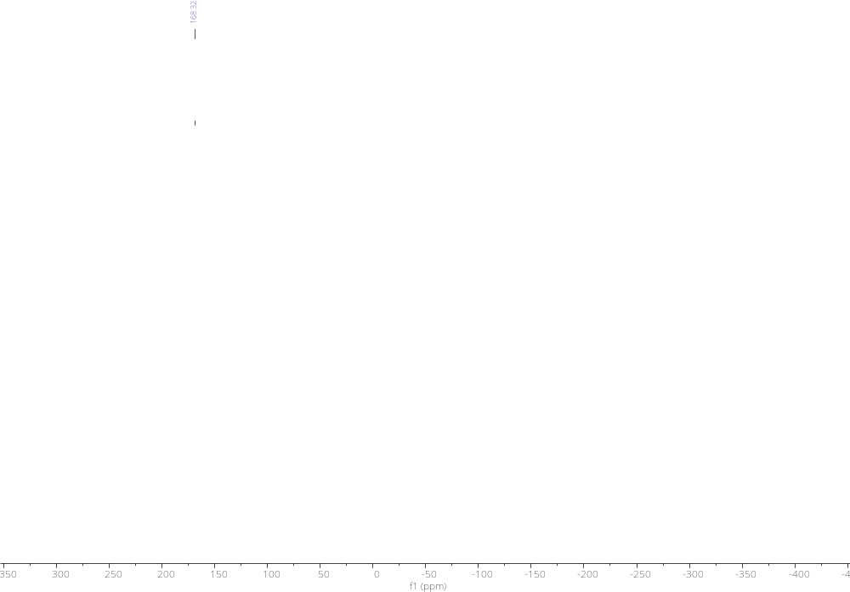
Figure S14. ³¹P{¹H} NMR S2 (202 MHz, C₆D₆).
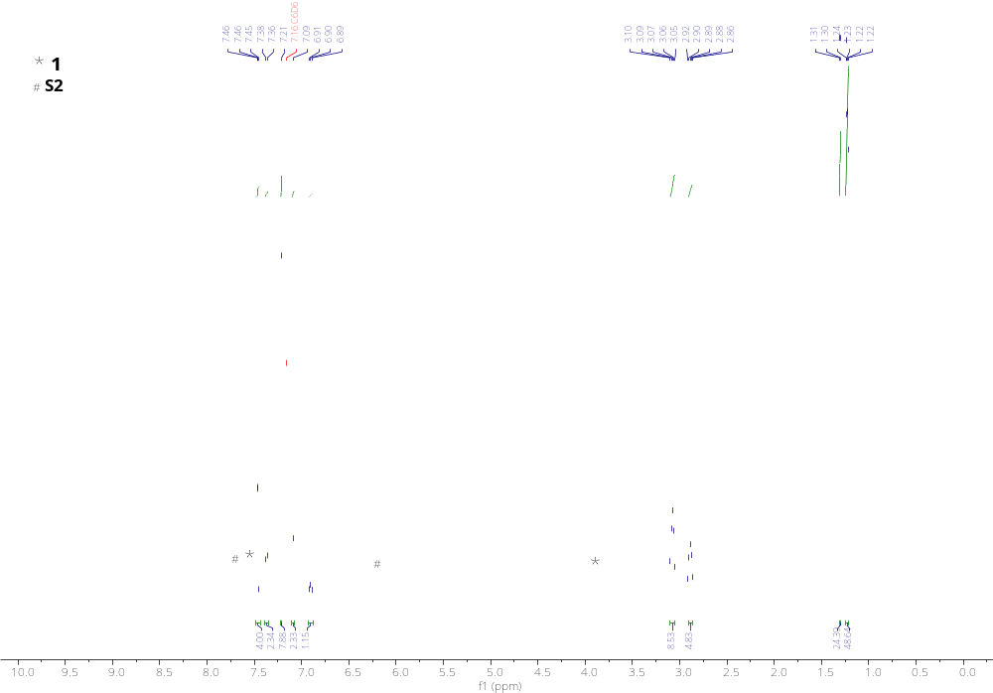Figure S15. ¹H NMR spectrum of 2 (500 MHz, C₆D₆).

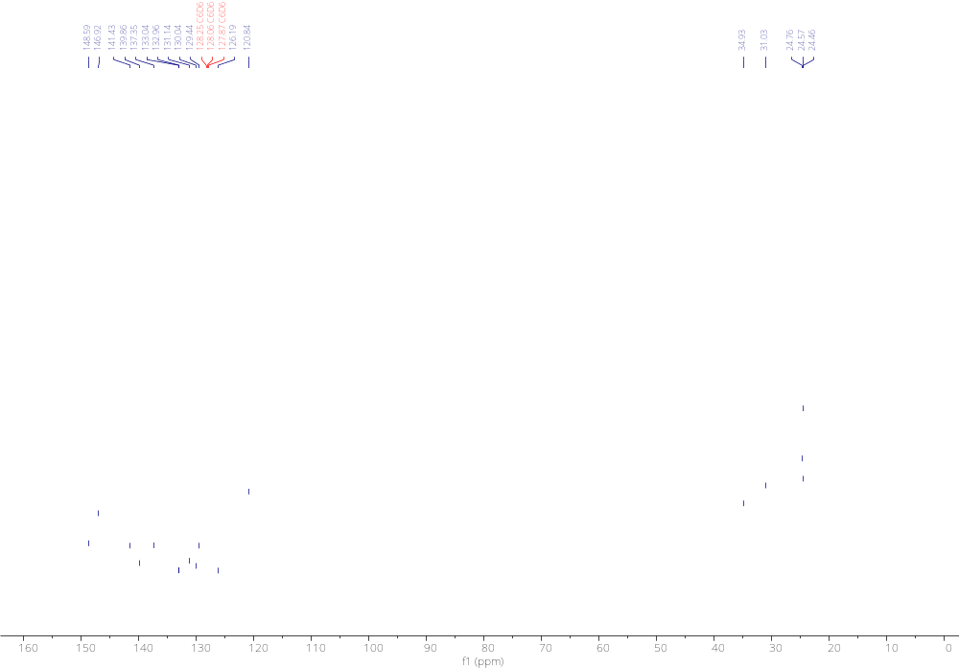
Figure S16. ¹³C NMR spectrum of 2 (500 MHz, C₆D₆).
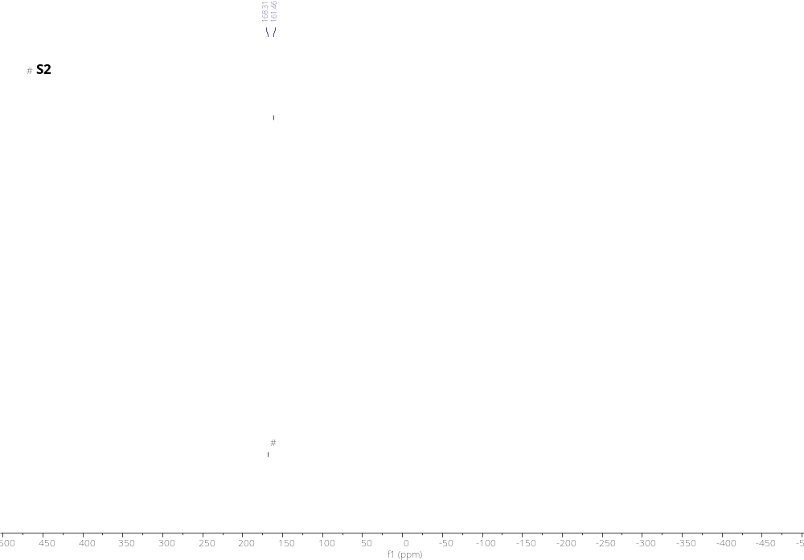
Figure S17. ³¹P{¹H} NMR S2 (202 MHz, C₆D₆).
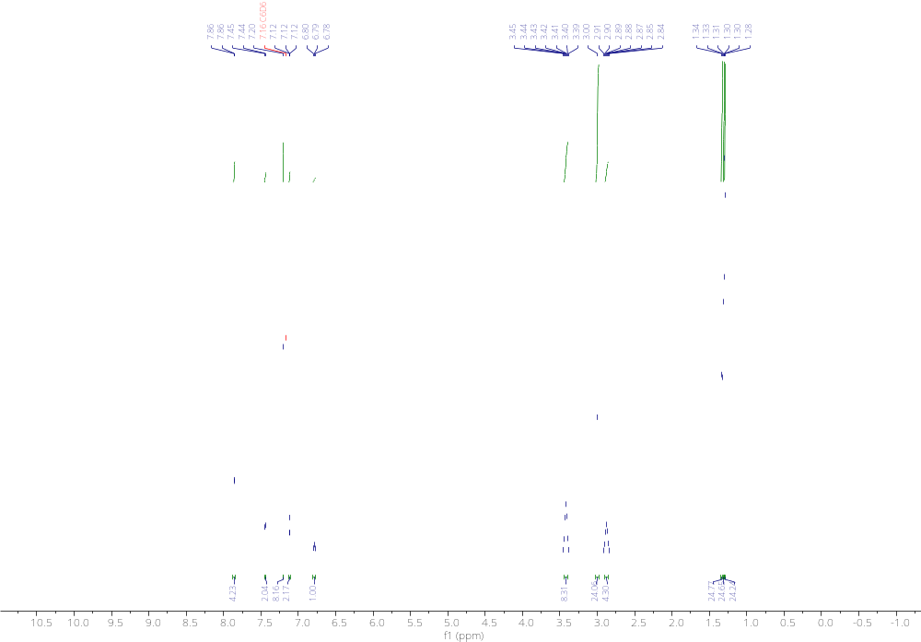
Figure S18. ¹H NMR spectrum of 3 (600 MHz, C₆D₆).
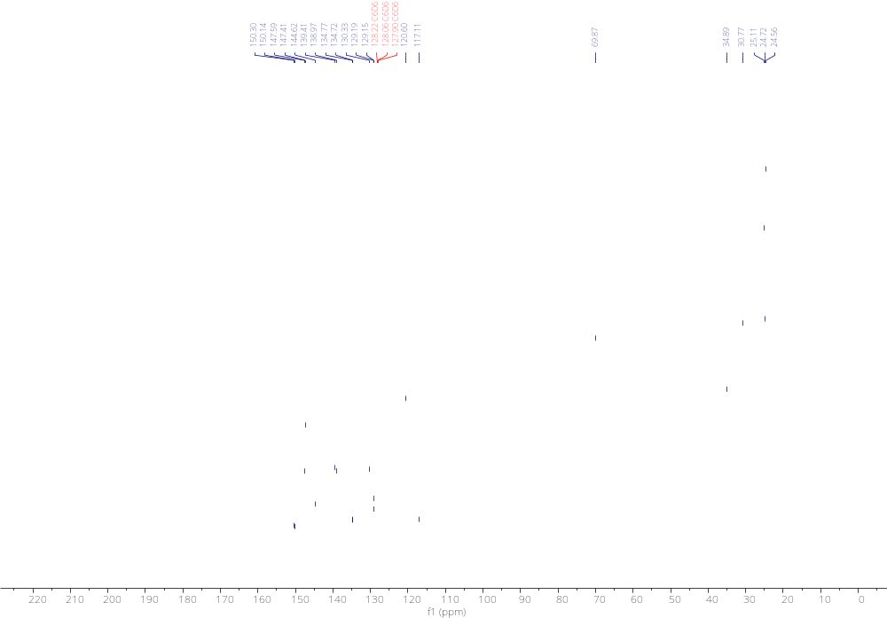
Figure S19. ¹³C NMR spectrum of 3 (151 MHz, C₆D₆).
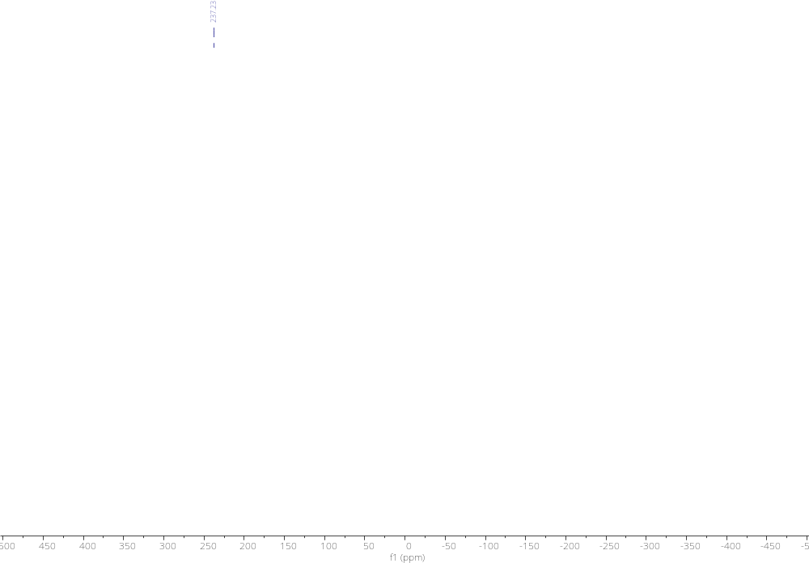
Figure S20. ³¹P NMR spectrum of 3 (162 MHz, C₆D₆).
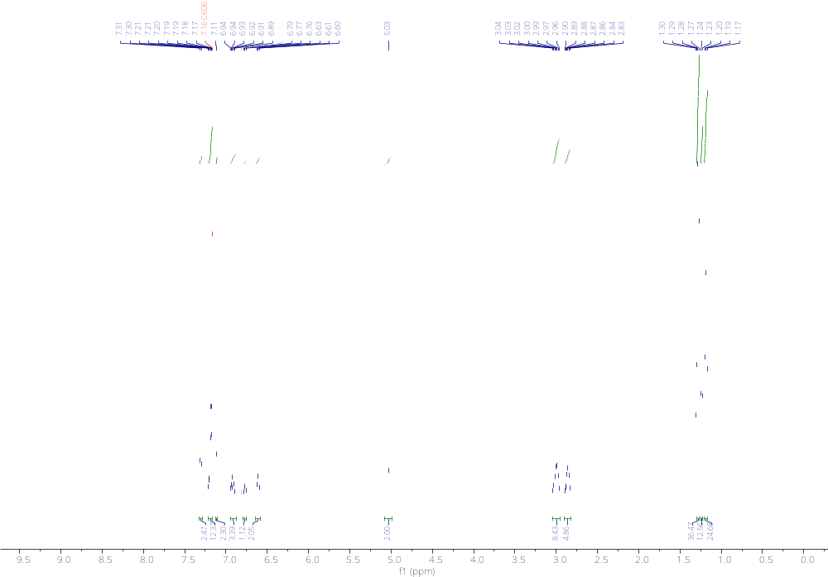
Figure S21. ¹H NMR spectrum of 4 (500 MHz, C₆D₆).
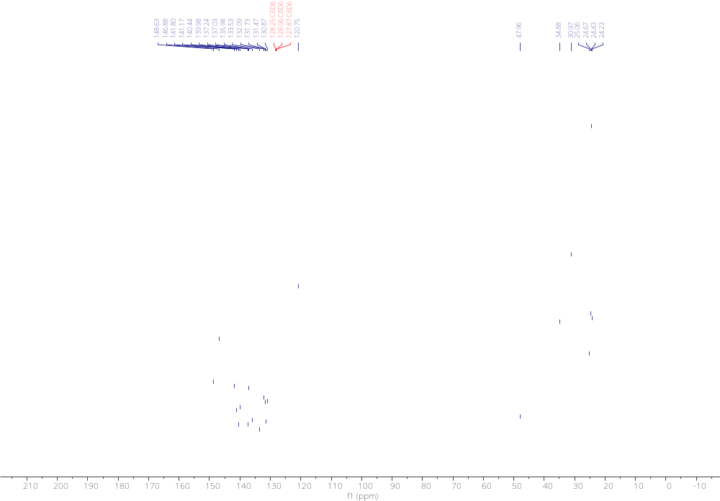
Figure S22. ¹³C NMR spectrum of 4 (125 MHz, C₆D₆).
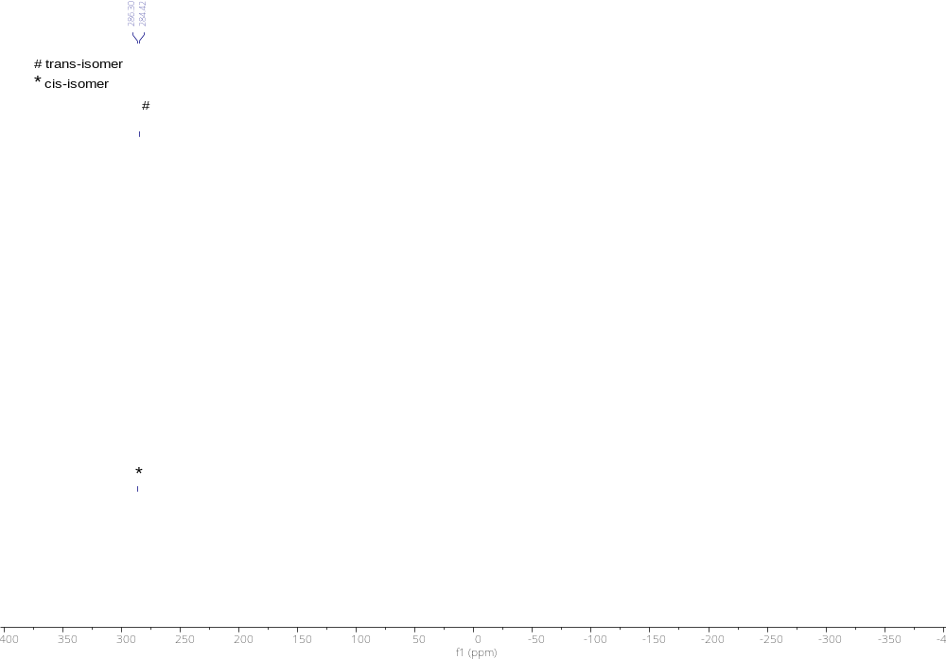
Figure S23. ³¹P{¹H} NMR spectrum of 4 (202 MHz, C₆D₆).
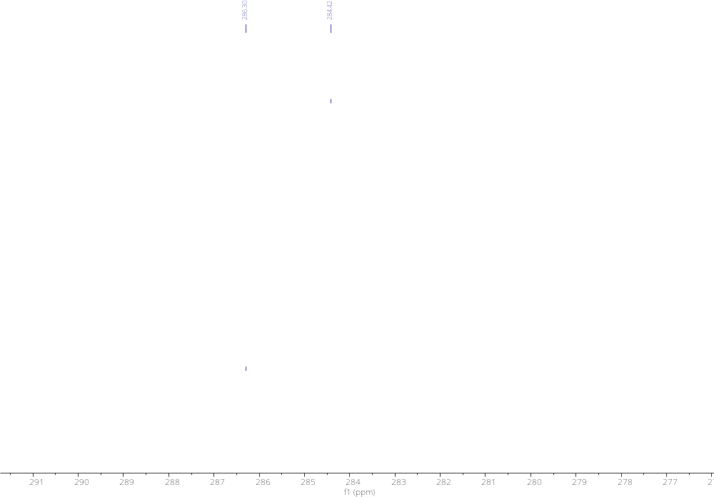
Figure S24. Zoomed in ³¹P{¹H} NMR spectrum of 4 (202 MHz, C₆D₆).
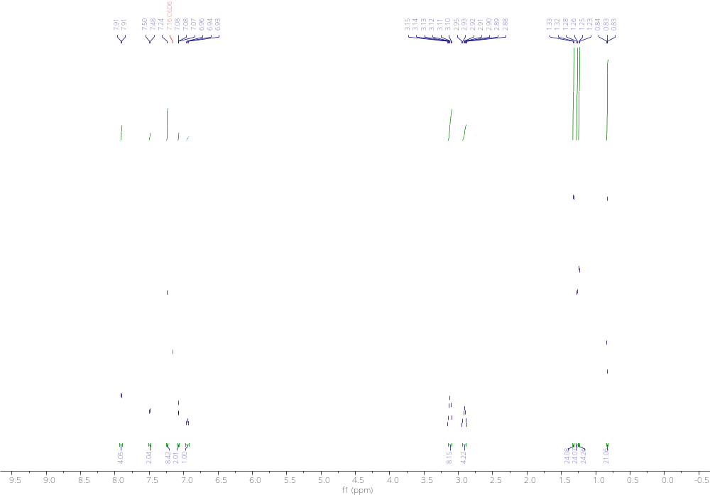
Figure S25. ¹H NMR spectrum of 5 (600 MHz, C₆D₆).
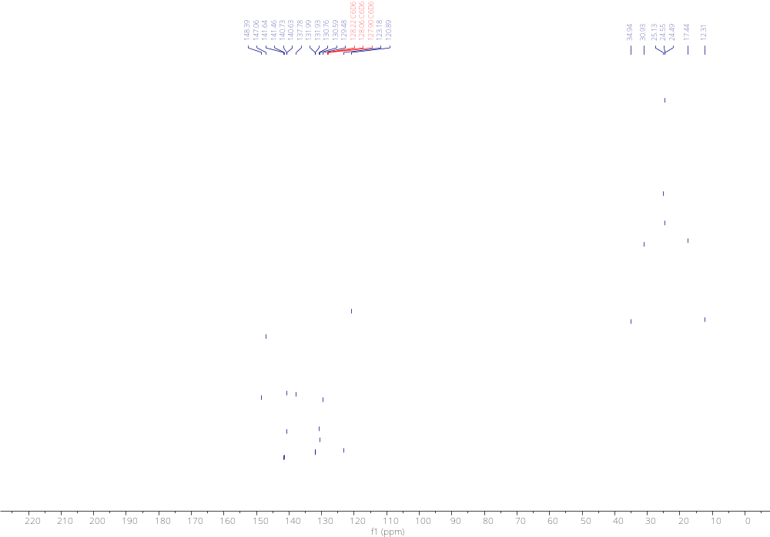
Figure S26. ¹³C NMR spectrum of 5 (151 MHz, C₆D₆).
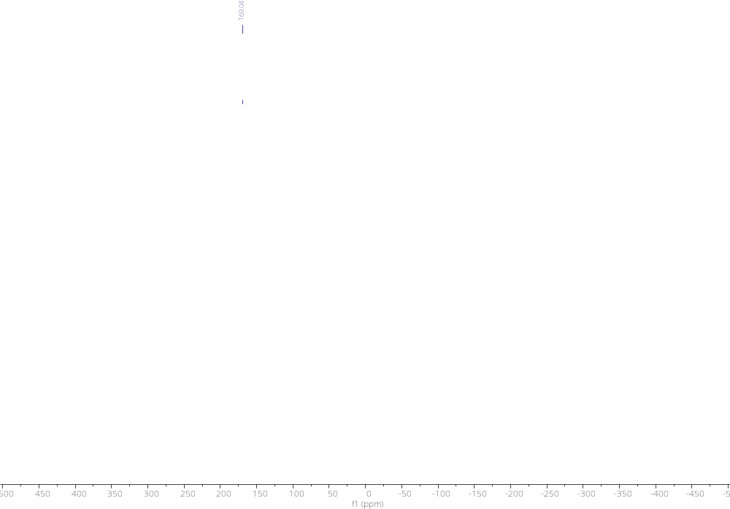
Figure S27. ³¹P NMR spectrum of 5 (162 MHz, C₆D₆).
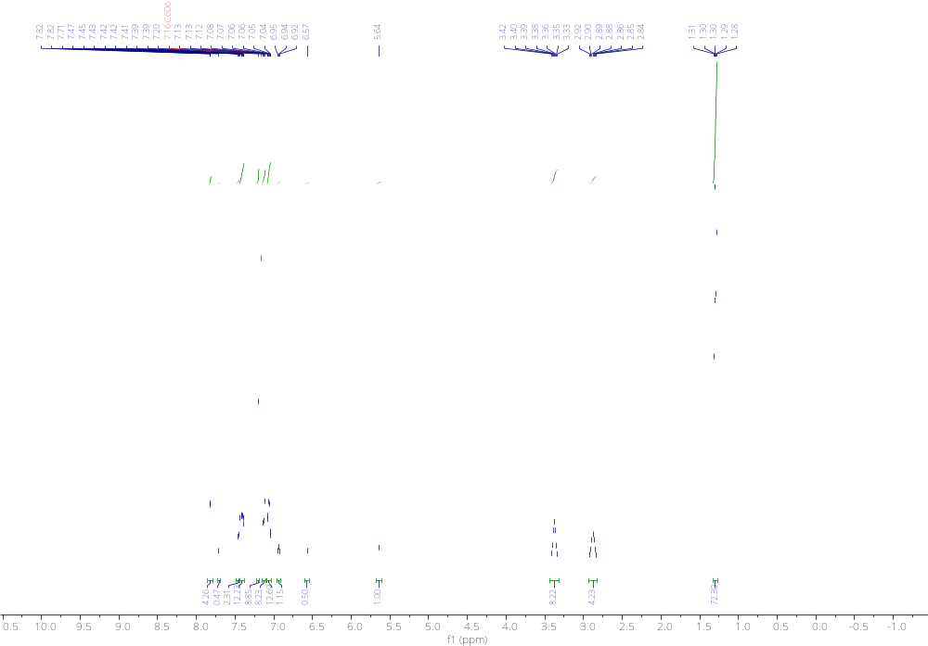
Figure S28. ¹H NMR spectrum of 6 (500 MHz, C₆D₆).
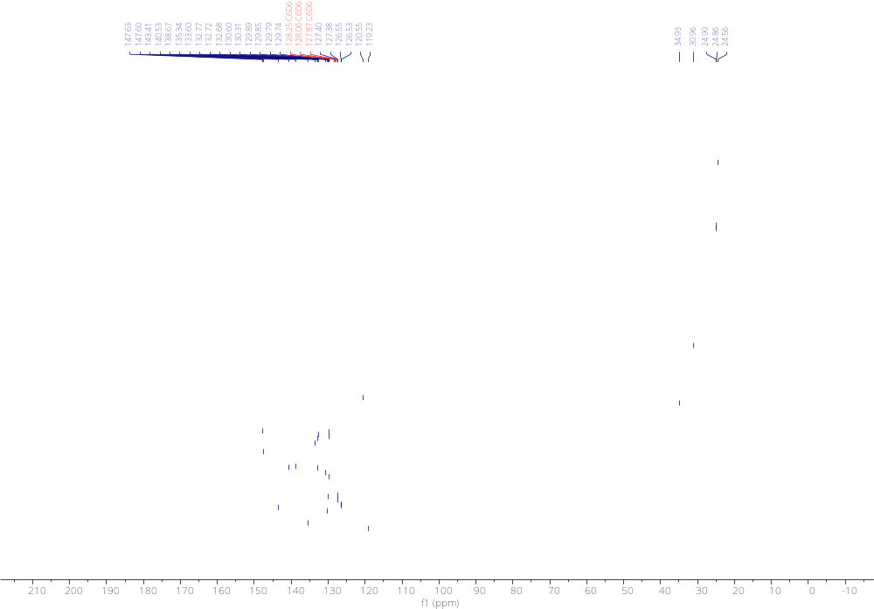
Figure S29. ¹³C NMR spectrum of 6 (125 MHz, C₆D₆).
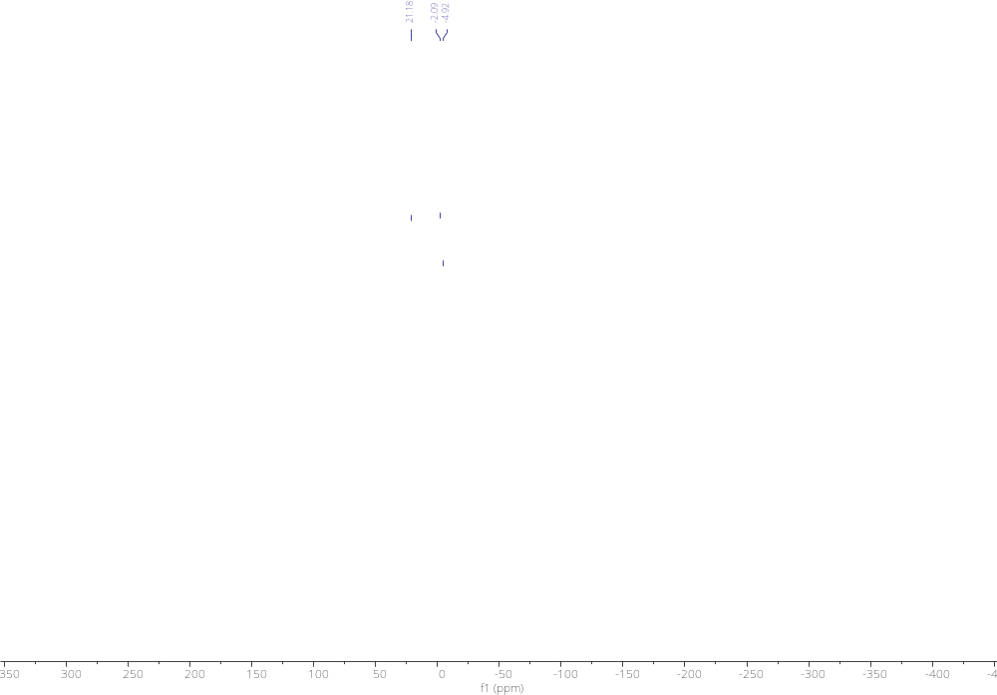
Figure S30. ³¹P NMR spectrum of 6 (202 MHz, C₆D₆).
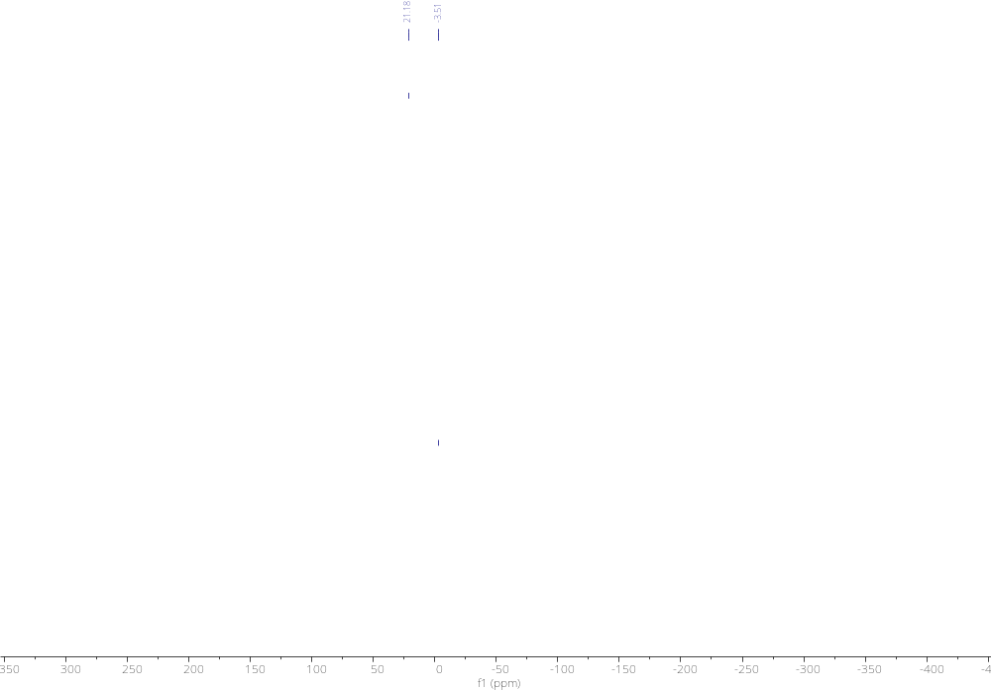
Figure S31. ³¹P{¹H} NMR spectrum of 6 (202 MHz, C₆D₆).
Figure S32. ¹H-¹H NOESY NMR spectrum of 6 (500 MHz, C₆D₆).
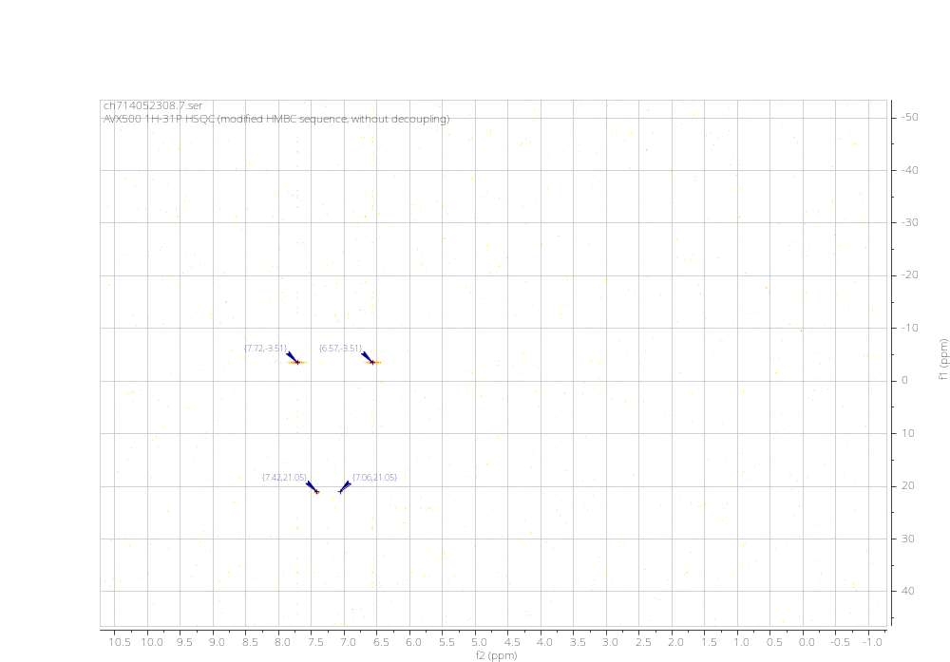
Figure S33. ¹H-³¹P HSQC NMR spectrum of 6 (500 MHz, C₆D₆).
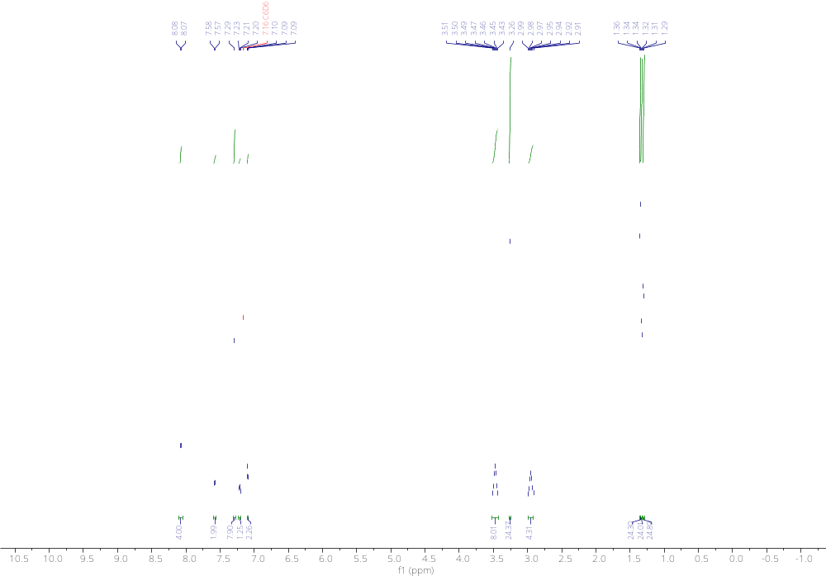
Figure S34. ¹H NMR spectrum of 7 (500 MHz, C₆D₆).
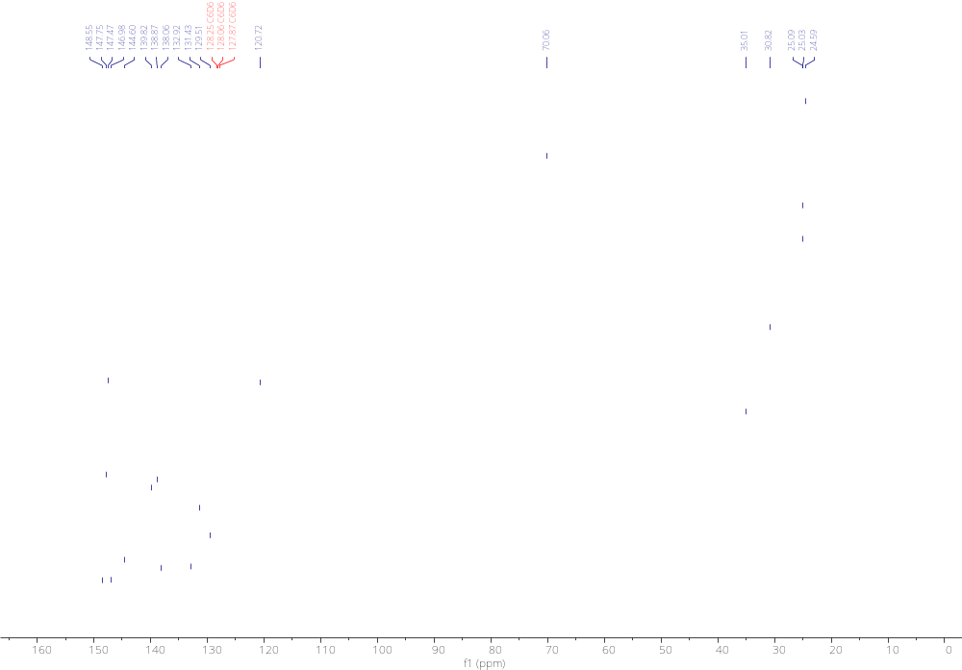
Figure S35. ¹³C NMR spectrum of 7 (125 MHz, C₆D₆).
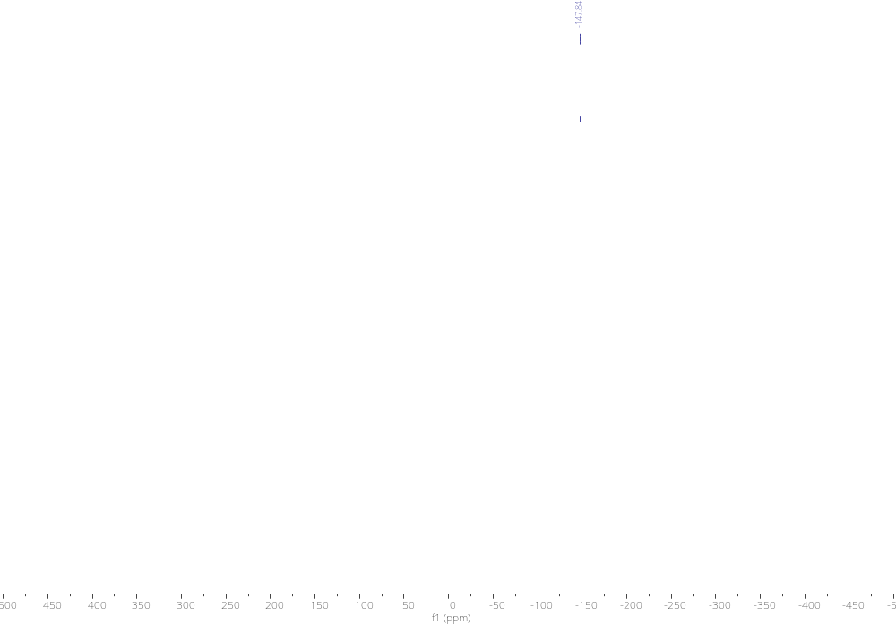
Figure S36. ³¹P{¹H} NMR spectrum of 7 (162 MHz, C₆D₆).
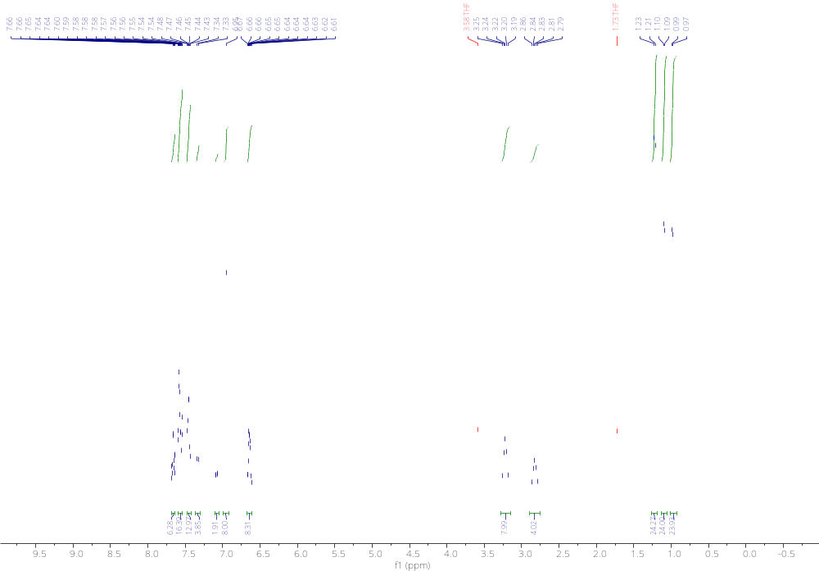
Figure S37. ¹H NMR spectrum of 8 (400 MHz, d₈-THF).
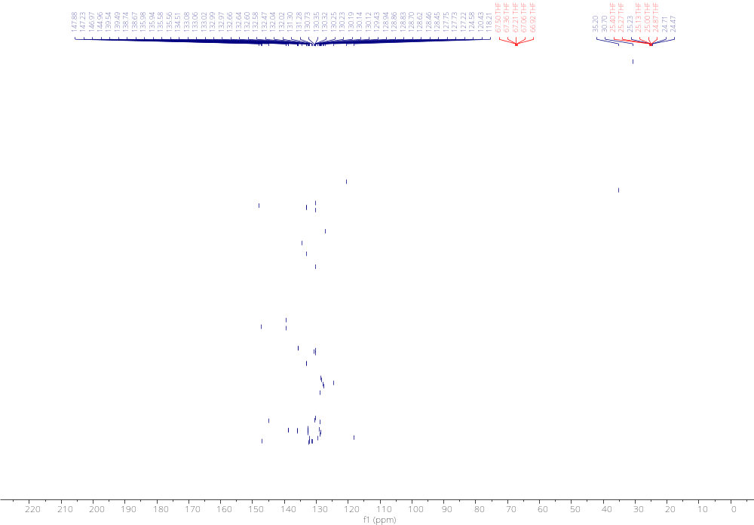
Figure S38. ¹³C NMR spectrum of 8 (600 MHz, d₈-THF).
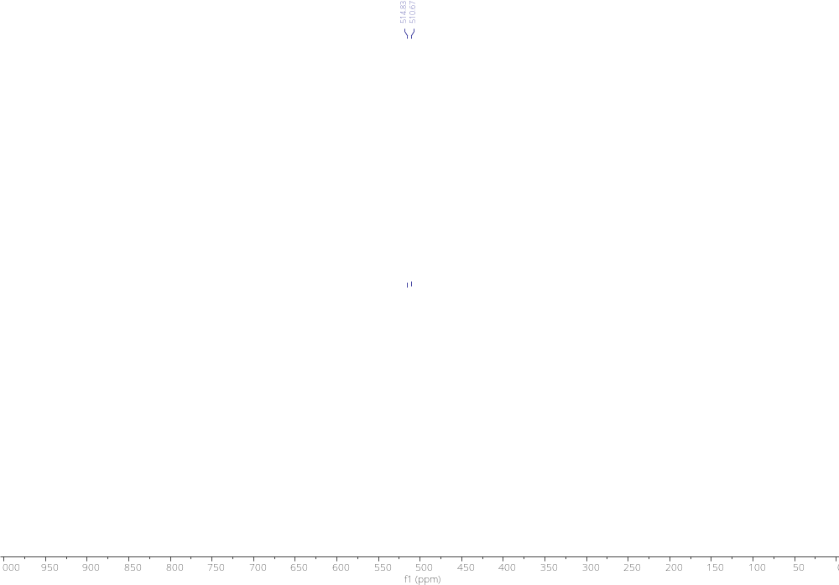
Figure S39. ⁷⁷Se NMR spectrum of 8 (95.4 MHz, d₈-THF).
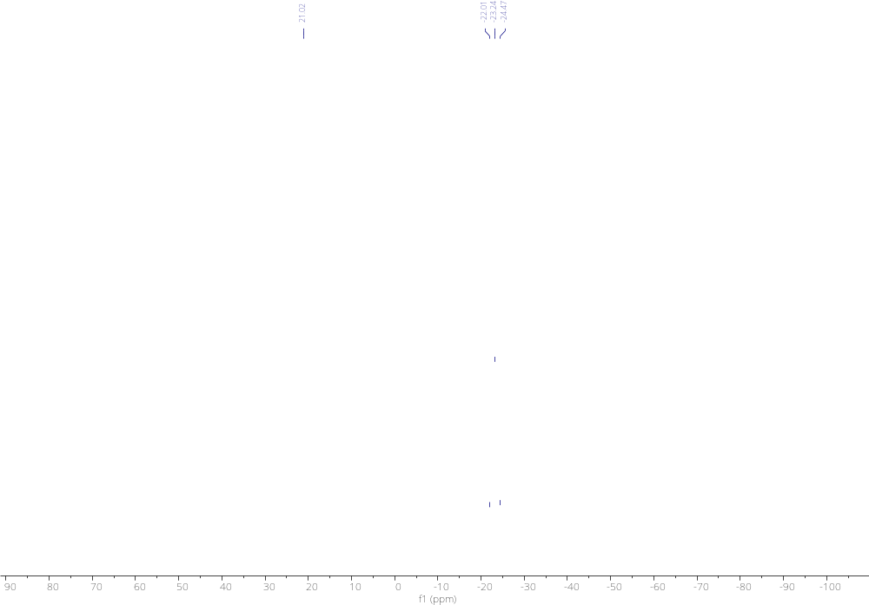
Figure S40. ³¹P NMR spectrum of 8 (162 MHz, d₈-THF).
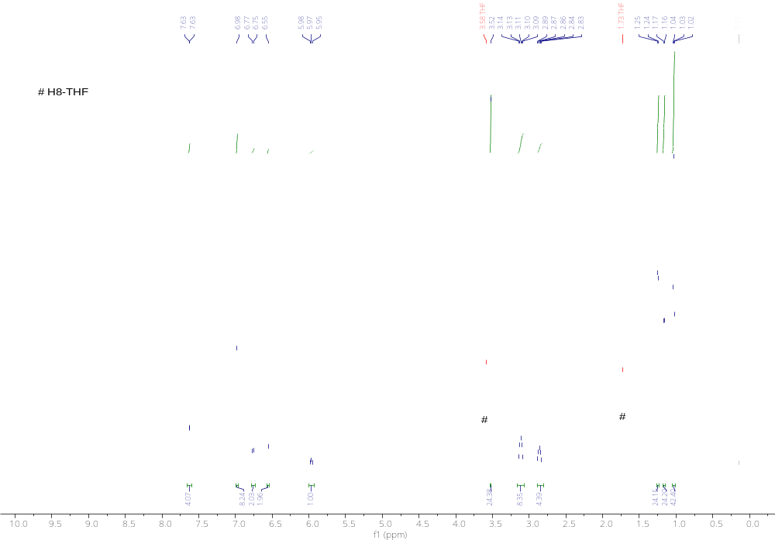
Figure S41. ¹H NMR spectrum of S3 (500 MHz, d₈-THF).
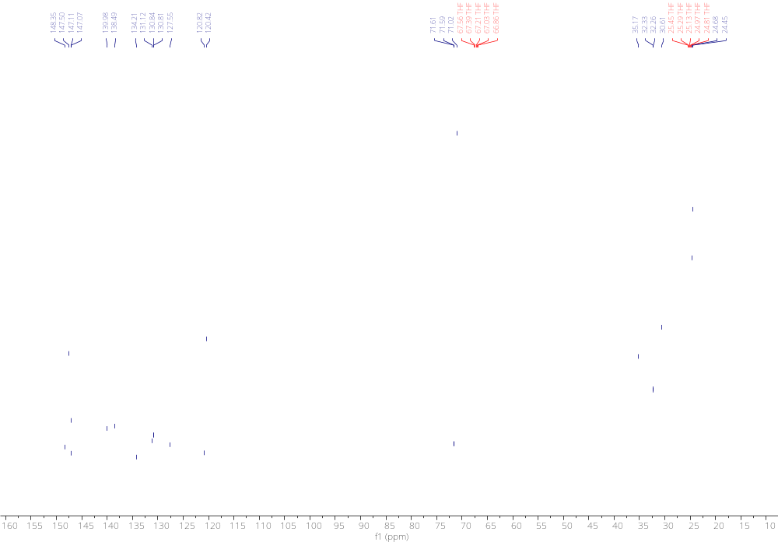
Figure S42. ¹³C NMR spectrum of S3 (125 MHz, d₈-THF).
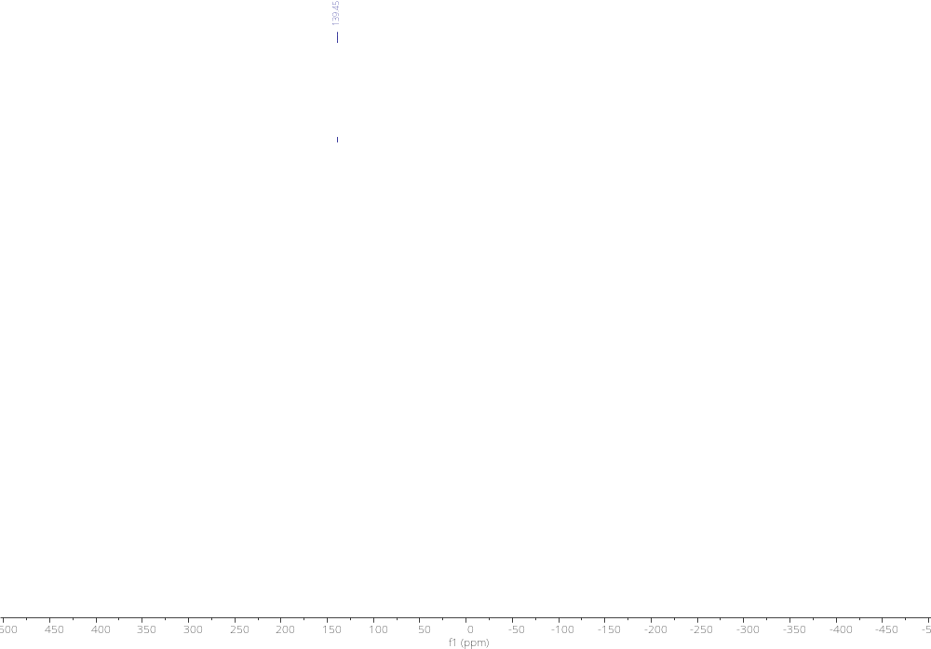
Figure S43. ³¹P NMR spectrum of S3 (162 MHz, d₈-THF).

5. X-ray Crystallographic Studies
Single-crystal X-ray diffraction data were collected using an Oxford Diffraction Supernova dual-source diffractometer equipped with a 135 mm Atlas CCD area detector. Crystals were selected under Paratone-N oil, mounted on micromount loops and quench-cooled using an Oxford Cryosystems open flow N₂ cooling device. Data were collected at 150 K using mirror monochromated Cu Kα (λ = 1.54184 Å) radiation and processed using the CrysAlisPro package, including unit cell parameter refinement and inter-frame scaling (which was carried out using SCALE3 ABSPACK within CrysAlisPro).^{[2]} Structures were subsequently solved using direct methods. ^{[3]}

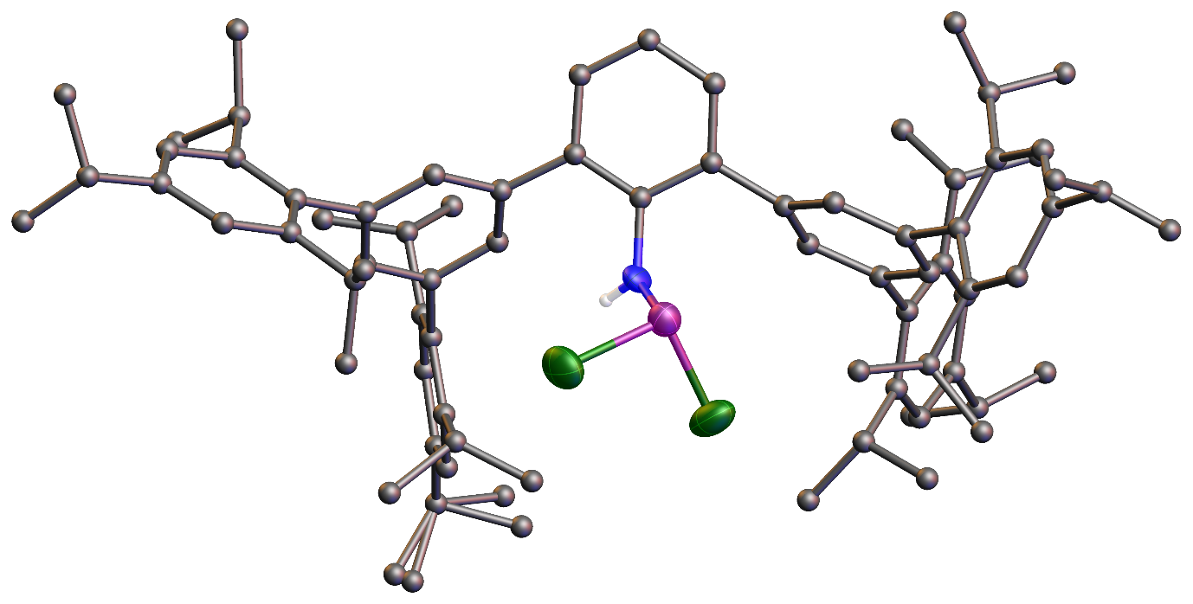
Figure S44. Single crystal X-ray structure of S2·hex. Thermal ellipsoids pictured at 50% probability level. Solvent of crystallization, hydrogen atoms (except for H1N), and minor disordered components are removed for clarity. Nitrogen: blue; Phosphorus: purple; Chlorine: green.

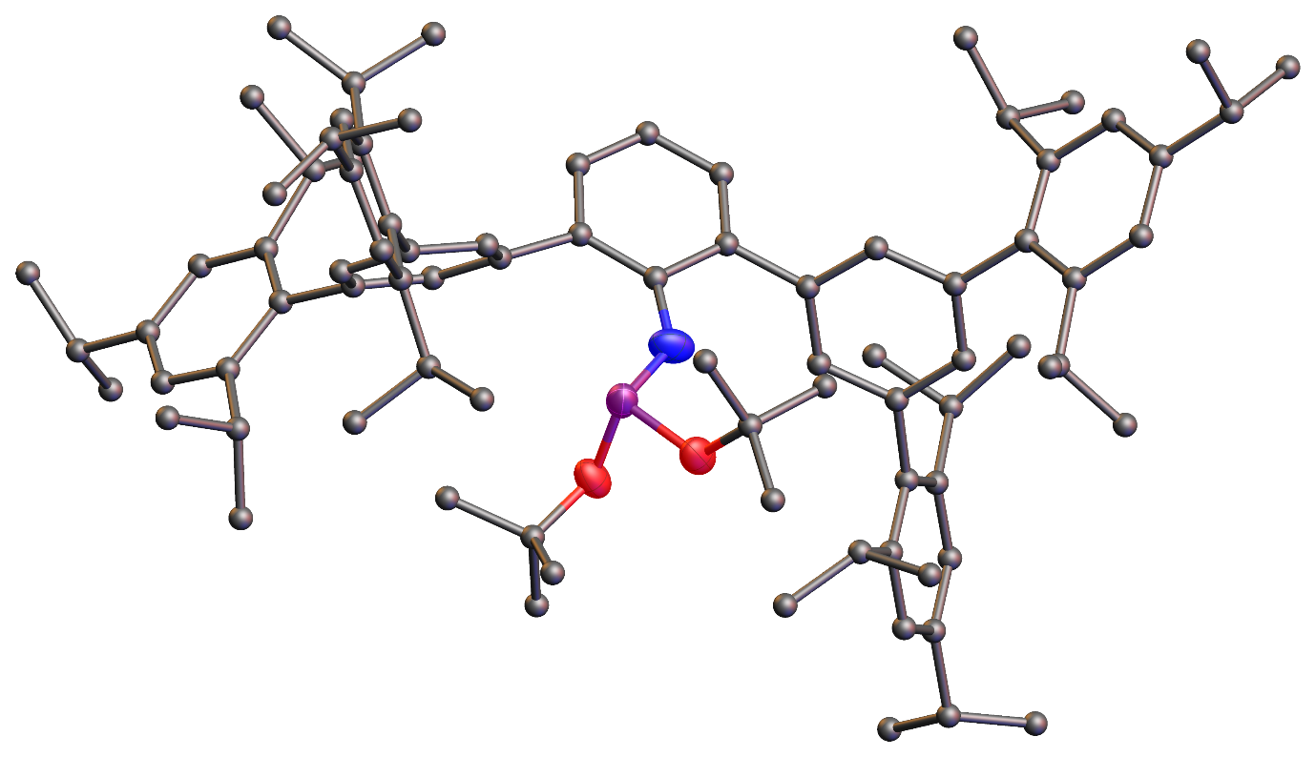
Figure S45. Single crystal X-ray structure of S3. Thermal ellipsoids pictured at 50% probability level. Solvent of crystallization, hydrogen atoms, [K(18-crown-6)(THF)₂]⁺ counter cation, and minor disordered components are removed for clarity. Nitrogen: blue; Phosphorus: purple; Oxygen: red.

Table S2. Selected X-ray data collection/refinement parameters for S2·hex, 2·hex, S3 and 3·2tol.
 | S2·hex | 2·hex | S3 | 3·2tol
Formula | C₈₄H₁₁₅Cl₂NP | C₈₄H₁₁₅ClNP | C₁₀₆H₁₅₉KNO₁₀P | C₁₀₄H₁₄₁KNO₇P
CCDC | 2339506 | 2339507 | 2339508 | 2339509
Fw [g mol^{–1}] | 1240.63 | 1205.18 | 1677.40 | 1587.24
Crystal system | monoclinic | triclinic | monoclinic | monoclinic
Space group | P2₁/c | P$\overline{\text{1}}$ | Cc | P2₁/c
a (Å) | 12.7686(2) | 10.8284(2) | 18.3672(1) | 12.6495(2)
b (Å) | 18.4116(3) | 17.3676(4) | 20.3124(1) | 19.3622(3)
c (Å) | 32.9514(6) | 21.7267(4) | 28.4218(1) | 40.1290(6)
α (°) | 90 | 76.291(2) | 90 | 90
β (°) | 92.0540(10) | 89.186(2) | 108.357(1) | 98.989(2)
γ (°) | 90 | 81.360(2) | 90 | 90
V (Å³) | 7741.6(2) | 3923.57(14) | 10064.06(10) | 9707.8(3)
Z | 4 | 2 | 4 | 4
Radiation, λ (Å) | Cu Kα, 1.54184 | Cu Kα, 1.54184 | Cu Kα, 1.54184 | Cu Kα, 1.54184
Temp (K) | 150(2) | 150(2) | 150(2) | 150(2)
ρ_{calc} (g cm^{–3}) | 1.064 | 1.020 | 1.107 | 1.086
μ (mm^{–1}) | 1.248 | 0.913 | 1.038 | 1.031
Reflections collected | 63407 | 86968 | 131464 | 88768
Independent reflections | 16035 | 16297 | 20225 | 20094
Parameters | 862 | 918 | 1215 | 1241
R(int) | 0.0616 | 0.0380 | 0.0245 | 0.0718
R1/wR2,^{[a]} I ≥ 2σI (%) | 7.41/20.29 | 7.75/22.89 | 5.13/13.59 | 5.95/15.30
R1/wR2,^{[a]} all data (%) | 10.35/23.23 | 9.35/24.76 | 5.25/13.72 | 9.17/18.13
GOF | 1.032 | 1.040 | 1.060 | 1.023
^{[a]} R1 = [Σ||F_{o}| – |F_{c}||]/Σ|F_{o}|; wR2 = {[Σw[(F_{o})² – (F_{c})²]²]/[Σw(F_{o}²)²}^{1/2}; w = [σ²(F_{o})² + (AP)² + BP]^{–1}, where P = [(F_{o})² + 2(F_{c})²]/3 and the A and B values are 0.1264 and 5.02 for S2·hex, 0.1404 and 2.33 for 2·hex, 0.0686 and 10.56 for S3, and 0.0863 and 2.17 for 3·2tol.

Table S3. Selected X-ray data collection/refinement parameters for 4, 5·hex, 6 and 7·hex.
 | 4 | 5·hex | 6 | 7·hex
Formula | C₈₈H₁₁₅NOP | C₉₃H₁₃₆NOPSi | C₁₁₈H₁₄₂N₂O₃P₃ | C₉₆H₁₃₉I₂KNO₇P
CCDC | 2339510 | 2339511 | 2339512 | 2339513
Fw [g mol^{–1}] | 1233.77 | 1343.08 | 1729.24 | 1742.94
Crystal system | triclinic | triclinic | monoclinic | monoclinic
Space group | P$\overline{\text{1}}$ | P$\overline{\text{1}}$ | P2₁/c | P2₁/n
a (Å) | 17.9057(8) | 10.9370(4) | 20.0566(2) | 22.1567(6)
b (Å) | 18.2358(8) | 19.8302(9) | 34.5871(3) | 12.4108(4)
c (Å) | 28.0067(15) | 21.5571(8) | 17.4123(1) | 36.1453(11)
α (°) | 83.449(4) | 76.643(4) | 90 | 90
β (°) | 77.074(4) | 83.450(3) | 97.495(1) | 103.880(3)
γ (°) | 68.082(4) | 74.530(4) | 90 | 90
V (Å³) | 8264.2(7) | 4377.2(3) | 11975.71(17) | 9649.1(5)
Z | 4 | 2 | 4 | 4
Radiation, λ (Å) | Cu Kα, 1.54184 | Cu Kα, 1.54184 | Cu Kα, 1.54184 | Cu Kα, 1.54184
Temp (K) | 150(2) | 150(2) | 150(2) | 150(2)
ρ_{calc} (g cm^{–3}) | 0.992 | 1.019 | 0.959 | 1.200
μ (mm^{–1}) | 0.597 | 0.721 | 0.788 | 6.040
Reflections collected | 38711 | 73507 | 150324 | 157402
Independent reflections | 17754 | 18081 | 24932 | 17019
Parameters | 1748 | 1024 | 1265 | 1033
R(int) | 0.0882 | 0.0726 | 0.0543 | 0.1713
R1/wR2,^{[a]} I ≥ 2σI (%) | 10.59/24.40 | 6.75/17.71 | 8.56/23.08 | 7.82/20.96
R1/wR2,^{[a]} all data (%) | 23.73/29.80 | 11.25/21.09 | 10.08/24.32 | 10.06/22.64
GOF | 0.952 | 1.024 | 1.081 | 1.040
^{[a]} R1 = [Σ||F_{o}| – |F_{c}||]/Σ|F_{o}|; wR2 = {[Σw[(F_{o})² – (F_{c})²]²]/[Σw(F_{o}²)²}^{1/2}; w = [σ²(F_{o})² + (AP)² + BP]^{–1}, where P = [(F_{o})² + 2(F_{c})²]/3 and the A and B values are 0.1340 and 0.00 for 4, 0.1030 and 1.30 for 5·hex, 0.0980 and 12.87 for 6, and 0.1230 and 15.31 for 7·hex.

Table S4. Selected X-ray data collection/refinement parameters for 8·3THF.
 | 8·3THF
Formula | C₁₃₈H₁₆₅N₂O₄P₃Se₂
CCDC | 2339514
Fw [g mol^{–1}] | 2166.54
Crystal system | orthorhombic
Space group | P2₁2₁2₁
a (Å) | 11.6624(1)
b (Å) | 29.5823(1)
c (Å) | 35.2891(1)
α (°) | 90
β (°) | 90
γ (°) | 90
V (Å³) | 12174.76(12)
Z | 4
Radiation, λ (Å) | Cu Kα, 1.54184
Temp (K) | 150(2)
ρ_{calc} (g cm^{–3}) | 1.182
μ (mm^{–1}) | 1.535
Reflections collected | 307967
Independent reflections | 25427
Parameters | 1554
R(int) | 0.0486
R1/wR2,^{[a]} I ≥ 2σI (%) | 3.74/9.86
R1/wR2,^{[a]} all data (%) | 3.88/9.99
GOF | 1.067
^{[a]} R1 = [Σ||F_{o}| – |F_{c}||]/Σ|F_{o}|; wR2 = {[Σw[(F_{o})² – (F_{c})²]²]/[Σw(F_{o}²)²}^{1/2}; w = [σ²(F_{o})² + (AP)² + BP]^{–1}, where P = [(F_{o})² + 2(F_{c})²]/3 and the A and B values are 0.0510 and 5.37 for 8·3THF.

6. Computational Details
Geometry optimizations were carried out using the Gaussian 16 package with the M06-2X functional.^{[4]} The def2-SVP basis set was used for all the atoms.^{[5]} Frequency calculations at TZVP level^{[6]} of theory were performed to identify the number of imaginary frequencies (zero for local minimum and one for transition states), and provide the thermal corrections of Gibbs free energy. Single-point energy calculations were performed at the M06-2X/def2-TZVP level of theory for the modelling of compounds in solution (Toluene). The gas-phase geometry was used for all the solution phase calculations. The SMD method was used with the corresponding solvent, while Bondi radii were chosen as the atomic radii to define the molecular cavity.^{[7]} The corrections of Gibbs free energy from frequency calculations were added to the single-point energies to obtain the Gibbs free energy in solution. All the energies reported in the paper correspond to the reference state of 1 mol/L, 298K. Natural bond orbital (NBO) calculations were carried out using NBO 7.0 program at the M06-2X/def2-SVP level of theory.^{[8]} The Dual Descriptor calculation was performed using Multiwfn 3.8.^{[9]} Optimized structures and orbitals were visualized using Chemcraft.^{[10]}

6.1 Calculated bond order table for 3,4 and 5
Table S5. Calculated Wiberg Bond Order (WBI) table for 3,4 and 5
Compound | N-P | P-O | N-O
3 | 1.25 | 1.24 | 0.16
4 | 0.88 | 1.40 | 0.11
5 | 1.55 | 0.75 | 0.09

Table S6. Calculated Mayer Bond Order table for 3,4 and 5
Compound | N-P | P-O | N-O
3 | 1.40 | 1.64 | 0.07
4 | 1.06 | 1.83 | 0.06
5 | 1.79 | 1.01 | Not detected

In compound 4, due to the functionalization of N atom, a formal P=O double bond has formed, which leads to an increase of bond order in P–O bond, and a concomitant decrease of bond order for the N–P bond. The N–O bond order also decreases, which can be reasoned by the more localized lone pair on the N atom leading to poorer resonance of the 3c-4e bond. Similarly, in compound 5, upon functionalization of the O atom, a formal N=P double bond is formed, resulting in the increase of N–P bond order as well as decrease of P–O bond order. The N–O bond order in Mayer bond order is not detected because there is no delocalized 3c-4e bond in compound 5.

6.2. Second-order perturbation theory analysis
6.2.1 Compound 4
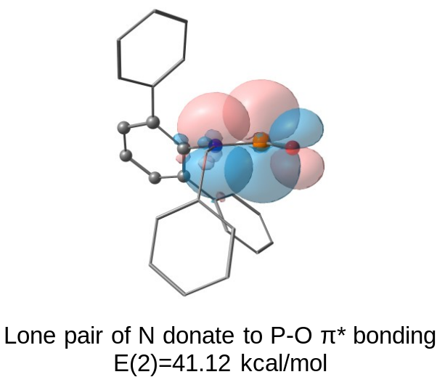
Figure S46. Selected NBOs of 4 from second-order perturbation theory analysis.

6.2.2 Compound 7
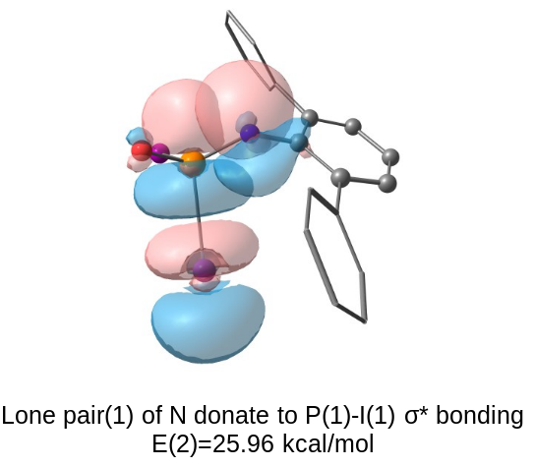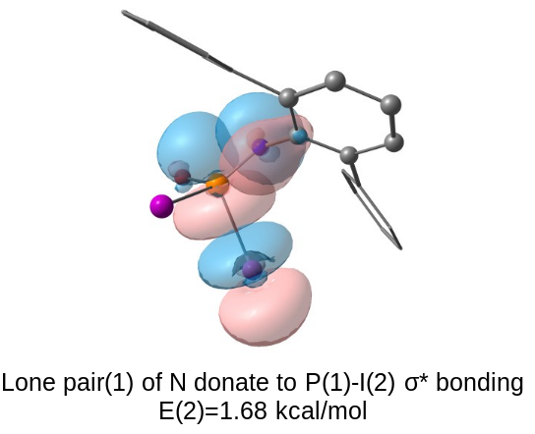
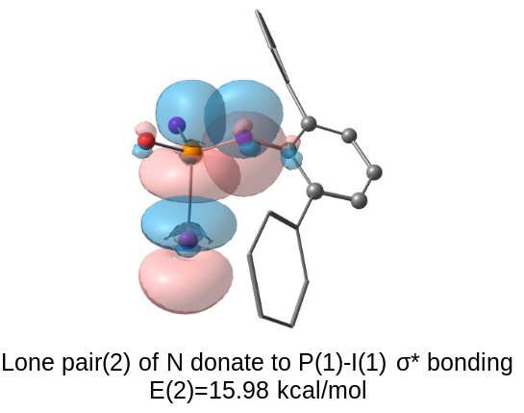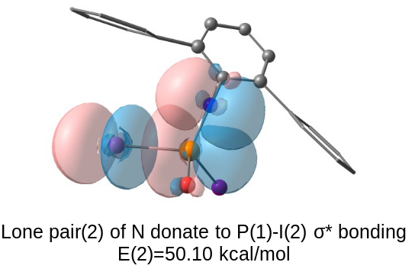
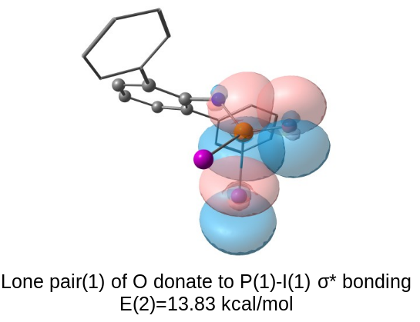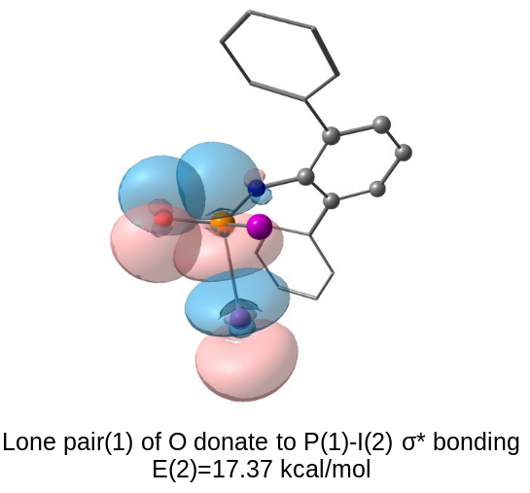
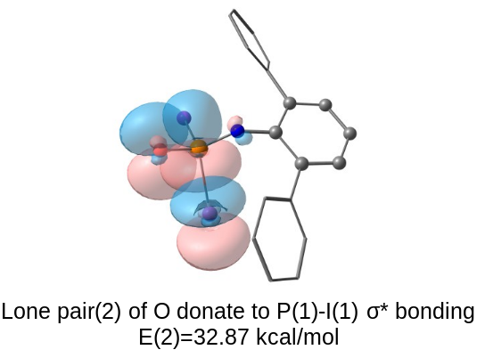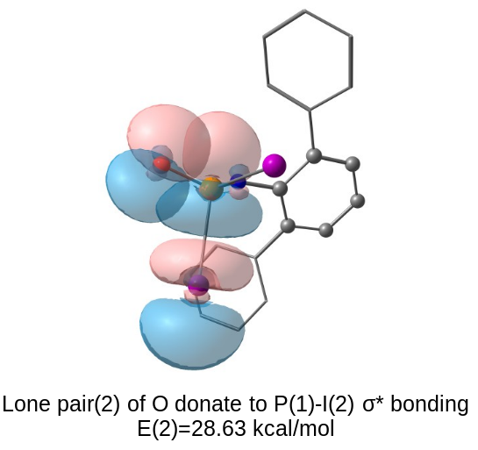
Figure S47. Selected NBOs of 7 from second-order perturbation theory analysis.

Table S7. Selected NBOs of 7 and their electron occupancy
NBO orbital | Electron occupancy
Lone pair (1) of N | 1.72427
Lone pair (2) of N | 1.70190
Lone pair (1) of O | 1.80225
Lone pair (2) of O | 1.76740
P(1)-I(1) σ* orbital | 0.36552
P(1)-I(2) σ* orbital | 0.37733

Due to the strong donation from lone pair electron in nitrogen or oxygen atoms to the two P-I σ* orbitals, the electron occupancy for these lone pair orbitals are slightly away from the theoretical value 2. In consequence, both P-I σ* orbitals are also partially filled.

6.2.3 Compound 8
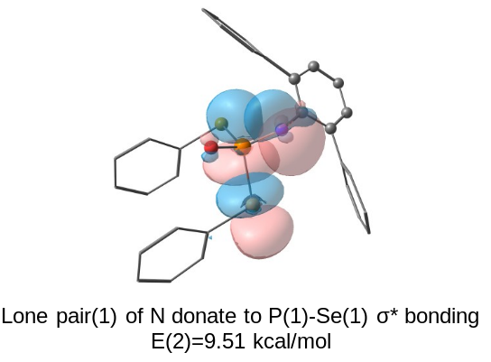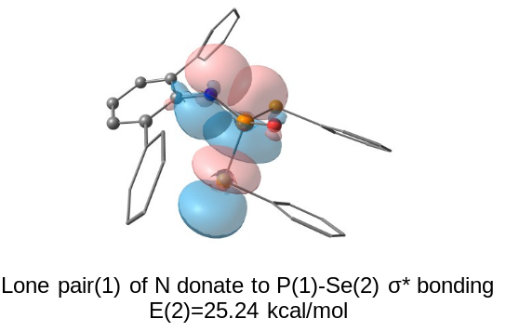
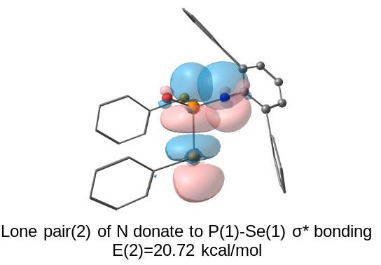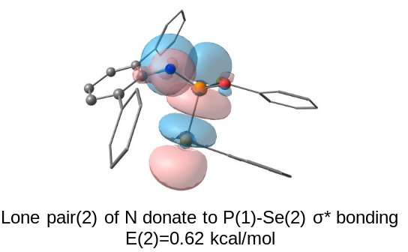
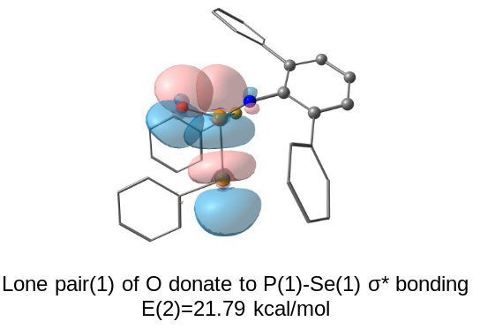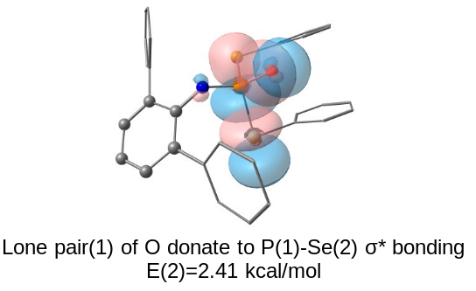
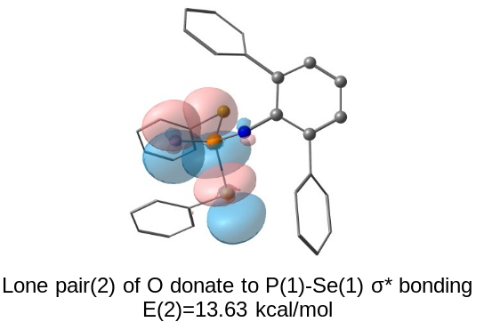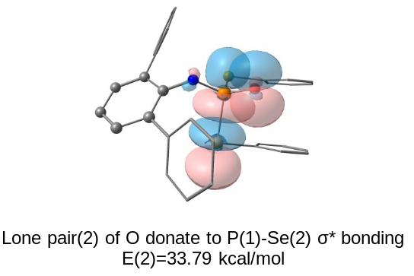
Figure S48. Selected NBOs of 8 from second-order perturbation theory analysis.

Table S8. Selected NBOs of 8 and their electron occupancy

NBO orbital | Electron occupancy
Lone pair (1) of N | 1.76811
Lone pair (2) of N | 1.70788
Lone pair (1) of O | 1.80961
Lone pair (2) of O | 1.79340
P(1)-Se(1) σ* orbital | 0.28540
P(1)-Se(2) σ* orbital | 0.27671

6.3. Energy Calculation for cis-trans isomerization
Table S9. Energies of Intermediates and Transition States and their isomers.
Species | Thermal Corrections of Gibbs Free Energies (Hartree) | Solvation Energies (Hartree)
4 | 1.605981 | -3775.344383
ts–4  cis–4 | 1.607385  1.605403 | -3775.310976  -3775.341842
trans–ArN(Bn)CHO  ts–ArN(Bn)CHO  cis–ArN(Bn)CHO | 1.622093  1.621863  1.621685 | -3472.672708  -3472.631515  -3472.668582

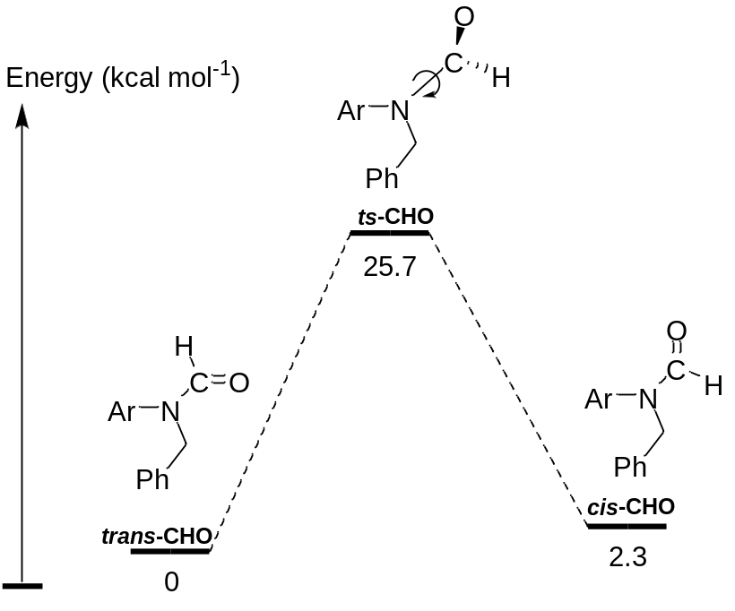
Figure S49. Energy plot for amide cis-trans isomerization

For comparison, here we have calculated the cis-trans isomerization process for an amide with same substituent as 4. The energy barrier was determined to be 25.7 kcal/mol, while conventional amides have a 19–20 kcal/mol energy barriers.^{[11]} This increase in energy barrier may be attributed to the extremely bulky meta-substituted terphenyl ligand. Compared to the calculated energy barrier for 4 (21.8 kcal/mol), the amide analog has a slightly higher energy barrier indicating that the N–P π bond is on a comparable order with the N–C π bond in amides, but slightly weaker.

6.4. Cartesian Coordinates
Me–NPO–
C 5.48340832 10.43011940 1.96636122
H 5.85371809 10.95156426 2.87324257
H 6.37468505 10.03451311 1.43164038
H 4.93713467 9.52499040 2.31150874
N 4.66988961 11.25479754 1.11478655
P 4.36750756 12.77727541 1.49869302
O 4.98540493 13.28269725 2.79794183

4
C -0.15050700 -0.09323000 -1.43280900
C 1.06512700 -0.17066700 -2.14535600
C 1.03232600 -0.14622100 -3.54565400
C -0.17054000 -0.07193800 -4.23854000
C -1.36443000 0.03816300 -3.53144100
C -1.36683000 0.06032400 -2.13476900
C -2.64652300 0.27577800 -1.40624600
C -2.78991900 1.37637300 -0.55532500
C -3.96662700 1.57118600 0.17286300
C -4.99300100 0.62656400 0.05541200
C -4.88218000 -0.46899200 -0.80467200
C -3.70778800 -0.62450200 -1.54807000
C -5.97249200 -1.48944200 -0.87850200
C -7.09929100 -1.27159000 -1.70088000
C -8.08650300 -2.25595300 -1.75920300
C -7.99058000 -3.44335500 -1.02598300
C -6.87971300 -3.62363600 -0.20507000
C -5.86714400 -2.66192200 -0.10765600
C -4.16185800 2.77333900 1.03963400
C -3.46728600 2.89837200 2.26574700
C -3.72493700 4.01084600 3.06563700
C -4.64119600 5.00191700 2.69653000
C -5.29644200 4.86609700 1.47603000
C -5.06594100 3.77182300 0.63215800
C 3.23023300 0.91741600 -1.61508500
C 4.48828600 0.96229200 -1.00889800
C 4.91062700 -0.13771600 -0.25790900
C 4.10250100 -1.26869600 -0.10345400
C 2.84677400 -1.29555600 -0.72179500
C 2.39970600 -0.20084200 -1.47285400
C 4.59934900 -2.43857600 0.68820000
C 5.31242300 -3.45964500 0.03463500
C 5.75209000 -4.55949400 0.78176900
C 5.52466100 -4.65646500 2.15273900
C 4.83123900 -3.61846700 2.78349900
C 4.34994800 -2.51558300 2.07715600
C 5.34841400 2.18039000 -1.11921600
C 5.24074500 3.18988600 -0.14497000
C 6.05132400 4.32516000 -0.26247600
C 6.95916500 4.47865200 -1.30812300
C 7.04790600 3.46045700 -2.26258200
C 6.25759700 2.31255000 -2.19070600
C -7.20872700 -0.01200700 -2.55000700
C -4.67585300 -2.90950200 0.80850900
C -2.50257500 1.81743500 2.73885300
C -5.79793500 3.70975300 -0.70310400
C 5.56257300 -3.41445100 -1.46668300
C 3.54875700 -1.43328100 2.78438500
C 4.22817800 3.09969500 0.98902800
C 6.41343100 1.20225000 -3.22104000
C -8.64851000 0.44673400 -2.78083700
C -6.48662600 -0.20971600 -3.88860100
C -5.09237200 -3.40308500 2.19610300
C -3.67937700 -3.87665500 0.16029200
C -3.26738800 0.63540000 3.34749500
C -1.44090000 2.32297800 3.71481800
C -7.28550100 3.39651500 -0.50970800
C -5.61397700 4.99613500 -1.51440800
C 4.49416300 -4.22408000 -2.21016500
C 6.96834800 -3.87808400 -1.85362500
C 2.80975800 -1.92308600 4.03086600
C 4.40953700 -0.21878500 3.15435200
C 2.98769300 3.93802100 0.66089000
C 4.81601600 3.49545800 2.34491100
C 6.72860700 1.71758400 -4.62606500
C 7.47857500 0.19607100 -2.76694600
H 1.97773000 -0.20573400 -4.08761600
H -0.17652100 -0.07773400 -5.32911400
H -2.31453100 0.14561800 -4.05851600
H -1.97469500 2.09882700 -0.46654400
H -5.90182500 0.74752200 0.65086600
H -3.60143800 -1.48532500 -2.21419000
H -8.96063600 -2.09614600 -2.39426900
H -6.80440300 -4.54214300 0.38288500
H -3.20170700 4.11854400 4.01837600
H -6.00834800 5.63084500 1.15922700
H 2.88257900 1.77677800 -2.19424900
H 5.89144800 -0.11176300 0.22395800
H 2.21971700 -2.18162000 -0.61975100
H 6.29237200 -5.36711900 0.28151200
H 4.63933700 -3.68360000 3.85698700
H 5.97111000 5.12019700 0.48333200
H 7.75503600 3.56885400 -3.08828500
H -6.69128700 0.79550300 -2.00842900
H -4.16046800 -1.94792000 0.95103900
H -1.97575800 1.43489000 1.84979600
H -5.35863900 2.89245200 -1.29302100
H 5.46572400 -2.36673200 -1.78869200
H 2.78323000 -1.08853200 2.07427400
H 3.90342000 2.05135400 1.07037700
H 5.45320300 0.66661200 -3.27328700
H -9.19678500 -0.24644300 -3.43650600
H -9.20157900 0.53292200 -1.83430800
H -8.65474100 1.42930700 -3.27480500
H -6.95669200 -1.02779300 -4.45607200
H -6.53531500 0.70565100 -4.49743500
H -5.42874500 -0.46628100 -3.73629600
H -4.21493200 -3.45358600 2.85743200
H -5.83077000 -2.72910600 2.65347700
H -5.53022900 -4.41171300 2.15564200
H -3.32848600 -3.49642100 -0.81069700
H -2.79935700 -4.02849900 0.80428400
H -4.14984300 -4.85672600 -0.01585900
H -2.56544500 -0.15130900 3.66374300
H -3.83458200 0.96604200 4.23130800
H -3.97879100 0.20085200 2.63003900
H -0.94098400 3.22599900 3.33234300
H -1.87853200 2.56462000 4.69544000
H -0.67744400 1.54751700 3.86124500
H -7.43079000 2.43971300 0.01284000
H -7.77490800 4.18146300 0.08776800
H -7.80057800 3.33805300 -1.48077100
H -6.06610900 4.88545900 -2.51113800
H -6.09776300 5.85571800 -1.02674200
H -4.54876400 5.23482900 -1.64273300
H 3.48513800 -3.84739100 -1.98825300
H 4.65358800 -4.17539000 -3.29808500
H 4.53425200 -5.28190300 -1.90450000
H 7.14209500 -3.70119400 -2.92530300
H 7.73898900 -3.33684000 -1.28595400
H 7.10718900 -4.95503600 -1.67571200
H 3.49479400 -2.05153700 4.88346900
H 2.05050100 -1.17927800 4.31213200
H 2.30430100 -2.88550500 3.86219000
H 5.17772300 -0.50303000 3.89046400
H 4.91948100 0.20807300 2.28083400
H 3.77552900 0.56511000 3.59629700
H 2.24413900 3.86662400 1.46948300
H 3.25997000 4.99766900 0.53475800
H 2.51349000 3.59535400 -0.27057100
H 5.72395600 2.91754500 2.57075100
H 5.07406700 4.56460900 2.38155000
H 4.08216700 3.30847300 3.14257100
H 6.01887700 2.49689600 -4.93853900
H 7.74422700 2.13666100 -4.68664900
H 6.67716100 0.89182800 -5.35040400
H 7.57696900 -0.62386400 -3.49475100
H 8.45650300 0.69322000 -2.67310100
H 7.22672000 -0.24117500 -1.79046300
N -0.17397700 -0.21014800 -0.00812800
P 0.74906800 0.81008700 0.96867200
O 0.69258500 0.25220700 2.35527500
C 7.82821300 5.71835900 -1.41238200
H 7.57015100 6.36473800 -0.55785100
C 7.53800500 6.49987300 -2.69690000
H 6.47459100 6.76865000 -2.76591300
H 8.13360100 7.42412500 -2.73353200
H 7.79276500 5.90123700 -3.58503000
C 9.31551600 5.36978100 -1.30482800
H 9.52921700 4.82668600 -0.37361000
H 9.62939100 4.73304600 -2.14628700
H 9.93188000 6.28081400 -1.32559500
C 5.99039700 -5.86790300 2.93871600
H 6.54009500 -6.51604700 2.23690500
C 4.79678000 -6.66372300 3.47635600
H 5.13320900 -7.57042600 4.00094400
H 4.21507600 -6.05868200 4.18927000
H 4.12270400 -6.96503100 2.66140900
C 6.94762600 -5.48038800 4.06876000
H 7.81140900 -4.92145300 3.68249100
H 6.44100400 -4.84683800 4.81269900
H 7.31762700 -6.37616000 4.58923100
C -9.07768300 -4.49867900 -1.11233000
H -8.77115600 -5.33026800 -0.45725400
C -9.21488300 -5.04797000 -2.53510600
H -8.25878900 -5.44927600 -2.89938900
H -9.96568400 -5.85121400 -2.57160600
H -9.53596300 -4.25730800 -3.23058400
C -10.41725900 -3.96438900 -0.59722600
H -10.32542600 -3.59045800 0.43210900
H -10.77518000 -3.13501500 -1.22651900
H -11.18383500 -4.75329900 -0.61376700
C -4.83634500 6.20626300 3.60144500
H -4.77920900 5.83378300 4.63802700
C -6.18748000 6.89564600 3.42573600
H -6.32209000 7.66994200 4.19440100
H -6.25649300 7.39377800 2.44664200
H -7.01946000 6.18140800 3.50521400
C -3.68993600 7.20571100 3.40206000
H -3.78982900 8.06017500 4.08804400
H -2.71345100 6.73266200 3.57724500
H -3.69755300 7.58855700 2.36992300
C -0.88590400 -1.36917900 0.56872100
H -1.86875800 -1.45625100 0.08598500
H -1.03936200 -1.15314900 1.63385900
C -0.09646900 -2.64199800 0.39894000
C -0.12912200 -3.34541100 -0.81106700
C 0.74832800 -3.07920200 1.42308000
C 0.68836400 -4.45958100 -0.99842000
H -0.78727000 -3.00521700 -1.61554100
C 1.56349000 -4.19663000 1.23895100
H 0.77663600 -2.51240400 2.35639900
C 1.53964800 -4.88289900 0.02458400
H 0.66596400 -4.99712300 -1.94788700
H 2.23596400 -4.52339200 2.03467700
H 2.18969600 -5.74678800 -0.12459600

ts–4
C -2.40242500 4.79321800 3.59665900
C -3.78655200 4.68576400 3.33196600
C -4.67620400 5.58724700 3.92556600
C -4.22241800 6.56068600 4.80947400
C -2.86020400 6.66258600 5.07758500
C -1.93864800 5.81449100 4.45665900
C -0.48698100 5.95799400 4.74674400
C 0.43896600 6.17410800 3.71927800
C 1.80877100 6.20523000 3.99601000
C 2.24263400 5.97340600 5.30821800
C 1.33534300 5.77909800 6.35499200
C -0.03252400 5.80432600 6.06014700
C 1.80819500 5.51674300 7.75064700
C 2.41372900 6.55201800 8.49865400
C 2.85404600 6.27660000 9.79482700
C 2.70923600 5.01291800 10.37183700
C 2.10400600 4.00926400 9.61807300
C 1.64829600 4.23160500 8.31414700
C 2.79726300 6.52650200 2.91843900
C 3.16507100 5.55415300 1.96035100
C 4.08963000 5.89917500 0.97669300
C 4.66694600 7.17214400 0.90911200
C 4.28841400 8.11338100 1.86216300
C 3.35543600 7.81585100 2.86461900
C -4.92084600 4.01702400 1.20678900
C -5.33254600 3.05374900 0.27759700
C -5.11188800 1.70500800 0.56444200
C -4.49247200 1.30345700 1.75554300
C -4.11213700 2.28039100 2.67737900
C -4.30058000 3.64063100 2.40164400
C -4.25600400 -0.14595800 2.05441400
C -5.22778800 -0.86311500 2.77421600
C -4.97823800 -2.20224100 3.10182500
C -3.80422700 -2.84640200 2.72249000
C -2.85696800 -2.11794000 1.99346700
C -3.05477500 -0.77938300 1.65274700
C -5.92771400 3.46085700 -1.03258400
C -5.07716100 3.67675300 -2.13386000
C -5.64529800 4.05350000 -3.35602600
C -7.02078600 4.21653700 -3.51125300
C -7.84303900 3.99817700 -2.40174200
C -7.32280800 3.62526400 -1.16137200
C 2.51953900 7.96552500 7.93689000
C 1.05702600 3.08030600 7.50754900
C 2.62583700 4.13536800 2.05456700
C 2.97636400 8.90764800 3.85650900
C -6.51761800 -0.20291700 3.24148700
C -1.99539700 -0.02294200 0.85947500
C -3.56374800 3.57129900 -1.99813200
C -8.24977500 3.35447400 0.01577700
C 3.62862200 8.80129500 8.57401500
C 1.17115500 8.68715600 8.05546000
C 2.10834900 2.48910000 6.56221600
C 0.42623600 1.97684300 8.35495500
C 3.46711200 3.32568600 3.04798300
C 2.53804400 3.41603100 0.71004100
C 4.16192200 9.27318300 4.75514300
C 2.41924400 10.14574500 3.14753200
C -6.40043400 0.21809700 4.71042600
C -7.74921800 -1.08352900 3.01869500
C -0.59075600 -0.62301000 0.96003900
C -2.36796800 0.09373400 -0.62475900
C -2.95086100 4.95719600 -1.76303800
C -2.89854800 2.87630000 -3.18706300
C -9.47344900 4.27134300 0.04733500
C -8.68118300 1.88259100 0.03192700
H -5.74109200 5.49321300 3.70491700
H -4.92788700 7.24372400 5.28398000
H -2.48605200 7.43357200 5.75427900
H 0.09827900 6.29219300 2.68799900
H 3.31589900 5.95742000 5.52092700
H -0.75405600 5.64982400 6.86793000
H 3.32292700 7.07117500 10.37826800
H 1.98883000 3.02020900 10.06539900
H 4.38257100 5.15527300 0.23175100
H 4.72262000 9.11504200 1.83239400
H -5.06446800 5.07721000 0.98153600
H -5.42049400 0.94865200 -0.16174500
H -3.64678800 1.98070000 3.61652300
H -5.72425400 -2.76270900 3.67104700
H -1.93219500 -2.61337000 1.69100500
H -4.99617400 4.23064500 -4.21716400
H -8.92283900 4.12491800 -2.50927500
H 2.75172300 7.88273000 6.86524400
H 0.25716200 3.49232000 6.87775900
H 1.60215300 4.21127600 2.44857600
H 2.17647100 8.52007400 4.50378300
H -6.65948400 0.71090500 2.64592800
H -1.96348800 0.99840500 1.27710700
H -3.34797400 2.96483600 -1.10563600
H -7.67357000 3.54065300 0.93508300
H 3.39472000 9.05942400 9.61797200
H 4.59360900 8.27408500 8.55904200
H 3.74596200 9.74714400 8.02608500
H 0.88458200 8.78578900 9.11398400
H 1.23141500 9.69557500 7.61808500
H 0.37532600 8.13493500 7.53593000
H 1.66157700 1.69782700 5.93899900
H 2.52360100 3.25823100 5.89691800
H 2.93876000 2.05022000 7.13699000
H -0.29380900 2.38287300 9.08092400
H -0.10798400 1.27193400 7.70024800
H 1.18532300 1.40290300 8.90811700
H 3.03856700 2.32347600 3.20685000
H 4.49283600 3.20484300 2.66613200
H 3.53045100 3.83092300 4.02177400
H 1.98520800 4.01703700 -0.02393900
H 3.53537500 3.18022300 0.30816100
H 2.00820800 2.45813300 0.83408500
H 4.54129900 8.39208900 5.29444600
H 4.99355400 9.68479200 4.16230400
H 3.86741000 10.03174500 5.49656800
H 2.08611500 10.89237000 3.88388800
H 3.18075400 10.62164400 2.51118500
H 1.56299900 9.88219600 2.51063900
H -5.55929200 0.91043400 4.85989500
H -7.32332700 0.71267700 5.04907500
H -6.22887500 -0.66299700 5.34942600
H -8.66356300 -0.51870600 3.25275900
H -7.81351500 -1.42533200 1.97559300
H -7.74027700 -1.97148600 3.66848000
H -0.51764000 -1.55697300 0.38251400
H 0.14473400 0.07611000 0.53523100
H -0.29304900 -0.85214000 1.99305100
H -2.42564300 -0.90838500 -1.07693300
H -3.33401400 0.59012600 -0.77309100
H -1.60362400 0.67201400 -1.16666400
H -1.86401400 4.88766400 -1.60153700
H -3.13293200 5.61205900 -2.62962700
H -3.39495700 5.44188900 -0.88031300
H -3.34965700 1.89201700 -3.38042300
H -2.97683100 3.47460300 -4.10720700
H -1.82667700 2.73202600 -2.98564900
H -9.18699600 5.32909300 -0.04059600
H -10.17611500 4.03925900 -0.76703300
H -10.01970600 4.13817900 0.99232200
H -9.33247400 1.67608500 0.89492800
H -9.23763600 1.63845400 -0.88626200
H -7.81292400 1.21109700 0.08963900
N -1.49011300 3.88646000 2.98534200
P -1.41114400 3.81204500 1.25518300
O -0.30662000 4.69294800 0.79167700
C -7.61255300 4.62467800 -4.84775400
H -6.77147100 4.73685100 -5.55103900
C -8.32951800 5.97457200 -4.75416900
H -7.65542900 6.75633600 -4.37699200
H -8.70520700 6.28535400 -5.74035200
H -9.19062600 5.91356900 -4.07100100
C -8.54545200 3.54347800 -5.40074700
H -8.02648300 2.57864600 -5.48799800
H -9.41390800 3.40078200 -4.73937600
H -8.92361200 3.82621800 -6.39439300
C -3.54634000 -4.29256800 3.10330400
H -4.45452600 -4.65864300 3.60907800
C -2.38174000 -4.40266300 4.09236800
H -2.21818700 -5.44884500 4.39081800
H -1.44900700 -4.03176900 3.63946400
H -2.57451600 -3.81257500 5.00000800
C -3.30865600 -5.17188800 1.87285800
H -4.14625700 -5.09852500 1.16521800
H -2.39179200 -4.87043700 1.34363500
H -3.19261100 -6.22573900 2.16588500
C 3.19911100 4.74199900 11.78224800
H 2.97148600 3.68680300 12.00465300
C 2.46199500 5.60742300 12.80834200
H 1.37480400 5.46013700 12.74343200
H 2.78604800 5.36119900 13.83046100
H 2.66841400 6.67545700 12.63915700
C 4.71496800 4.92903300 11.89316900
H 5.24675200 4.29237600 11.17229100
H 4.99545000 5.97415800 11.69070400
H 5.06591000 4.67735900 12.90503100
C 5.62879700 7.49240900 -0.22207700
H 6.22009800 6.57864300 -0.40121000
C 6.60262300 8.62389400 0.09921300
H 7.35326100 8.71796800 -0.69851900
H 6.08087800 9.59042800 0.17057400
H 7.12752000 8.44817900 1.04912100
C 4.84710700 7.80028100 -1.50543800
H 5.53081200 7.98263100 -2.34816700
H 4.17829700 6.97037300 -1.77339000
H 4.22636400 8.69823500 -1.36330600
C -0.59539000 3.03233400 3.78549100
H 0.12020500 3.63570600 4.36898100
H 0.01201700 2.44226400 3.07633000
C -1.36331000 2.08549500 4.68039000
C -2.05434300 2.56186600 5.80295500
C -1.48490100 0.73502800 4.34278400
C -2.86482100 1.70713200 6.54905900
H -1.97250400 3.61362000 6.08467300
C -2.29995300 -0.12344500 5.08074500
H -0.96062200 0.35620600 3.46457200
C -2.99443600 0.36476000 6.18663100
H -3.40243000 2.09352200 7.41640900
H -2.40946900 -1.16501400 4.76985600
H -3.64202700 -0.29792800 6.76280400

cis–4
C -0.11684600 -0.05004400 -1.48906300
C 1.09830000 -0.15451900 -2.19570400
C 1.07022400 -0.11518900 -3.59464200
C -0.12881900 0.00325600 -4.28968400
C -1.32067500 0.14181400 -3.58569500
C -1.32511300 0.14969800 -2.18765900
C -2.59761900 0.39120200 -1.45724100
C -2.69246000 1.44974000 -0.54770500
C -3.85933500 1.64923500 0.19610900
C -4.93603900 0.77507200 0.01207900
C -4.87176500 -0.27579200 -0.90806800
C -3.69871800 -0.45165200 -1.64785600
C -6.01177600 -1.23345100 -1.04421000
C -7.07878400 -0.94851400 -1.92197100
C -8.11607300 -1.87492300 -2.03980800
C -8.12699200 -3.06761800 -1.31015300
C -7.07265900 -3.31430100 -0.43259300
C -6.01291700 -2.41363400 -0.27689000
C -3.96178400 2.76515400 1.18616000
C -3.36672900 2.63053500 2.46062100
C -3.50831800 3.67153500 3.37767500
C -4.21996100 4.83716400 3.07525600
C -4.78827200 4.94998100 1.80833900
C -4.66499800 3.93568500 0.85071700
C 3.34036900 0.79066100 -1.68724200
C 4.57499700 0.77199300 -1.03128400
C 4.86859700 -0.29055900 -0.17285500
C 3.95952200 -1.33620200 0.02390300
C 2.74515700 -1.31256600 -0.66682900
C 2.41694500 -0.24276900 -1.50639800
C 4.28029600 -2.47142400 0.94687200
C 5.02962900 -3.56059300 0.46583200
C 5.28869500 -4.63652100 1.32455200
C 4.84027600 -4.65070600 2.64250100
C 4.10895000 -3.55079200 3.10424700
C 3.81240600 -2.46216100 2.28269000
C 5.54877200 1.89323500 -1.20465800
C 5.41612300 3.05557400 -0.42371000
C 6.34558000 4.08870000 -0.59505200
C 7.39355500 3.99710600 -1.50804900
C 7.50098000 2.83270100 -2.27524900
C 6.59524900 1.77919700 -2.14523700
C -7.07608400 0.32023300 -2.76349500
C -4.87781600 -2.73389800 0.68727500
C -2.64038500 1.34892500 2.84893500
C -5.30688600 4.11587300 -0.51837900
C 5.50336100 -3.61171800 -0.98048200
C 2.99724200 -1.29017400 2.81719100
C 4.29247700 3.22632700 0.58842400
C 6.76512600 0.51884400 -2.98291900
C -8.47132500 0.90567800 -2.98456800
C -6.37731100 0.06598700 -4.10466500
C -5.37181500 -3.29291600 2.02317400
C -3.86446600 -3.68353200 0.03872700
C -3.63755900 0.28853400 3.33344300
C -1.53769900 1.55789500 3.88610200
C -6.82111500 3.88880600 -0.44616600
C -4.98979000 5.48003900 -1.13687100
C 4.46427600 -4.32531300 -1.85296300
C 6.88289500 -4.25170500 -1.14344700
C 2.19016900 -1.61454400 4.07522700
C 3.86618000 -0.05615000 3.09358400
C 3.33311000 4.34237700 0.16654800
C 4.83960100 3.46597900 1.99863100
C 7.14813200 0.81312800 -4.43487100
C 7.78463800 -0.42655500 -2.33643800
H 2.01482600 -0.19710500 -4.13506300
H -0.13167100 0.01111300 -5.38031400
H -2.26514200 0.28491700 -4.11444400
H -1.84268800 2.12622100 -0.41744200
H -5.84196500 0.90469700 0.61035400
H -3.62698200 -1.28322200 -2.35442600
H -8.94430200 -1.66207900 -2.71976700
H -7.08208300 -4.23794300 0.15159900
H -3.05577600 3.58266400 4.36827000
H -5.34305000 5.85328400 1.54767400
H 3.07871000 1.64319200 -2.31801300
H 5.81908700 -0.29657100 0.36772500
H 2.04939700 -2.14082600 -0.54380400
H 5.86106700 -5.49149800 0.95704000
H 3.75444100 -3.55216500 4.13680500
H 6.24722600 4.99825600 0.00460500
H 8.31540000 2.74708100 -2.99920400
H -6.48666600 1.07466700 -2.21963500
H -4.35360000 -1.79119400 0.90619300
H -2.16392500 0.95817800 1.93484800
H -4.88666700 3.35022500 -1.18701100
H 5.58008200 -2.57506200 -1.34069200
H 2.28221300 -1.02276200 2.02035000
H 3.70252900 2.29935200 0.61231000
H 5.79471000 0.00009100 -2.99809900
H -9.08058600 0.26987900 -3.64447700
H -9.01123300 1.02884300 -2.03466300
H -8.39347800 1.89077100 -3.46718200
H -6.91693700 -0.70588100 -4.67504000
H -6.34661200 0.98446300 -4.70982500
H -5.34567600 -0.28289300 -3.95496300
H -4.53179500 -3.38396200 2.72745900
H -6.13106400 -2.63810200 2.47452200
H -5.81030700 -4.29553400 1.90883100
H -3.45149300 -3.25430700 -0.88590700
H -3.02449200 -3.89215700 0.71961700
H -4.34313600 -4.64082900 -0.22051000
H -3.12240600 -0.65773300 3.56208200
H -4.14245200 0.63418700 4.24866600
H -4.40921400 0.08658700 2.57732600
H -0.85137200 2.36542400 3.59182900
H -1.95418300 1.80310200 4.87469100
H -0.94936500 0.63507200 4.00146200
H -7.05799900 2.88301300 -0.07007800
H -7.29007800 4.61969500 0.23102400
H -7.28003800 4.00074800 -1.44036100
H -5.36988600 5.52620600 -2.16791100
H -5.46356300 6.30032400 -0.57698500
H -3.90655000 5.66466800 -1.15963300
H 3.48637800 -3.82589400 -1.79550100
H 4.78511500 -4.34300800 -2.90558100
H 4.33390600 -5.36605600 -1.51545000
H 7.23221500 -4.13163200 -2.17937000
H 7.62306100 -3.78830000 -0.47514200
H 6.86084400 -5.33162600 -0.93310500
H 2.84525000 -1.70033800 4.95570400
H 1.47809400 -0.80063300 4.27734300
H 1.62759000 -2.55557400 3.99107900
H 4.61825200 -0.28814100 3.86347100
H 4.38972300 0.29108900 2.19486300
H 3.24278000 0.77344400 3.46211400
H 2.49522100 4.41029400 0.87433500
H 3.84851300 5.31544900 0.13039800
H 2.90504400 4.13456900 -0.82365000
H 5.52123600 2.65888900 2.30589700
H 5.39362900 4.41561700 2.05907200
H 4.01404100 3.51563700 2.72457400
H 6.45720600 1.53539000 -4.89248400
H 8.16712700 1.22106300 -4.51256500
H 7.12403000 -0.11297400 -5.02776300
H 7.89041100 -1.35053400 -2.92554300
H 8.77185500 0.05766500 -2.27595000
H 7.48304000 -0.70254000 -1.31581500
N -0.13679200 -0.15676400 -0.06156800
P 0.59248500 0.97517300 0.95536800
O 1.10240300 2.09914400 0.12416300
C 8.38948100 5.13036100 -1.67230700
H 8.09420000 5.92266100 -0.96540200
C 8.33975200 5.71924000 -3.08504500
H 7.32542100 6.05908500 -3.33690900
H 9.02609100 6.57437600 -3.17574200
H 8.63862200 4.96794600 -3.83228800
C 9.80961900 4.68503600 -1.31197800
H 9.85092900 4.28057300 -0.29091500
H 10.15916900 3.89987100 -1.99999800
H 10.51251700 5.52864700 -1.38103500
C 5.11918700 -5.83386500 3.55097900
H 5.75102300 -6.53470500 2.98152400
C 3.82339100 -6.56346300 3.91890100
H 4.03235500 -7.44276200 4.54627700
H 3.14941800 -5.89992600 4.48306100
H 3.28963000 -6.90148400 3.01886600
C 5.89221700 -5.41886500 4.80554700
H 6.82681600 -4.90384100 4.54296500
H 5.29427600 -4.73640300 5.42868400
H 6.14011900 -6.29847400 5.41782100
C -9.26598800 -4.05919900 -1.46016300
H -9.04205500 -4.90916500 -0.79527200
C -9.35857400 -4.59484000 -2.89172900
H -8.40878100 -5.04855500 -3.20778900
H -10.15064500 -5.35394500 -2.97291700
H -9.59710500 -3.78476400 -3.59798400
C -10.59862200 -3.45152900 -1.01283400
H -10.54043100 -3.08674900 0.02223400
H -10.87538600 -2.60115600 -1.65487500
H -11.40652900 -4.19567100 -1.07459600
C -4.29148500 5.95458100 4.10125300
H -4.30184500 5.47233700 5.09301100
C -5.54913800 6.81391900 3.98609700
H -5.61083100 7.51261000 4.83265200
H -5.53714300 7.41861000 3.06661700
H -6.45988600 6.19822100 3.97845700
C -3.03112500 6.82484400 4.01879900
H -3.04462100 7.61012000 4.78940200
H -2.12161500 6.22243600 4.15233200
H -2.97029800 7.30987100 3.03244900
C -0.86053300 -1.28776900 0.54808000
H -1.91321500 -1.26385100 0.22156300
H -0.85691600 -1.12039800 1.63813200
C -0.23567800 -2.62655200 0.23844600
C -0.36846700 -3.20162100 -1.03185000
C 0.56294700 -3.26511600 1.19010900
C 0.31562100 -4.37438400 -1.34663600
H -0.99354100 -2.71510800 -1.78502200
C 1.25654400 -4.43452000 0.87725700
H 0.66977500 -2.81962700 2.18051700
C 1.13587000 -4.98732100 -0.39657100
H 0.21506400 -4.80886300 -2.34236900
H 1.90923500 -4.89485100 1.62247500
H 1.68370000 -5.89559500 -0.65192800

trans–ArN(Bn)CHO
C -2.30297500 4.52183200 3.83498000
C -3.67419600 4.34782400 3.55281300
C -4.60590900 5.18146700 4.18429900
C -4.20550900 6.14441900 5.10391300
C -2.85027900 6.32558100 5.36305800
C -1.88889400 5.54639800 4.71394300
C -0.44455600 5.82642500 4.93288200
C 0.39106100 6.09163900 3.84279900
C 1.76151600 6.29452900 4.02142300
C 2.28882500 6.21965900 5.31591000
C 1.47147500 5.97866400 6.42346100
C 0.09935800 5.79697600 6.22162800
C 2.06749400 5.84483200 7.78822300
C 2.32359600 6.99156000 8.57021400
C 2.86430400 6.82605500 9.84595700
C 3.16118100 5.56126500 10.36405600
C 2.91992700 4.44703300 9.56314600
C 2.38466300 4.56306700 8.27500600
C 2.66014200 6.59053700 2.86390800
C 3.00305600 5.56707700 1.94872200
C 3.88089800 5.87172200 0.90956300
C 4.42998300 7.14829200 0.74434000
C 4.06404900 8.14146500 1.64833100
C 3.17772500 7.88854100 2.70370400
C -4.75152800 3.84877100 1.37306800
C -5.21458600 2.98094800 0.38126500
C -5.11296700 1.60315800 0.59516200
C -4.54093600 1.08833000 1.76154900
C -4.07466700 1.97554800 2.73985300
C -4.17342600 3.35812800 2.55064200
C -4.45120600 -0.39135800 1.96796700
C -5.45460600 -1.04716000 2.70323800
C -5.33362800 -2.42341200 2.93240100
C -4.26790200 -3.16315900 2.42508500
C -3.29983100 -2.49400500 1.66911600
C -3.35914900 -1.11828100 1.44200800
C -5.74076300 3.50688800 -0.91590000
C -4.85754300 3.63683500 -2.00571100
C -5.35745800 4.12349000 -3.21875000
C -6.69599700 4.47954400 -3.37538600
C -7.55100400 4.34349900 -2.27786200
C -7.09913600 3.86373300 -1.04722100
C 1.96756800 8.37889500 8.05345500
C 2.13831100 3.31191600 7.44219800
C 2.47934800 4.14631700 2.12531300
C 2.80125100 9.03044400 3.63948700
C -6.64809700 -0.29333900 3.27433100
C -2.25854200 -0.42359200 0.65252800
C -3.37275800 3.32872400 -1.85825700
C -8.06606700 3.67677000 0.11398900
C 2.90887200 9.47595300 8.55113300
C 0.51283900 8.71737900 8.40166700
C 3.32632300 2.34745500 7.45840100
C 0.85302700 2.60580300 7.88709600
C 3.28276100 3.41079500 3.20627800
C 2.45545400 3.32910100 0.83487500
C 3.96381800 9.39286500 4.56986000
C 2.31390200 10.26316200 2.87194700
C -6.46575900 -0.04034600 4.77429100
C -7.97538100 -1.00222600 2.99281800
C -0.89068600 -1.09818900 0.78823800
C -2.61719900 -0.31647800 -0.83560800
C -2.60120900 4.60147200 -1.48796300
C -2.76233600 2.66823700 -3.09477100
C -9.19611700 4.70654400 0.13823100
C -8.63826200 2.25343200 0.10901000
H -5.66410200 5.04350500 3.95540500
H -4.94810700 6.76715100 5.60408600
H -2.51585900 7.10807000 6.04704400
H -0.03187500 6.13823000 2.83671900
H 3.36542400 6.33944600 5.46381200
H -0.54751800 5.58493100 7.07741100
H 3.06351600 7.70858300 10.45812600
H 3.16295200 3.45595400 9.95511300
H 4.15929000 5.09168200 0.19737300
H 4.47178200 9.14800500 1.53612800
H -4.82055400 4.92870700 1.21575800
H -5.48240100 0.91607200 -0.17008600
H -3.64113800 1.57798400 3.65823700
H -6.09802700 -2.93850400 3.52049100
H -2.45659100 -3.06057700 1.26698100
H -4.68364400 4.23400100 -4.07159100
H -8.60177900 4.62099700 -2.38791600
H 2.04873300 8.35115600 6.95560500
H 1.99682900 3.62982200 6.39846100
H 1.43852400 4.21979900 2.47748800
H 1.96497600 8.69025600 4.26717000
H -6.69202900 0.68687000 2.77728900
H -2.15907300 0.59860500 1.05006800
H -3.25366600 2.62284400 -1.02281500
H -7.48789000 3.79752100 1.04291200
H 2.78316300 9.66333900 9.62817900
H 3.96183400 9.21658200 8.36924500
H 2.69180200 10.42088900 8.03206000
H 0.37654000 8.72932800 9.49415900
H 0.23683600 9.70721400 8.00809400
H -0.17955200 7.97409400 7.98157600
H 3.15119100 1.52189200 6.75298900
H 4.25680500 2.85670000 7.16912200
H 3.47645300 1.90168700 8.45312300
H -0.01293100 3.28131800 7.82381900
H 0.64704500 1.72639100 7.25756400
H 0.93821200 2.26946900 8.93237900
H 2.89394700 2.39102800 3.35278200
H 4.33861400 3.33227500 2.90431300
H 3.24461300 3.93727800 4.17093800
H 1.95240400 3.87366200 0.02282400
H 3.47215300 3.06891100 0.50233000
H 1.89865000 2.39713000 1.00047900
H 4.27753200 8.53026500 5.17551200
H 4.83693100 9.72923600 3.98918500
H 3.67656100 10.20602400 5.25390600
H 1.95243800 11.02982700 3.57311500
H 3.12144900 10.71579400 2.27722700
H 1.49280900 10.00570900 2.18809300
H -5.55133900 0.53816200 4.96934500
H -7.32365300 0.51466300 5.18323500
H -6.38455900 -0.99438200 5.31970900
H -8.81732900 -0.37236500 3.31621400
H -8.09485800 -1.21305700 1.92035300
H -8.05204100 -1.95554400 3.53705900
H -0.83165400 -2.01876600 0.18691100
H -0.10785800 -0.41497900 0.42868400
H -0.66142800 -1.36701700 1.82972000
H -2.73472500 -1.32085600 -1.27194000
H -3.55376500 0.23327700 -0.99630700
H -1.81808400 0.20709000 -1.38179700
H -1.54389400 4.36786200 -1.28961800
H -2.64967700 5.33521900 -2.30772900
H -3.02850900 5.07630900 -0.59212000
H -3.32667700 1.77209300 -3.39130100
H -2.73373000 3.35508600 -3.95402200
H -1.72529500 2.36854300 -2.88449200
H -8.80967200 5.73296800 0.06139500
H -9.90784900 4.54695200 -0.68567900
H -9.76401800 4.61980300 1.07578500
H -9.32003800 2.10383900 0.96006900
H -9.20118200 2.07340800 -0.81992000
H -7.84013400 1.50067300 0.17333000
N -1.32377900 3.65261300 3.26967600
O -0.61510400 2.55140000 1.39718100
C -7.21343700 5.00433200 -4.70204300
H -6.35743300 5.02400300 -5.39594800
C -7.74413600 6.43472900 -4.57043200
H -6.97545200 7.10709800 -4.16434800
H -8.06444800 6.82301000 -5.54868300
H -8.61292600 6.46901600 -3.89510300
C -8.27695900 4.07566900 -5.29505400
H -7.89128100 3.05291600 -5.40917200
H -9.16357900 4.03110300 -4.64396900
H -8.60328000 4.43660100 -6.28175700
C -4.14332700 -4.64915600 2.70557800
H -5.04272400 -4.94767300 3.26842300
C -2.92185900 -4.93917000 3.58366800
H -2.85848200 -6.01000800 3.82820400
H -1.99317500 -4.65693000 3.06335700
H -2.96673100 -4.37161800 4.52459800
C -4.10191700 -5.47211500 1.41547500
H -4.98339500 -5.27334400 0.78999100
H -3.20634700 -5.22994100 0.82321100
H -4.07145100 -6.54825600 1.64167600
C 3.74572700 5.41055400 11.75639900
H 3.88154900 4.33119500 11.93294400
C 2.79017000 5.94474600 12.82708400
H 1.80982600 5.45179400 12.76552400
H 3.20087900 5.77760600 13.83386900
H 2.63180500 7.02733800 12.70521900
C 5.11909400 6.07996700 11.86123800
H 5.81271200 5.68172100 11.10752400
H 5.03726400 7.16642200 11.70345300
H 5.55686000 5.91743500 12.85735100
C 5.34461900 7.41499200 -0.43871200
H 5.94498200 6.50134600 -0.58457400
C 6.30920700 8.57876900 -0.22141000
H 7.02917800 8.63549400 -1.05025100
H 5.77394500 9.54001500 -0.18924100
H 6.87077900 8.46878100 0.71731100
C 4.51242900 7.63285200 -1.70868900
H 5.16254100 7.77563300 -2.58485600
H 3.85068100 6.77721500 -1.90343700
H 3.88090900 8.52774300 -1.59772800
C -0.50671900 2.81245800 4.15596600
H -0.12378000 3.43448500 4.97629700
H 0.34515500 2.46459000 3.55819800
C -1.28519500 1.64129700 4.69872900
C -2.11457400 1.79723600 5.81553400
C -1.25147800 0.41092600 4.03732400
C -2.90855700 0.73846000 6.25503300
H -2.14667500 2.76019800 6.33277500
C -2.03923200 -0.65202600 4.47999600
H -0.61794800 0.30855700 3.15369200
C -2.87368200 -0.48642600 5.58533600
H -3.56020500 0.86976500 7.12057900
H -2.02202500 -1.60648000 3.95052400
H -3.50258300 -1.31343700 5.91981500
C -1.28318100 3.41454500 1.92465000
H -1.91553700 4.11931300 1.34574100

ts–ArN(Bn)CHO
C -0.02357600 0.24243400 -1.51252400
C 1.19623300 0.09095800 -2.20596200
C 1.19677000 0.05975700 -3.60493600
C 0.00693900 0.11637700 -4.32308200
C -1.19954200 0.24119500 -3.63995000
C -1.22819500 0.33949200 -2.24643300
C -2.52400900 0.50923300 -1.53796500
C -2.74147300 1.60592300 -0.69612200
C -3.91496500 1.70150700 0.05628500
C -4.85240800 0.66137000 -0.01510000
C -4.66985400 -0.43100400 -0.86945600
C -3.50785900 -0.47728500 -1.64886100
C -5.66648400 -1.54656200 -0.92670900
C -6.93133300 -1.33590200 -1.52142600
C -7.84330700 -2.39276500 -1.55540900
C -7.53955500 -3.64866400 -1.02507400
C -6.28446300 -3.83524800 -0.44912600
C -5.33605000 -2.80874000 -0.38571000
C -4.18432300 2.90879800 0.89941600
C -3.49307600 3.10769000 2.11389400
C -3.77567100 4.24692300 2.87119800
C -4.72080900 5.19071600 2.46522900
C -5.38572100 4.97699900 1.25820800
C -5.13086300 3.85693900 0.46136400
C 3.46319000 0.95286800 -1.59548400
C 4.68155100 0.85338200 -0.91424400
C 4.92019500 -0.27528500 -0.12508800
C 3.96303200 -1.28798600 0.00754400
C 2.75064800 -1.16522900 -0.67878100
C 2.49137800 -0.04602200 -1.47978200
C 4.24891800 -2.51497700 0.81739700
C 4.70749900 -3.67137600 0.16007900
C 4.91478900 -4.83752800 0.90723800
C 4.70927300 -4.87753200 2.28372800
C 4.28186400 -3.70786300 2.92056100
C 4.03502100 -2.52925900 2.21498600
C 5.69570400 1.95037700 -0.98772300
C 5.71519000 2.93580100 0.01922200
C 6.67388400 3.95195100 -0.05583400
C 7.60238400 4.01508500 -1.09382900
C 7.56001300 3.02757300 -2.08190900
C 6.62265500 1.99338400 -2.05016200
C -7.27318100 -0.00581800 -2.18384700
C -4.00496000 -3.04426500 0.32031000
C -2.51901500 2.05984200 2.63125300
C -5.88047100 3.70957000 -0.85621400
C 4.95816300 -3.69312900 -1.34188300
C 3.54272000 -1.28934000 2.95070400
C 4.67034500 2.94577700 1.12763200
C 6.64059700 0.90111500 -3.11102200
C -8.77341400 0.26415900 -2.28784700
C -6.61805500 0.08281000 -3.56807200
C -4.04944900 -2.49008400 1.74838700
C -3.54692900 -4.50155000 0.33228200
C -3.29193700 0.95494800 3.36058300
C -1.41309300 2.62421100 3.52069500
C -7.37019600 3.44591600 -0.61514500
C -5.67688900 4.92691300 -1.76316100
C 3.80927500 -4.39374200 -2.07440000
C 6.30566700 -4.32612700 -1.69886900
C 2.74512100 -1.60926900 4.21842100
C 4.70281100 -0.35314100 3.31621300
C 3.44216000 3.75480500 0.69141600
C 5.20466800 3.45393800 2.46695900
C 7.08976800 1.39447500 -4.48685000
C 7.51305800 -0.27424100 -2.65191500
H 2.15113500 -0.04794400 -4.12408500
H 0.01940200 0.06653000 -5.41242800
H -2.14206100 0.30383300 -4.18772200
H -1.97534600 2.37946000 -0.60369000
H -5.75256700 0.71054700 0.60511300
H -3.34643000 -1.32987500 -2.31520100
H -8.82218200 -2.23740200 -2.01272500
H -6.04312400 -4.81526600 -0.03331100
H -3.24646300 4.41035000 3.81223400
H -6.12291200 5.71010100 0.91787300
H 3.26367000 1.83125800 -2.21505100
H 5.87904900 -0.36975800 0.39049400
H 2.00686300 -1.95937400 -0.59851000
H 5.25300100 -5.74512600 0.40010000
H 4.11580600 -3.72610900 3.99982200
H 6.69946500 4.72467600 0.71571500
H 8.28160400 3.06676400 -2.90100700
H -6.84186900 0.79530500 -1.56597000
H -3.23683900 -2.47481300 -0.22043000
H -2.02947600 1.61465400 1.75360200
H -5.46981400 2.83954200 -1.38864200
H 4.98680700 -2.65095100 -1.69185100
H 2.87659900 -0.75189500 2.25451400
H 4.34326600 1.90631000 1.28382800
H 5.61041100 0.52757800 -3.21414800
H -9.25915100 -0.41151200 -3.00802100
H -9.27543000 0.14835200 -1.31625300
H -8.94527900 1.29032200 -2.64298800
H -7.01001400 -0.70898900 -4.22512900
H -6.83018800 1.05652100 -4.03569700
H -5.52734200 -0.03590800 -3.50286600
H -3.06640400 -2.60038500 2.23384800
H -4.31948700 -1.42530600 1.75385800
H -4.79536400 -3.03434000 2.34833100
H -3.55646900 -4.93940600 -0.67693800
H -2.51908900 -4.55970200 0.72101400
H -4.18133200 -5.12295500 0.98264300
H -2.62049900 0.14005900 3.67459200
H -3.78035400 1.36266500 4.25932100
H -4.07450900 0.52776000 2.71803400
H -0.89217800 3.45764900 3.03049100
H -1.80466900 2.96798800 4.49035200
H -0.66887100 1.84075600 3.73173000
H -7.52324100 2.54621700 -0.00024500
H -7.83858100 4.29248100 -0.08934000
H -7.89959900 3.30548100 -1.56985700
H -6.16270600 4.76441000 -2.73685600
H -6.11249100 5.83616400 -1.32181000
H -4.60788300 5.11405700 -1.93725900
H 2.85042100 -3.89296200 -1.87806300
H 3.98456200 -4.39669800 -3.16079200
H 3.71877300 -5.43967200 -1.73983900
H 6.50058400 -4.21775400 -2.77603000
H 7.12936200 -3.84726700 -1.15014400
H 6.32464700 -5.40224700 -1.46989900
H 3.40794500 -1.93894800 5.03270300
H 2.22239200 -0.70890800 4.57305500
H 2.00154900 -2.40281500 4.05658600
H 5.40551700 -0.87141500 3.98676000
H 5.26130000 -0.02252800 2.43192800
H 4.32818800 0.54150000 3.83674300
H 2.64612700 3.71121500 1.44950900
H 3.71804800 4.80895000 0.53228200
H 3.02584700 3.37156300 -0.25129500
H 6.11600500 2.91699400 2.76843800
H 5.43597600 4.52907000 2.43252600
H 4.44528900 3.31392500 3.25014900
H 6.52972700 2.28774600 -4.79850800
H 8.16195100 1.64170700 -4.49926300
H 6.93182200 0.60755400 -5.23839100
H 7.51026200 -1.07906900 -3.40275400
H 8.55251900 0.05816000 -2.50614300
H 7.15416500 -0.69188100 -1.70068400
N -0.04821300 0.29327900 -0.09571900
O 0.28594400 2.33329100 0.92155400
C 8.63122300 5.12910000 -1.15314500
H 8.46140700 5.77083500 -0.27339700
C 8.45043500 5.99161300 -2.40551600
H 7.43333500 6.40443700 -2.45920600
H 9.16581800 6.82738600 -2.40974100
H 8.62189100 5.39826100 -3.31684100
C 10.05797600 4.57987700 -1.06477700
H 10.19484600 3.97588900 -0.15684900
H 10.28564400 3.94135400 -1.93220100
H 10.79104000 5.40007100 -1.05080500
C 4.91090700 -6.16109800 3.06744600
H 5.32626200 -6.90375700 2.36704900
C 3.57228800 -6.69994500 3.58270600
H 3.71027400 -7.65286900 4.11496400
H 3.10988300 -5.98658900 4.28304600
H 2.86729600 -6.86586800 2.75509700
C 5.91157800 -5.98541900 4.21217300
H 6.87374400 -5.60379800 3.84297700
H 5.53237300 -5.27615200 4.96358500
H 6.09032500 -6.94407200 4.72101700
C -8.55065300 -4.77905600 -1.07594900
H -8.07996400 -5.65321900 -0.59738200
C -8.89222000 -5.16144000 -2.51896000
H -7.98748200 -5.42750200 -3.08335200
H -9.58153800 -6.01856200 -2.54234800
H -9.38072700 -4.32375200 -3.04010600
C -9.81554100 -4.43465200 -0.28445000
H -9.57454000 -4.18075800 0.75731400
H -10.33282000 -3.57136600 -0.73064500
H -10.51716600 -5.28204500 -0.28281700
C -5.00785700 6.42018500 3.30706900
H -4.37640600 6.34818000 4.20749800
C -6.46968900 6.46205100 3.76076400
H -6.64993100 7.32757400 4.41555500
H -7.14537600 6.54980900 2.89604200
H -6.74140600 5.54889300 4.30866700
C -4.62461000 7.70472300 2.56645300
H -4.78570300 8.58625900 3.20476100
H -3.56953000 7.68523100 2.25964200
H -5.23665500 7.82944700 1.65983900
C -0.79810700 -0.66813600 0.71987400
H -1.87989100 -0.60239500 0.51226800
H -0.67162200 -0.36491400 1.77077900
C -0.30756300 -2.08702100 0.54386900
C -0.54857400 -2.78435200 -0.64792300
C 0.47309600 -2.69275600 1.53130500
C 0.00682400 -4.04687700 -0.85141600
H -1.15970300 -2.32730000 -1.42961400
C 1.02979100 -3.95708900 1.33347600
H 0.66407800 -2.15250900 2.46102700
C 0.80235700 -4.63314300 0.13576900
H -0.17917300 -4.57508500 -1.78810000
H 1.66131000 -4.40296900 2.10475700
H 1.24865600 -5.61522100 -0.02965400
C 0.73148900 1.27547200 0.58322200
H 1.79045500 1.00692000 0.80271600

cis–ArN(Bn)CHO
C -0.10143900 -0.07337500 -1.52939400
C 1.10648200 -0.18678600 -2.24416800
C 1.06680400 -0.15924300 -3.64280700
C -0.13987500 -0.05057300 -4.32726800
C -1.32576800 0.09351400 -3.61466400
C -1.31593100 0.11868500 -2.21637400
C -2.57348100 0.38525300 -1.47055700
C -2.62136400 1.43658600 -0.54899000
C -3.77090500 1.66638800 0.21211700
C -4.87723800 0.82821600 0.03604900
C -4.85895600 -0.21540800 -0.89443400
C -3.70257800 -0.42145400 -1.65311300
C -6.03028600 -1.13623300 -1.01981700
C -7.10892000 -0.80455800 -1.86687000
C -8.17645700 -1.69710100 -1.97427600
C -8.20655400 -2.90125900 -1.26392100
C -7.13996500 -3.19416200 -0.41621100
C -6.05004100 -2.32819800 -0.27144800
C -3.81809000 2.77391900 1.21504000
C -3.16457600 2.62155300 2.45891500
C -3.25164200 3.65468600 3.39083000
C -3.96440200 4.83072000 3.13285100
C -4.59003800 4.96136100 1.89532400
C -4.52241900 3.95508900 0.92337100
C 3.34966900 0.75726000 -1.73249000
C 4.57814700 0.73889700 -1.06635000
C 4.86667200 -0.32546200 -0.20766200
C 3.95407900 -1.36759800 -0.01438900
C 2.74519100 -1.34412500 -0.71537600
C 2.42480700 -0.27546500 -1.55685000
C 4.24830600 -2.49431600 0.92751700
C 4.94881700 -3.62164400 0.46312200
C 5.16266700 -4.69448000 1.33826100
C 4.71554500 -4.66903500 2.65652600
C 4.03733200 -3.52909100 3.10332100
C 3.79079200 -2.44008500 2.26609700
C 5.54008800 1.87393500 -1.21169200
C 5.38098600 3.01715100 -0.40679600
C 6.29187000 4.07048100 -0.55208900
C 7.34736800 4.01577900 -1.45985400
C 7.48223800 2.86900200 -2.24866000
C 6.59465800 1.79689800 -2.14617100
C -7.08696900 0.47779900 -2.68733600
C -4.90523400 -2.69855400 0.66261000
C -2.44082700 1.32507200 2.79992500
C -5.21825600 4.16186600 -0.41529600
C 5.42571000 -3.71187200 -0.97993800
C 3.05379600 -1.21195200 2.78950600
C 4.23193300 3.15101200 0.58313500
C 6.79034400 0.55528300 -3.00557200
C -8.47050200 1.09887100 -2.88278500
C -6.40975900 0.23039200 -4.04083200
C -5.38965500 -3.23649500 2.01074300
C -3.95176200 -3.69079900 -0.01218700
C -3.43336800 0.28040000 3.32611500
C -1.27999500 1.50579300 3.77679300
C -6.73485500 3.98726400 -0.27882100
C -4.88009400 5.51754400 -1.04176400
C 4.38439000 -4.43551600 -1.84076400
C 6.80047400 -4.36816500 -1.11896800
C 2.21442700 -1.47614600 4.04140000
C 4.01727600 -0.05353500 3.08298000
C 3.18437800 4.14278300 0.06795300
C 4.71855900 3.53949000 1.98168800
C 7.20936000 0.87940400 -4.44101800
C 7.79635200 -0.40062000 -2.35326000
H 2.00649400 -0.24544900 -4.19114700
H -0.15282400 -0.05401700 -5.41790600
H -2.27463400 0.23208900 -4.13664500
H -1.74565400 2.07891300 -0.41775000
H -5.76968700 0.97951700 0.64935300
H -3.66724000 -1.24884100 -2.36735300
H -9.01392800 -1.44820200 -2.63018000
H -7.16340400 -4.12677700 0.15332800
H -2.75501100 3.55191400 4.35870300
H -5.14657700 5.87273800 1.66863000
H 3.09481900 1.60791400 -2.36874300
H 5.81391100 -0.33162800 0.33817900
H 2.04568200 -2.16975500 -0.59640200
H 5.69694200 -5.57901200 0.98298000
H 3.68638700 -3.49805100 4.13671500
H 6.17270300 4.96730300 0.06225000
H 8.30322800 2.81291200 -2.96796700
H -6.47416400 1.20923800 -2.13782500
H -4.33531600 -1.77984100 0.86840900
H -2.01963500 0.93487100 1.86042200
H -4.85374600 3.38601300 -1.10441300
H 5.51369300 -2.68444900 -1.36320400
H 2.37554900 -0.88735400 1.98189800
H 3.72872900 2.17691900 0.66620300
H 5.82192900 0.03473500 -3.05490900
H -9.10067500 0.48962700 -3.54808600
H -8.99804200 1.21661800 -1.92526600
H -8.37473200 2.09071300 -3.34801900
H -6.97377200 -0.51932200 -4.61711500
H -6.36519200 1.15799200 -4.63101500
H -5.38465300 -0.14405400 -3.90949300
H -4.53649300 -3.37013300 2.69213500
H -6.10359100 -2.54636400 2.48293000
H -5.88007300 -4.21594300 1.90696500
H -3.55167100 -3.28163600 -0.95141300
H -3.10029700 -3.93064800 0.64355100
H -4.47667900 -4.62878900 -0.25199500
H -2.92847200 -0.67943200 3.51922000
H -3.88479900 0.62622400 4.26879900
H -4.24590900 0.10291100 2.60708400
H -0.57378900 2.27349600 3.42709500
H -1.63058500 1.78981500 4.78013800
H -0.73392900 0.55618300 3.89044200
H -6.99061700 2.98863000 0.10392600
H -7.14937000 4.73076600 0.41984200
H -7.23161000 4.11966900 -1.25208300
H -5.30617300 5.58472600 -2.05353600
H -5.29551700 6.35096000 -0.45552300
H -3.79295300 5.66172200 -1.11467500
H 3.41240100 -3.92300500 -1.80280700
H 4.71197500 -4.48414700 -2.89030400
H 4.23863500 -5.46567700 -1.47789400
H 7.15659800 -4.27824300 -2.15566000
H 7.54081400 -3.89384800 -0.45866200
H 6.76760000 -5.44182300 -0.87989700
H 2.85565500 -1.62815100 4.92291400
H 1.57873500 -0.60403600 4.25506700
H 1.56909200 -2.36161700 3.94848400
H 4.73215500 -0.34826100 3.86669300
H 4.58490600 0.24561600 2.19419700
H 3.46020700 0.82716900 3.43775500
H 2.33447400 4.19419400 0.76267400
H 3.61865300 5.14928200 -0.04339000
H 2.78981600 3.82358000 -0.90660000
H 5.47654200 2.83412000 2.35333800
H 5.16070200 4.54760700 1.99295200
H 3.87444500 3.54318600 2.68739400
H 6.53152200 1.61280200 -4.90053700
H 8.23093000 1.28603900 -4.48478700
H 7.19824100 -0.03403600 -5.05353300
H 7.92183100 -1.31056200 -2.96004600
H 8.77924400 0.08629900 -2.25577700
H 7.46838100 -0.70098000 -1.34800600
N -0.11226500 -0.17554700 -0.10108600
O 1.04083900 1.77319300 0.23310900
C 8.32288100 5.17049000 -1.59505500
H 8.00561100 5.94491000 -0.87790700
C 8.27613000 5.78231100 -2.99808500
H 7.25792600 6.10644100 -3.25502800
H 8.94637000 6.65212500 -3.06710600
H 8.59744400 5.04989300 -3.75467400
C 9.74759600 4.74595500 -1.22767300
H 9.78644500 4.32571200 -0.21290400
H 10.11834400 3.97863100 -1.92467400
H 10.43528400 5.60345000 -1.27603100
C 4.93970500 -5.85144600 3.58116300
H 5.54837600 -6.58317600 3.02552400
C 3.61256800 -6.52493500 3.94445800
H 3.78008000 -7.40166600 4.58770300
H 2.95821600 -5.82688800 4.48973800
H 3.07636400 -6.85670100 3.04351700
C 5.71717500 -5.45393500 4.83858000
H 6.67245000 -4.97638200 4.57958400
H 5.14012100 -4.74458700 5.45126500
H 5.92714000 -6.33673800 5.46034800
C -9.37900400 -3.85486500 -1.40192900
H -9.16469900 -4.72331800 -0.75809900
C -9.52457800 -4.36100000 -2.83978300
H -8.59770300 -4.83765100 -3.18843700
H -10.34164500 -5.09390600 -2.91368700
H -9.75577400 -3.53115700 -3.52522700
C -10.68031700 -3.21502300 -0.90949200
H -10.58447800 -2.87130700 0.12997400
H -10.94667000 -2.34488400 -1.52906700
H -11.51229700 -3.93280100 -0.96330700
C -3.97617600 5.93752900 4.17287400
H -3.96795700 5.44386800 5.15910200
C -5.21438700 6.82932600 4.10681400
H -5.23189600 7.51935300 4.96246500
H -5.21542600 7.44413900 3.19398100
H -6.14041700 6.23696400 4.12109300
C -2.69748000 6.77729000 4.06094500
H -2.66754800 7.55332700 4.84038400
H -1.79946600 6.15132100 4.15920800
H -2.65513000 7.27242800 3.07868200
C -0.83139300 -1.28610600 0.53413100
H -1.89036100 -1.25648000 0.22877600
H -0.80363200 -1.10412100 1.61917000
C -0.23335800 -2.63840400 0.22754100
C -0.43015200 -3.23632800 -1.02326300
C 0.59894300 -3.26915800 1.15521000
C 0.21784000 -4.42834300 -1.34261800
H -1.07937100 -2.75300500 -1.75794800
C 1.25685000 -4.45749700 0.83789100
H 0.76551500 -2.80294700 2.12756600
C 1.06676600 -5.03699800 -0.41557400
H 0.06536400 -4.88162600 -2.32323900
H 1.93702600 -4.91073800 1.56273300
H 1.58501600 -5.96163400 -0.67408000
C 0.50939000 0.77680200 0.65914000
H 0.46043800 0.53726600 1.74586100

7
P 3.79658500 1.15728100 3.80851900
I 2.77855900 1.47747900 6.13375400
I 6.22735000 1.76155200 4.38387300
N 3.21110400 2.17915600 2.79859900
O 3.79528500 -0.29996400 3.53912600
C 2.82440100 3.49584300 2.83331000
C 1.51471200 3.86455600 3.26201400
C 1.14064900 5.21430700 3.25090400
H 0.12408900 5.47767300 3.54849300
C 2.01224400 6.21308300 2.83609000
H 1.69386800 7.25619700 2.82470100
C 3.28255500 5.85699600 2.39844100
H 3.96518000 6.62303000 2.02498500
C 3.69940400 4.52229100 2.37685500
C 0.49844700 2.87042600 3.71043300
C 0.31841500 1.63246900 3.07457800
H 0.96596600 1.35369300 2.24260200
C -0.68383400 0.75145000 3.48961600
C -1.51576900 1.10777100 4.55747600
H -2.30517300 0.42024100 4.87656200
C -1.37856100 2.34542800 5.19257500
C -0.36421100 3.20565700 4.76364100
H -0.23521700 4.16055700 5.27897300
C -0.94423400 -0.51874700 2.73963800
C -1.97013900 -0.54232500 1.77767200
C -2.22633000 -1.73256700 1.08435300
H -3.02285900 -1.75524300 0.33407800
C -1.48657000 -2.88839500 1.31389600
C -0.46175000 -2.83869300 2.26492700
H 0.13831300 -3.73255700 2.44877300
C -0.17347000 -1.67893200 2.98509700
C -2.79935700 0.69141900 1.44624000
H -2.43509700 1.52305300 2.06590800
C -4.27816500 0.47956300 1.78232100
H -4.85690600 1.39334400 1.57514400
H -4.41059600 0.22003200 2.84369600
H -4.70965800 -0.33638000 1.18137500
C -2.61713600 1.10735300 -0.01648000
H -2.98281300 0.32754800 -0.70258700
H -1.55603900 1.28558200 -0.24125500
H -3.17522600 2.03232200 -0.22802300
C -1.77177000 -4.16527600 0.54449000
H -2.61922300 -3.95389800 -0.12876300
C -0.57584900 -4.57543900 -0.31978300
H -0.29133800 -3.76756100 -1.00834000
H -0.80872600 -5.47420800 -0.91137800
H 0.29884200 -4.80124700 0.30903100
C -2.18831200 -5.30423100 1.47952200
H -2.44166500 -6.20956600 0.90669700
H -3.05998200 -5.01907200 2.08546400
H -1.36942300 -5.55985700 2.16917800
C 0.91051100 -1.67748300 4.05094400
H 1.38024000 -0.68383900 4.04934800
C 0.28766500 -1.89912000 5.43398200
H -0.16208900 -2.90379700 5.49459200
H -0.49973300 -1.16119400 5.64111300
H 1.05523100 -1.80700000 6.21715400
C 2.03040500 -2.68398300 3.80217200
H 2.85176100 -2.48512000 4.50263800
H 2.44396800 -2.57448700 2.79041800
H 1.68690400 -3.72194300 3.94593100
C -2.32146100 2.76852900 6.27833400
C -3.65554300 3.11275900 5.95507200
C -4.51451600 3.52440900 6.97686200
H -5.54429600 3.79214900 6.73153800
C -4.09486300 3.61001400 8.30635900
C -2.77854700 3.26621100 8.60351600
H -2.44319500 3.32560200 9.64128100
C -1.88103200 2.84396200 7.61616200
C -4.14197600 3.10375400 4.50956800
H -3.67545000 2.24378100 4.00843800
C -5.65527600 2.94202500 4.36994700
H -6.02595100 2.08047000 4.94461900
H -5.91849700 2.78861400 3.31348800
H -6.19413700 3.83936200 4.71140300
C -3.67120900 4.36558100 3.77565500
H -4.09910200 5.26330200 4.24930000
H -3.99187000 4.34293000 2.72239000
H -2.57607500 4.45238600 3.79752000
C -5.04888200 4.06417400 9.39599600
H -4.48728600 4.04251400 10.34433100
C -6.23920800 3.11066300 9.53402000
H -6.89633900 3.42036700 10.36104200
H -5.90098900 2.08225400 9.72347000
H -6.84012800 3.10172300 8.61154200
C -5.52249200 5.50199100 9.16451700
H -6.09987300 5.57590100 8.23000900
H -4.66947100 6.19064200 9.08687200
H -6.17008000 5.83961200 9.98813700
C -0.48008700 2.39578600 8.00228500
H 0.19049500 2.64039700 7.16750800
C -0.45181400 0.87225300 8.16846900
H 0.56213900 0.52707700 8.42261300
H -0.75098800 0.37132100 7.23746700
H -1.14168100 0.56167800 8.96971600
C 0.07607600 3.08418200 9.24770600
H -0.02085000 4.17797700 9.18465100
H 1.14322800 2.84063400 9.35483500
H -0.43061600 2.74575500 10.16517600
C 5.04944900 4.23713100 1.81637100
C 5.24180500 3.26003200 0.82915000
H 4.39848400 2.63908700 0.52240700
C 6.48625300 3.10027900 0.21408800
C 7.55573600 3.91079600 0.61122100
H 8.53026200 3.78812800 0.12962100
C 7.39197100 4.89076300 1.59410300
C 6.68971000 2.13171700 -0.91005500
C 6.13581500 5.04027600 2.18838600
H 6.00048300 5.79522000 2.96730300
C 6.53147900 2.57088900 -2.24105900
C 6.76764600 1.67252400 -3.28472400
H 6.65089500 2.01591800 -4.31679000
C 7.15238100 0.35163200 -3.04467800
C 7.29936500 -0.06097800 -1.72108600
H 7.59354400 -1.09452900 -1.52117700
C 7.07737400 0.80445400 -0.64441500
C 6.15759900 4.01119400 -2.56357500
H 5.79489700 4.47786200 -1.63646700
C 5.03036100 4.11108700 -3.59379100
H 5.34679400 3.74057400 -4.58096000
H 4.72153000 5.15964900 -3.71983600
H 4.15325800 3.52921300 -3.27725300
C 7.39224600 4.79428800 -3.02338800
H 8.18330800 4.76905700 -2.25914000
H 7.13772700 5.84715700 -3.22200700
H 7.80438800 4.36001900 -3.94824800
C 7.39959700 -0.60899800 -4.19369400
H 7.68895900 -1.57478800 -3.74816900
C 6.12945500 -0.83498100 -5.01870900
H 5.30674200 -1.19437500 -4.38497600
H 6.30505400 -1.57350200 -5.81595700
H 5.80188300 0.10277000 -5.49366800
C 8.55436200 -0.13799700 -5.08238500
H 8.31066100 0.82336600 -5.56059800
H 8.75909900 -0.86832000 -5.88023800
H 9.47239700 0.00304300 -4.49465600
C 7.18137400 0.29422900 0.78155100
H 7.32579700 1.16315700 1.44063500
C 8.36197900 -0.64985500 1.00993700
H 8.22074600 -1.61510600 0.49878000
H 8.45587000 -0.86147500 2.08517300
H 9.30759300 -0.21019200 0.65832900
C 5.86296800 -0.36957000 1.18854600
H 5.01996600 0.33397100 1.11929200
H 5.89358400 -0.72561900 2.22742000
H 5.64445900 -1.22494800 0.52798400
C 8.53357300 5.79129700 1.95589300
C 8.83774600 6.89550000 1.12915200
C 9.91252800 7.72048100 1.46950400
H 10.14810800 8.57700200 0.83332500
C 10.69143900 7.48531400 2.60481200
C 10.37127200 6.39291600 3.40903600
H 10.97381300 6.20242600 4.30017800
C 9.30594400 5.53751500 3.10691600
C 7.96588300 7.23680400 -0.07236300
H 7.53802300 6.29657700 -0.45013500
C 6.79732700 8.12825200 0.36515600
H 6.19947700 7.63558800 1.14456400
H 6.13642000 8.35307800 -0.48599100
H 7.17468600 9.07915500 0.77340700
C 8.73501000 7.88399500 -1.22420800
H 9.07620400 8.89906000 -0.96887600
H 8.08421700 7.97481600 -2.10628300
H 9.61533500 7.28784100 -1.50621300
C 11.85318600 8.39761600 2.95453400
H 12.30480500 8.00259900 3.87925700
C 12.92795800 8.38211400 1.86385500
H 13.28570300 7.35986500 1.67687400
H 13.78802600 9.00605200 2.15138300
H 12.52768200 8.77595900 0.91686000
C 11.37986900 9.82629200 3.23757500
H 10.92719900 10.27180400 2.33826100
H 12.22222000 10.46582000 3.54276900
H 10.62416300 9.84064600 4.03543900
C 9.02026900 4.32234500 3.97389500
H 7.93843200 4.13458700 3.92471900
C 9.72095100 3.08257600 3.40405900
H 10.81298700 3.23061700 3.39383800
H 9.38961100 2.87507100 2.37654200
H 9.49411800 2.19611000 4.01643600
C 9.38153600 4.51144800 5.44644600
H 10.47178100 4.53058300 5.60247900
H 8.97977500 3.67216200 6.03286600
H 8.95942500 5.44329900 5.85002500

8
P 0.94435800 11.08610800 7.93225500
O 0.18659400 12.04019500 7.06439100
N 2.46413200 11.31400400 8.23651000
Se -0.11740800 11.00650600 10.02479500
Se 0.65379600 8.90425700 7.17405900
C 3.51056600 10.44873000 8.40182900
C 4.08132900 10.26187200 9.69408700
C 5.13336500 9.36352300 9.88003800
H 5.55146500 9.24675200 10.88286800
C 5.66864300 8.64853300 8.81126600
H 6.50082500 7.96053500 8.96548200
C 5.14726000 8.85095600 7.53840400
H 5.58656400 8.33015400 6.68464700
C 4.08827400 9.73818700 7.30681500
C 3.57370600 11.03065100 10.86192800
C 3.45460800 12.42805100 10.80340700
H 3.68705300 12.93951700 9.86835100
C 3.06881600 13.16471900 11.92365900
C 2.76839100 12.48886300 13.11308800
H 2.45263100 13.05945200 13.99124500
C 2.87244300 11.09897600 13.19807400
C 3.27844900 10.38167700 12.06610000
H 3.34985100 9.29186300 12.11897800
C 3.01480000 14.66088600 11.89243400
C 4.10862300 15.40583500 12.38170800
C 4.03460100 16.80084900 12.37985300
H 4.88035000 17.37782700 12.76518500
C 2.91094000 17.47681000 11.89846900
C 1.84566800 16.72015000 11.41297300
H 0.96276900 17.23754100 11.02826100
C 1.87134300 15.32107600 11.40185400
C 5.34957100 14.72206600 12.94033600
H 5.31810900 13.66842400 12.62727100
C 6.64765900 15.31973200 12.39218200
H 7.51181400 14.72989800 12.73301800
H 6.64645200 15.32635600 11.29306900
H 6.79842600 16.35365900 12.73887500
C 5.33940200 14.75121500 14.47273600
H 4.43635800 14.26651300 14.87205600
H 6.21936200 14.23011400 14.88136000
H 5.35390800 15.78985100 14.84000700
C 2.85475700 18.99374800 11.89988400
H 1.87745500 19.27927500 11.47763300
C 3.94462900 19.59611700 11.00864600
H 3.87410200 19.20767000 9.98307600
H 3.86162200 20.69329400 10.97356400
H 4.94513300 19.34560000 11.39405900
C 2.93434800 19.55837900 13.32111400
H 2.13813800 19.14374200 13.95531400
H 3.89991000 19.30673900 13.78669600
H 2.83979600 20.65516400 13.31401900
C 0.70346100 14.54197700 10.82356700
H 0.76942800 13.51051900 11.19609600
C 0.80854400 14.47405700 9.29645000
H 1.71162600 13.93444000 8.97417800
H -0.05031900 13.93525000 8.87138200
H 0.83488900 15.48881200 8.86570400
C -0.66259700 15.08364400 11.24753100
H -0.73277900 15.19674700 12.33998400
H -0.87995300 16.06029900 10.78635700
H -1.44699300 14.38448800 10.91907900
C 2.56321600 10.39936400 14.48515600
C 3.53021700 10.35249000 15.51284600
C 3.21457000 9.70378700 16.70919100
H 3.96144800 9.66255200 17.50564300
C 1.97102900 9.10092600 16.91439000
C 1.03169200 9.15891200 15.88623900
H 0.05613500 8.69106500 16.03877300
C 1.30224400 9.79908500 14.67186000
C 4.92159000 10.93378000 15.29840100
H 4.82181100 11.77879400 14.60086600
C 5.56708400 11.46964200 16.57622400
H 6.50026800 11.99841000 16.33209600
H 4.90131900 12.17059000 17.10091300
H 5.82876900 10.65858500 17.27319100
C 5.82850300 9.89255500 14.63113600
H 6.82844700 10.31072000 14.43872300
H 5.93971600 9.01110400 15.28226800
H 5.40506300 9.55887900 13.67360100
C 1.65393600 8.39760000 18.22175000
H 0.62004900 8.02345600 18.14271700
C 1.71411100 9.36190100 19.40969000
H 1.03964700 10.21648300 19.25890400
H 1.42945100 8.85260100 20.34311800
H 2.73327900 9.75753400 19.53962400
C 2.57227400 7.19281100 18.44668300
H 2.51281400 6.48895800 17.60469800
H 3.62073900 7.51533400 18.54108600
H 2.29972200 6.65774000 19.36927700
C 0.23278900 9.90112100 13.59642900
H 0.74273400 9.93509200 12.62374600
C -0.54370100 11.21565200 13.74385000
H -1.28945400 11.32008400 12.94071200
H -1.06594700 11.24601600 14.71392200
H 0.12951500 12.08254200 13.68548000
C -0.72264300 8.70927800 13.56171500
H -0.17749500 7.75419500 13.56970700
H -1.42130100 8.71514700 14.41331200
H -1.32149500 8.74709700 12.63977600
C 3.60596100 9.91490200 5.90781700
C 3.29965600 11.18043400 5.38353600
H 3.36664500 12.05759300 6.02847500
C 2.89521800 11.33072500 4.05443800
C 2.76630200 10.19586000 3.24548400
H 2.44789400 10.30731900 2.20533600
C 3.05349500 8.92359600 3.74558300
C 3.47684900 8.79767000 5.07074700
H 3.67531300 7.80006800 5.47084300
C 2.67405900 12.69204900 3.46983000
C 1.39014000 13.27183200 3.45570200
C 1.23565400 14.54874600 2.90463400
H 0.24409700 15.00755800 2.89633800
C 2.30843400 15.26052700 2.37041300
C 3.57003300 14.66202600 2.38543900
H 4.42362100 15.20612800 1.97182500
C 3.77284600 13.38820000 2.92177100
C 0.17792100 12.51112100 3.96949100
H 0.53205400 11.80252200 4.73268000
C -0.46499200 11.72884100 2.81689000
H 0.23920000 11.00739900 2.37851800
H -1.35018100 11.17196800 3.16382000
H -0.78844600 12.41677500 2.01889300
C -0.85668900 13.39814500 4.66025700
H -0.38662400 14.00708200 5.44335800
H -1.38097800 14.05391100 3.94564200
H -1.60590900 12.76186300 5.15506700
C 2.11198400 16.65043400 1.79265200
H 1.03957200 16.88798000 1.88524400
C 2.47690700 16.70055000 0.30633400
H 1.89967200 15.96137400 -0.26692200
H 2.27997400 17.69922900 -0.11303100
H 3.54534600 16.47875900 0.15963700
C 2.89463000 17.70132500 2.58529500
H 2.61723300 17.67969600 3.64837500
H 3.97723200 17.51260000 2.51734300
H 2.70302900 18.71230900 2.19386600
C 5.17671500 12.79793000 2.95014100
H 5.07875500 11.71215300 3.09670400
C 5.94126300 13.01217700 1.64196900
H 6.89531900 12.46428400 1.66778800
H 5.36209500 12.65574100 0.77753700
H 6.18065500 14.07395400 1.47700800
C 5.96455000 13.35362900 4.14159200
H 5.45287400 13.13307600 5.08847800
H 6.97281400 12.91382200 4.18411600
H 6.06712800 14.44719700 4.05714300
C 2.89518700 7.72015200 2.87005800
C 1.64207800 7.08984300 2.76169600
C 1.51776700 5.97460100 1.92249700
H 0.54658900 5.47760400 1.83985000
C 2.59298200 5.47271300 1.19497600
C 3.83108600 6.11132000 1.32182100
H 4.68636100 5.72749400 0.76000600
C 4.00349600 7.22366500 2.14639900
C 0.42799100 7.55978700 3.55018800
H 0.70564200 8.47272000 4.09830600
C -0.75080100 7.90392500 2.63544400
H -1.58064600 8.31512600 3.23079400
H -0.46513100 8.64884000 1.87847800
H -1.12562600 7.01161500 2.10889600
C 0.02198600 6.51508200 4.59435300
H -0.82820200 6.88098300 5.19097000
H -0.27584600 5.56968500 4.11202500
H 0.85443800 6.30384600 5.28147900
C 2.43127300 4.26143500 0.29453500
H 1.37623900 3.94926400 0.36248600
C 2.72536100 4.60483800 -1.16852400
H 2.08850300 5.43056700 -1.51574600
H 3.77445900 4.91498400 -1.29245100
H 2.55297200 3.73342300 -1.81864200
C 3.29812800 3.09107900 0.76781900
H 3.07086300 2.82866300 1.81057400
H 3.13428900 2.20186800 0.13994000
H 4.36660100 3.35085100 0.71237700
C 5.35447700 7.92281800 2.22003300
H 5.41406900 8.41414200 3.20239500
C 6.54257200 6.96615800 2.11057500
H 7.47827600 7.50251300 2.32642400
H 6.45229700 6.13008700 2.81903300
H 6.63643100 6.54658400 1.09706000
C 5.44765500 9.01916200 1.15145800
H 6.40973300 9.55042500 1.21898300
H 5.36487100 8.57881900 0.14505800
H 4.64102300 9.75632200 1.26867400
C -1.97628400 11.35303700 9.66770400
C -2.91453300 10.83319000 10.57070000
H -2.57770700 10.20444900 11.39738100
C -4.27359400 11.10104500 10.41410700
H -4.98766000 10.69118300 11.13155500
C -4.71792100 11.87606900 9.34375300
H -5.78218200 12.08183200 9.21553500
C -3.78634100 12.37748800 8.43490600
H -4.12012800 12.97323300 7.58240900
C -2.42249100 12.13008600 8.59060700
H -1.69901400 12.50667600 7.86514000
C -1.23832500 9.11544500 6.95103500
C -2.13434900 8.58366000 7.88123500
H -1.74706800 8.06346600 8.75928100
C -3.50766100 8.75566900 7.70179200
H -4.20355200 8.35863200 8.44306300
C -3.98811000 9.45527700 6.59615300
H -5.06238900 9.60029900 6.46763600
C -3.09289600 9.98810200 5.66683700
H -3.46203700 10.54850800 4.80474700
C -1.72104800 9.82218600 5.84411000
H -1.00708400 10.25236000 5.13965500

7. References
[1] a) Perrin, C. L. & Engler, R. E. Accurate Rate Constants for Chemical Exchange from Improved Weighted Linear-Least-Squares Analysis of Multiple 1D-EXSY Data. J. Magn. Reson. 123A, 188−195 (1996); b) Bain, A. D. & Cramer, J. A. Slow Chemical Exchange in an Eight-Coordinated Bicentered Ruthenium Complex Studied by One-Dimensional Methods. Data Fitting and Error Analysis. J. Magn. Reson., 118A, 21−27 (1996).
[2] CrysAlisPro, Version 1.171.35.8.
[3] a) Sheldrick G. M. in SHELXL97, Programs for Crystal Structure Analysis (Release 97-2), Institut für Anorganische Chemie der Universität, Tammanstrasse 4, D-3400 Göttingen, Germany, 1998; b) Sheldrick, G. M. Phase Annealing in SHELX-90: Direct Methods for Larger Structures. Acta Crystallogr. Sect. A 46, 467−473 (1990); c) Sheldrick, G. M. A Short History of SHELX. Acta Crystallogr. Sect. A 64, 112−122 (2008).
[4] Frisch, M. J., Trucks, G. W., Schlegel, H. B., Scuseria, G. E., Robb, M. A., Cheeseman, J. R.; Scalmani, G.; Barone, V.; Petersson, G. A.; Nakatsuji, H.; Li, X.; Caricato, M.; Marenich, A. V.; Bloino, J., Janesko, B. G., Gomperts, R., Mennucci, B., Hratchian, H. P., Ortiz, J. V., Izmaylov, A. F., Sonnenberg, J. L., Williams-Young, D., Ding, F., Lipparini, F., Egidi, F., Goings, J., Peng, B., Petrone, A., Henderson, T., Ranasinghe, D., Zakrzewski, V. G., Gao, J., Rega, N., Zheng, G., Liang, W., Hada, M., Ehara, M., Toyota, K., Fukuda, R., Hasegawa, J., Ishida, M., Nakajima, T., Honda, Y., Kitao, O., Nakai, H., Vreven, T., Throssell, K., Montgomery Jr., J. A., Peralta, J. E., Ogliaro, F., Bearpark, M. J., Heyd, J. J., Brothers, E. N., Kudin, K. N., Staroverov, V. N., Keith, T. A., Kobayashi, R., Normand, J., Raghavachari, K., Rendell, A. P., Burant, J. C., Iyengar, S. S., Tomasi, J., Cossi, M., Millam, J. M., Klene, M., Adamo, C., Cammi, R., Ochterski, J. W., Martin, R. L., Morokuma, K., Farkas, O., Foresman, J. B. & Fox, D. J. Gaussian 16, Revision B.01, Wallingford, CT, (2016); b) Zhao, Y & Truhlar, D. G. The M06 Suite of Density Functionals for Main Group Thermochemistry, Thermochemical Kinetics, Noncovalent Interactions, Excited States, and Transition Elements: Two New Functionals and Systematic Testing of Four M06-Class Functionals and 12 Other Functionals. Theor. Chem. Acc. 120, 215−241 (2008).
[5] a) Weigend, F. & Ahlrichs, R. Balanced Basis Sets of Split Valence, Triple Zeta Valence and Quadruple Zeta Valence Quality for H to Rn: Design and Assessment of Accuracy. Phys. Chem. Chem. Phys. 7, 3297−3305 (2005); b) Weigend, F. Accurate Coulomb-Fitting Basis sets for H to Rn. Phys. Chem. Chem. Phys. 8, 1057−1065 (2006).
[6] a) Schäfer, A.; Horn, H. & Ahlrichs, R. Fully Optimized Contracted Gaussian Basis Sets for Atoms Li to Kr. J. Chem. Phys. 97, 2571−2577, (1992); b) Schäfer, A.; Huber, C. & Ahlrichs, R. Fully Optimized Contracted Gaussian Basis Sets of Triple Zeta Valence Quality for Atoms Li to Kr. J. Chem. Phys. 100, 5829−5835 (1994).
[7] a) Marenich, A. V.; Cramer, C. J. & Truhlar, D. G. Universal Solvation Model Based on Solute Electron Density and on a Continuum Model of the Solvent Defined by the Bulk Dielectric Constant and Atomic Surface Tensions. J. Phys. Chem. B 113, 6378−6396 (2009); b) Bondi, A. van der Waals Volumes and Radii. J. Phys. Chem. 68, 441–451 (1964).
[8] Glendening, E. D.; Badenhoop, J. K., Reed, A. E., Carpenter, J. E., Bohmann, J. A., Morales, C. M., Karafiloglou P.; Landis C. R. & Weinhold, F., NBO 7.0, University of Wisconsin: Madison, WI (2018).
[9] a) Lu, T. & Chen, F. Multiwfn: A Multifunctional Wavefunction Analyzer. J. Comput. Chem. 33, 580−592 (2012); b) Morell, C.; Grand, A. & Toro-Labbé, A. New Dual Descriptor for Chemical Reactivity. J. Phys. Chem. A 109, 205−212 (2005).
[10] Chemcraft - Graphical Software for Visualization of Quantum Chemistry Computations. Version 1.8, build 682. https://www.chemcraftprog.com
[11] Hu, X.; Zhang, W.; Carmichael, I. & Serianni, A. S. Amide Cis−Trans Isomerization in Aqueous Solutions of Methyl N-Formyl-d-glucosaminides and Methyl N-Acetyl-d-glucosaminides: Chemical Equilibria and Exchange Kinetics. J. Am. Chem. Soc. 132, 4641−4652 (2010).

