Supplementary materials
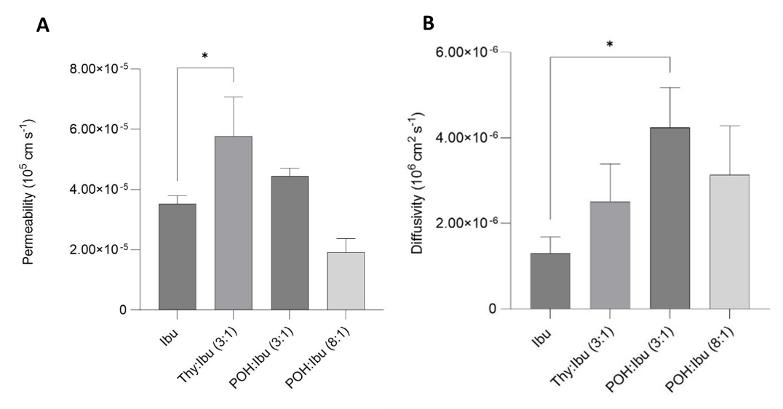
Figure S1. Influence of THEDES on Ibu (A) permeability and (B) diffusivity in comparison to the control composed of Ibu in powder form. Data indicated as mean ± SD. ns P > 0.05 *p ≤ 0.05, as the statistical significance compared with the control.
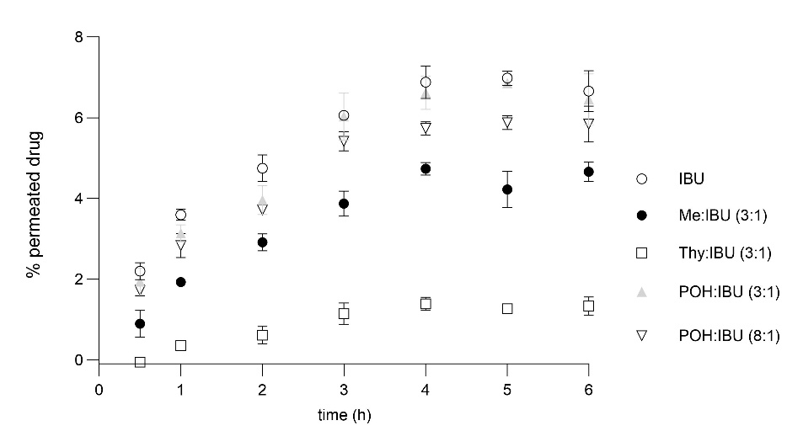
Figure S2. Influence of different THEDES on percentage of permeated drug (Ibu) over time, using a differentiated Caco-2 transwell cell model in comparison to the control composed of Ibu in powder form. The results were obtained from three independent experiments, and data is indicated as mean ± SD.
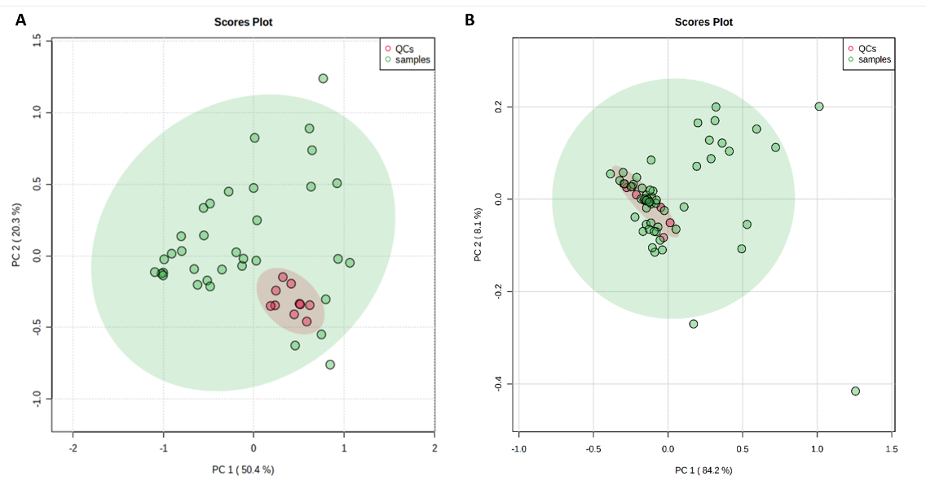
Figure S3. PCA scores plot obtained from GC-MS chromatograms of (A) intracellular samples of all conditions under study (HT29 cells exposed to Me:Ibu (3:1), Thy:Ibu (3:1), POH:Ibu (3:1), POH:Ibu (8:1), Lim:Ibu (4:1), Lim:Ibu (8:1) and controls, n=35, green circles) and the quality control samples (QCs, n=10, red circles), and (B) extracellular media of all samples under study (HT29 cells exposed to Me:Ibu (3:1), Thy:Ibu (3:1), POH:Ibu (3:1), POH:Ibu (8:1), Lim:Ibu (4:1), Lim:Ibu (8:1) and controls, n=56, green circles) and the quality control samples (QCs, n=13, red circles).

Table S1. MS derivative metabolites identified in the metabolomic analysis of the intracellular environment of all samples under study (HT29 cells exposed to Me:Ibu (3:1), Thy:Ibu (3:1), POH:Ibu (3:1), POH:Ibu (8:1), Lim:Ibu (4:1), Lim:Ibu (8:1) and controls).
Compound | RT (min) | m/z | Rmatch
1-Monopalmitin, 2 TMS derivative | 19.12 | 73/ 147/ 371/ 459 | 915
1-Octadecanol, TMS derivative | 15.31 | 73/75/103/ 327 | 929
4-Aminobutanoic acid, 3 TMS derivative | 10.75 | 73/ 84/ 147/ 174 | 831
Cholesterol, TMS derivative | 24.40 | 73/ 129/ 329/458 | 887
D-Fructose, TMS derivative (Z) | 13.21 | 73/ 103/147/ 217/ 307 | 899
D-Fructose, TMS derivative (E) | 13.27 | 73/ 103/147/ 217/ 307 | 897
D-Glucose, TMS derivative (Z) | 13.40 | 73, 103, 129, 147, 160, 205, 319 | 958
D-Glucose, TMS derivative (E) | 13.55 | 73, 103, 129, 147, 160, 205, 319 | 956
Glycerol monostearate, 2 TMS derivative | 20.68 | 73/ 129/ 147/ 399 | 915
Glycine, 3 TMS derivative | 8.76 | 73/ 147/ 174/ 248 | 900
5-Oxoproline, 2 TMS derivative | 10.70 | 73/ 147/ 156 | 954
Lactate, 2 TMS derivative | 6.14 | 73/ 117/ 147 | 966
Isoleucine, 2 TMS derivative | 8.62 | 73/ 158/ 218 | 904
Proline, 2 TMS derivative | 8.69 | 73/ 142/ 216 | 819
Myo-Inositol, 6 TMS derivative | 14.78 | 73/ 147/ 217/ 305 | 931
Oxalic acid, 2 TMS derivative | 7.06 | 73/133/ 147 | 786
Palmitic Acid, TMS derivative | 14.47 | 73/ 117/ 129/ 145/ 313 | 925
Stearic acid, TMS derivative | 16.08 | 73/ 117/145/ 341 | 905
Abbreviations: RT – Retention time; TMS – Trimethylsilyl derivatives

Table S2. PFBHA derivative metabolites identified in the metabolomic analysis of the extracellular environment of all samples under study (HT29 cells exposed to Me:Ibu (3:1), Thy:Ibu (3:1), POH:Ibu (3:1), POH:Ibu (8:1), Lim:Ibu (4:1), Lim:Ibu (8:1), controls and blanks).
Compound | RT (min) | m/z | Rmatch
2-Heptanone oxime, O-[(pentafluorophenyl)methyl]- | 24.03 | 181/ 253 | 671
2-Hexanone oxime, O-[(pentafluorophenyl)methyl]- | 22.46 / 22.74 | 181/ 253 | 798 / 807
4-Methyl-2-pentanone oxime, O-[(pentafluorophenyl)methyl]- | 21.59 | 181/ 253 | 830
Acetaldehyde oxime, O-[(pentafluorophenyl)methyl]- | 14.65 | 161/ 181/ 209 | 942
Acetone oxime, O-[(pentafluorophenyl)methyl]- | 16.33 | 181/ 253 | 926
Benzaldehyde oxime, O-[(pentafluorophenyl)methyl]- | 29.40 | 181/ 271/ 301 | 854
Cyclohexanone oxime, O-[(pentafluorophenyl)methyl]- | 26.02 | 67/ 82/ 181 | 845
Dimethylglyoxal dioxime, O,O’bis[(pentafluorophenyl)methyl]- | 35.92 | 181/ 279 | 808
Glutaraldehyde oxime, bis (-O-(pentafluorophenyl)methyl- | 36.21 | 181/ 293 | 776
Glyoxal dioxime, bis-O-(pentafluorophenyl)methyl- | 34.58 | 181/ 235 | 907
Hexanal oxime, O-[(pentafluorophenyl)methyl]- | 24.16 | 181/ 239 | 829
Methylglyoxal oxime, bis-O-(pentafluorophenyl)methyl- | 35.36 | 181/ 239 | 931
Nonanal oxime, O-[(pentafluorophenyl)methyl]- | 30.86 | 181/ 239 | 764
Octanal oxime, O-[(pentafluorophenyl)methyl]- | 28.68 | 181/ 239 | 658
Phenylacetaldehyde oxime, O-[(pentafluorophenyl)methyl]- | 30.39 | 91/ 181 | 886
Isobutanal oxime, O-[(pentafluorophenyl)methyl]- | 17.98 | 181/ 250 | 857
Pentanal oxime, O-[(pentafluorophenyl)methyl]- | 19.31 | 181/ 239 | 853

Abbreviations: RT – Retention time; PFBHA – O-(2,3,4,5,6-pentafluorobenzyl) hydroxylamine

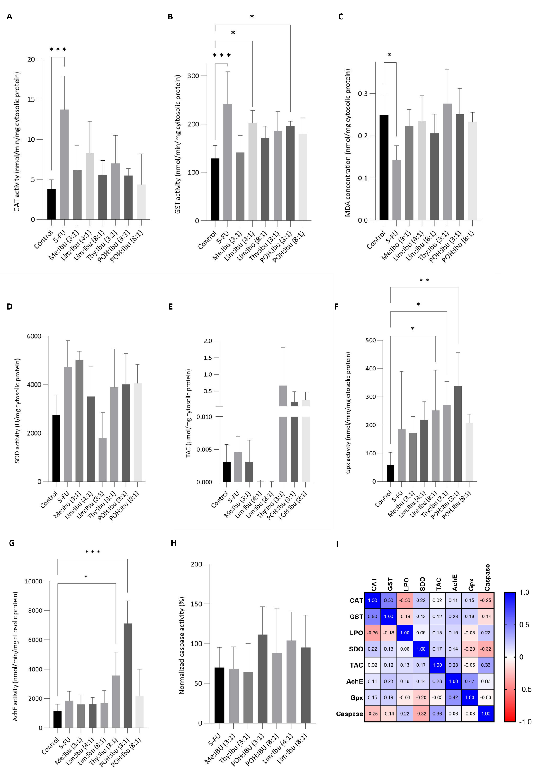
Figure S4. Influence of THEDES and 5-FU exposure on different biomarkers in comparison to the control. (A) CAT activity, (B) GST activity, (C) LPO represented by MDA concentration, (D) SOD activity, (E) TAC activity, (F) Gpx activity, (G) AChE activity, (H) Caspase-3 activity, (I) Spearman's rank correlation coefficient. Data indicated as mean ± SD. ns P > 0.05 *p ≤ 0.05, **p ≤ 0.01, ***p ≤ 0.001 and ****p ≤ 0.0001, as the statistical significance compared with the control.

