Supplementary Data:
The petroleum extract was further characterized using fractional distillation, column chromatography and Fourier transform infrared spectroscopy:
Typical Reference Ranges of Frequencies in FTIR
Bond | Compound Type | Frequency range, cm⁻¹
C-H | Alkanes | 2960-2850
C-H | Alkanes | 1470-1350
C-H | CH₃ Umbrella Deformation | 1380
C-H | Alkenes | 3080-3020
C-H | Alkenes | 1000-675
C-H | Aromatic Rings | 3100-3000
C-H | Phenyl Ring Substitution Bands | 870-675
C-H | Phenyl Ring Substitution Overtones | 2000-1600
C-H | Alkynes | 3333-3267
C-H | Alkynes | 700-610
C=C | Alkenes | 1680-1640
CC | Alkynes | 2260-2100
C=C | Aromatic Rings | 1600, 1500
C-O | Alcohols, Ethers, Carboxylic acids, Esters | 1260-1000
C=O | Aldehydes, Ketones, Carboxylic acids, Esters | 1760-1670
O-H | Monomeric -- Alcohols, Phenols | 3640-3160
O-H | Hydrogen-bonded -- Alcohols, Phenols | 3600-3200
O-H | Carboxylic acids | 3000-2500
N-H | Amines | 3500-3300
N-H | Amines | 1650-1580
C-N | Amines | 1340-1020
CN | Nitriles | 2260-2220
NO₂ | Nitro Compounds | 1660-1500
NO₂ | Nitro Compounds | 1390-1260

Chemical analysis and characterization of each fractional distillation fraction:
Fraction D₁:
1. Organic spotting:
  - Boiling range : <60°C
  - Colour: light yellow
  - Odour : pleasant
  - Saturation test : saturated compound
  - Elemental analysis : C, H, (O)
  - Determination of functional groups : Ketonic groups
2. Chromatographic study:
- TLC : single spot
Fraction D₂:
- Organic spotting:
  - Boiling range : 60-80°C
  - Colour : light brown
  - Odor : pungent
  - Saturation test : saturated compound
  - Elemental analysis : C, H, (O).
  - Determination of functional group : carboxylic group present.

- Chromatographic separation:
- TLC : two distinct spots. Therefore, further separation was performed by column chromatography.

- Chromatographic separation of B:
Fraction B was adsorbed on 1 gm activated silica gel and loaded on a silica gel column 30 cm in length.
Various fractions collected and monitored using TLC techniques are shown in tabular form below.
Test tube nos. | Composition of Mobile Phase | TLC results
1-18 | Pet. Ether (100%) | -
19-20 | Pet. Ether : Chloroform (9:1) | -
21 | Pet. Ether : Chloroform (8:2) | -
22 | Pet. Ether : Chloroform (7:3) | -
23 | Pet. Ether : Chloroform (6:4) | -
24-26  (distilled) | Pet. Ether : Chloroform (5:5) | Single spot
27 | Pet. Ether : Chloroform (3:7) | -
28 | Chloroform: Methanol (7:3) | -
29 | Methanol (100%) | Two distinct spots

Fraction 24-26

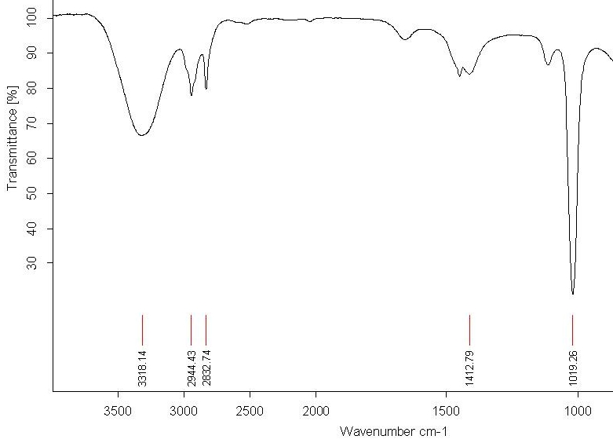

Sr. No. | Peaks | Functional | Group
 |  | Structural Form | Names
1. | 3318.14 | O-H | Alcohols
2. | 2944.43 | C-H | Alkanes
3. | 2832.74 | C-H | Alkanes
4. | 1412.79 | C-H | Alkenes
5. | 1019.26 | C-O | Ethers, Carboxylic Acids

Fraction 29
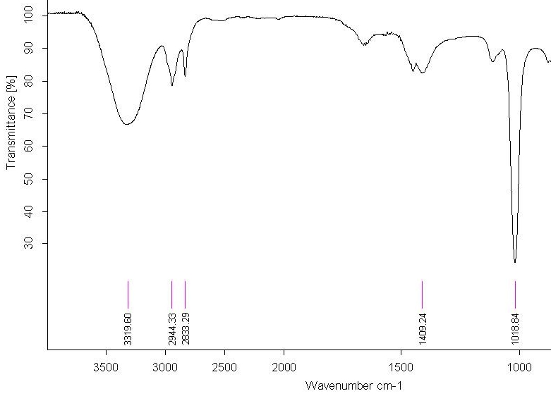
Sr. No. | Peaks | Functional | Group
 |  | Structural Form | Names
1. | 3319.60 | O-H | Alcohols
2. | 2944.33 | C-H | Alkanes
3. | 2833.29 | C-H | Alkanes
4. | 1409.24 | C-H | Alkenes
5. | 1018.84 | C-O | Ethers, Carboxylic Acids

Fraction D₃:
1. Organic spotting:
- Boiling range : 80-90°C
- : brown
- Odor : pungent
- Saturation test : saturated compound
- Elemental analysis : C, H, (O).
- Determination of functional groups (since the quantity remaining was not suitable for classical methods, further information about functional groups was collected using IR spectroscopy)
2. Chromatographic separation:
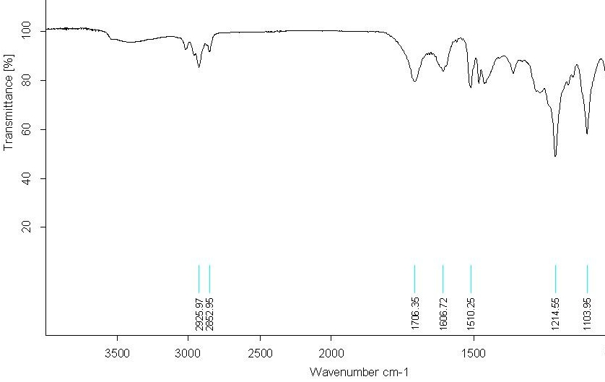
- TLC : two distinct spots. (The fraction size was too small, so column chromatography was not implemented.)
3. IR SPECTRUM:

Sr. no. | Peaks | Functional | Group
 |  | Structural Form | Names
1. | 2925.97 | C-H | Alkanes
2. | 2852.95 | O-H | Carboxylic Acids
3. | 1606.72 | C-H | Phenyl Ring Substitution
4. | 1510.25 | NO₂ | Nitro Compound
5. | 1214.55 | C-O | Alcohol, Ester, Carboxylic Acid
6. | 1103.95 | C-O | Alcohol, Ester, Carboxylic Acid

Fraction D₄:
1. Organic spotting:
- Colour : brown
- Odor : pungent
- : saturated compound.
- Elemental analysis : C, H, (O).
- Determination of functional groups : OH
- Boiling range : 90-98°C
2. Chromatographic separation:
(The fraction size was too small, so column chromatography was not implemented.)

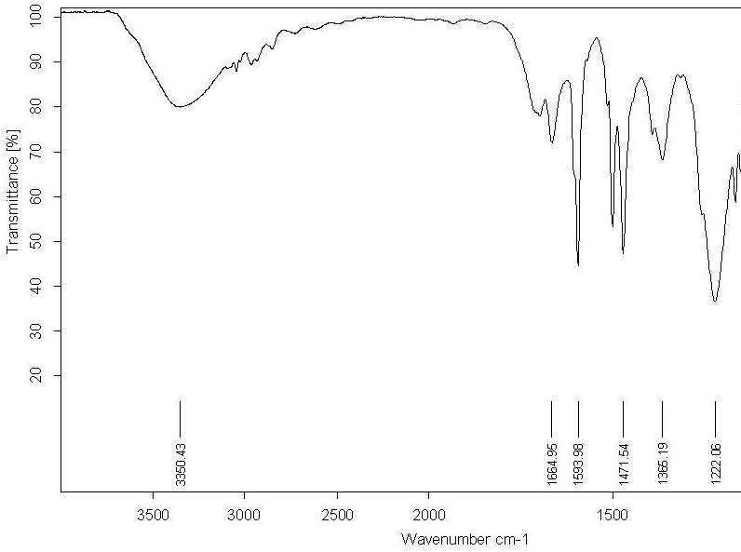
- IR SPECTRUM:
Sr. no. | Peaks | Functional Group | Names
1. | 3350.43 | O-H |  | Monomeric -- Alcohols, Phenols
2. | 1664.95 | C=C |  | Alkenes
3. | 1593.98 | N-H |  | Amines
4. | 1471.54 | C=C |  | Aromatic Ring
5. | 1366.19 | NO₂ |  | Nitro Compounds
6. | 1222.06 | C-O |  | Alcohol, Ester, Carboxylic Acid
Test tube no. | Composition of Mobile phase | TLC results | Fractions
1-5 | Pet. Ether (100%) | -- | --
6-17 | Pet. Ether : Chloroform (98:2) | -- | --
18-25 | Pet. Ether : Chloroform (95:5) | -- | --
26-28 | Pet. Ether : Chloroform (93:7) | -- | --
29-35 | Pet. Ether : Chloroform (92:8) | -- | --
36-42 | Pet. Ether : Chloroform (90:10) | -- | --
43-54 | Pet. Ether : Chloroform (90:10) | Single spot | A (light yellow)
55-64 | Pet. Ether : Chloroform (90:1) | -- | --
65-73 | Pet. Ether : Chloroform (87:13) | -- | --
74-81 | Pet. Ether : Chloroform (85:15) | -- | --
82-83 | Pet. Ether : Chloroform (83:17) | -- | --
84-86 | Pet. Ether : Chloroform (80:20) | -- | --
87-91 | Pet. Ether : Chloroform (70:30) | -- | --
92-113 | Pet. Ether : Chloroform (50:50) | -- | --
114-127 | Pet. Ether : Chloroform (40:60) | -- | --
128 - 133  (distilled) | Pet. Ether : Chloroform (40:60) | Single spot | B (faint green)
134-151 | Pet. Ether : Chloroform (40:60) | -- | --
152 - 169  (distilled) | Pet. Ether : Chloroform (30:70) | -- | --
170 - 182  (distilled) | Pet. Ether : Chloroform (20:80) | -- | --
183-199(distilled) | Pet. Ether : Chloroform (20:80) | Single spot | C (yellow)
200 - 210  (distilled) | Pet. Ether : Chloroform (10:90) | -- | --
211 - 232  (distilled) | Pet. Ether : Chloroform (5:95) | -- | --
233 - 247  (distilled) | Pet. Ether : Chloroform (97:3) | -- | --
248 - 253  (distilled) | Pet. Ether : Chloroform (99:1) | -- | --
254 - 256  (distilled) | Chloroform (100%) | -- | --
257 - 262  (distilled) | Chloroform: methanol (90:10) | Single spot | D (orange)
263 - 265  (distilled) | Chloroform: methanol (85:15) | -- | --
266 - 268  (distilled) | Chloroform: methanol (85:15) | Single spot | E (light orange)
269 - 271  (distilled) | Chloroform: methanol (85:15) | -- | --
272 - 281  (distilled) | Chloroform: methanol (85:15) | Single spot | F (yellow)
282 - 284  (distilled) | Chloroform: methanol (70:30) | -- | --
285 - 287  (distilled) | Chloroform: methanol (70:30) | -- | --
288 - 292  (distilled) | Chloroform: methanol (60:40) | -- | --
293 - 297  (distilled) | Chloroform: methanol (50:50) | -- | --
298 - 302  (distilled) | Chloroform: methanol (30:70) | -- | --
303 - 307  (distilled) | Chloroform: methanol (20:80) | -- | --
308 - 320  (distilled) | Methanol (100%) | -- | --

Sr. no. | Peaks | Functional | Group
 |  | Structural form | Names
1. | 2921.23 | C-H | Alkanes and aliphatic molecules
2. | 2851.78 | C-H | Alkanes and aliphatic molecules
3. | 1711.88 | C=O | Ketone
4. | 1462.76 | C=C | Aromatic ring

Column Chromatography of Petroleum Ether Extract E1:
Qualitative Analysis of various Fractions
- Fraction A

- IR SPECTRUM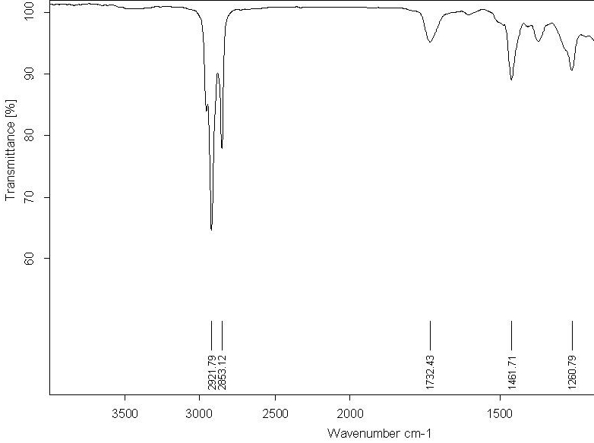

- FractionB

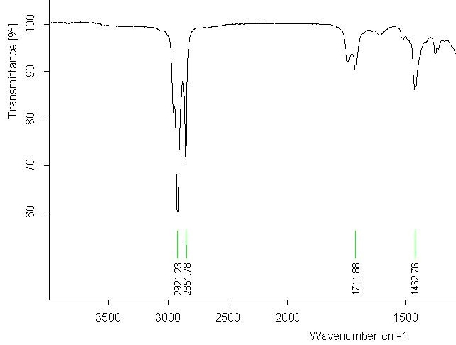
- IR SPECTRUM

Sr. no. | Peaks | Functional | Group
 |  | Structural form | Names
1. | 2921.79 | C-H | Alkanes and aromatic molecules
2. | 2853.12 | C-H | Alkanes and aromatic molecules
3. | 1732.43 | C=O | Ketones
4. | 1461.71 | C=C | Aromatic ring
5. | 1260.79 | C-O | Alcoholic

- Fraction C

- IR SPECTRUM
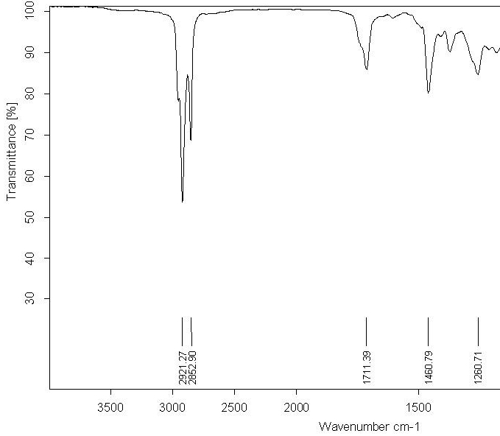
Sr. no. | Peaks | Functional | Group
 |  | Structural form | Names
1. | 2921.27 | C-H | Alkanes and aromatic molecules
2. | 2852.90 | C-H | Alkanes and aromatic molecules
3. | 1711.39 | C=O | Ketone
4. | 1460.79 | C=C | Aromatic ring

- FractionD

- IR SPECTRUM
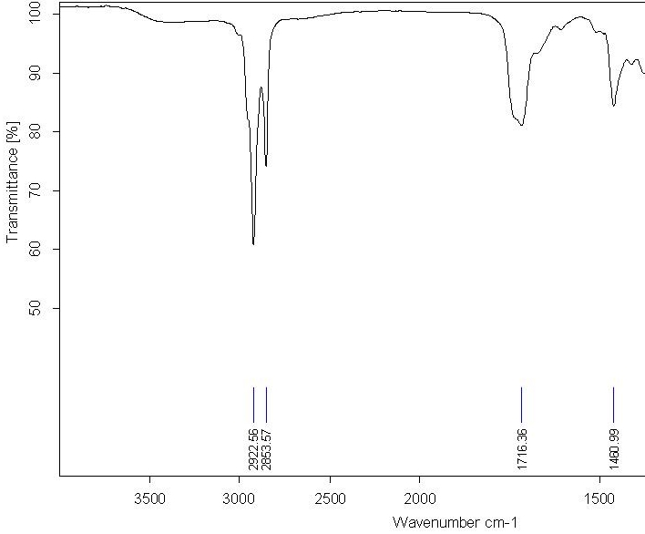
Sr. no. | Peaks | Functional | Group
 |  | Structural form | Names
1. | 2922.56 | C-H | Alkanes and aromatic molecules
2. | 2853.57 | C-H | Alkanes and aromatic molecules
3. | 1716.36 | C=O | Ketone
4. | 1460.99 | C=C | Aromatic ring

Fraction E

- IR SPECTRUM
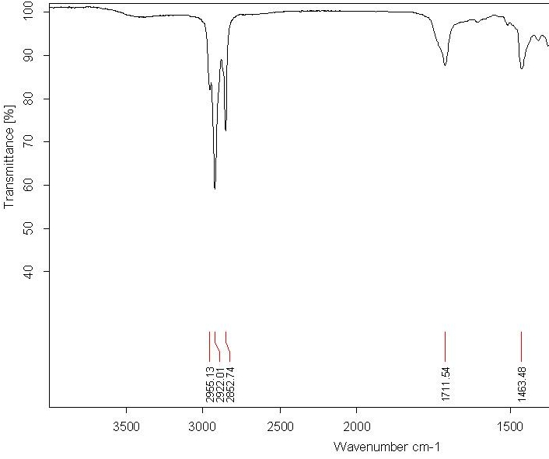
Sr. no. | Peaks at | Functional | group
 |  | Structural form | Names
1. | 2955.13 | C-H | Alkanes and aromatic molecules
2. | 2922.01 | C-H | Alkanes and aromatic molecules
3. | 2852.74 | C-H | Alkanes and aromatic molecules
4. | 1711.54 | C=O | Ketone
5. | 1463.48 | C-H | Alkanes

Fraction F
- IR SPECTRUM
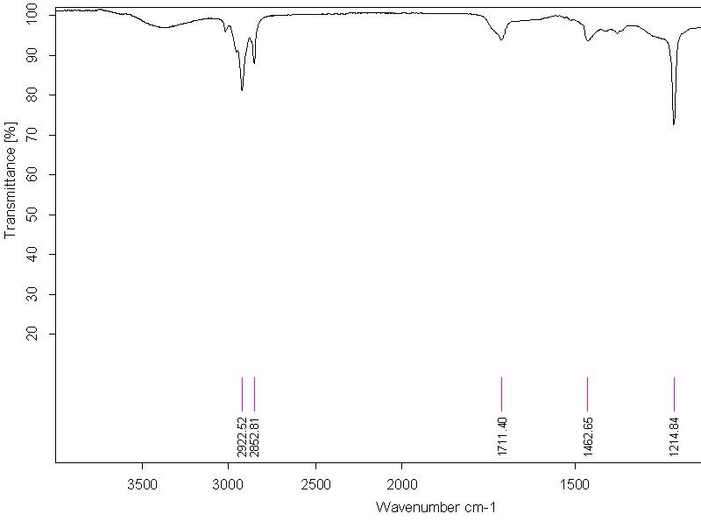
Sr. no. | Peaks | Functional | Group
 |  | Structural form | names
1. | 2922.52 | C-H | Alkanes and aromatic molecules
2. | 2852.81 | C-H | Alkanes and aromatic molecules
3. | 1711.40 | C=O | Ketone
4. | 1462.65 | C=C | Aromatic ring
5. | 1214.84 | C-O | Alcoholic

**************************

