Supplementary information

Targeting TaPDK: A Promising Strategy for Effective Control of the Destructive Tomato Leaf Miner, Tuta absoluta

Shu-Yan Yan^{1,**}, Jia-Hui Song^{2,**}, Wen-Jia Yang^{2,**}, Wan-xue Liu¹, Gui-Fen Zhang¹, Fang-Hao Wan¹, Nicolas Desneux ³, and Yi-Bo Zhang^{1,*}

¹ State Key Laboratory for Biology of Plant Diseases and Insect Pests, Key Laboratory of Invasive Alien Species Control of Ministry of Agriculture and Rural Affairs, Institute of Plant Protection, Chinese Academy of Agricultural Sciences, Beijing 100193, China
² Key Laboratory of Surveillance and Management of Invasive Alien Species in Guizhou Education Department, College of Biological and Environmental Engineering, Guiyang University, Guiyang 550005, China
³ Université Côte d’Azur, INRAE, CNRS, UMR ISA, 06000 Nice, France

* Corresponding author: zhangyibo@caas.cn
** These authors contributed equally to this work
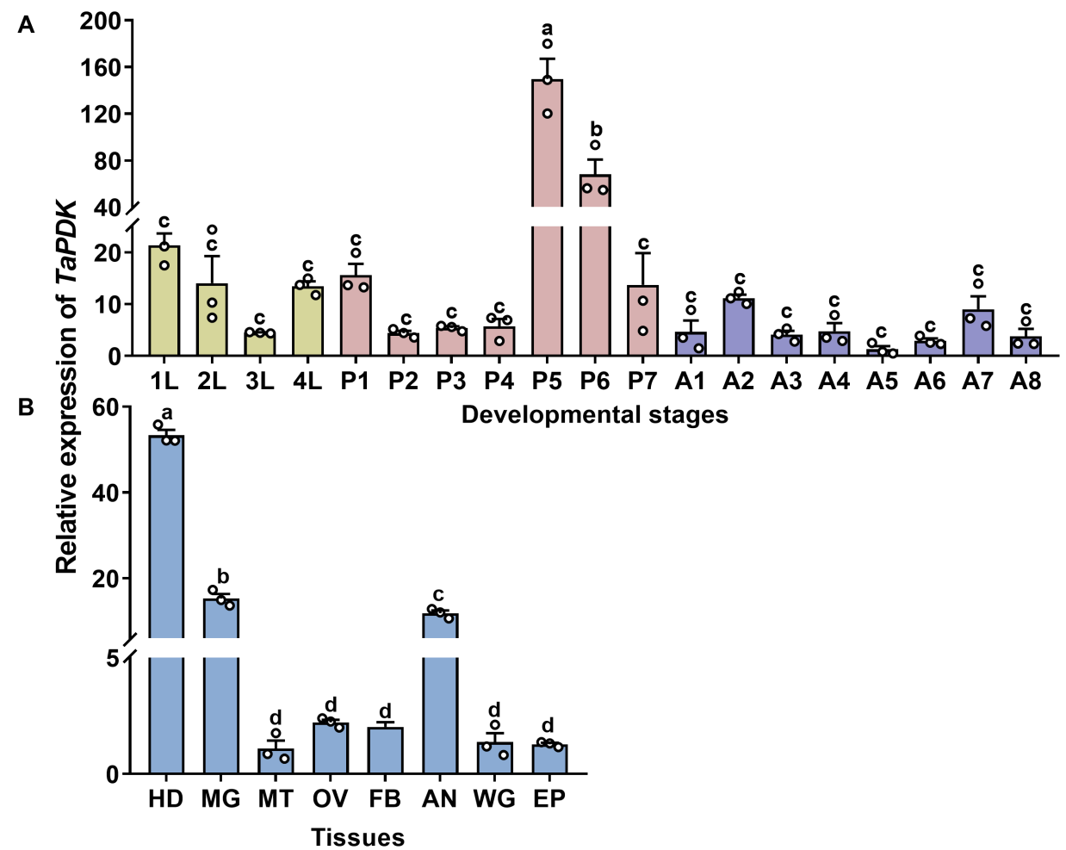
Figure S1. Expression profiles of TaPDK by real-time PCR. (A) Expression of TaPDK at different developmental stages. 1L–4L, first-instar larvae to fourth-instar larvae; P1–P7, days 1 to 7 of the pupae; A1–A8, days 1 to 8 of the adults. (B) Expression of TaPDK in different tissues of 2-day-old female adults. HD, head; MG, midgut; MT, Malpighian tubules; OV, ovary; FB, fat body; AN, abdomen; WG, wing; EP, epidermis. Data are shown as the mean values ± SE (n = 3). Different letters above the bars indicate significant differences between the samples (one-way ANOVA followed by Turkey’s test, P<0.05).

Table S1. Primers used in this study
Appilation primers | Gene name | Forward primer (5′-3′) | Reverse primer (5′-3′)
Full-length clone | TaPDK | TGCGACGGGTCGAAATG | CAGGTAGTAGGTGCGGTTGG
 | TaPDK | GAGGATCGTTCGAGGAGGAG | TGCTTCAGGATCAACTCGC
qPCR analysis | TaECR | GCGCTGCCTAGTTTTGAAGA | TTGTGGTGGCGCATAATACG
qPCR analysis | TaUSP | GAAGTTTGGTGGCGGAGAAG | TGCTTTGTCACTTCGCAGTT
qPCR analysis | TaE75 | GTCCCACCTACTCACAACCA | TAAGTGGCGCATCGAACATG
qPCR analysis | TaHR3 | CGTCATGGAAACCTTAGGCG | CATCTCCACGATCCTGTCCA
qPCR analysis | TaHR38 | GCGCTGCCTAGTTTTGAAGA | TTGTGGTGGCGCATAATACG
qPCR analysis | TaFTZ-F1 | TGCGCTCCTGAACAACAATC | GGGCACAGTTCTTCGATCAC
qPCR analysis | TaCHS | CATCCAGCGTGCCTATGTTC | TCTCAAGATGCACTGCTGGA
qPCR analysis | TaUAP | AACCGCTCGAGATGATTTGC | ACCGTTACCATTCAGTCCGT
qPCR analysis | TaCHT5 | ATGTGGGAGTACTTGGAGCC | TCTACTCCTTCATCGGCGTC
qPCR analysis | TaCDA1 | CGCCTAAGAAAGACGACAGC | CACTTTGCGCTCCTTGTTCT
qPCR analysis | TaJHAMT | AGACCACAGGATCCAGTTCG | ATATCAGCAGACACTCCCCG
qPCR analysis | TaKr-h1 | TGCGGCATTATAGGACCCAT | GAGCGTGACGATGGAGTTTC
qPCR analysis | TaMet | ATGAACGACGCAGAGCTCTA | TGAACTGCCGCAAAATCTCC
qPCR analysis | TaVg | TGGTACGTGGTTATGCAGGA | TACTTCGACACTGGGGGTTC
qPCR analysis | TaVgR | GCAAACCTGAGAGCCACTTC | CAGCGGCTGTCATTTCTACA
qPCR analysis | TaEF1a | CCTGGGCACAGAGATTTCAT | GATCAGCTGCTTGACACCAA
dsRNA synthesis | TaPDK | TAATACGACTCACTATAGGGGTTTCTCGCCAAGGACAT | TAATACGACTCACTATAGGGGCAACTCAGGGCTCACGT
dsRNA synthesis | GFP | TAATACGACTCACTATAGGGTACAAGACGCGTGCTGAAGT | TAATACGACTCACTATAGGGCAATGTTGTGGCGAATTTTG

