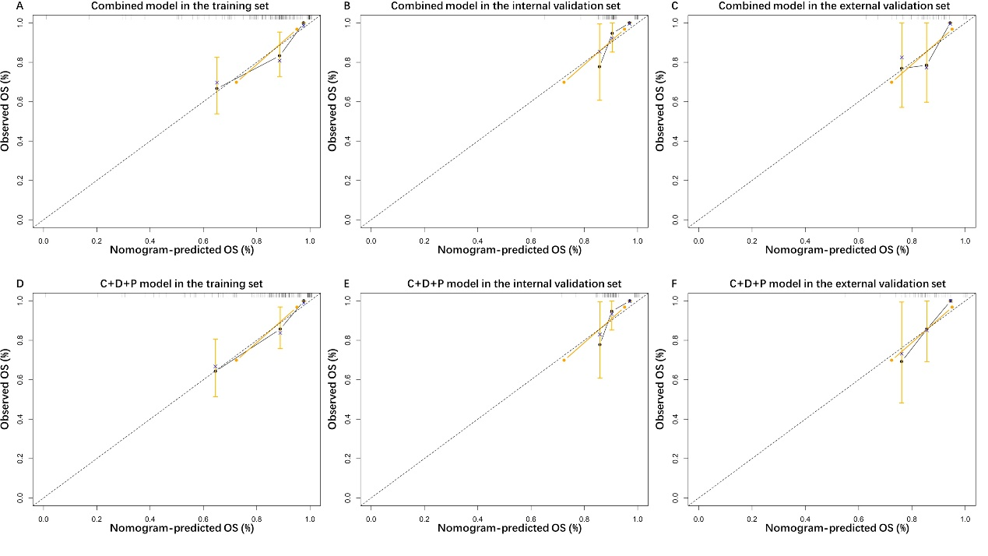
Figure S1. The ROC curve of treatment response models in the training set and internal validation set.

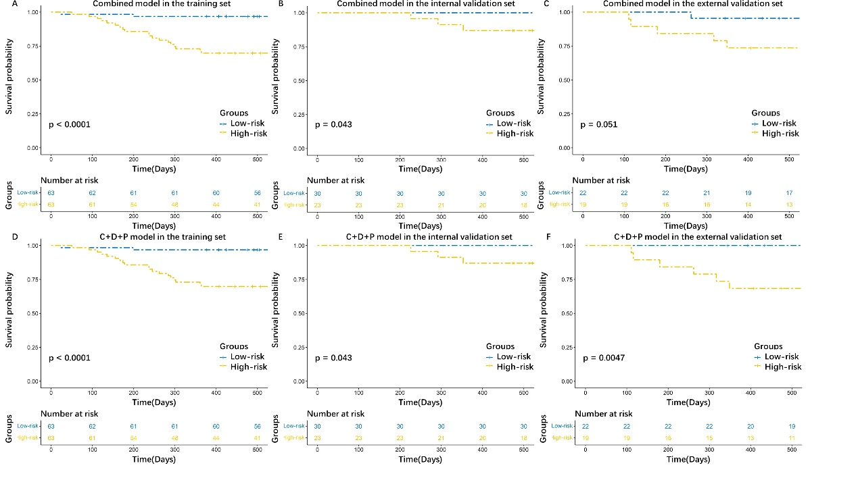
Figure 3. KM curves of models for 1-year OS prediction. (A, B, C) The KM curves of combined models in the training set, internal validation set and external validation set. (D, E, F) The KM curves of C+D+P models in the training set, internal validation set and external validation set. Abbreviations: C, clinical; D, dosiomics; P, pathomics.

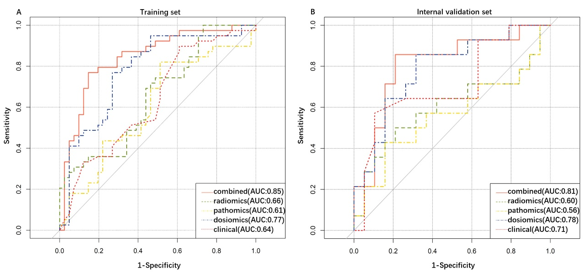
Figure 4. Calibration curves of models for 1-year OS prediction. (A, B, C) The calibration curves of combined models in the training set, internal validation set and external validation set. (D, E, F) The calibration curves of C+D+P models in the training set, internal validation set and external validation set. Abbreviations: C, clinical; D, dosiomics; P, pathomics.

