Supporting Information
Groundwater-born Fe (II) affects concentrations of dissolved O2 in streamwater
Silvia Parra-Suarez¹, Romy Wild², Johannes Barth³, Benjamin S Gilfedder¹, Juergen Geist², Sven Frei¹, Stefan Peiffer¹
¹Bayreuth Center of Ecology and Environmental Research (BayCEER), Department of Hydrology, University of Bayreuth.
² Aquatic Systems Biology, TUM School of Life Sciences, Technical University of Munich
³GeoZentrum Nordbayern, Friedrich-Alexander-Universität Erlangen-Nürnberg (FAU)

Supplementary Note: Experimental Setup
Supplementary Note: Filling protocol of the FeCl2 treatment flumes
Figure S1. Weakly mean values of pH values determined in surface waters and pore waters from Fe(II) treated and control flumes.
Figure S2. Weakly mean values of Fe(II) concentrations determined in surface waters and pore waters from Fe(II) treated and control flumes.
Figure S3. Comparison of Fe(II) concentrations in surface waters and porewaters between control and treated flumes. we considered only the data we measured after pH recovery (weeks 3-6).
Figure S4. Weakly mean values of DO concentrations in treated and untreated flumes. Only the data obtained after the pH has recovered (week 3-6). a) Comparison between surface waters and porewaters, b) comparison of all samples between the type of sediment.
Figure S5. Weakly mean values of DOC concentrations determined in surface waters and pore waters from Fe(II) treated and control flumes.
Figure S6. Effects of flume parameters on mean DO concentrations in surface waters and pore waters from treated and control flumes.

Supplementary Note: Experimental Setup
The flume system consisted of 12 flumes that were installed outdoors at the experimental test site of the Institute of Aquatic Systems Biology at the Technische Universität München. Each flume was split into two flume cells labeled A and B, with a total of 24 flume cells labeled 1A to 12 A and 1B to 12 B (Fig. 1a). A single flume cell had a length of 7m, a width of 0.5m, and a depth of 1m. The flumes were filled with different sediment types up to 0.6m inside the flume. Flume cells with the letter A were filled with fine sediment, and flume cells with the letter B with coarse sediment. The “coarse” sediment consisted of coarse gravel (0.1-32 mm) with a sand (0-4 mm) fraction of 10 %. For the “fine” sediment fraction, the “coarse” fraction was further diluted with the sand fraction in a ratio of 70 % to 30%. The sediment material is local calcite quaternary gravel from the formation "Munich gravel plain" (Kieswerk Berglern, Rohrdorfer Sand und Kies GmbH).
The flume system was supplied with organic matter through natural leaf fall, photosynthesis, and subsequent biofilm formation from May 2020 until Oct 2021 while being used for other experiments ¹.
Surface flow in the A and B flumes was generated by two separate pumping system systems with pumping system (PS) 1 (in orange in Fig. 1) supplying flume cells treated with FeCl₂ and (PS) 2 (blue, in Fig. 1a) supplying untreated flume cells. Each pumping system consisted of 2 water feeding tanks and a backflow basin (Fig. 1a). A pump in tank 2 of each pumping system produces the surface inflow regulated by individual flume valves to adjust the surface-water flow rate for each flume. In addition, each pumping system had a common backflow basin in which the surface outflow from each flume was collected and sent back to the feeding tanks with an additional pump, respectively.
Six flumes (both A and B) were supplied with a "moderate flow rate" (3 L s⁻¹) and six flumes with a discharge simulating drought condition ("low flow rate" 0.5 L s⁻¹). Hence, each pumping system fed an equal number of flumes with i) the combinations "moderate flow rate "/ coarse sediment and "moderate flow rate"/ fine sediment, and ii) the combination "low flow rate"/coarse sediment and "low flow rate"/fine sediment.
FeCl₂ treatment was applied to the flumes in orange (PS1). The control group was the flumes in blue (PS2). Therefore, all the flumes with uneven numbers were treated with FeCl₂ (1,3,5,7,9,11). All flumes with even numbers belonged to the control group (2,4,6,8,10,12, Fig. 1a). The bottom of each flume cell had an independent subsurface inflow pipe (7m long) that circulated from a single water source (container) (Fig. 1b). Each subsurface pipe in every sub-flume had an on/off valve (red circle in Fig. 1b) that could be closed or opened. After filling the flume cells of the treatment group with FeCl₂ (cf. below), we established permanent subsurface flow in all flumes, including the control flumes.
The subsurface water source was a container connected to tap water and continuously kept at a volume of 510 L. The container water was permanently circulated with the pumping system being connected to the flumes through a bypass system that allowed us to control the subsurface water flow into the flumes through a port at the bottom of the flumes. The subsurface flow rates were established to be 6 L min⁻¹ for the 24 flumes, which splits into 0.25 L min⁻¹ per flume. Considering the geometry of a flume cell and the porosity, this value corresponds to a vertical groundwater flow velocity of ~ 0.33 m per day, matching typical mean flow velocities in aquifers with streamflow under neutral and losing conditions in small headwater streams ^{2–5}. The sediment porosity of the two sediments was estimated gravimetrically to be 0.25 for the fine sediment and 0.32 for the coarse sediment.
Tap water filled into the subsurface water container had dissolved oxygen concentrations with a mean value of 5.8 mg L^{-1,} and the pH varied between 6.2 and 8.8.
Temperature sensors were installed at the inflow and outflow of each flume cell in May 2021 at various depths (7,11,15,19,23,31,39 and 47 cm). The sensors were anchored in a metal L pole and filled with epoxy glue to avoid damage during the installation. The temperature was logged at 10-minute intervals using an Arduino data-logging system. During the period in which the experiments for this study were performed, sensors were only active in cells 5A and 5B, which constrained the potential for temperature measurements to characterize exchange fluxes between surface and subsurface water.
Supplementary Note: Filling protocol of the FeCl₂ treatment flumes
Filling the flumes with a FeCl₂ solution was achieved using the subsurface pumping system described above. We targeted a complete filling of the pore waters of a single flume with a solution containing an initial concentration of 0.1 mmol L⁻¹ Fe(II) as FeCl₂. The dilute FeCl₂ solution was prepared from a FeCl₂ flocculation reagent (KEMIRA PIX-209, Germany). To calculate the volume of diluted FeCl₂ to be added, a porosity of 0.3 was used for both sections, A (fine) and B (coarse). The pore volume for one flume cell (A or B) is 525 L, so 1050 L of diluted FeCl₂ was filled into the FeCl₂ treatment flumes simultaneously at a filling velocity of 75 L per minute. During the FeCl₂ filling procedure in the treatment flumes, the surface water flow of these flumes (PS1) was reduced to the minimum.
Each flume cell was gently filled with FeCl₂ solution diluted in tap water using three containers (350 L) from which the solution was pumped via the subsurface water entrance port into the corresponding flume. During the filling of each sub-flume, the total Fe concentration was checked in the first container to be used, and a range of 0. 1mmol L⁻¹ Fe (II) +/- 0,01 mmol L⁻¹ was observed. The pH of the diluted solution ranged between 6.5 and 7.5. Filling of the flumes was performed within one day, and the experiments were started the following day.

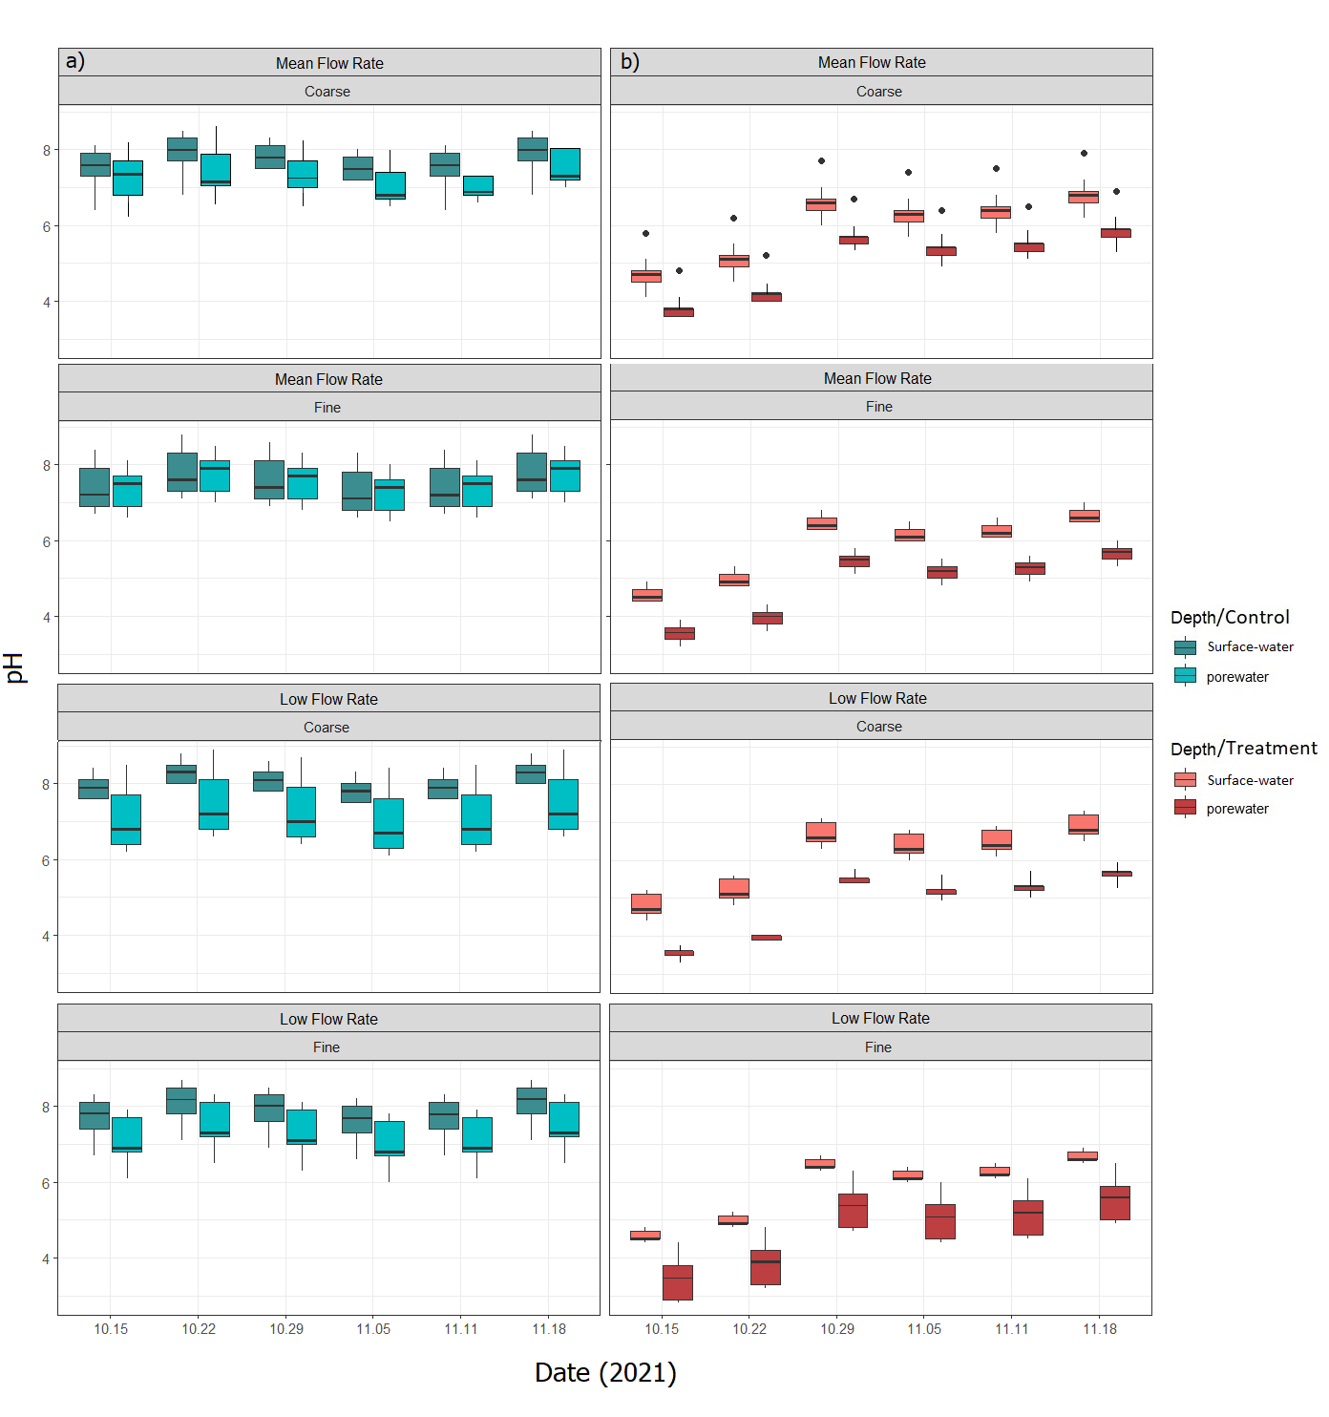

Figure S1. Weakly mean values of pH values determined in surface waters and pore waters from Fe(II) treated and control flumes.

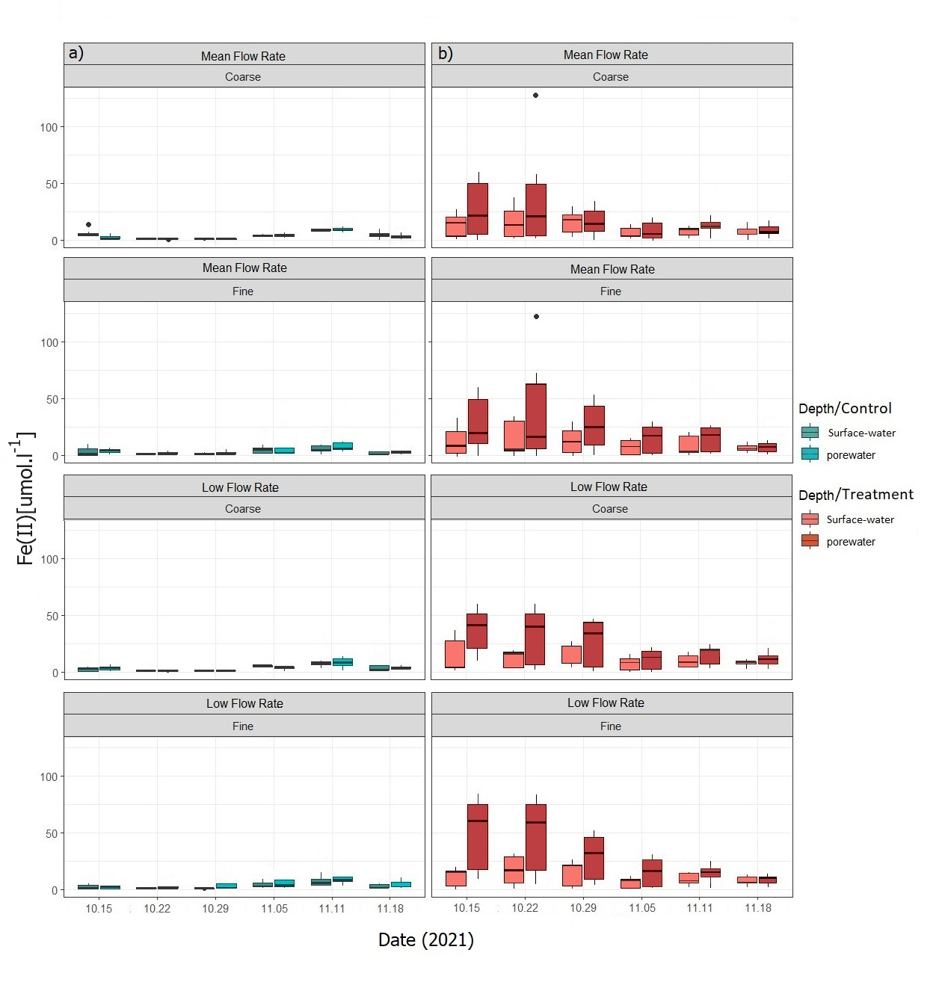
Figure S2. Weakly mean values of Fe(II) concentrations determined in surface waters and pore waters from Fe(II) treated and control flumes.

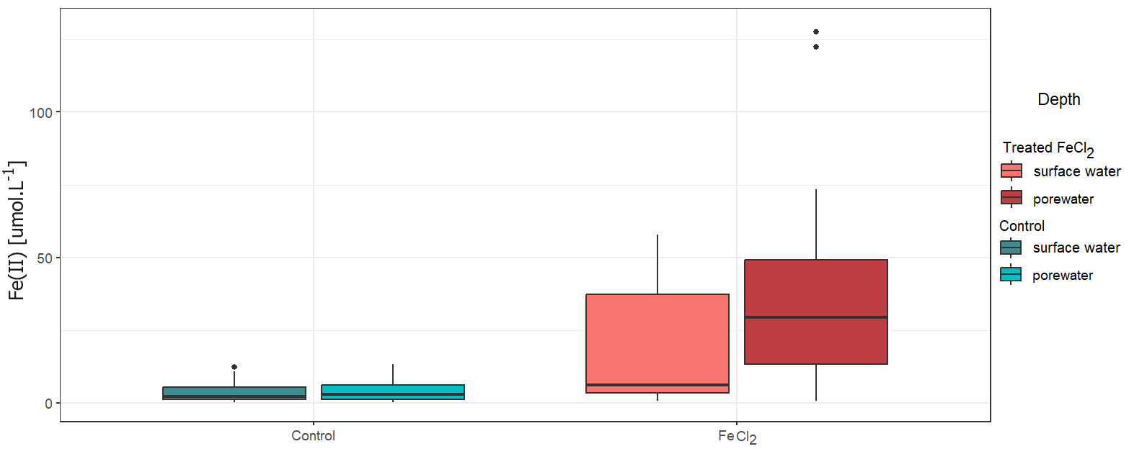
Figure S3. Comparison of Fe(II) concentrations in surface waters and porewaters between control and treated flumes. we considered only the data we measured after pH recovery (weeks 3-6).

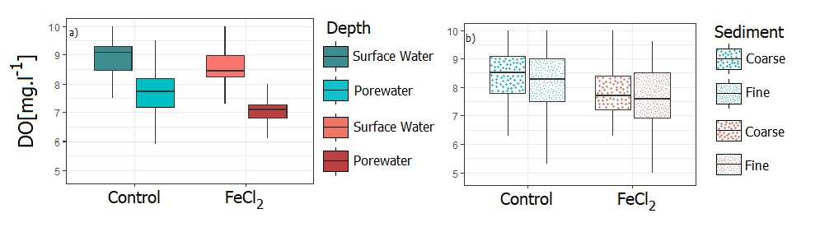

Figure S4. Weakly mean values of DO concentrations in treated and untreated flumes. Only the data obtained after the pH has recovered (week 3-6). a) Comparison between surface waters and porewaters, b) comparison of all samples between the type of sediment.

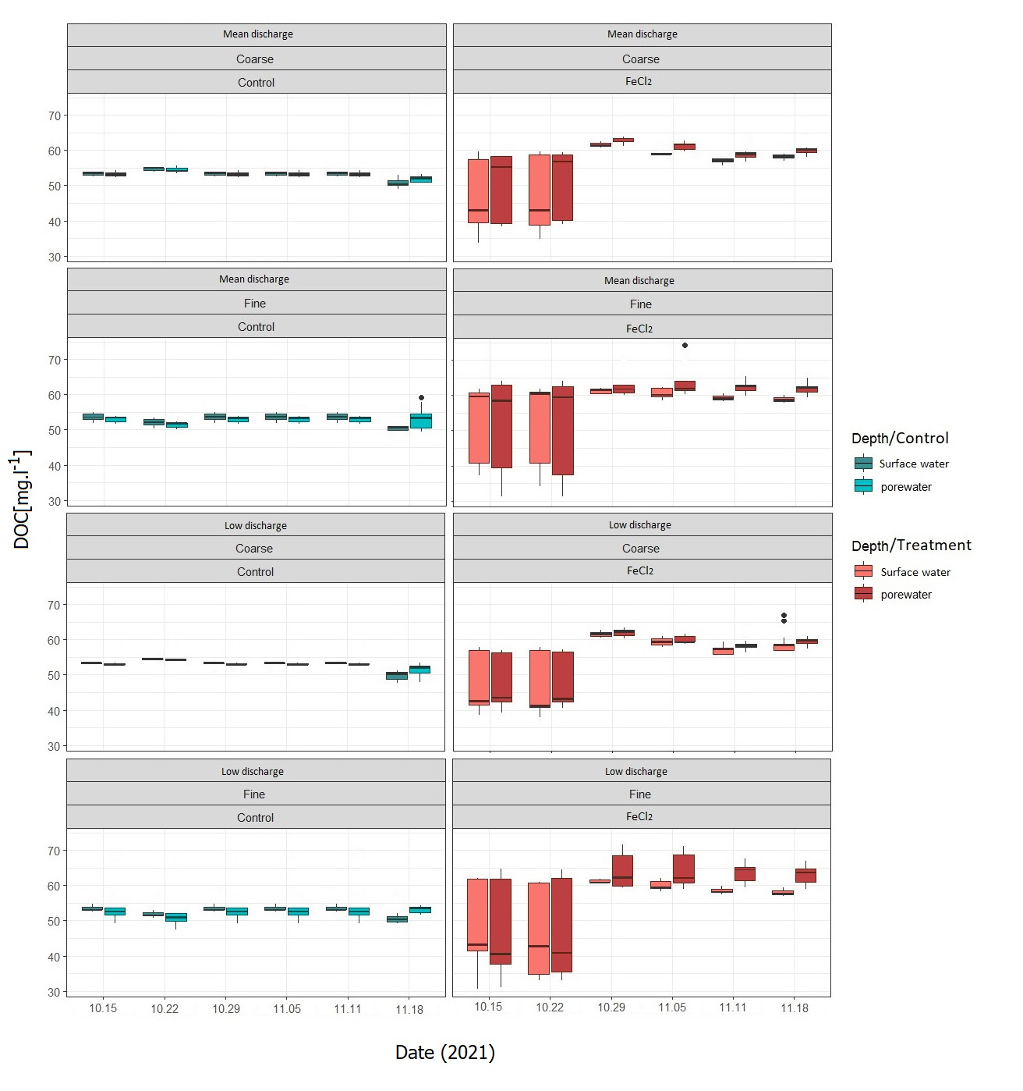
Figure S5: Weakly mean values of DOC concentrations determined in surface waters and pore waters from Fe(II) treated and control flumes.

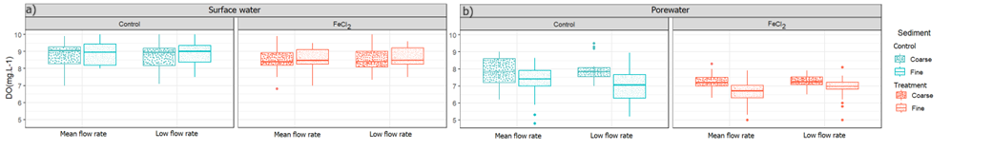
Figure S6. Effects of flume parameters on mean DO concentrations in surface waters and pore waters from treated and control flumes.

References.
1. Wild, R., Nagel, C. & Geist, J. Climate change effects on hatching success and embryonic development of fish: Assessing multiple stressor responses in a large-scale mesocosm study. Science of The Total Environment 893, 164834 (2023).
2. Galloway, J., Fox, A., Lewandowski, J. & Arnon, S. The effect of unsteady streamflow and stream-groundwater interactions on oxygen consumption in a sandy streambed. Sci Rep 9, (2019).
3. Harris, F. C. & Peterson, E. W. 1-D vertical flux dynamics in a low-gradient stream: An assessment of stage as a control of vertical hyporheic exchange. Water (Switzerland) 12, 1–15 (2020).
4. Campana, M. et al. Simulation of Stream Groundwater Exchange and Near Stream Flow Paths of Two First Order Mountain Streams Using Modflow Landscape Influences on Ecosystem Function: Local and Routing Control of Oxygen Dynamics in a Floodplain Aquifer View Project Seasonal Variation in Surface-Subsurface Water Exchange and Lateral Hyporheic Area of Two Stream-Aquifer Systems. WATER RESOURCES RESEARCH vol. 34 https://www.researchgate.net/publication/30069235 (1998).
5. Kaule, R. & Gilfedder, B. S. Groundwater Dominates Water Fluxes in a Headwater Catchment During Drought. Frontiers in Water 3, (2021).

