Pneumonia activates renal antioxidant defense function to reduce the damage of aristolochic acid Ⅰ through Keap1/Nrf2/NQO1 signaling pathway

Table of contents
Abbreviation 2
Supporting methods 3
1. Method for detection of AAI by LC-MS 3
2. Method for detection of DNA adducts by LC-MS 5
3. Methodological validation of DNA adducts 7
Supporting Reagents 10
Supplementary Figures 11
Figure S1 11
Figure S2 12

Abbreviation
Acronym | Full name
AAI | Aristolochic acid I
AAs | Aristolochic acids
Cr | Creatinine
BUN | Blood urea nitrogen
Keap1 | Kelch-like ECH-associated protein 1
Nrf2 | Nuclear factor erythroid 2-related factor 2
CYP1A2 | Cytochrome P450 1A2
CYP1A1 | Cytochrome P450 1A1
NQO1 | Nad(p)hquinonedehydrogenase 1
BALF | Bronchoalveolar lavage fluid
dA-ALI | 7-Deoxyadenosin-N6-yl aristolactam I
ROS | Reactive oxygen species
MDA | Malondialdehyde
SOD | Superoxide dismutase
R-GSH | Reduced glutathione
T/GSSH | Ratio of reduced glutathione to oxidized glutathione
TQD | Tandem Quadrupole Detector
ESI | Electron spray ionization
MRM | Multiple reactions monitoring

Supporting methods

Method for detection of AAI by LC-MS
  - Chromatographic conditions
Using Fenomex biphenyl chromatography column, the model and specification are Phenomenex Bi-phenyl, 2.6um, 3.0×50 mm. Mobile phase A: water (containing 0.1% formic acid, 2mM ammonium formate), mobile phase B: acetonitrile (containing 0.1% formic acid). Injection volume: 5 μL. Column temperature: 35 ℃. Flow rate: 0.4 mL/min. The Elution gradient is shown in the table 1.
Table 1 Elution gradient
Time(min) | Phase A（%） | Phase B（%）
0 | 80 | 20
0.2 | 80 | 20
5.5 | 35 | 65
5.51 | 5 | 95
6.6 | 5 | 95
6.61 | 90 | 20
8 | STOP
  - Mass spectrometry conditions
The ion source is electric spray (ESI) ion source, the ionization mode is positive ion mode, and the ion atomization voltage (IS) is 5500 V; The temperature (TEM) is 380 ℃; The pressure of atomized gas 1 (GS1, N2) is 70 p.s.i; The pressure of gas 2 (GS2, N2) is 60 p.s.i; The pressure of the curtain gas (N2) is 30 p.s.i; The collision gas (N2) pressure is 9 p.s.i; Scanning method: Multi reaction ion monitoring (MRM) method. The specific conditions of MRM ion pairs are shown in the table 2.
Table 2 MRM ion-pairing conditions
analyte | Parent Ion | Daughter Ion | Declustering potential | Collision energyr
AAI | 359 | 298 (quantitative ion) | 30 v | 17 v
AAI | 359 | 296 (Qualitative ions) | - v
  - Preparation of sample solutions
Preparation of reference stock solution: Accurately weigh 1.32 mg of AAI solid, add 1.32 mL of 1% sodium bicarbonate solution, sonicate for 1 hour, and prepare 1 mg/mL mother solution for later use.
Preparation of ARR Sample Solution: ARR is ground into powder using a pulverizer. 0.5g of Asarum is accurately weighed and placed in a conical flask with a stopper. 25ml of 70% methanol is precisely added, sealed, and weighed. Ultrasonic treatment (power 500W, frequency 40kHz) is performed for 1 hour, cooled, and then weighed. The lost weight is supplemented with 70% methanol, shaken well, centrifuged at 10000rpm for 5 minutes, and the supernatant filtrate is taken.
Preparation of CAM Sample Solution: CAM is ground into powder using a pulverizer. 0.5g of Asarum is accurately weighed and placed in a conical flask with a stopper. 25ml of 70% methanol is precisely added, sealed, and weighed. Ultrasonic treatment (power 500W, frequency 40kHz) is performed for 1 hour, cooled, and then weighed. The lost weight is supplemented with 70% methanol, shaken well, centrifuged at 10000rpm for 5 minutes, and the supernatant filtrate is taken.

Method for detection of DNA adducts by LC-MS
2.1 Extraction and digestion of DNA
DNA extraction was performed using the DNeasy Blood & Tissue Kit. According to the protocol of the kit, the main steps involved removing 25 milligrams of kidney tissue and incubating it with protease for 3 h. Then, buffer and ethanol were added, and the proteins were transferred to a rotating column provided by the kit for centrifugation at a speed of 6000 × g. Then, buffer 1 and buffer 2 were added, and the sample was centrifuged again. Finally, the DNA was eluted with 100 μL of eluent to obtain DNA.
Then, 1 μL of 1 U/μL DNase Ⅰ and 70 μL of 0.01 mol/L Tris-0.01 mol/L MgCl2 buffer (pH 7.0) were added to 160 μg of mouse kidney tissue DNA, and 300 μL of 0.01 mol/L Tris-5 mmol/L NaCl buffer (pH 7.5) was added until the total volume reached 400 μL. The mixture was incubated at 37°C for 2 h. After incubation, 400 μL of 0.2 mol/L Tris buffer (pH 9.0) and 4 μL of 100 U/μL phosphodiesterase I were added, and the mixture was incubated at 37°C for 24 hours. (Configuration method for 100 U/μL phosphodiesterase I: Add 0.11 mol/L NaCl and 15 mmol/L MgCl2 to 0.11 mol/L Tris HCl buffer, pH 8.9, and dissolve 100 U phosphodiesterase I in 1 mL of Tris salt buffer to obtain it.)

2.2 Chromatographic and Mass spectrometry conditions
The ultrahigh-performance liquid chromatography tandem triple quadrupole mass spectrometry system used was an ACQUITY UPLC Xevo TQD (IVD) system (Waters, Singapore), which consisted of a CH-A column manager, an SM-FTN sample manager, a QSM quaternary solvent manager, an ACQUITY HSS T3 column (2.1 mm×100 mm intradermallym, 1.8 μm particle size, Waters) and a Xevo TQ-S micro triple quadrupole mass spectrometer.
Mobile phase A was an aqueous solution of 0.1% formic acid, and mobile phase B was 100% acetonitrile. The flow rate was 0.65 mL/min, the injection volume was 10 μL, the column temperature was 25°C, and the retention time of dA-ALI was 1.53 min. The elution gradient is shown in Table 3.
Table 3 The gradient elution procedure of this method
Time  (min) | Flow rate  (mL/min) | Mobile phase A  (％) | Mobile phase B  (％)
0.00 | 0.65 | 95 | 5
2.00 | 0.65 | 0 | 100
4.00 | 0.65 | 0 | 100
5.00 | 0.65 | 95 | 5
7.00 | 0.65 | 95 | 5

The ion source was an electron spray ionization source, the ionization mode was positive ion mode, the positive ion atomization voltage was 3.2 kV, the temperature was 500°C, and the source gas flow was 600 L/hr. The scanning mode was multiple reaction ion monitoring mode, and the specific conditions of the MRM ion pair were as follows:
Table 4 Mass spectrometry parameters
Compound Name | Parent(m/z) | Daughter(m/z) | Cone(V) | Collision(V)
dA-ALI | 543.14 | 427 | 62 | 26
dA-ALI | 543.14 | 395 | 62 | 54
dA-ALI | 543.14 | 292 | 62 | 40

Methodological validation of Method for detection of DNA adducts
  - Method
The linearity, selectivity, accuracy, precision, recovery, matrix effect and stability of the HPLC‒MS/MS method were validated according to the Food and Drug Administration (FDA) guidelines. The specificity of the method was determined by analyzing blank mouse kidneys, blank mouse kidneys spiked with dA-ALI and mouse kidneys after oral AAI (n = 6). Linearity was obtained by plotting the peak area of dA-ALI. The calibration curves of dA-ALI in the kidney were linear over the 0.5–20 ng/mL concentration range. The intra/inter-day precision and accuracy, extraction recovery and matrix effect of dA-ALI were determined by three quality control (QC) methods (0.5, 7.5, and 20 ng/mL). We also evaluated the stability of dA-ALI under different sample storage conditions in our experiments. The QC kidney samples were exposed to 4°C for 24 h and stored at −20°C for 72 h to determine the stability.
  - Result of the methodological validation of the dA-ALI assay
Our methodological validation in this study was conducted under FDA guidelines and in accordance with FDA requirements. Based on our preexperimental results, we limited the standard curve of dA-ALI to the range of 0.5-20 ng/ml, which is more reliable and accurate. The standard curve we produced was y=0.0093x+0.3604, where R^2=0.9998, y is the concentration of dA-ALI, and x is the peak area of the sample measured on the machine. Figure S2 A shows the chromatogram of the blank matrix (control group mouse kidney tissue hydrolyzed DNA) in MRM mode, with no target peak and low intensity at a retention time of approximately 1.53 min. Figure S2 B is a blank matrix chromatogram with the addition of the control (dA-ALI standard) and shows a peak at a retention time of 1.53 minutes, and the measured data were used to calculate recovery and matrix effects. Figure S2 C is the chromatogram of a mouse kidney DNA sample after administration of CAM, which can be seen to have a peak at a retention time of 1.53 min. The selectivity, accuracy, precision, recovery, matrix effects, and stability results of this assay method are shown in Table 5, 6&7 below, all of which meet FDA standards for HPLC-MS/MS methods.

Table 4 Results of precision and accuracy of dA-ALI (x±s, n=6)
Mass concentration  (/ng·mL⁻¹) | Interday 1 |  | Interday 2 |  |  | Interday 3 |  |  |  | Intraday
Mass concentration  (/ng·mL⁻¹) | RE％ | Precision  RSD％ | RE％ | Precision  RSD％ |  |  | RE％ | Precision  RSD％ |  |  | RE％ | Precision  RSD％
0.5 | 100±15.50 | 10.88 | 101.8±17.67 |  | 13.25 |  | 102.1±11.17 |  | 8.84 | 101.3±16.42 |  |  | 12.85
7.5 | 104.3±8.27 | 6.55 | 104.3±7.73 |  | 5.29 |  | 106.3±6.64 |  | 5.27 | 102.9±6.25 |  |  | 4.83
20 | 96.39±8.37 | 6.41 | 97.56±7.10 |  | 5.37 |  | 93.55±7.23 |  | 6.62 | 93.33±8.75 |  |  | 6.40

Table 5 Stability of dA-ALI (x±s, n=6)
Mass concentration  (/ng·mL⁻¹) | 25℃ 12 h |  |  | 4℃ 24 h |  |  | -80℃ 7d
Mass concentration  (/ng·mL⁻¹) | RE％ | Precision  RSD％ |  | RE％ | Precision  RSD％ |  |  |  | RE％ | Precision  RSD％
0.5 | 100±16.13 |  | 13.28 | 100.8±8.92 |  | 6.31 |  | 100.1±18.54 |  |  | 13.13
7.5 | 104.9±3.72 |  | 3.07 | 104.1±8.49 |  | 6.32 |  |  | 99.43±6.66 |  | 5.32
20 | 98.05±12.35 |  | 8.88 | 96.50±4.17 |  | 3.07 |  |  | 91.61±5.28 |  | 4.26

Table 6 Results of matrix effects and extraction recovery (x±s, n=6)
Mass concentration  (/ng·mL⁻¹) | Matrix effects |  |  | Extraction recovery
Mass concentration  (/ng·mL⁻¹) | $x±s$％ | Precision  RSD％ |  | $x±s$％ | Precision  RSD％
0.5 | 104.7±7.67 |  | 5.49 | 97.79±11.46 |  | 7.98
7.5 | 96.41±10.41 |  | 8.77 | 96.70±10.37 |  | 8.31
20 | 101.8±6.17 |  | 4.65 | 101.2±6.08 |  | 4.20
- ARR and CAM water decoction extraction methods
ARR decoction extraction: Accurately weigh 10 g of ARR medicinal herb, grind it into coarse powder and place it in a suitable container. Immerse the medicinal herb in about 1000mL of water for 30 minutes, heat it to a slight boil, and keep it for 60 minutes. Separate the first water decoction, add water to the residue and boil 2-3 times. Finally, mix all collected water decoction and concentrate to 200mL.
CAM decoction extraction: Accurately weigh 10 g of CAM medicinal herb, grind it into coarse powder and place it in a suitable container. Immerse the medicinal herb in about 1000mL of water for 30 minutes, heat it to a slight boil, and keep it for 60 minutes. Separate the first water decoction, add water to the residue and boil 2-3 times. Finally, mix all collected water decoction and concentrate to 200mL.

Supporting Reagents
Reagents | Producer | Catalugue number
NQO1 antibody (1:20000) | Proteintech | 67240-1-Ig
CYP1A2 antibody (1:2000) | Proteintech | 19936-1-AP
β-actin antibody (1:5000) | Proteintech | 81115-1-RR
Ca2+ ionophore A23187 | Abcam | ab120287
Aristolochic Acid I | MCE | HY-N0510
Creatinine (Cr) Assay kit | Nanjing Jiancheng | C011-2-1
Urea Assay Kit | Nanjing Jiancheng | C013-2-1
DNeasy Blood & Tissue Kit | QIAGEN | 69504
Dnase I(2000U/mg) | Biotopped | D6071C
Phosphodiesterase I | Sigma | P3243
Phosphatase,Alkaline from E.coli | Biotopped | C0052C
Lipopolysaccharide | Sigma | L2280
malondialdehyde colorimetric assay kit | Elabscience | E-BC-K025-M
reduced glutathione colorimetric assay kit | Elabscience | E-BC-K030-M
reactive oxygen species assay kit | Elabscience | E-BC-K138-F
total superoxide dismutase | Elabscience | E-BC-K020-M
total glutathione / oxidized glutathione colorimetric assay kit | Elabscience | E-BC-K097-M
CYP1A1 antibody | Proteintech | 13241-1-AP
KEAP1 antibody | ABclonal | A17062
NRF2 antibody | ABclonal | A0674

Supplementary Figures

Figure S1
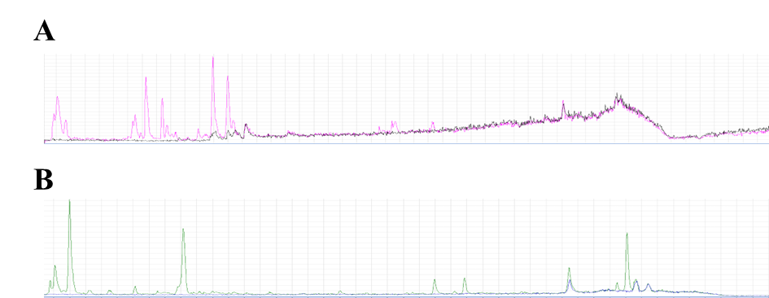
Cryptochlorogenic acid
Calceolarioside B
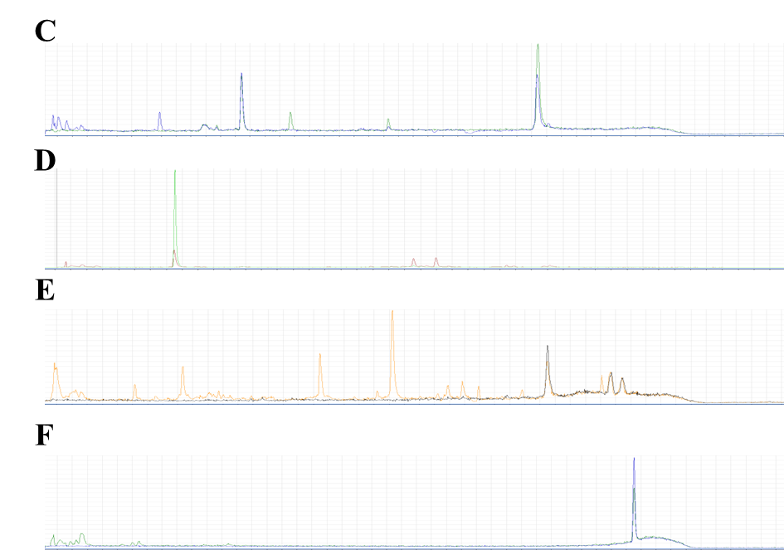
Sesamin
Asarinin
Higenamine
Quercetin
Figure S1 Extracting Molecular Ion Peaks from CAM and ARR Fingerprint after Standard and Sample Fitting. A. CAM and Calceolarioside B B. CAM and Cryptochlorogenic acid. C. ARR and Quercetin D. ARR and Higenamine E. ARR and Asarinin F. ARR and Sesamin

Figure S2
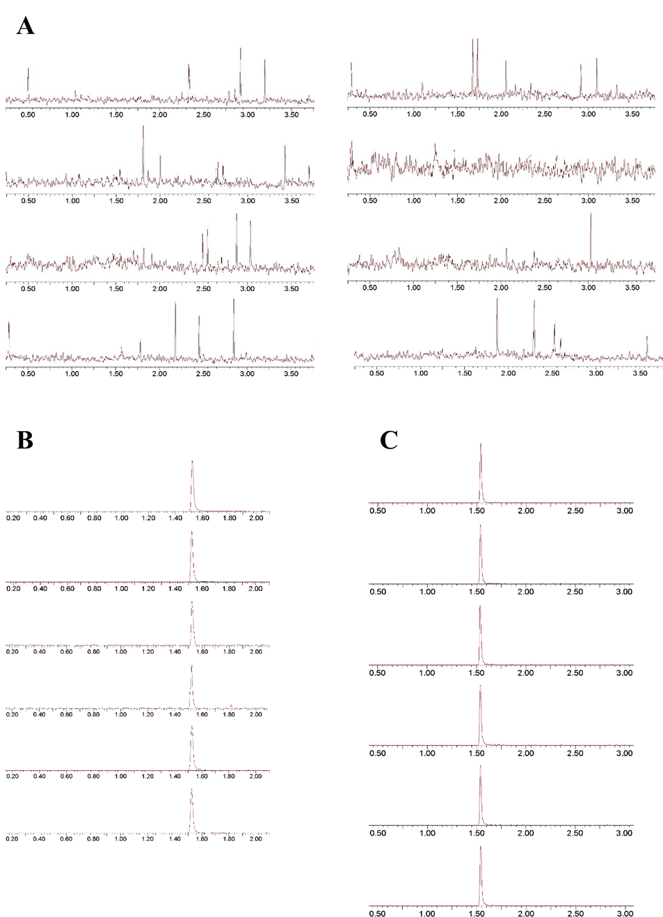
Figure S2 Methodological validation of the dA-ALI assay. A. Blank matrix chromatogram. B. Add the blank matrix chromatogram of the dA-ALI standard. C. Chromatogram of mouse kidney DNA sample after CAM administration.

