Teesside University Ethics Approval
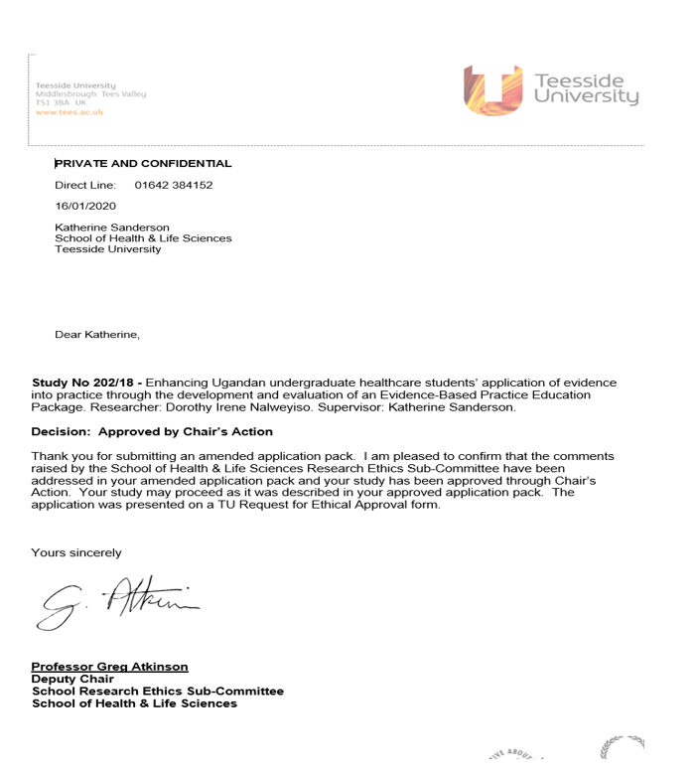

Makerere University Ethics A approval
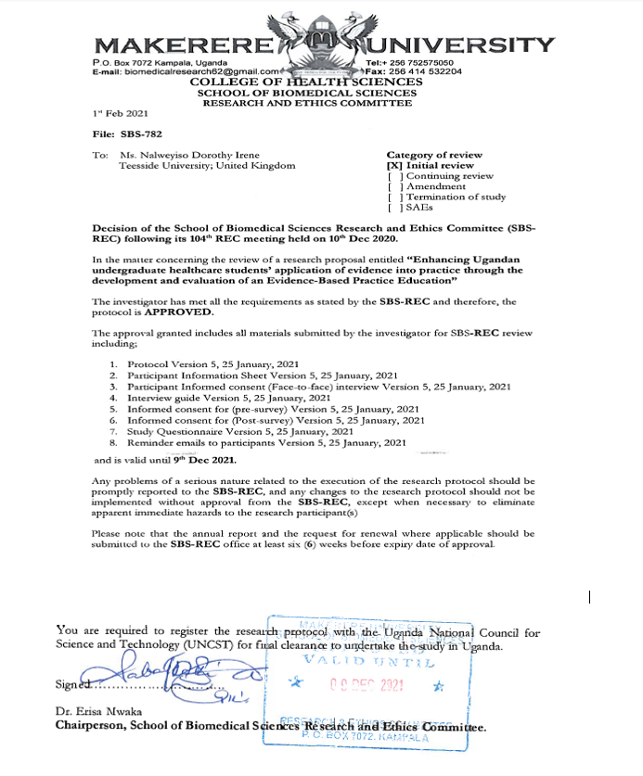

Uganda National Council for Science & Technology Ethics Approval
