Supporting Information
Acidic hydrolytic stability of the Lifitegrast: Degradation, Method development, Validation, Synthesis, LC-MS/NMR Characterization, In silico and In vitro cytotoxicity
Kandula Jony Susanna¹, Mahendar Gantala², Ankita Nishad³, Sujithra Shankar⁴, Shivam Kumar Vyas³, Vaibhav Anil Dixit³, Vivek Singh⁴, P. Radhakrishnanand *¹
¹Department of Pharmaceutical Analysis, National Institute of Pharmaceutical Education and Research, Guwahati, SilaKatamur (Halugurisuk), P.O.: Changsari, District: Kamrup, Assam, India-781101

²Daicel Chiral Technologies (India) Private Limited, Turkapally, Shamirpet Mandal, Medchal-Malkajgiri District, Hyderabad, Telangana, India-500101
³Department of Medicinal Chemistry, National Institute of Pharmaceutical Education and Research, Guwahati, SilaKatamur (Halugurisuk), P.O.: Changsari, District: Kamrup, Assam, India-781101

⁴Prof. Brien Holden Eye Research Center, L.V. Prasad Eye Institute, Kallam Anji Reddy Campus, L V Prasad Marg, Hyderabad – 500 034

*Corresponding author
P. Radhakrishnanand, Ph.D.
Professor
Department of Pharmaceutical Analysis
National Institute of Pharmaceutical Education and Research
(NIPER)-Guwahati, Assam - 781101
Phone: +91- 9866072232
Email: radha.krishnanand@niperguwahati.ac.in

Table of contents
S.No. | Figures | Pg. no.
1 | Schematic representation of forced degradation procedure followed in the current study. | 3
2 | Representative chromatogram of separation of Lifitegrast and its degradation products | 3
3 | HPLC chromatograms of various degradation samples | 4
4 | Calibration curve and control chart representation for the Linearity and accuracy results of the LFT as a part of the method validation | 5
5 | High resolution LC-ESI-MS spectra of the lifitegrast (LFT) and its two acidic thermolytic degradants DP1 and DP2 in ESI positive and negative ionization modes | 6
6 | One dimensional ¹³C spectrum of the synthesized LFT DP1, dissolved in DMSO-d₆ with TMS as an internal reference | 7
7 | Expanded portions of different regions of the ¹³C NMR spectrum of LFT DP1 | 7-8
8 | One dimensional ¹H spectrum of synthesized LFT DP1 dissolved in DMSO-d₆ with TMS as an internal reference. (*) indicates solvent peak | 9
9 | Expanded portions of different regions of the one-dimensional proton NMR spectrum of DP1 | 9-10
10 | One dimensional ¹³C spectrum of the LFT DP2 dissolved in DMSO-d₆ with TMS as an internal reference | 10
11 | Expanded portion of the ¹³C NMR spectrum of LFT-DP2 | 11
12 | One dimensional ¹H spectrum of synthesized LFT DP2 dissolved in DMSO-d₆ with TMS as an internal reference. | 11
13 | Expanded portions of the one-dimensional proton NMR spectrum of LFT-DP2 | 12
14 | IR spectra of the (a) LFT-DP1 and (b) LFT-DP2 using FT-IR | 12
15 | Representative chromatograms of the synthesized DP1 and commercial DP2, under validated chromatographic method conditions. | 13
16 | Swiss ADME prediction tool revealed the Structural representation of the DP1 and DP2 matched with query compound N-Phenethylbenzamide Furan respectively | 13
17 | Figure 17. Preliminary data charts representing viability of HCE cells treated LFT DP 1 and DP 2 at 5-300 µg/mL for 48 h by MTT assay. | 14
Tables
1 | Assay parameters for the determination of LFT under the optimized RP-HPLC method | 15
2 | Accuracy and precision results of the optimized method for the determination of LFT | 15
3 | Robustness results of the optimized method for the determination of LFT | 16
4 | Solution stability testing of the LFT under various temperature conditions using the optimized method | 16
5 | Mass accuracy data of LFT, DP1 and DP2 | 17

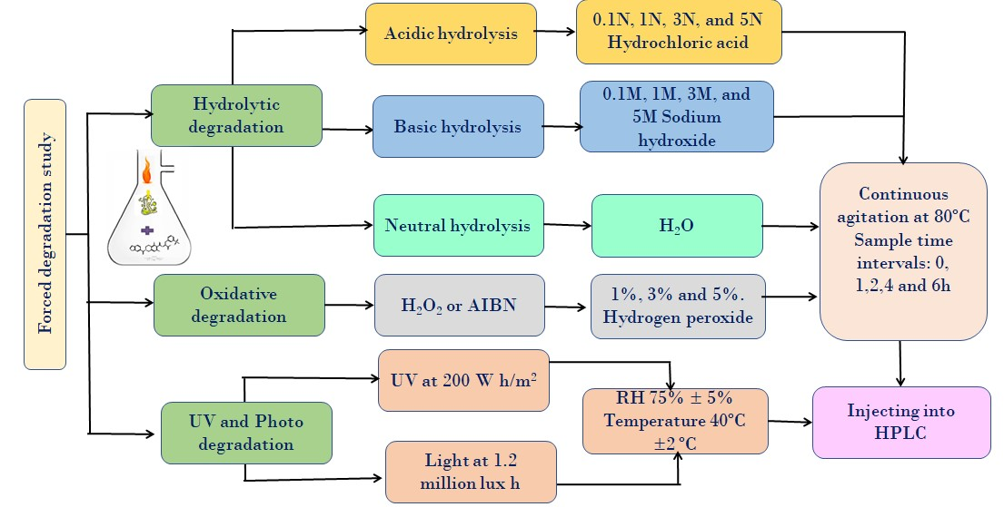
Figure S1. Schematic representation of forced degradation procedure followed in the current study.

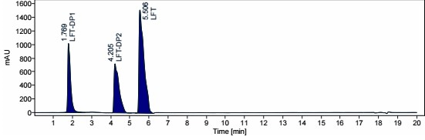
Figure S2. Representative chromatogram of separation of Lifitegrast and its degradation products using reverse-phase Hypersil GOLDTM C18 stationary phase (150 mm, 4.6 mm, 3µm) in combination with 0.1% aqueous formic acid and acetonitrile; Lifitegrast at RT 5.6 minutes; Two major degradation products (DP1 and DP2) of Lifitegrast under acidic conditions (3N HCl, at 80 °C) were eluted at RT 1.7, 4.2 minutes.
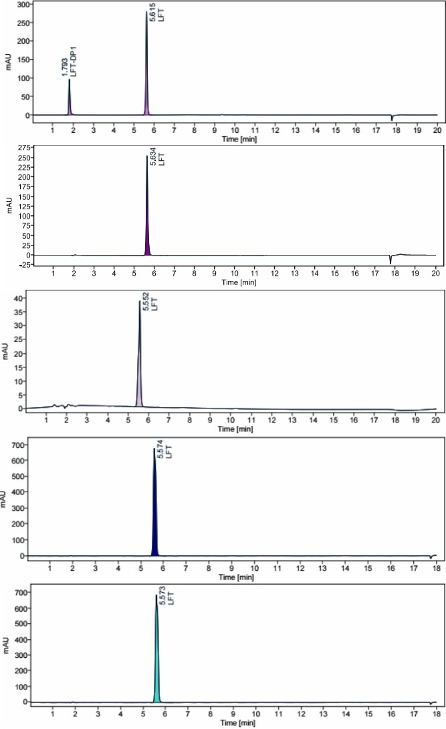
Figure S3. HPLC chromatograms of LFT degradation samples (a). Degradation peak was formed in 5% H₂O₂ at 80 °C and eluted at 1.7 minutes which is one of the RT of acidic degradants; (b). No degradation peak was identified in alkaline degradation sample without neutralization; (c). No degradation peaks were observed in LFT neutral hydrolytic sample; (d). No degradation peaks were observed in LFT after exposure to UV radiation; (e). No degradation peaks were observed in LFT after exposure to Photo degradation conditions.

Figure S4. Calibration curve and control chart representation for the Linearity and accuracy results of the LFT as a part of the method validation.

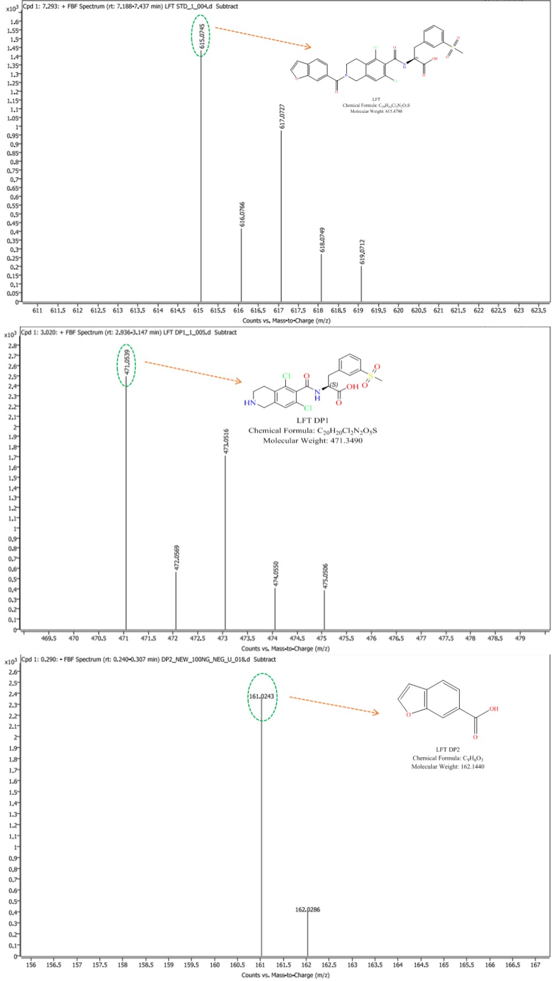
Figure S5. High resolution LC-ESI-MS spectra of the lifitegrast (LFT) and its two acidic thermolytic degradants DP1 and DP2 in ESI positive and negative ionization mode.

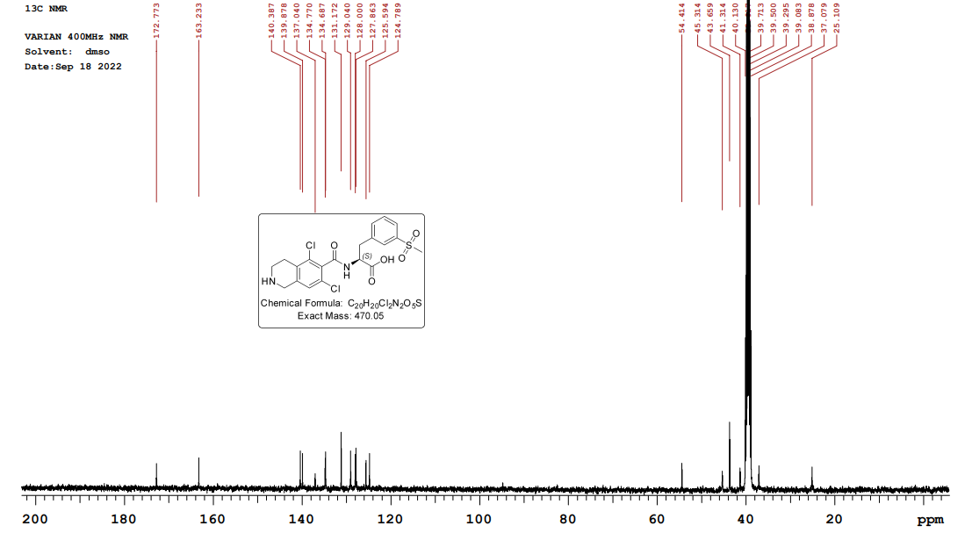
Figure S6. One dimensional ¹³C spectrum of the synthesized LFT DP1, dissolved in DMSO-d₆ with TMS as an internal reference.

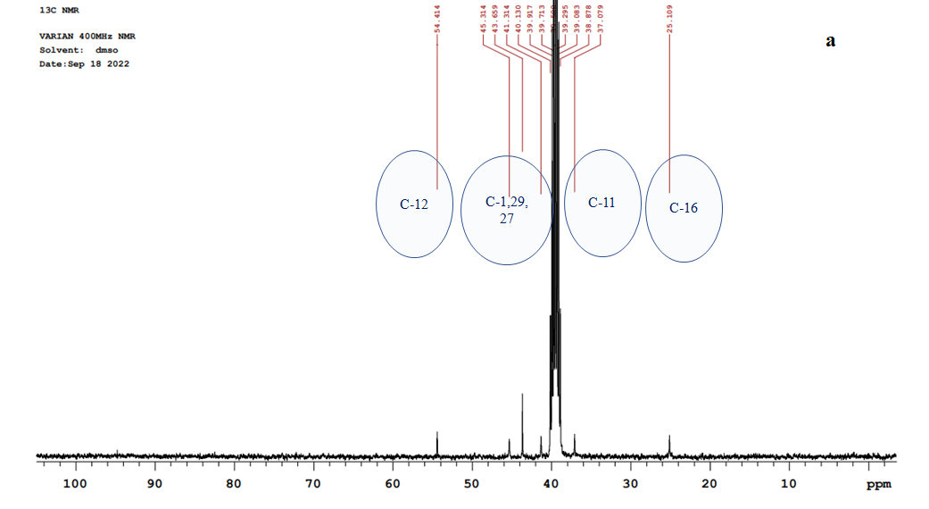

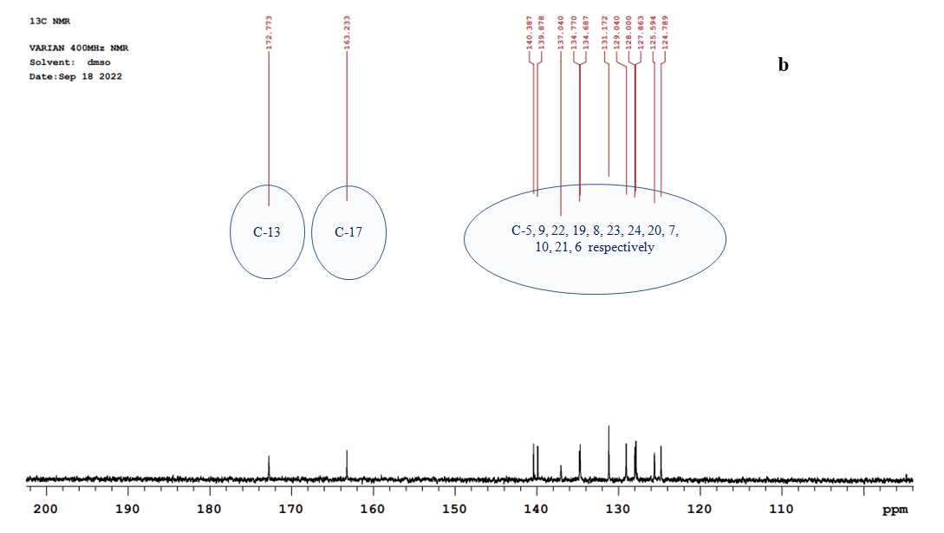
Figure S7. Expanded portions of different regions of the ¹³C NMR spectrum of LFT DP1.
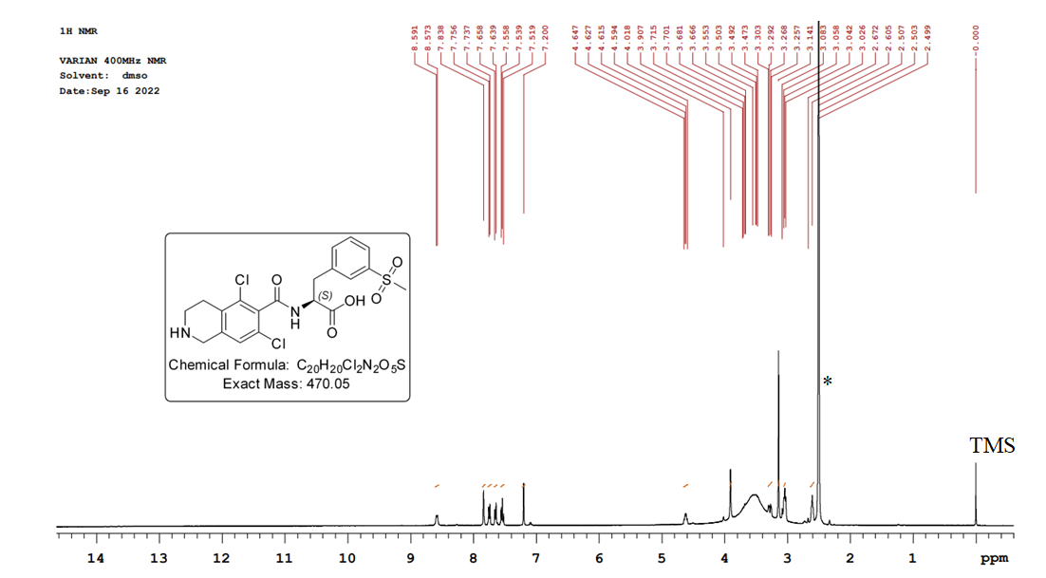
Figure S8. One dimensional ¹H spectrum of synthesized LFT DP1 dissolved in DMSO-d₆ with TMS as an internal reference. (*) indicates solvent peak.

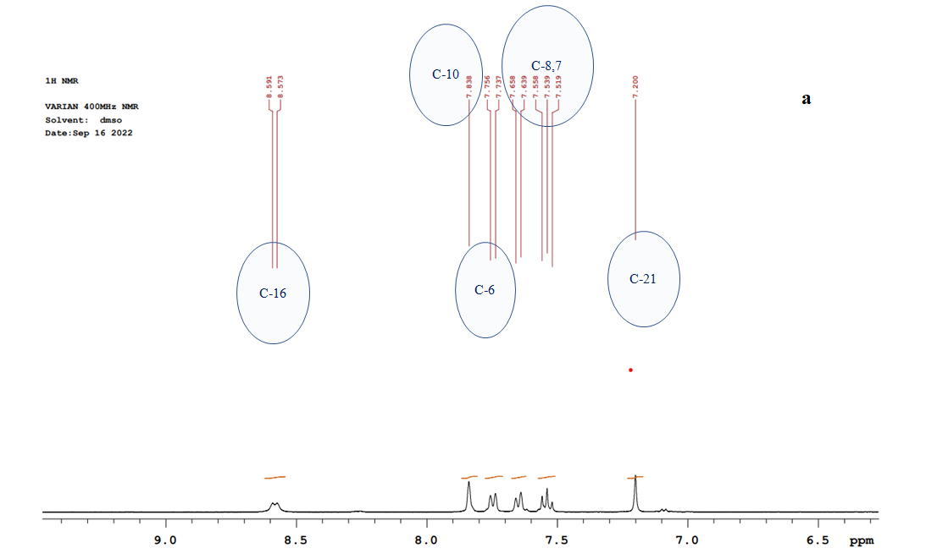
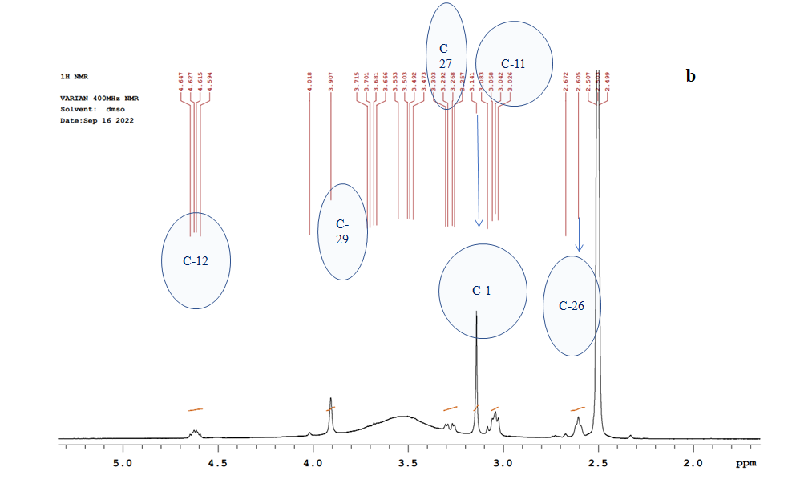
Figure S9. Expanded portions of different regions of the one-dimensional proton NMR spectrum of LFT DP1
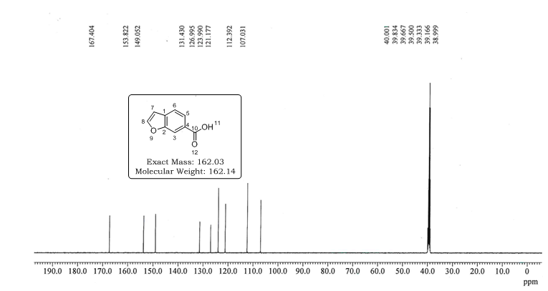
Figure S10. One dimensional ¹³C spectrum of the LFT DP2 dissolved in DMSO-d₆ with TMS as an internal reference.
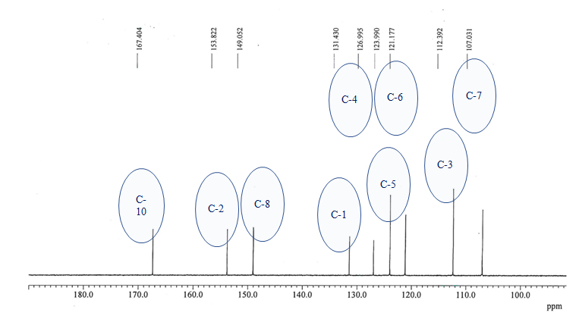
Figure S11. Expanded portion of the ¹³C NMR spectrum of LFT-DP2.
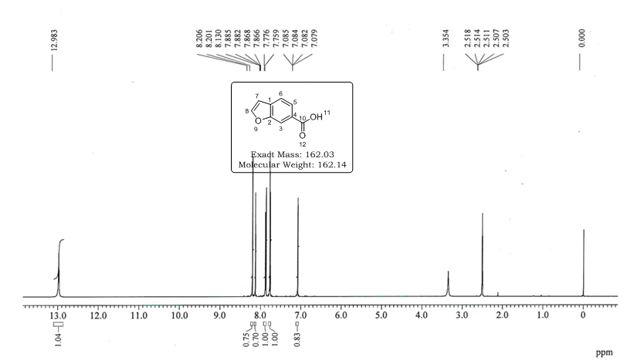
Figure S12. One dimensional ¹H spectrum of synthesized LFT DP2 dissolved in DMSO-d₆ with TMS as an internal reference.

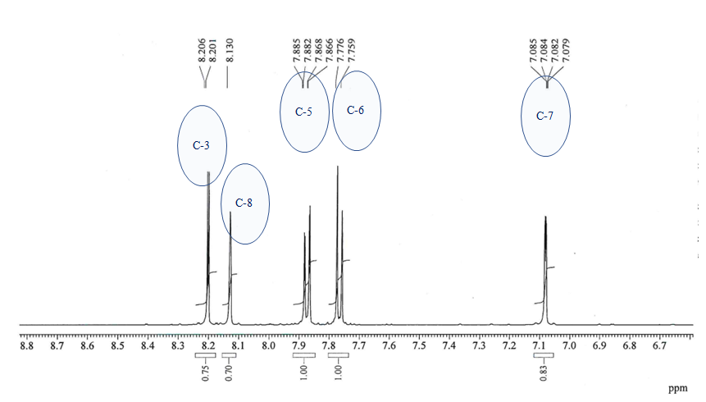
Figure S13. Expanded portions of the one-dimensional proton NMR spectrum of LFT-DP2.

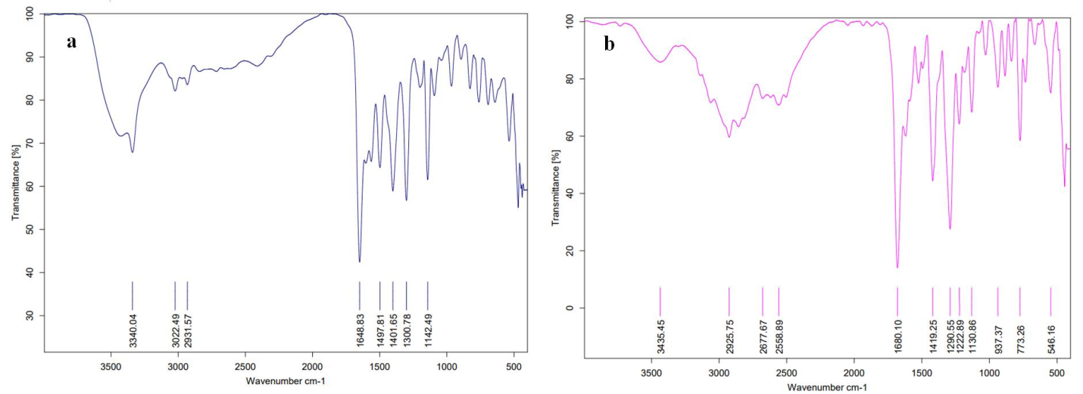

Figure S14. IR spectra of the (a) LFT-DP1 and (b) LFT-DP2 using FT-IR.

e
d
c

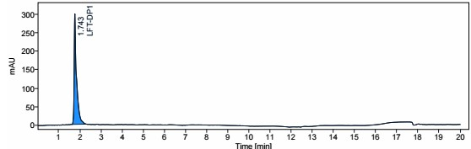
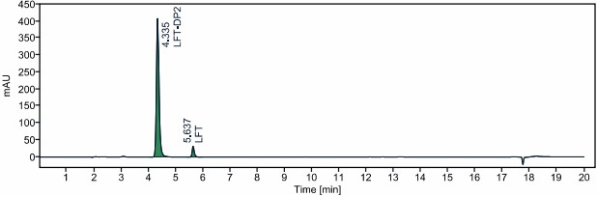
Figure S15. Representative chromatograms of the synthesized DP1 and procured DP2 under validated chromatographic method conditions.

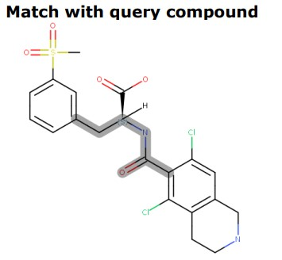
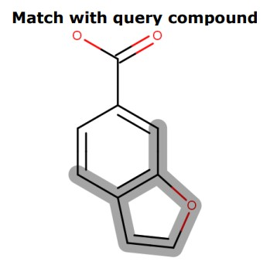
Figure S16. Swiss ADME prediction tool revealed the structural representation of the DP1 and DP2 matched with query compound N-Phenethylbenzamide and Furan respectively.

Figure 17. Preliminary data charts representing viability of HCE cells treated LFT DP 1 and DP 2 at 5-300 µg/mL for 48 h by MTT assay.

Table S1. Assay parameters for the determination of LFT under the optimized RP-HPLC method
Parameter | Result
Range | 30 - 500 µg/mL
Slope | 45.45
Coefficient of intercept | 650.01
Correlation coefficient (R²) | 0.999
Standard error of intercept | 137.50
System suitability testing
RSD% ª (mean ± SD) | 0.04 (5.53 ± 0.002) min
RSD% ^{b} (mean ± SD) | 0.23 (5169.25 ± 12.14)
RSD% ^{c} (mean ± SD) | 1.46 (0.97 ± 0.01)
RSD% ^{d} (mean ± SD) | 1.82 (17315 ± 316.54)
Note: RSD% ª: Retention time, RSD% ^{b}: peak area, RSD% ^{c}: tailing factor, RSD% ^{d}: theoretical plates, SD: standard deviation, RSD: relative standard deviation

Table S2. Accuracy and precision results of the optimized method for the determination of LFT
Accuracy level | % Recovery  (mean ±SD) | Intraday precision  % RSD (mean ± SD) | Inter-day precision  % RSD (mean ± SD)
80% | 91.97 ± 1.33 | 0.99 (4705.28 ± 26.92) | 1.17 (4707.59 ± 31.80)
100% | 100.76 ± 0.23 | 0.14 (5197.66 ± 7.59) | 0.42 (5210.71 ± 22.08)
120% | 103.67 ± 1.41 | 1.138 (6703.32 ± 87.66) | 1.08 (6712.17 ± 83.89)

Table S3. Robustness results of the optimized method for the determination of LFT
Altered condition | Variation | Retention time (min) | Peak area
Optimized method | - | 5.53 | 5190.49
Flow rate (ml/min) | 1.1 | 5.17 | 5207.54
 | 0.9 | 5.95 | 5087.84
Acetonitrile (%) | + 2 % | 5.18 | 5365.22
 | - 2 % | 5.88 | 5043.32
Temperature (°C) | 32.0 | 5.50 | 5180.49
 | 28.0 | 5.51 | 5156.55
Formic acid (%) | 0.11 | 5.561 | 5250.49
 | 0.09 | 5.566 | 5136.43

Table S4. Solution stability testing of the LFT under various temperature conditions using the optimized method
Temperature conditions | Area | Retention time (min)
Standard | 5102.96 | 5.538
25 ºC ± 2 ºC (post 24 h) | 5172.00 | 5.535
4 ºC ± 2 ºC (post 24 h) | 5113.41 | 5.533
-20 ºC (post 48 h) | 5124.12 | 5.534
-80 ºC (post 48 h) | 5025.88 | 5.532
% RSD (mean ± SD) | 1.03 (5107.67 ± 52.80) | 0.041 (5.534 ± 0.002)

Table S5. Mass accuracy data of LFT, DP1 and DP2

 | LFT/DP1/DP2 | Proposed molecular formula | Theoretical m/z | Practical m/z | Mass Error (ppm)
LFT |  | C₂₉H₂₄Cl₂N₂O₇S | 615.0759 | 615.0745 | -2.27
DP1 |  | C₂₀H₂₀Cl₂N₂O₅S | 471.0548 | 471.0539 | -1.91
DP2 |  | C₉H₆O₃ | 161.0242 | 161.0243 | -0.62
LFT | D1 | C₁₉H₁₂Cl₂NO₃ | 372.0189 | 372.0187 | 0.53
LFT | D2 | C₁₀H₈Cl₂NO | 227.9977 | 227.9988 | -4.82
LFT | D3 | C₉H₅O₂ | 145.0284 | 145.0289 | -3.44
DP1 | D1 | C₁₀H₈Cl₂NO | 227.9977 | 227.9979 | -0.87
DP1 | D2 | C₉H₈Cl₂N | 200.0028 | 200.0024 | 1.99
DP1 | D3 | C₉H₈ClN | 165.0340 | 165.0341 | -0.60
DP2 | DP2 D1 | C₈H₅O. | 117.0340 | 117.0344 | -3.41
Notes: LFT: Lifitegrast; DP1 and DP2: Degradation product 1 and 2, D1, D2, D3: Daughter ions 1, 2, 3

