Determination the number of food products in closed packages with the help of X-ray imaging and image processing

Purpose: Precise identification of the number of food products in sealed packages.

- Method (X-Ray Imaging+Image Processing):

  - X-Ray imaging
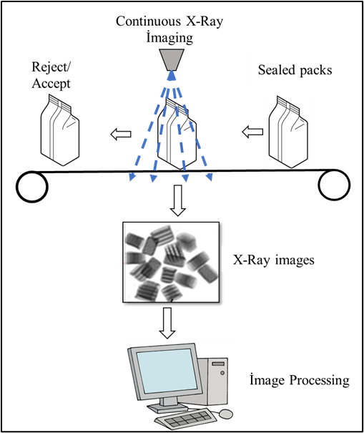

Figure 1. X-Ray imaging

  - Image Processing
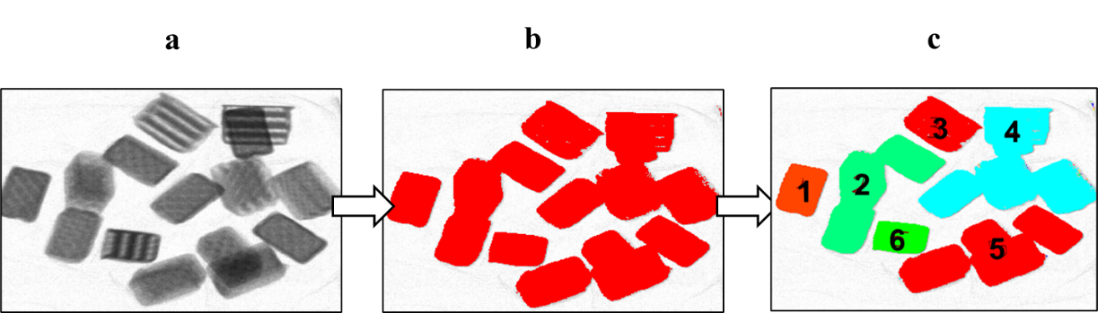
Figure 2. Image Processing
a: X-Ray image,
b: Paintign the products to eliminate bacground image impurities,
c: Definin the product groups for each packs,
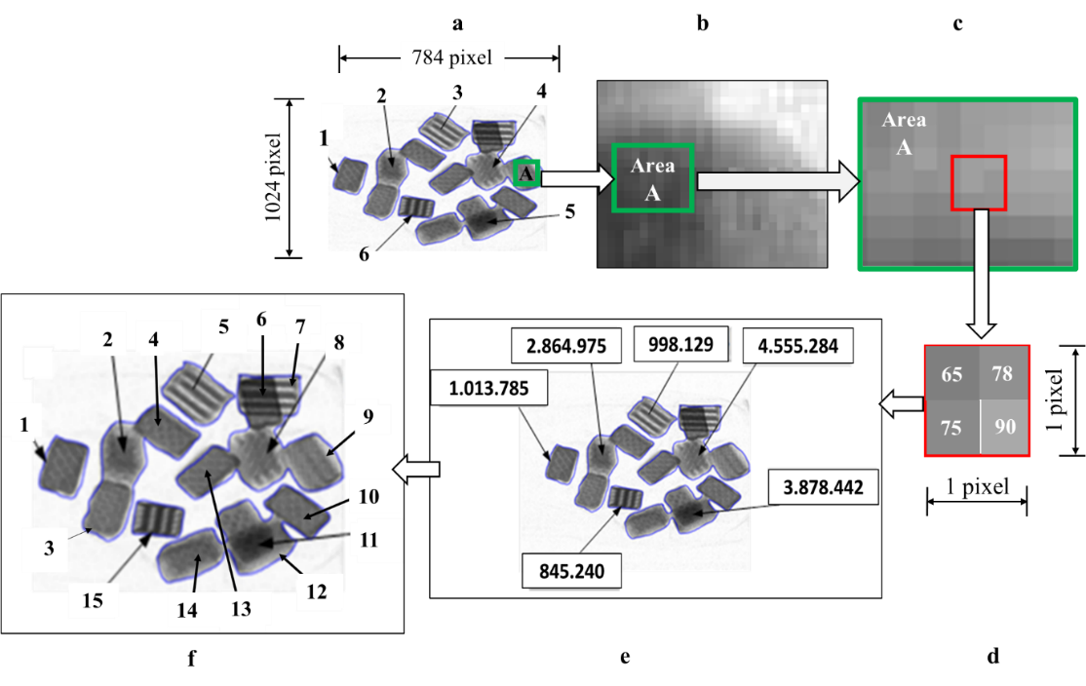
Figure 3. Graynes colour calculations and number of the product in a pack
a: Definition the number of groups
b, c, d,e: Total graynes color calculations for each groups
f: Calculation of number of products according to mooving average grayness colour

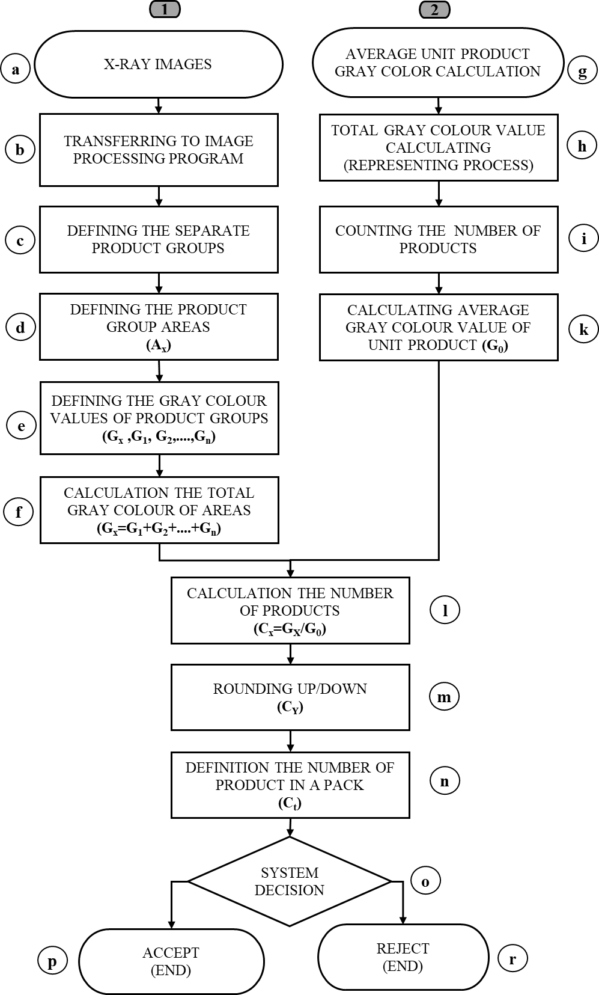
Figure 4. The new method algorithm

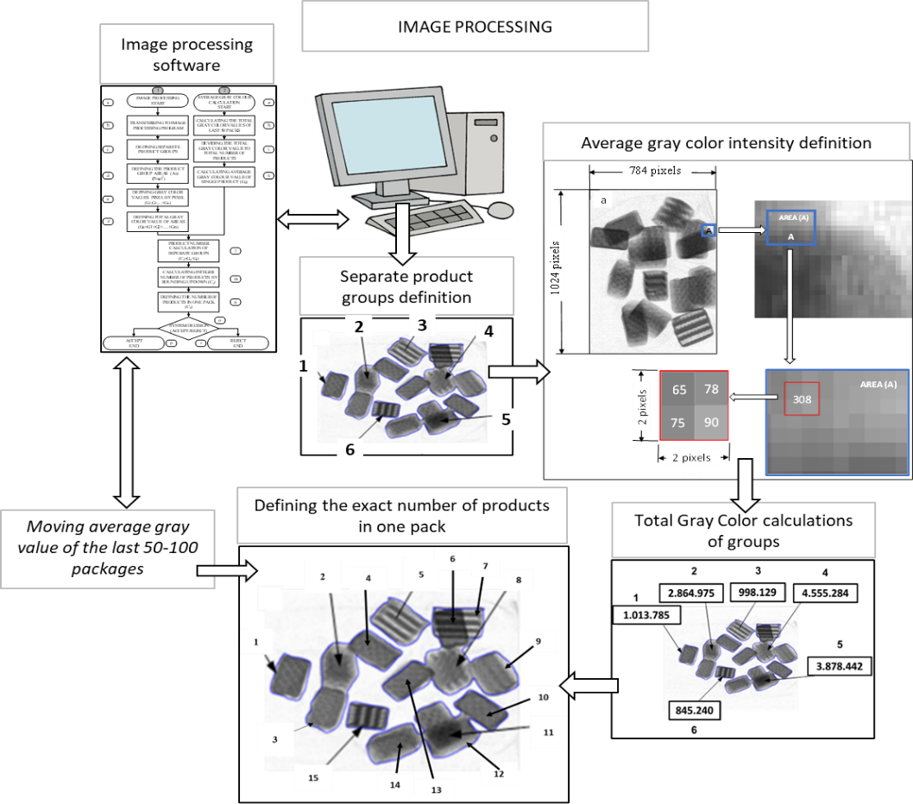
Figure 5. Algorithm and process flow

- Results,Outputs, Comparisions

Figure 6. Results and comparisions

