Appendix

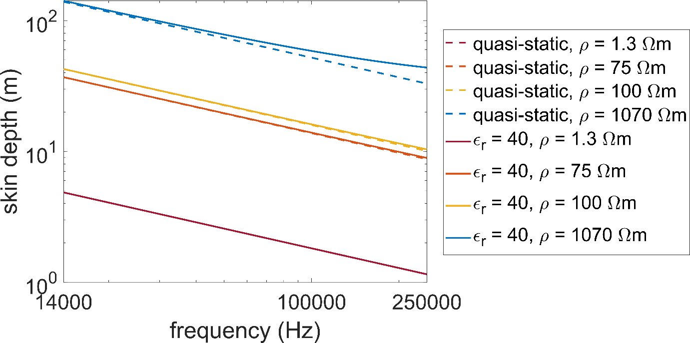

Figure A1: Skin depths for a minimum half space resistivity of 1.3 Ωm, two medium resistivities of 75 Ωm and 100 Ωm, and a maximum resistivity of 1070 Ωm plotted over the measured RMT frequency range. The resistivities were derived from a resistivity model of the southern part of our measurement area which was created with ERT data (Flechsig et al. 2008). The skin depths are plotted for the quasi-static case (ε_{r} = 0) and for a case, where displacement currents were considered (ε_{r} = 40). The skin depth is altered by displacement currents only in the maximum resistivity scenario at the highest frequencies.

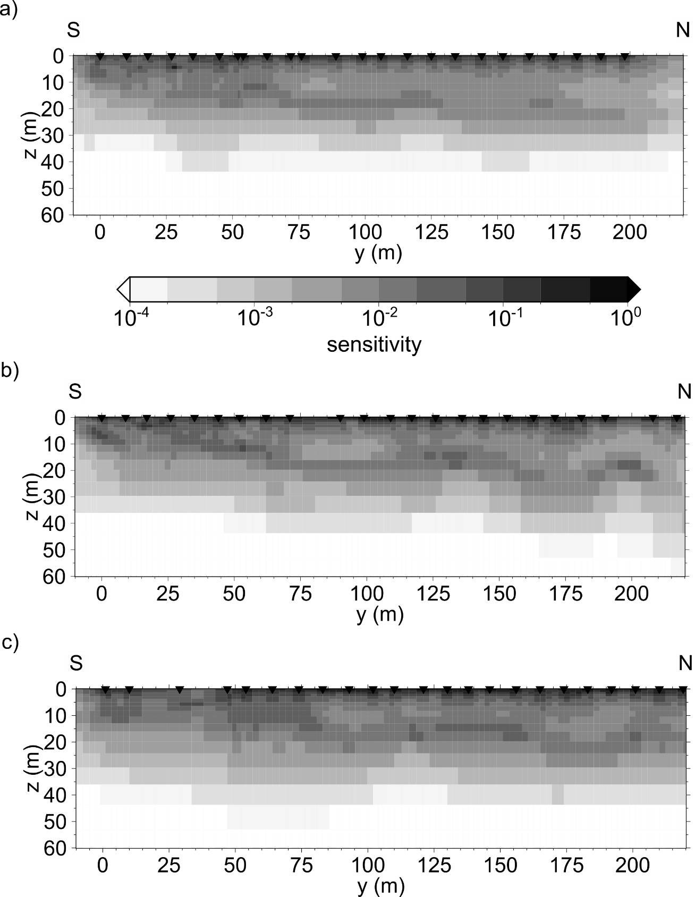

Figure A2: Normalised accumulated sensitivities of the 2D models (Fig. 5 a-c) using the approach of Schwalenberg et al., 2002. The subfigures a), b) and c) correspond to profiles p0, p1, p2, respectively.

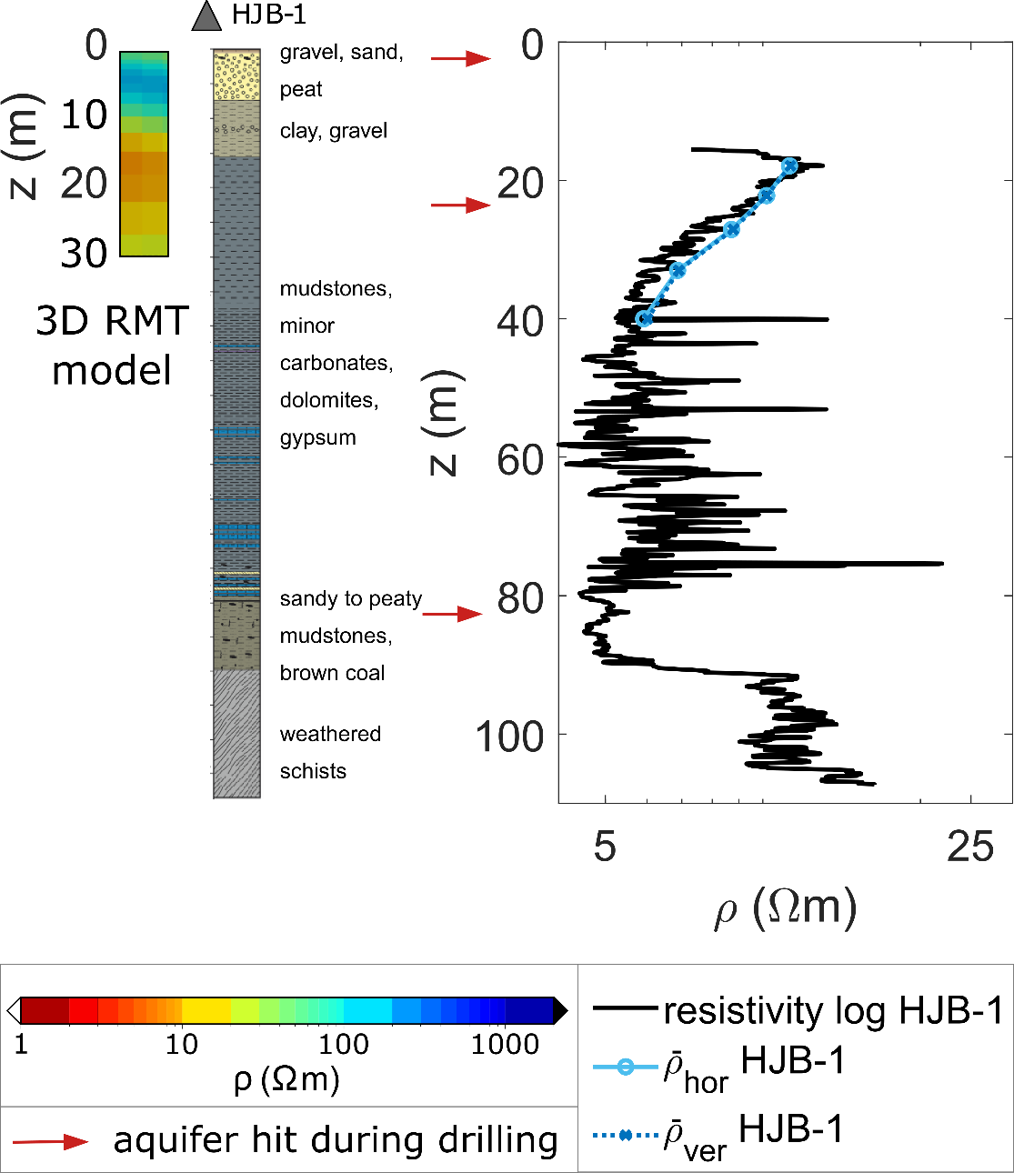

Figure A3: Stratigraphy and apparent resistivities of laterolog measurements in borehole HJB-1 with depth of penetrated aquifers (modified after Bussert et al. 2017) and average apparent resistivities (ρ_{hor}, ρ_{ver}) of HJB-1 for horizontally and vertically flowing currents obtained by averaging the laterolog data (following Pedersen et al. 1992). As ρ_{hor} and ρ_{ver} are approximately the same, an isotropic inversion approach is justified. The location of an aquifer and a minimum in resistivity in borehole HJB-1 at approx. 20 m depth match the conductive anomaly in the 3D model at the borehole location (cf. C2 in Figs. 4 & 5). Note, that the resistivities obtained with focused electrical resistivity measurements in the borehole HJB-1 cannot be directly correlated to the resistivity models obtained with RMT data due to the different measurement methods and their resolution scales. However, a comparison of the upper 30 m of the 3D RMT model at the borehole location to the stratigraphy indicates a correlation of the sandy top layer and the clays and mudstones below with high and low resistivities in the model, respectively.

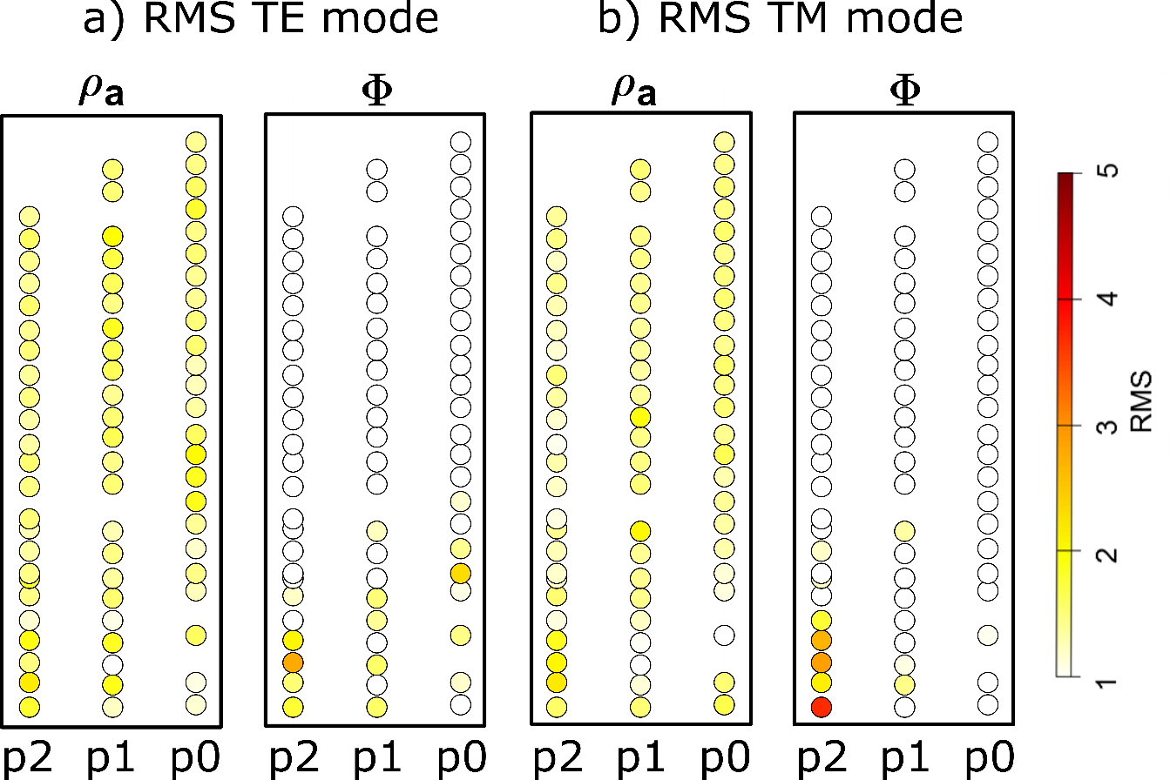

Figure A4: RMS distribution in TE mode (a) and TM mode (b) averaged over frequency for all stations included in the 2D inversions. Overall, the RMS fit for phases is better than for apparent resistivities.
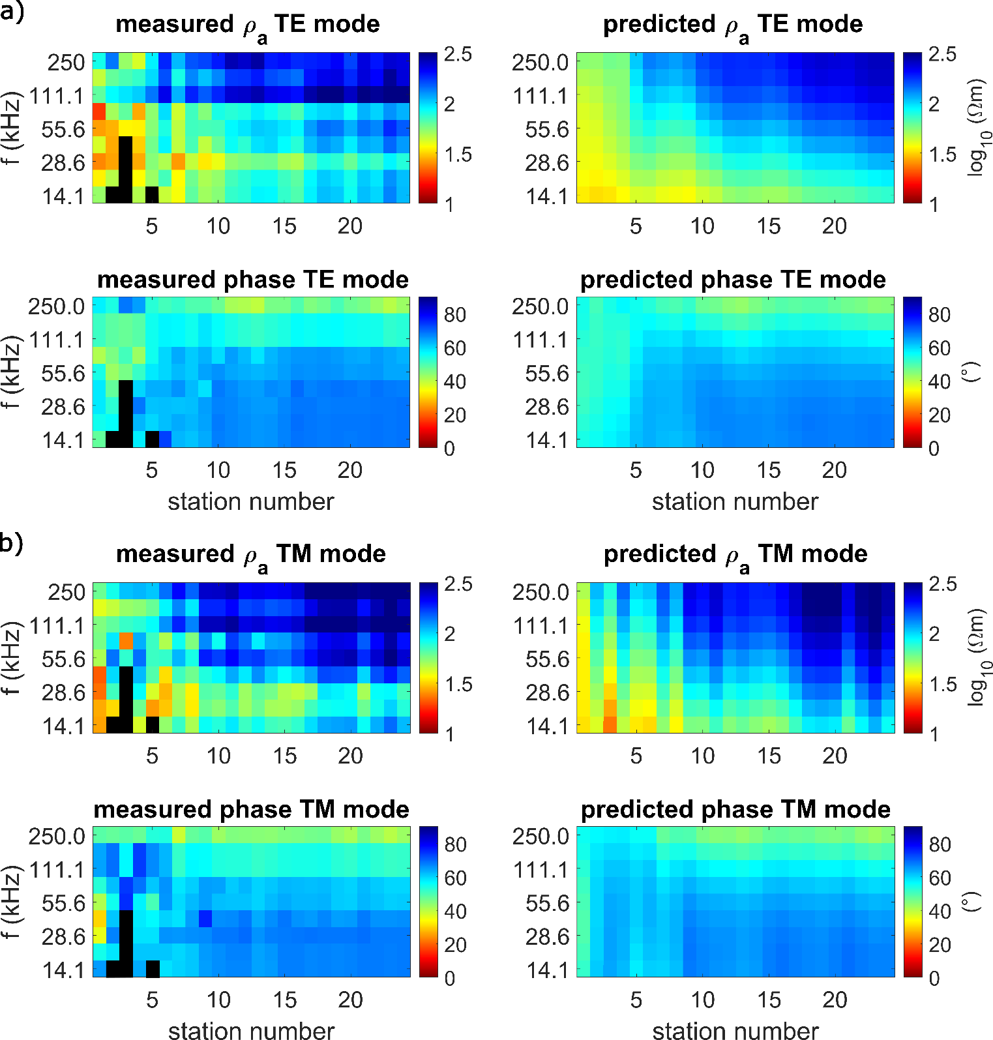

Figure A5: Pseudo-sections of profile p0 for (a) TE mode and (b) TM mode of rotated measured and predicted data. Black colour marks single data points excluded from the 2D inversion.
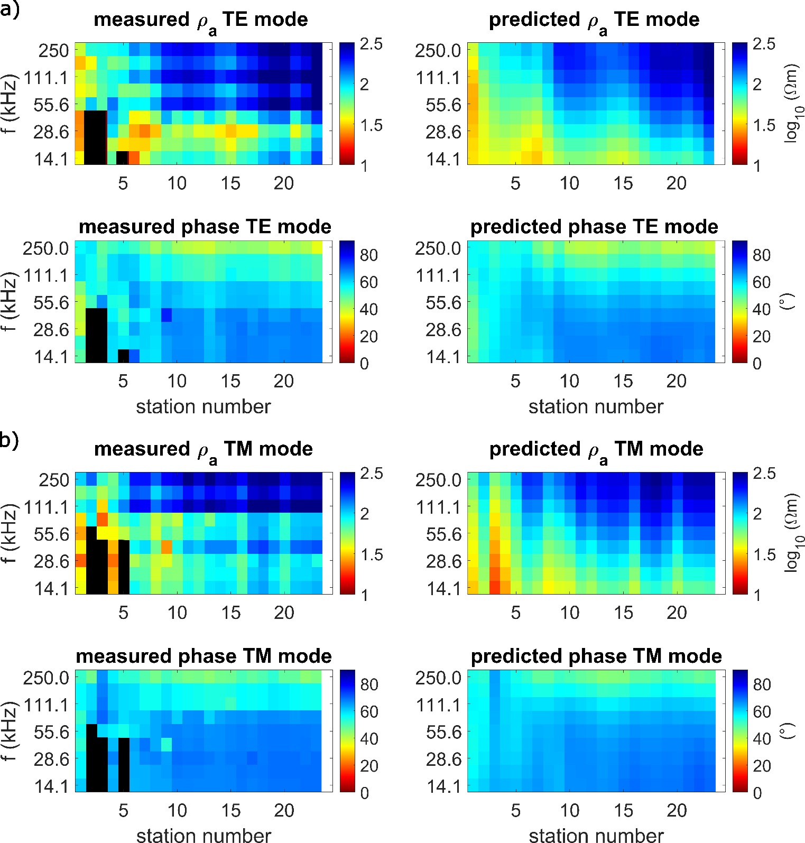

Figure A6: Pseudo-sections of profile p1 (a) TE mode and (b) TM mode of rotated measured and predicted data. Black colour marks single data points excluded from the 2D inversion.
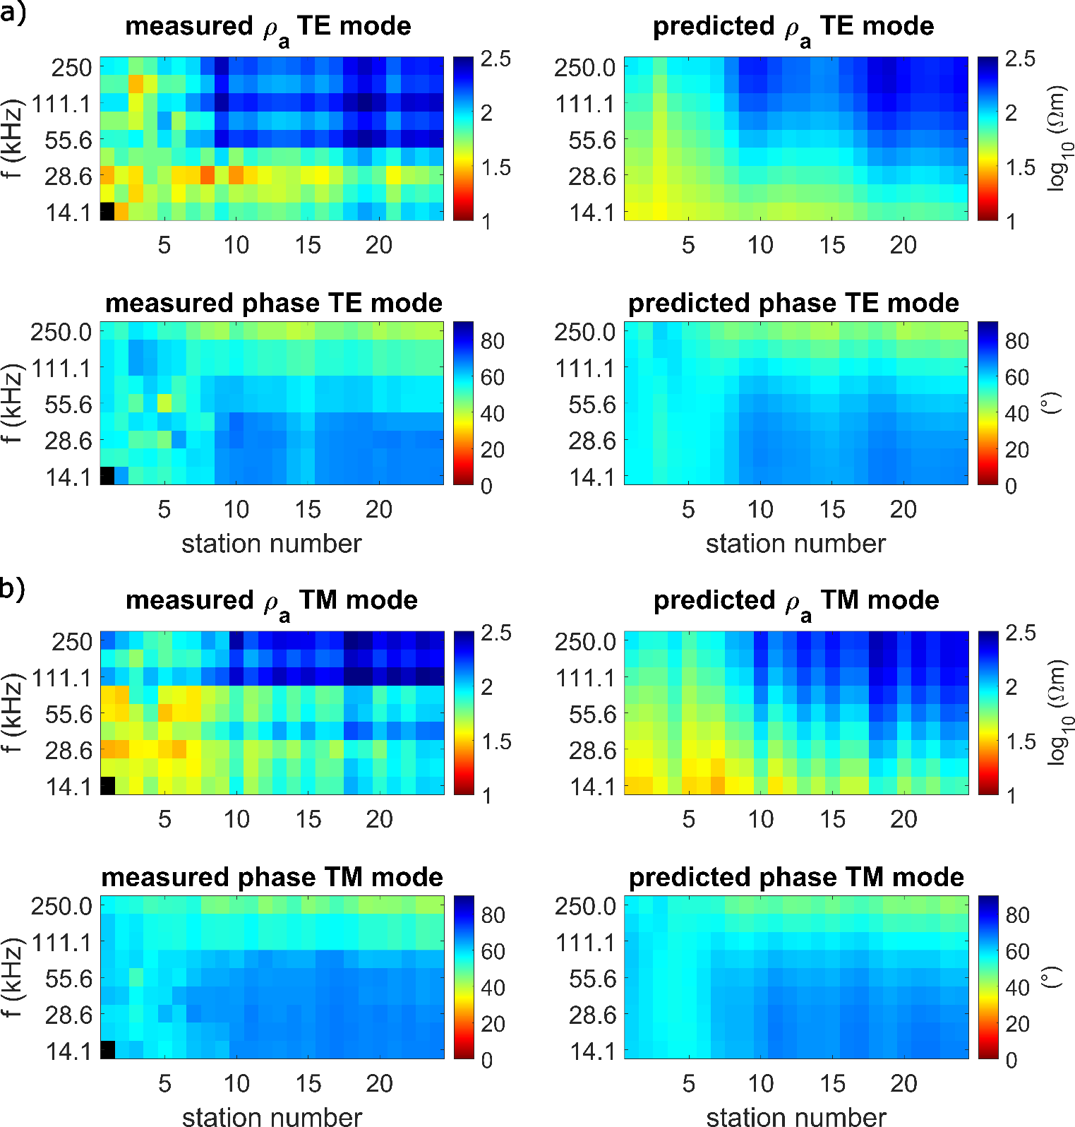

Figure A7: Pseudo-sections of profile p2 for (a) TE mode and (b) TM mode of rotated measured and predicted data. Black colour marks single data points excluded from the 2D inversion.
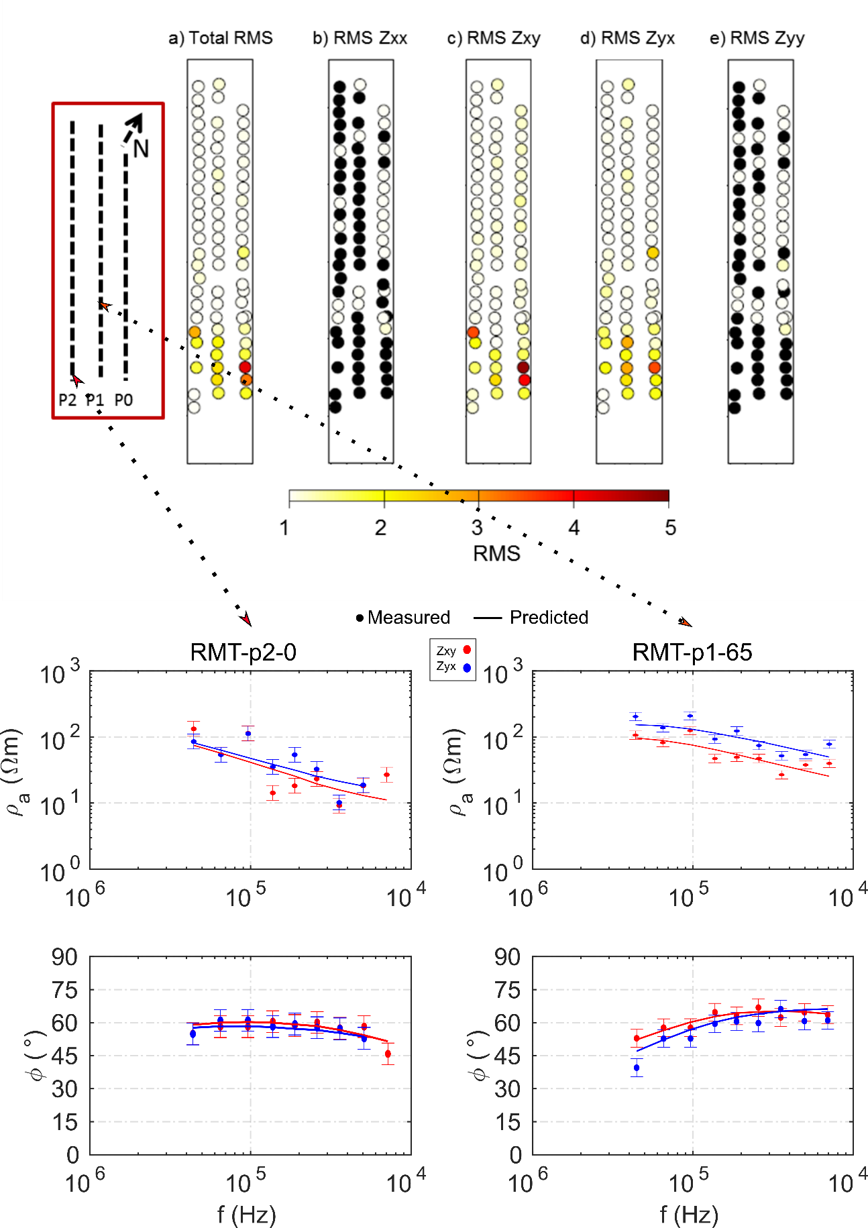
Figure A8: RMS distribution averaged over frequency and components (a) and for individual impedance tensor components (b-e) for each station included in the 3D inversion and exemplary data fit plots for two stations (below). Black dots mark components excluded from the inversion because of poor data quality. Overall, the data fit in the northern part of the model is better. Figure modified after Rulff (2018).
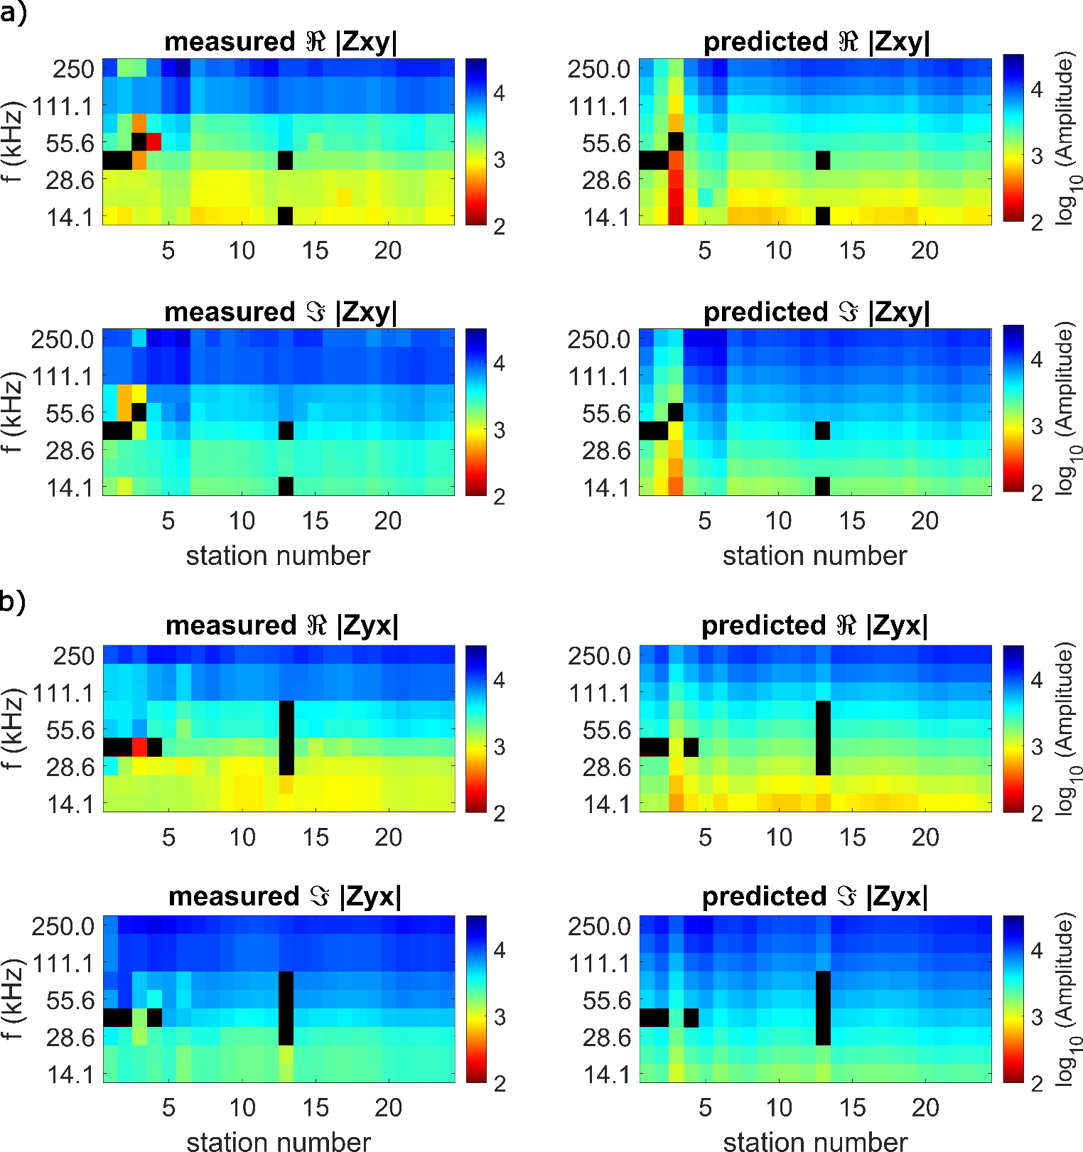

Figure A9: Pseudo-sections of profile p0 for (a) Zxy and (b) Zyx components of measured and predicted data. Black colour marks single data points excluded from the 3D inversion because of poor data quality.

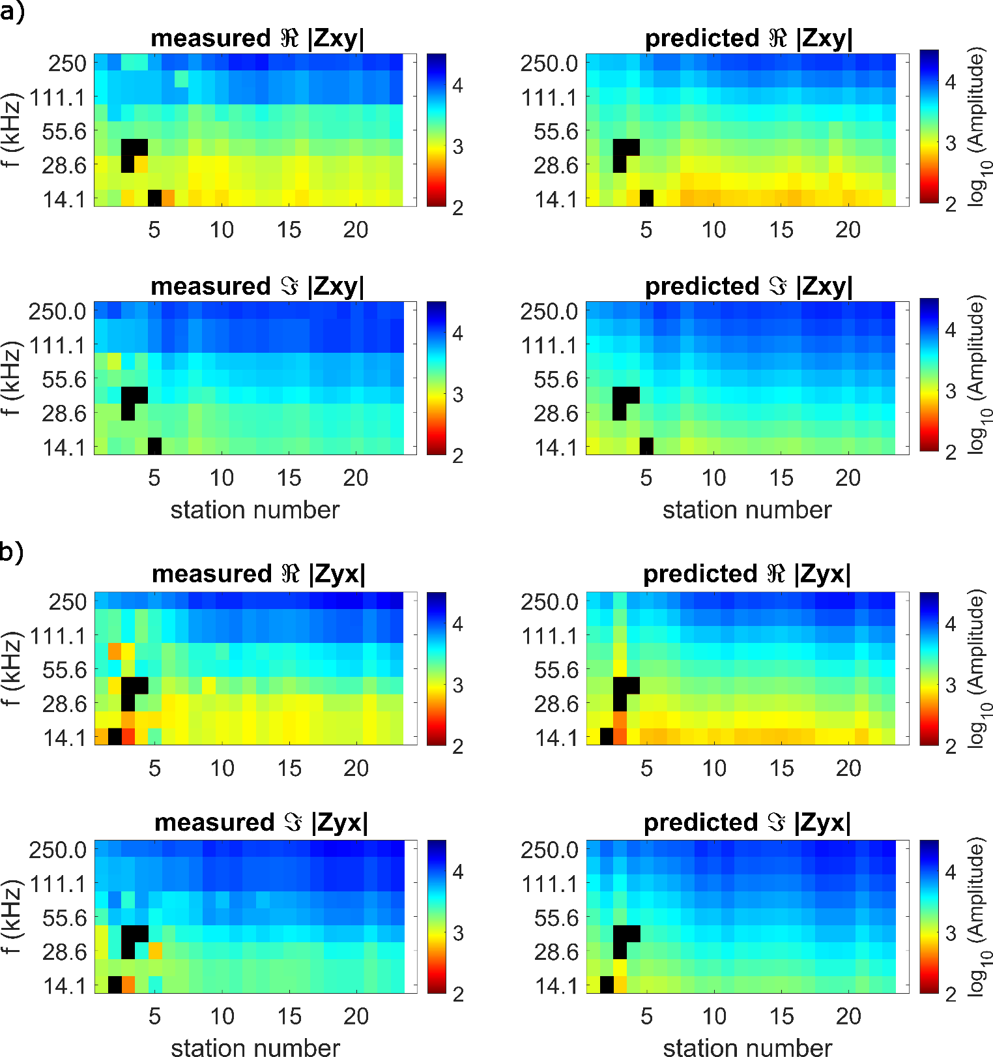

Figure A10: Pseudo-sections of profile p1 for (a) Zxy and (b) Zyx components of measured and predicted data. Black colour marks single data points excluded from the 3D inversion because of poor data quality.

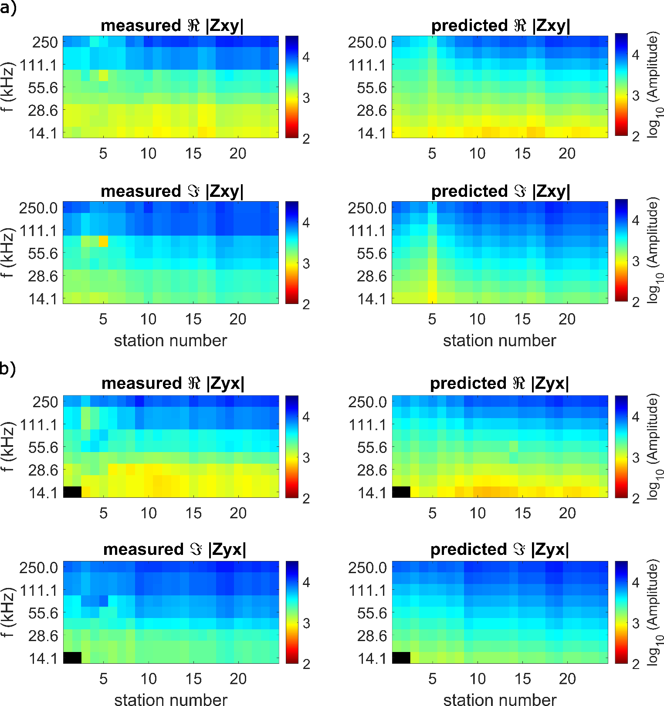

Figure A11: Pseudo-sections of profile p2 for (a) Zxy and (b) Zyx components of measured and predicted data. Black colour marks single data points excluded from the 3D inversion because of poor data quality.

