Supplementary materials

Exploring the Influence of Urbanization on Gut Mycobiota through Dietary Changes in Burkina Faso

Sonia Renzi§ª, Niccolò Meriggi§ª, Monica Di Paolaª, Giovanni Bacciª, Benedetta Cerasuoloª, Agnese Goriª, Silene Casari^{b}, Elena Banci^{c}, Alessia de Blasi^{b}, Salou Diallo^{d}, Berenger Kaborè^{d}, Karim Derra^{d}, Halidou Tinto^{d}, Carlotta De Filippo^{e} , Quirijn De Mast^{f}, Paolo Lionetti^{bg}, Duccio Cavalieri*ª

ª Department of Biology, University of Florence, Sesto Fiorentino, 50019 Florence, Italy.
^{b} Meyer Children's Hospital IRCCS, Gastroenterology and Nutrition Unit, 50139 Florence, Italy.
^{c} Meyer Children's Hospital IRCCS, UP Dietetica, 50139 Florence, Italy.
^{d} Institut de Recherche en Sciences de la Santé-Clinical Research Unit of Nanoro (IRSS-URCN), Nanoro 18, Burkina Faso.
^{e} National Research Council, Institute of Agricultural Biology and Biotechnology, Pisa, Italy
^{f} Department of Internal Medicine, Radboud University Medical Center, Nijmegen, the Netherlands.
^{g} Department of Neurology, Pharmacology, Psychology and Child Health (NEUROFARBA), University of Florence, 50139 Florence, Italy.

* Authors to whom correspondence should be addressed.
§ Authors who equally contributed to the work.

General overview of fungal sequence analysis

DADA2 pipeline produced a total of 13'594'609 reads inferred from internal transcribed spacer 1 region (ITS1) and clustered in a total of 10’526 amplicon sequence variants (ASVs). After quality filtering (see materials and methods for additional details), two samples that showed zero fungal counts (ITIBD21F1 and F304N) were removed from the dataset in order to properly perform the downstream statistical analyses, thus a total of 8’364’411 reads clustered in a total of 1’655 different fungal ASVs were obtained.
The reads distribution within sample groups shows the presence of ASVs with average reading levels higher in African samples groups than in Italian ones, with an increasing trend of the average number of reads in the rural samples (median number of reads of 13’334.5 counts, represented by the dashed red line in Fig. S3a). The rarefaction curves showed that the number of ASVs (referred as Species Richness in Fig. S3b) detected as a function of sequencing depth reached a plateau condition indicating that our sampling effort was effective in assessing the natural fungal diversity within sample groups (Fig. S3b).
Prevalence-abundance ratio was inspected to depict most representative ASVs within the dataset as shown in Fig. S4. Prevalence and total abundance were calculated for each area separately. We set the prevalence threshold of 30 (i.e. ASVs present in at least 30% of samples) and total abundance threshold of 10’000 counts to select the most representative ASVs in the entire dataset (Fig. S4a) and each cohort separately (Fig. S4b). The ASVs selected were resumed with the related summary statistics (prevalence and total abundance) and deepest taxonomic assignment in Table S2.
The metabarcoding analysis showed that the dataset was mainly represented by the taxa belonging to the Class Saccharomycetes (mean relative abundances: 52% in rural villages households, 48% in the semi-urbanized households of Nanoro town, 57% in urban families of Ouagadougou, 44% in Italian families; Table S5 and Fig. S2). Other two taxa widely represented within the dataset belong to the Class Eurotiomycetes (rural villages: 6.5%, Nanoro: 12%, Ouagadougou: 13%, Italy: 25%) and Dothideomycetes (rural villages: 21%, Nanoro: 14%, Ouagadougou: 9%, Italy: 9.7%; Table S3 and Fig. S5). The mean relative abundance of these taxa follows an increased and decreased gradient, respectively, among cohorts according to the rural-to-urban transition. Interestingly, regardless of the sequencing depth, the rate of unknown sequence variants was on average higher in the African datasets, particularly in the rural villages area. Class-level unknown rates were 3.14%, 9.2%, 10.8%, and 7.4% for Italy, Ouagadougou, Nanoro, and the rural villages, respectively. In accordance with this trend, genus-level unknown rates were 5.2%, 13.9%, 16.2% and 18.2% for Italy, Ouagadougou, Nanoro and rural villages, respectively.

Supplementary Table 1. Environmental, nutritional and socio-economical factors inherent the level of globalization. The table reported all the environmental parameters acquired through questionnaires.

Supplementary Fi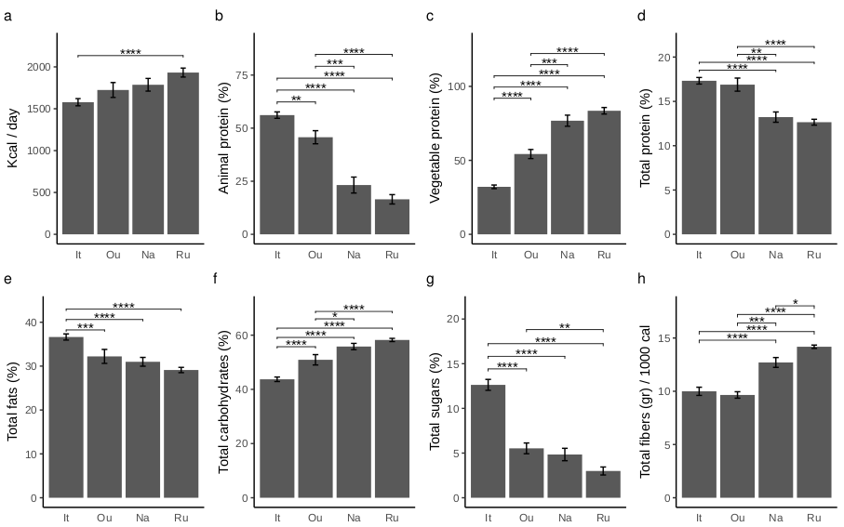Supplementary Fig. 1. Differences in macronutrient intake in adult subjects (>18 years old) according to geographical areas. The bar plots represent the rate of macronutrients assumed by each subject and the error bars reported the standard error. The y-axis of each panel reported: the total kcal intake per day (a) percentage of animal proteins (b) percentage of vegetable proteins (c) percentage of total proteins (d) percentage of total fats (e) percentage of total carbohydrates (f) percentage of total sugars (g) fiber intake expressed in grams per 1000 kcal (h). Pairwise comparisons among groups performed by Wilcoxon test (Benjamini-Hochberg correction method). Significant pairs were reported using asterisks (*, p-value <0.05; **, p-value <0.01; ***, p-value <0.001, ****, p-value <0.0001).

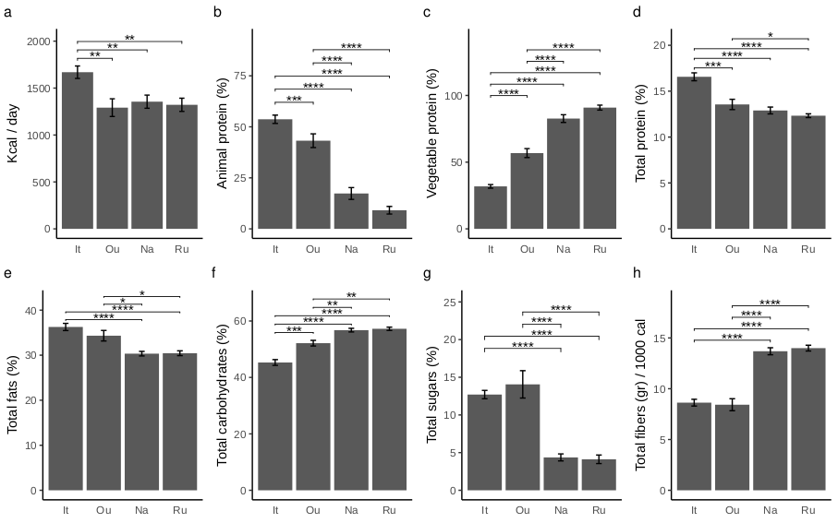
Supplementary Fig. 2. Differences in macronutrient intake in young subjects (<18 years old) according to geographical areas. The bar plots represent the rate of macronutrients assumed by each subject and the error bars reported the standard error. The y-axis of each panel reported: the total kcal intake per day (a) percentage of animal proteins (b) percentage of vegetable proteins (c) percentage of total proteins (d) percentage of total fats (e) percentage of total carbohydrates (f) percentage of total sugars (g) fiber intake expressed in grams per 1000 kcal (h). Pairwise comparisons among groups performed by Wilcoxon test (Benjamini-Hochberg correction method). Significant pairs were reported using asterisks (*, p-value <0.05; **, p-value <0.01; ***, p-value <0.001, ).

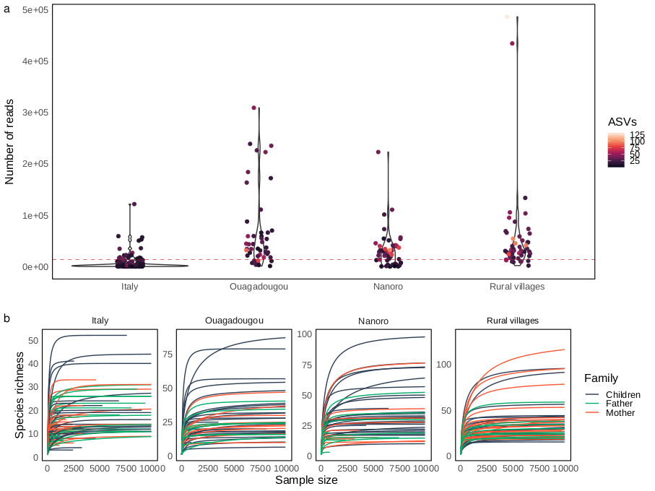
Supplementary Fig. 3. Sequence variants distribution and sequencing depth. Violin plot represents the total number of reads (y-axis) and the number of ASVs (color gradient) for each sample among different areas obtained after DADA2 pipeline (a). The rarefaction curves displayed the total number of ASVs (Species richness) and total number of reads (Sample size) according to the four different areas. The family degree was highlighted using the color pattern in the legend. Rarefaction curves were computed with an increasing step of 1000.

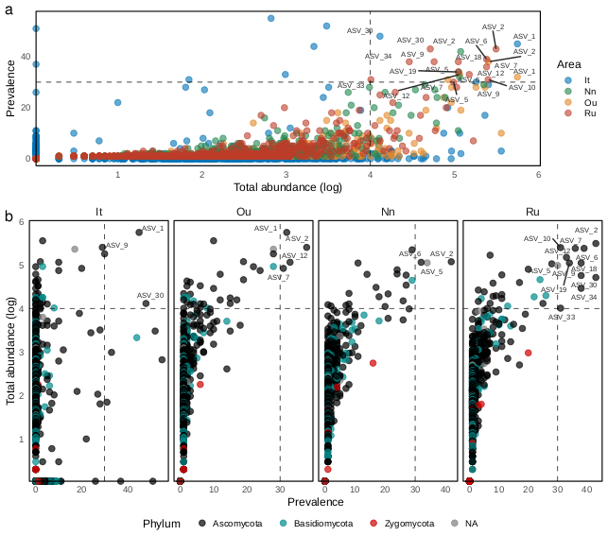
Supplementary Fig. 4. ASVs prevalence-abundance across samples. (a-b) ASVs distribution according to their prevalence (percentage of samples where the ASV is present) and the base 10 logarithm of total abundance. Top panel (a) reports the ASVs distribution of each area highlighted using color scheme in the legend whereas bottom panels (b) report the ASVs distribution of each area separately highlighting the taxonomic assignment at Phylum level. Each panel reported the ASVs according to the prevalence threshold of 30 (ASVs present in at least the 30% of samples) and total abundance (log10) threshold of 40 (corresponding to 10’000 counts). The threshold values are highlighted using the dashed lines. The ASVs deepest taxonomic assignment is reported in Table S2.

Supplementary Table 2. Prevalence-abundance table. Table reports the ASVs with prevalence equal or higher than 30 (ASVs present in at least the 30% of samples) and total abundance equal or higher than 10’000 counts. ASVs are reported with the area in which the ASV is detected with the related prevalence and total abundance scores. The ASV deepest taxonomic assignment is reported.

ASV | Area | Prevalence | Total abundance | Taxa
ASV_30 | It | 48 | 13002 | Davidiella
ASV_1 | It | 45 | 557817 | Candida sp VVT 2012
ASV_9 | It | 30 | 179584 | Eurotium
ASV_2 | Ou | 38 | 253216 | Pichia
ASV_12 | Ou | 33 | 115203 | Candida tropicalis
ASV_1 | Ou | 32 | 557817 | Candida sp VVT 2012
ASV_7 | Ou | 31 | 83231 | Pichia
ASV_2 | Nn | 42 | 118126 | Pichia
ASV_5 | Nn | 34 | 111752 | Fungi
ASV_6 | Nn | 32 | 114713 | Epicoccum sorghi
ASV_2 | Ru | 43 | 311165 | Pichia
ASV_30 | Ru | 43 | 51487 | Davidiella
ASV_6 | Ru | 39 | 240130 | Epicoccum sorghi
ASV_18 | Ru | 38 | 110807 | Pichia
ASV_9 | Ru | 38 | 57192 | Eurotium
ASV_34 | Ru | 38 | 28976 | Kluyveromyces marxianus
ASV_7 | Ru | 36 | 240056 | Pichia
ASV_19 | Ru | 34 | 110887 | Pleosporales
ASV_12 | Ru | 33 | 149429 | Candida tropicalis
ASV_10 | Ru | 31 | 250531 | Candida mesorugosa
ASV_33 | Ru | 31 | 10135 | Aspergillus flavus
ASV_5 | Ru | 30 | 97449 | Fungi

Supplementary Table 3. Mean relative abundance table. Table reported Class-level mean relative abundance (compositional transformed ASVs) for each area. Mean relative abundance was reported in the third column, while the related taxonomic assignment and areas were reported in the second and first columns respectively.

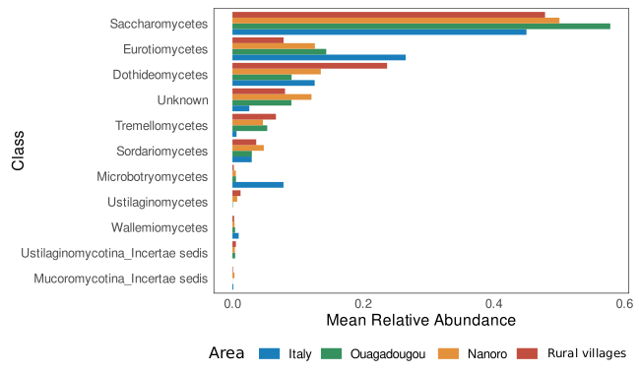
Supplementary Fig. 5. Mean relative abundances among sample groups. Mean relative abundances (compositional transformed ASVs) of the main fungal classes depicted for each geographical area. Mean relative abundance was represented using barplot and the four areas were highlighted following the color pattern in the legend. After singleton removal only ASVs present in more than 5% of samples within the dataset were reported.

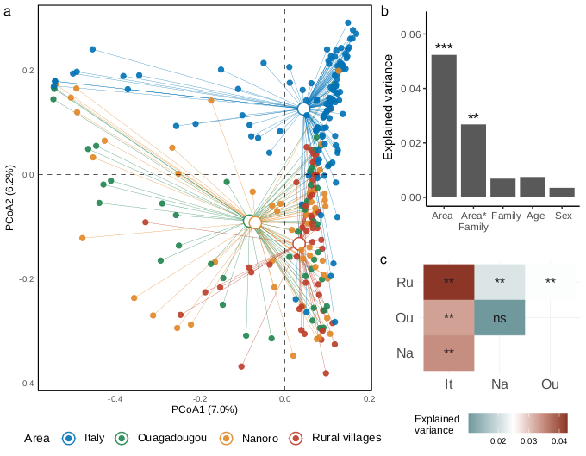
Supplementary Fig. 6. Fungal distribution based on Jaccard distance matrix.
Principal Coordinates Analysis based on Jaccard distance matrix depicted the four different geographical areas represented following the color scheme shown in the legend (Area) (a). Statistically significant factors and variance explained value from adonis PERMANOVA performed on Jaccard distance matrix reported using barplot (b). Statistically significant contrasts and variance explained from pairwise adonis PERMANOVA (Holm correction method) performed on Jaccard distance matrix displayed for each group comparison were reported in the heatmap using color gradient, from lower value (blue scale) to higher value (red scale) (c). The four different geographical areas compared in the adonis PERMANOVA (c) were reported by using the following label code, It: Italy, Ou: Ouagadougou, Na: Nanoro, Ru: Rural villages. Statistically significant results were represented using asterisks (ns, not significant; *, p-value <0.05; **, p-value <0.01; ***, p-value <0.001).

Supplementary Table 4. Results from adonis PERMANOVA according to the main variables tested. The results from multivariate analyses were reported for both diversity indices (Bray-Curtis and Jaccard), factor tested in the model formula (Factor), degree of freedom (Df), sum of squares (SumOfSqs), variance explained (R-squared), F model (F) and p-value (Pr(>F) ). Significant effects were displayed using asterisks (*, p-value <0.05; **, p-value <0.01; ***, p-value <0.001). The analysis was carried out using 1000 numbers of permutations. The proportion of variance unexplained by the factor considered was reported in the Residual column.

Index | Factor | Df | SumOfSqs | R-squared | F | Pr(>F) | Sign
Bray-Curtis | Area | 3 | 9.204 | 0.080 | 7.710 | 9.99e-4 | ***
Bray-Curtis | Family | 2 | 0.793 | 0.007 | 0.997 | 0.445
Bray-Curtis | Age range | 2 | 0.857 | 0.007 | 1.077 | 0.304
Bray-Curtis | Sex | 1 | 0.391 | 0.003 | 0.983 | 0.467
Bray-Curtis | Area*Family | 6 | 3.159 | 0.027 | 1.323 | 0.003 | **
Bray-Curtis | Residual | 253 | 100.672 | 0.875
Bray-Curtis | Total | 267 | 113.447 | 1
Jaccard | Area | 3 | 6.398 | 0.052 | 4.886 | 9.99e-4 | ***
Jaccard | Family | 2 | 0.842 | 0.007 | 0.964 | 0.545
Jaccard | Age range | 2 | 0.916 | 0.007 | 1.049 | 0.322
Jaccard | Sex | 1 | 0.423 | 0.004 | 0.985 | 0.489
Jaccard | Area*Family | 6 | 3.277 | 0.027 | 1.251 | 0.002 | **
Jaccard | Residual | 253 | 110.442 | 0.903
Jaccard | Total | 267 | 122.305 | 1

Supplementary Table 5. beta dispersion among groups. Multivariate homogeneity of groups dispersions (variances) tested for each pair among the variables area, family and the interaction of both variables using Tukey HSD test. Significant contrast combinations for each variable were highlighted using asterisks (*, p-value <0.05; **, p-value <0.01).

Supplementary Table 6. Pairwise adonis PERMANOVA across different areas.
The results from the pairwise comparisons from pairwise adonis PERMANOVA were reported for both distance indexes (Bray-Curtis and Jaccard). The table reported all factor contrast combinations (Pairs), degree of freedom (Df), sum of squares (SumOfSqs), variance explained (R-squared), F model (F-model) and Holm adjusted p-value (P-adjust).
Significant contrast were highlighted using asterisks (*, p-value <0.05; **, p-value <0.01; ***, p-value <0.001). The analysis was carried out using 1000 numbers of permutations. The four different geographical areas compared were reported by using the following label code, It: Italy, Ou: Ouagadougou, Na: Nanoro, Ru: Rural villages.

Index | Pairs | Df | SumOfSqs | F-model | R-squared | P-adjust | Sign
Bray-Curtis | Na - Ou | 1 | 0.400 | 1.070 | 0.011 | 0.345
Bray-Curtis | Na - Ru | 1 | 1.040 | 2.814 | 0.028 | 0.006 | **
Bray-Curtis | Na - It | 1 | 4.040 | 9.675 | 0.054 | 0.006 | **
Bray-Curtis | Ou - Ru | 1 | 1.224 | 3.297 | 0.034 | 0.006 | **
Bray-Curtis | Ou - It | 1 | 3.737 | 8.902 | 0.051 | 0.006 | **
Bray-Curtis | Ru - It | 1 | 5.128 | 12.335 | 0.067 | 0.006 | **
Jaccard | Na - Ou | 1 | 0.407 | 0.966 | 0.010 | 0.498
Jaccard | Na - Ru | 1 | 0.905 | 2.157 | 0.021 | 0.006 | **
Jaccard | Na - It | 1 | 2.747 | 6.113 | 0.035 | 0.006 | **
Jaccard | Ou - Ru | 1 | 1.001 | 2.381 | 0.025 | 0.006 | **
Jaccard | Ou - It | 1 | 2.540 | 5.635 | 0.033 | 0.006 | **
Jaccard | Ru - It | 1 | 3.421 | 7.626 | 0.043 | 0.006 | **

Supplementary Table 7. Results from adonis PERMANOVA according to the family degree. The results from multivariate analyses performed on Bray-Curtis distance matrix were reported according to the four different area -based datasets (Area), considering the factor tested in the model formula (Factor), degree of freedom (Df), sum of squares (SumOfSqs), variance explained (R-squared), F model (F) and p-value (Pr(>F) ). Significant effects were displayed using asterisks (*, p-value <0.05; **, p-value <0.01; ***, p-value <0.001). The analysis was carried out using 1000 numbers of permutations. The proportion of variance unexplained by the factor considered was reported in the Residual column.

Area | Factor | Df | SumOfSqs | R-squared | F | Pr(>F) | Sign
Italy | Family | 2 | 0.632 | 0.012 | 0.720 | 0.950
Italy | Age range | 2 | 0.669 | 0.013 | 0.762 | 0.905
Italy | Sex | 1 | 0.409 | 0.008 | 0.933 | 0.579
Italy | Residual | 116 | 50.876 | 0.967
Italy | Total | 121 | 52.586 | 1
Ouagadougou | Family | 2 | 0.626 | 0.038 | 0.825 | 0.763
Ouagadougou | Age range | 2 | 0.670 | 0.041 | 0.882 | 0.652
Ouagadougou | Sex | 1 | 0.268 | 0.016 | 0.707 | 0.838
Ouagadougou | Residual | 39 | 14.797 | 0.904
Ouagadougou | Total | 44 | 16.361 | 1
Nanoro | Family | 2 | 1.442 | 0.080 | 2.047 | 9.99e-4 | ***
Nanoro | Age range | 2 | 0.649 | 0.036 | 0.921 | 0.604
Nanoro | Sex | 1 | 0.520 | 0.029 | 1.478 | 0.086
Nanoro | Residual | 44 | 15.497 | 0.856
Nanoro | Total | 49 | 18.108 | 1
Rural villages | Family | 2 | 1.193 | 0.065 | 1.667 | 0.008 | **
Rural villages | Age range | 2 | 0.591 | 0.032 | 0.825 | 0.768
Rural villages | Sex | 1 | 0.380 | 0.021 | 1.062 | 0.369
Rural villages | Residual | 45 | 16.108 | 0.882
Rural villages | Total | 50 | 18.272 | 1

Supplementary Table 8. Anova type II table. Table showed results from Anova type II performed on model formula. The table reported the terms present in the formula (Factor), sum of square (Sum Sq), degrees of freedom (Df), F value and p-value (Pr(>F)). Significant effects were displayed using asterisks (*, p-value <0.05; **, p-value <0.01; ***, p-value <0.001).

Index | Factor | Sum Sq | Df | F value | Pr(>F) | Sign
Observed | Area | 24650 | 3 | 30.183 | <0.001 | ***
Observed | Family | 745 | 2 | 1.368 | 0.257
Observed | Age range | 233 | 2 | 0.428 | 0.653
Observed | Sex | 209 | 1 | 0.768 | 0.382
Observed | Area*Family | 1973 | 6 | 1.208 | 0.303
Shannon  index | Area | 14.362 | 3 | 10.749 | <0.001 | ***
Shannon  index | Family | 0.331 | 2 | 0.372 | 0.690
Shannon  index | Age range | 1.197 | 2 | 1.344 | 0.263
Shannon  index | Sex | 0.601 | 1 | 1.350 | 0.246
Shannon  index | Area*Family | 5.172 | 6 | 1.936 | 0.076
Inverse Simpson  index | Area | 239.90 | 3 | 6.706 | <0.001 | ***
Inverse Simpson  index | Family | 10.34 | 2 | 0.434 | 0.649
Inverse Simpson  index | Age range | 39.70 | 2 | 1.665 | 0.191
Inverse Simpson  index | Sex | 35.18 | 1 | 2.950 | 0.087
Inverse Simpson  index | Area*Family | 105.78 | 6 | 1.478 | 0.186

Supplementary Table 9. Alpha diversity measures among different areas.
Results from pairwise comparisons among different geographical areas assessed using Wilcoxon rank sum test (Benjamini-Hochberg correction method). In the columns were displayed the alpha diversity measure (Observed, Shannon index and Inverse simpson index), group comparisons (Group 1 and 2), p-value, adjusted p-value and significant contrast (Sign). Significant contrasts were displayed using asterisks (*, p-value <0.05; **, p-value <0.01; ***, p-value <0.001, ****, p-value <0.0001). The four different geographical areas compared were reported by using the following label code, It: Italy, Ou: Ouagadougou, Na: Nanoro, Ru: Rural villages.

Index | Group1 | Group2 | P-value | P-adjust | Sign
Observed | It | Ou | 9.18e-11 | 2-75e-10 | ****
Observed | It | Na | 1.69e-10 | 3.38e-10 | ****
Observed | It | Ru | 6.97e-19 | 4.18e-18 | ****
Observed | Ou | Na | 8.06e-1 | 8.06e-1
Observed | Ou | Ru | 6e-3 | 9e-3 | **
Observed | Na | Ru | 2.3e-2 | 2.7e-2 | *
Shannon  index | It | Ou | 2e-2 | 3.6e-2 | *
Shannon  index | It | Na | 1.7e-5 | 5.1e-5 | ****
Shannon  index | It | Ru | 3.73e-7 | 2.24e-6 | ****
Shannon  index | Ou | Na | 1.5e-1 | 1.8e-1
Shannon  index | Ou | Ru | 2.4e-2 | 3.6e-2 | *
Shannon  index | Na | Ru | 4.3e-1 | 4.3e-1
Inverse Simpson  index | It | Ou | 1.53e-1 | 2.29e-1
Inverse Simpson  index | It | Na | 4e-3 | 1.2e-2 | *
Inverse Simpson  index | It | Ru | 9.1e-5 | 5.45e-4 | ***
Inverse Simpson  index | Ou | Na | 2.88e-1 | 3.46e-1
Inverse Simpson  index | Ou | Ru | 3.1e-2 | 6.2e-2
Inverse Simpson  index | Na | Ru | 4.69e-1 | 4.69e-1

Supplementary Table 10. DESeq2 results table. Significant ASVs obtained using the loglikelihood ratio test (LRT) of DESeq2. All significant ASVs were reported with the relative taxonomic annotation.

Supplementary Table 11. Pairwise Wilcoxon test of significant fungal species relative abundance among different areas. Results from the Wilcoxon test (Benjamini-Hochberg correction method) performed on the relative abundance of significant Species-level ASVs. Significant pairs were reported using asterisks (*, p-value <0.05; **, p-value <0.01; ***, p-value <0.001).

Supplementary Table 12. Pairwise Wilcoxon test of significant fungal ASVs relative abundance among different areas. Results from the Wilcoxon test (Benjamini-Hochberg correction method) performed on the relative abundance of significant ASVs with different taxonomic assignments (from Domain to Genus). Significant pairs were reported using asterisks (*, p-value <0.05; **, p-value <0.01; ***, p-value <0.001).

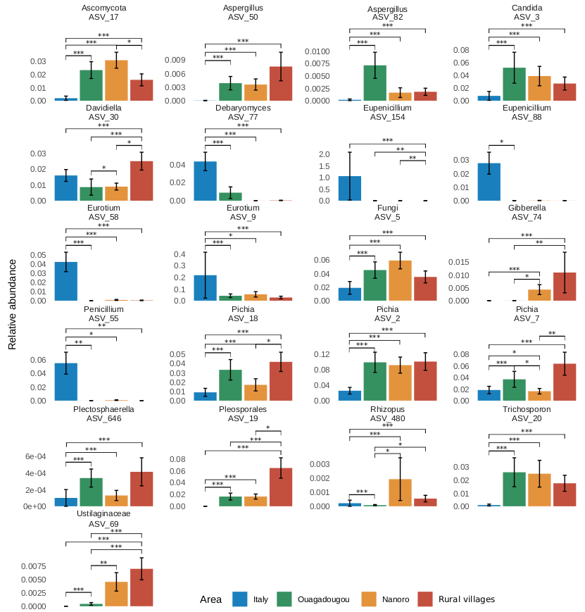
Supplementary Fig. 7. Pairwise comparisons of significant fungal ASVs abundance.
Relative abundance of significant ASVs (loglikelihood ratio test of DESeq2) with different taxonomic assignments (from Domain to Genus) displayed according to the four different areas. Differences in the abundance values were tested by using the Wilcoxon test (Benjamini-Hochberg correction method). Different areas were depicted following the color pattern in the legend. Significant contrasts were displayed using asterisks (*, p-value <0.05; **, p-value <0.01; ***, p-value <0.001).

