EXTENDED DATA

Molecular Basis for RNA Polymerase-Dependent Transcription Complex Recycling By The Helicase-like Motor Protein HelD
Timothy Newing², Aaron Oakley², Michael Miller¹, Catherine Dawson¹, Simon Brown², James Bouwer², Gökhan Tolun²*, Peter J. Lewis¹*
¹School of Environmental and Life Sciences, University of Newcastle, Callaghan, NSW 2308, Australia
²Molecular Horizons and School of Chemistry and Molecular Bioscience, University of Wollongong, and Illawarra Health and Medical Research Institute, Wollongong, NSW 2522, Australia

*For correspondence: Peter.Lewis@newcastle.edu.au or gokhan_tolun@uow.edu.au

Extended Data Figure 1.
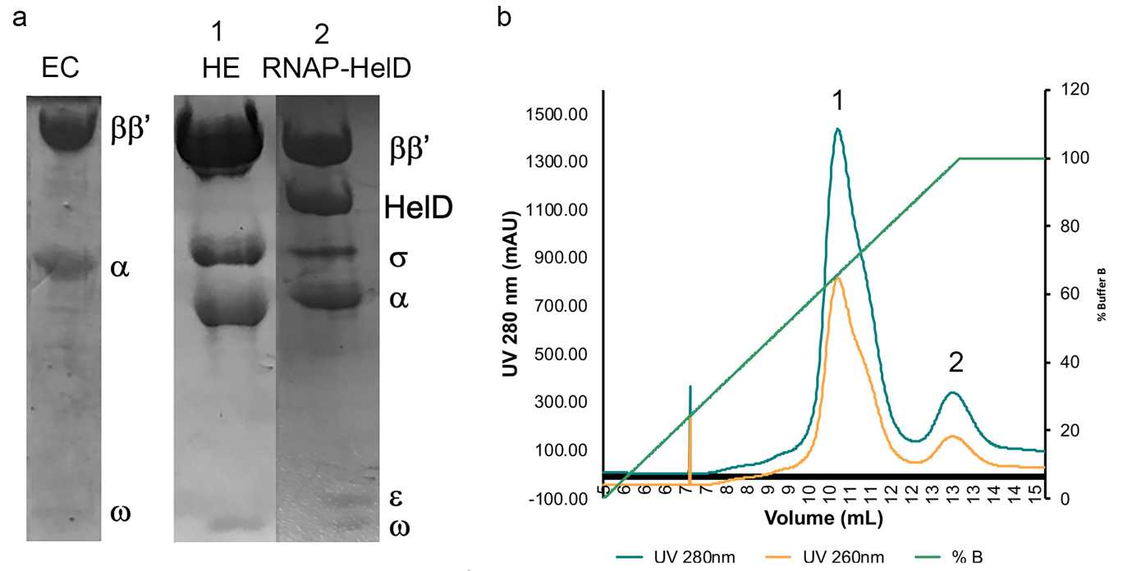

Extended Data Figure 1. Purification of B. subtilis RNAP core and RNAP-HelD complexes. a, B. subtilis RNAP core (EC), holoenzyme (α₂ββ’ωσ^{A}; HE) and RNAP-HelD complexes were purified as described in Methods and an image of Coomassie blue stained SDS-PAGE samples is shown. b, The final step of the purification of the RNAP-HelD complex was performed by heparin sepharose chromatography which separated holoenzyme (HE; peak 1) from HelD complex (peak 2). The HE complex contained no detectable ε and the RNAP-HelD complex contained sub-stoichiometric levels of σ^{A} which was not detectable in cryoEM reconstructions.

Extended Data Figure 2.

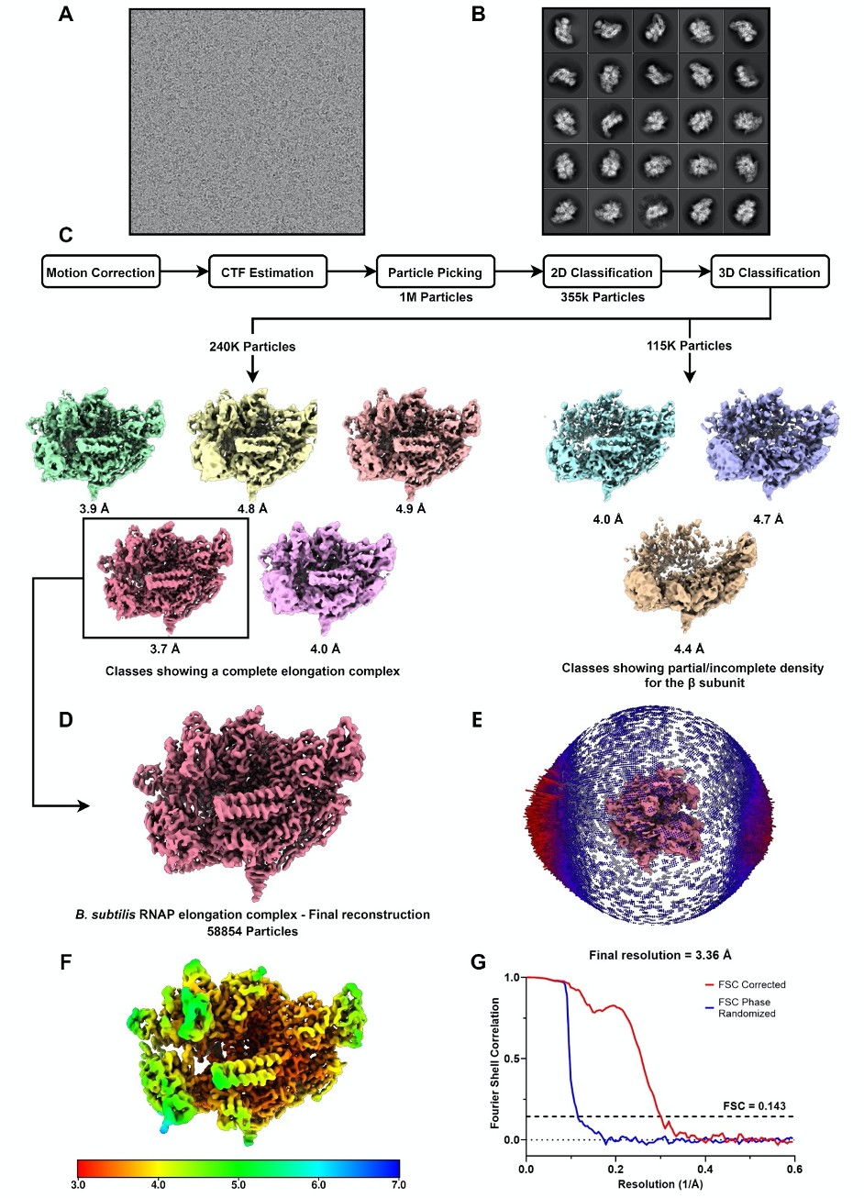
Extended Data Figure 2: Reconstruction of the B. subtilis RNAP elongation complex.
a, Representative micrograph b, Representative class averages, ordered by particle number (descending, left to right, top to bottom). c, Simplified workflow for preprocessing and classification of the RNAP elongation complex. d, Final refined, unsharpened map of the B. subtilis RNAP elongation complex. Final reconstruction was performed with a subset of 58,854 particles. e, Orientational distribution for the RNAP elongation complex. Relative particle frequency per orientation is shown by the height and color of the cylinder (higher frequency = longer cylinder, red, lower frequency = shorter cylinder, blue). f, Local resolution across the final RNAP elongation complex reconstruction. Local resolution estimation was performed in RELION. g, Fourier shell correlation curves for the RNAP elongation complex reconstruction. Resolution estimation was performed in RELION using the GS-FSC criterion.

Extended Data Figure 3.

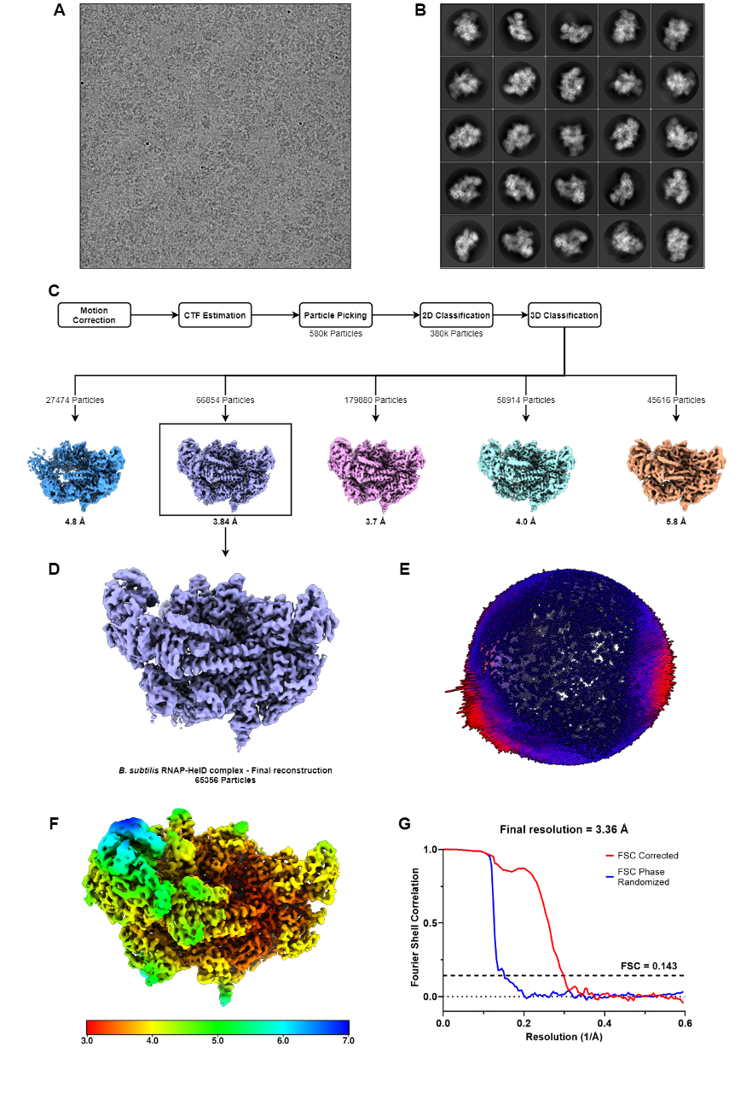

Extended Data Figure 3: Reconstruction of the B. subtilis RNAP-HelD complex.
a, Representative micrograph b, Representative class averages, ordered by particle number (descending, left to right, top to bottom). c, Simplified workflow for preprocessing and classification of the RNAP-HelD complex. d, Final refined, unsharpened map of the B. subtilis RNAP HelD complex. Final reconstruction was performed with a subset of 65,356 particles. e, Orientational distribution for the RNAP HelD complex. Relative particle frequency per orientation is shown by the height and color of the cylinder (higher frequency = longer cylinder, red, lower frequency = shorter cylinder, blue). f, Local resolution across the final RNAP HelD complex reconstruction. Local resolution estimation was performed in RELION. g, Fourier shell correlation curves for the RNAP HelD complex reconstruction. Resolution estimation was performed in RELION using the gold-standard fourier-shell correlation criterion (GS-FSC).

Movies of the 3D reconstructions and structures:
Movie 1 RNAP-EC.mp4

Movie 2 RNAP-HelDmp4

Extended data movie files for RNAP-EC and RNAP-HelD show 360° rotations for the RNAP-HelD and Elongation Complex, respectively.

Extended Data Figure 4.
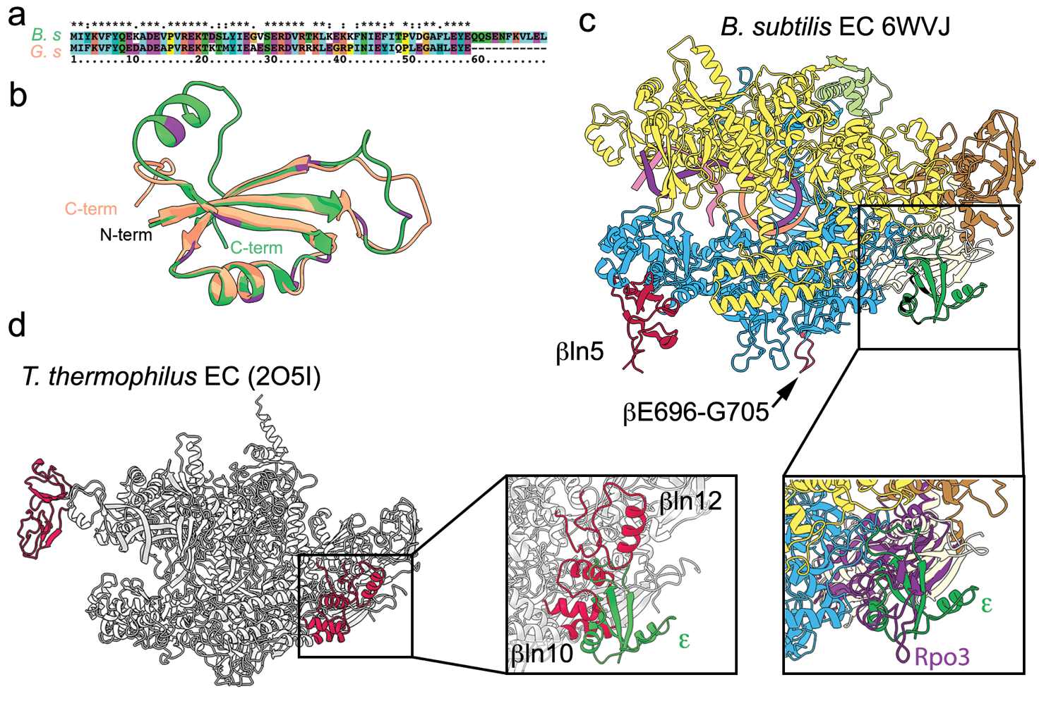

Extended Data Figure 4. Sequence and structure alignment of ε, and co-location with archaeal Rpo3. a, shows the sequence alignment of ε from B. subtilis (B. s) and G. stearothermophilus (G. s). b, ε structure alignment. G.S ε (PDB ID: 4NJC) is shown in orange, and B. subtilis ε from this work in green. The proteins are 67% identical (with 81% similarity) over the 58 amino acids for which their structures were determined. Locations of amino acid differences (neither identical nor similar) are shown in purple on the B. subtilis structure. All of the amino acids that were neither identical nor similar, other than B. subtilis T49 (G. stearothermophilus Q49), were solvent-exposed and are not involved in interaction with RNAP. c, B. subtilis EC with ε docked based on similarity with the RNAP-HelD complex. αI (pale yellow), αII (brown), β (azure), β’ (yellow), ω (pale green), ε (green), template DNA (purple), non-template DNA (pink), RNA (orange). The location of the βln5 and β E696-G705 insertions are shown in red. In the insert the docked Rpo3 subunit of Saccharolobus shibatae RNAP (PDBB ID: 2WAQ) is shown in purple. Although there is no structural similarity, the location of ε closely matches that of the C-terminal half of archaeal RNAP Rpo3 (Y167-V222, PDBID: 2WAQ), and eukaryotic RNAP polII RPB3. RPB3 along with RPB10, -11, and -12 are required for assembly and stability of eukaryotic RNAP polII. d, T. thermophilus EC (PDB ID 2O5I) with lineage-specific inserts shown in red. The insert shows ε superimposed on the structure illustrating the overlap with the postions of the βln10 and βln12 inserts.
Extended Data Figure 5.

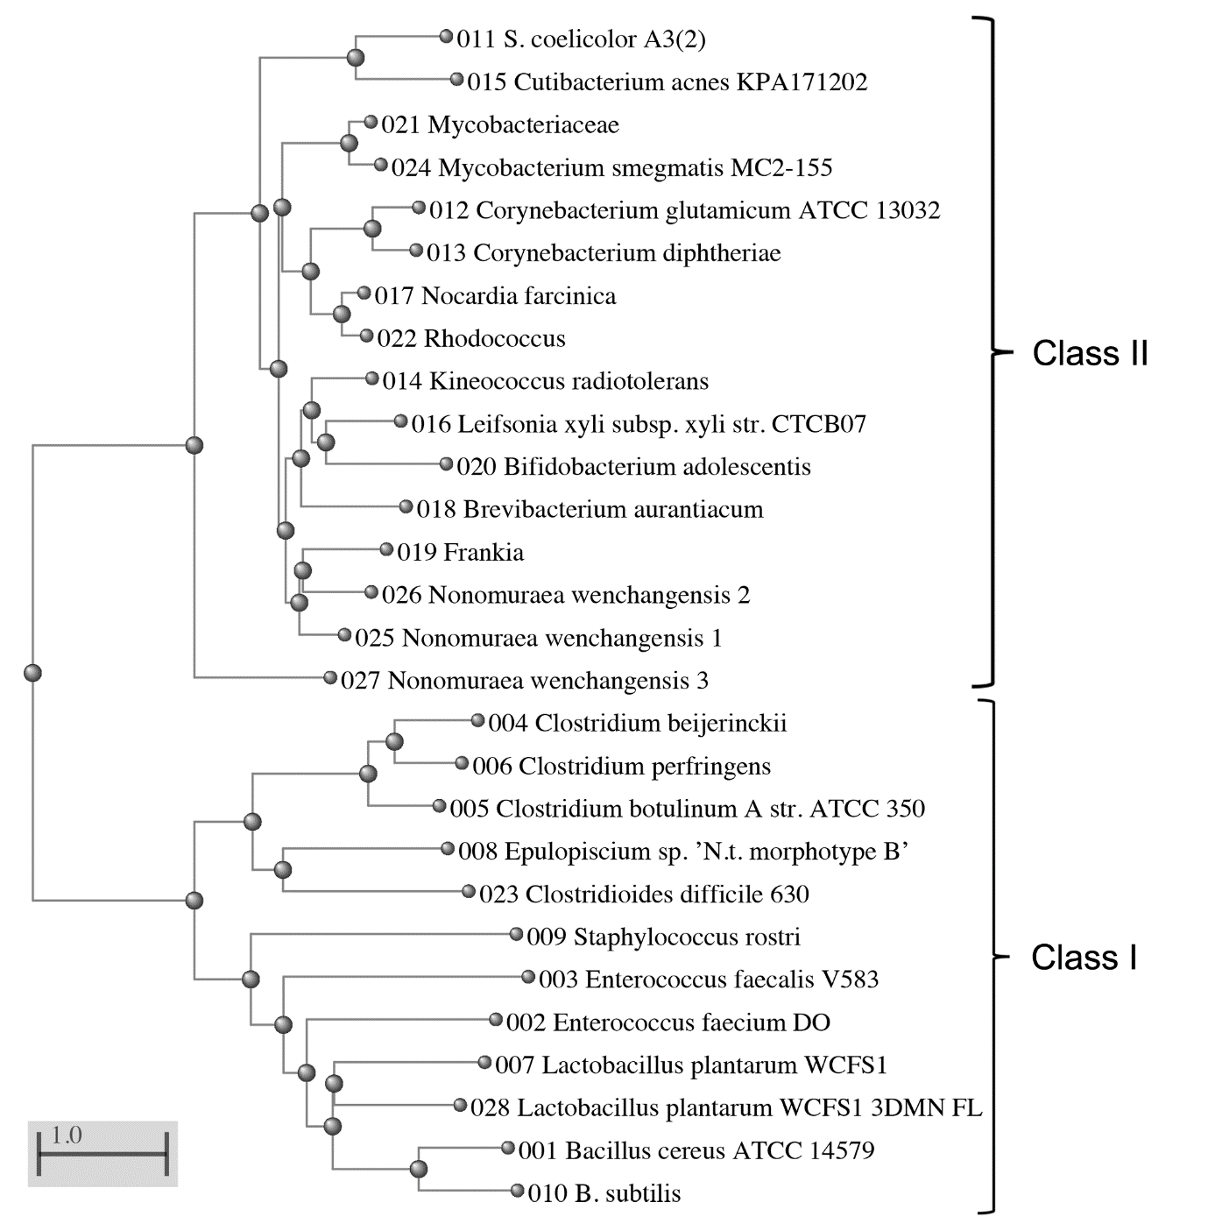

Extended Data Figure 5. Phylogenetic tree view (Grishin general) of selected HelD sequences. The HelD family of proteins is present predominantly in the Gram-positive eubacteria and is represented by 24436 entries with a sequence length of ~750 aa that segregates into at least two related classes (Class I and II, respectively). There are two additional minor families comprising 74 and 37 entries, respectively, with DUF4968 or DUF4968 + GH31_N superfamily motifs present as a C-terminal extension. These proteins are >1000 aa in length with a ~750 aa N-terminal region that is similar to HelD Class II proteins. These minor families are restricted exclusively to Gram-positive obligate anerobes related to the Clostridiales/Lachnospiraceae and are important in general gut health. This smaller group of larger proteins are essentially indistinguishable from other HelD (class II) proteins other than the fact that they have C-terminal extensions. Sequence numbers correspond to: 001, Bacillus cereus ATCC14579; 002, Enterococcus faecium DO; 003, Enterococcus faecalis V583; 004, Clostridium beijerinckii, 005, Clostridium botulinum A str. ATCC 3502; 006, Clostridium perfringens, 007; Lactobacillus plantarum WCFS1 helD1; 008 Epulopiscium sp. 'N.t. morphotype B'; 009, Staphylococcus rostri; 010, Bacillus subtilis 168; 011, Streptomyces coelicolor A3(2); 012, Corynebacterium glutamicum ATCC 13032; 013, Corynebacterium diphtheriae; 014, Kineococcus radiotolerans; 015, Cutibacterium acnes KPA171202; 016, Leifsonia xyli subsp. xyli str. CTCB07; 017, Nocardia farcinica; 018, Brevibacterium aurantiacum; 019, Frankia sp.; 020, Bifidobacterium adolescentis; 021, Mycobacteriaceae; 022, Rhodococcus sp.; Clostridioides difficile 630; 024, Mycobacterium smegmatis MC2-155; 025 Nonomuraea wenchangensis helD1; 026, Nonomuraea wenchangensis helD2; 027, Nonomuraea wenchangensis helD3; 028, Lactobacillus plantarum WCFS1 helD2 (sequence from which PDB ID: 3DMN was derived). Sequence alignments are shown in Supplementary Information Figure 1.

Extended Data Figure 6.

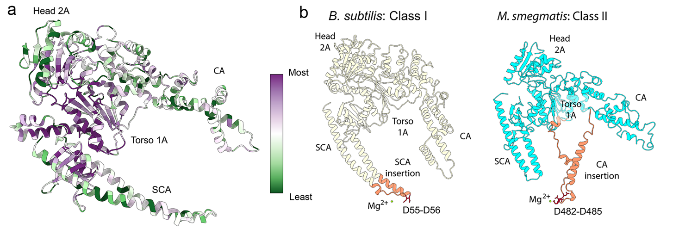

Extended Data Figure 6. HelD sequence conservation relative to structure and structural comparison of Class I and II HelD proteins. a, The image was constructed using the HelD chain from the RNAP-HelD complex with the alignment file from Supplementary Information Figure 1 in ConSurf. Most highly conserved amino acids relative to location, purple, and least conserved in green. b, The architecture of Class I and II HelD proteins has been addressed in the main text of this article (Class I) and in the accompanying paper by Kouba et al (Class II). The key structural differences that separate Class I and II HelD proteins involve the structural motif that causes nucleic acid displacement from the active site of RNAP are shown in orange close to the active site Mg²⁺ (small green sphere) with acidic residues labelled and shown as red sticks.

Extended Data Table 1. Conserved HelD sequence motifs. Despite the relatively low level of overall similarity between HelD sequences from even closely related organisms, a series of motifs could be identified that define HelD proteins and also enable classification into one of two classes (Classes I and II). Sequence numbers refer to the B. subtilis HelD sequence (010 in multiple alignment Supplementary Information Figure 1). X corresponds to a poorly conserved sequence (any amino acid) and h to a conserved hydrophobic residue. Residues coloured red are specific to class I and green to class II sequences.

Motif | Position (B. subtilis numbering) | Sequence
I | 098-102 | ^{P}_{X} ^{Y}_{X} F ^{G}_{A} ^{R}_{K}
II | 118-121 | ^{Y}_{H} ^{I}_{h} G ^{R}_{X}
III | 135-146 | h X D W R ^{A}_{S} ^{P}_{X} X ^{A}_{S} X X ^{F}_{Y} Y
IV | 209-222 | ^{I}_{V} ^{V}_{I} X T ^{I}_{L} Q X E Q ^{D}_{N} X ^{I}_{V} ^{I}_{V} R
V | 233-240 | G X ^{P}_{A} G ^{T}_{S} G K T | Walker A site
VI | 244-255 | ^{L}_{M} ^{H}_{Q} R X A ^{Y}_{F} L L ^{Y}_{F} X X ^{R}_{K}
VII | 279-285 | ^{V}_{I} L P X L G ^{E}_{X}
VIII | 543-550 | G X ^{P}_{A} G ^{T}_{S} G K T | Walker B site
IX | 568-576 | T X X G D X ^{A}_{x} Q
X | 603-610 | L X X X ^{Y}_{F} R ^{T}_{S} ^{P}_{X}
XI | 713-718 | K G ^{L}_{h} E ^{F}_{Y} D
XII | 740-747 | Y ^{V}_{X} X X ^{T}_{S} R ^{A}_{X} ^{T}_{h}

Extended Data Figure 7.
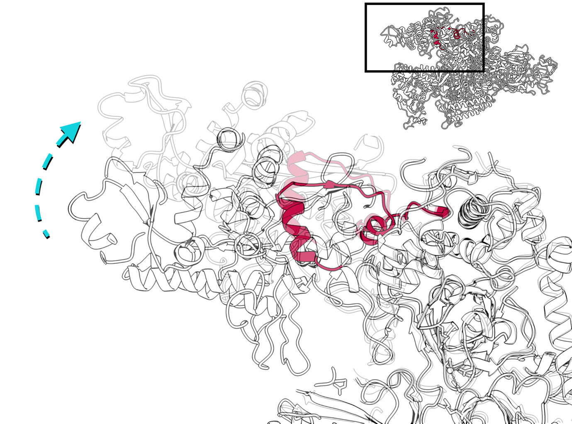

Extended Data Figure 7. HelD-induced clamp movement is due to SW5 movement. The conserved SW5 motif is located in the C-terminal portion of the β’ subunit from Q1140-T1175 (red) and forms a hinge upon which the β’ clamp is able to swing up and down. Superimposing the SW5- β’ clamp regions of the EC and RNAP-HelD structures shows the hinge movement that enables the dramatic opening of the β’ clamp upon HelD binding and CA movement, and that conformational changes are largely restricted to the β’ clamp domain (boxed region). The β clamp from the elongation complex is shown overlayed with the same region of the RNAP-HelD complex as a ghost image. Clamp movement is illustrated by the dashed cyan arrow. The inset shows the elongation complex (with nucleic acids removed for clarity) with the portion of RNAP shown in the main panel boxed.

Movie of conformational changes caused by HelD interaction with RNAP.
Movie 3 RNAP - Remodelling by HelD.mp4

Extended Data Figure 8.

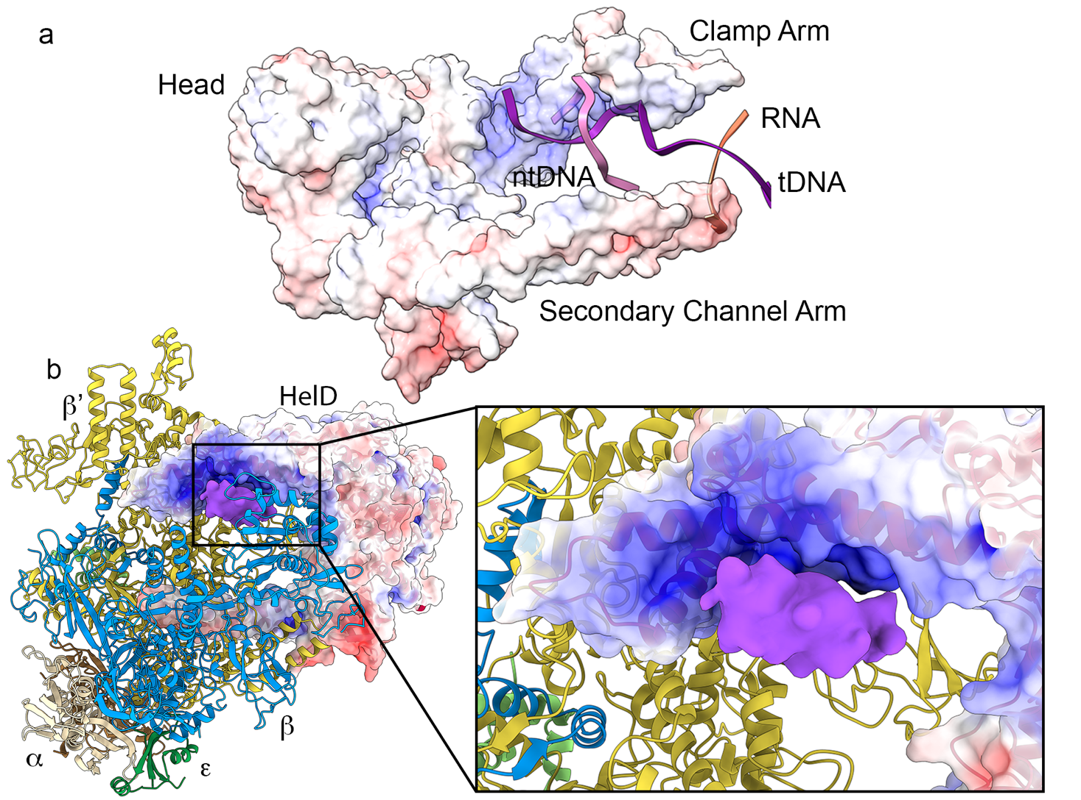

Extended Data Fig 8. Visible orphan density in the RNAP-HelD complex. a, ABPS surface electrostatic charge of HelD from red, most negative, to blue, most positive surface charge shown. The nucleic acids from the RNAP EC are also shown superimposed to illustrate the close juxtaposition between the positively charged region of the Clamp Arm with DNA. b, At low thresholds, orphan density was visible adjacent to the Clamp Arm in the unsharpened, unmasked electron density map. The orphan density is shown in purple, and all other subunits of RNAP coloured as in previous figures.

3D variability analysis shows conformational flexibility resides principlally in the CA.
Movie 4 RNAP - HelD 3DVA.mp4

Extended Data Figure 9.

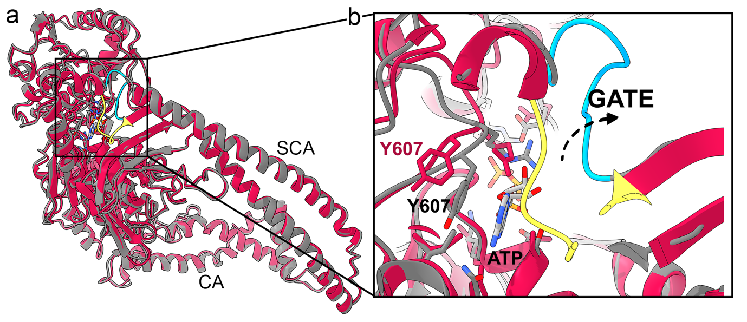
Extended Data Fig 9. ATP binding to HelD. a, HelD (grey) and PcrA (not shown) with ATP bound (PDB ID 1QHH) were superimposed to place ATP in the binding site, followed by energy minimisation and manual displacement of HelD ATP gate residues F183-G190 (blue). Unmodified HelD (red) is also shown with the ATP gate (yellow) in the closed position. b, Expanded view of the area boxed in a showing ATP with Y607 which stacks with the purine ring on binding. Dashed arrow indicates the movement of the gate residues from closed to open.

