Article title: Psychosocial impacts on patients with Hypertrophic Cardiomyopathy (HCM) who received a Variant of Uncertain Significance (VUS) genetic test result
Journal name: Journal of Community Genetics
Authors’ names:
- Philippa Emily Benigno Thomas ¹ ² ³
- Jonathan Roberts ³ ⁴
Authors’ institutional affiliations:
¹ Centre for Medical Education, School of Medicine, Cardiff University, University Hospital of Wales Heath Park, Cardiff, CF14 4XN (institute Academic work was conducted with).
2 The Newcastle upon Tyne Hospitals NHS Foundation Trust, Northern Genetics Service, Biomedicine East, Central Parkway, Newcastle upon Tyne, NE1 3BZ (institute where data was collected).
3 Cambridge University Hospitals NHS Foundation Trust, Clinical Genetics, Box 134, Cambridge University Hospital’s NHS Foundation Trust, Addenbrooke’s Hospital, Hills Road, Cambridge, CB2 0QQ, UK (present affiliation).
4 Genomics England, One Canada Square, London E14 5AB
Corresponding author’s email address: Philippa.thomas2@nhs.net

Additional file- Supplemental Information
Table 1. Demographics of participants. The participant pseudonyms are not the participant’s real names to maintain anonymity.
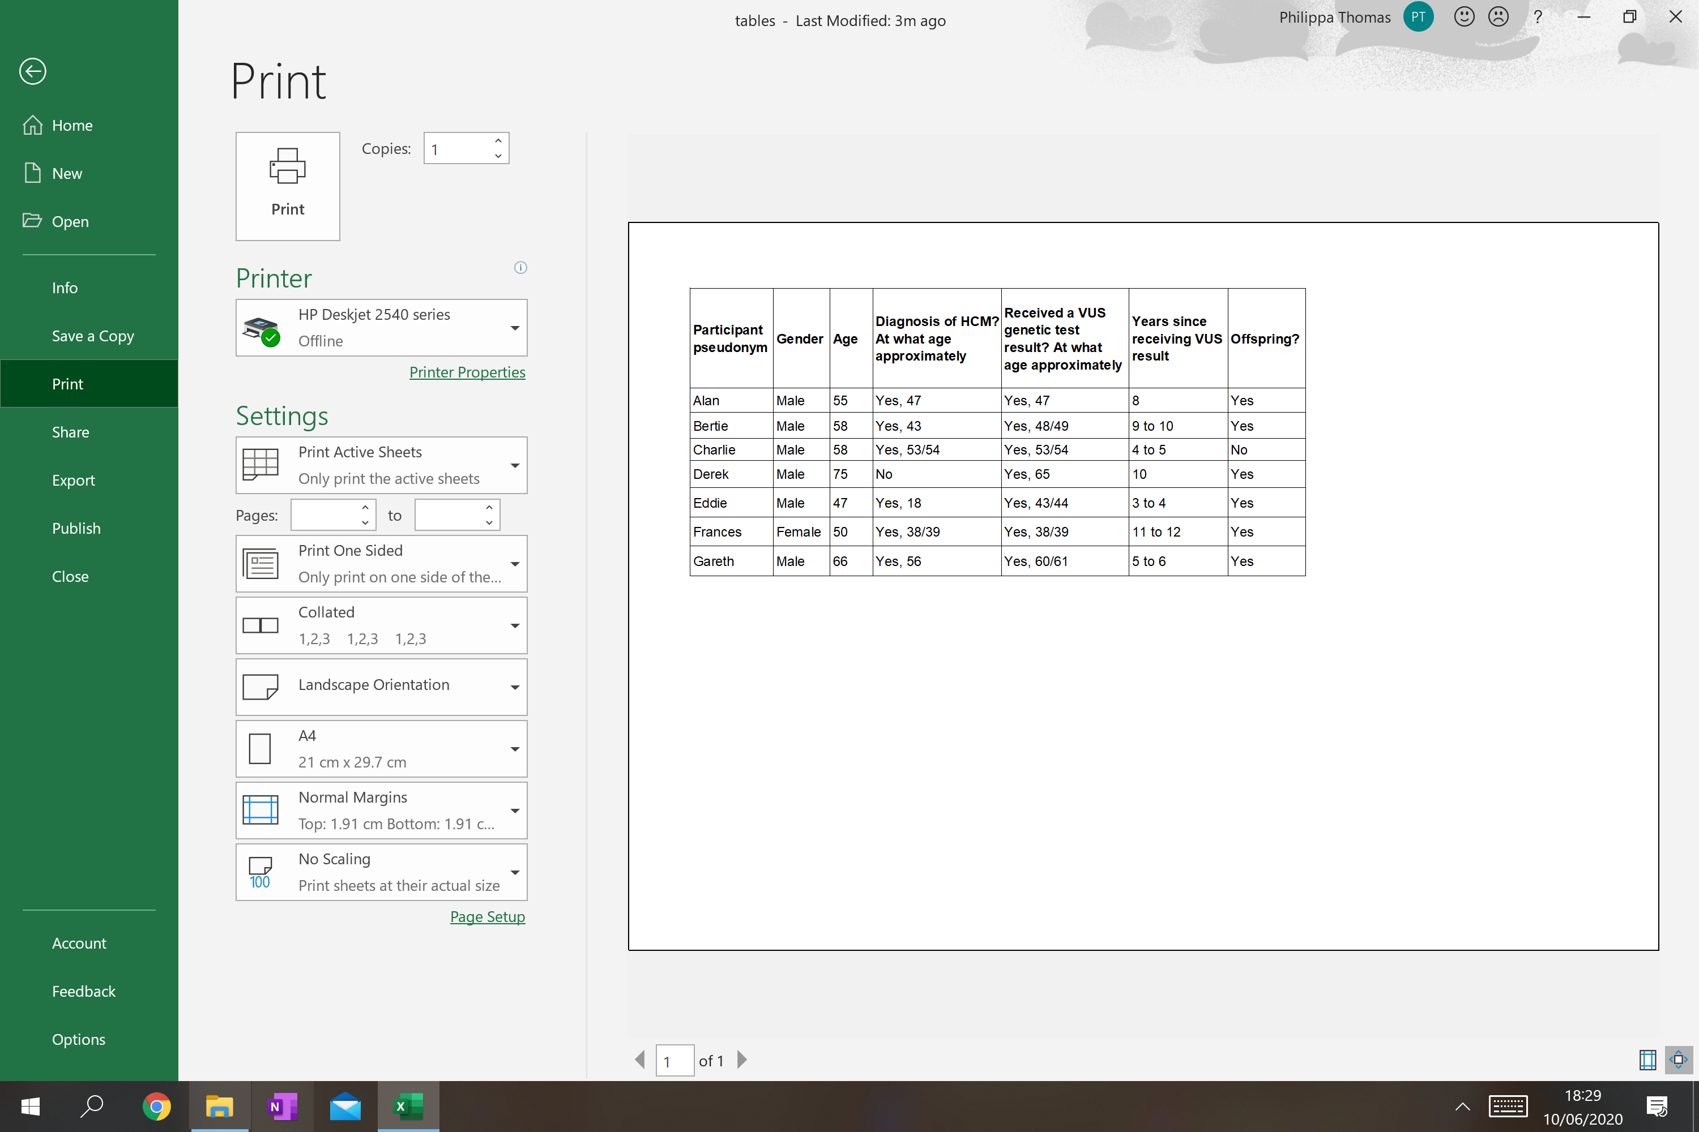

Table 2. Recruitment response rate and types of interviews conducted.
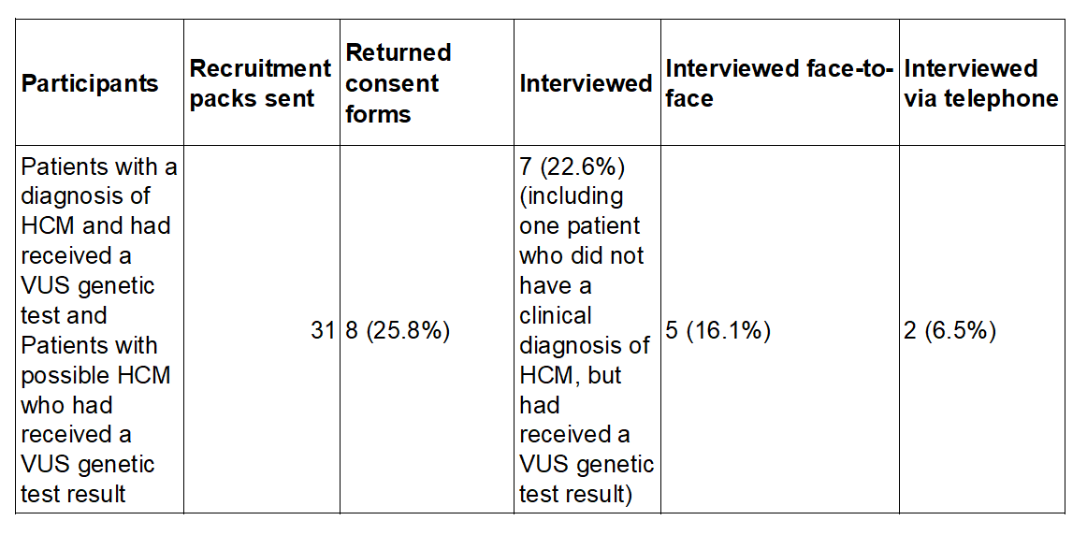

Table 3. Table showing the terminology participants used to describe their VUS result. Some participants seemed to use language that could be seen as having negative connotations.
Terminology participants used to describe their VUS result
Alan: “mutation”
Bill: “faulty gene” “problem gene” “bad gene”
Derek: “change in the MYBPC3 gene.”
Eddie: “unidentified defect” “defect”
Fran: “… probable abnormality in a gene…”
Gareth: “abnormal gene” “funny gene”

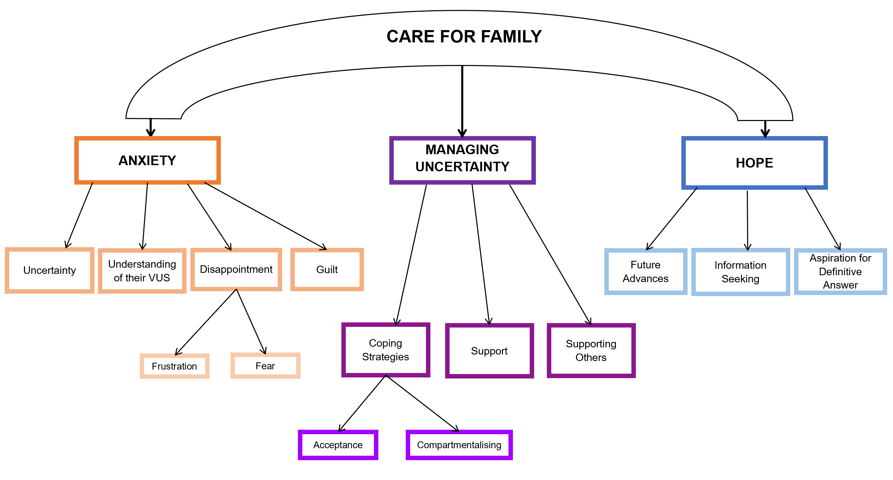
Figure 1. Final thematic map showing the three main themes: ‘Anxiety’, ‘Managing Uncertainty’ and ‘Hope’ and their linking sub-themes and sub-sub-themes, all under the overarching, ‘umbrella’ theme of ‘Care For Family’. The lightening colours, reducing font size and downward pointing arrows show the hierarchy of overarching theme, main theme, sub-theme, sub-sub-theme.

Final Interview Guide used in the study
(after feedback from trialling it with on patients from the North East Cardiomyopathy UK Support Group, feedback from a Genetic Counsellor and the amendments requested by the REC
