Supplemental Data

Biochanin A inhibits excitotoxicity-triggered ferroptosis by targeting GPX4 in hippocampal neurons

Jun Pil Won¹, Hyuk Gyoon Lee¹, Han Jun Yoon¹, and Han Geuk Seo^{1*}

¹Department of Food Science and Biotechnology of Animal Resources, College of Sang-Huh Life Sciences, Konkuk University, 120 Neungdong-ro, Gwangjin-gu, Seoul 05029, Korea

* To Whom Correspondence Should Be Addressed:
Han Geuk Seo
College of Sang-Huh Life Sciences, Konkuk University, 120 Neungdong-ro, Gwangjin-gu, Seoul 05029, Korea
Tel: +82-2-450-0428, Fax: +82-2-455-1044
E-mail: hgseo@konkuk.ac.kr

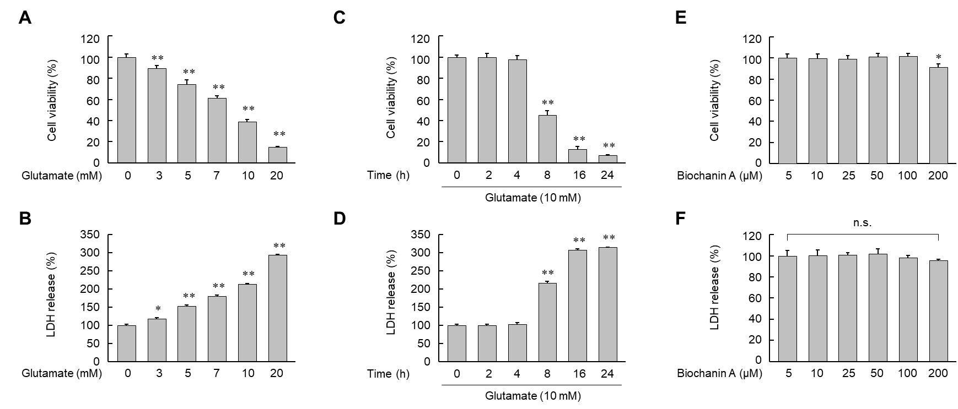
Supplemental figure 1: Effects of glutamate and biochanin A on cell viability and LDH release in HT22 cells.
(A, B, E and F) Cells were treated with increasing concentrations of glutamate (A and B) or biochanin A (E and F) for 8 h. (C and D) Cells were treated with 10 mM glutamate for the indicated period and cellular toxicity was determined using a trypan blue exclusion assay (A, C and E) and LDH release assay (B, D and F). Results are expressed as means ± SE (n = 4). *, p < 0.05; **, p < 0.01 relative to the untreated group. n.s., not significant.

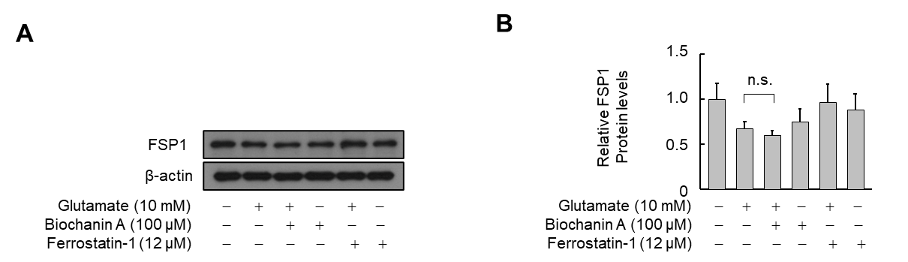
Supplemental figure 2: Effects of biochanin A on FSP1 protein expression in HT22 cells.
(A and B) Cells were treated with the indicated reagent in the presence or absence of glutamate for 8 h. Protein levels were analyzed by Western blot (A) and quantified using ImageJ software (B), with β-actin used as a loading control. Results are expressed as means ± SE (n = 3). n.s., not significant. Ferrostatin-1 was used as a positive control compounds.

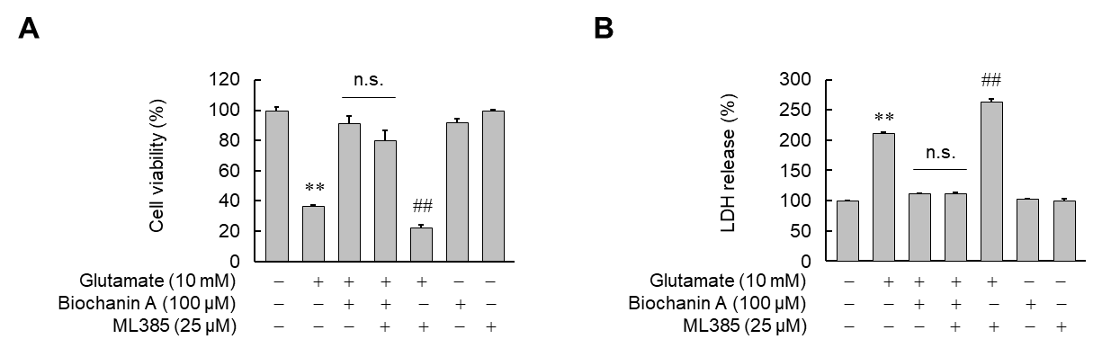
Supplemental figure 3: Effects of Nrf2 inhibition on glutamate-induced ferroptotic death of HT22 cells.
(A and B) Cells were treated with the indicated reagent in the presence or absence of glutamate for 8 h. Cellular toxicity was determined using a trypan blue exclusion assay (A) and LDH release assay (B). Results are expressed as means ± SE (n = 3). **, p < 0.01 relative to the untreated group; ##, p < 0.01 relative to the glutamate-treated group. ML385 was used as an Nrf2 inhibitor.

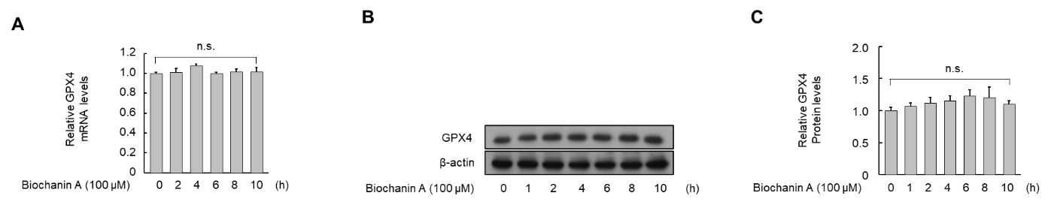
Supplemental figure 4: Effects of biochanin A on expression of GPX4 mRNA and protein in HT22 cells.
(A-C) Cells were treated with 100 μM biochanin A for the indicated time period. The level of GPX4 mRNA was quantified by real-time PCR (A). GPX4 protein levels were determined by Western blot (B) and quantified by ImageJ software (C), with β-actin used as a loading control. Results are expressed as means ± SE (n = 3). n.s., not significant.

