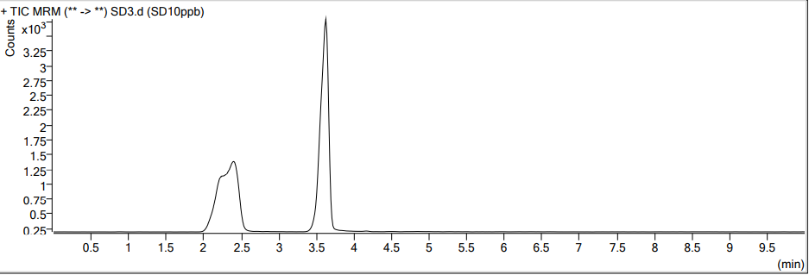
（a）
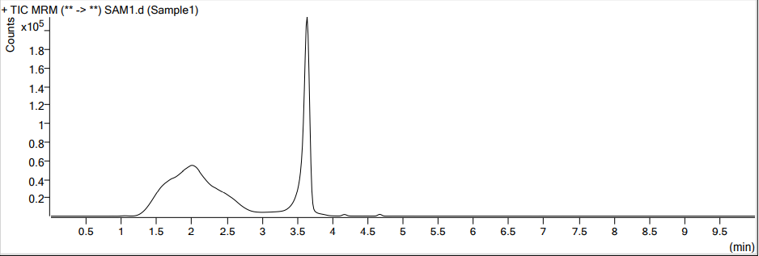
（b）
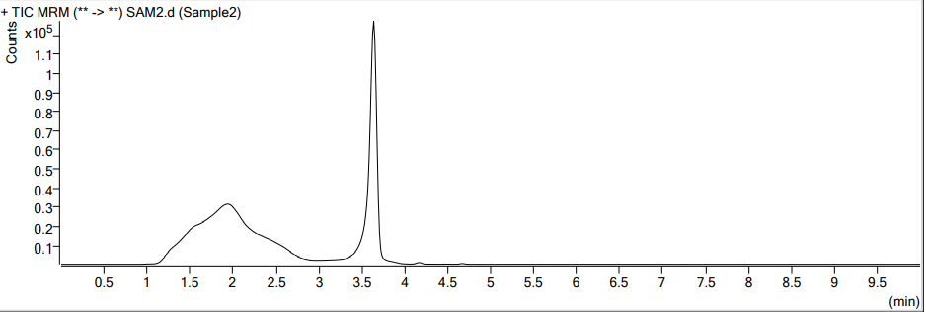
（c）
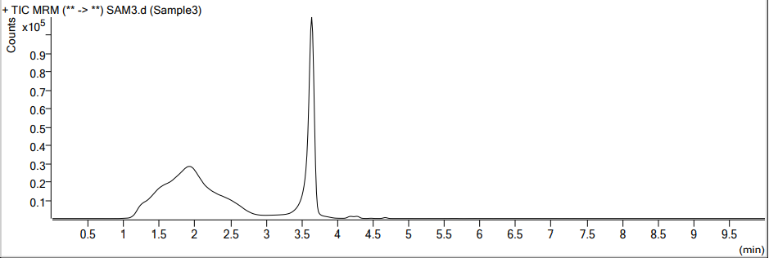
（d）
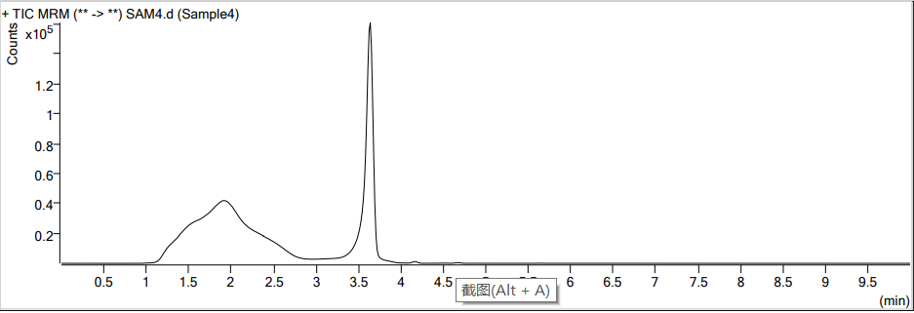
（e）
Fig. S1. UPLC-MS/MS chromatograms of acephate and standard (a), soil sample (b), maize stalks sample (c), maize leaves sample (d), maize roots sample (e).

Table S1 Recovery rates and relative standard deviations (RSD) of acephate and methamidophos in maize leaves, stalk, root, and soil (n = 5).
Matrix | Fortification Level (mg·kg⁻¹) | Acephate |  | Methamidophos
Matrix | Fortification Level (mg·kg⁻¹) | Mean recovery (%) | RSD (%) | Mean recovery (%) | RSD (%)
Maize leaves | 0.01 | 91.76 | 6.45 | 78.94 | 8.10
Maize leaves | 0.1 | 86.15 | 5.89 | 80.69 | 6.40
Maize leaves | 5 | 88.43 | 1.25 | 88.98 | 1.43
Stalk | 0.01 | 94.40 | 6.42 | 92.89 | 9.79
Stalk | 0.1 | 91.44 | 10.75 | 87.46 | 8.58
Stalk | 5 | 97.95 | 3.47 | 92.18 | 4.66
Root | 0.01 | 110.50 | 10.20 | 95.18 | 10.31
Root | 0.1 | 98.58 | 2.04 | 89.39 | 4.38
Root | 5 | 95.04 | 3.96 | 97.79 | 5.44
Soil | 0.01 | 103.97 | 7.65 | 95.41 | 7.14
Soil | 0.1 | 97.90 | 2.68 | 88.01 | 4.11
Soil | 5 | 95.52 | 2.40 | 97.21 | 4.80

Table S2 Terminal residues of acephate and methamidophos in maize grain and soil in Guangzhou and Jinan on the 60day.
Location | Dosage /g.a.i/ha | Acephate |  | Methamidophos
Location | Dosage /g.a.i/ha | maize grain | soil | maize grain | soil
Guang  zhou | 3000 | ＜LOD | ＜LOD | ＜LOD | ＜LOD
Guang  zhou | 6000 | ＜LOD | ＜LOD | ＜LOD | ＜LOD
Jinan | 3000 | ＜LOD | ＜LOD | ＜LOD | ＜LOD
Jinan | 6000 | ＜LOD | ＜LOD | ＜LOD | 0.03±0.01
* Mean ± SD, average residues and standard deviation from three replicates. LOD, limit of detection.

