Supplementary Information

Surface acoustic wave sensing chip based on acoustic impedance effect: a method for rapid gas leakage detection and respiratory monitoring
Baile Cui^{a,b}, Wen Wang^{a,b,*}, Lina Cheng^{a,b}, Jing Jinª, Anyu Hu^{a,b}, Zixuan Ren^{a,b}, Xufeng Xueª, Yong Liangª

a. State Key Laboratory of Acoustics, Institute of Acoustics, Chinese Academy of Sciences, Beijing 100190, P. R. China.
b. University of Chinese Academy of Sciences, Beijing 100190, P. R. China.
⁎ Corresponding authors.
E-mail address: wangwenwq@mail.ioa.ac.cn (W. Wang).

Contents
Figure list.
Figure S1. Fabrication of SAW device.
Figure S2. SAW sensing system.
Figure S3. Experimental environment.
Figure S4. Sensitivity and repeatability of SAW gas device based on AI effect.
Figure S5. Experimental platform for simulating hydrogen leakage.
Figure S6. Optical image of device surface during human respiration.
Figure S7. Baseline of SAW sensing system.
Figure S8. Response of SAW chip with different gas layers under 5 v/v% concentration.
Table list.
Table S1. Parameters of gas (300K).
Table S2. Design parameters of SAW sensor.
Table S3. Summary of the characteristics of different gas leakage detection devices.
Note list.
N1. Simulation of the SAW device.
N2. Conversion method between SAW propagation loss response and sensing system voltage response.
N3. Calculation method of hydrogen leakage concentration.
N4. Algorithm for calculating respiratory rate.
Reference

Fig. S1 shows the manufacturing process of the SAW chip based on AI effect in this work. Fig. S1a shows Y35ºX Quartz after acetone cleaning, Fig. S1b shows the SAW chip after covering the photoresist. Fig. S1c shows the method of exposing the photoresist with an ultraviolet light source, and Fig. S1d shows the deposition of aluminum film on wafers with specific pattern structures and photoresist by electron beam evaporation technology. A multilayer SAW chip structure of aluminum/photoresist/Y35ºX Quartz as shown in Fig. S1e is formed. Finally, the SAW chip shown in Fig. S1e is placed in acetone for debonding, and a delayed linear SAW chip (Fig.S1f) with a specific interdigital transducer pattern is prepared.
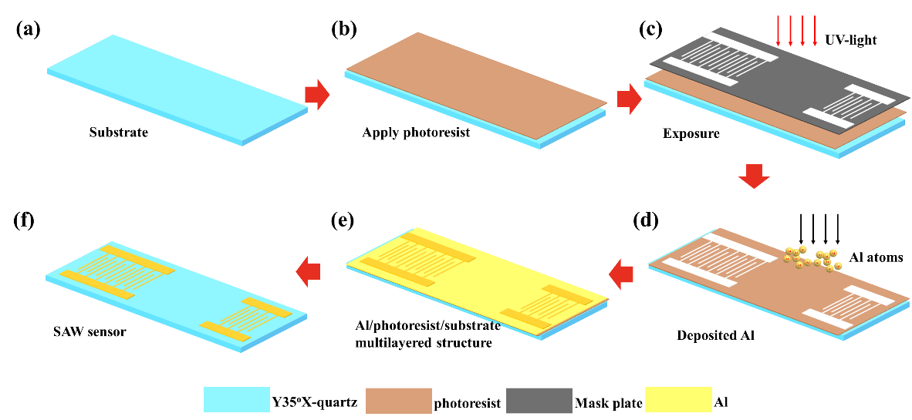
Figure S1. Fabrication of SAW device. Substrate of SAW chip (a). (b) SAW chip after applying photoresist and (c) exposing by the UV-light. (d) Deposition of Aluminum Thin Films by Electron Beam Evaporation and (e) SAW sensor with multilayer structure. (f) SAW sensor after photoresist removal.

Fig.S2 illustrates the principle and PCB circuit structure of the SAW sensing system. Fig. S2a represents the design principle of the SAW acoustic attenuation sensing system. A 200 MHz signal source transmits the RF signal to the SAW chip and the amplitude detector through a divider. The SAW chip conveys the modulated SAW signal that reflects changes in gas load to the other end of the amplitude detector. The amplitude discriminator AD8302 provides an amplitude difference signal by comparing the amplitudes of the signal inputs (The relationship between dB and voltage is 1 dB=30 mV which is determined by the AD8302). After the signal passes through an ADC to convert analog signals to digital signals, it is transmitted to the microcontroller unit (MCU) processor for signal processing and algorithm programming. Finally, the signal is transmitted to the PC software at the host computer via serial communication. Fig. S2b shows the physical PCB of the prepared SAW sensing system, with Fig. S2c showing the front side of the system's PCB, featuring electrical connection pads for the SAW chip to meet signal connection requirements. In Fig. S2d, the SAW chip is fixed on the PCB base using adhesive, and the electrical connection and transmission of the SAW chip are completed through wire bonding.
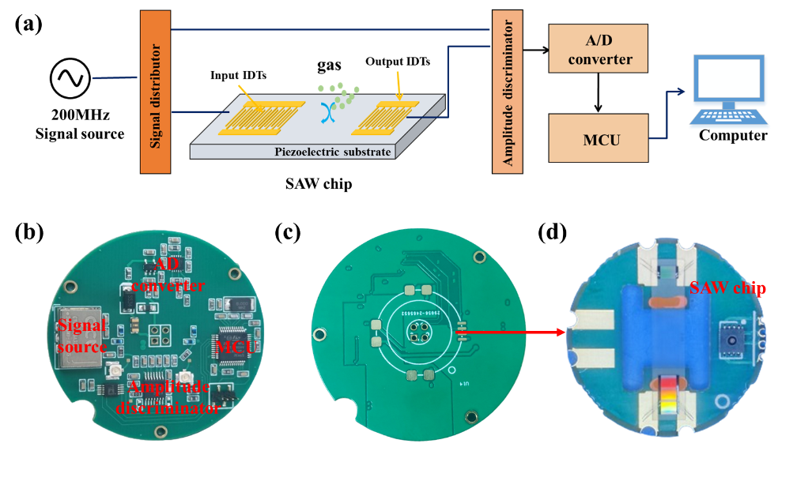
Figure S2. SAW sensing system. (a)Principle of SAW chip acoustic attenuation detection circuit, (b) Back optical microscope of SAW detection system, (c) Front optical microscope of SAW detection system, and (d) Electrical connection method of SAW chip.
Fig. S3 is an experimental platform for surface acoustic wave (SAW) gas detection. It uses N₂, H₂, He, Ar, O₂ and CO₂ with a concentration of 100 v/v% as standard gases. The background gas is set to N₂, and the other gases are mixed using a gas generator to create different mixtures of target gases (H₂, He, Ar, O₂ and CO₂) and N₂. These mixtures flow through a 500 mL gas chamber at a flow rate of 800 mL/min. The SAW chip and its detection system are placed in the gas chamber to sense the gas concentration changes. The data collected by the sensing system is stored in the host computer software.
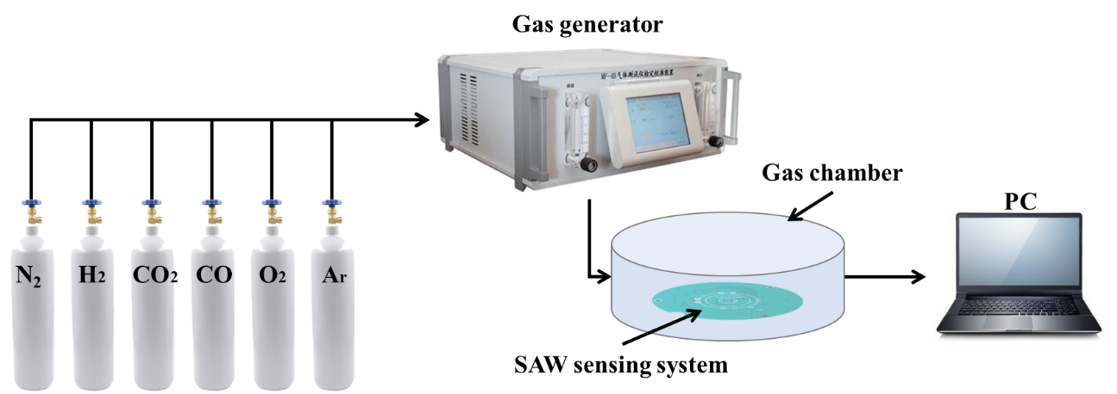
Figure S3. Experimental environment

Fig. S4 shows the sensitivity, repeatability, and repeatability error of the SAW chip using the acoustic impedance effect for detecting different gases. In Fig. S4a, the sensitivity of the SAW chip response within the gas concentration range of 0-95 v/v% is obtained through a linear fit. It can be seen from the graph that H₂ has the highest sensitivity, while CO₂ has the highest reverse sensitivity, due to the opposite impedance changes with concentration for these two gases. Fig. S4b shows the response of the SAW chip tested repeatedly 10 times at 55 v/v% gas concentration. It demonstrates the SAW chip's rapid response and recovery capabilities for similar gas concentrations, with excellent stability in the response amplitude. Additionally, Fig. S4c illustrates that the SAW chip exhibits small repeatability errors (maximum error <4% CO₂).
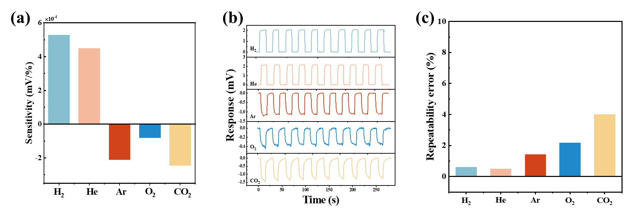
Figure S4. Sensitivity and repeatability of SAW gas device based on AI effect. (a)Sensitivity of SAW device to H₂, He, Ar, O₂ and CO₂. (b) Repeat the device response 10 times at the same gas concentration (55 v/v%) with different gases (H₂, He, Ar, O₂ and CO₂)

In order to ensure the safety of the experiment, Fig. S5a shows the hydrogen leakage experiment platform built inside a gas ventilation hood. The experimental setup includes a DC power supply, a computer workstation, a hydrogen leakage source (with concentrations of 40 v/v% and 100 v/v% standard hydrogen/nitrogen gas mixtures), and a SAW sensing system. The SAW sensing system, as shown in Fig. S5b, is fixed on a pole, and the SAW chip surface is protected by a gas filter cover. The distance L between the SAW sensing system and the hydrogen leakage source is maintained at 5 cm. By opening/closing the gas cylinders to simulate hydrogen leakage. Furthermore, by changing the distance between the SAW sensor and the hydrogen leakage source, possible random gas concentration leaks in a real environment can be simulated.
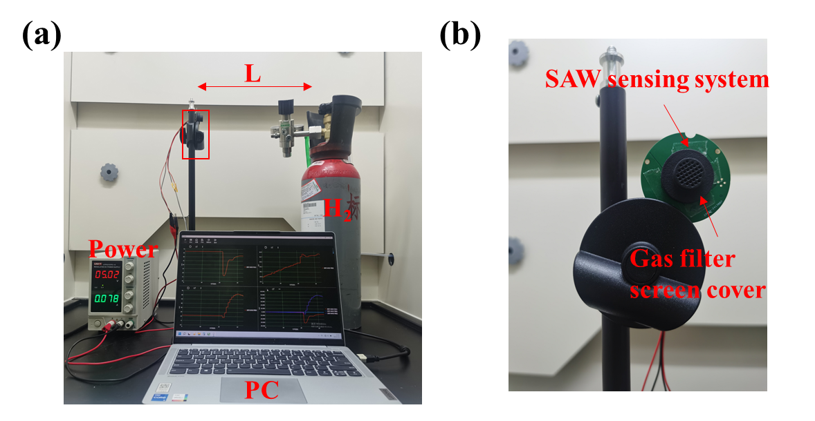
Figure S5. Experimental platform for simulating hydrogen leakage. (a) hydrogen leakage environment. (b) SAW sensing system integrated with a gas filter screen cover for detecting hydrogen.

Fig. S6 shows the optical images of device surfaces during human exhalation and inhalation processes. Fig. S6a shows that the upper layer of the SAW chip is clean during inhalation. As shown in Fig. S6b, due to the high humidity of human breath reaching 90% RH, a large amount of humid airflow impacts the surface of the SAW chip, leading to the formation of tiny water droplets on the chip surface, thereby increasing the acoustic loss of the SAW chip.
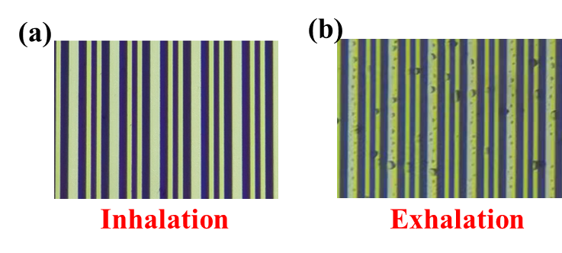
Figure S6. Optical image of device surface during human respiration.

Fig. S7 shows the baseline of the SAW sensing system within 120 s. It can be seen that the amplitude discriminating circuit used for SAW acoustic signal acquisition has extremely low baseline noise (±15 μV), which is also due to the low insertion loss of the SAW chip (-12 dB), thus improving the signal-to-noise ratio of SAW sensing system.
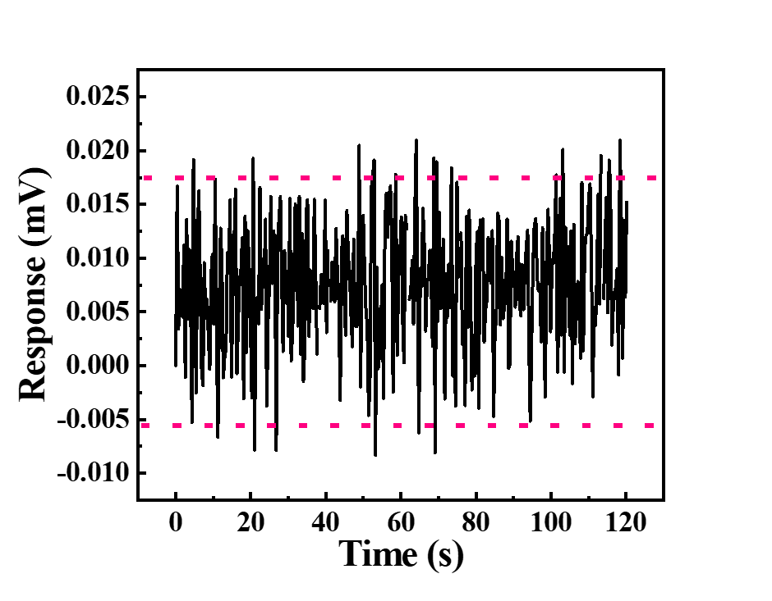
Figure S7. Baseline of SAW sensing system.

Fig. 8 shows the response of the SAW chip at 5 v/v% gas concentration. From the figure, it can be seen that the response of the SAW chip to H₂, He, Ar, O₂ and CO₂ at the same concentration of 5 v/v% is about 0.3 mV, 0.25 mV, -0.15 mV, -0.1 mV and-0.18 mV respectively. Therefore, based on the estimation method of the lower limit of gas detection in the International Union of Pure and Applied Chemistry, the lower limit of gas detection is considered when the sensing response exceeds three times of the baseline noise. Therefore, based on the baseline noise of the SAW sensor system (±0.015 mV) and the linear response relationship, we estimate the detection limits of the SAW chip as 0.8 v/v% @ H₂, 0.9 v/v% @ He, 1.5 v/v% @ Ar, 2.3 v/v% @ O₂ and 1.25 v/v% @ CO₂.
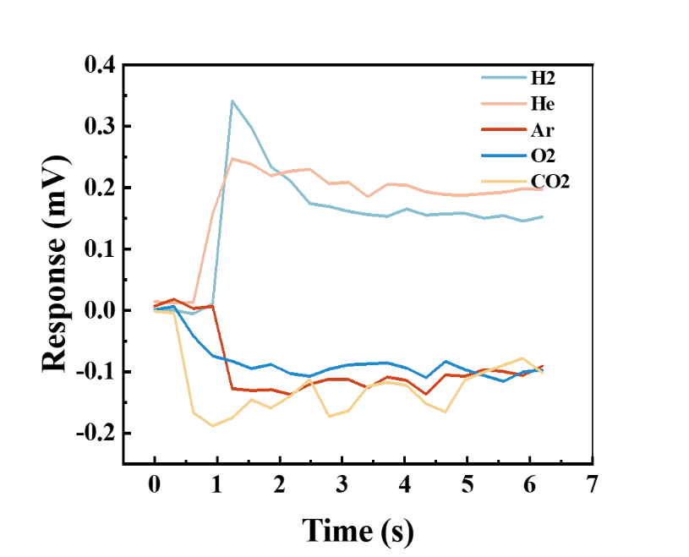
Figure S8. Response of SAW chip with different gas layers under 5 v/v% concentration.

Table S1 gives the parameters of gas and the data sources are from the COMSOL (https://cn.comsol.com/).
Table S1. Parameters of gas (300K)
Gas | Molecular mass (g/mol) | Viscosity  (Pa$∙$s) | Diffusion rate (cm²/s) | Density (kg/m³) | Velocity (m/s) | AI (kg/(m²$∙$s)) | Change of AI (kg/(m²$∙$s) *
N₂ | 28.00 | 1.78×10⁻⁵ | 0.206 | 1.17 | 353 | 413.01 | 0
H₂ | 2.01 | 8.76×10⁻⁶ | 0.787 | 0.09 | 1323 | 119.07 | 293.94
He | 4.00 | 2.00×10⁻⁵ | 0.709 | 0.18 | 938 | 168.84 | 244.17
Ar | 39.95 | 2.11×10⁻⁵ | 0.198 | 1.78 | 296 | 526.88 | -113.87
O₂ | 32.00 | 2.07×10⁻⁵ | 0.164 | 1.43 | 312 | 446.16 | -33.15
CO₂ | 44.01 | 1.57×10⁻⁵ | 0.208 | 1.98 | 283 | 560.34 | -147.33
* AI_{N2}-AI_{other gases}

Table S2 gives the design parameters of the SAW chip, including the materials of substrate and IDTs, thickness of IDTs and the length of the acoustic path.
Table S2. Design parameters of SAW sensor
Substrate | IDT |  |  |  |  | Acoustic path
Y35X-Quartz | Materials | Finger width | Finger thickness | Number of fingers | Acoustic aperture | 850λ
Y35X-Quartz | Al | 0.25λ, 0.125λ | 120 nm | 150/40 | 150λ | 850λ

Table S3 shows the performance comparison of hydrogen, helium, argon, carbon dioxide and oxygen sensors in recent years. From the table, it can be seen that the SAW chip based on the acoustic impedance effect has obvious advantages in detection range, response and recovery time.
Table S3. Summary of the characteristics of different gas leakage detection devices
Gas | Principle | Materials | T₉₀ | T₁₀ | Range | Temperature | Ref.
H₂ | Resistive | Pt NPs | 9 s | 10 s | <1 v/v% | 200ºC | ¹
H₂ | Resistive | Pd/PMMA | 3.5 s | - | <4 v/v % | RT | ²
H₂ | Resistive | Pd-doped RGo/ZnO-SnO₂ | 4 s | 8 s | <0.01 v/v% | 380ºC | ³
H₂ | Resistive | 3D porous polurethane | 68 s | 37 s | 2~100 v/v% | RT | ⁴
H₂ | Thermal | / | 3 s | - | 2~20 v/v% | 100 ºC | ⁵
H₂ | Optical | Pd/TiO₂ | <45 s | <45 s | <0.05 v/v % | 33ºC | ⁶
H₂ | SAW | Pd/SnO₂ film | 1 s | 583 s | < 0.2 v/v % | 175ºC | ⁷
H₂ | SAW | Pt/WO₃ | 34 s | 53 s | <1.2 v/v % | RT | ⁸
H₂ | SAW | / | <1 s | <0.5 s | 0.8~100 v/v % | RT | This work
He | SAW | / | <60 s | / | <100 v/v% | Heat | ⁹
He | Resistive | V₂O₅·1.6H₂O | 9 s | 10 s | 300 ppm | RT | ¹⁰
He | Thermal | / | 3 s | 3 s | 1~5 v/v% | ~100 ºC | ⁵
He | SAW | / | <1 s | <0.5 s | 0.9~100 v/v % | RT | This work
Ar | Thermal | / | 3 s | 3 s | 1~100 v/v% | ~100 ºC | ⁵
Ar | SAW | / | <1 s | <0.5 s | 1.5~100 v/v % | RT | This work
O₂ | Photonic | PDMS/PC/PDMS | 76 s | 435 s | <100 v/v% | RT | ¹¹
O₂ | Resistive | Ceria powder | <1 s | / | <100 v/v% | 1073 K | ¹²
O₂ | Resistive | TiO₂/GaN NWs | 91 s | 221 s | 1~25 v/v% | RT | ¹³
O₂ | Optical | CA film | 66 s | 180 s | 5~100 v/v% | RT | ¹⁴
O₂ | Fluorescence | Cs₂AgBiBr₆ | 56 s | 91 s | <24 v/v% | RT
O₂ | SAW | / | <1 s | <0.5 s | 2.3~100 v/v % | RT | This work
CO₂ | Resistive | P-Si/MoO₃ | 8 s | / | 100 ppm | 250ºC | ¹⁵
CO₂ | Resistive | Ni-ZnO | 14.32 s | 14.67 s | 500 ppm | RT | ¹⁶
CO₂ | Non-resonant photoacoustic | / | 80 s | / | 0~100 v/v% | RT | ¹⁷
CO₂ | NDIR | / | 22 s | / | 0-20 v/v% | RT | ¹⁸
CO₂ | SAW | / | <1 s | <0.5 s | 1.25~100 v/v % | RT | This work
N1. Simulation of SAW device
As shown in Fig. N1.1, the simulation model of 200MHz SAW single-period device with Y35ºX Quartz as piezoelectric crystal is constructed by using finite element method (COMSOL), with layer1 as piezoelectric crystal and layer2 as gas loading layer. The relationship between material parameters of gas loading layer and gas concentration is replaced by the parameters of mixed gas (formula (1-6)) deduced in the text. The physical field of piezoelectric effect is constructed by solid mechanics and electrostatic field, combined with the pressure acoustic physical field, so as to meet the continuous boundary condition of the solid-gas interface and couple the SAW energy into the gas loading layer. The grid division is shown in Fig. N1.2 Because the SAW energy is concentrated on the surface of the piezoelectric crystal, the surface of the piezoelectric crystal adopts a dense grid to obtain more accurate calculation values, and the minimum grid division unit is λ/28. The specific structural parameters of the simulation model are shown in Table N1.1. The resonant frequency of SAW sensor is calculated by using the characteristic frequency research method, and the acoustic loss in unit wavelength is calculated by using the following formula N1.F1:
(N1.F1)
Where V₀ is the velocity of SAW，f is the frequency under different gas loading layers，λ is the wavenumber.
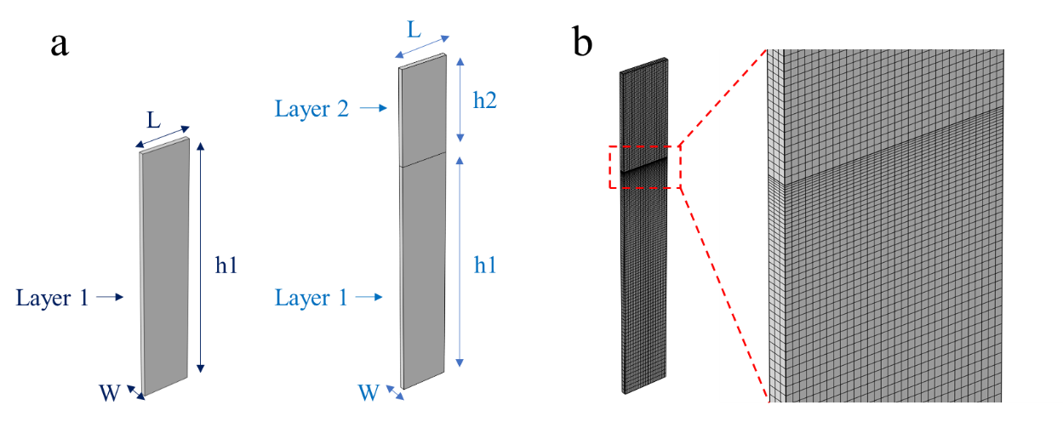
Figure N1.1. (a) Single-cycle SAW sensor model, (b) Mesh generation of SAW device.
Table N1.1. Simulation structure of SAW device
Structure | Materials | Size
Layer 1 | Y35ºX | h1=5λ, W=λ/10, L=λ
Layer 2 | Air | h2=2λ, W=λ/10, L=λ

N2. Acoustic loss calculation step
The acoustic loss A_{g} (dB/λ) can be calculated by the method from N1 and Fig. 1h in the main shows the A_{g} in different gas loading layers. Considering the SAW propagation length L=850λ, so the acoustic loss of SAW chip can be represented by:
Loss_{g}=A_{g}×L (1)
Formula (1) shows the acoustic loss in the special acoustic propagation length and gas layer. Combined with the relationship between acoustic loss and voltage (1 dB=30 mV), so the response of SAW sensing system can be represented by:
Response=Loss_{g}×L (2)
Based on the formula (1-2), we can achieve the comparation results between the experimental and simulation.

N3. Calculation method of hydrogen leakage concentration.
The detection method of H₂ leakage concentration of SAW chip is to integrate a simple concentration prediction algorithm into the SAW sensing system. As shown in Fig. N3.1, the relationship between the change of system sensing response voltage value ($∆V$) and H₂ concentration is given, and then the calibration task of hydrogen leakage concentration is completed. The relationship between system voltage change and hydrogen concentration is obtained by quadratic polynomial fitting method：
y=-1.73x²+26.54x+1.14
Where y represents the H₂ concentration predicted by the system and x represents the $∆V$.
In the system, the basis of H₂ leakage is set by referring to the lower limit of gas sensing detection given by International Union of pure and applied chemistry¹⁹: when the voltage changes more than three times the baseline noise, it is gas leakage, which can be expressed as:
$$∆V>3×SN$$
Where SN is the baseline noise of the SAW sensing system. The concentration of H2 can be calculated by the transient $∆V$ during the gas leakage state, and the value of concentration can be transmitted to the upper computer software. When the $∆V<3×SN$, the gas leakage is over.
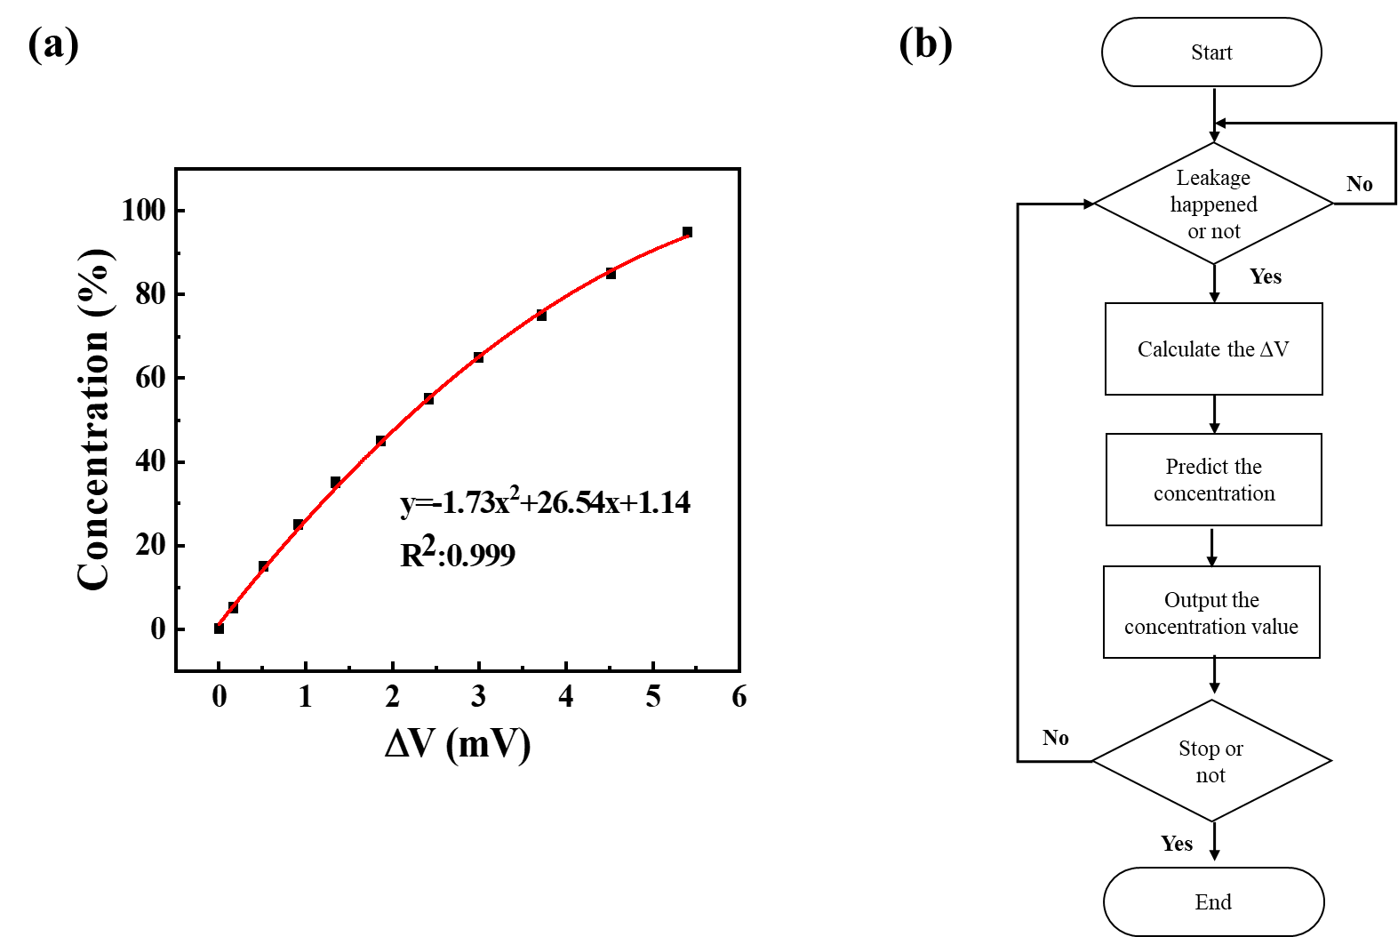
Figure N3.1 (a) The relationship between response and concentration. (b) The H₂ concentration prediction step in the SAW sensing system.
N4. Algorithm for calculating respiratory rate.
The respiratory data of volunteers collected in real-time through the SAW sensing system, as shown in Fig. N4.1a, is recorded as a time series R(i), where i=1,2,3... Due to the SAW chip based on the acoustic impedance effect being able to quickly sense changes in surface gas components, it exhibits good periodicity as shown in Fig. N4.1b. Therefore, by searching for local peaks, such as maximum or minimum values, the duration of a single breath cycle of the human body can be obtained. Deriving from the time point of the peaks M(j), where j=1,2,3..., the breathing cycle can be calculated as follows:
T(j)= M(j+1)- M(j).
So, the respiratory rate can be represented by:
RR(k)=60/T(j),
So as to obtain the human respiratory rate in a short time as shown in Fig. N4.1c, it can be seen that the number of breaths per minute at the rest state of the human body is between 18 and 22.
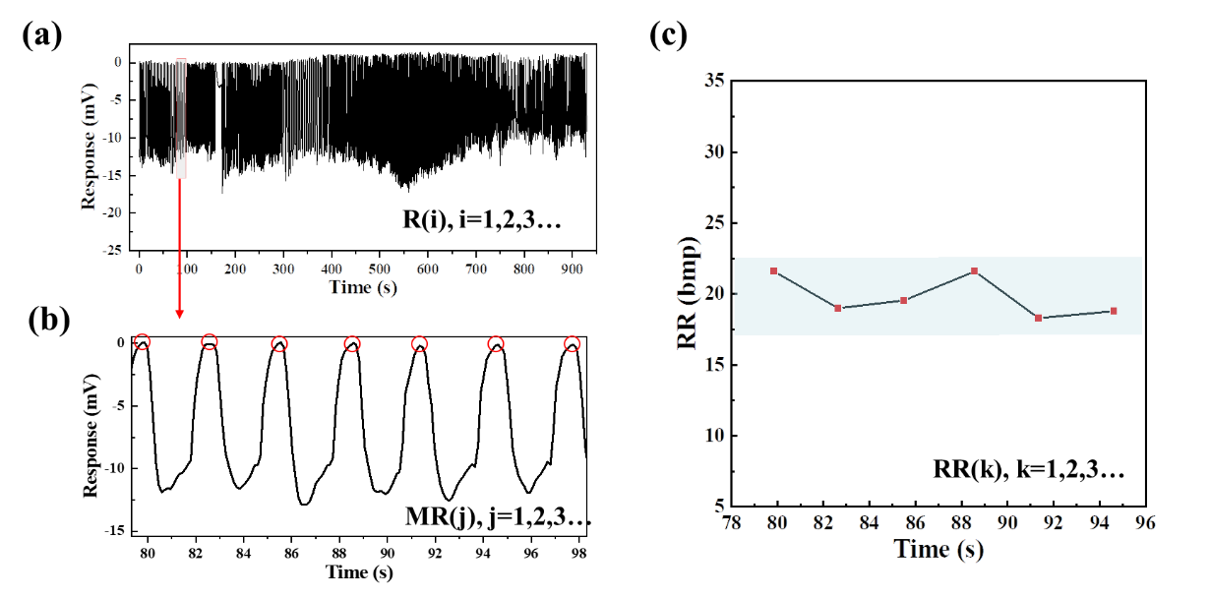
Figure N4.1 (a) Response curve of SAW chip when volunteers breathe in real time, (b) Short-term human respiration curve detected by SAW chip. (c) Real-time respiration rate calculation.

Reference
1. Phan D-T, Youn J-S, Jeon K-J. High-sensitivity and fast-response hydrogen sensor for safety application using Pt nanoparticle-decorated 3D graphene. Renew. Energy 144, 167-171 (2019).
2. She X, Yao Q, Yang G, Shen Y, Jin C. Suspended Palladium/Polymer Bilayer for High-Contrast and Fast Hydrogen Sensors. ACS Sens 7, 116-122 (2022).
3. Zhang X, et al. Ultralow detection limit and ultrafast response/recovery of the H2 gas sensor based on Pd-doped rGO/ZnO-SnO2 from hydrothermal synthesis. Microsyst Nanoeng 8, 67 (2022).
4. Wang C, Du L, Xing X, Feng D, Yang D. Lightweight Porous Polyurethane Foam Integrated with Graphene Oxide for Flexible and High-Concentration Hydrogen Sensing. ACS Sens 7, 2420-2428 (2022).
5. Cho W, Kim T, Shin H. Thermal conductivity detector (TCD)-type gas sensor based on a batch-fabricated 1D nanoheater for ultra-low power consumption. Sens. Actuator B-Chem 371, (2022).
6. Alenezy EK, et al. Low-Temperature Hydrogen Sensor: Enhanced Performance Enabled through Photoactive Pd-Decorated TiO2 Colloidal Crystals. ACS Sens 5, 3902-3914 (2020).
7. Yang L, Yin C, Zhang Z, Zhou J, Xu H. The investigation of hydrogen gas sensing properties of SAW gas sensor based on palladium surface modified SnO 2 thin film. Mater. Sci. Semicond. Process 60, 16-28 (2017).
8. Ye Z, Ruan H, Hu X, Dai J, Luo X, Yang M. TBAOH intercalated WO3 for high-performance optical fiber hydrogen sensor. Int. J. Hydrog. Energy 47, 28204-28211 (2022).
9. Shuh- Haw Sheen, Hual-Te Chien, Apostolos C Raptics. Ultrasonic techniques for detecting helium leaks. Sens. Actuator B-Chem 71, 197-202 (2000).
10. Chauhan PS, Bhattacharya S. Highly sensitive V2O5·1.6H2O nanostructures for sensing of helium gas at room temperature. Mater. Lett 217, 83-87 (2018).
11. Chen S, et al. A highly sensitive and flexible photonic crystal oxygen sensor. Sens. Actuator B-Chem 355, (2022).
12. Izu N, Shin W, Murayama N. Fast response of resistive-type oxygen gas sensors based on nano-sized ceria powder. Sens. Actuator B-Chem 93, 449-453 (2003).
13. Li Z, Huang H, Zhao D, Chen S, Cai W, Tang T. UV-activated room temperature oxygen gas sensor based on TiO2-decorated bridging GaN nanowires. Sens. Actuator B-Chem 401, (2024).
14. Wu H, Ding L, Long G, Jiang XD, Ma F. Preparation of a high stability optical fiber oxygen sensor based on the bilayer sensitive membrane. Opt. Fiber Technol 77, (2023).
15. Thomas T, et al. Porous silicon/α-MoO3 nanohybrid based fast and highly sensitive CO2 gas sensors. Vacuum 184, (2021).
16. Kumar V, et al. Environment-sensitive and fast room temperature CO2 gas sensor based on ZnO, NiO and Ni-ZnO nanocomposite materials. Environmental Functional Materials, (2023).
17. Xu M, Zheng K, Tian X, Lin Y, Xu Y, Tao J. Development of a non-resonant photoacoustic gas sensor for CO2 detection. Infrared Phys. Technol 137, (2024).
18. Xu M, et al. Development of a compact NDIR CO2 gas sensor for harsh environments. Infrared Phys. Technol 136, (2024).
19. Lloyd A. Currie. Nomenclature in evaluation fo analytical methods including detection and quantification capabilities. Anal. Chim. Acta 391, 105-126 (1995).

