Supplementary Information files

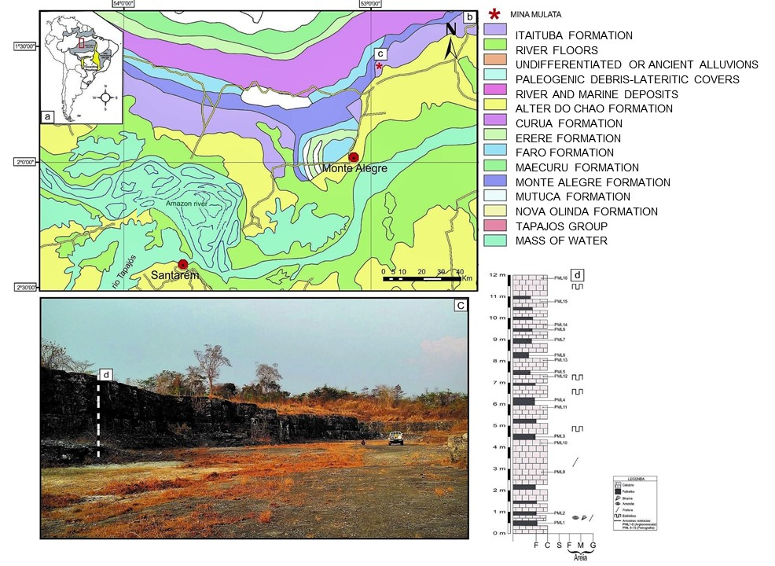
Fig 1. A map of the Carbonate rocks (53°0’00′′.N E 2°0’00′′ .S)
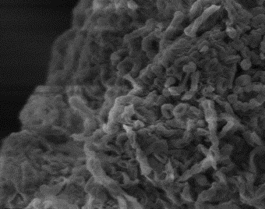
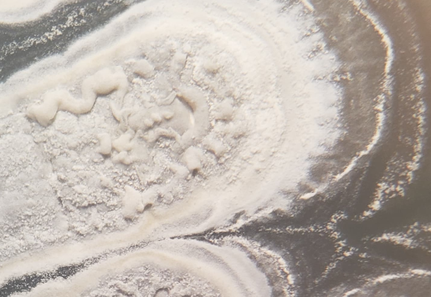

a b
Fig 2 Morphology of PML5. (a) Colony morphology on ISP2 agar after incubation at 30◦C for 14 days. (b) Spore chains of PML5 under scanning electron microscopy

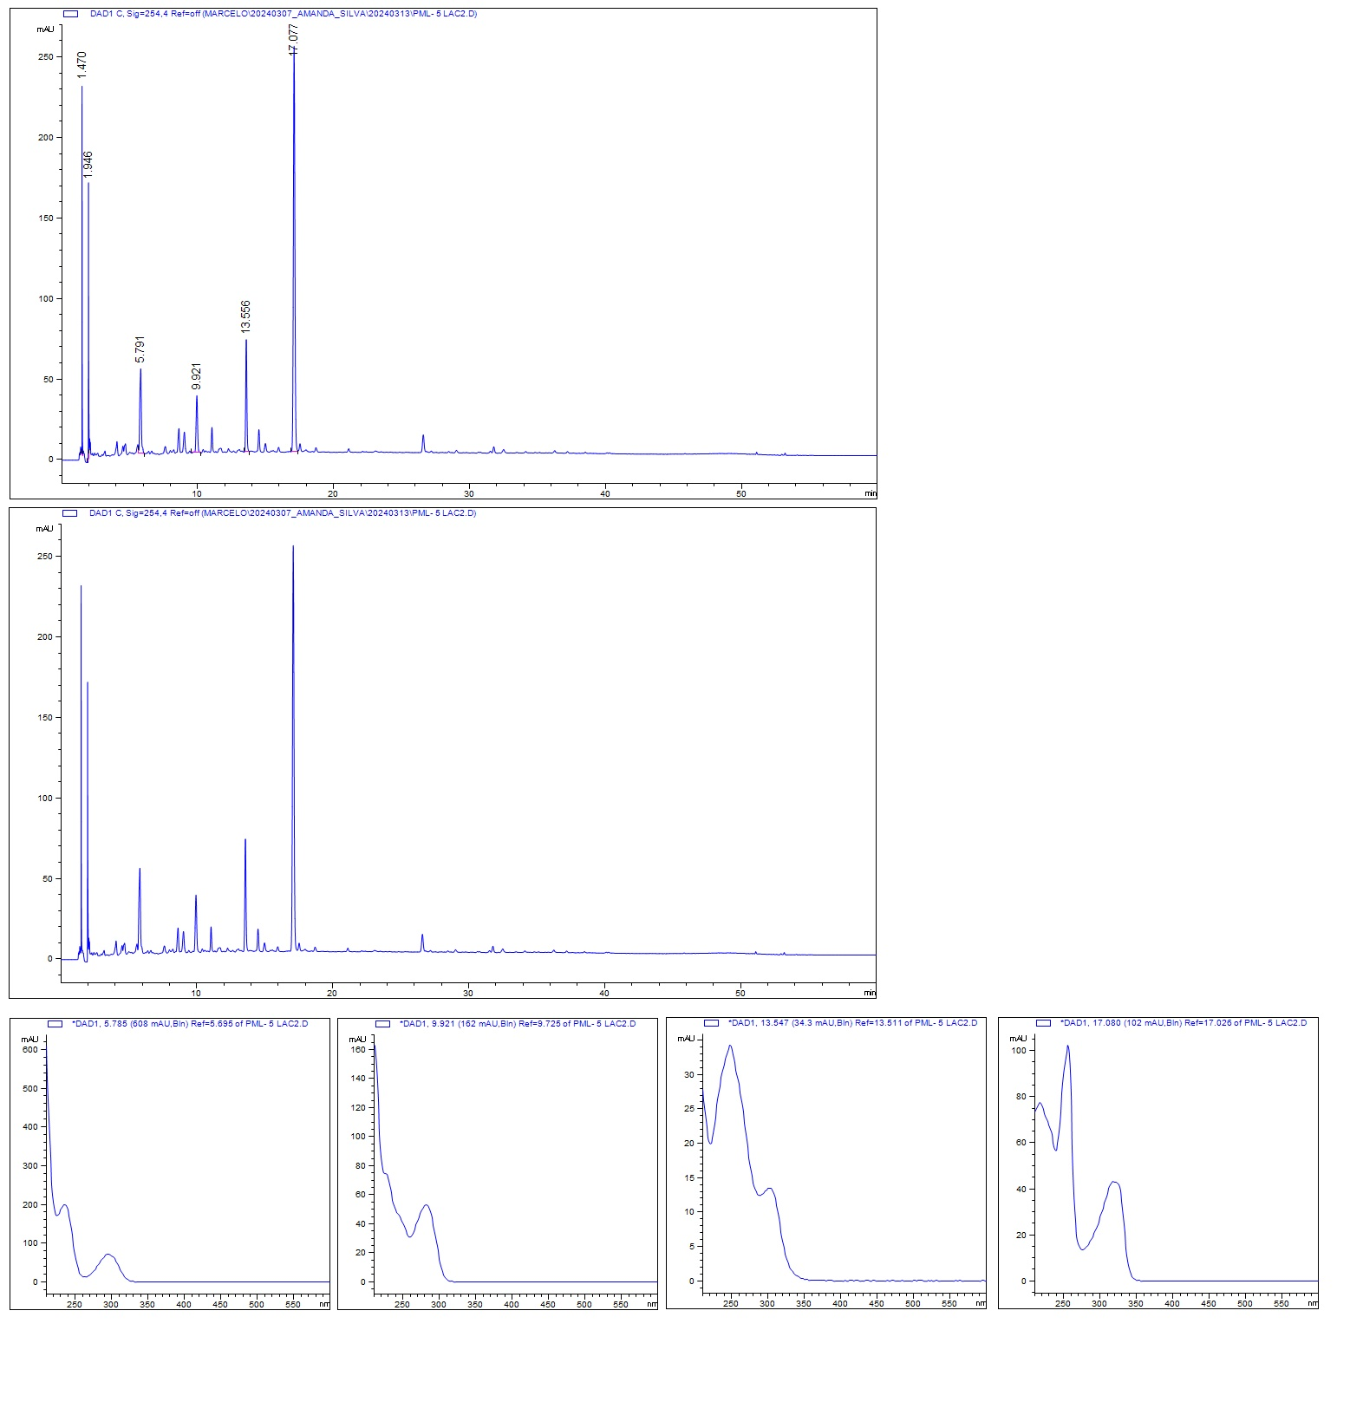
Fig 3: Chemical profile of PML5 metabolic extract.

Fig 4: PML5 Mass Spectrometry.

Table 1: Halos of pathogen growth inhibition against isolates
Pathogens | PML5
Streptococcus pneumoniae ATCC700699 | 12 ± 0,58
Staphylococcus aureus ATCC14458 | 12 ± 1,0
Staphylococcus epidermidis ATCC12228 | 12 ± 0,56
Micrococcus lutteus ATCC7468 | 12 ± 1,00
Escherichia coli ATCC25922 | 15 ± 0,00
Escherichia coli ATCC10536 | 13 ± 0,00
Klebsiella pneumoniae OXA48 | 12 ± 0,59
Acinetobacter baumannii ATCC19606 | 13 ± 1,15
Salmonella enteritidis INCQS00268 | 16 ± 0,00
Proteus vulgaris ATCC13315 | 13 ± 0,29
Aeromonas hydrophyla INCQS00318 | 10 ± 0,58

Table 2: Identification of chemical compounds of the PML5 isolate using GC-MS analysis.
Time (min) | Area (%) | M.W  (g/mol) | Molecular Formula | Compound Name | Bioactivity
14.816 | 0.76 | 206.32 | C₁₄H₂₂O | 2,4-Di-tert-butylphenol | Antitumor activity (33)
19.029 | 83.75 | 168,32 | C₁₂H_{24​}​​ | Cyclododecane | Antimicrobial and antitumor activity (34)
21.255 | 1.11 | 316.5 | C₁₈H₃₆O₄ | Tetradecanoic acid, 12-methyl-, methyl ester, (S)- | Antioxidant and antitumor activity (35)
23.144 | 2.76 | 270.5 | C₁₇H₃₄O₂ | Pentadecanoic acid, 14-methyl-, methyl ester | Antioxidant and antitumor activity (36)
23.551 | 1.32 | 196,2 | C₁₀H₁₆N₂O₂ | Cyclo(L-prolyl-L-valine) | Antimicrobial activity (37)
23.902 | 2.96 | 210.27 | C₁₁H₁₈N₂O₂ | Pyrrolo[1,2-a]pyrazine-1,4-dione, hexahydro-3-(2-methylpropyl)- | Antimicrobial activity (38)
25.262 | 0.62 | 316.5 | C₁₈H₃₆O₄ | Tetradecanoic acid, 12-methyl-, methyl ester, (S)- | Antioxidant and anti-rumoral activity (35)
25.537 | 1.08 | 168.32 | C₁₂H₂₄ | Cyclododecane | Antimicrobial and antitumor activity (34)
32.289 | 1.36 | 172.18 | C₈H₁₂O₄ | 4-Octene, (Z) | Antimicrobial Activity (39)
37.536 | 4.27 | 166.13 | C₈H₆O₄ | 1,4-Benzenedicarboxylic acid | Antimicrobial Activity (40)

