Supplementary Material

Title: The Protective Impact of Residual Cholesterol on Mortality Risk in Oldest Old
Supplementary List
Supplement 1. Figure S1. Flowchart of the inclusion of study participants.
Supplement 2. Figure S2. Correlations between three different methods for calculating LDL-C and measured LDL-C.
Supplement 3. Figure S3. Normal Q-Q Plot for remnant cholesterol.
Supplement 4. Table S1. Sensitivity analyses after excluding study participants who died during the first year of follow-up.
Supplement 5. Table S2. Sensitivity analyses after excluding study participants with hypertension at baseline.
Supplement 6. Table S3. Sensitivity analyses after excluding study participants with diabetes at baseline.
Supplement 7. Table S4. Sensitivity analyses after excluding study participants with disability in activities of daily living at baseline.
Supplement 8. Table S5. Association of RC with all-cause among 1263 younger old adults.
Supplement 9. Table S6. Association of RC with all-cause among 3026 Chinese oldest old.
Supplement 10. Supplemental Methods S1. Detailed content of the covariates.
This supplement has been provided by the authors to give readers additional information about our work.

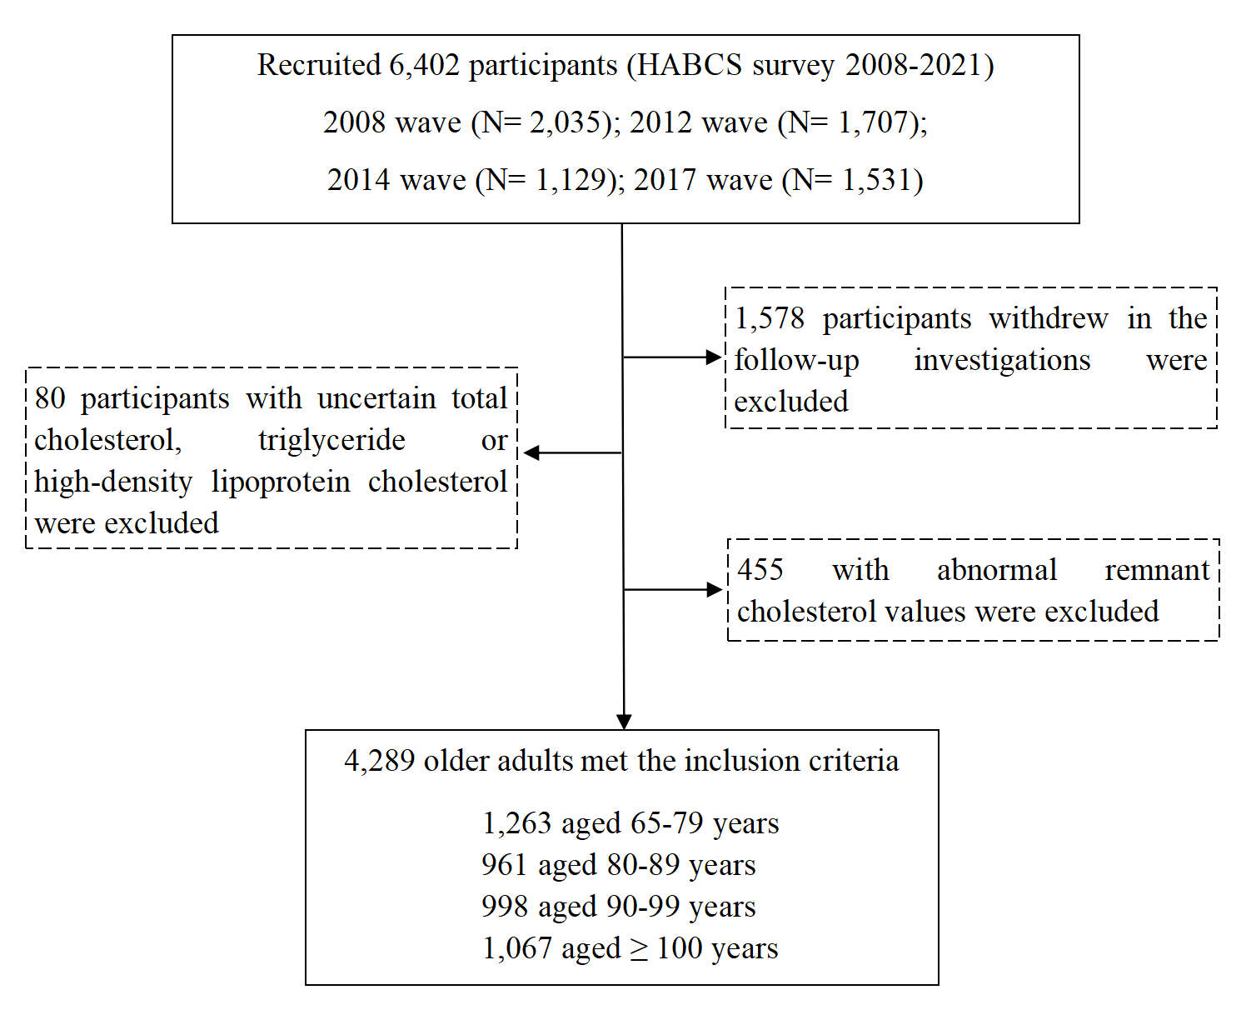
Supplement 1 Figure S1. Flowchart of the inclusion of study participants (HABCS Survey from 2008 to 2021).
Abbreviations: HABCS, Healthy Aging and Biomarkers Cohort Study

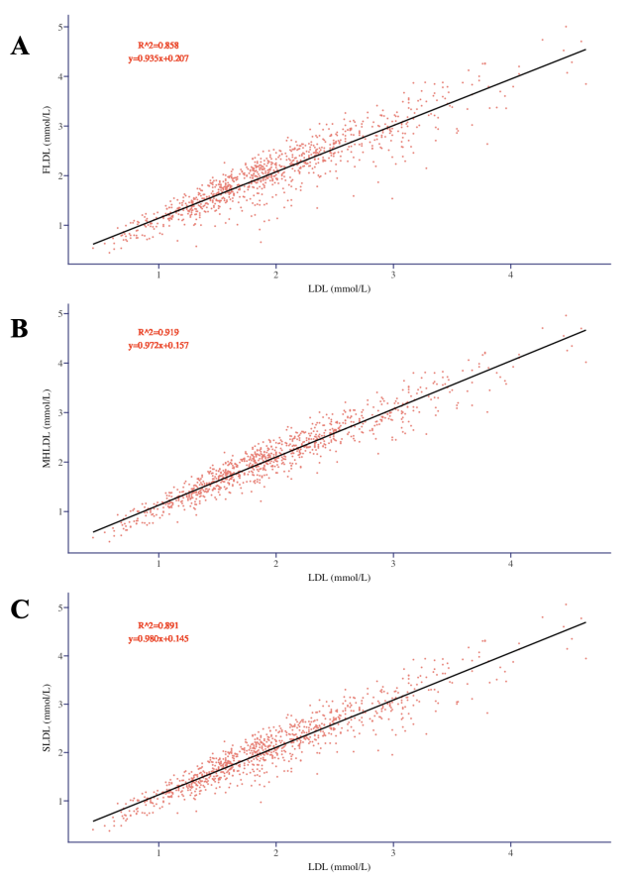
Supplement 2 Figure S2. Correlations between three different methods for calculating LDL-C and measured LDL–C.
Black lines show linear regressions for (A) Friedewald regressed on measured LDL-C, (B) Martin–Hopkins regressed on measured LDL-C, and (C) Sampson–NIH regressed on measured LDL-C.
Abbreviations: LDL-C, Low Density Lipoprotein; HABCS, Healthy Aging and Biomarkers Cohort Study.

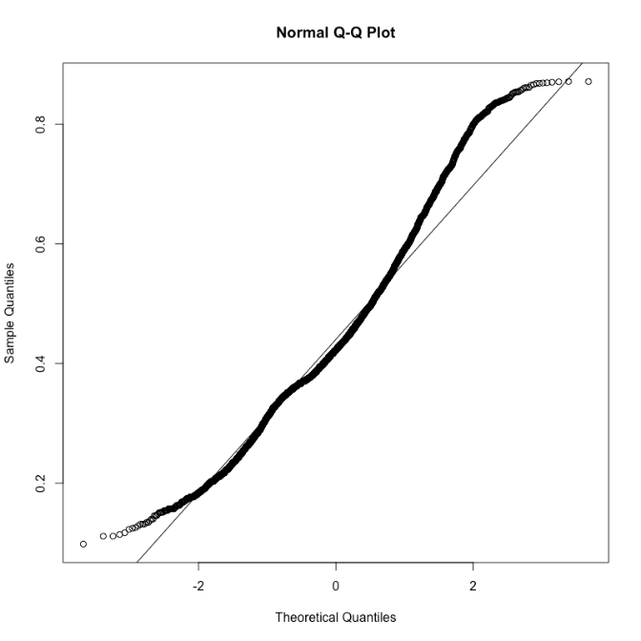
Supplement 3 Figure S3 Normal Q-Q Plot for remnant cholesterol.

Supplement 4 Table S1. Sensitivity analyses after excluding study participants who died during the first year of follow-up
Baseline exposure  MHRC | Events  (n) | Participants  (n) | Model1  HR (95%CI) | Model2  HR (95%CI) | Model3  HR (95%CI) | Model4  HR (95%CI) | P _{value}
pear 1SD | 2111 | 3875 | 0.948 (0.905–0.993) | 0.955 (0.911–1.001) | 0.954 (0.910–1.000) | 0.953 (0.909–0.999) | 0.047
pear 0.1mmol/L | 2111 | 3875 | 0.964 (0.934–0.995) | 0.969 (0.938–1.001) | 0.968 (0.938–1.000) | 0.968 (0.937–1.000) | 0.047
T1 (< 0.373) mmol/L | 655 | 1284 | Ref. | Ref. | Ref. | Ref.
T2 (0.373–0.486) mmol/L | 772 | 1278 | 0.933 (0.840–1.036) | 0.910 (0.818–1.011) | 0.909 (0.817–1.010) | 0.891 (0.802–0.991) | 0.034
T3 ≥0.486) mmol/L | 684 | 1313 | 0.871 (0.781–0.972) | 0.878 (0.786–0.980) | 0.875 (0.783–0.977) | 0.860 (0.770–0.961) | 0.008
<0.424 mmol/L | 1032 | 1924 | 1.000 | 1.000 | 1.000 | 1.000
≥0.424 mmol/L | 1079 | 1951 | 0.930(0.852–1.010) | 0.938 (0.859–1.024) | 0.931 (0.853–1.017) | 0.923 (0.845–1.008) | 0.074
Footnotes: The median value of RC for the 4289 Chinese old adults of our cohort is 0.422 mmol/L.
Abbreviations: RC, remnant cholesterol; HR, hazard ratio; CI, confidence interval; and SD, standard deviation.
Model 1 adjusted for age (year), sex (men or women);
Model 2 adjusted for the variables in model 1 plus nationality (Han or others), dietary intake of major oil (vegetable oil or animal fat oil), smoking status (yes or no), drinking status (yes or no), regular exercise status (yes or no), marital status (married or not), educational background (low or high), residence (rural or urban), living pattern (with family or alone or in an institution), dietary diversity score (DDS) type (poor or well), self-report life status (good, commonly or bad), self-report health status (good, commonly or bad);
Model 3 adjusted for the variables in model 2 plus systolic blood pressure (mmHg), diastolic blood pressure (mmHg), body mass index (kg/m²);
Model 4 adjusted for the variables in model 3 plus history (with or without) of type 2 diabetes, hypertension, cognitive impairment, cardiovascular disease and cancer.

Supplement 5 Table S2. Sensitivity analyses after excluding study participants with hypertension at baseline
Baseline exposure  MHRC | Events  (n) | Participants  (n) | Model1  HR (95%CI) | Model2  HR (95%CI) | Model3  HR (95%CI) | Model4  HR (95%CI) | P _{value}
pear 1SD | 1954 | 3181 | 0.930 (0.886–0.976) | 0.937 (0.891–0.985) | 0.936 (0.890–0.983) | 0.936 (0.891–0.984) | 0.010
pear 0.1mmol/L | 1954 | 3181 | 0.952 (0.921–0.984) | 0.957 (0.925–0.990) | 0.956 (0.924–0.989) | 0.956 (0.924–0.989) | 0.010
T1 (< 0.373) mmol/L | 655 | 1284 | Ref. | Ref. | Ref. | Ref.
T2 (0.373–0.486) mmol/L | 772 | 1278 | 0.968 (0.870–1.078) | 0.952 (0.853–1.061) | 0.951 (0.853–1.061) | 0.919 (0.824–1.025) | 0.129
T3 ≥0.486) mmol/L | 684 | 1313 | 0.862 (0.769–0.967) | 0.876 (0.780–0.984) | 0.870 (0.774–0.977) | 0.850 (0.756–0.955) | 0.006
<0.422 mmol/L | 969 | 1591 | 1.000 | 1.000 | 1.000 | 1.000
≥0.422 mmol/L | 985 | 1590 | 0.925 (0.845–1.010) | 0.935 (0.853–1.024) | 0.927 (0.845–1.016) | 0.923 (0.845–1.008) | 0.074
Footnotes: The median value of RC for the 4289 Chinese old adults of our cohort is 0.422 mmol/L.
Abbreviations: RC, remnant cholesterol; HR, hazard ratio; CI, confidence interval; and SD, standard deviation.
Model 1 adjusted for age (year), sex (men or women);
Model 2 adjusted for the variables in model 1 plus nationality (Han or others), dietary intake of major oil (vegetable oil or animal fat oil), smoking status (yes or no), drinking status (yes or no), regular exercise status (yes or no), marital status (married or not), educational background (low or high), residence (rural or urban), living pattern (with family or alone or in an institution), dietary diversity score (DDS) type (poor or well), self-report life status (good, commonly or bad), self-report health status (good, commonly or bad);
Model 3 adjusted for the variables in model 2 plus systolic blood pressure (mmHg), diastolic blood pressure (mmHg), body mass index (kg/m²);
Model 4 adjusted for the variables in model 3 plus history (with or without) of type 2 diabetes, cognitive impairment, cardiovascular disease and cancer.

Supplement 6 Table S3. Sensitivity analyses after excluding study participants with diabetes at baseline
Baseline exposure  MHRC | Events  (n) | Participants  (n) | Model1  HR (95%CI) | Model2  HR (95%CI) | Model3  HR (95%CI) | Model4  HR (95%CI) | P _{value}
pear 1SD | 2473 | 4170 | 0.936 (0.897–0.977) | 0.944 (0.903–0.986) | 0.945 (0.905–0.988) | 0.944 (0.903–0.986) | 0.010
pear 0.1mmol/L | 2473 | 4170 | 0.956 (0.928–0.985) | 0.961 (0.933–0.990) | 0.962 (0.934–0.991) | 0.962 (0.933–0.991) | 0.010
T1 (< 0.373) mmol/L | 655 | 1284 | Ref. | Ref. | Ref. | Ref.
T2 (0.373–0.486) mmol/L | 772 | 1278 | 0.944 (0.857–1.039) | 0.910 (0.818–1.011) | 0.909 (0.817–1.010) | 0.891 (0.801–0.991) | 0.033
T3 ≥0.486) mmol/L | 684 | 1313 | 0.863 (0.780–0.955) | 0.878 (0.786–0.980) | 0.875 (0.783–0.977) | 0.860 (0.769–0.960) | 0.007
<0.422 mmol/L | 1223 | 2077 | 1.000 | 1.000 | 1.000 | 1.000
≥0.422 mmol/L | 1250 | 2093 | 0.932 (0.860–1.010) | 0.944 (0.871–1.024) | 0.941 (0.868–1.021) | 0.932(0.859–1.011) | 0.091
Footnotes: The median value of RC for the 4289 Chinese old adults of our cohort is 0.422 mmol/L.
Abbreviations: RC, remnant cholesterol; HR, hazard ratio; CI, confidence interval; and SD, standard deviation.
Model 1 adjusted for age (year), sex (men or women);
Model 2 adjusted for the variables in model 1 plus nationality (Han or others), dietary intake of major oil (vegetable oil or animal fat oil), smoking status (yes or no), drinking status (yes or no), regular exercise status (yes or no), marital status (married or not), educational background (low or high), residence (rural or urban), living pattern (with family or alone or in an institution), dietary diversity score (DDS) type (poor or well), self-report life status (good, commonly or bad), self-report health status (good, commonly or bad);
Model 3 adjusted for the variables in model 2 plus systolic blood pressure (mmHg), diastolic blood pressure (mmHg), body mass index (kg/m²);
Model 4 adjusted for the variables in model 3 plus history (with or without) of hypertension, cognitive impairment, cardiovascular disease and cancer.

Supplement 7 Table S4. Sensitivity analyses after excluding study participants with disability in activities of daily living at baseline
Baseline exposure  MHRC | Events  (n) | Participants  (n) | Model1  HR (95%CI) | Model2  HR (95%CI) | Model3  HR (95%CI) | Model4  HR (95%CI) | P _{value}
pear 1SD | 1913 | 3617 | 0.955 (0.910–1.000) | 0.962 (0.916–1.011) | 0.959 (0.914–1.007) | 0.959 (0.913–1.007) | 0.091
pear 0.1mmol/L | 1913 | 3617 | 0.969 (0.938–1.000) | 0.974 (0.942–1.007) | 0.972 (0.940–1.005) | 0.972 (0.940–1.005) | 0.091
T1 (< 0.373) mmol/L | 757 | 1358 | Ref. | Ref. | Ref. | Ref.
T2 (0.373–0.486) mmol/L | 867 | 1341 | 0.934 (0.835–1.040) | 0.916 (0.819–1.025) | 0.912 (0.815–1.021) | 0.898 (0.802–1.005) | 0.060
T3 ≥0.486) mmol/L | 743 | 1332 | 0.897 (0.800–1.010) | 0.903 (0.805–1.014) | 0.894 (0.796–1.004) | 0.885 (0.788–0.994) | 0.039
<0.422 mmol/L | 907 | 1768 | 1.000 | 1.000 | 1.000 | 1.000
≥0.422 mmol/L | 1006 | 1849 | 0.953 (0.870–1.040) | 0.959 (0.874–1.052) | 0.949 (0.865–1.042) | 0.945 (0.861–1.037) | 0.233
Footnotes: The median value of RC for the 4289 Chinese old adults of our cohort is 0.422 mmol/L.
Abbreviations: RC, remnant cholesterol; HR, hazard ratio; CI, confidence interval; and SD, standard deviation.
Model 1 adjusted for age (year), sex (men or women);
Model 2 adjusted for the variables in model 1 plus nationality (Han or others), dietary intake of major oil (vegetable oil or animal fat oil), smoking status (yes or no), drinking status (yes or no), regular exercise status (yes or no), marital status (married or not), educational background (low or high), residence (rural or urban), living pattern (with family or alone or in an institution), dietary diversity score (DDS) type (poor or well), self-report life status (good, commonly or bad), self-report health status (good, commonly or bad);
Model 3 adjusted for the variables in model 2 plus systolic blood pressure (mmHg), diastolic blood pressure (mmHg), body mass index (kg/m²);
Model 4 adjusted for the variables in model 3 plus history (with or without) of type 2 diabetes, hypertension, cognitive impairment, cardiovascular disease and cancer.

Supplement 8 Table S5. Association of RC with all-cause among 1263 younger old adults
Baseline exposure  MHRC | Events  (n) | Participants  (n) | Model1  HR (95%CI) | Model2  HR (95%CI) | Model3  HR (95%CI) | Model4  HR (95%CI) | P _{value}
pear 1SD | 264 | 1263 | 1.050 (0.938–1.180) | 1.064 (0.939–1.206) | 1.051 (0.928–1.191) | 1.052 (0.927–1.194) | 0.433
pear 0.1mmol/L | 264 | 1263 | 1.030 (0.967–1.120) | 1.043 (0.958–1.136) | 1.035 (0.950–1.127) | 1.035(0.950–1.128) | 0.433
T1 (< 0.373) mmol/L | 73 | 425 | Ref. | Ref. | Ref. | Ref.
T2 (0.373–0.486) mmol/L | 96 | 379 | 1.093 (0.805–1.490) | 0.980 (0.717–1.340) | 0.942 (0.687–1.291) | 0.928 (0.676–1.274) | 0.644
T3 ≥0.486) mmol/L | 95 | 459 | 0.977 (0.718–1.330) | 0.952 (0.697–1.300) | 0.931 (0.679–1.276) | 0.917 (0.668–1.259) | 0.593
<0.422 mmol/L | 123 | 618 | 1.000 | 1.000 | 1.000 | 1.000
≥0.422 mmol/L | 141 | 645 | 0.970 (0.759–1.240) | 0.941 (0.733–1.207) | 0.963 (0.749–1.239) | 0.959 (0.745–1.235) | 0.747
Footnotes: The median value of RC for the 4289 Chinese old adults of our cohort is 0.422 mmol/L.
Abbreviations: RC, remnant cholesterol; HR, hazard ratio; CI, confidence interval; and SD, standard deviation.
Model 1 adjusted for age (year), sex (men or women);
Model 2 adjusted for the variables in model 1 plus nationality (Han or others), dietary intake of major oil (vegetable oil or animal fat oil), smoking status (yes or no), drinking status (yes or no), regular exercise status (yes or no), marital status (married or not), educational background (low or high), residence (rural or urban), living pattern (with family or alone or in an institution), dietary diversity score (DDS) type (poor or well), self-report life status (good, commonly or bad), self-report health status (good, commonly or bad);
Model 3 adjusted for the variables in model 2 plus systolic blood pressure (mmHg), diastolic blood pressure (mmHg), body mass index (kg/m²);
Model 4 adjusted for the variables in model 3 plus history (with or without) of type 2 diabetes, hypertension, cognitive impairment, cardiovascular disease and cancer.

Supplement 9 Table S6. Association of RC with all-cause among 3026 Chinese oldest old.
Baseline exposure  MHRC | Events  (n) | Participants  (n) | Model1  HR (95%CI) | Model2  HR (95%CI) | Model3  HR (95%CI) | Model4  HR (95%CI) | P _{value}
pear 1SD | 2261 | 3026 | 0.926 (0.885–0.969) | 0.936 (0.893–0.980) | 0.939 (0.896–0.983) | 0.937 (0.894–0.981) | 0.006
pear 0.1mmol/L | 2261 | 3026 | 0.949 (0.920–0.979) | 0.956 (0.926–0.987) | 0.958 (0.928–0.988) | 0.956 (0.926–0.987) | 0.006
T1 (< 0.373) mmol/L | 757 | 1358 | Ref. | Ref. | Ref. | Ref.
T2 (0.373–0.486) mmol/L | 867 | 1341 | 0.926 (0.837–1.024) | 0.916 (0.827–1.013) | 0.918 (0.830–1.016) | 0.896 (0.809–0.992) | 0.034
T3 ≥0.486) mmol/L | 743 | 1332 | 0.854 (0.768–0.949) | 0.873 (0.784–0.971) | 0.877 (0.788–0.976) | 0.857 (0.770–0.954) | 0.005
<0.422 mmol/L | 1121 | 1518 | 1.000 | 1.000 | 1.000 | 1.000
≥0.422 mmol/L | 1140 | 1508 | 0.936 (0.860–1.020) | 0.951 (0.873–1.035) | 0.949 (0.872–1.033) | 0.938 (0.861–1.021) | 0.140
Footnotes: The median value of RC for the 4289 Chinese old adults of our cohort is 0.422 mmol/L.
Abbreviations: RC, remnant cholesterol; HR, hazard ratio; CI, confidence interval; and SD, standard deviation.
Model 1 adjusted for age (year), sex (men or women);
Model 2 adjusted for the variables in model 1 plus nationality (Han or others), dietary intake of major oil (vegetable oil or animal fat oil), smoking status (yes or no), drinking status (yes or no), regular exercise status (yes or no), marital status (married or not), educational background (low or high), residence (rural or urban), living pattern (with family or alone or in an institution), dietary diversity score (DDS) type (poor or well), self-report life status (good, commonly or bad), self-report health status (good, commonly or bad);
Model 3 adjusted for the variables in model 2 plus systolic blood pressure (mmHg), diastolic blood pressure (mmHg), body mass index (kg/m²);
Model 4 adjusted for the variables in model 3 plus history (with or without) of type 2 diabetes, hypertension, cognitive impairment, cardiovascular disease and cancer.

Supplement 10 Detailed content of the covariates

1.Dietary intake of major oil: Which oil main intake in dietary was identified by the question “Which fuels are normally used for cooking in your home?”
2.Smoking: The smoking status was identified by the question “Do you smoke at the present time?”
3.Drinking: The drinking status was identified by the question “Do you drink alcohol at the present time?”
4.Marital status: The status of “married and living with spouse” or “married but not living with spouse” was identified married. And the status of “divorced”, “widowed” or “never married” was identified not married.
5.Educational years: The years of “educational years” were identified by the question “How many years did you attend school?”.
6.Self-report life statue: The self-report life statue was identified by the question “How do you rate your life at present?”.
7.Self-report health statue: The self-report health statue was identified by the question “How do you rate your health at present?”.
8.Systolic blood pressure: Take the average of two measurements of systolic blood pressure for analysis.
9.Diastolic blood pressure: Take the average of two measurements of diastolic blood pressure for analysis.
10.Body mass index: BMI is calculated by body weight (kg) dividing square of directly measured height values (m).
11.DDS score type: We also used threshold 4 to classify DDS as a dummy variable. Specifically, “poor DDS” was defined as a DDS of 0–3, whereas “well DDS” was defined as a DDS of 4–7.
12.History of Cognitive impairment: We used education-specific cutoffs to define cognitive impairment based on the latest normative and validation study of the mini-mental status examination in the Chinese population: less than or equal to 16 for those without schooling, less than or equal to 19 for those with 1–6 years of education, and less than or equal to 23 for those with more than 6 years of education.
13History of cognitive impairment: Cognitive function was assessed by the Chinese version of the mini-mental state examination (MMSE); participants whose MMSE scores were less than 18 were identified as cognitive impairment.
14.History of type 2 diabetes mellitus: The history of type 2 diabetes mellitus was identified by the question “Are you suffering from any of the diabetes?”.
15.History of hypertension: The history of hypertension was identified by the question “Are you suffering from any of the hypertension?”.
16.History of cardiovascular disease: The history of cardiovascular disease was identified by the question “Are you suffering from any of the heart disease?”.
17.Cognitive impairment was determined by utilizing education-specific cut-off points derived from the most recent normative and validation study of the Chinese population’s mini-mental status examination (MMSE). The cut-off points were as follows: ≤16 for individuals without schooling, ≤19 for those with 1-6 years of education, and ≤23 for those with more than 6 years of education.
18.The term “restriction in activities of daily living (ADL)” was used to refers to a participant’s dependence on assistance for tasks such as bathing, toileting, dressing, continence, indoor activities, or eating.
19.We classified DDS as a binary variable using a threshold of 4. We defined “poor DDS” as a DDS score ranging from 0 to 3, and “well DDS” as a DDS score ranging from 4 to 7.

