Appendix 1
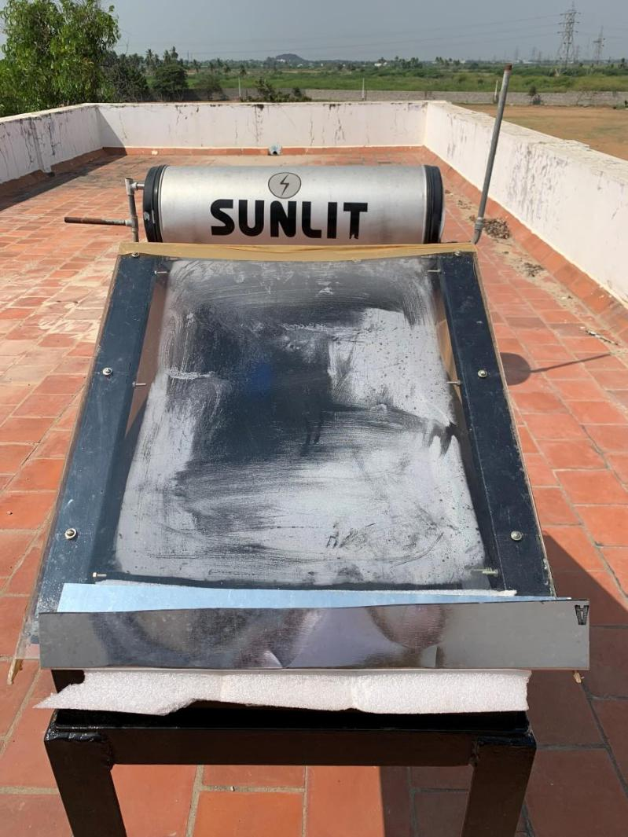

Fig. A1 Passive solar distillation setup at the Saranathan college of Engineering, Trichy, Tamilnadu, India

