Fixed-bed column dynamics of ultrasound and Na-functionalized diatomite to remove phosphate from water
Junxiu Ye, Min Yang, Xuemei Ding, Wei Tan, Guizhen Li , Shuju Fang, Hongbin Wang*

School of Chemistry and Environment, Yunnan Minzu University, Kunming 650500, Yunnan, China

Corresponding author
Hongbin Wang, School of Chemistry and Environment, Yunnan Minzu University, Kunming 650500, Yunnan, P.R. China (E-mail: wanghb2152@126.com; Tel. +13708440749)

Fig. S1 SEM images of diatomite: A, the natural diatomite; B, the pickling diatomite; C, the
pickling and NaCl modified diatomite; D, the pickling, NaCl modified, and calcining diatomite.
Fig. S2(a) The elemental composition of the natural diatomite by use of EDS.
Fig. S2(b) The elemental composition of the U-D-Na by use of EDS.
Fig. S3(a) The phosphate adsorption isotherm by U-D-Na at 25 ℃.
Fig. S3(b) The linear langmuir isotherm equation for phosphate removal by U-D-Na at 25 ℃.
Table S1 The phosphate adsorption parameters fitted by Langmuir model.

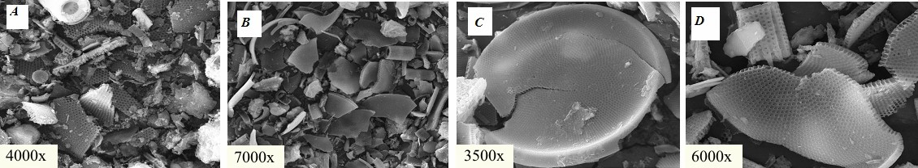

Fig. S1. SEM images of diatomite: A, natural diatomite; B, pickling diatomite; C,
pickling and NaCl modified diatomite; D, pickling, NaCl modified and calcining
diatomite.
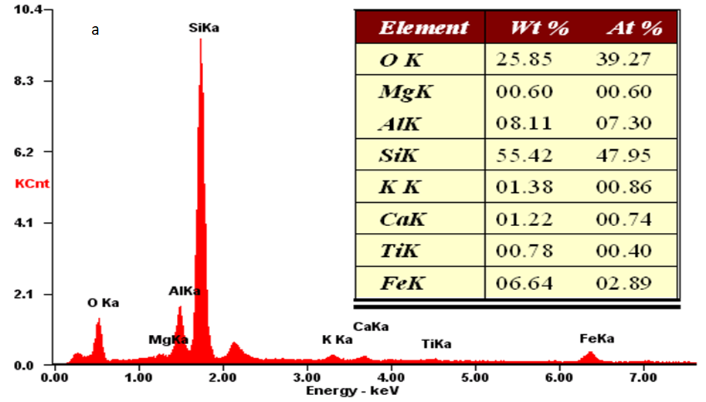

Fig. S2(a) The elemental composition of the natural diatomite by use of EDS

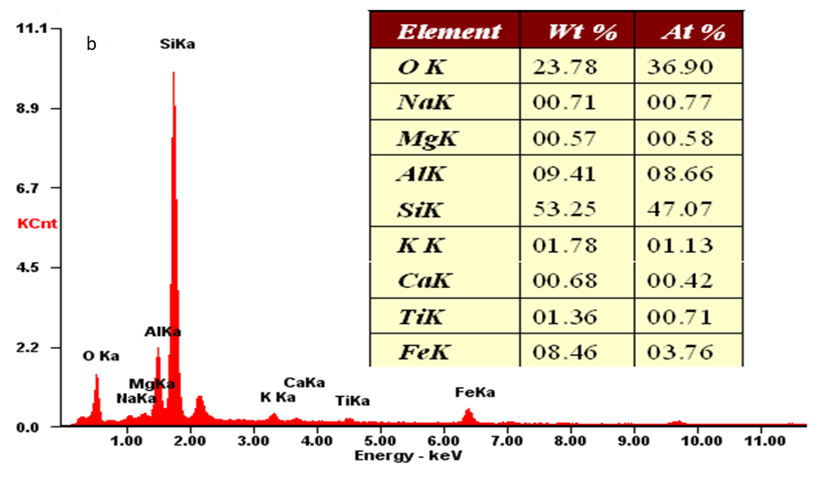

Fig. S2(b) The elemental composition of the U-D-Na by use of EDS

Fig. S3(a) The phosphate adsorption isotherm by U-D-Na at 25 ℃.

b
Fig. S3(b) The linear langmuir isotherm equation for phosphate removal by U-D-Na at 25 ℃.

Langmuir model | Equation | K_{L} | Q_{m} | R
Langmuir model | Q_{e}=0.8104C_{e}/(1+0.3138Ce) | 0.2543 | 3.1867 | 0.9626
Table S1 The phosphate adsorption parameters fitted by Langmuir model at 25 ℃.

