Supplementary Results and Supplemental Figure Legends:
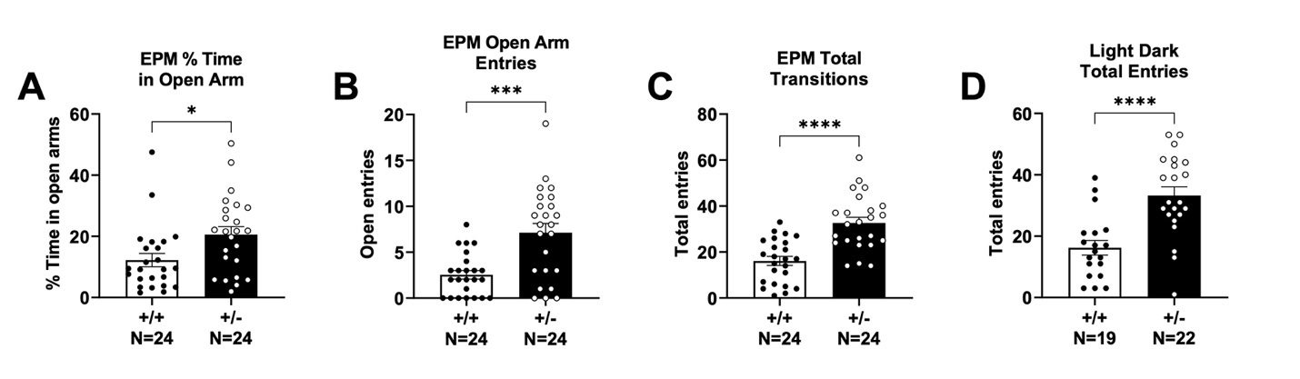
Hyperactivity and reduced anxiety like phenotype
Anxiety -like activity was assessed using the elevated plus maze and the light-dark box tasks. An increased percentage of time spent in the open arms of the elevated plus maze was observed in the Syngap1^{+/-} mice when compared to Syngap1^{+/+} mice using a student’s unpaired t-test (Fig. S1A; t (46) = 2.471, P = 0.0172) indicating reduced anxiety-like behavior. Syngap1^{+/-} mice also showed heightened open arm entries (Fig. S1B; t (46) = 4.104, P = 0.0002) as well as total transitions between open and closed arms in the elevated plus maze when analyzed with an unpaired t-test (Fig. S1C; t (46) = 5.240, P < 0.0001). Similar elevated total entries were observed in the light-dark task with the Syngap1^{+/-} mice showing a significantly increased number of total entries into the light space when compared to Syngap1^{+/+} mice (Fig. S1D; t (39) = 4.481, P < 0.0001).
Figure S1. Reduced anxiety-like behavior and hyperactivity when assessed in the elevated plus maze (EPM) and the light-dark conflict task. (A) In the EPM, percent time spent on the open arms, (B) the total number of open arm entries, and the (C) total number of transitions were elevated in Syngap1^{+/-} mice when compared to Syngap1^{+/+} mice. (D) In the light-dark task, total transitions between chambers was elevated in the Syngap1^{+/-} mice. Data are expressed as mean ± S.E.M. * = P < 0.05, *** = P < 0.001, **** = P < 0.0001 when analyzed with a student’s unpaired t-test.

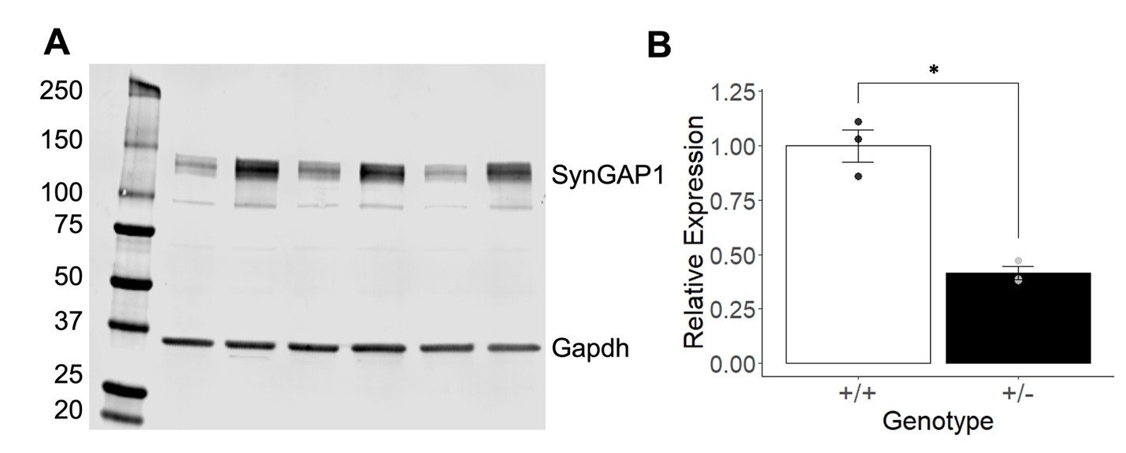
Figure S2. Unedited western blot of SynGAP1 and Gapdh protein expression in Syngap1^{+/+} (WT) and Syngap1^{+/-} (HT) mice at PND42. (A) A significant decrease in expression of Syngap1 was observed in the Syngap1^{+/-} mice. Bands not at 140 kDa or 37 kDa are non-specific and do not show significant changes between genotypes. (B) Quantification of Syngap1 protein expression using Gapdh expression as normalization. Syngap1 protein expression was decreased to 41% of WT expression. Data was analyzed using a Student’s t-test and is expressed as mean ± S.E.M. *P = 0.0051. (WT N = 3, HT N = 3)
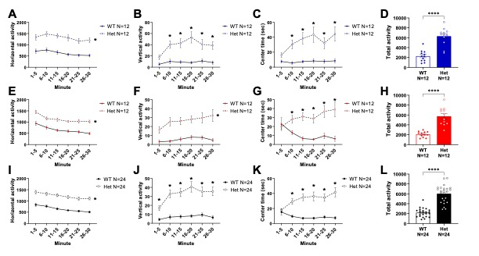

Figure S3. No observed gross motor differences in open field assay between Syngap1^{+/+} (WT) and mice with a loss of Syngap1 expression, Syngap1^{+/-} mice. (A,E,I) Time spent exploring the center of the open field apparatus over six 5-minute time bins for males (A, blue), females (E, red) and combined sexes (I, black). (B, F, J) Summed total activity for the 30-minute session for males (B, blue), females (F, red) and combined sexes (J, black). Data are expressed as mean ± S.E.M. * = P < 0.05, *** = P < 0.001, **** = P < 0.0001 when analyzed with a two-way ANOVA (center time) or with student’s unpaired t-test (total activity).

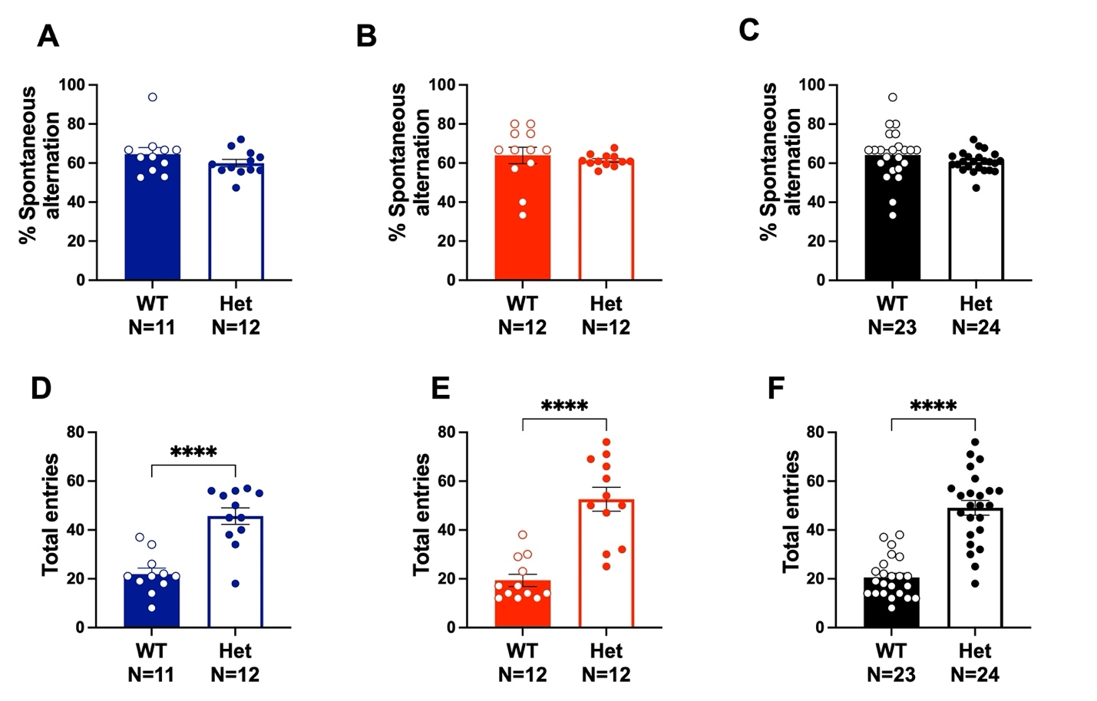
Figure S4. No observed sex differences in spontaneous alternation in the Y-Maze between Syngap1^{+/+} (WT) and loss of Syngap1 expression Syngap1^{+/-} mice. (A-C) Percent of spontaneous alternations in males (A, blue), females (B, red), and combined sexes (C, black). (D-F) Elevated arm entries in Syngap1^{+/-} males (D, blue), females (E, red), and combined sexes (F, black) compared to Syngap1^{+/+} mice. Data are expressed as mean ± S.E.M. * = P < 0.05, *** = P < 0.001, **** = P < 0.0001 when analyzed with student’s unpaired t-test.
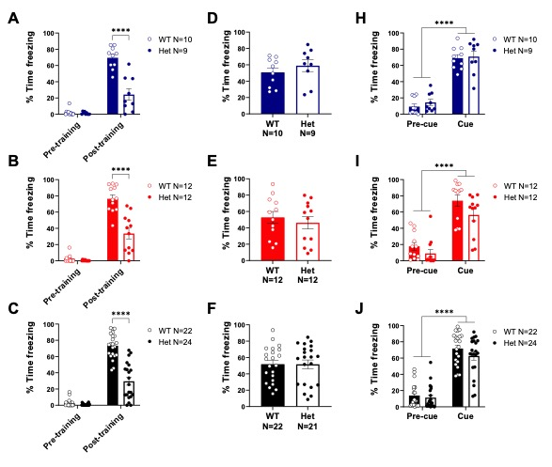

Figure S5. No observed sex differences in fear conditioning learning between Syngap1^{+/+} (WT) and loss of Syngap1 expression, Syngap1^{+/-} mice. (A-C) Percent of time spent freezing pre-training and post-training for males (A, blue), females (B, red), and combined sexes (C, black). (D-F) Total percent time freezing between Syngap1^{+/+} (WT) and Syngap1^{+/-} (HT) mice for males (D), females (E), and combined sexes (F). (G-I) Percent time freezing pre-cue and when cued for males (G), females (H), and combined sexes (I). Data are expressed as mean ± S.E.M. * = P < 0.05, *** = P < 0.001, **** = P < 0.0001 when analyzed with student’s unpaired t-test.

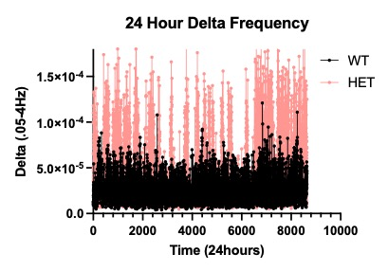
Figure S6. Representative Trace of the elevated delta spectral power over 24 hours of the 72-hour recording period.

