Supplementary Figures
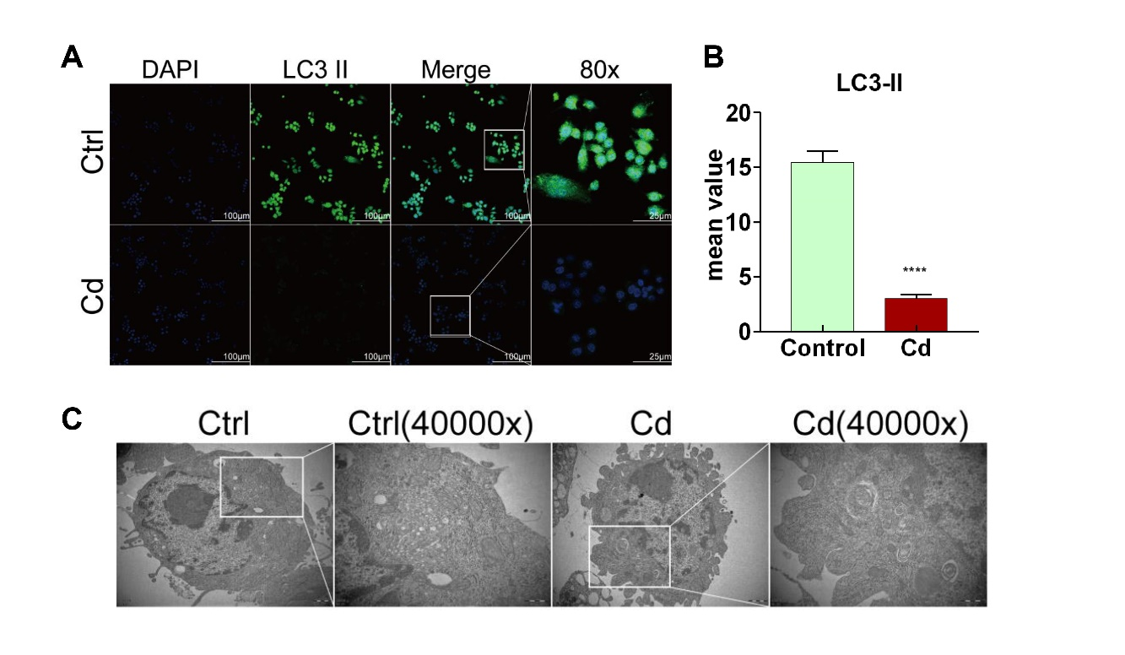
Supplementary Fig. S1. The changes of mitochondrial protective autophagy after Cd exposure. (A, B) Immunofluorescence images and fluorescence intensity of autophagosome marker, LC3II, in RAW264.7 cells after treatment with Cd. (C) Representative TEM images of autophagosome in RAW264.7 cells after treatment with Cd. Data are shown as mean ± SD. *p < 0.05, **p < 0.01, ***p < 0.001, ****p < 0.0001.
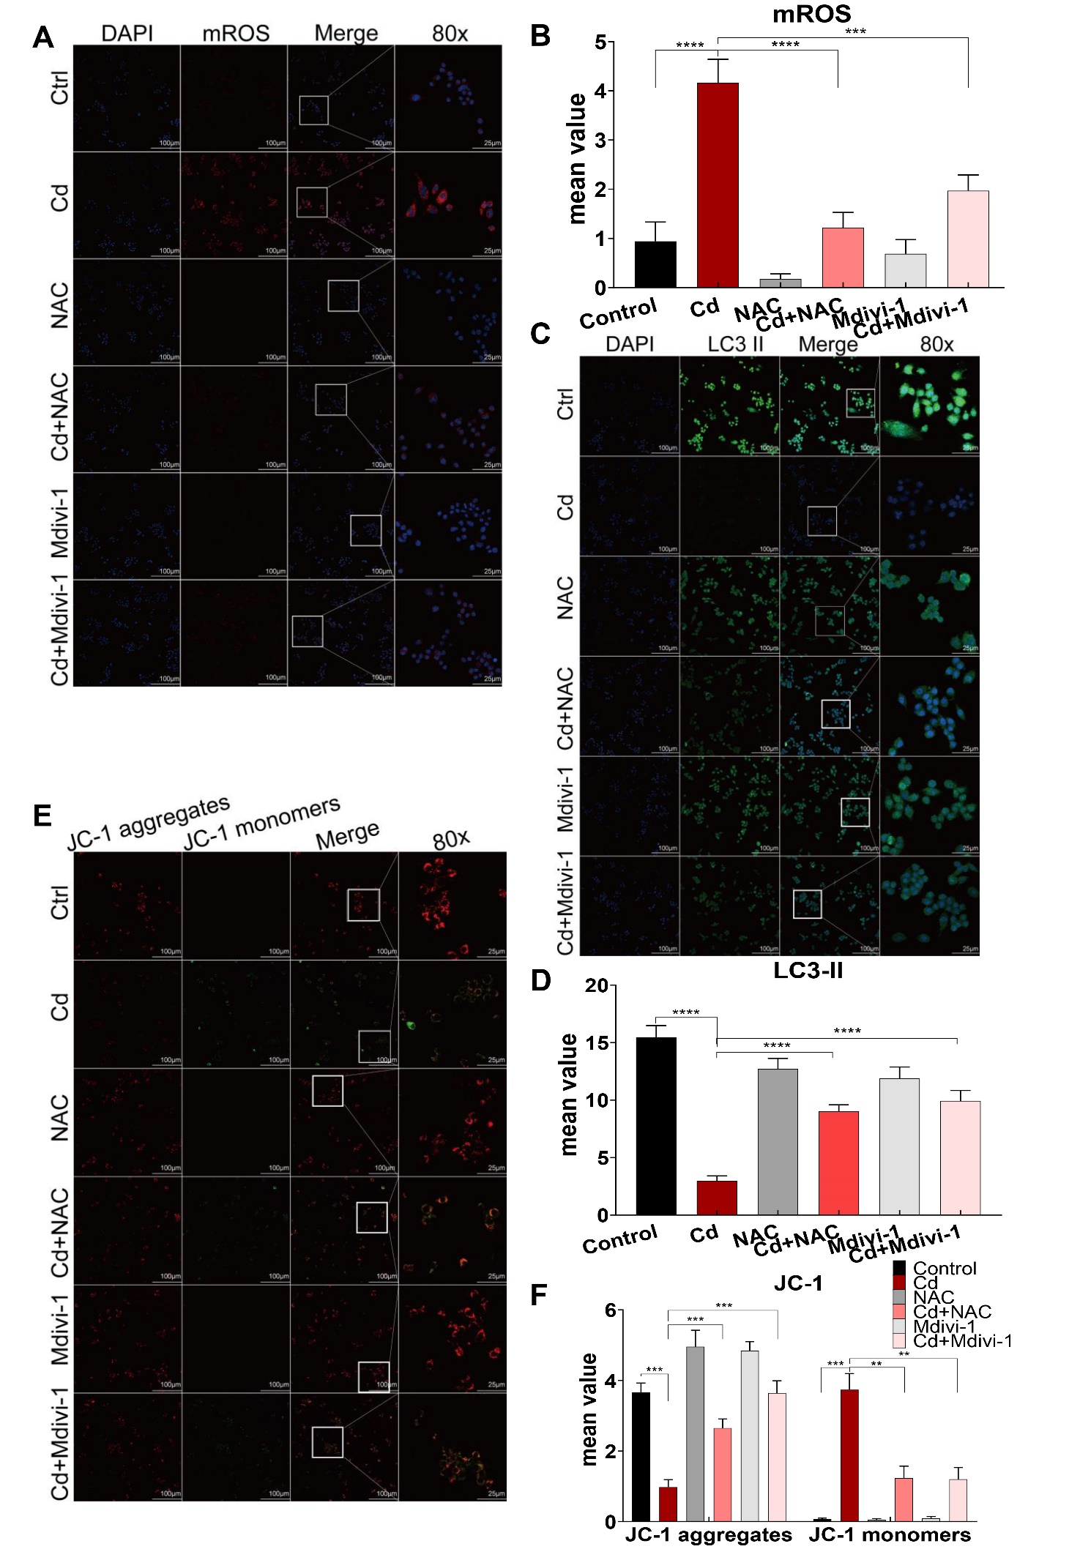
Supplementary Fig. S2. Improving mitochondrial homeostasis in the process of macrophage M1-type polarization in vitro. (A, B) Immunofluorescence images and fluorescence intensity of mitochondrial superoxide (mROS) in RAW264.7 cells. (C, D) Immunofluorescence images and fluorescence intensity of autophagosome marker, LC3II, in RAW264.7 cells. (E, F) Mitochondrial membrane potential showed by fluorescent probe (JC-1). Data are shown as mean ± SD. *p < 0.05, **p < 0.01, ***p < 0.001, ****p < 0.0001.
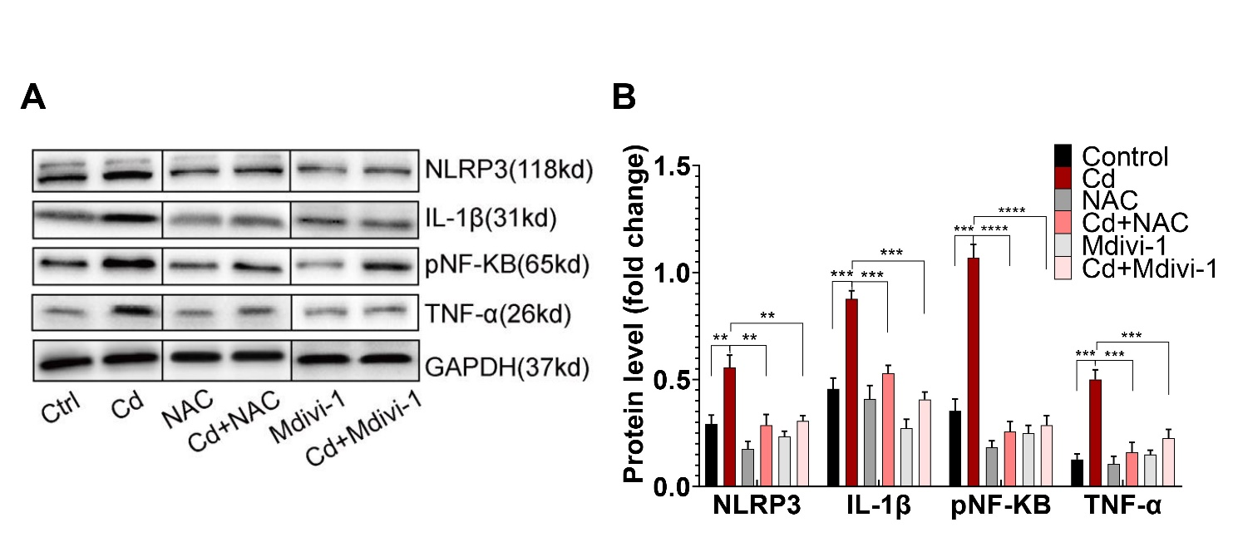
Supplementary Fig. S3. Improving mitochondrial homeostasis in the process of macrophage M1-type polarization in vitro. (A, B) The protein expression levels of NLRP3, IL-1β, pNF-KB and TNF-α in RAW264.7 cells. Data are shown as mean ± SD. *p < 0.05, **p < 0.01, ***p < 0.001, ****p < 0.0001.
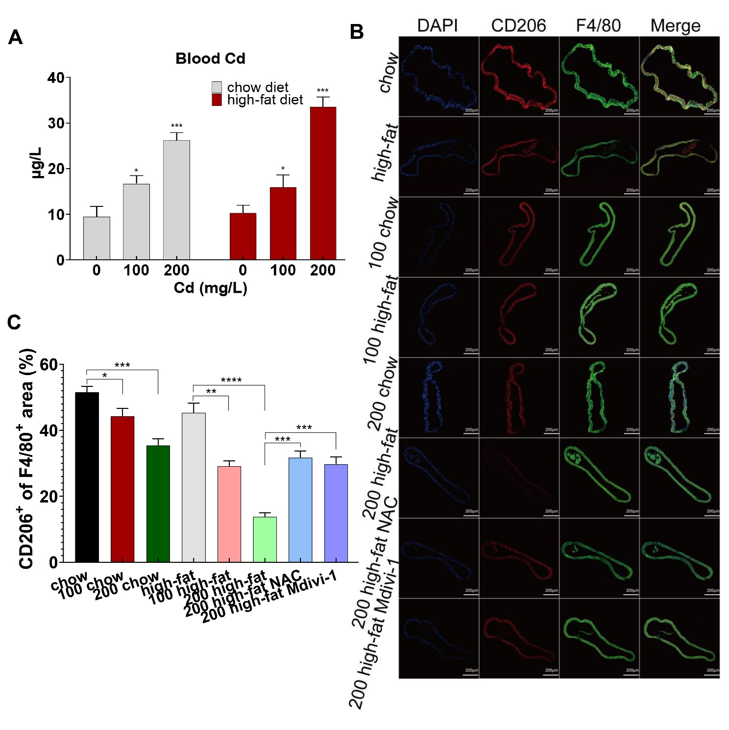
Supplementary Fig. S4. Mitochondrial homeostasis mediated inflammation of Cd-induced atherosclerosis in vivo. (A) The concentration of blood Cd in ApoE^{-/-} mice fed up with high-fat diet with Cd exposure. (B) Aortic arch of Cd‐, high-fat‐, NAC- and Mdivi-1-treated ApoE^{-/-} mice were probed with specific antibodies against the macrophage marker F4/80 and co‐probed with antibodies against the markers of M2 (CD206). (C) Quantification of CD206⁺ of F4/80⁺ area in aortic arch. Data are shown as mean ± SD. *p < 0.05, **p < 0.01, ***p < 0.001, ****p < 0.0001.
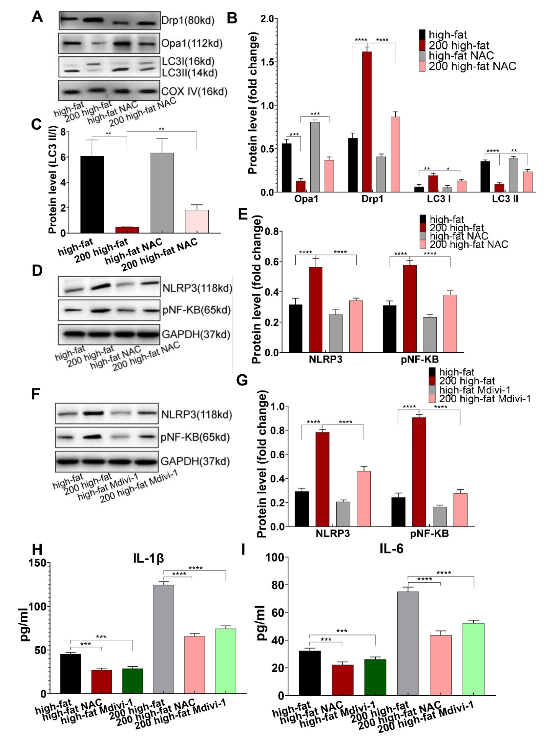
Supplementary Fig. S5. Mitochondrial homeostasis mediated inflammation of Cd-induced atherosclerosis in vivo. (A, B) The protein expression levels of Opa1, Drp1, LC3I and LC3II in mitochondria of mice aortic arch after treatment with Cd, high-fat, and NAC. COX-IV is the internal reference of the mitochondrial protein. (C) The ratio of LC3II and LC3I indicating the autophagy level. (D-G) The protein expression levels of NLRP3 and pNF-KB in mice aortic arch after treatment with Cd, high-fat, NAC and Mdivi-1. (H, I) The concentration of IL-1β and IL-6 in plasma. Data are shown as mean ± SD. *p < 0.05, **p < 0.01, ***p < 0.001, ****p < 0.0001.
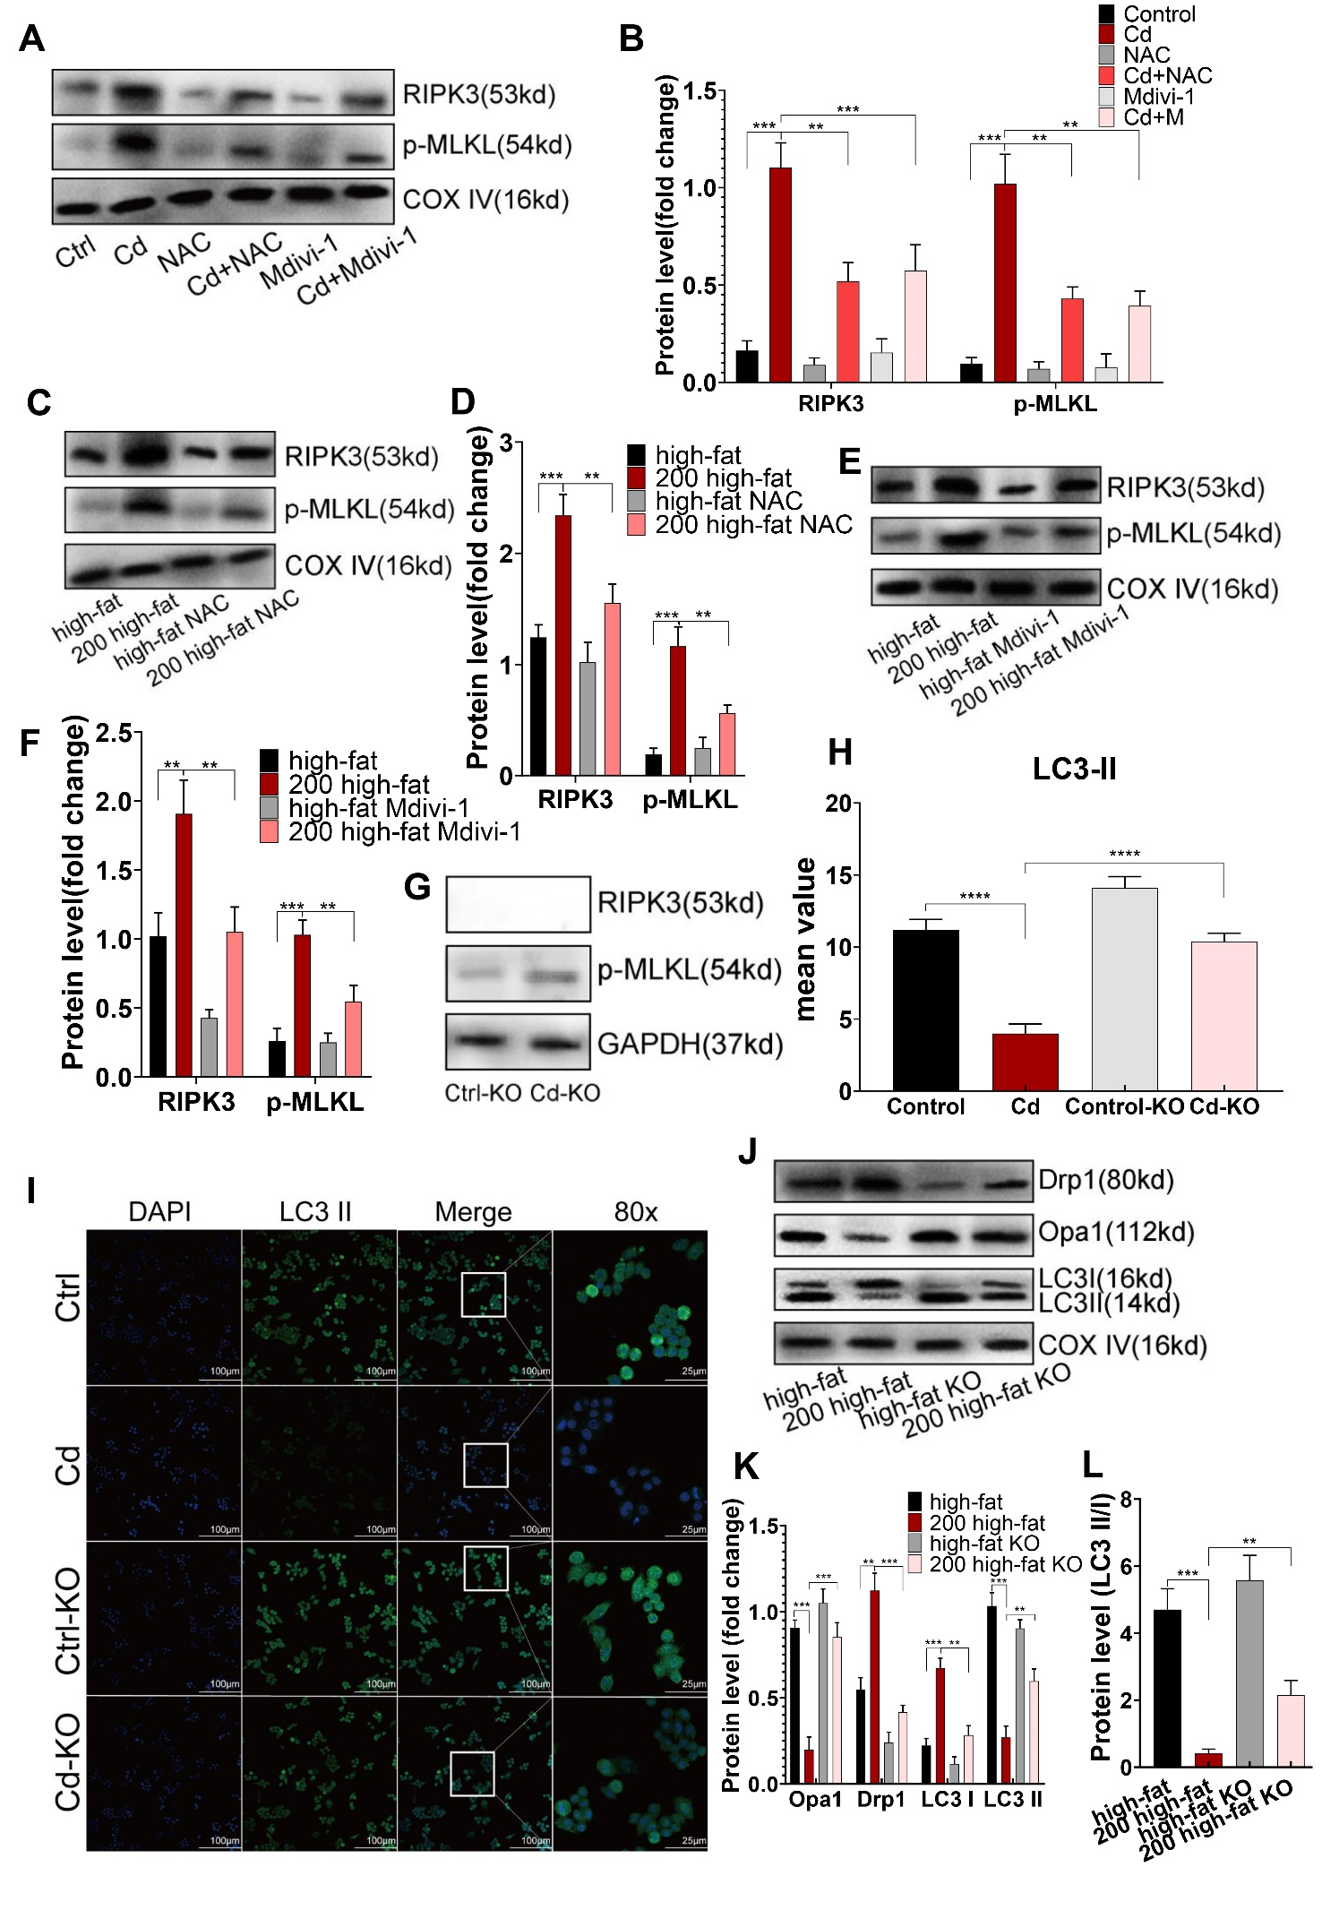
Supplementary Fig. S6. The RIPK3-p-MLKL pathway regulated mitochondrial homeostasis in atherosclerosis. (A, B) The protein expression levels of RIPK3 and p-MLKL in mitochondria of RAW264.7 after treatment with Cd, NAC and Mdivi-1. (C-F) The protein expression levels of RIPK3 and p-MLKL in mitochondria of mice aortic arch after treatment with Cd, high-fat, NAC and Mdivi-1. (G)The protein expression levels of RIPK3 and p-MLKL in RIPK3-/-mice to indicate the RIPK3 gene has been knocked out successfully. (H, I) Immunofluorescence images and fluorescence intensity of autophagosome marker, LC3II, in BMDMs from ApoE^{-/-} or RIPK3^{-/-}/ApoE^{-/-} mice. (J, K) The protein expression levels of Opa1, Drp1, LC3I and LC3II in mitochondria of ApoE^{-/-} or RIPK3^{-/-}/ApoE^{-/-} mice aortic arch after treatment with Cd. (L) The ratio of LC3II and LC3I indicating the autophagy level. Data are shown as mean ± SD. *p < 0.05, **p < 0.01, ***p < 0.001, ****p < 0.0001.
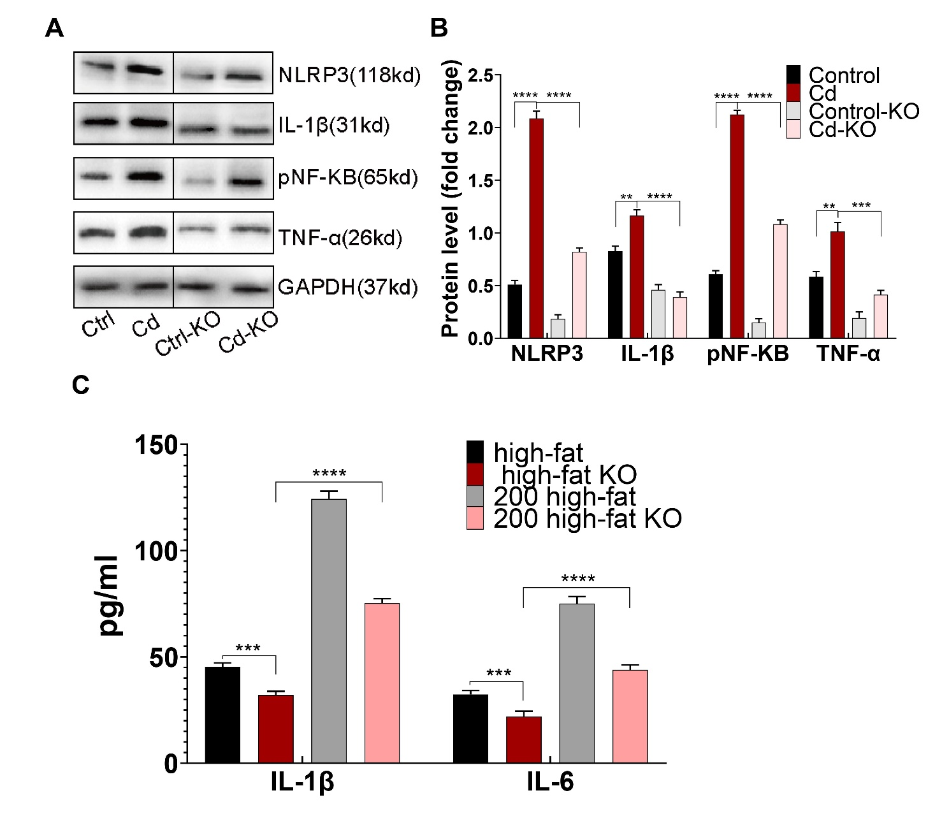
Supplementary Fig. S7. Deletion of RIPK3 inhibited polarity shift toward inflammatory macrophages and atherosclerosis. (A, B) The protein expression levels of NLRP3, IL-1β, pNF-KB and TNF-α in BMDMs from ApoE^{-/-} or RIPK3^{-/-}/ApoE^{-/-} mice after treatment with Cd. (C) The concentration of IL-1β and IL-6 in plasma of ApoE^{-/-} or RIPK3^{-/-}/ApoE^{-/-} mice. Data are shown as mean ± SD. *p < 0.05, **p < 0.01, ***p < 0.001, ****p < 0.0001.

