Supplementary materials

Tables main manuscript
Table 1
The relationship between perceived societal threat and perceived threat from ethnic minorities
 | Perceived minority threat
Predictors | Estimates | std. Error | CI | Statistic | p | df
(Intercept) | 3.72 | 0.18 | 3.37,4.07 | 21.05 | <0.00001 | 2111.00
Perceived societal threat | -0.17 | 0.02 | -0.21,-0.13 | -8.10 | <0.00001 | 2111.00
Buddhist | -0.19 | 0.08 | -0.35,-0.02 | -2.20 | 0.02794 | 2111.00
Education | -0.18 | 0.03 | -0.24,-0.11 | -5.35 | <0.00001 | 2111.00
Woman | -0.06 | 0.08 | -0.21,0.09 | -0.78 | 0.43796 | 2111.00
Age | 0.00 | 0.00 | -0.00,0.01 | 0.04 | 0.97072 | 2111.00
City | 0.04 | 0.07 | -0.10,0.17 | 0.57 | 0.57163 | 2111.00
Observations | 2118
R² / R² adjusted | 0.053 / 0.051

Table 2
The relationship between perceived societal threat and perceived threat from Muslims
 | Perceived Muslim threat
Predictors | Estimates | std. Error | CI | Statistic | p | df
(Intercept) | 3.35 | 0.17 | 3.01, 3.70 | 19.23 | <0.00001 | 2017.00
Perceived societal threat | -0.16 | 0.02 | -0.21, -0.12 | -7.90 | <0.00001 | 2017.00
Buddhist | 0.06 | 0.08 | -0.10, 0.23 | 0.73 | 0.46532 | 2017.00
Education | -0.09 | 0.03 | -0.16, -0.03 | -2.89 | 0.00386 | 2017.00
Woman | -0.18 | 0.08 | -0.33, -0.03 | -2.32 | 0.02021 | 2017.00
Age | 0.00 | 0.00 | -0.00, 0.01 | 0.20 | 0.84439 | 2017.00
City | -0.01 | 0.07 | -0.14, 0.13 | -0.10 | 0.92345 | 2017.00
Observations | 2024
R² / R² adjusted | 0.040 / 0.037

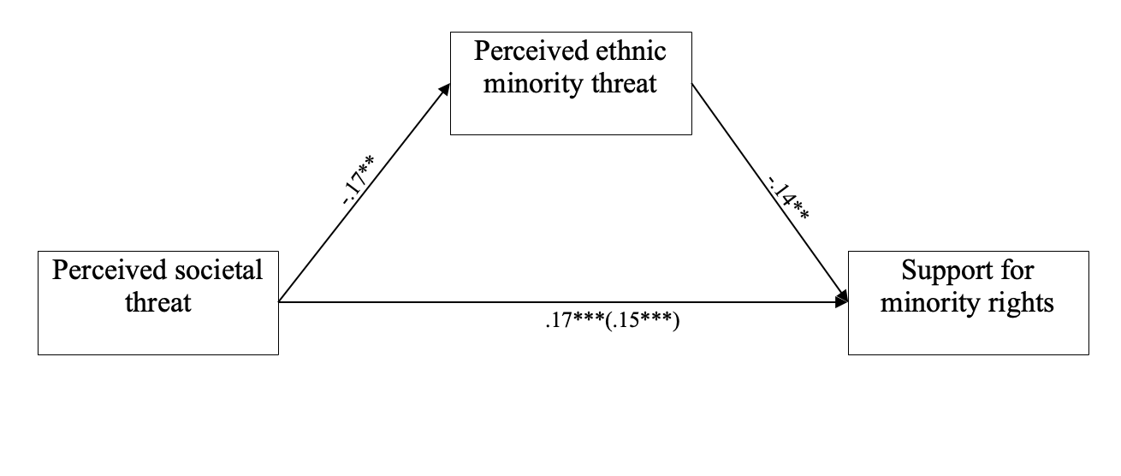
Figure 1. Mediation model of the relationship between societal threat and support for minority rights, mediated by perceived ethnic minority threat.

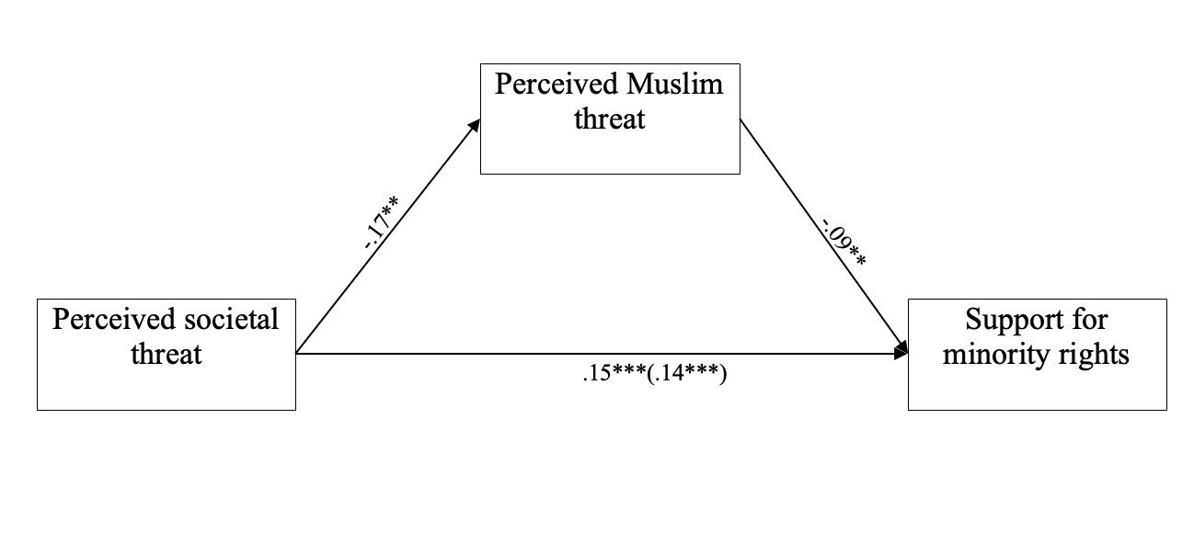
Figure 2. Mediation model of the relationship between societal threat and support for minority rights, mediated by perceived Muslim minority threat.

Multiple imputation
Given the large number of missing datapoints, we reanalyzed the main results using multiple imputation as research has shown this technique to be preferential in cases of large missingness (Newman, 2014b). Multiple imputation generates a series of datasets where in each dataset guesses are made for the values of missing datapoints based on the values of non-missing values of correlated variables (45). Aggregation of the results generated by each of the datasets allows for a more precise understanding of the influence of missingness on the results. Using this method, we started by employing two multiple linear regression models in which either perceived minority threat or perceived Muslim threat was predicted, wave 2 (wave 2 = 1, wave 1 or wave 3 =0) and wave 3 (wave 3 = 1, wave 1 or wave 2 = 0) were dummy coded and all the demographical variables were added as control variables (i.e., the fit.mult.impute function of the Hmisc package; (46). The same demographic variables were used as controls in the regression models. In all the models reported below, we used 13 iterations of the multiple imputation process, with a burn-in of three iterations, conforming to what is deemed desirable in the literature (47).
In the first model, both in wave 2 (b = -.42, SE = .02, t =-21.93, CI = [-.46 -.38], p < .001) and wave 3 (b =-.33 SE = .02, t =-14.56, CI = [-.37, -.29], p < .001) perceived ethnic minority threat (i.e., after the coup) was lower than in wave 1 (i.e., before the coup). In addition, the contrast between wave 2 and wave 3 was significant (b = .09, SE = .02, CI = [.05, .13], t = 4.46, p < .001), showing an increase from wave 2 to wave 3 in perceived ethnic minority threat. In the second model, perceived Muslim threat was lower in wave 2 than in wave 1 (b = -.21, SE = .02, t = -11.84, CI = [-.24 -.17], p < .001). However, perceived Muslim threat was not significantly higher or lower in wave 3 vs. wave 1 (b = .01, SE = .02, CI = [.03, .06], t = .72, p = .47). In addition, the increase in perceived threat from wave 2 to wave 3 was significant (b = .22, SE = .02, CI = [.19, 26], t = 12.05, p < .001). Given the previously found increase in perceived societal threat from wave 2 to wave 3 (see above), perceived societal threat follows the inverse temporal trend as perceived ethnic minority and Muslim threat. Thus, temporal increases of societal threat coincided with temporal decreases in perceived minority threat and vice versa.
Then, we went over to examine whether perceived ethnic minority threat and perceived Muslin threat would mediate the relationship between perceived societal threat and support for minority rights. The claim that lower perceived minority threat and perceived Muslim threat will mediate the relationship between perceived societal threat and support for minority rights, was tested on multiple imputed datasets from wave 2 and wave 3 constructing 2 structural equation models using the Lavaan R-package (48) like in the main analyses. A first model was constructed with perceived ethnic minority threat variable as the mediator variable. In addition, the control variables were introduced to the models, using the same coding as the other analyses. A second model used the same formulation, yet now perceived Muslim threat served as the mediator variable.
The results of the first model show that the total effect of perceived societal threat on support for minority rights (b = .13, SE = 0.01, t(13.04) = 4.40, p < .001) was partially mediated by perceived ethnic minority threat as both the direct (b = .12, SE = 0.01, t(15.35) = 8.00, p < .001) as well as the indirect (b = .02, SE = 0.005, t(13.04) = 4.40 p < .001) effect of perceived societal threat on support for minority rights were significant in the associated model. The results of the second model show that the total effect of perceived societal threat on support for minority rights (b = .16, SE = 0.01, t(15.48) = 11.85, p < .001) was partially mediated by perceived Muslim threat as both the direct (b = .15, SE = 0.02, t(14.60) = 9.56, p < .001) as well as the indirect (b = .01, SE = 0.003, t(13.97) = 4.16, p < .001) effect of perceived societal threat on support for minority rights were significant in the associated model. In sum, the analyses using multiple imputed datasets confirm the conclusions of the main analysis.

Reanalyzing without age 65+

Individuals that were older than 65 were all given the same value (i.e., 98), restricting the range of the variable. Therefore, we reanalyzed the data without observations of those who are older than 65. We first tested H1a and H2a, to examine whether perceived minority threat would be lower or higher directly after the coup relative to before the coup, as well as whether threat would change a year after the coup relative to right after the coup. We statistically compared perceived ethnic minority threat and perceived Muslim threat before (when the threat of military coup was low), right after the coup (when the threat of military coup was high) and a year after the coup (when we assumed citizens would habituate to the threat) in two separate models. Each model consisted of an ANCOVA in which perceived minority threat was predicted by wave and the demographic variables. Gender (0 = “man”, 1 = “woman”), city-resident (0 = “Living in a town or a village”, 1 = “living in a city”) and religion (0 = non-Buddhist, 1 = Buddhist) were dummy-coded before being entered to the regression.
In the first model, perceived ethnic minority threat differed significantly between time points (F(2, 4896) = 91.11, p < .001, $η_{p}^{2}$= .04). Tukey contrasts showed that both in wave 2 (w2-w1 = -.74, p < .001) and wave 3 (w3-w1 = -.47, p < .001) perceived minority threat (i.e., after the coup) was lower than in wave 1 (i.e., before the coup). Due to lack of measures of perceived societal threat in wave 1, we cannot test differences between wave 1 and the other waves in perceived societal threat. However, we did find statistical support that perceived societal threat decreased from wave 2 to wave 3 (w3- w2 = -.36, F(1, 3975) = 57.35, p < .001, $η_{p}^{2}$= .01), which coincided with an increase in perceived minority threat from wave 2 to wave 3 (w3-w2 = .26, p < .001). The model yielded support for H1b, that the onset of the military coup (being associated with perceived threat) coincided with lower perceived minority threat and that a decrease in perceived threat in the aftermath of the coup coincided with an increase in perceived minority threat (see Figure 1).

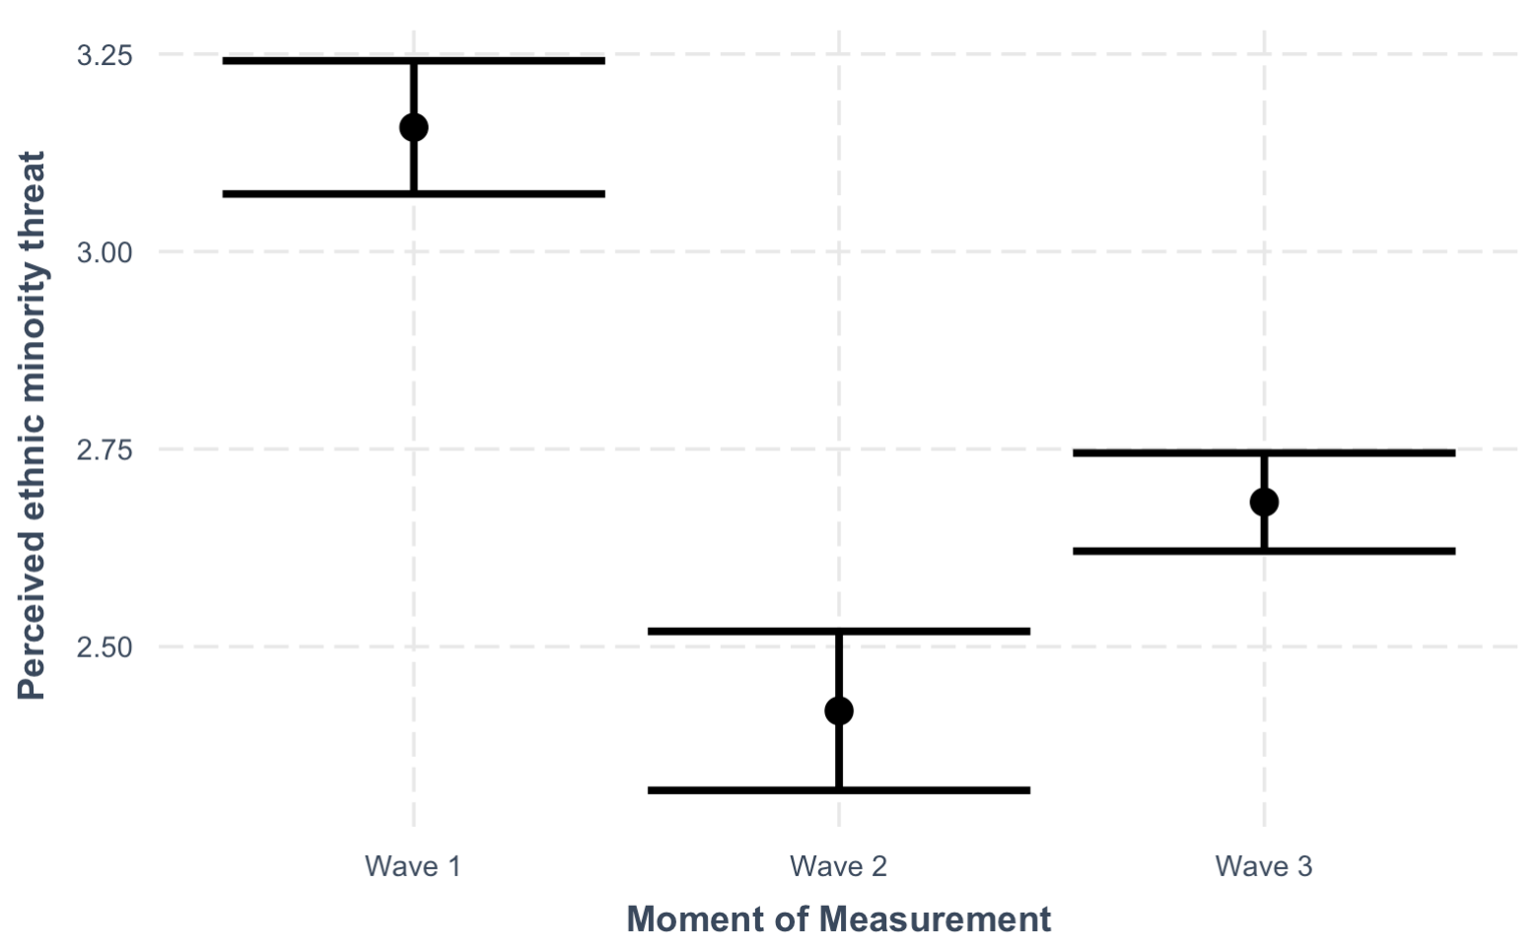
Figure 1. Interval plot showing the confidence intervals of perceived ethnic minority threat per wave (wave 1 = one year before the coup, wave 2 = one month after the coup and wave 3 = one year after the coup). The dots indicate the average perceived ethnic minority threat per wave.

In the second model, perceived Muslim threat differed significantly between time points (F(2, 4735) = 23.95, p < .001, $η_{p}^{2}$= .01). Tukey contrasts showed that in wave 2 (w2-w1 = -.36, p < .001), but not in wave 3 (w3-w1 = -.07, p = .34) perceived Muslim threat (i.e., after the coup) was lower than in wave 1 (i.e., before the coup). Indeed, the decreased reported perceived societal threat from wave 2 towards wave 3 (w3- w2 = -.36, F(1, 3975) = 57.35, p < .001, $η_{p}^{2}$= .01) coincided with an increase in perceived Muslim threat from wave 2 to wave 3 (w3-w2 = .28, p < .001), explaining the lack of significant difference between wave 1 and wave 2 on perceived Muslim threat. The model yielded support for H1b, that the onset of the military coup (being associated with perceived societal threat) coincided with lower perceived Muslim threat and that a decrease in perceived threat in the aftermath of the coup coincided with an increase in perceived Muslim threat (see Figure 2).

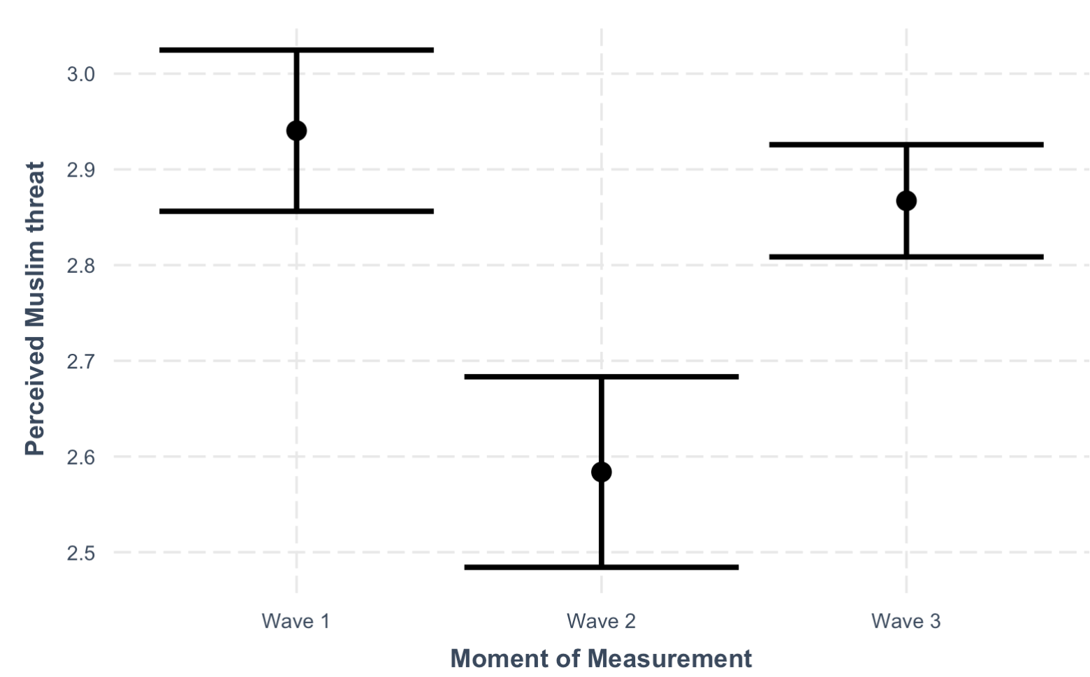
Figure 2. Interval plot showing the confidence intervals of perceived Muslim threat per wave (wave 1 = one year before the coup, wave 2 = one month after the coup and wave 3 = one year after the coup). The dots indicate the average perceived Muslim threat per wave.

After investigating the temporal relationships between perceived societal threat and perceived minority threat, we went over to examine hypotheses H2a/ H2b, i.e., whether perceived threat from minorities would mediate the positive/ negative relationship between perceived societal threat and support for minority rights. Since we have no datapoints for the independent variable or outcome variable in wave 1, these analyses only used data from wave 2 and wave 3. First, multiple linear regression models tested the relationship between societal threat and perceived ethnic minority and Muslim threat. The analysis showed that those who perceived more societal threat, perceived lower threat from ethnic minorities (b = -.16, SE = .02, CI[-.20, -.12], t = -7.62, p < .001) and Muslims (b = -.17, SE = .02, CI[-.21, -.13], t = -8.06, p < .001) threat and that those higher on perceived threat from ethnic minorities (b = -.17, SE = .02, CI[-.21, -.13], t = -8.17, p < .001) and those higher on perceived Muslim threat (b = -.13, SE = .02, CI[-.17, -.08], t = -5.73, p < .001) were less likely to support minority rights.
Finally, we tested two mediation models using structural equation modeling with the “Lavaan” package in R (48). The models were estimated separately as in the first two waves the perceived ethnic minority threat and perceived Muslim threat items were randomized between participants, therefore dramatically reducing power when including both into the same model. In the first model, besides including intergroup threat as the independent variable, perceived support for minority rights was taken up as the dependent variable and perceived ethnic minority threat and the control variables were introduced to the model, using the same coding as the other analyses. In the model, testing perceived minority threat as a mediator, the total effect of perceived societal threat on support for minority rights (b = .15, SE = 0.02, t = 7.45, p < .001) was partially mediated by perceived minority threat as both the direct (b = .13, SE = 0.02, t = 6.08, p < .001) as well as the indirect (b = .02, SE = 0.005, t = 4.61 = p < .001) effect of perceived societal threat on support for minority rights were significant. As a result, this analysis provided support for H2b, that perceived intergroup threat will relate positively with support for minority rights, and that lower perceived minority threat will mediate the relationship between perceived societal threat and support for minority rights.
The second mediation model was identical to the first model (see above), yet now with perceived Muslim threat as the mediator instead of perceived Muslim threat. In this model, the total effect of perceived societal threat on support for minority rights (b = .14, SE = 0.02, t = 6.12, p < .001) was partially mediated by perceived Muslim threat as both the direct (b = .12, SE = 0.02, t = 5.11, p < .001) as well as the indirect (b = .02, SE = 0.005, t = 3.63 = p < .001) effect of perceived societal threat on support for minority rights. As a result, this analysis provided additional support for H2b, that perceived societal threat will relate negatively with support for minority rights, and that lower perceived Muslim threat will mediate the relationship between perceived societal threat and support for minority rights.

Robustness analysis: narrow measure perceived general societal threat
Then, we reanalyzed the data while using linear regression while predicting a narrower measure of perceived societal threat. In this narrower conceptualization of perceived societal threat, we measured whether participants agreed (1 = agree, 0 = not agree) that “the rights and freedoms of the entire population” were threatened by the military coup.

Similar to the main analyses, perceived societal threat (narrow) decreased significantly from wave 2 to wave 3 (see Table 3).

Table 3
The relationship between wave and a narrowly defined measure of perceived societal threat
 | Perceived societal threat (narrow)
Predictors | Estimates | std. Error | CI | p | df
(Intercept) | 0.40 | 0.04 | 0.32 – 0.48 | <0.001 | 4065.00
Wave 3 | -0.04 | 0.01 | -0.07 – -0.01 | 0.006 | 4065.00
Woman | 0.06 | 0.02 | 0.02 – 0.09 | 0.001 | 4065.00
Age | -0.00 | 0.00 | -0.00 – 0.00 | 0.360 | 4065.00
Buddhist | 0.04 | 0.02 | 0.00 – 0.08 | 0.030 | 4065.00
Education | 0.05 | 0.01 | 0.04 – 0.07 | <0.001 | 4065.00
City | 0.03 | 0.02 | -0.00 – 0.06 | 0.078 | 4065.00
Observations | 4072
R² / R² adjusted | 0.023 / 0.021

As in the main analysis, perceived societal threat (narrow) relates negatively with perceived minority threat (see Table 4 below).
Table 4
The relationship between a narrowly defined measure of perceived societal threat and perceived minority threat
 | Perceived ethnic minority threat
Predictors | Estimates | std. Error | CI | p | df
(Intercept) | 3.72 | 0.18 | 3.38 – 4.07 | <0.001 | 2111.00
Perceived societal threat (narrow) | -0.64 | 0.07 | -0.78 – -0.50 | <0.001 | 2111.00
Education | -0.17 | 0.03 | -0.23 – -0.10 | <0.001 | 2111.00
Woman | -0.08 | 0.08 | -0.23 – 0.07 | 0.318 | 2111.00
Age | -0.00 | 0.00 | -0.01 – 0.00 | 0.938 | 2111.00
City | 0.04 | 0.07 | -0.10 – 0.17 | 0.591 | 2111.00
Buddhist | -0.17 | 0.08 | -0.33 – -0.00 | 0.049 | 2111.00
Observations | 2118
R² / R² adjusted | 0.060 / 0.057

As in the main analysis, perceived societal threat relates negatively with perceived Muslim threat (see Table 5 below).

Table 5
The relationship between a narrowly defined measure of perceived societal threat and perceived minority threat

 | Perceived Muslim threat
Predictors | Estimates | std. Error | CI | p | df
(Intercept) | 3.37 | 0.17 | 3.03 – 3.70 | <0.001 | 2017.00
Perceived societal threat | -0.65 | 0.07 | -0.78 – -0.51 | <0.001 | 2017.00
Education | -0.08 | 0.03 | -0.15 – -0.02 | 0.008 | 2017.00
Woman | -0.14 | 0.08 | -0.29 – 0.00 | 0.055 | 2017.00
Age | 0.00 | 0.00 | -0.00 – 0.00 | 0.996 | 2017.00
City | -0.02 | 0.07 | -0.15 – 0.11 | 0.775 | 2017.00
buddhist | 0.10 | 0.08 | -0.07 – 0.26 | 0.257 | 2017.00
Observations | 2024
R² / R² adjusted | 0.052 / 0.049

Then, we tested two mediation models testing ethnic minority threat and Muslim threat as 2 separate mediators of the relationship between the narrow definition of perceived societal threat and support for minority rights. In the first model, besides including intergroup threat as the independent variable, perceived support for minority rights was taken up as the dependent variable and perceived ethnic minority threat and the control variables were introduced to the model, using the same coding as the other analyses. In the model, testing perceived minority threat as a mediator, the total effect of perceived societal threat on support for minority rights (b = .44, SE = 0.07, t = 6.35, p < .001) was partially mediated by perceived minority threat as both the direct (b = .35, SE = 0.07, t = 4.83, p < .001) as well as the indirect (b = .09, SE = 0.02, t = 4.99 = p < .001) effect of perceived societal threat on support for minority rights. As a result, this analysis provided support for H2b, that perceived intergroup threat will relate positively with support for minority rights, and that lower perceived minority threat will mediate the relationship between perceived societal threat and support for minority rights.
The second mediation model was identical to the first model (see above), yet now with perceived Muslim threat as the mediator instead of perceived Muslim threat. In this model, the total effect of perceived societal threat on support for minority rights (b = .57, SE = 0.07, t = 8.00, p < .001) was partially mediated by perceived Muslim threat as both the direct (b = .52, SE = 0.08, t = 6.86, p < .001) as well as the indirect (b = .05, SE = 0.02, t = 3.31, p = .001) effect of perceived societal threat on support for minority rights. As a result, this analysis provided additional support for H2b, that perceived societal threat will relate negatively with support for minority rights, and that lower perceived Muslim threat will mediate the relationship between perceived societal threat and support for minority rights.

Realistic ethnic minority and Muslim threat
Then, we conducted analyses replacing our original measure of perceived ethnic minority and Muslim threat (which referred more to perceived symbolic threat) by measures of perceived realistic threat. This analysis only uses data from wave 3. Perceived realistic ethnic minority threat was as the agreement with the statement “Ethnic minorities pose a threat to the availability of resources to other groups in this country” on a 1 = strongly disagree to 5= strongly agree scale. Perceived realistic Muslim threat was as the agreement with the statement “Muslims pose a threat to the availability of resources to other groups in this country” on a 1 = strongly disagree to 5= strongly agree scale.

As in the main analysis, perceived societal threat relates negatively with perceived realistic ethnic minority threat (See Table 6 below).

Table 6
The relationship between perceived societal threat and perceived ethnic minority threat
 | Perceived realistic ethnic minority threat
Predictors | Estimates | std. Error | CI | Statistic | p | df
(Intercept) | 3.98 | 0.21 | 3.57,4.38 | 19.22 | <0.00001 | 1123.00
Perceived societal threat | -0.16 | 0.03 | -0.21,-0.11 | -6.00 | <0.00001 | 1123.00
Education | -0.24 | 0.04 | -0.32,-0.16 | -6.17 | <0.00001 | 1123.00
Woman | -0.09 | 0.09 | -0.26,0.09 | -0.96 | 0.33793 | 1123.00
Age | 0.00 | 0.00 | -0.00,0.01 | 0.51 | 0.61331 | 1123.00
Buddhist | -0.16 | 0.10 | -0.36,0.05 | -1.52 | 0.12923 | 1123.00
City | 0.14 | 0.08 | -0.02,0.30 | 1.75 | 0.08093 | 1123.00
Observations | 1130
R² / R² adjusted | 0.075 / 0.070

As in the main analysis, perceived societal threat relates negatively with perceived realistic Muslim threat (See below Table 7).
Table 7
The relationship between perceived societal threat and perceived realistic Muslim threat
 | Perceived realistic Muslim threat
Predictors | Estimates | std. Error | CI | Statistic | p | df
(Intercept) | 3.57 | 0.20 | 3.17, 3.97 | 17.60 | <0.00001 | 1102.00
Perceived societal threat | -0.17 | 0.03 | -0.22, -0.12 | -6.47 | <0.00001 | 1102.00
Education | -0.10 | 0.04 | -0.17, -0.03 | -2.65 | 0.00805 | 1102.00
Woman | -0.14 | 0.09 | -0.31, 0.04 | -1.51 | 0.13089 | 1102.00
Age | 0.00 | 0.00 | -0.00, 0.01 | 0.57 | 0.56855 | 1102.00
Buddhist | -0.05 | 0.10 | -0.25, 0.15 | -0.46 | 0.64236 | 1102.00
City | -0.07 | 0.08 | -0.23, 0.09 | -0.82 | 0.41040 | 1102.00
Observations | 1109
R² / R² adjusted | 0.050 / 0.045

As in the main analysis, perceived realistic ethnic minority threat relates negatively with support for minority rights (See below Table 8).

Table 8

The relationship between perceived realistic ethnic minority threat and support for minority rights

 | Support for minority rights
Predictors | Estimates | std. Error | CI | Statistic | p | df
(Intercept) | 4.00 | 0.21 | 3.59, 4.40 | 19.24 | <0.00001 | 1311.00
Perceived realistic ethnic minority threat | -0.18 | 0.03 | -0.23, -0.12 | -6.63 | <0.00001 | 1311.00
Education | 0.08 | 0.04 | 0.01, 0.15 | 2.34 | 0.01923 | 1311.00
Woman | 0.11 | 0.08 | -0.05, 0.27 | 1.32 | 0.18659 | 1311.00
Age | 0.00 | 0.00 | -0.00, 0.01 | 1.15 | 0.25038 | 1311.00
Buddhist | 0.04 | 0.09 | -0.14, 0.22 | 0.40 | 0.68694 | 1311.00
City | 0.15 | 0.07 | 0.00, 0.29 | 1.97 | 0.04857 | 1311.00
Observations | 1318
R² / R² adjusted | 0.048 / 0.044

As in the main analysis, perceived realistic Muslim threat relates negatively with support for minority rights (see Table 9 below).

Table 9
The relationship between perceived realistic ethnic minority threat and support for minority rights
 | Support for minority rights
Predictors | Estimates | std. Error | CI | Statistic | p | df
(Intercept) | 4.17 | 0.21 | 3.75, 4.58 | 19.74 | <0.00001 | 1266.00
Perceived realistic Muslim threat | -0.17 | 0.03 | -0.23, -0.12 | -6.13 | <0.00001 | 1266.00
Education | 0.08 | 0.04 | 0.01, 0.15 | 2.23 | 0.02604 | 1266.00
Woman | -0.01 | 0.09 | -0.18, 0.16 | -0.16 | 0.87480 | 1266.00
Age | -0.00 | 0.00 | -0.01, 0.00 | -0.12 | 0.90330 | 1266.00
Buddhist | 0.01 | 0.10 | -0.18, 0.20 | 0.10 | 0.92312 | 1266.00
City | 0.05 | 0.08 | -0.10, 0.21 | 0.69 | 0.48924 | 1266.00
Observations | 1273
R² / R² adjusted | 0.036 / 0.032

Then, two mediation models tested perceived realistic ethnic minority threat and perceived realistic Muslim threat as 2 separate mediators of the relationship between perceived societal threat and support for minority rights. In the first model, besides including intergroup threat as the independent variable, perceived support for minority rights was taken up as the dependent variable and perceived ethnic minority threat and the control variables were introduced to the model, using the same coding as the other analyses. In the model, testing realistic perceived ethnic minority threat as a mediator, the total effect of perceived societal threat on support for minority rights (b = .12, SE = 0.03, t = 4.52, p < .001) was partially mediated by realistic perceived ethnic minority threat as both the direct (b = .09, SE = 0.03, t = 3.34, p < .001) as well as the indirect (b = .03, SE = 0.006, t = 4.10, p = .001) effect of perceived societal threat on support for minority rights were significant. As a result, this analysis provided support for H2b, that perceived intergroup threat will relate positively with support for minority rights, and that lower perceived realistic minority threat will mediate the relationship between perceived societal threat and support for minority rights.
The second mediation model was identical to the first model (see above), yet now with perceived realistic Muslim threat as the mediator instead of perceived Muslim threat. In this model, the total effect of perceived societal threat on support for minority rights (b = .11, SE = 0.03, t = 4.22, p < .001) was partially mediated by with perceived realistic Muslim threat as both the direct (b = .09, SE = 0.03, t = 3.13, p = .002) as well as the indirect (b = .02, SE = 0.006, t = 3.80, p < .001) effect of perceived societal threat on support for minority rights. As a result, this analysis provided additional support for H2b, that perceived societal threat will relate negatively with support for minority rights, and that lower with perceived realistic Muslim threat will mediate the relationship between perceived societal threat and support for minority rights.

Bivariate correlations main variables
Table 10
Means, standard deviations, and correlations with confidence intervals across waves
Variable | M | SD | 1 | 2 | 3 | 4 | 5 | 6 | 7 | 8
2. Perceived societal threat | 1.99 | 1.52 | .19**
3. Perceived Muslim threat | 2.77 | 1.52 | -.12** | -.15**
4. Perceived ethnic minority threat | 2.74 | 1.65 | -.17** | -.19** | .54**
5. Age | 29.38 | 16.22 | -.02 | -.01 | .03** | .01
6. City | 0.42 | 0.49 | .04** | .05** | .02 | .02 | -.00
7. Education | 3.93 | 1.17 | .13** | .11** | -.08** | -.08** | -.13** | .09**
8. Woman | 0.25 | 0.43 | .03 | .05** | -.01 | -.01 | .03** | .02** | -.01
9. Buddhist | 0.75 | 0.43 | .03* | .02 | .00 | -.01 | -.06** | -.02* | .15** | -.04**
Note. M and SD are used to represent mean and standard deviation, respectively. Values in square brackets indicate the 95% confidence interval for each correlation. The confidence interval is a plausible range of population correlations that could have caused the sample correlation (Cumming, 2014). * indicates p < .05. ** indicates p < .01.

Test contrasts perceived minority threat with robust errors
A Bartlett test indicated that for perceived minority threat, the between time contrasts the homogeneity of variances assumption was violated (K-squared = 13.584, df = 2, p = 0.001), whereas this was not the case for perceived Muslim threat (K-squared = 5.4819, df = 2, p = 0.06451). Therefore, we reran the linear regression predicting differences between waves in perceived minority threat (while controlling for the demographics), now with robust standard errors.

Table 11
Predictors | Estimates | Std.  Error | CI | Statistic | p
(Intercept) | 3.61 | .11 | 3.39, 3.83 | 31.90 | <.001
Wave2 | -.72 | .07 | -.85, -.58 | -10.53 | <.001
Wave3 | -.44 | .05 | -.54, -.33 | -8.27 | <.001
Woman | -.11 | .05 | -.21, -.01 | -2.20 | .03
Age | .00 | .00 | .00,.01 | 1.28 | .20
Buddhist | -.07 | .06 | -.18, .04 | -1.32 | .19
Education | -.12 | .02 | -.17, -.08 | -5.37 | <.001
City | .10 | .05 | .01, .19 | 2.19 | .03

Survey items per wave

Wave 1

# | English
0 | What is your age and gender?
 | Male
 | Female
1 | What is the highest level of education you have completed?
 | No schooling, monastic schooling, incomplete primary school
 | Primary school
 | Middle school
 | High school or higher
2 | In what administrative region do you reside?
 | Ayeyarwady Region
 | Bago Region
 | Chin State
 | Kachin State
 | Kayah State
 | Kayin State
 | Magway Region
 | Mandalay Region
 | Mon State
 | Rakhine State
 | Shan State
 | Sagaing Region
 | Tanintharyi Region
 | Yangon Region
 | Naypyidaw Union Territory
 | Danu Self-administered Zone
 | Kokang Self-administered Zone
 | Naga Self-administered Zone
 | Pa’O Self-administered Zone
 | Pa Laung Self-administered Zone
 | Wa Self-administered Division
3 | What is your religion, if you have one?
 | Buddhist
 | Muslim
 | Hindu
 | Christian
 | Other
 | None
4 | To what ethnic group do you belong?
 | Bamar
 | Shan
 | Karen
 | Rakhine
 | Han-Chinese
 | Mon
 | Kachin
 | Indian
 | Chin
 | Kayah
 | “Rohingya”/ Bengali Muslim
 | Other
5 | In the past week, which of the following outlets did you listen to, watch, or read for political news. Please check all that apply.
 | 7Day News Journal
 | Eleven Media
 | BBC Burmese
 | MRTV
 | Myanmar Now
 | The Irrawaddy
 | The Myanmar Times
 | DVB News
 | VOA Burmese News
 | New Light of Myanmar
 | The Mirror
 | Thuriya Naywin
 | Another outlet
 | None
 | No more, continue
6 | In the past week, how often did you read political news from the internet? <br>This includes Facebook, and any other websites you accessed.
 | Never
 | Once
 | A few times
 | Almost every day
 | Daily
 | Several times a day
7 | In the past week, how often did you read political news from <b>Facebook specifically</b>?
 | Never
 | Once
 | A few times
 | Almost every day
 | Daily
 | Several times a day
8a | To what degree do you trust the information you read about politics from Facebook?
8b | To what degree do you trust the information you read about Muslims from Facebook?
 | Trust a lot
 | Trust somewhat
 | Neither trust, nor distrust
 | Distrust somewhat
 | Distrust a lot
9 | How much trust do you have in the mass media (newspapers, TV, radio) to report the news fully, accurately, and fairly?
 | A great deal
 | A fair amount
 | Not very much
 | None at all
Module 4 | Political discussions
10 | In the past week, how often did you share your political views in face-to-face conversations with others, such as with family or friends, or at tea shops?
 | Never
 | Once
 | A few times
 | Almost every day
 | Daily
11 | In the past week, how often did you share your political views online?
 | Never
 | Once
 | A few times
 | Almost every day
 | Daily
12 | How often do you search out other evidence to support a news story?
 | Never
 | Sometimes
 | Often
 | Always
13 | What best describes the area you live?
 | City
 | Town
 | Village
 | Rural place
14 | Imagine you have a daughter traveling to a neighbouring town to attend high school. She was asked to show an identity card (which she did not have). She got arrested by the police. <br> How would you feel as a parent?
 | Continue
15 | Do you agree or disagree?
15a | Ethnic minorities are a threat to Myanmar culture and traditions.
15b | Muslims are a threat to Myanmar culture and traditions.
16a | Ethnic minorities contribute significantly to Myanmar society
16b | Muslims contribute significantly to society
17a | The government needs to do more to protect the rights of ethnic minorities
17b | The government needs to do more to protect the rights of Muslims
 | Strongly agree
 | Somewhat agree
 | Neither agree nor disagree
 | Somewhat disagree
 | Strongly disagree
Module 6
 | ETHNIC GROUP / RELIGION PLURAL
 | Bamar
 | Karen
 | Rakhine
 | Kachin
 | Shan
 | Chin
 | Indian-Hindus
 | Buddhists
 | Muslims
 | Christians
 | Bengali-Muslims
 | Bamar-Buddhists
 | Bamar-Muslims
 | Bamar-Christians
 | Karen-Buddhists
 | Karen-Christians
 | Rakhine-Buddhists
 | Rakhine-Muslims
 | Kachin-Christians
 | Kachin-Buddhists
 | Shan-Buddhists
 | Shan-Christians
 | Chin-Buddhists
 | Chin-Christians
 | Kayah
 | ETHNIC GROUP / RELIGION SINGULAR
 | Bamar
 | Karen
 | Rakhine
 | Kachin
 | Shan
 | Chin
 | Indian-Hindu
 | Buddhist
 | Muslim
 | Christian
 | Bengali-Muslim
 | Bamar-Buddhist
 | Bamar-Muslim
 | Bamar-Christian
 | Karen-Buddhist
 | Karen-Christian
 | Rakhine-Buddhist
 | Rakhine-Muslim
 | Kachin-Christian
 | Kachin-Buddhist
 | Shan-Buddhist
 | Shan-Christian
 | Chin-Buddhist
 | Chin-Christian
 | Kayah
 | AGE
 | 33 years old
 | 55 years old
 | INCOME
 | 1600 Kyat per day.
 | 22,000 Kyat per day.
 | YEARS IN MM
 | 1 year.
 | 10 years.
 | his entire life.
18 | Over the past year there have been many controversial protests held against the government across the country by different groups of Myanmar citizens.<br>Imagine that a group of
 | [insert ethnic group PLURAL]
 | engaged in a non-violent protest in the streets, and the government sought to shut down the protest using the police. <br> How supportive would you be of the government's decision?
 | Very supportive
 | Somewhat supportive
 | Not very supportive
 | Not at all supportive
 | INSTRUCTIONS FOR LIGUIST
Example: | Imagine that a group of [insert ethnic group] engaged in a nonviolent protest in the streets, and the government sought to shut down the protest using the police.
Example of full statement | Imagine that a group of Muslims engaged in a nonviolent protest in the streets, and the government sought to shut down the protest using the police.
19 | Over the past year there has been considerable controversy about the granting of Myanmar citizenship to any person outside the 135 recognized groups.<br> Suppose a person has been living in Myanmar for
 | [insert number of years in mm]
 | He is a
 | [Insert ethnicity and religion SINGULAR]
 | who is
 | [Insert age]
 | and earns
 | [Insert income]
 | <br>How supportive would you be of this man having Myanmar citizenship?
 | Very supportive
 | Somewhat supportive
 | Not very supportive
 | Not at all supportive
20 | Sometimes people move within Myanmar in search of economic opportunities. This may have important effects on local communities. <br>Suppose a person moves into your neighbourhood.
 | He is a
 | [Insert ethnicity and religion SINGULAR]
 | who is
 | [Insert age]
 | and earns
 | [Insert income]
 | <br>How comfortable would you be with this person as your neighbour?"
 | Very comfortable
 | Somewhat comfortable
 | Not very comfortable
 | Not at all comfortable
 | Complete
Module 7
21 | How do you feel about the following groups? Use any number from 0 to 100. Zero means you really dislike the group, and 100 means you really like them.
21 | How do you feel about the following groups? Use any number from 0 to 10. Zero means you really dislike the group, and 10 means you really like them.
a | Bamar
b | Shan
c | Karen
d | Rakhine
e | Kachin
f | Chin
g | Rohingya
h | Bengali Muslim
i | Buddhists
j | Indians/Hindus
k | Myanmar Muslims
l | Muslims in Rakhine State
m | Christians
 | Kayah

Wave 2

Demo Module
# |  | Question/Answers
0,5 |  | In what administrative region do you reside?
 |  | Ayeyarwady Region
 |  | Bago Region
 |  | Chin State
 |  | Kachin State
 |  | Kayah State
 |  | Kayin State
 |  | Magway Region
 |  | Mandalay Region
 |  | Mon State
 |  | Rakhine State
 |  | Shan State
 |  | Sagaing Region
 |  | Tanintharyi Region
 |  | Yangon Region
 |  | Naypyidaw Union Territory
 |  | Danu Self-administered Zone
 |  | Kokang Self-administered Zone
 |  | Naga Self-administered Zone
 |  | Pa’O Self-administered Zone
 |  | Pa Laung Self-administered Zone
 |  | Wa Self-administered Division
1 |  | What is the highest level of education you have completed?
 |  | No schooling/Incomplete primary school
 |  | Monastic schooling
 |  | Primary/Middle school
 |  | High School
 |  | University/Graduate school
2 |  | To what religious group do you belong?
 |  | Buddhist
 |  | Muslim
 |  | Hindu
 |  | Christian
 |  | Other
 |  | I don't identify with a particular religion
Key Questions Module
# | Question/Answers
3 | In the past weeks, did you personally experience any of the following events? Select all that apply
 | Witnessed military or police crackdowns
 | Family or friends that were arrested
 | Police/military violence against civilians
 | Family or friends that went into hiding
 | Internet shutdowns or the unavailability of social media accounts
 | A curfew and restrictions on gatherings
 | None of the above
 | No more, continue
4 | Recently, in reaction to the military actions, people have been protesting through participation in a range of actions. <br><b>Which of these would you be willing to or have you participated in?</b> Select all that apply.
 | Participating in a peaceful protest to restore our democraticaly elected government
 | Participating in a violent protest to restore our democraticaly elected government
 | Sharing the 3-finger symbol of the Civil disobedience movement in public or online
 | Participating in the nightly din of pots and pans
 | Showing my support for the civil disobedience movement online
 | Coordinating civil disobedience activities with others online
 | None of the above
 | No more, continue
5a | Do you agree or disagree?
 | Ethnic minorities are a threat to Myanmar culture and traditions.
 | Muslims are a threat to Myanmar culture and traditions.
 | Strongly agree
 | Somewhat agree
 | Neither agree nor disagree
 | Somewhat disagree
 | Strongly disagree
6a | Do you agree or disagree?
 | Ethnic minorities contribute significantly to Myanmar society
 | Muslims contribute significantly to society
 | Strongly agree
 | Somewhat agree
 | Neither agree nor disagree
 | Somewhat disagree
 | Strongly disagree
Content Questions Module
# |  | Question/Answers
7 |  | How <b>hopeful</b> were you when you heard the news of the state of emergency the military enacted on Feb 1?
 |  | 1 - not at all
 |  | 2
 |  | 3
 |  | 4
 |  | 5 - to a very large extent
8 |  | How <b>afraid</b> were you when you heard the news of the state of emergency the military enacted on Feb 1?
 |  | 1 - not at all
 |  | 2
 |  | 3
 |  | 4
 |  | 5 - to a very large extent
9 |  | How <b>hopeful</b> were you when witnessing people's participation in the civil disobedience movement?
 |  | 1 - not at all
 |  | 2
 |  | 3
 |  | 4
 |  | 5 - to a very large extent
10 |  | How <b>afraid</b> were you when witnessing people's participation in the civil disobedience movement?
 |  | 1 - not at all
 |  | 2
 |  | 3
 |  | 4
 |  | 5 - to a very large extent
11 |  | Which of the below do you personally feel are threatened by the military takeover? Select all the apply.
 |  | The rights and freedoms of the entire Burmese population
 |  | The rights and freedoms of minorities in Burma
 |  | Your personal security and safety
 |  | The security and safety of your community
 |  | Your personal financial safety
 |  | No more, continue
### |  | To what degree do you trust the information you read about politics and recent events from the below?
 |  | Local independent media
 |  | Foreign western news sources
 |  | Facebook
 |  | Twitter
 |  | State owned media
 |  | 1 - do not trust at all
 |  | 2
 |  | 3
 |  | 4
 |  | 5 - extremely high trust
15 |  | Which of these statements do you agree <b>most</b> with? Select all that apply
 |  | I feel furious at the military for taking over control
 |  | I think that together, the people of Myanmar can protect Myanmar's democracy
 |  | I feel a moral obligation to take part in the Civil disobedience movement
 |  | I believe that my participation in the Civil disobedience movement may lead others to participate as well
 |  | Participating in protests for democracy poses significant risks to myself and my loved ones
 |  | I can’t afford to participate in the civil disobedience movement for fear of losing my income
 |  | I can identify with other people in Myanmar as we support the same cause
 |  | None of the above
16 |  | To what degree would you be willing to risk negative consequences to yourself and to the safety of your loved ones, as a result of your civil disobedience activities? (e.g., get arrested, go to jail)
 |  | 1 - not at all
 |  | 2
 |  | 3
 |  | 4
 |  | 5 - to a very large extent
17 |  | Over the past year there have been many controversial protests held against the government across the country by different groups of Myanmar people. Imagine that a group of Christians engaged in a non-violent protest in the streets, and the government sought to shut down the protest using the police. <br>How supportive would you be of the government's decision?
 |  | Over the past year there have been many controversial protests held against the government across the country by different groups of Myanmar people. Imagine that a group of Rohingya engaged in a non-violent protest in the streets, and the government sought to shut down the protest using the police. <br>How supportive would you be of the government's decision?
 |  | Over the past year there have been many controversial protests held against the government across the country by different groups of Myanmar people. Imagine that a group of Muslims engaged in a non-violent protest in the streets, and the government sought to shut down the protest using the police. <br>How supportive would you be of the government's decision?
 |  | 1 - not at all supportive
 |  | 2
 |  | 3
 |  | 4
 |  | 5 - very supportive
18-20 |  | To what degree do you value the below?
 |  | The right to demonstrate/protest
 |  | The right of the people to elect their government representatives
 |  | The right to protection for all minorities
 |  | Freedom of expression
 |  | Freedom to access information (e.g., online)
 |  | Online data privacy
 |  | 1 - not at all
 |  | 2
 |  | 3
 |  | 4
 |  | 5 - to a very large degree
Content Questions Module
# |  | Question/Answers
21-22 |  | To what extent do you believe that other people in Myanmar oppose the recent military government takeover?
 |  | To what extent do you believe that other people in Myanmar support the democratic process in Myanmar?
 |  | To what extent do you believe that other people in Myanmar value tolerance towards minority groups in Myanmar?
 |  | 1 - not at all
 |  | 2
 |  | 3
 |  | 4
 |  | 5 - to a very large extent
23 |  | Which of these do you agree with <b>MOST</b>?
 |  | Democracy is always preferable to any other kind of government
 |  | Under some circumstances, an authoritarian government can be preferable to a democratic one.
 |  | For people like me, it does not matter whether we have a democratic or a nondemocratic regime
24 |  | What best describes the area you live?
 |  | City
 |  | Town
 |  | Village
25 |  | Which of these countries has a greater degree of influence in Myanmar?
 |  | China
 |  | US
26 |  | Which of these countries is a better model for Myanmar's future development?
 |  | China
 |  | US
 |  | Japan

Wave 3

No. | Skip Logic | Question
1 |  | To what religious and ethnic groups do you belong (select all that apply)
 |  | Buddhist
 |  | Muslim
 |  | Hindu
 |  | Christian
 |  | Other
 |  | Bamar
 |  | Non-Bamar
 |  | I don't identify with a particular religion
 |  | I don't identify with a particular ethnic group
2 |  | What gender do you identify with the most?
 |  | Male
 |  | Female
 |  | Non-binary
 |  | Other
 |  | I prefer not to disclose
3 |  | Recently, in reaction to the military actions, people have been protesting through participation in a range of actions. Which of these would you be willing to or have you participated in?  Select all that apply.
 |  | Participating in a peaceful protest to restore our democratically elected government
 |  | Participating in armed resistance to restore our democraticaly elected government
 |  | Showing my support for the civil disobedience movement online
 |  | Planning civil disobedience activities with others online
 |  | Not involved with any of these activities
 |  | No more, continue
 |  | I do not agree with the protests against the military
4 |  | How much do you agree or disagree with the following statements?
4a | matrix | Ethnic minorities are a threat to Myanmar culture and traditions
 |  | Strongly agree
 |  | Somewhat agree
 |  | Neither agree nor disagree
 |  | Somewhat disagree
 |  | Strongly disagree
4b | matrix | Ethnic minorities pose a threat to the economic and technological progress of Burma as a country
 |  | Strongly agree
 |  | Somewhat agree
 |  | Neither agree nor disagree
 |  | Somewhat disagree
 |  | Strongly disagree
4c | matrix | Ethnic minorities pose a threat to the availability of resources to other groups in this country
 |  | Strongly agree
 |  | Somewhat agree
 |  | Neither agree nor disagree
 |  | Somewhat disagree
 |  | Strongly disagree
4d | matrix | Ethnic minorities contribute significantly to Myanmar society
 |  | Strongly agree
 |  | Somewhat agree
 |  | Neither agree nor disagree
 |  | Somewhat disagree
 |  | Strongly disagree
5 |  | How much do you agree or disagree with the following statements?
5a | matrix | Muslims are a threat to Myanmar culture and traditions
 |  | Strongly agree
 |  | Somewhat agree
 |  | Neither agree nor disagree
 |  | Somewhat disagree
 |  | Strongly disagree
5b | matrix | Muslims pose a threat to the economic and technological progress of Burma as a country
 |  | Strongly agree
 |  | Somewhat agree
 |  | Neither agree nor disagree
 |  | Somewhat disagree
 |  | Strongly disagree
5c | matrix | Muslims in Burma pose a threat to the availability of resources to other groups in this country
 |  | Strongly agree
 |  | Somewhat agree
 |  | Neither agree nor disagree
 |  | Somewhat disagree
 |  | Strongly disagree
5d | matrix | Muslims contribute significantly to Myanmar society
 |  | Strongly agree
 |  | Somewhat agree
 |  | Neither agree nor disagree
 |  | Somewhat disagree
 |  | Strongly disagree
6 |  | How hopeful do you feel about the ability of the current military rule to bring out positive change for Burmese citizens?
7 |  | How afraid are you about potential negative consequences of the current military rule for Burmese citizens?
8 |  | To which extent do you feel hopeful with regard to EAO's collaboration with the National Unity Government?
9 |  | To which extent do you feel afraid with regard to Ethnic Armed Organizations collaborating with the National Unity government?
 |  | 1 - not at all
 |  | 2
 |  | 3
 |  | 4
 |  | 5 - to a very large extent
10 |  | To which extent do you value the below?
10a | matrix | The right to protection for all minorities
10b | matrix | The right of minorities to receive equal treatment and not to be discriminated against
10c | matrix | The right of minorities to participate effectively in cultural, religious, social, economic and political life
 |  | 1 - not at all
 |  | 2
 |  | 3
 |  | 4
 |  | 5 - to a very large extent
11 |  | Which of the below do you personally feel are threatened by the military takeover? Select all the apply.
 |  | The rights and freedoms of the entire Myanmar population
 |  | The rights and freedoms of minorities in Myanmar
 |  | Your personal security and safety
 |  | The security and safety of your community
 |  | Economic growth of Myanmar
 |  | No more, continue
 | Multi select | In response to the recent events in the country, several domestic topics have come up in public discourse, that perhaps were not publicly or openly discussed in the past. Which of the following topics do you feel are the ones that are important for public discussion in the current environment and will have the greatest impact on Myanmr's future? (select in order of importance)
 |  | Gender issues
 |  | Peace process
 |  | Minority rights
 |  | LGBT rights
 |  | The generation gap
 |  | The rights of labour workers
 |  | Federalism
12 | multi select | Over the last few weeks, which sources did you consult most often for information? Select all that apply.
12a |  | NUG - media, official sites, and Facebook pages
12b |  | Independant Burmese media
12c |  | International media outlets
12d |  | Information shared by Facebook friends
12e |  | Military-run media
 |  | Never
 |  | Rarely
 |  | Weekly
 |  | Daily
 |  | Several times a day
13 | matrix | To which extent do you agree with the following items?
13a |  | I feel furious at the military for taking over control
13b |  | Citizens of Burma in general feel furious at the military for taking over control
13c |  | I feel desperate because of the ongoing military control over Burma
13d |  | Citizens of Burma in general feel desperate because of the ongoing military control over Burma
13e |  | Citizens of Burma in general feel fear regarding potential negative consequences of the current military rule for Burmese citizens.
14 |  | I feel mentally exhausted as a result of the current political situation
 |  | Strongly agree
 |  | Somewhat agree
 |  | Neither agree nor disagree
 |  | Somewhat disagree
 |  | Strongly disagree
15 |  | Being Burmese is an important part of who I am
 |  | Strongly agree
 |  | Somewhat agree
 |  | Neither agree nor disagree
 |  | Somewhat disagree
 |  | Strongly disagree
16 |  | Being part of my religious group is an important part of who I am
 |  | Strongly agree
 |  | Somewhat agree
 |  | Neither agree nor disagree
 |  | Somewhat disagree
 |  | Strongly disagree
17 |  | Being part of my ethnic group is an important part of whoI am
 |  | Strongly agree
 |  | Somewhat agree
 |  | Neither agree nor disagree
 |  | Somewhat disagree
 |  | Strongly disagree
18 |  | To which extent do you value the below?
18a | matrix | The right to protection for all minorities
18b | matrix | The right of minorities to participate effectively in cultural, religious, social, economic  and political life
 |  | 1 - not at all
 |  | 2
 |  | 3
 |  | 4
 |  | 5 - to a very large degree
19 |  | To what extent do you believe that other people in Myanmar oppose the military government takeover?
20 |  | To what extent do you believe that other people in Myanmar support the democratic process in Myanmar?
21 |  | To what extent do you believe that other people in Myanmar value tolerance towards minority groups in Myanmar?
 |  | 1 - not at all
 |  | 2
 |  | 3
 |  | 4
 |  | 5 - to a very large extent
22 |  | Which of these do you agree with <b>MOST</b>?
 |  | Democracy is always preferable to any other kind of government
 |  | Under some circumstances, an authoritarian government can be preferable to a democratic one.
 |  | For people like me, it does not matter whether we have a democratic or a nondemocratic regime
23 |  | What best describes the area you live?
 |  | City
 |  | Town
 |  | Village
24 |  | What is the highest level of education you have completed?
 |  | No schooling/Incomplete primary school
 |  | Monastic schooling
 |  | Primary/Middle school
 |  | High School
 |  | University/Graduate school
F
To what degree do you agree with the following statetements?
I think the majority of people in Myanmar would be content to have the previous government restored
I think the majority of people in Myammar now have greater demands of a future government than during the 2020 elections
In response to the recent events in the country, several domestic topics have come up in public discourse, that perhaps were not publicly or openly discussed in the past. Which of the following topics do you feel are the ones that are important for public discussion in the current environment and will have the greatest impact on Myanmr's future? (select in order of importance)
Gender issues
Peace process
Minority rights
LGBT rights
The generation gap
The rights of labour workers
Federalism

