Supporting Information
Multispectral camouflage for infrared, visible, laser and microwave with radiative cooling
Huanzheng Zhu¹, Qiang Li^{1, a)}, Chenning Tao¹, Yu Hong¹, Ziquan Xu¹, Weidong Shen¹, Sandeep Kaur¹, Pintu Ghosh¹ and Min Qiu^{2, 3, b)}
¹State Key Laboratory of Modern Optical Instrumentation, College of Optical Science and Engineering, Zhejiang University, Hangzhou 310027, China.
²Key Laboratory of 3D Micro/Nano Fabrication and Characterization of Zhejiang Province, School of Engineering, Westlake University, 18 Shilongshan Road, Hangzhou 310024, China.
³Institute of Advanced Technology, Westlake Institute for Advanced Study, 18 Shilongshan Road, Hangzhou 310024, China.
a) E-mail: qiangli@zju.edu.cn
b) E-mail: qiumin@westlake.edu.cn
Section S1. Band emittance
The band emittance of the selective emitter is calculated with the following formula:
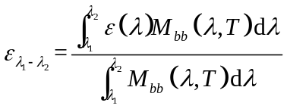

Section S2. Design of ZnS/Ge multilayer film selective emitter (SE)
The thickness of ZnS/Ge multilayer SE is determined by a genetic algorithm, with the following optimization targets - maximum absorbance in the non-atmospheric window, maximum absorbance at 10.6 μm and 1.55 μm, and minimum absorbance in both atmospheric windows.
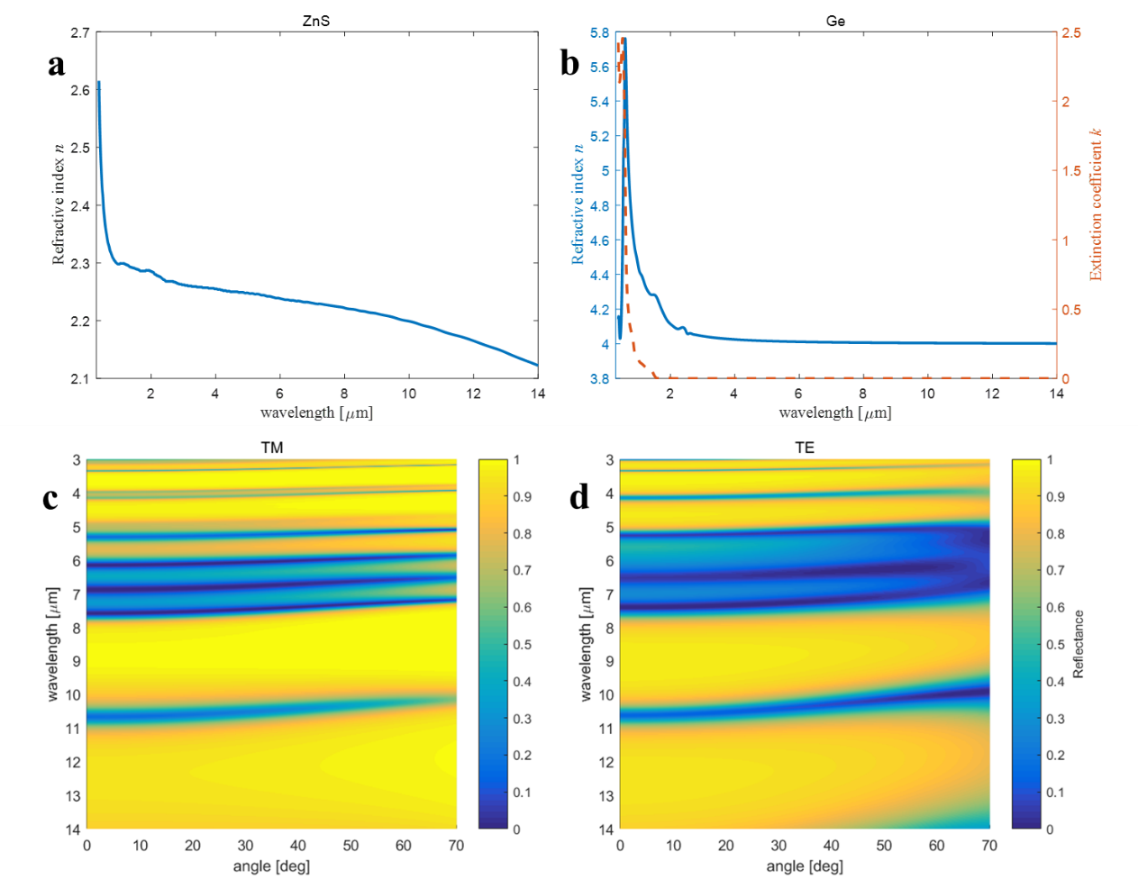
Fig. S1. (a) and (b) Refractive index n and extinction coefficient k for ZnS and Ge. (c) and (d) Simulated angle-dependent reflectance of the SE for both polarizations.

Section S3. Reflectance spectrum variation with different t_{ZnS}
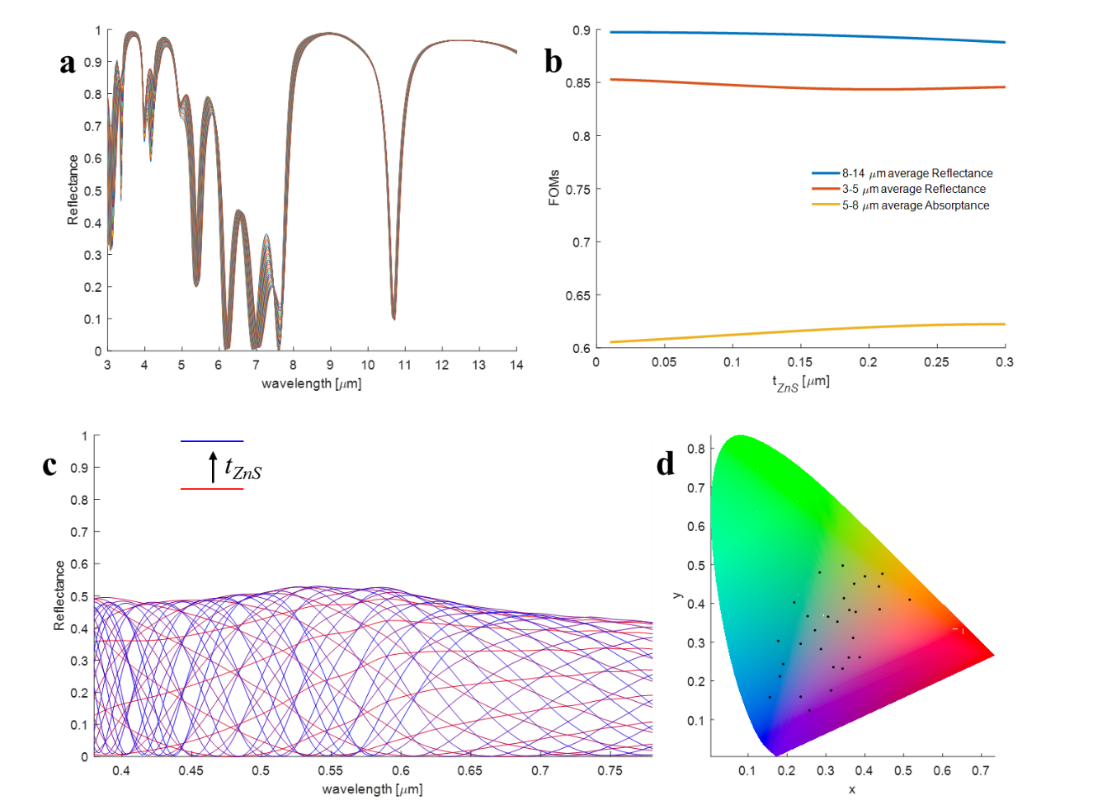
Fig. S2. (a) MIR reflectance spectra for different t_{ZnS} varying from 10 nm to 300 nm. (b) The figure of merit plots, which are band average reflectance for 3-5 and 8-14 μm or band average absorbance for 5-8 μm (Higher the value, better it is). (c) Visible reflectance spectrum for different t_{ZnS} varying from 10 nm to 300 nm. (d) The corresponding visible colors of spectra in (c) indicated in the CIE 1931 chromaticity diagram.

Section S4. Measured absorbance for SE and Cr film
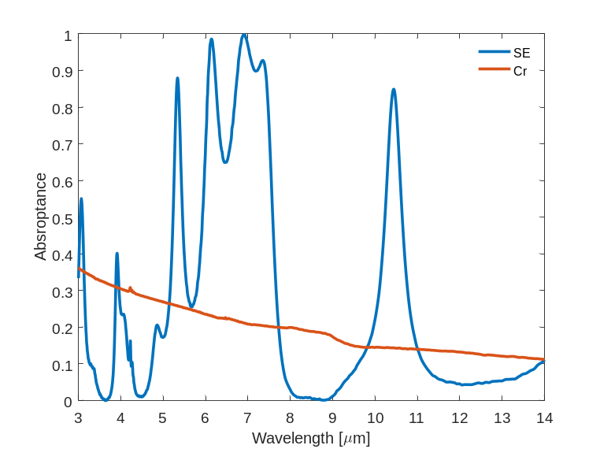
Fig. S3. Measured absorbance spectra for SE and Cr.

Section S5. Heat transfer modeling
For normal pressure case, the power input at thermal equilibrium state (stable state) for different temperature can be defined as
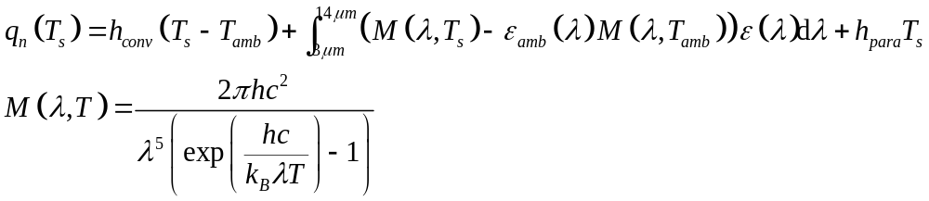
where h_{conv} is the convective heat transfer coefficient, M(λ, T) is the spectral radiance of blackbody, ε(λ) is the spectral emittance, and h_{para} denotes heat transfer coefficient for other all heat transfer channels.
For vacuum case, the power input can be defined as
As it is difficult to determine the value of temperature-related h_{para} due to heat dissipation by conduction and radiation/convection on the sides of the structure, the difference between power inputs for SE and Cr under identical experiment configuration eliminates the influence of parasitic heat loss by considering the emittance of ambiance to be 1 constantly:
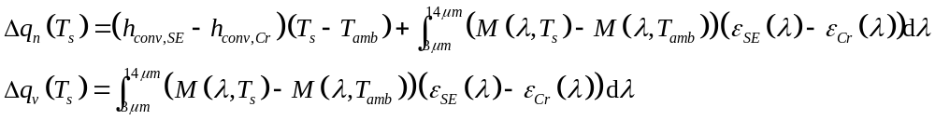
Therefore the Δq_{v}(T_{s}) can be determined by the surface temperature and emittance of samples, as shown by the simulated power difference without convection (vacuum condition, T_{v,SE}-T_{v,Cr}) in Fig. 4(c).
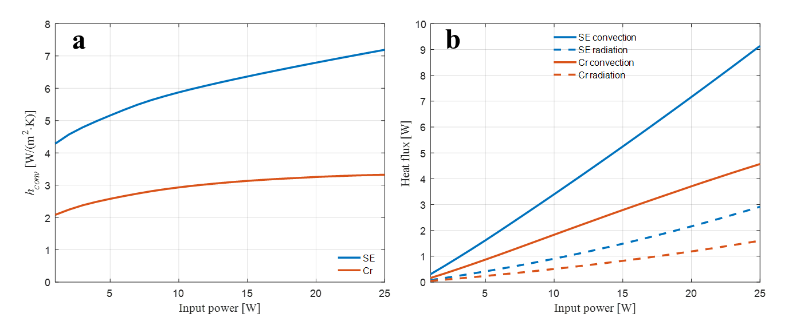
Fig. S4. (a) The convective heat transfer coefficients h_{conv} on the samples’ surfaces versus input powers. (b) The convective heat flux and radiative heat flux in the surface normal directions.

For the Δq_{n}(T_{s}), the convective heat transfer coefficients are dependent on the surface temperature, therefore related to the input power. The h_{conv} for both SE and Cr cases are obtained by conjugate heat transfer (coupling to laminar flow for natural convection) simulations in COMSOL Multiphysics, as shown in Fig. S4(a). For the Cr case, as the surface emittance is reltively low in the MIR band, the radiative heat transfer is simplified as surface-to-ambient radiation with a constant surface emittance 0.2. For the SE case, the wavelength-selective emittance is simulated with temperature-dependent surface emittance and the heat transfer is modelled with coupling among heat transfer in solids, radiation in participating media, and laminar flow. The absorption coefficients of atmosphere is determined by band average of the extinction coefficients k of water vapor and relative humidity identical to experiments’ value (60 %). In the radiation in participating media module, the P1 approximation is applied for radiation discretization. As shown in Fig. S4, by coupling to radiation, the convection of SE is enhanced indicated by both larger h_{conv} and convective heat flux compared to the Cr. The difference in radiation heat flux between SE and Cr is mainly related to the surface emittance difference.

