Supplemental figures and tables
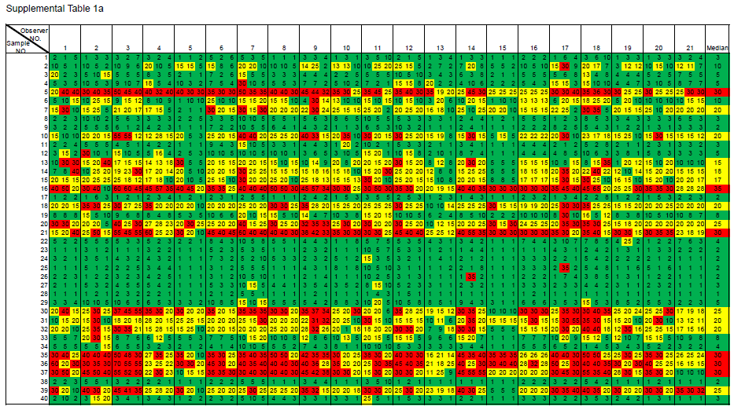
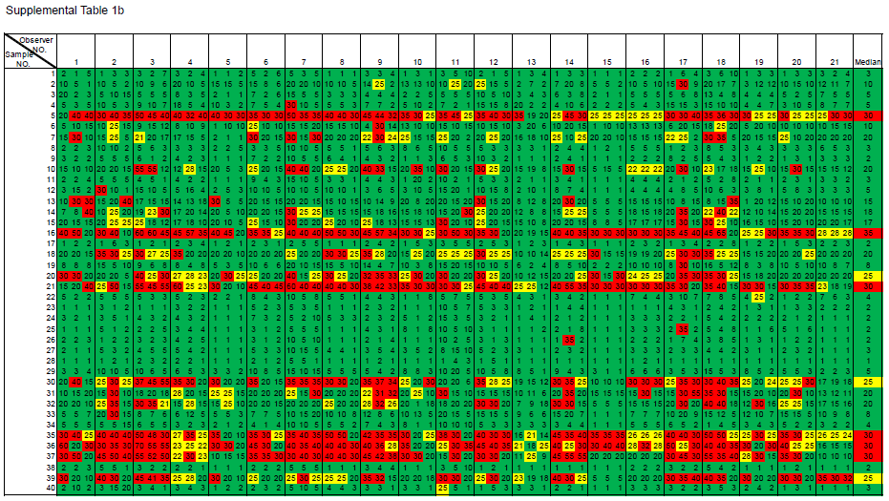
Table S1: Heat map of KI67 scores (a: NHCC; b: NHCCa9).
Rows are used to indicate sample numbers while columns to indicate Ki67 scores from 21 observers in triplicate in blind. The median is that of all 63 IHC scores of each sample. (a) The specimens were stratified into low, intermediate and high risk group by following National Health Committee of China (NHCC) guidance. The score equal or less than (≤)10% is indicated by green, between 10~30% by yellow, and equal or more than (≥) 30% by red. (b) The specimens were stratified into low, intermediate and high risk group by following National Health Committee of China (NH(CC), appendix a9 (NHCCa9) guidance. A score equal or less (≤) 20% is indicated by green, 20~30% by yellow, and equal or more than (≥) 30% by red.

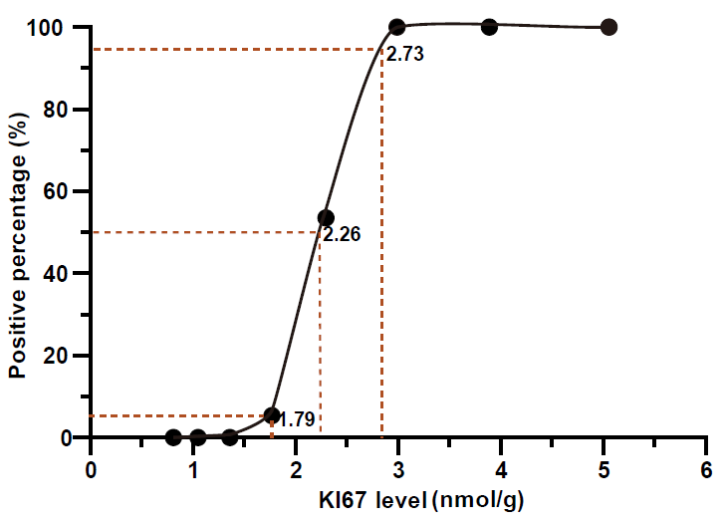

Fig S1: Defining C₅, C₅₀, and C₉₅ of the validated 2.31 nmole/g Ki67 cutoff. The 2.31 nmol/g was developed and validated previously ^{1, 2}. Total protein lysates were extracted from several breast cancer specimens, and mixed to adjust final Ki67 levels ~ 5 nmole/g. The mixed lysate was then serially diluted and loaded in 56-plicates at indicated concentrations in the figure. C₅, C₅₀ and C₉₅ of the cutoff was calculated statistically based on the percentage of specimens above 2.31 nmole/g at each concentration. The calculated values of C₅, C₅₀ and C₉₅ were marked at the figure.

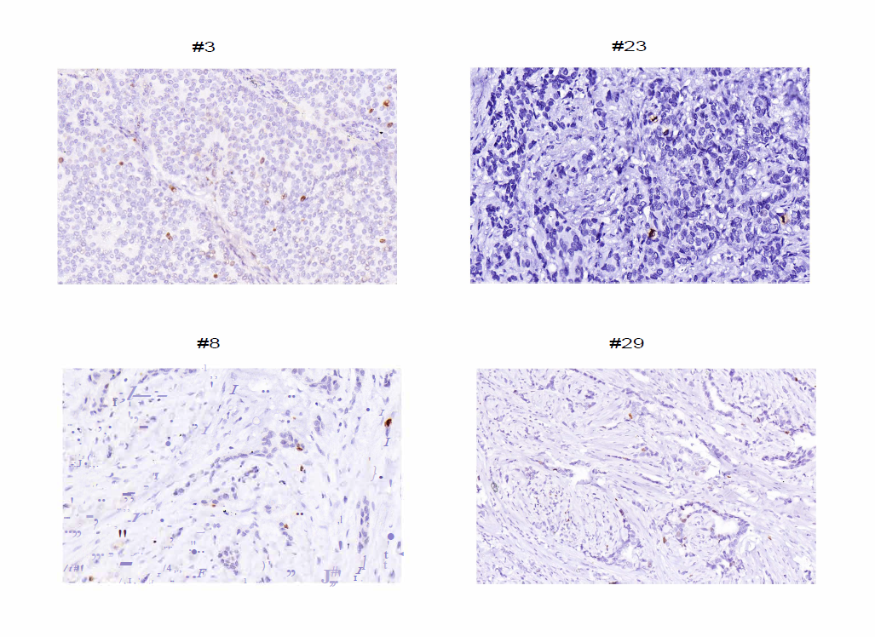
Fig S2: Representative IHC images of 4 breast cancer specimens used in the study. The median IHC scores and Ki67 levels from QDB analysis were as following [median IHC% vs QDB levels (nmole/g)]: #3(5 vs 1.44); #8(3 vs 1.34); #23(2 vs 5.52); #29(5 vs 3.25).

