Table 1

Table1: Clinicopathological characteristics of 40 breast cancer specimens.

Characteristics Number of Cases (%) Age
<50 15(37.5)
≥50 25(62.5)
Pathologial Lymph Node Status, pN
pN0 | 22(55.0)
pN1 | 10(25.0)
pN2 | 5(12.5)
pN3 | 3(7.5)
athological Tumor Size, pT  pT1 | 17(42.5)
pT2 | 20(50.0)
pT3 | 1(2.5)
pT4 | 2(5.0)
istological Grade
I 1(2.5)
II | 29(72.5)
III | 7(17.5)
Unknown | 3(7.5)

P

H

ER
≥1% 40(100.0)
PR
＜1% 3(7.5)
≥1% 37(92.5)
HER2
HER2- 37(92.5)
HER2+ 3(7.5)

Table 2

Table 3

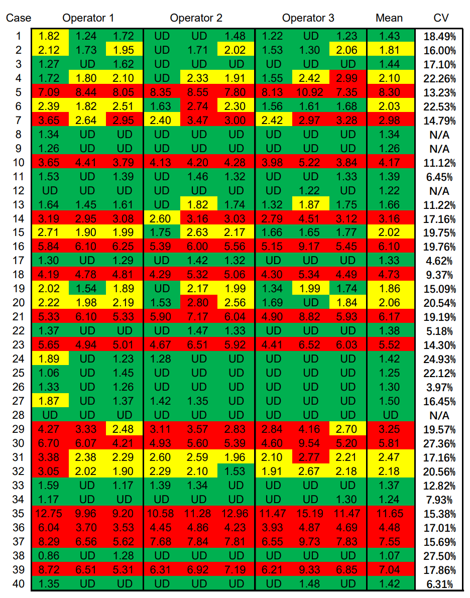

Table 4

