Supplementary Material

Table S1: Count of reads and ASVs per sample found from rRNA 16s gene sequencing from coral polyps and fragments

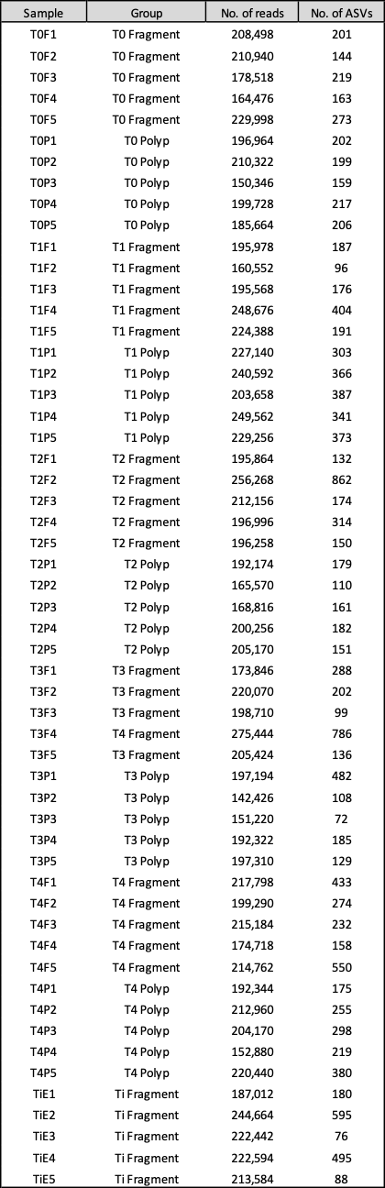
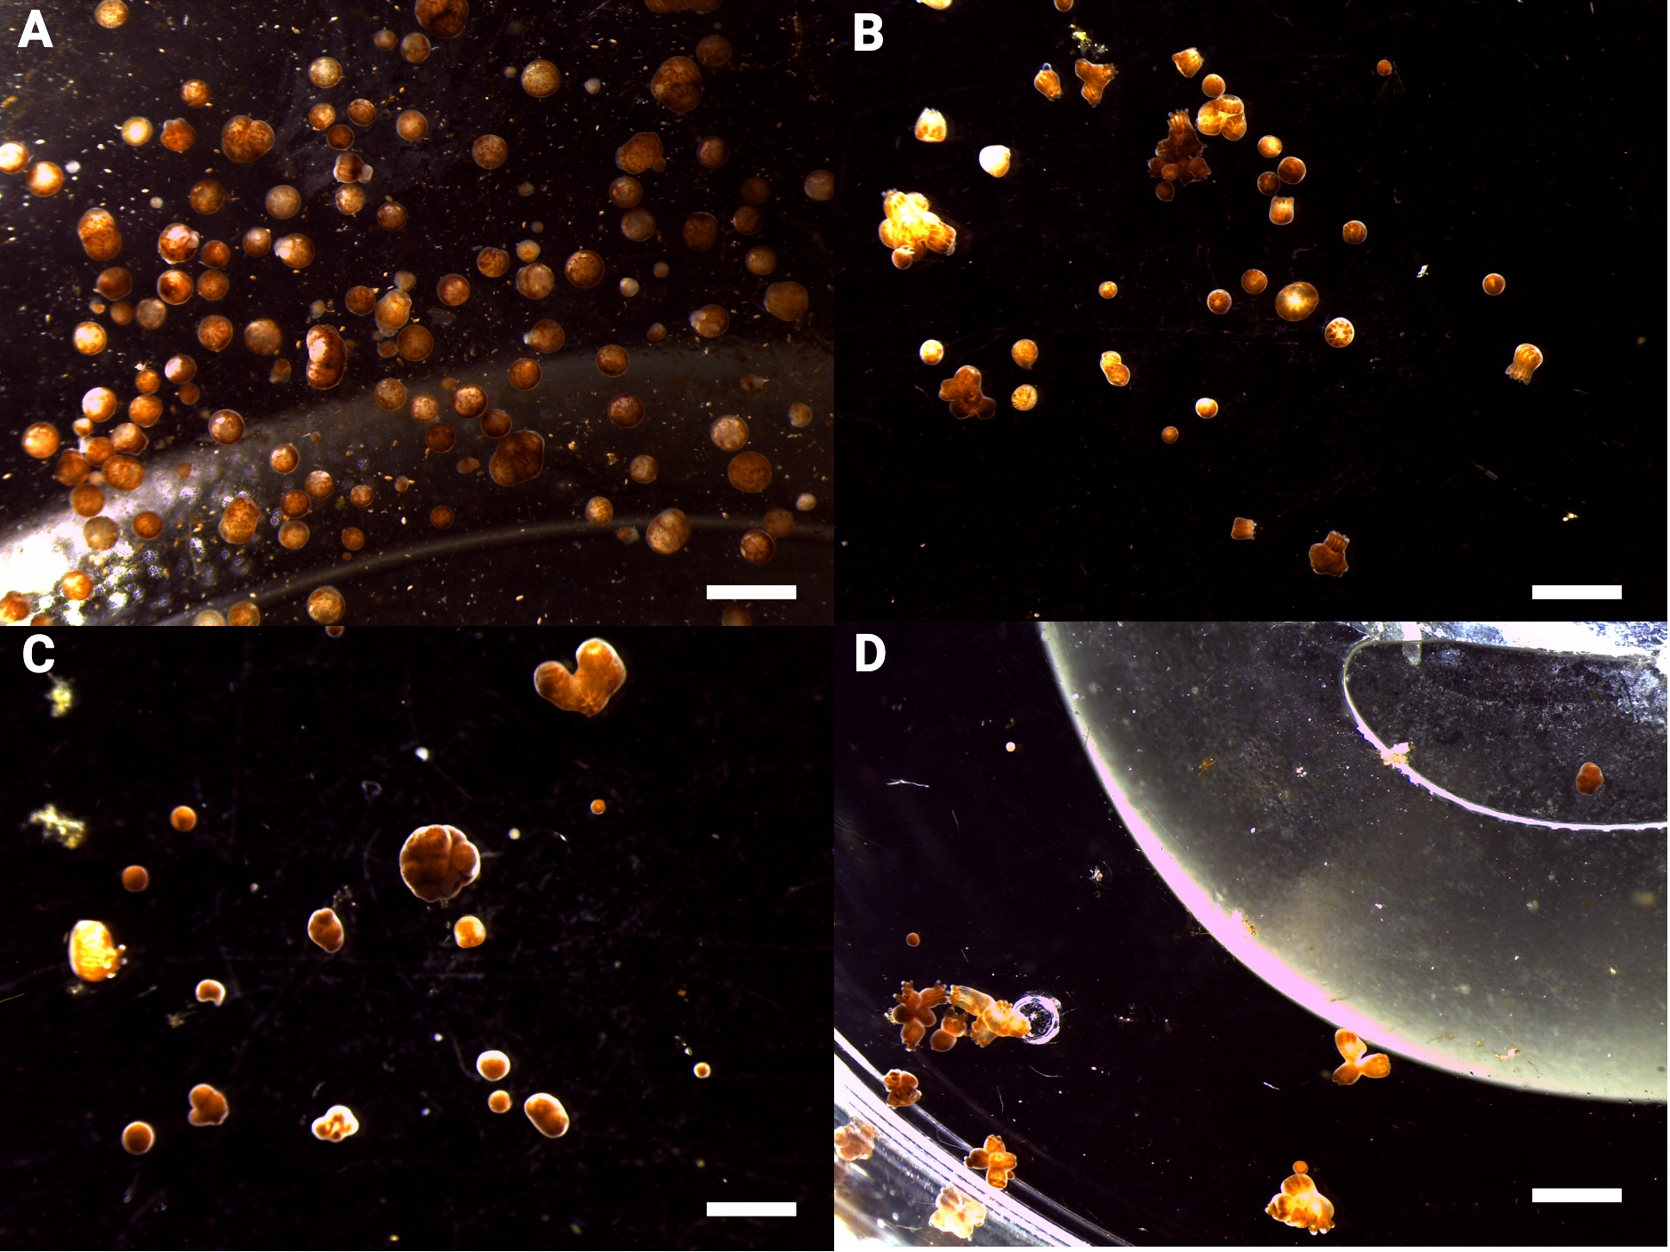

Figure S1: Photos of Pocillopora verrucosa polyps taken three days (A), one week (B), two weeks (C) and three weeks (D) after polyp bail-out, illustrating fused and contracted polyps found in study.

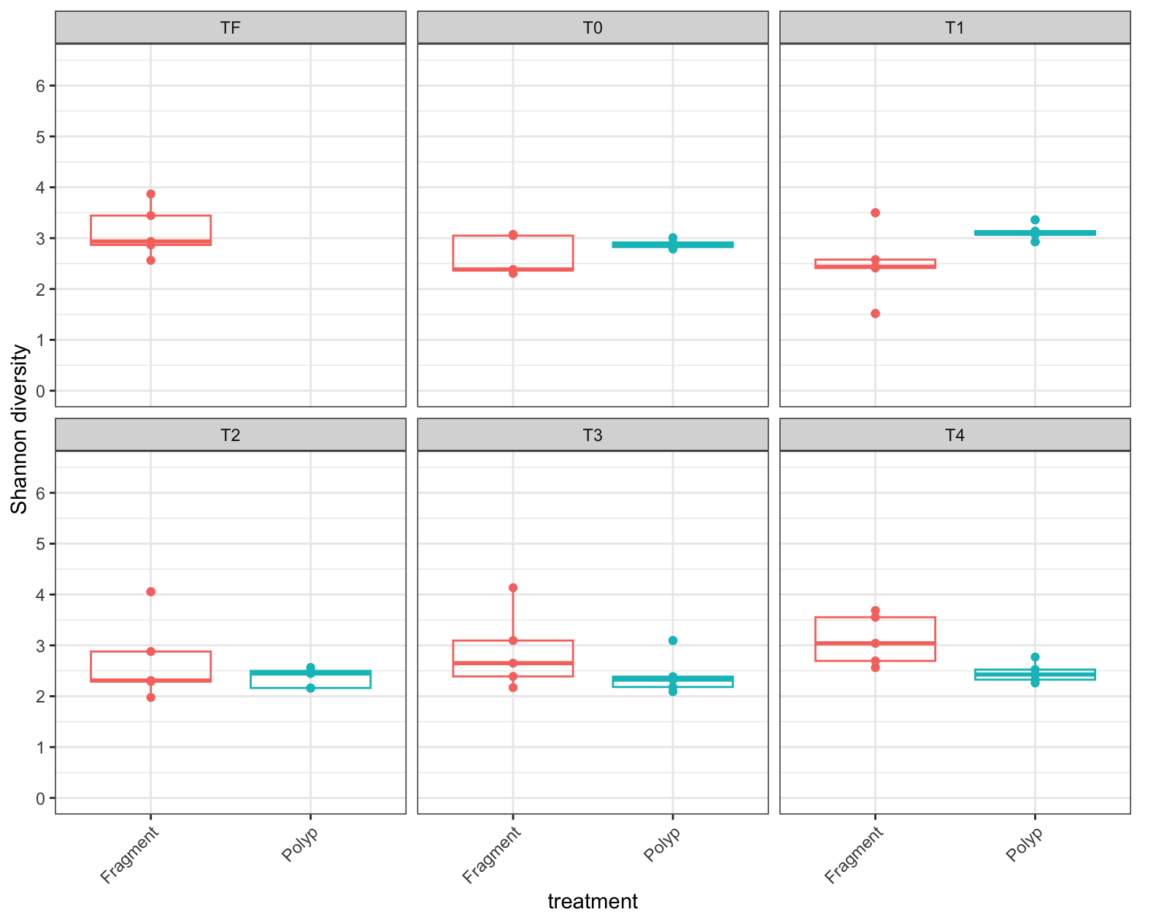
Figure S2: Boxplots of the Shannon diversity estimated based on ASVs from coral polyp and fragments samples constructed from 16s rRNA gene amplicon sequencing. Data corresponds to data points before (Ti) immediately (T0), three days (T1), one week (T2), two weeks (T3) and three weeks (T4) after beginning of the polyp bail-out microbiome experiment.

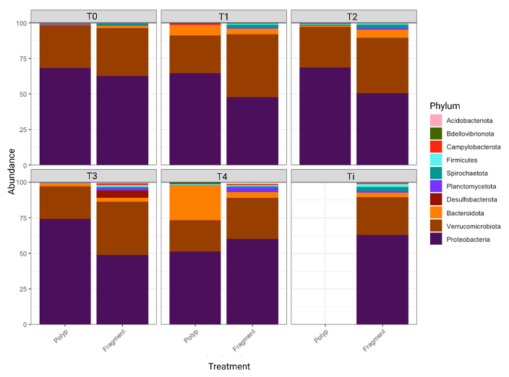

Figure S3: Stacked bar graph showing relative abundances of the ten most abundant phyla found in coral polyp and fragments samples estimated from 16s rRNA gene amplicon sequencing. Data corresponds to data points before (Ti), immediately (T0), three days (T1), one week (T2), two weeks (T3) and three weeks (T4) after beginning of the polyp bail-out microbiome experiment.

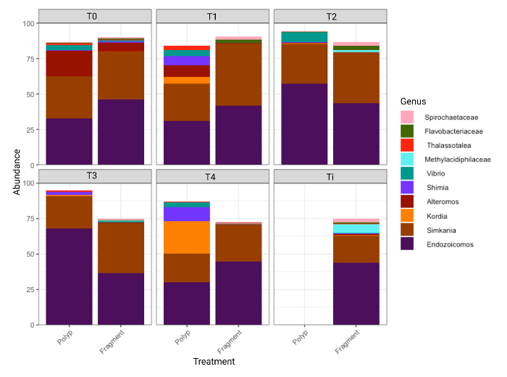

Figure S4: Stacked bar graph showing relative abundances of the ten most abundant genera found in coral polyp and fragments samples estimated from 16s rRNA gene amplicon sequencing. Data corresponds to data points before (Ti) immediately (T0), three days (T1), one week (T2), two weeks (T3) and three weeks (T4) after beginning of the polyp bail-out microbiome experiment.

