Training Cohort (n=91)
Validation Cohort (n=39)
DLBCL patients from 2013 to 2018 (n=369)
130 cases eligible patients were included in the study
Exclusion
- poor quality of CT images due to artefacts (n=51)
- the presence of contraindications to chemotherapy, severe cardiac, epatic, and renal diseases, and those who have not completed 4 cycles of chemotherapy in a standardized manner (n=104)
- imperfect imaging and follow-up data (n=84)

Fig S1

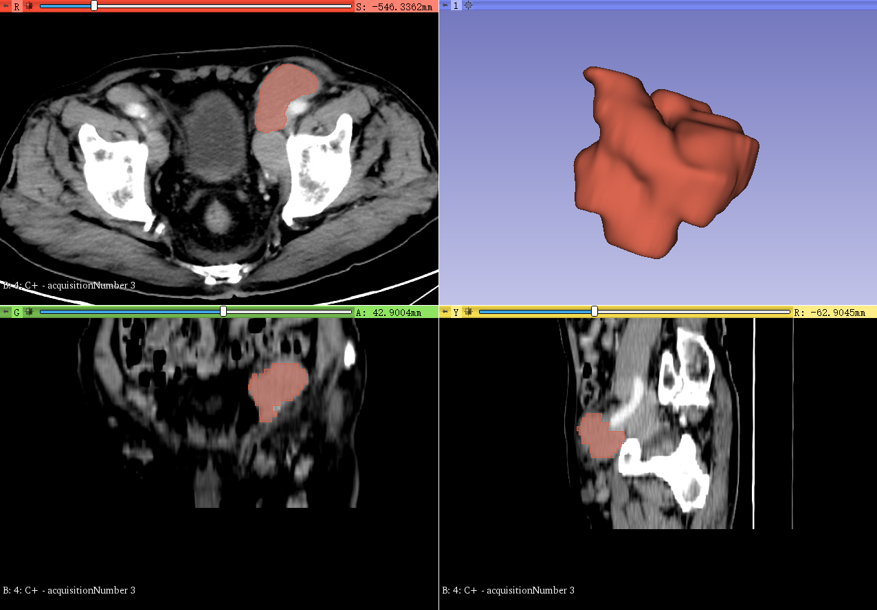 | 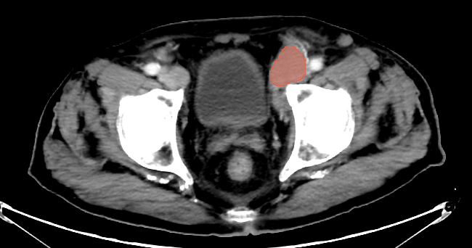
Sagittal plane | Segmentation region in axial plane | Coronal plane | Three-Dimensional view
Fig S2

Radiomics Features (N=851)
Shape Features(n=14) | FirstOrder Features(n=162) | Gray Level CO-Occurrence Matrix(n=216) | Gray Level Dependence Matrix(n=126) | Gray Level run length matrix(n=144) | Gray Level size zone matrix(n=144) | Neighboring gray tone difference matrix(n=45)
Elongation  Flatness  LeastAxisLength  MajorAxisLength  Maximum2DDiameterColumn  Maximum2DDiameterRow  Maximum2DDiameterSlice  Maximum3DDiameter  MeshVolume  MinorAxisLength  Sphericity  SurfaceArea  SurfaceVolumeRatio  VoxelVolume | Percentile  Energy  Entropy  InterquartileRange  Kurtosis  Maximum  Mean  MeanAbsoluteDeviation  Median  Minimum  Range  RobustMeanAbsoluteDeviation  RootMeanSquared  Skewness  TotalEnergy  Uniformity  Variance | Autocorrelation  ClusterProminence  ClusterShade  ClusterTendency  Contrast  Correlation  DifferenceEntropy  DifferenceVariance  Id  Idm  Idmn  Idn  Imc  InverseVariance  JointAverage  JointEnergy  JointEntropy  MaximumProbability  MCC  SumAverage  SumEntropy  SumSquares | DependenceEntropy  DependenceNonUniformity  DependenceNonUniformityNormalized  DependenceVariance  GrayLevelNonUniformity  GrayLevelVariance  HighGrayLevelEmphasis  LargeDependenceEmphasis  LargeDependenceHighGrayLevelEmphasis  LargeDependenceLowGrayLevelEmphasis  LowGrayLevelEmphasis  SmallDependenceEmphasis  SmallDependenceHighGrayLevelEmphasis  SmallDependenceLowGrayLevelEmphasis | GrayLevelNonUniformity  GrayLevelNonUniformityNormalized  GrayLevelVariance  HighGrayLevelRunEmphasis  LongRunEmphasis  LongRunHighGrayLevelEmphasis  LongRunLowGrayLevelEmphasis  LowGrayLevelRunEmphasis  RunEntropy  RunLengthNonUniformity  RunLengthNonUniformityNormalized  RunPercentage  RunVariance  ShortRunEmphasis  ShortRunHighGrayLevelEmphasis  ShortRunLowGrayLevelEmphasis | GrayLevelNonUniformity  GrayLevelNonUniformityNormalized  GrayLevelVariance  HighGrayLevelZoneEmphasis  LargeAreaEmphasis  LargeAreaHighGrayLevelEmphasis  LargeAreaLowGrayLevelEmphasis  LowGrayLevelZoneEmphasis  SizeZoneNonUniformity  SizeZoneNonUniformityNormalized  SmallAreaEmphasis  SmallAreaHighGrayLevelEmphasis  SmallAreaLowGrayLevelEmphasis  ZoneEntropy  ZonePercentage  ZoneVariance | Busyness  Coarseness  Complexity  Contrast  Strength
Table S1

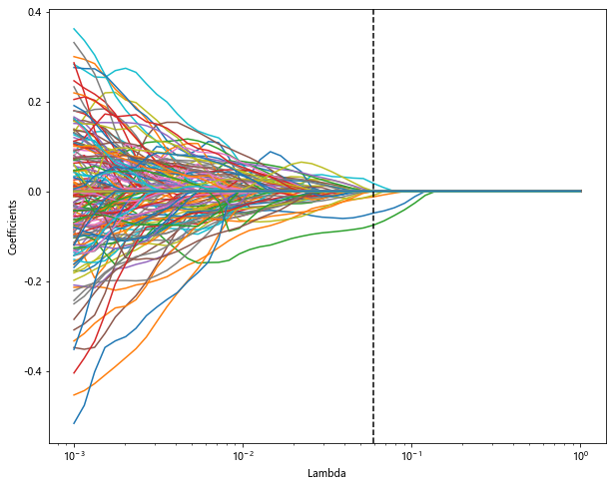 | 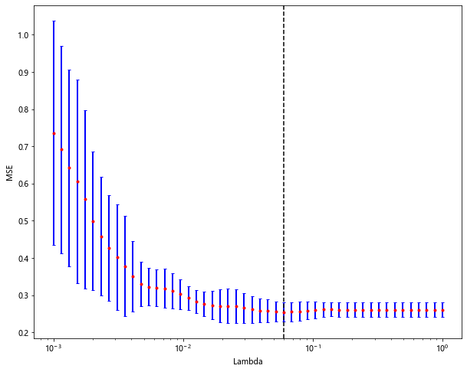
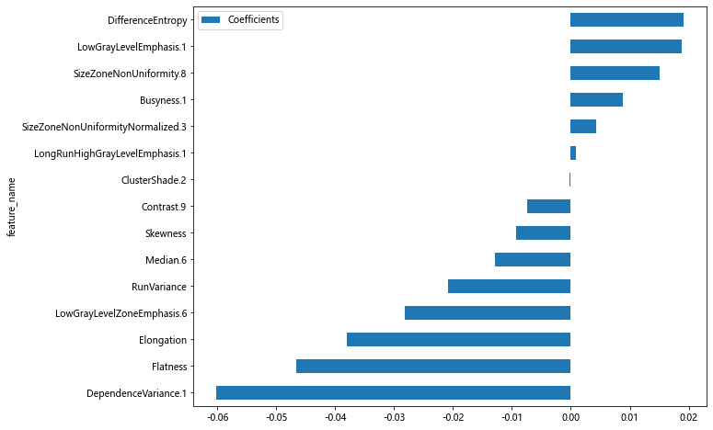
Fig S3

Table S2 Selected features and their coefficients
 | Coefficients | Features
1 | 0.019083 | DifferenceEntropy
2 | 0.018787 | LowGrayLevelEmphasis.1
3 | 0.004305 | SizeZoneNonUniformityNormalized.3
4 | 0.008847 | Busyness.1
5 | 0.004305 | SizeZoneNonUniformityNormalized.3
6 | 0.000918 | LongRunHighGrayLevelEmphasis.1
7 | -0.000250 | ClusterShade.2
8 | -0.007406 | Contrast.9
9 | -0.009312 | Skewness
10 | -0.012821 | Median.6
11 | -0.020902 | RunVariance
12 | -0.028171 | LowGrayLevelZoneEmphasis.6
13 | -0.038004 | Elongation
14 | -0.046530 | Flatness
15 | -0.060094 | DependenceVariance.1

OS=1 = 0.4607838228701024 -0.038004 * Elongation -0.046530 * Flatness -0.009312 * Skewness +0.019083 * DifferenceEntropy -0.020902 * RunVariance -0.060094 * DependenceVariance.1 +0.018787 * LowGrayLevelEmphasis.1 +0.000918 * LongRunHighGrayLevelEmphasis.1 +0.008847 * Busyness.1 -0.000250 * ClusterShade.2 +0.004305 * SizeZoneNonUniformityNormalized.3 -0.007406 * Contrast.9 -0.012821 * Median.6 -0.028171 * LowGrayLevelZoneEmphasis.6 +0.015123 * SizeZoneNonUniformity.8

