International Journal of Systematic and Evolutionary Microbiology Supplementary Material
Catenovulum algicola sp. nov. , an agar-hydrolysing gammaproteobacterium isolated from kelp seedlings
Rui-Ying Chen¹, Yang-Yang Sun^{1,2}, Ya Gong^{1,3}* and Zong-Jun Du^{1,3}*
¹Marine College, Shandong University, Weihai, Shandong, 264209, People’s Republic of China
²Joint Science College, Shandong University, Weihai, Shandong, 264209, People’s Republic of China
³WeiHai Research Institute of Industrial Technology of Shandong University, Weihai, Shandong, 264209, People’s Republic of China

* Author for correspondence:
Ya Gong: gongya@sdu.edu.cn, ORCID ID, 0000-0001-9167-3048
Zong-Jun Du: duzongjun@sdu.edu.cn, ORCID ID, 0000-0002-7886-5667
Telephone and fax number: +86-631-5688303
Supplementary Fig. S1 The phylogenetic tree was reconstructed by using maximum-likelihood algorithm based on 16S rRNA gene sequences showing the positions of C. algicola 2E275^{T}
Only bootstrap values (expressed as percentages of 1,000 replications) of >70 % are shown at branching points. Escherichia coli NBRC 102203^{T} (AB681728) is used as an out group. Scale bar 0.02 substitutions per nucleotide position.

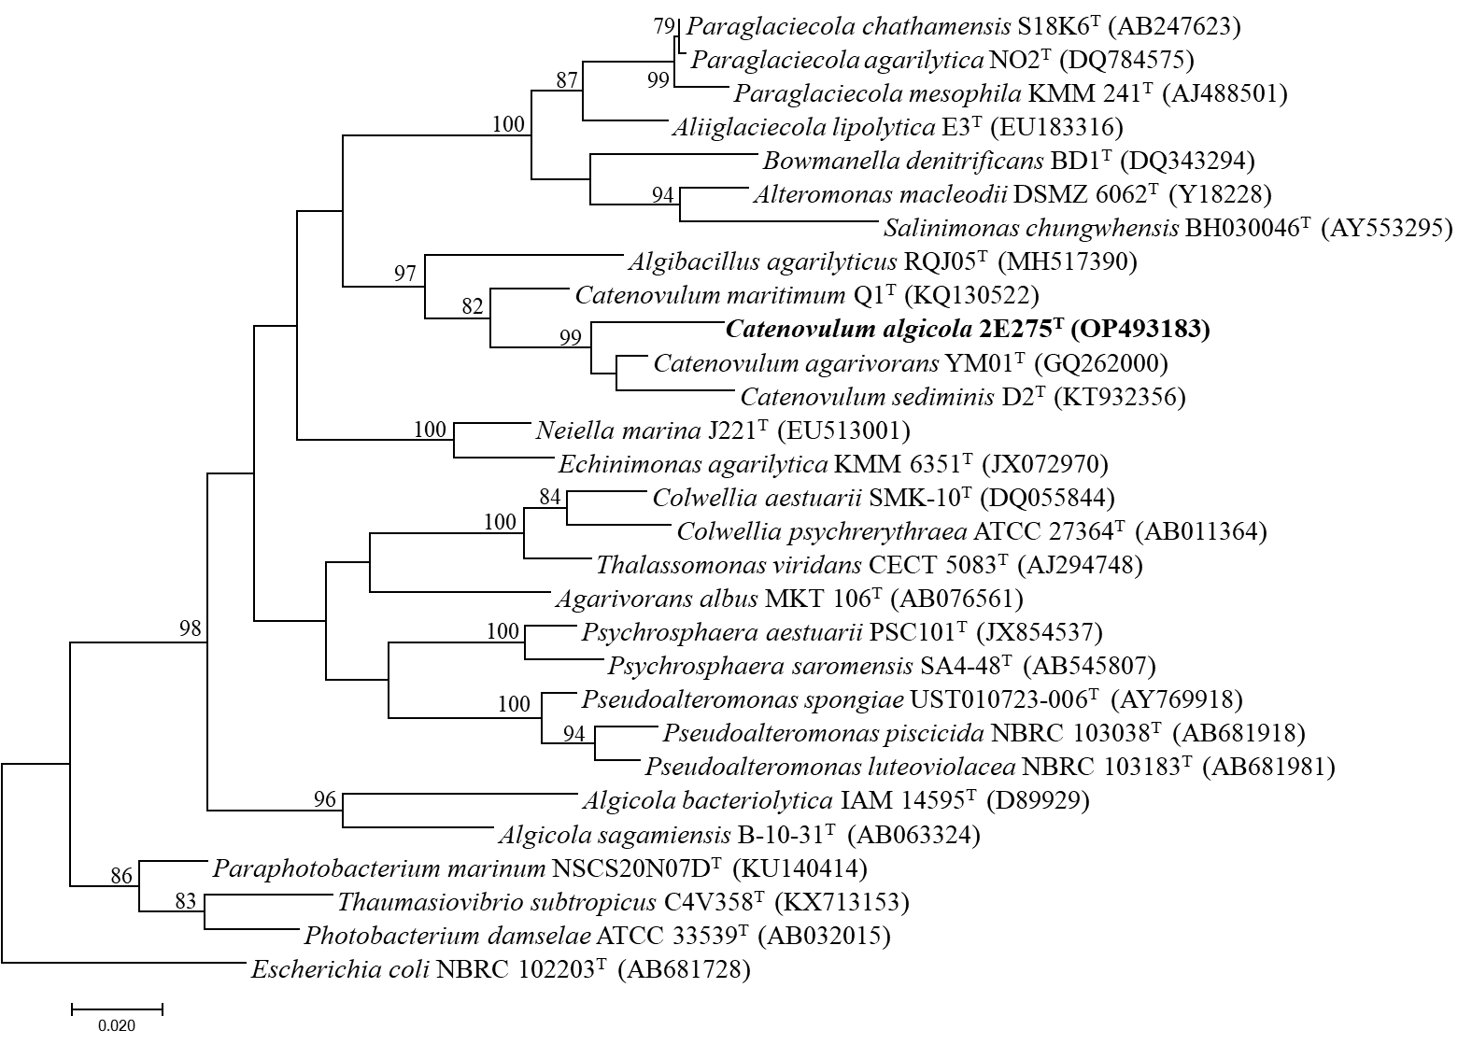

Supplementary Fig. S2 Transmission electron microscopy of cells of strains 2E275^{T}
Cells were grown on MA at 37 °C for 48 h. Bar, 500 nm.

Supplementary Fig. S3 Two-dimensional thin-layer chromatogram of polar lipids of the strains
Strains: (A) strain 2E275^{T}; (B) C. agarivorans YM01^{T}
PE, Phosphatidylethanolamine; PG, Phosphatidylglycerol; PL, Phospholipid; PN, Aminophospholipid; L, unidentified Lipid.

(A) (B)

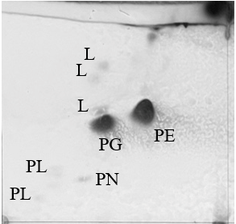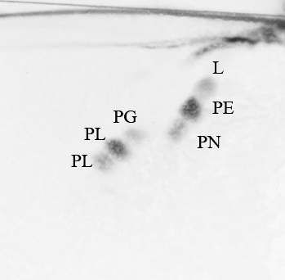

Table S1 The genome-to-genome distance among strains 2E275^{T} and C. agarivorans YM01^{T} (AJWM00000000.1) and C. sediminis WS1-A^{T} (FNEB00000000)

Genome_A | Genome_B | DDH | ANI
2E275 | Catenovulum agarivorans | 22.9 %  [20.7-25.4 %] | 73.5 %
2E275 | Catenovulum sediminis | 21.2 %  [19.0 – 23.6 %] | 72.2%

