Assessment of Sustainable and Machinable Performance Metrics of Monocrystalline Silicon Carbide Wafer with Electrophoretic Assisted Multi-Diamond Wire Sawing
Eyob Messele Sefene^{a, [0000-0003-4660-6262]} Chao-Chang Arthur Chen,^{b*}, Yueh-Hsun Tsaiª,Ting-Huan Laiª, Ding-Xuan Huangª
Corresponding author email: artchen@mail.ntsut.edu.tw

- Department of Mechanical Engineering, National Taiwan University of Science and Technology, No. 43, Keelung Rd, Sec.4, Da’an Dist., Taipei 10607, Taiwan
- CMP Innovation Center, National Taiwan University of Science and Technology, No. 43, Keelung Rd, Sec.4, Da’an Dist., Taipei 10607, Taiwan

* To whom correspondence should be addressed.
E-mail: artchen@mail.ntsut.edu.tw *

Supplementary Information

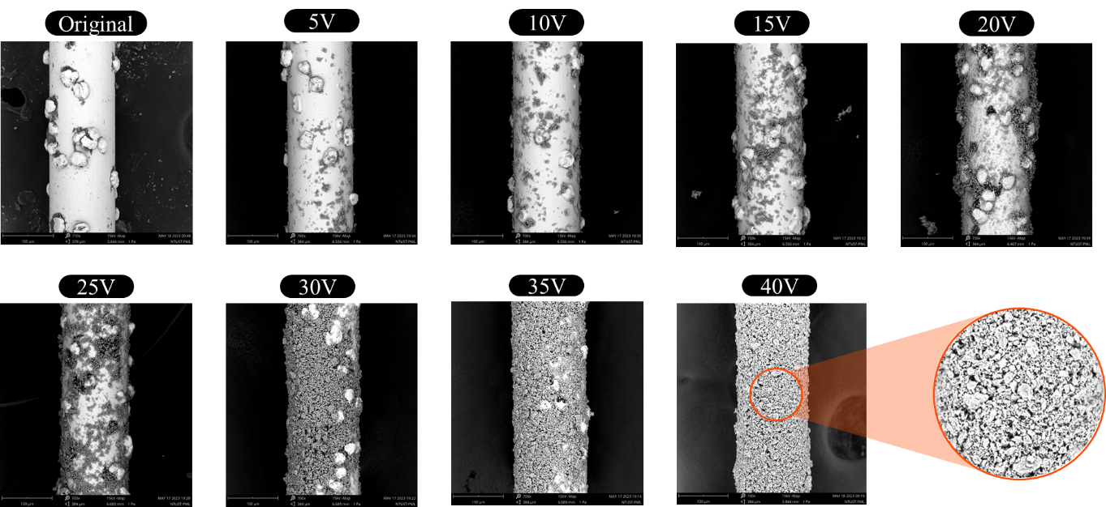
Fig. A.1 Electrophoretic deposition of diamond wire at different voltages.
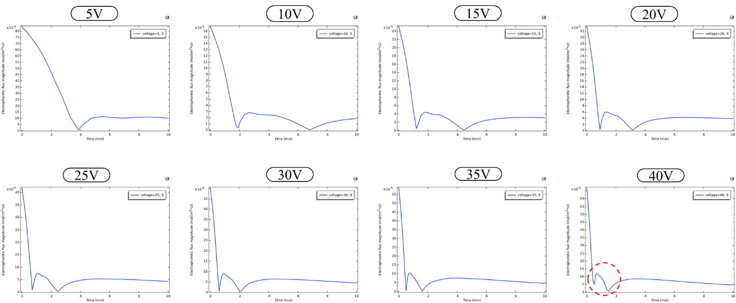
Fig. A.2 Optimization of Electrophoretic deposition of diamond wire at different voltages using COMSOL software.

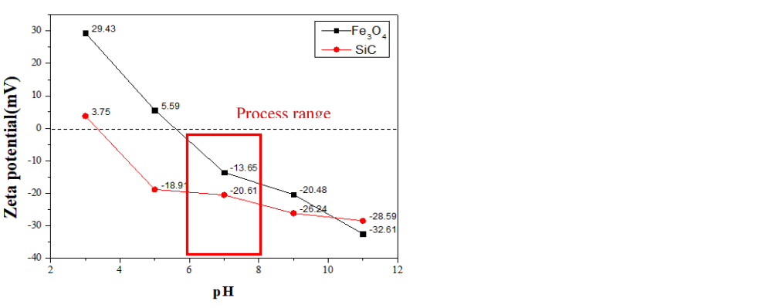
Fig. A.3 Variation of zeta potential of Fe₃O₄ and SiC particles between pH3 and pH11.
Table A.1 Life Cycle Assessment of cooling materials.
Input | Element | Life Cycle Inventory |  |  | Quantity | GWP100 (kgCO₂e) | Share Impact
Input | Element | Emission Factor (kgCO₂e) | Functional Unit | Source | Quantity | GWP100 (kgCO₂e) | Share Impact
Reactive Coolant | Di-water | 0.00048 | kg | ecoinvent 3.8, 2022. Market for water, deionized. World except Europe. | 38.25 | 0.018 | 0.1%
Reactive Coolant | Coolant #787 | 1.87285 | kg | ecoinvent 3,8. 2022. Market for chemical production, inorganic. World | 1.6 | 2.997 | 13.8%
Reactive Coolant | Fe₃O₄ | 0.91723 | kg | ecoinvent 3.8, 2022. Market for magnetite. World | 0.25 | 0.229 | 1.1%
Reactive Coolant | H₂O₂ | 1.53836 | kg | ecoinvent 3.8, 2022. Market for hydrogen peroxide. World except Europe. | 7.5 | 11.538 | 53.1%
Reactive Coolant | Dp-500 | 1.87285 | kg | ecoinvent 3,8. 2022. Market for chemical production, inorganic. World | 2.5 | 4.682 | 21.6%
Electricity | Taiwan Electricity | 0.7773 | kW.h | ecoinvent 3.8, 2022. Market for electricity, low voltage Taiwan. | 2.907 | 2.260 | 10.4%
 |  |  |  |  |  | 21.724

