Supplementary materials

Functional connectivity between IPL and action execution areas
Methods
We used Nilearn to calculate the functional connectivity between the IPL and PCG during the observation of foot-related verbs, as well as between the IPL and PoCG during the observation of hand-related verbs. First, we extracted the time series data from each ROI for each subject. Second, the Pearson correlation was calculated between the IPL and the PcG, as well as between the IPL and the PoCG. Last, we converted the Pearson correlation coefficient into z-score using a Fisher’s r-to-z transformation.
We then conducted statistical analyses on the obtained correlation coefficients and corresponding z-scores. Firstly, we performed one-sample t-tests on the correlation coefficients separately for each condition and each group. Subsequently, we conducted a 2x2 repeated measures ANOVA on the obtained z-scores.

Results
The results of one-sample t-tests showed that among experts and novices, there is a moderate strength of correlation between the IPL and the PCG, as well as between the IPL and the PoCG (for experts, rIPL-PCG=0.388, t=9.552, p<0.001; rIPL-PoCG=0.427, t=7.251, p<0.001, for novice, rIPL-PCG=0.454, t=12.197, p<0.001; rIPL-PoCG=0.383, t=10.098, p<0.001). The results of repeated measures ANOVA showed that no significant main effect for both group(F = 0.013, p=0.0908) and condition(F=0.014, p=0.905), and the interaction of group and condition was not significant(F=2.619, p=0.111).
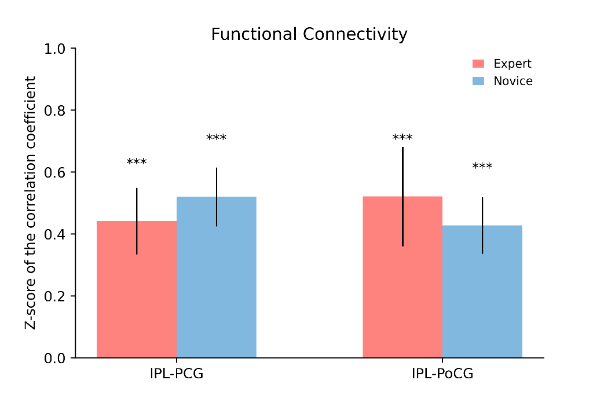
Supplementary Figure1. Results of function connectivity between IPL and PCG(IPL-PCG), as well as IPL and PoCG(IPL-PoCG). Error bar indicate 95% Confidence Interval, and asterisks indicate effects of two-tailed t test(upper) between PCG and PoCG in novices, and FEW-corrected(α=0.05) one-tailed t tests(lower) against chance-level(50%, *p<0.05, **p<0.01, ***p<0.001).

Seed-based functional connectivity analyses
Methods
Seed-based FC analyses were performed using the DPABI (Yan et al., 2016), and this entailed four components. First, we used the action execution areas (PCG and PoCG) as the seed regions. Second, the time coursed of all voxels within each seed region were extracted and averaged for each group and each condition. Third, the Pearson correlation was calculated between the mean time courses and those of all other voxels over the whole brain. Last, all FC maps were converted into z-maps using a Fisher’s r-to-z transformation to improve their normality and enhance the quality of the statistical analysis. Thus, we got the FC z-maps for each group and condition. Subsequently, we conducted a second level test using ANNOVA. Correction for multiple comparisons was conducted using the FWE (α = 0.05) method.

Results
The results of the ANOVA indicated that when the ROI was the PCG, there was a main effect of the group on the strength of functional connectivity between the PCG and the right MFG(MNI coordinates (38,-52,6); FWE corrected, α = 0.05, F=26.35, p=0.047). when the ROI was the PoCG, no significant main effects or interaction on the strength of functional connectivity.

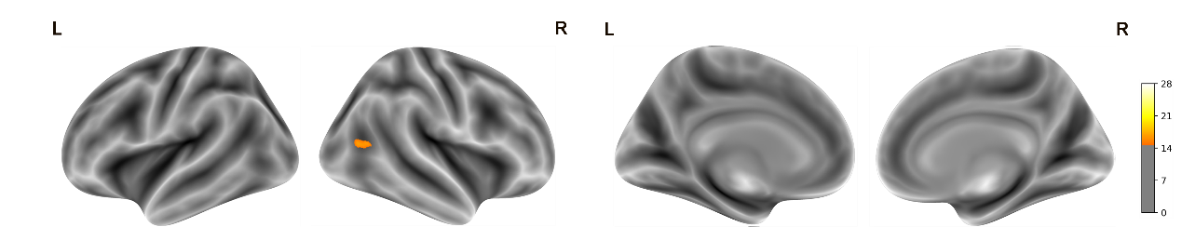
Supplementary Figure2. Results of seed-based functional connectivity analyses for PCG. Functional connectivity results with the PCG as the ROI presented as a F-map indicating the statistical significance of the main effect of group. The maps are thresholded by FEW(α=0.05) corrected for multiple comparisons.

