Bibliography

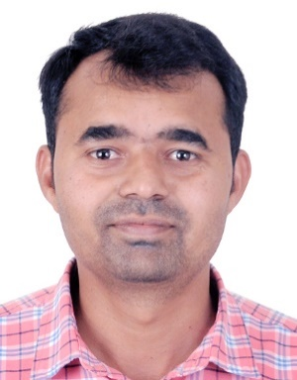 | Ravindra Patil BE (Civil) from Walchand college of Engineering, Sangli, Maharashtra and MBA from Indian Institute of business Studies, He is working in Structural engineering field for the last 17.5 years. Having the exposure of IS and BS, ACI codes, He has worked on most of the prestigious projects globally. He has wide range of experience including water & Sewage treatment plants, Metal & Mining, Industrial, Process, infrastructure, Residential, Commercial, and educational Structures. His area of interest is in water retaining structures. He is pursuing master’s degree in structure from Sinhgad college of Engineering, Pune (Savitribai Phule Pune University)
 | Pallavi Khatawkar M.E. (Structure). She is working as Assistant Professor in Sinhgad college of engineering, Pune. She has vied experience of teaching field.

